Robotanks
- Introduction.
We are doing this project because we felt the need to challenge ourselves and our friends and compete in programming related tasks. The project may not be a life-changing experience for you, but it sure was for us, because doing this improved our performances and most important our team work. Enjoy this project as we asure you that this project combines the best in computer science.
Robotanks is a multiplayer programming web based game, an arena where robotanks battle with other robotanks for supremacy. Players can code their own robots.
- Problem Statement
There are lots of battle programming games over the world, but none of them unifies everything under a single streamlined interface. They are either poor featured, either lack the power of a real programming language or simply require too much effort in order to play the game.
- Procedures
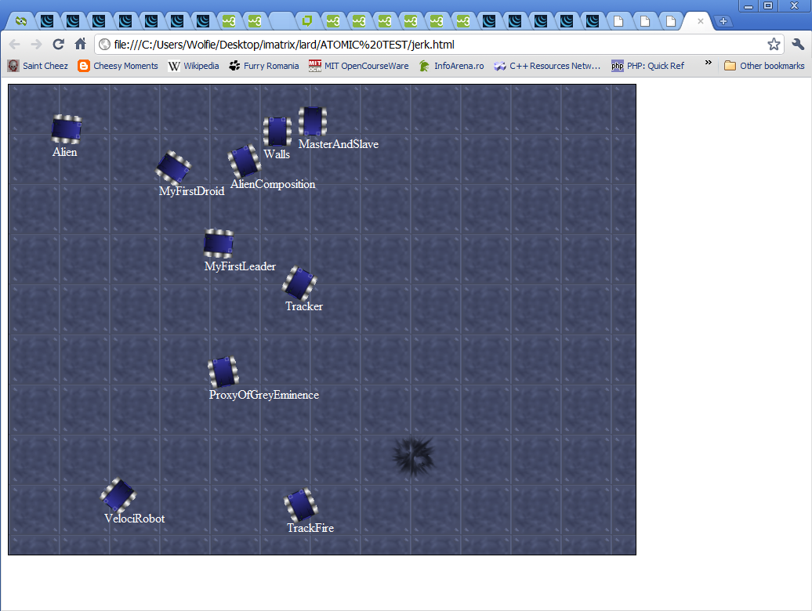
We considered that creating our own game engine would be like reinventing the wheel. We already knew RobotBattle, but it was quite outdated, used hard-to-find libraries and hadn’t been updated for years (9 years, to be exact). So we found Robocode. It uses Java, so we can develop and run it on most operating systems and it had a vastly developed engine. It could even run .NET and JavaScript robots!
The next step was setting the engine up to work in an automated manner (the game engine needed to be ran, configured and queried by the game logic).
After all these steps, we needed to find a way to show the user what is actually happening with his robot. This wasn’t any easy task. We had to find a way to get the info out of the game engine in an easily parseable form and send it to the browser. This proved to be a needy task as modern browsers only support WebSockets. So we had to send the info from the engine to a server via TCP Sockets and convert the packets to WebSockets. This had to be done with as much caching and economy as possible since a normal packet weighs about 10KB. Using a 4FPS rate the game would easily generate a 2MB traffic per minute per client. Using new features only available in CSS3, we managed to fully recreate the battlefield of the game.
Solving these problems left one more big problem: creating and editing your own robot. The editor of choice is ACE (Ajax.Org Cloud9 Editor), which recently merged with Mozilla’s Bespin. The editor sends the info back to the server and compiles it.
The game logic runs the battles and fetches the result, setting competition ratings and establishing robot and user ratings.
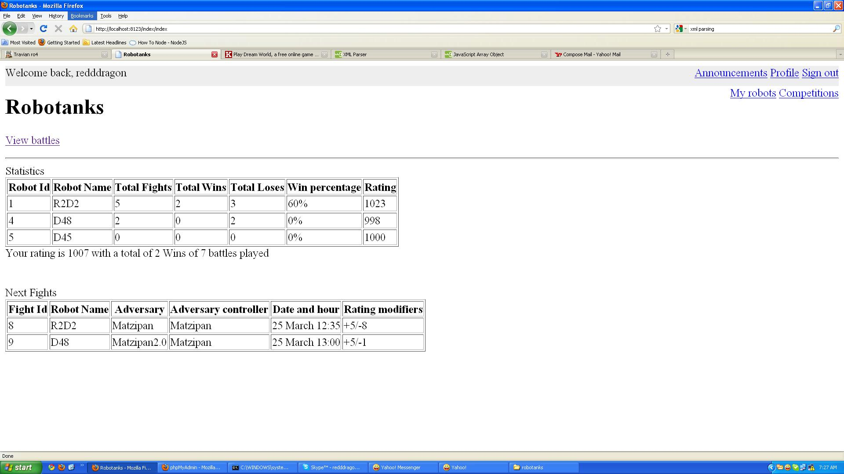
All these features may be released in the future as open-source Robocode components.

- Results.
The game is currently in full development, and is capable of running fully featured battles, displaying them. Future plans include complexity levels (kids, starters and advanced) and robot types (tanks and naval).

