ENERGY METER

BILLING SYSTEM

Using GSM Module

By: Nery, Thederick Matthew F.

Alexis Jasa

**INTRODUCTION**

To sustain our comfort of life, electricity is definitely one of the vital requirements needed. The meralco is one of the power company. If there is something problem, they are also partially responsible for this because we are still not able to estimate our exact amount consumption of electricity. And still, power theft is in there. Most of the time consumers have complaints regarding statistical errors in their monthly bill and some consumers are not satisfied with the services of power companies.

Nowadays, the energy consumption and energy distribution has become an issue because of some technical errors and services of power company. In this regard, energy consumers are facing problems due to the frequent power failures.

We think of something that can solve this problem and we are trying to present an idea towards the statistical and technical errors to reduce the power theft. With our proposal, we are aiming to help the consumers to monitor their electric bill by using a device that can help them to reduce the use of power. By this, they don’t need to be worried when they already reached the maximum average consumption.

According to V. Samson DK (2013), “ Nowadays, power theft is serious problem, due to energy theft heavy revenue losses are incurred by our country. No proper planning of power distribution is leading to tariff calculation problems. Many statistical errors prevail in monthly customer billing process. “

This idea is useful because we can get the meter reading in a such way that you can set your device in a maximum average consumption connected to your energy meter. We also use a modem that is responsible for sending a meter bill reading via SMS. The purpose of this project is to monitor and inform the consumers regularly to see if their power consumption is high.

Literature Review

**Arduino**

According to Res.J.Engineering Sci(2013)The Arduino board is where the code is written and executed. Arduino senses the environment by receiving input from a variety of sensors and can affect its surroundings by controlling lights, motors and other actuators. The microcontroller on the board is programmed using the Arduino programming language and the Arduino development environment (based on Processing). Arduino projects can be stand-alone or can communicate with software running on a computer.

**Power Supply**

According to Wavelength Electronics (2013) A power supply takes the AC from the wall outlet, converts it to unregulated DC, and reduces the voltage using an input power transformer, typically stepping it down to the voltage required by the load. For safety reasons, the transformer also separates the output power supply from the mains input.

**Monitor**

According to Oxana Smirnova (2014) According to The basic module, providing access to the most required information, is the Monitor, showing the overall status of the system. It serves as a starting point for browsing the system information. The purpose of this module is to give a quick overview of the current status of the Grid infrastructure by showing the list of the available clusters and the most essential information.

.

**Relay**

According to the book of Allen-Bradley(2005), Safety monitoring relay units used in dual channel circuits with infrequent operation or with more than one switching device connected. switching between the first opening/last closing will not change the state of the monitoring unit input circuits.

**Energy Meter**

According to H.Singhal( 2014) “An energy meter is a device that measures the amount of electrical energy supplied to a residential or commercial building. The most common unit of measurement made by a meter is the kilowatt hour (kWh), which is equal to the amount of energy used by a load of one kilowatt in one hour.”

**Statement of the Purpose**

People nowadays Seeks Practicality and Seek Security. The Purpose of this project is to design and develop an Energy billing System with SMS that sends Consumption and Bill to the Consumer and to protect them from unnecessary Energy Consumption. The Following objectives are:

1. To secure consumers from being charged way too much.
2. To promote the use of this system
3. To eliminate Extra Charges
4. To evaluate the Accuracy of the Device

**Significance of the Study**

**Users**

The study will benefit the users to inform them regarding meter reading, total load used and the level of energy they consumed by sending them through an SMS. This helps in considerable reduction of power thefts as well to calculate average power consumption of particular locality. It also helps the user to read the meter reading regularly without the person visiting their house by using GSM communication technology.

**The Researchers**

The study will also benefit the researchers for they will have actual experience in developing a system and for the students to be able to enhance and challenge their skills in programming and to improve more their knowledge.

**Activity Diagram**

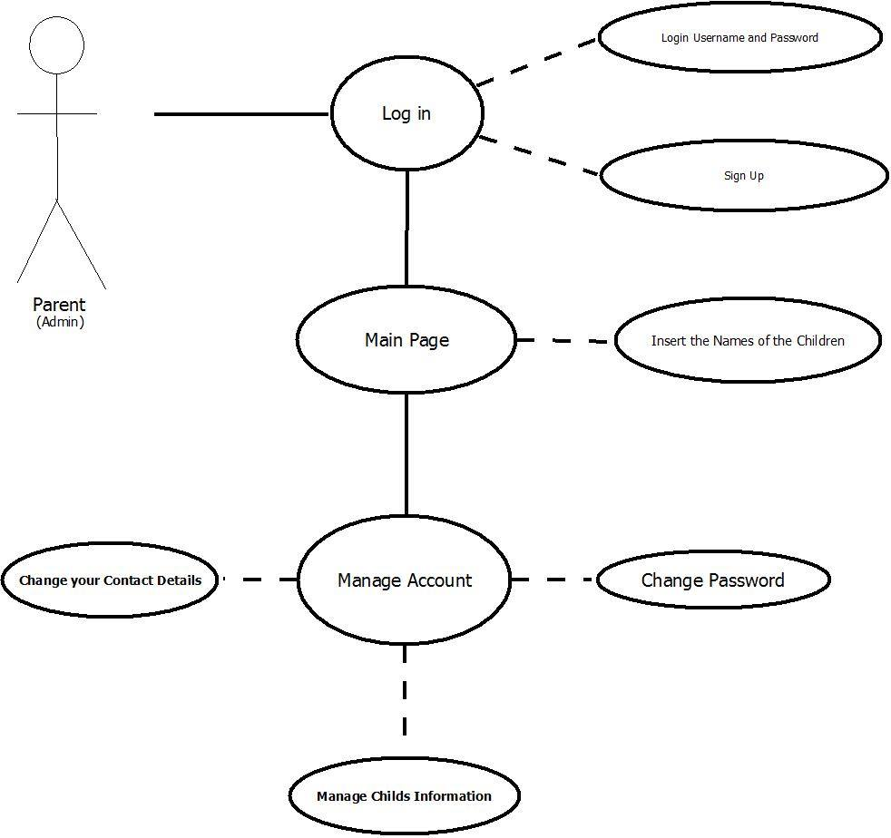

**Use Case Diagram**

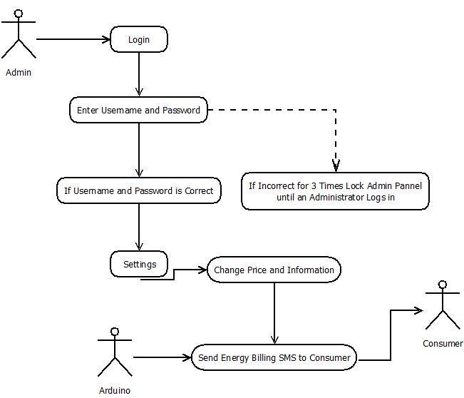

**Related System**

According to V.Suresh( Trends in Evaluation of Energy meters at consumer premises2014) “

Energy meter is the only instrument which measures and registers actual energy consumed by the consumer. Also, testing of Energy Meter is required at consumer premises on receipt of consumers compliant [1]. Periodic testing of meters in-service also minimises the revenue loss of utilities [2]. Metrological testing and functional verifications shall be carried out on meters.”

According to J. Phillies(Arduino Energy Monitoring2013) “Open Energy Monitoring System an end-to-end open-source energy monitoring system that is Arduino IDE compatible is a project to develop an open-source energy monitoring too help the general public relate to their energy consumption, Jacks Phillies energy system, and the challenge of sustainable energy.”

According to S. George ( GSM Based Automatic Energy Meter reading system with instant billing2003) “The proposed system replaces traditional meter reading methods and enables remote access of existing energy meter by the energy provider. Also they can monitor the meter readings regularly without the person visiting each house. A GSM based wireless communication module is integrated with electronic energy meter of each entity to have remote

access over the usage of electricity. “

According to IJITECH ( Arduino Based Energy Consumption using Zigbee and GSM Technology2015) “ Those meters are economical ones and installed at home and as well as in industries .A mobile and internet based home automation system that consists of a mobile phone with android capabilities, an internet based application, and a home server. The home appliances are controlled by the Arduino which receives commands from the server computer, which operates according to the commands received from the mobile application via the wireless network or the internet.”

According to H.Singhal ( Designing a Tamper Proof Energy Meter using Kinetis 2014) “To control revenue losses, utility companies worldwide must detect meter tampering and ensure accurate billing even when tampering has occurred. Tampering ranges from simple techniques such as manipulating live or neutral wires to more sophisticated techniques such as hacking firmware and changing energy consumption records. The Kinetis KM34 series provides excellent solutions to implement multiple layers of tamper detection through hardware and software solutions.”