Friday 2-5

Effect of Propeller and Rudder on Boat Dynamics
(Your title should be short but informative, i.e. not too general)-> it is too general now

Mauricio Pereira

4/25/26
2.671 Measurement and Instrumentation
Friday PM
Dr. Po-Hsun Huang

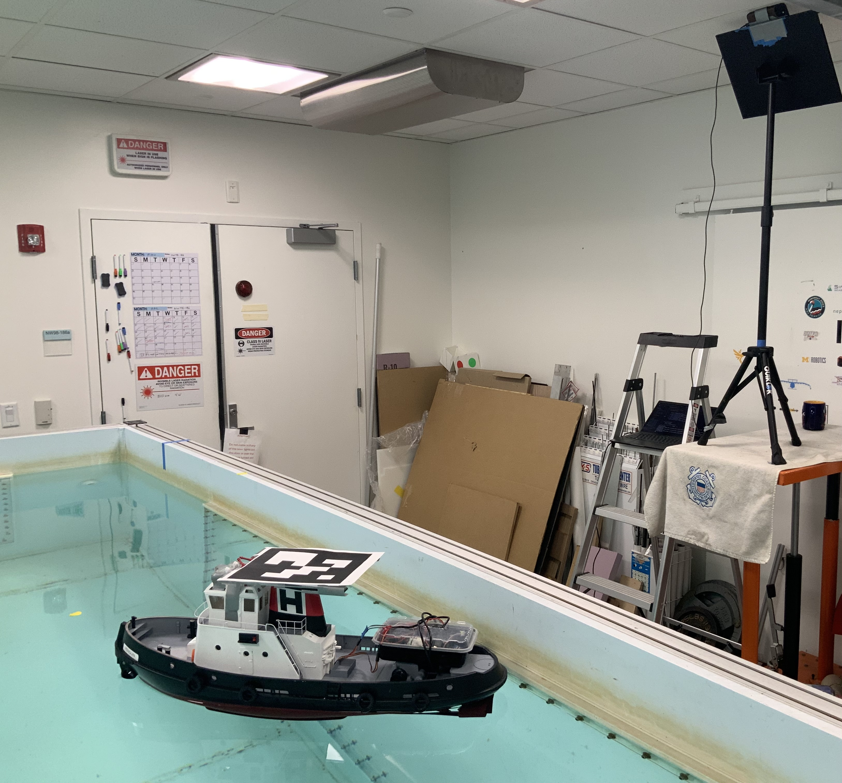
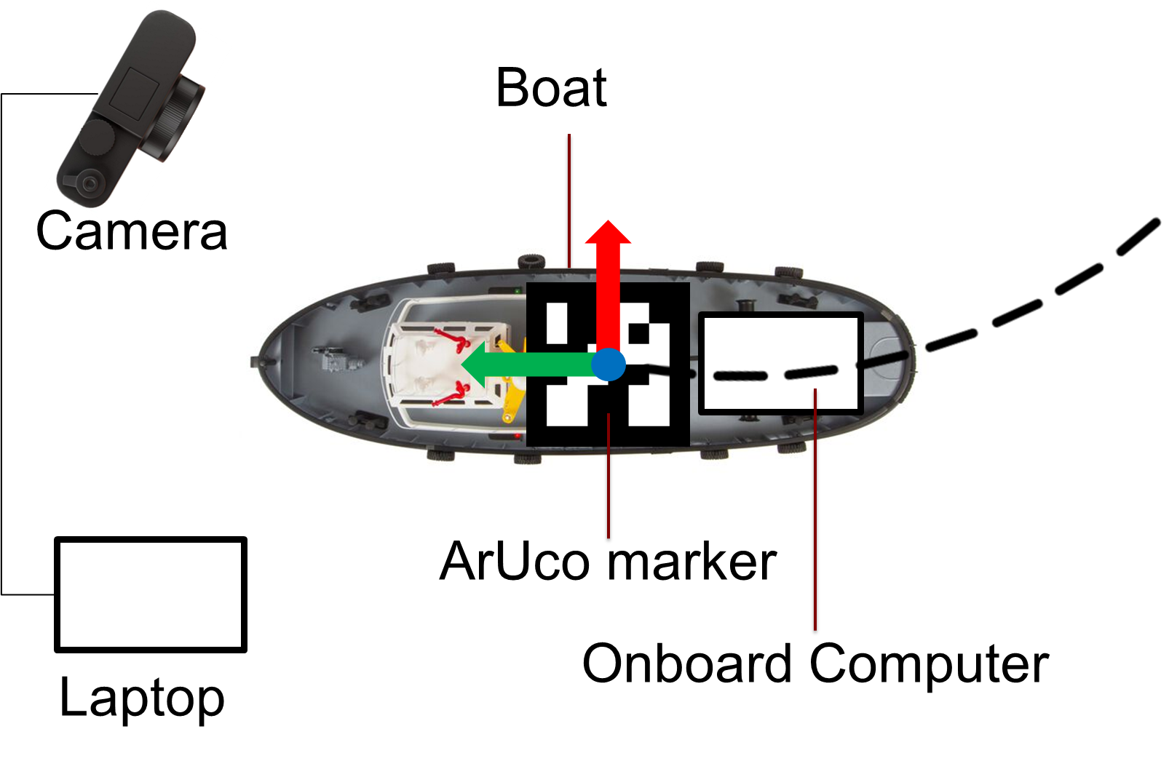

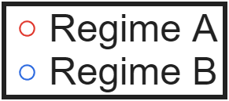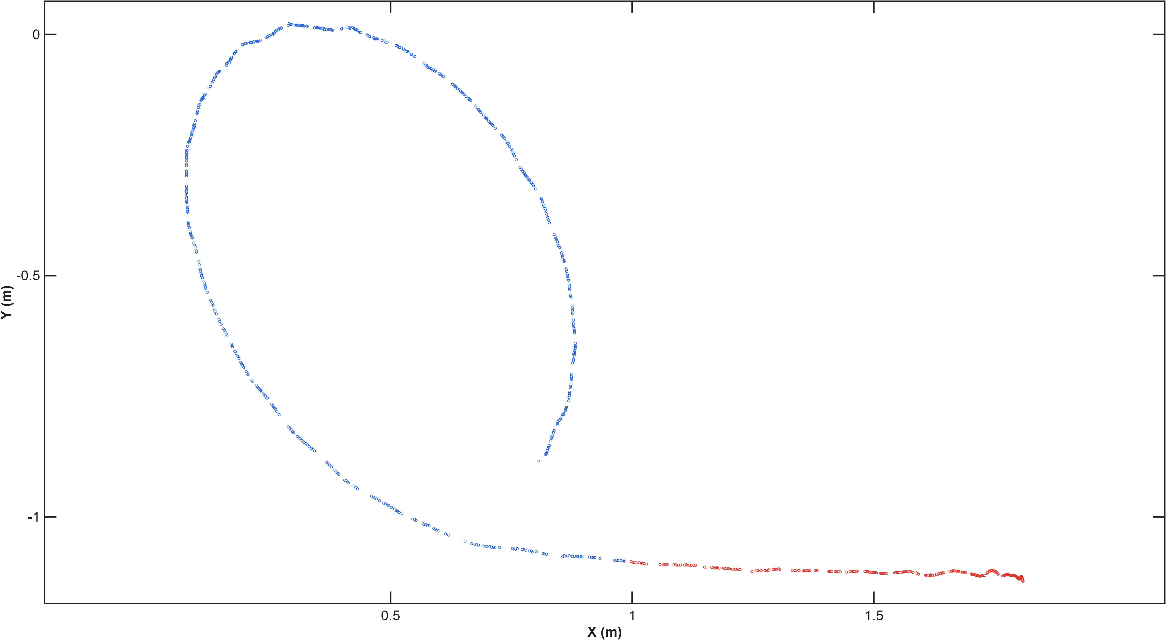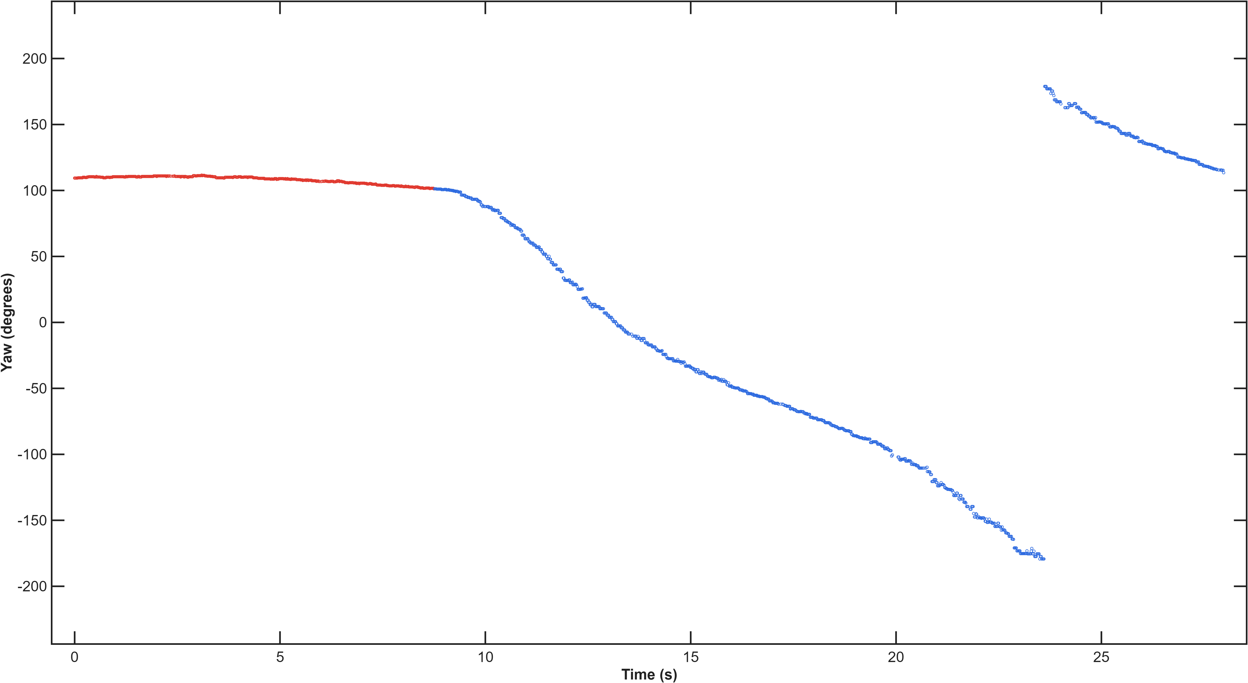
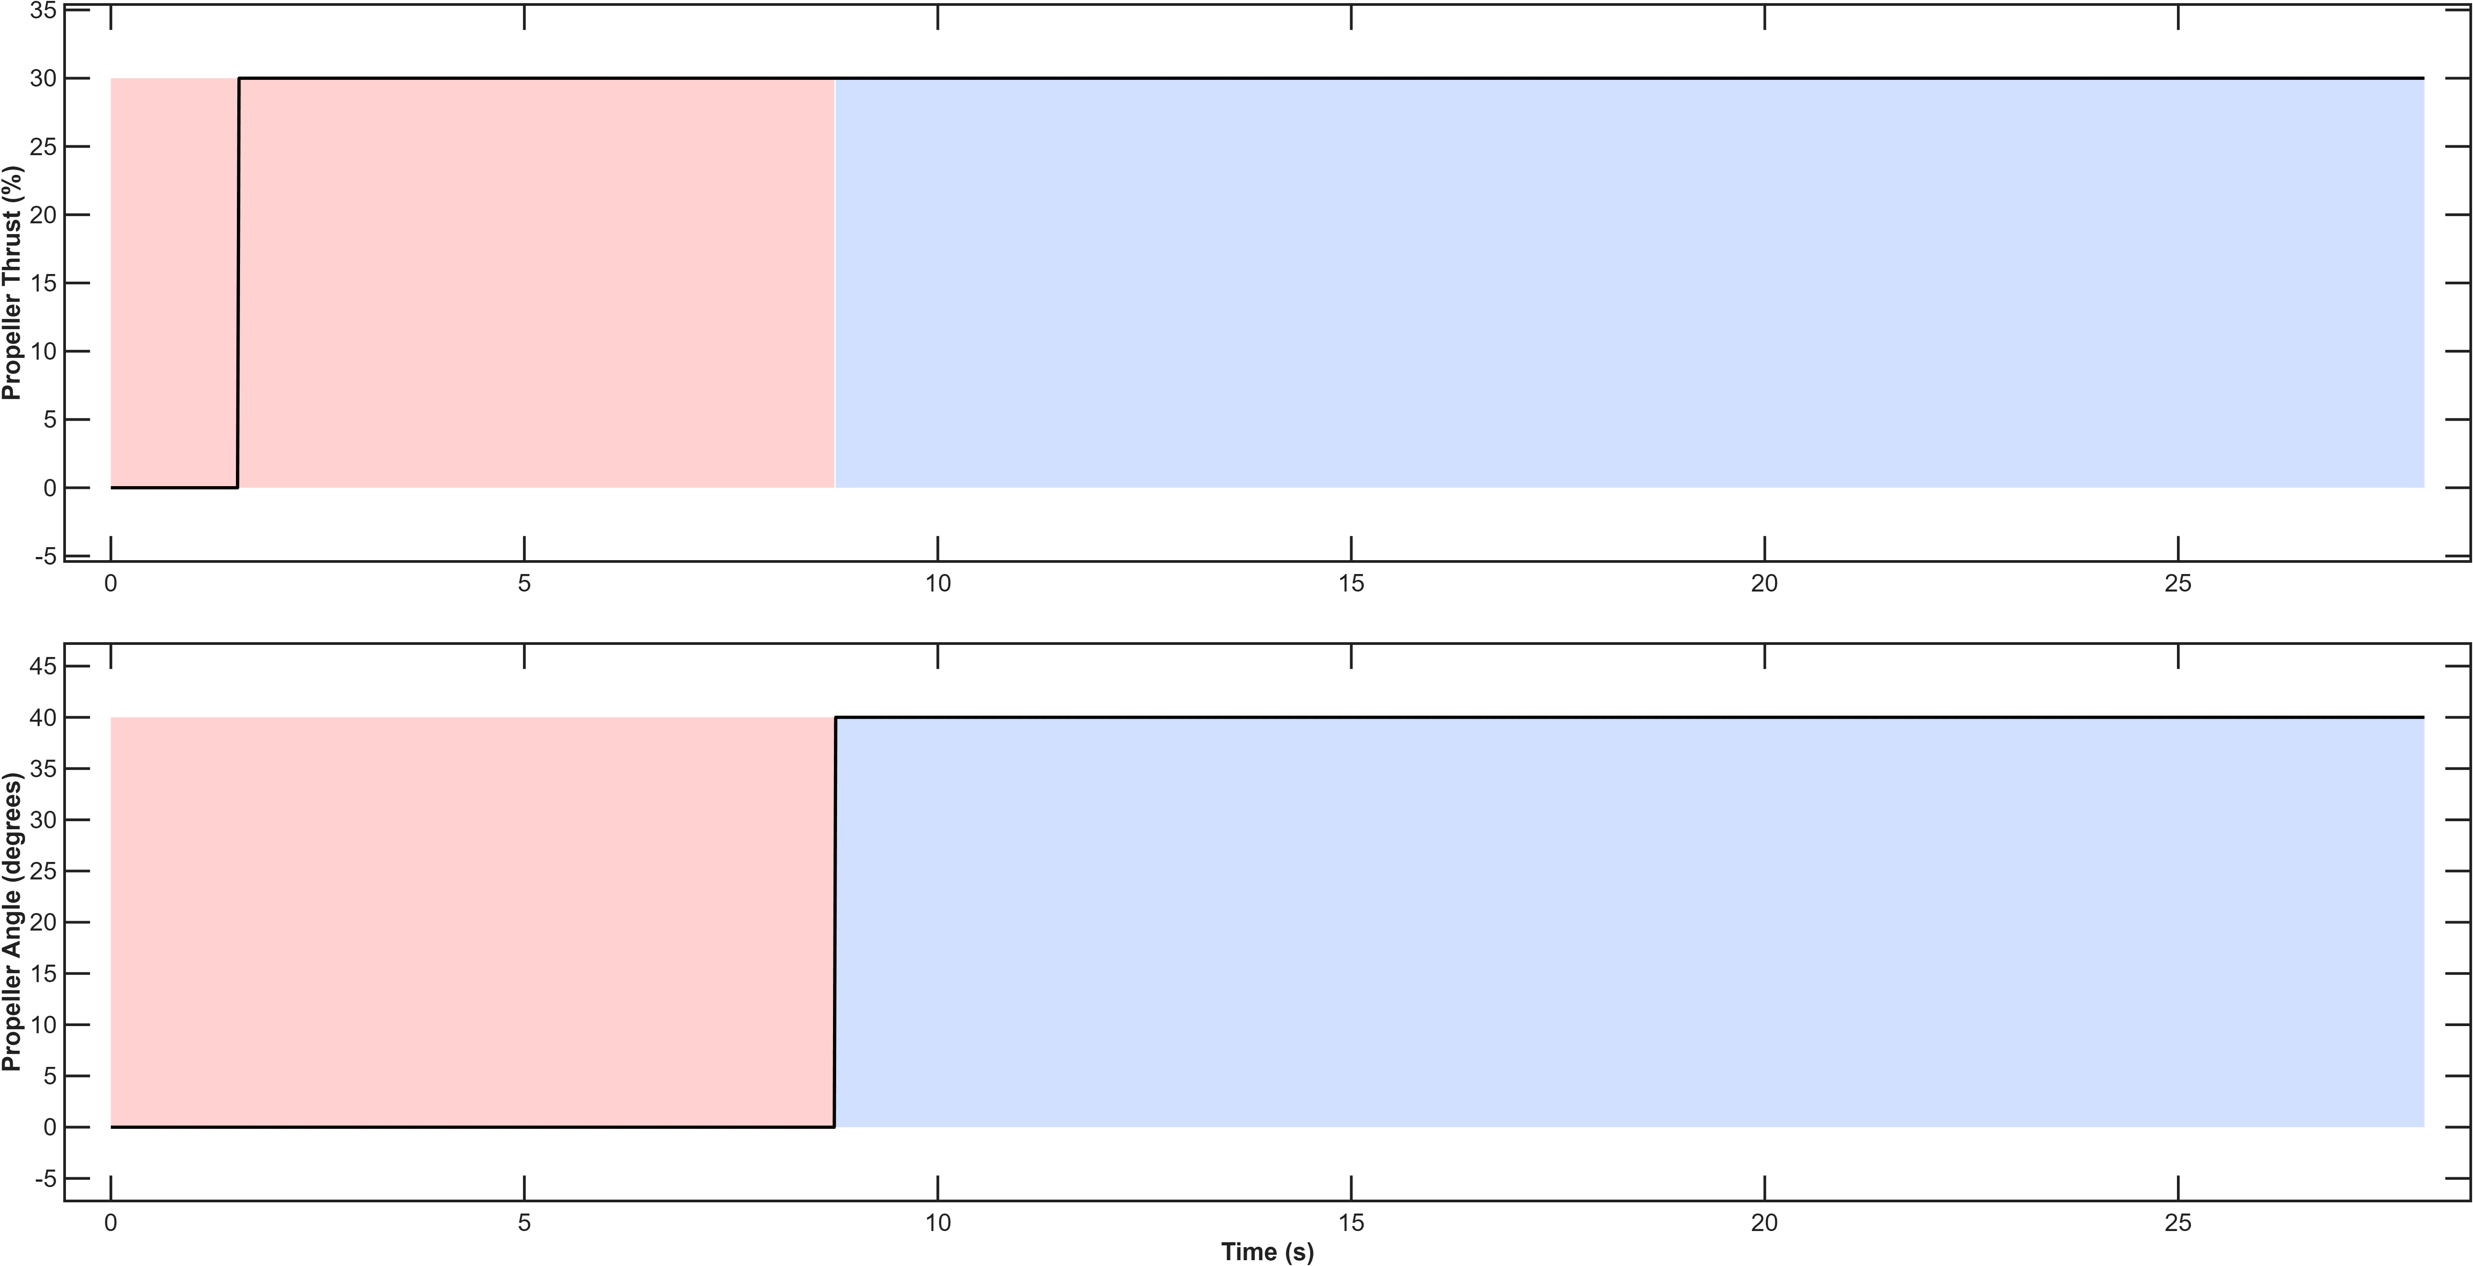

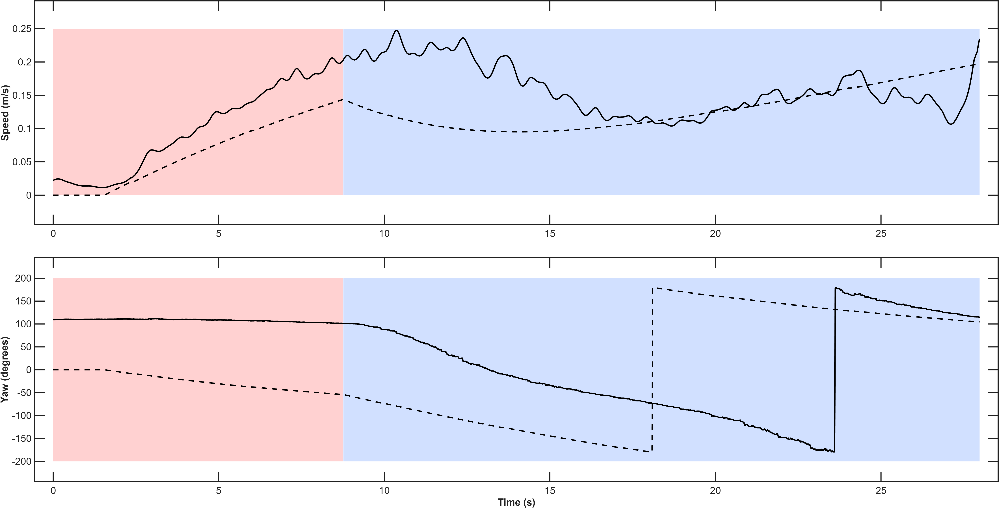

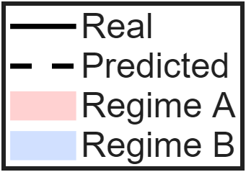
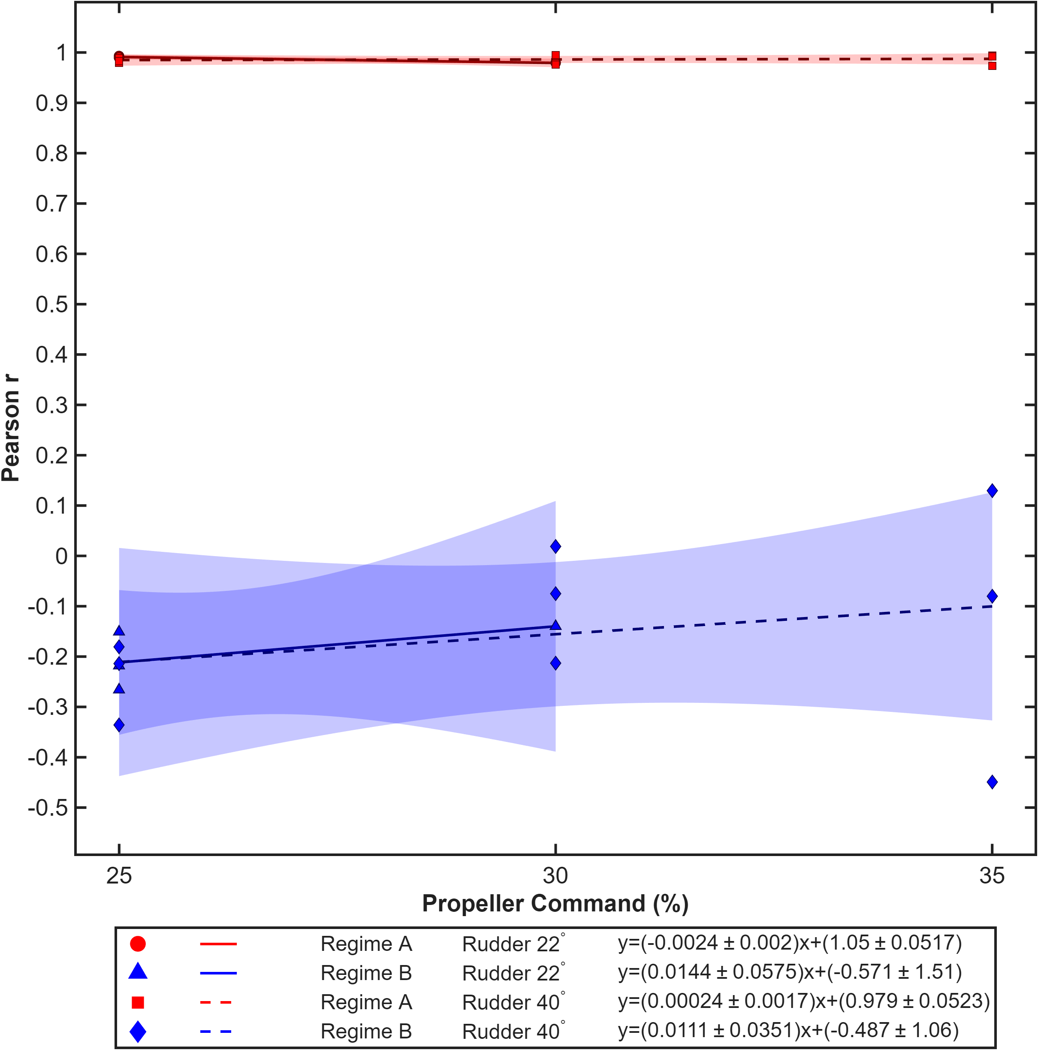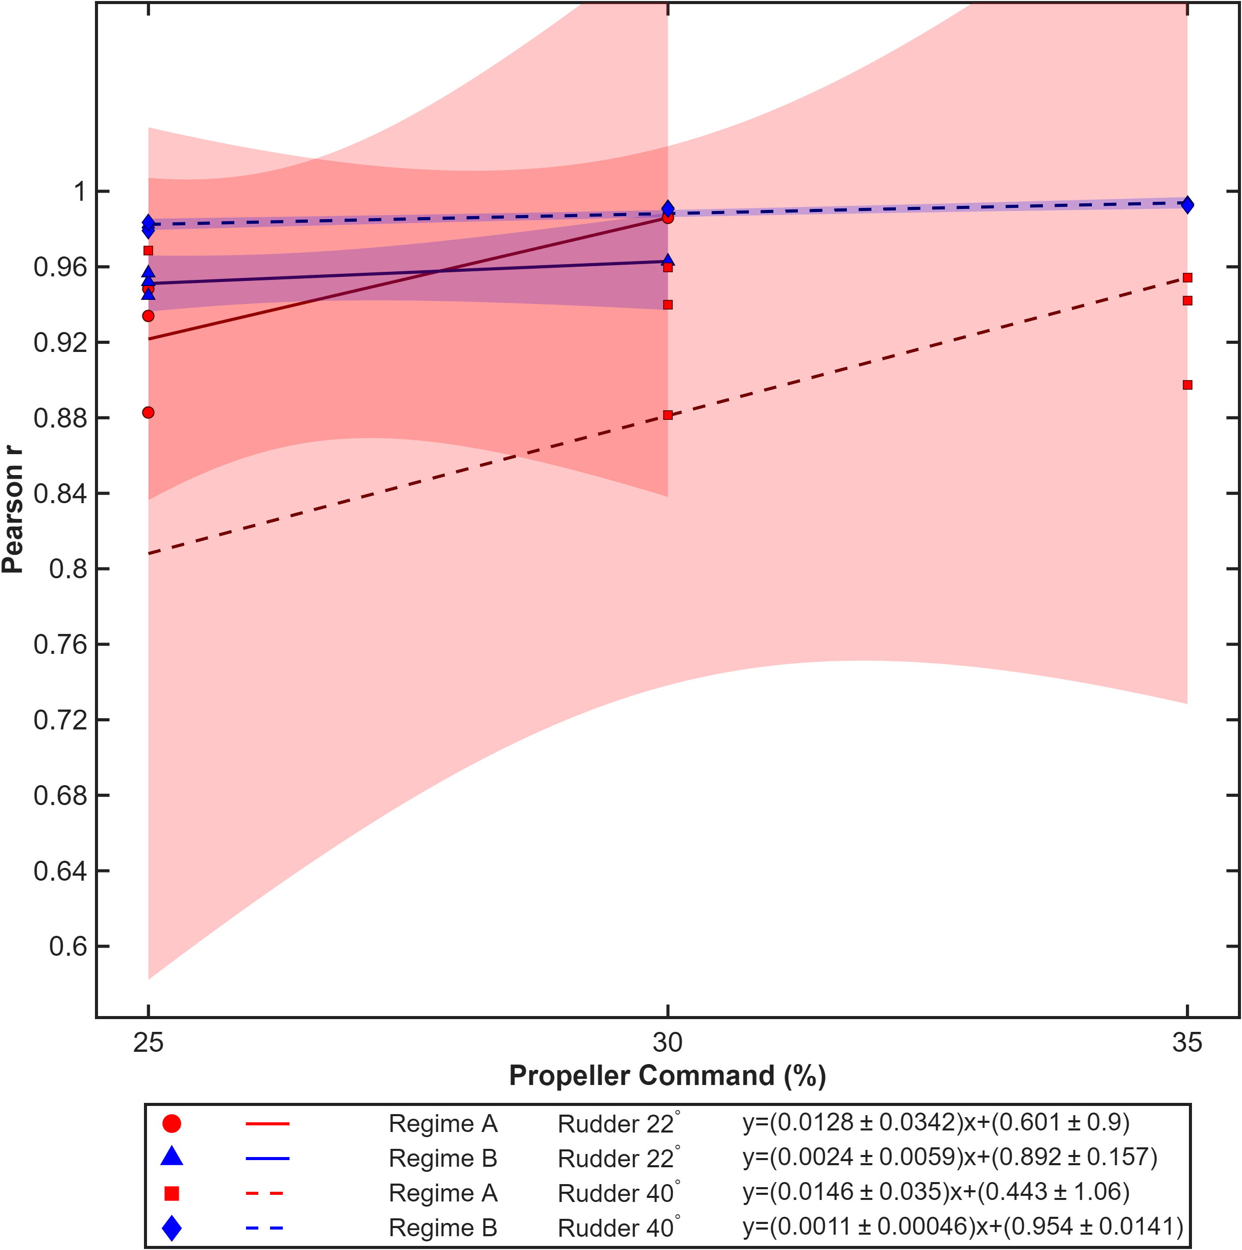

Speed Theil

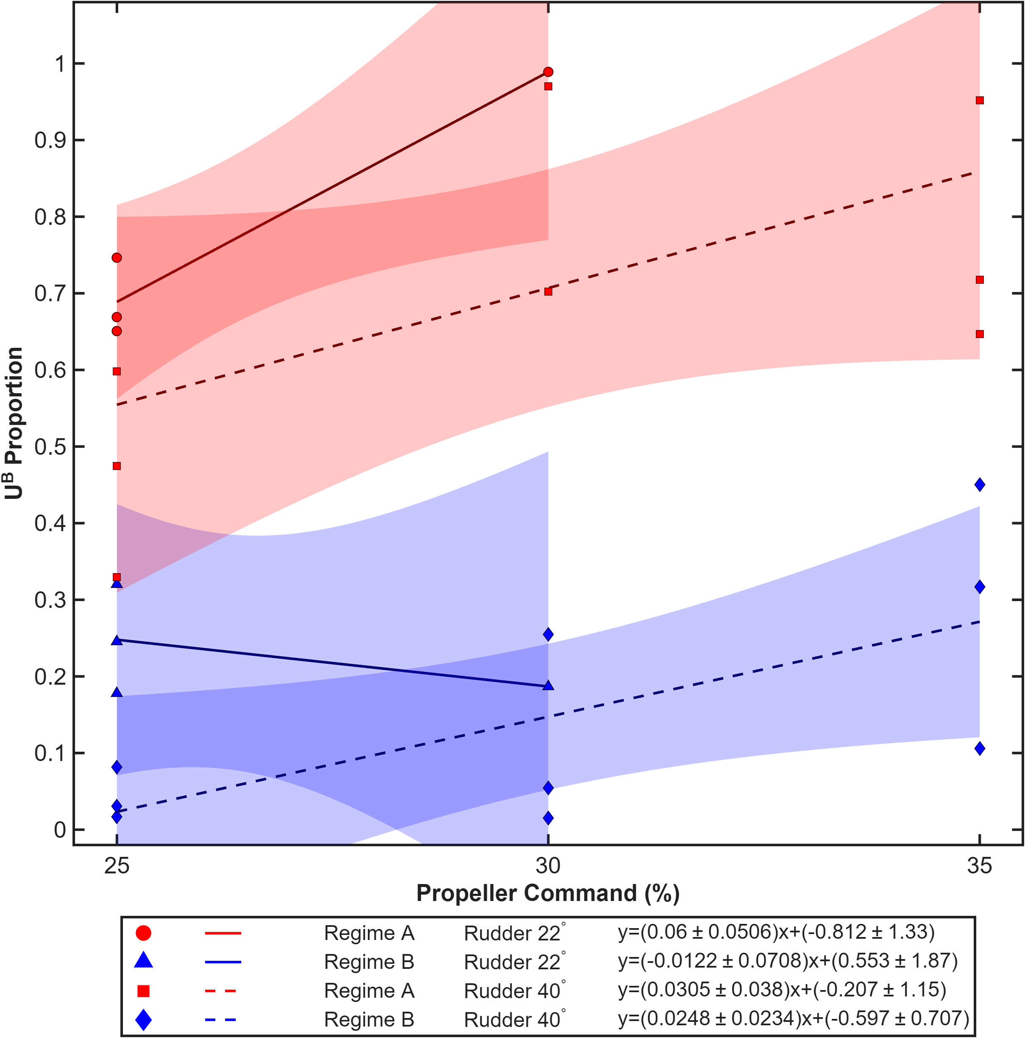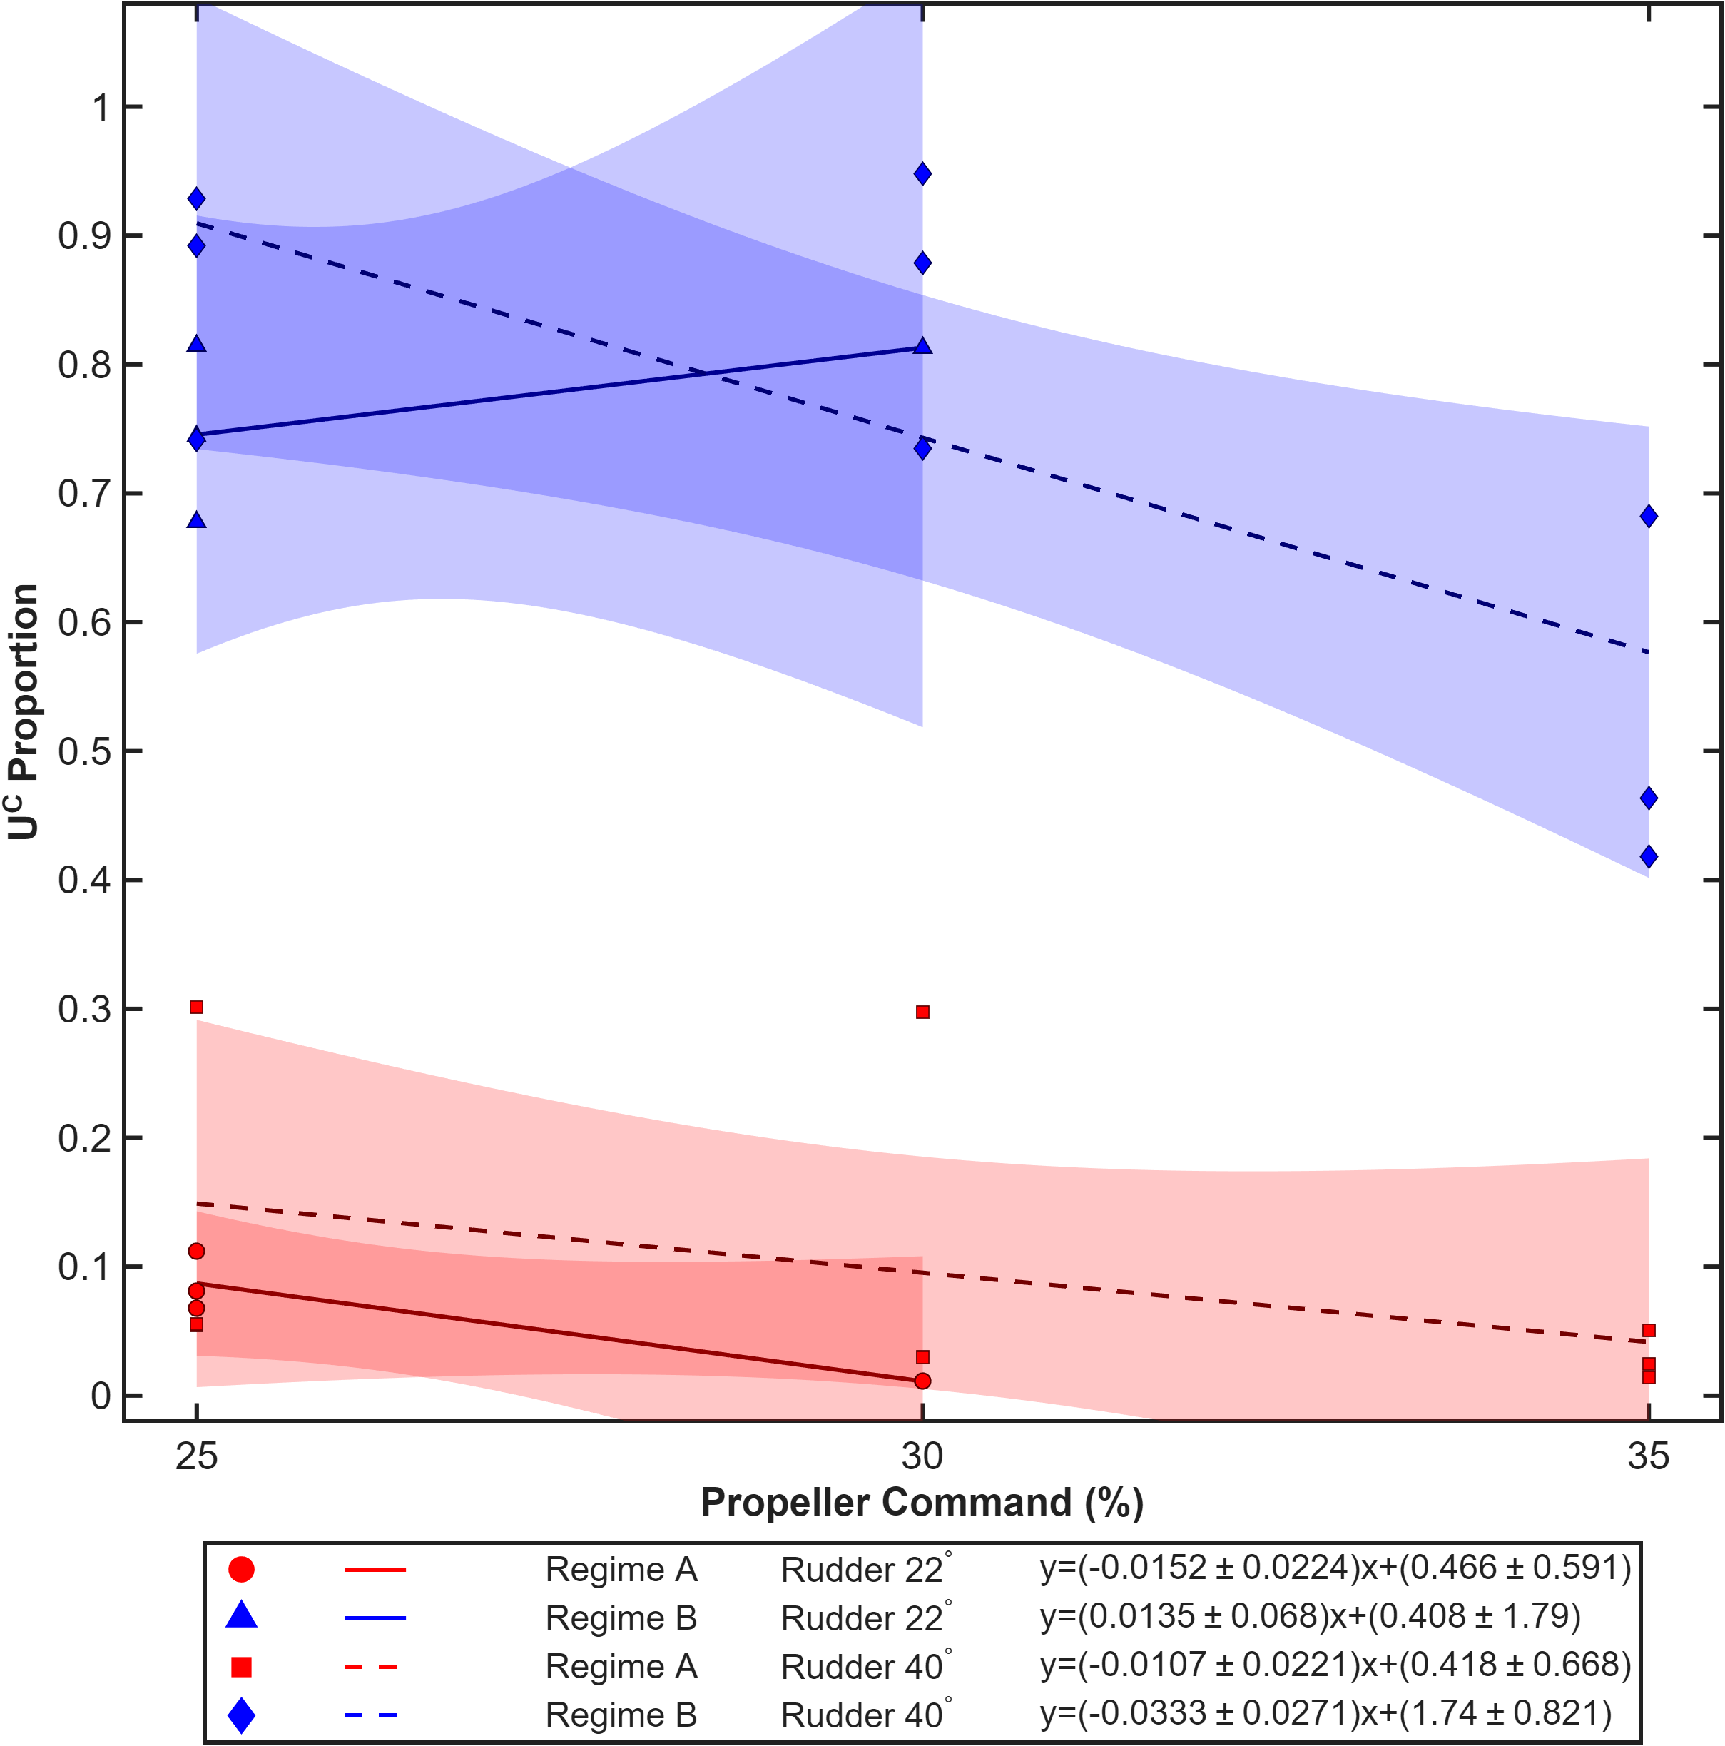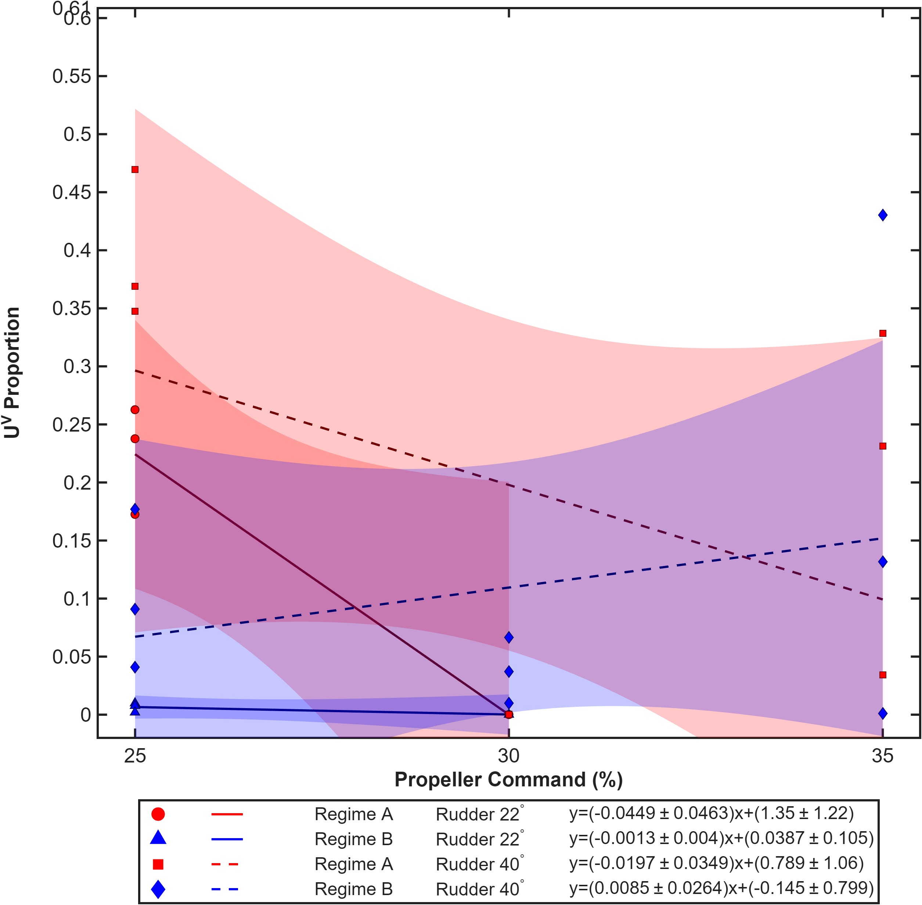

Yaw Theil

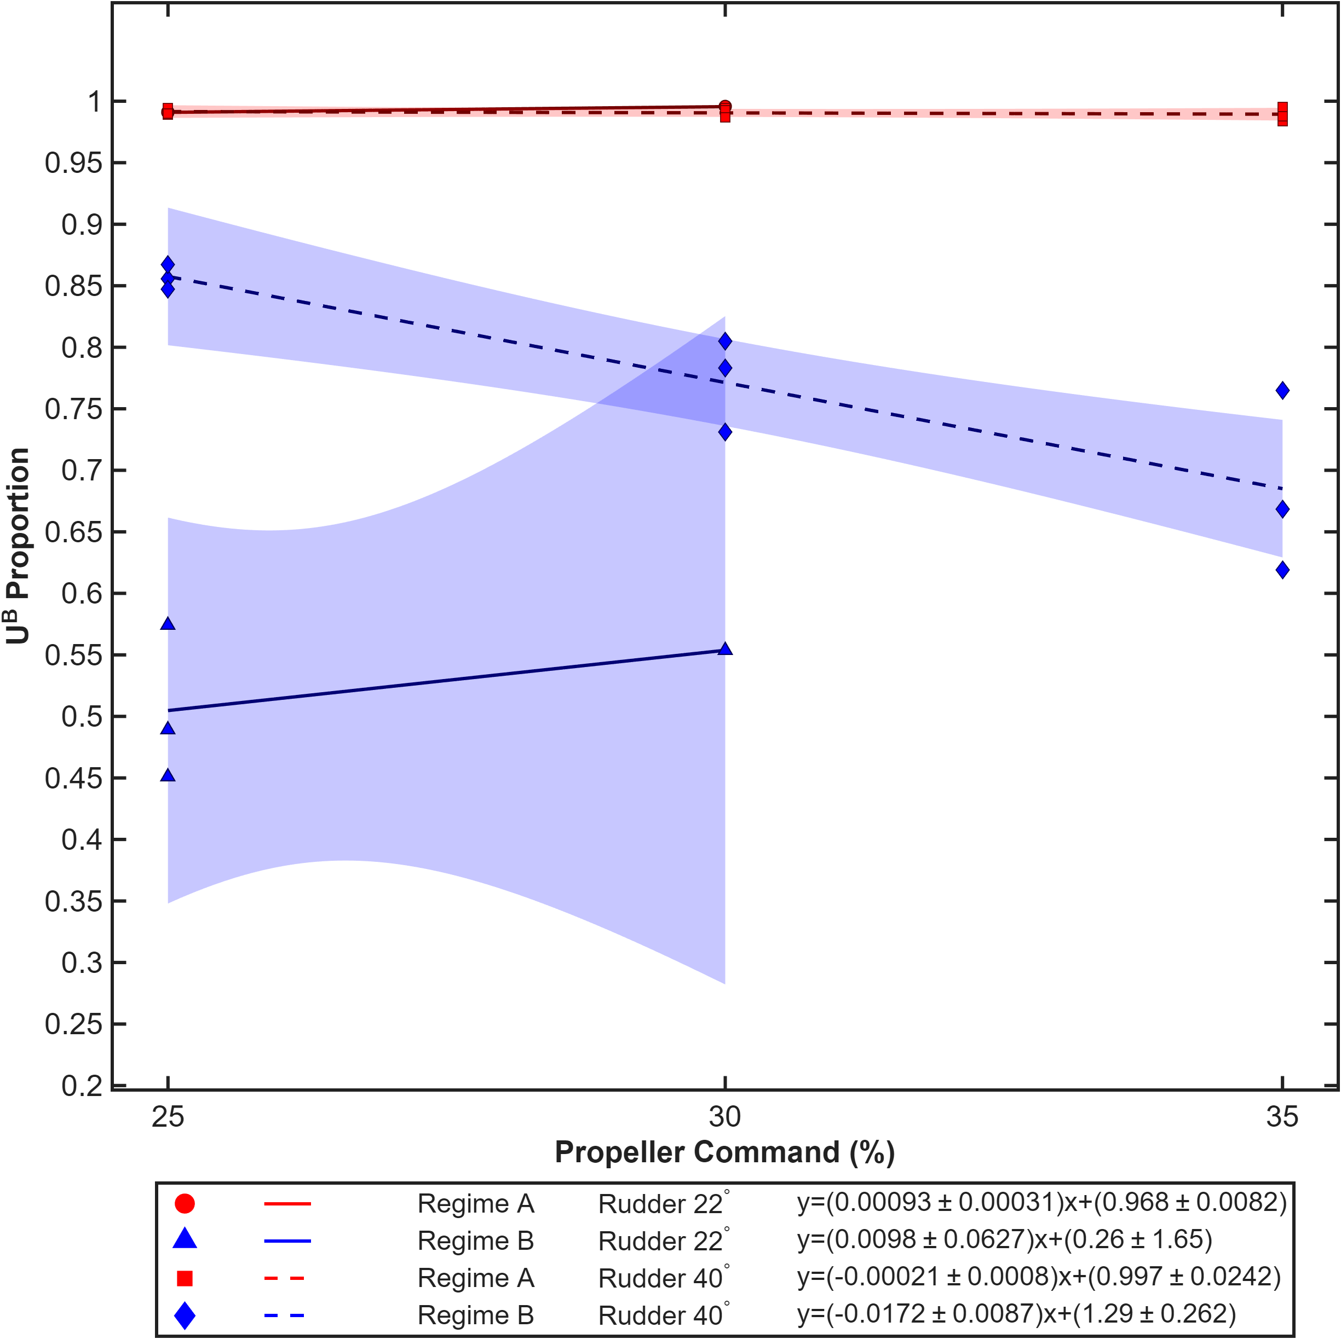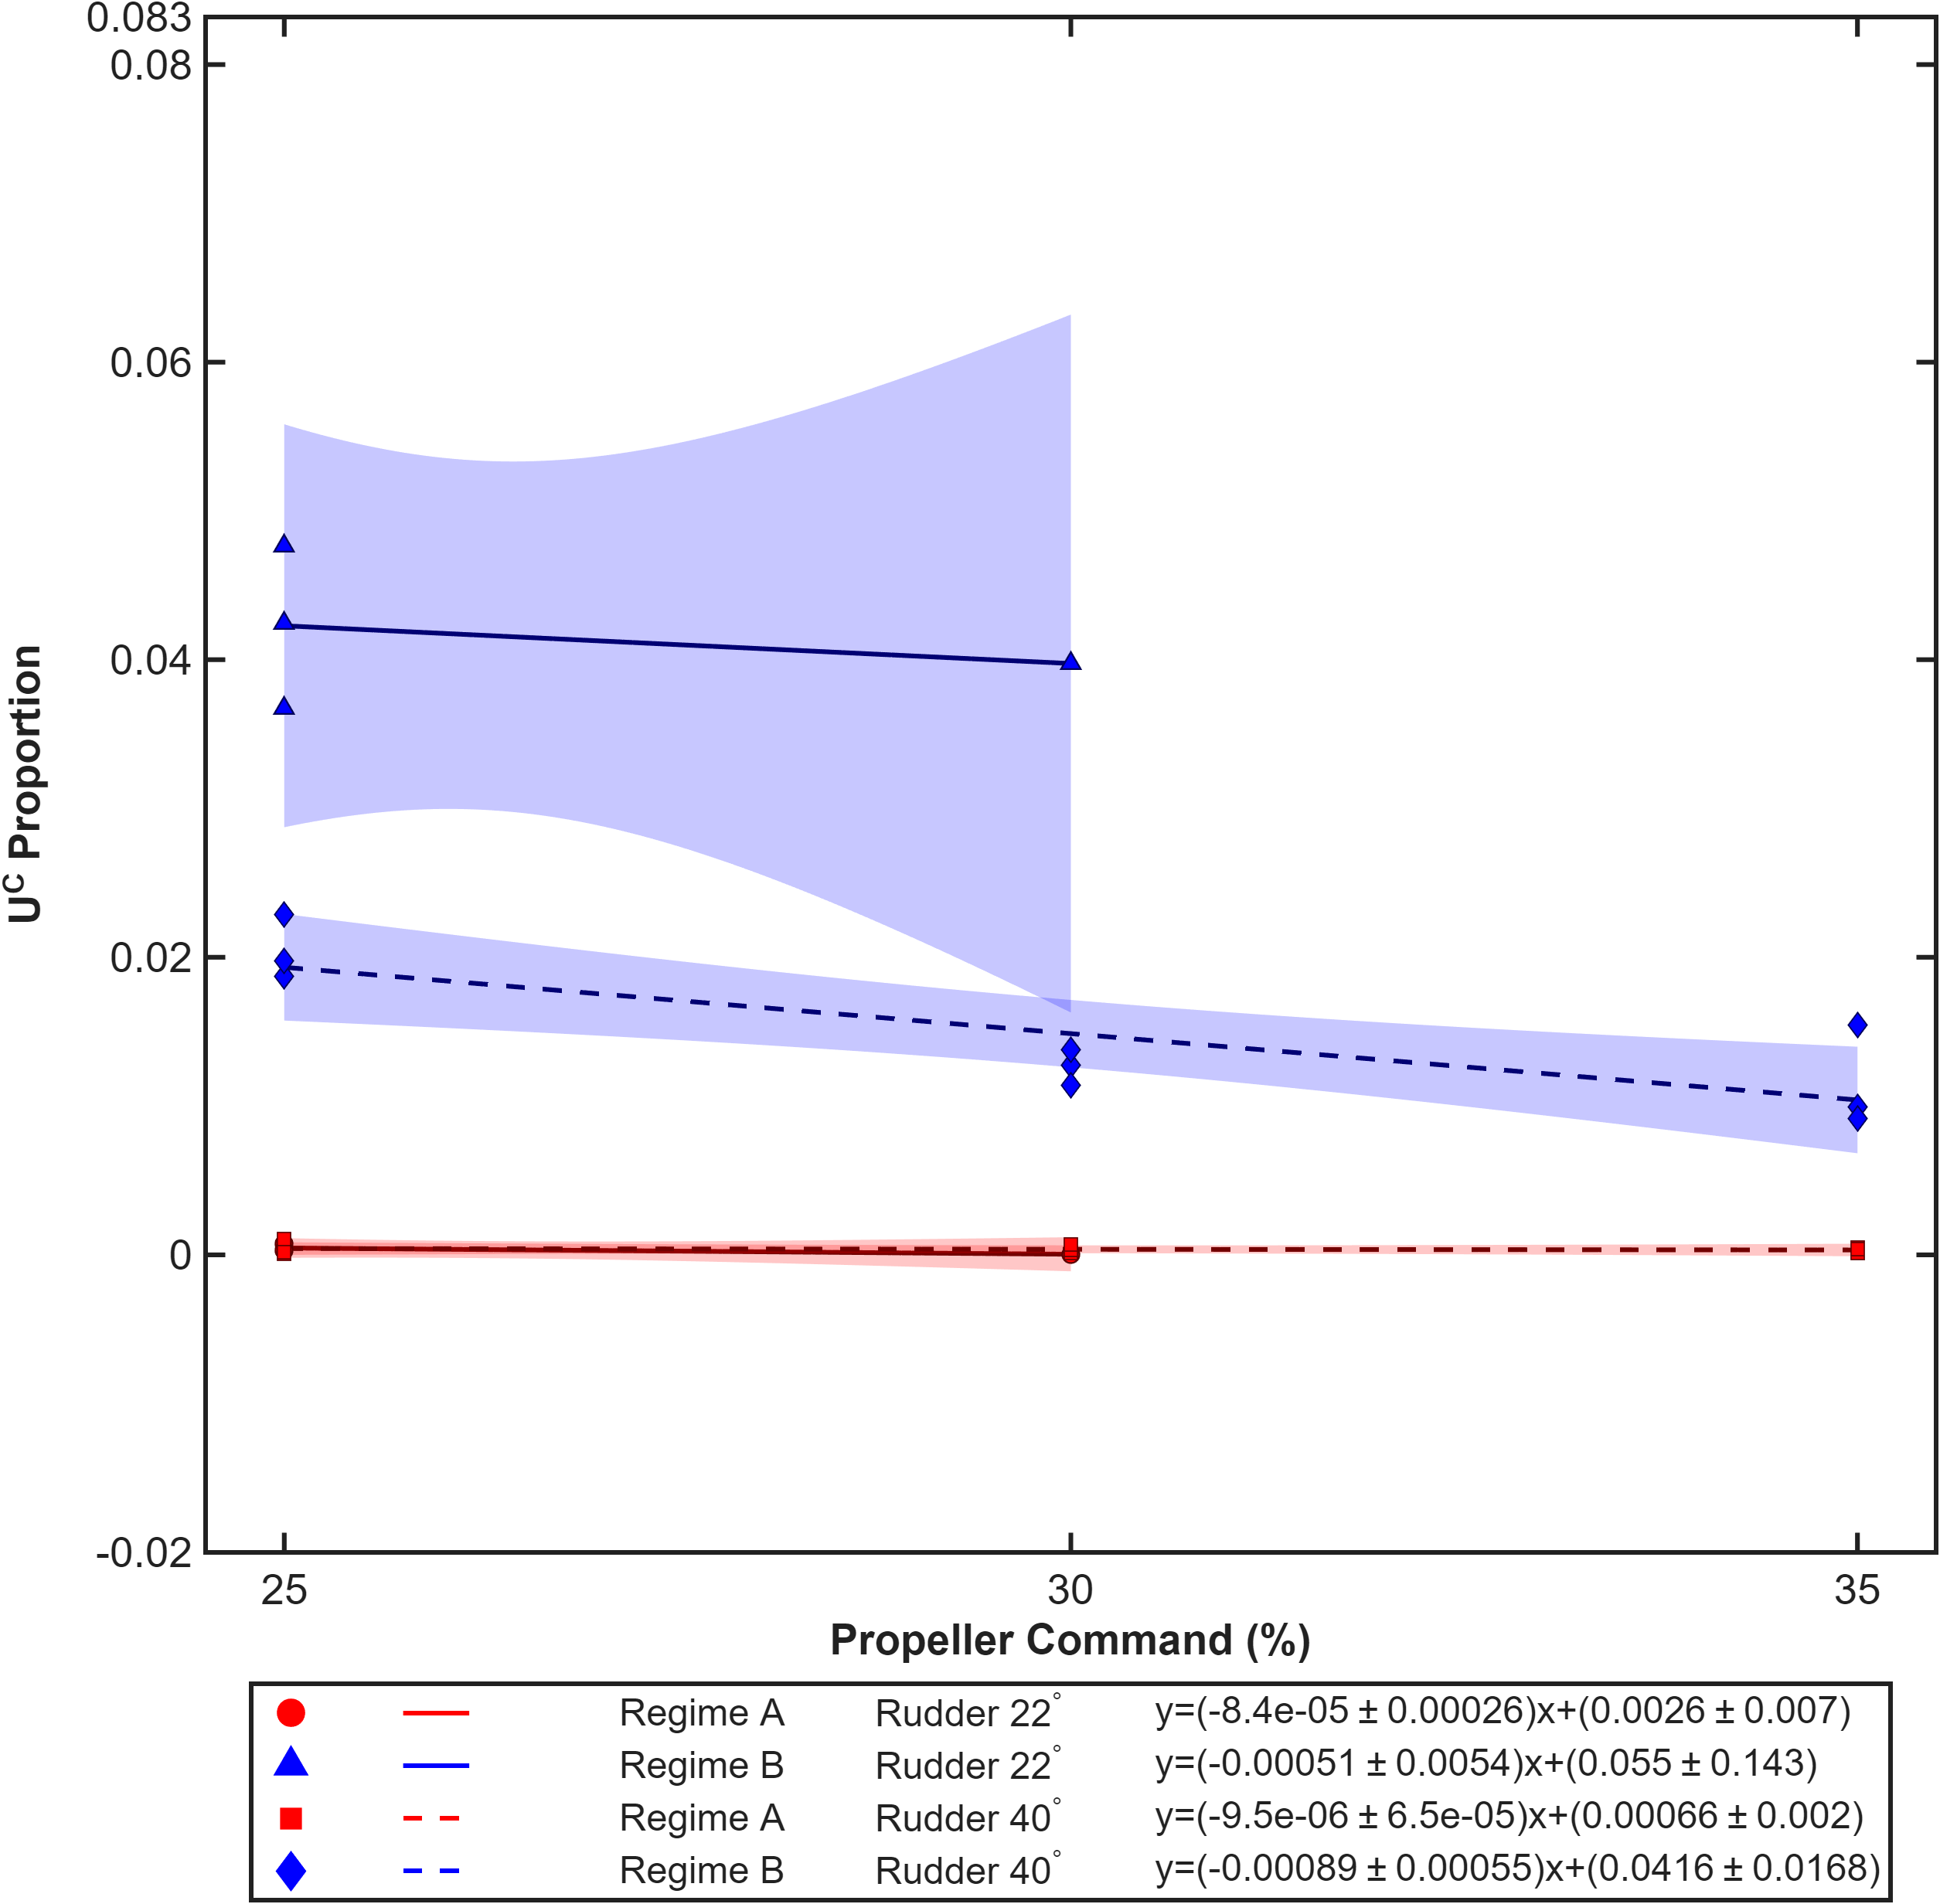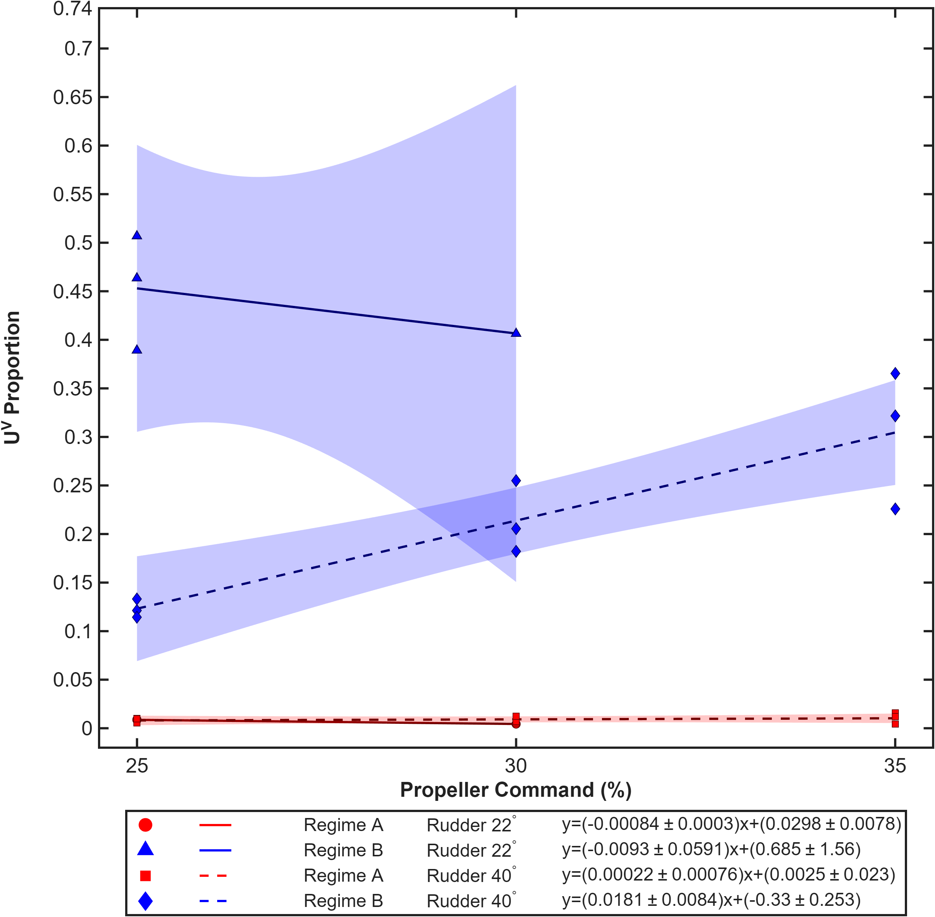

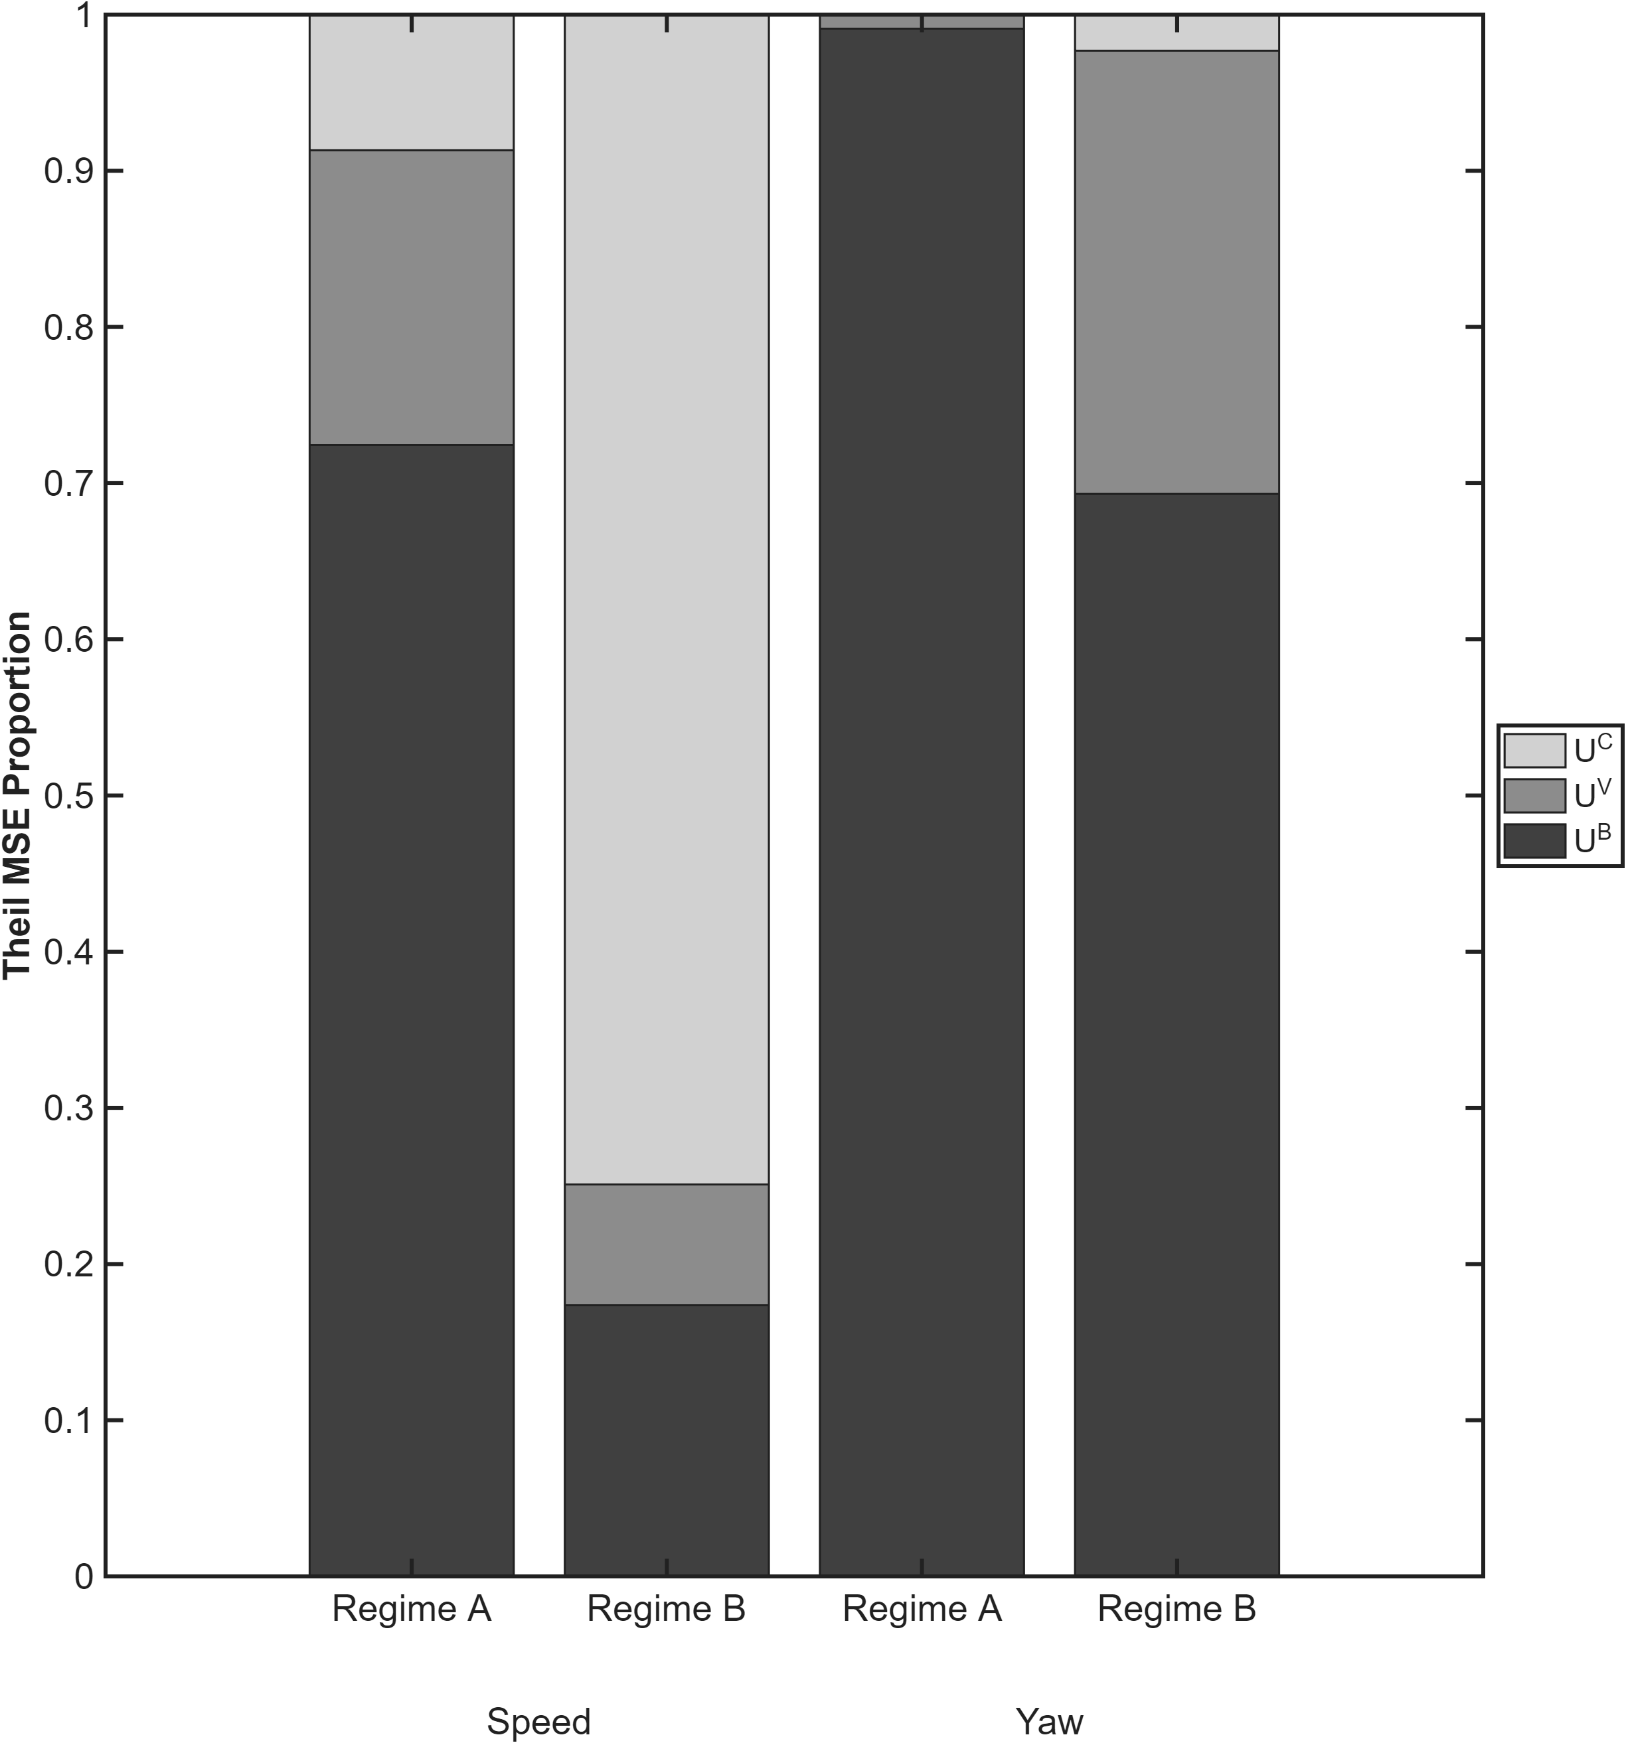

Abstract
Type your abstract here, no more than 150 words
Keywords: type your keywords here. (For the Intro & Background assignment, which has no Abstract, the keywords should be placed between the Introduction and the background)

1. Introduction
Type your introduction here, only 2 – 4 paragraphs

2. Background (or Theory) You may want to replace this “generic” name with a more descriptive name for your topic. Any subsections should have descriptive names. More information on the Wiki – Communicate section on Background

3. Experimental Design See guidelines on Wiki for names for subsections.

3.1 Apparatus This is here as an example of the subsection format, Heading 2. You may not want to split the Apparatus and Methods if both sections are short, Refer to the Guidelines in the Communicate section of the 2.671 Wiki, and don’t use the generic name (Apparatus) included in this template

4. Results and Discussion often the most challenging section for new writers.

5. Conclusion
Your paper should have 1500 – 3000 words in Sections 1 – 5. If you need more for your Go Forth paper, that is fine, but remember that more words is not necessarily better.

Acknowledgments

References
Use ASME style for References. Refer to the Wiki for instructions.

Other styles available in template:
Use the 2.671 Text style for all body text.
For section titles in your paper, use Heading 1, Heading 2, or Heading 3.
Figure 1: This is the figure caption style (you need to bold the text before the colon yourself. Notice that this is fully justified with 0.5” margins on both sides.) If a figure caption is only one line, it should be centered, rather than justified with margins. Figure captions go below the figure
Table 1: This is the table caption. Table captions go above the figure. If only one line long it should be centered on the page. If longer, it should be equally justified with inset margins as shown.
Note that this template is set up to start numbering on
Abstract:
Robust autonomous navigation requires accurate models of vehicle dynamics. This work experimentally characterizes the planar motion of an unmanned surface vehicle developed for 2.017 Design of Electromechanical Robotic Systems, focusing on how propeller and rudder inputs influence speed and heading. Step-response experiments are first conducted to capture the direct effect of PWM commands and provide an interpretable baseline [1]. To obtain a model, inputs in the form of pseudo-random binary sequence (PRBS) signals are applied, and a multivariable state-space model is identified using numerical algorithms for subspace state-space system identification (N4SID) [2]. Motion data are captured using a camera tracking an ArUco marker mounted on the boat, enabling reconstruction of speed and heading over time. Model performance is evaluated by comparing predicted and measured outputs, with percent-error trends demonstrating strong agreement and validating the model for control-oriented applications.

Experimental Design Draft:
Setup:
Water tank (160 inches by 100 inches) with calm water and indoors
Ceiling with great upper lights
Boat: Horizon Harbor 30-inch Tug Boat
Camera: iPhone 15
ArUco Markers 20 x 20 cm
Checkerboard square grid (10x7 squares with square size of 23 x 23 mm)

ESP32-DEVKITC-32D
Electronic Speed Controller: Spektrum Firma 40A Brushed Smart 2-in-1 ESC
Arduino Carrier Board: MIT 2.007
Battery to ESC: 11.1V 5000mAh 3S 30C Smart Hardcase LiPo Battery: IC5
Battery to Arduino Carrier Board: Zippy Flightmax Lipo Battery 1300mah 3s1p 20c

Experimental Design

3. Experimental Design
3.1 System Architecture
The experiment combines vision-based pose estimation, wireless actuation, and synchronized logging to generate input–output datasets for system identification. The setup consists of three components: (i) a calibrated camera system that measures boat pose in a fixed world frame, (ii) an embedded controller that applies propeller and rudder PWM inputs, and (iii) a logging pipeline that records inputs and states for offline modeling.

3.2 Vision-Based Measurement
Boat motion is measured using fiducial marker tracking. A printed ArUco marker (DICT_6X6_250) is mounted rigidly on the boat, parallel to the water surface and positioned above the center of mass. Additional fixed markers define the pool-plane coordinate frame.
An overhead camera captures the scene from an oblique angle. Marker detection and pose estimation recover the boat state in a world frame aligned with the pool surface, producing:
$$\left(x(t), y(t), ψ(t)\right)$$
A constant z-offset is applied to map the detected marker pose to the boat’s center of mass.

3.3 Camera Calibration
Camera intrinsics are estimated from chessboard images at the experiment resolution. These parameters are held fixed during extrinsic calibration, which uses known positions of reference markers on the pool plane.
Calibration quality is quantified using reprojection error:
- Intrinsics RMSE: 2.56 px
- Extrinsics RMSE: 8.46 px
The extrinsic residual does not significantly change with additional frames, indicating a stable solution dominated by systematic error sources such as residual lens distortion, corner localization bias under oblique viewing, and slight non-coplanarity of reference markers.
The resulting planar position uncertainty is approximately 3 mm, which is small relative to the scale of the observed trajectories.

3.4 Actuation and Communication
Propeller thrust and rudder angle are commanded via PWM signals. An ESP32 receives wireless commands from a laptop and converts them into microsecond-level signals for the electronic speed controller and rudder servo.
Commands are transmitted as:
$$\left(u_{\text{prop}} , u_{\text{rudder}}\right)$$
3.5 Data Acquisition
Each trial produces synchronized time series data:
$$\left[t , u_{\text{prop}} , u_{\text{rudder}} , x , y , ψ\right]$$
A single runtime loop performs marker detection, command updates, and logging. The nominal sampling rate is 60 Hz, with an observed rate of approximately 40 Hz due to processing overhead. All analysis uses timestamp-derived sample intervals.

3.6 Experimental Procedure
Each trial follows a fixed sequence:
- Boat initialized at rest with neutral inputs (1500 µs).
- Step increase in propeller command (1600, 1650, or 1700 µs).
- Forward motion allowed to reach approximately steady speed.
- Step input applied to rudder (1800 or 2000 µs).
- Data recorded through the turning phase and then stopped.
Trajectories consist of an initial straight segment followed by a curved path, with a transient transition region between them.

3.7 Experimental Matrix
- Propeller PWM: 1600, 1650, 1700
- Rudder PWM: 1800, 2000
- Trials per condition: 3
Total trials: 18
Each trial is treated as an independent realization under fixed input conditions.

3.8 Data Processing
Raw pose data are transformed into signals suitable for identification:
- Yaw is unwrapped to remove discontinuities
- Forward speed is computed from $\left(x , y\right)$ derivatives and filtered
- Inputs and outputs are time-aligned using recorded timestamps
These processed signals form the input–output dataset for model estimation.

3.9 Model Identification and Validation
A discrete-time linear state-space model is identified using N4SID. Identification is performed on a subset of trials, with the remaining trials reserved for validation and analysis.
Model predictions are compared to measured trajectories using time-domain error signals and aggregate metrics. The largest discrepancies are expected near the onset of turning, where transient dynamics, actuator delays, and nonlinear hydrodynamic effects are most pronounced.

Methodology
This document consolidates the full workflow developed so far: the original multi-trial n4sid identification/validation pipeline and the newer regime-based level-3 diagnostics. It is written as technical source material for later manuscript drafting, with emphasis on procedure, modeling assumptions, and mathematical interpretation rather than implementation details.

1) Problem framing and modeling objective
The goal is to identify a compact dynamic model of a small autonomous boat from camera-derived trajectories and commanded actuator signals, then evaluate the model’s predictive fidelity across many experiments and across operating regimes. The outputs of interest are translational speed and yaw, and the inputs are propeller and rudder commands.
A key methodological choice in this work is to move beyond single global fit metrics and instead separate error sources by:
- signal type (speed vs yaw),
- time regime (pre-turn vs turning/circle),
- error mechanism (bias, scale, dynamic mismatch).
This gives diagnostic interpretability, not only a scalar “fit percentage.”

2) Dataset structure, curation, and trial handling
Each experiment produces time-aligned sequences:
- timestamp $t$,
- propeller thrust PWM command $u_{\text{prop}\text{eller thrust}\text{,pwm}}$,
- propeller angle PWM command $u_{\text{propeller angle,pwm}}$,
- position $\left(x , y\right)$,
- heading/yaw $ψ$.
Data quality handling includes:
- removal of rows with non-finite values (NaN/Inf),
- minimum sample count checks to avoid degenerate identification/validation runs,
- exclusion/separation of known invalid experiments (e.g., boundary-contact events).
Validation iterates over experiment files in the main dataset folder (excluding non-experiment aggregate files). Identification can use one file, a manually selected subset, or all available experiment files merged as multi-experiment identification data.

3) Input channel construction (PWM to physical controls)
Raw PWM signals are transformed into physically interpretable channels before identification:
$$u_{1}≡u_{\text{prop}\text{eller thrust}\text{,\%}}=\frac{u_{\text{prop}\text{eller thrust}\text{,PWM}}-1500}{500}⋅100,u_{1}∈[0,100] \\ u_{2}≡u_{\text{propeller angle,deg}}=\frac{u_{\text{propeller angle,PWM}}-1500}{500}⋅40,u_{2}∈[-40,40]$$
So the model input vector is:
$$u(t)=\left[\begin{aligned}u_{1}(t) \\ u_{2}(t)\end{aligned}\right]$$
This scaling ensures numerical consistency and interpretable control ranges during system identification.

4) Output channel construction (speed and yaw)
4.1 Speed derivation from position
Speed is not directly measured, so it is derived from tracked kinematics:
- Smooth $x(t),y(t)$ (Savitzky-Golay with fallback smoothing on short records),
- Differentiate to obtain velocities $\dot{x}(t),\dot{y}(t)$,
- Compute speed magnitude:
$$v(t)=\sqrt{\dot{x}(t)^{2}+\dot{y}(t)^{2}}$$
- Apply low-pass, zero-phase filtering to reduce differentiation noise.
4.2 Yaw representation
For identification, yaw is unwrapped to preserve continuity:
$$ψ_{\text{id}}(t)=unwrap⁡(ψ(t))$$
Thus identification outputs are:
$$y(t)=\left[\begin{aligned}v(t) \\ ψ_{\text{id}}(t)\end{aligned}\right]$$
For some visual diagnostics, wrapped yaw is used:
$$ψ_{\text{wrap}}(t)=atan2⁡(sin⁡ψ(t),cos⁡ψ(t))$$
This split (unwrapped for fitting, wrapped when needed for interpretation) avoids $±π$ discontinuity artifacts in estimation while retaining intuitive heading-cycle plots.

5) Identification model and estimation setup
A discrete-time innovations state-space form is estimated via n4sid:
$$x_{k+1}=Ax_{k}+Bu_{k}+Ke_{k},y_{k}=Cx_{k}+Du_{k}+e_{k}$$
with user-selected order $n_{x}$ (currently $n_{x}=2$), estimated under simulation-focused fitting. Multi-file identification merges experiments into a joint identification dataset when desired.
This setup allows one model to be tested against all trials, enabling robust cross-trial validation and regime-wise stress testing.

6) Baseline validation protocol (all trials)
For each validation trial:
- Reconstruct processed $u(t)$, $y(t)$ using the same pipeline as identification.
- Simulate model output $\hat{y}(t)$ from measured $u(t)$.
- Compare real vs predicted trajectories for speed and yaw.
- Compute scalar metrics and time-varying error summaries.
This ensures strict preprocessing consistency between identification and validation, minimizing confounding from feature-construction mismatch.

7) Error metrics: definitions and diagnostic meaning
7.1 Pearson correlation (shape similarity)
For each output channel:
$$r=corr⁡(y,\hat{y})$$
Large $r$ indicates co-variation/shape tracking; it does not by itself imply low bias or correct amplitude.
7.2 NRMSE-style normalized error
NRMSE-style summaries are used with normalization by either standard deviation or range (configurable), to compare errors across channels with different scales.
7.3 Compare-style fit percentage
Goodness-of-fit style percentages are computed from normalized error conventions to provide familiar “fit %” interpretation.
7.4 Theil-type MSE decomposition
Let:
$$MSE=E[(y-\hat{y})^{2}]$$
Decompose error into:
- Bias component:
$$U^{B}=\frac{{\left(\overset{ˉ}{\hat{y}}-\overset{ˉ}{y}\right)}^{2}}{MSE}$$
- Variance component:
$$U^{V}=\frac{{\left(σ_{\hat{y}}-σ_{y}\right)}^{2}}{MSE}$$
- Covariance/dynamic-shape component:
$$U^{C}=\frac{2σ_{y}σ_{\hat{y}}(1-r)}{MSE}$$
Then normalize so:
$$U^{B}+U^{V}+U^{C}≈1$$
Interpretation:
- high $U^{B}$: offset/calibration error,
- high $U^{V}$: gain/amplitude mismatch,
- high $U^{C}$: timing/shape/dynamic mismatch (structural deficiency).
7.5 Percent-error time curves
Speed:
$$e_{v}^{\%}(t)=100⋅\frac{∣\hat{v}(t)-v(t)∣}{max⁡(∣v(t)∣,ϵ_{v})}$$
with floor $ϵ_{v}$ for numerical stability near zero speed.
Yaw (wrapped angular error):
$$e_{ψ}(t)=atan2⁡\left(sin⁡({\hat{ψ}}_{\text{wrap}}-ψ_{\text{wrap}}),cos⁡({\hat{ψ}}_{\text{wrap}}-ψ_{\text{wrap}})\right) \\ e_{ψ}^{\%}(t)=100⋅\frac{∣e_{ψ}(t)∣}{π}$$
This avoids singular behavior around small absolute yaw values.

8) Regime-based validation
To diagnose operating-condition dependence, each trial is split into two regimes.
Final regime definition used:
- Regime A (red): from $t=0$ to just before detected turn onset.
- Regime B (blue): from end of Regime A to trial end (continuous block).
This final continuous definition replaced an earlier sample-wise gated turning mask, which produced fragmented B segments and hindered interpretability.
Regime QA visualization
For each trial, speed-vs-time and yaw-vs-time plots are overlaid with colored background bands (A red, B blue), with real and predicted traces on top. This acts as a segmentation sanity-check before interpreting metrics.

9) Regime-conditioned statistical summaries
Across all trials, the following are computed for each output and regime:
- weighted Pearson $r$,
- mean Theil triplet $\left[U^{B} , U^{V} , U^{C}\right]$,
- residual correlation diagnostics.
This provides a 2 (output) × 2 (regime) matrix of interpretable model behavior.

10) Residual-based diagnostics (what they test)
Define residual:
$$e(t)=y(t)-\hat{y}(t)$$
10.1 Residual autocorrelation (ACF)
Checks whether residuals are temporally structured:
- white residuals: near-zero ACF for nonzero lags,
- structured residuals: significant nonzero-lag correlation.
10.2 Residual-input cross-correlation (CCF)
Checks whether residuals are still input-driven:
- near-zero CCF suggests input effects captured,
- nonzero CCF suggests missing input-to-output dynamics.
Reported summaries include:
- peak $∣ACF∣$ or $∣CCF∣$ excluding lag 0,
- fraction of nonzero lags exceeding confidence bound,
- RMS magnitude over nonzero lags.
Important practical note observed: if an input is nearly constant in a regime (e.g., rudder in pre-turn), CCF can collapse toward zero and become uninformative despite nontrivial model error.

11) Integrated interpretation of current results
Using the latest terminal outputs:
- Weighted Pearson:
  - speed-A high ($∼0.99$),
  - speed-B poor/negative,
  - yaw-A good, yaw-B very high.
- Theil means:
  - speed-A dominated by $U^{B}$ (bias-heavy, lower dynamic mismatch),
  - speed-B dominated by $U^{C}$ (strong dynamic/shape mismatch),
  - yaw-A almost pure bias ($U^{B}$ near 1),
  - yaw-B mostly bias + variance with very low $U^{C}$.
- Residual ACF:
  - strong non-white structure in both regimes, stronger in B.
- Residual CCF (vs rudder):
  - low informativeness in A (input near constant),
  - meaningful nonzero structure in B.
Technical conclusion from this pattern
- Yaw dynamics are relatively well captured structurally (low $U^{C}$), but calibration/scaling remains.
- Speed in turning regime is the primary unresolved issue, with large covariance/dynamic mismatch and weak Pearson behavior.
- The regime split is methodologically valuable: it isolates a failure mode that global metrics can obscure.

12) Methodological value of the combined workflow
The final workflow contributes a layered validation strategy:
- Global fit (all-trial, all-time),
- Regime decomposition (A vs B),
- Mechanistic error decomposition ($U^{B},U^{V},U^{C}$),
- Residual structure checks (ACF/CCF),
- Segmentation QA figures (background regime overlays).
This combination supports stronger scientific claims than single-number fit reporting because it distinguishes:
- “model is wrong because offset/gain is off” from
- “model is wrong because dynamics are structurally missing,” and localizes where each issue occurs in operation.

Preliminary Results Paragraph (for paper-building context)s
At the present stage, the identification/validation framework indicates regime-dependent model quality. Pre-turn behavior (Regime A) shows strong speed shape agreement and yaw tracking, with errors largely attributable to bias/calibration terms. During turning (Regime B), yaw remains comparatively well-structured but speed performance degrades markedly, with Theil decomposition shifting toward covariance/dynamic mismatch. Residual diagnostics corroborate persistent temporal structure, especially in Regime B, consistent with unresolved turning-related dynamics. These results suggest that the current methodology is effective at isolating failure mechanisms and that subsequent model improvement should prioritize turning-regime speed dynamics while applying calibration refinements to yaw and pre-turn channels.

Results and Discussion

For the validation data: prop1650rudder2000_3.csv vs model

Speed
 | Regime A | Regime B
$$r$$ | 0.995 | 0.019
$$U^{B}$$ | 0.702 | 0.055
$$U^{C}$$ | 0.297 | 0.879
$$U^{V}$$ | 0.000 | 0.067

Yaw
 | Regime A | Regime B
$$r$$ | 0.881 | 0.991
$$U^{B}$$ | 0.987 | 0.783
$$U^{C}$$ | 0.001 | 0.011
$$U^{V}$$ | 0.013 | 0.205

What was done (final state)
- Data were analyzed at three operating commands:
$$\text{propeller PWM}∈\{1625,1650,1675\}$$(later also represented as percentages $25,30,35\%$ for plotting).
- Two regimes were used throughout:
  - Regime A (red)
  - Regime B (blue)
- Rudder conditions were separated (mapped to ${22}^{∘}$ and ${40}^{∘}$, i.e., 1775 and 2000 PWM).
Figures produced for paper
- Pearson plots (speed and yaw), with per-series fits.
- Mean Theil decomposition plot (stacked $U^{B},U^{V},U^{C}$ by regime/output).
- Theil component trend plots for $U^{B},U^{C},U^{V}$, split by output and regime/rudder group.
Mathematical reporting structure that was implemented
1) Pearson metric
For each trial/regime subset:
$$r=corr(y_{\text{real}},y_{\text{model}})$$
computed separately for speed and yaw.
2) Theil decomposition
Error was decomposed into:
$$U^{B}, U^{V}, U^{C},U^{B}+U^{V}+U^{C}=1$$
and analyzed by regime/output/rudder.
3) Fit model and uncertainty
For every plotted trend (Pearson or Theil component), the fit form became:
$$y=mx+b$$
with 95% uncertainty reported as:
$$m=m_{0}±u_{m},b=b_{0}±u_{b}$$
or compactly:
$$y=(m_{0}±u_{m})x+(b_{0}±u_{b})$$
and reported with:
- $n$ (sample count),
- $R^{2}$,
- RMSE,
- CI bounds $\left[m_{min},m_{max}],[b_{min},b_{max}\right]$.
Significance criterion used in discussion:
- slope considered meaningful if 95% CI of $m$ excludes 0.

Key quantitative results captured in the recovered chat
Weighted Pearson (regime-level summary)
$$\text{speed-A}=0.988,\text{speed-B}=-0.182,\text{yaw-A}=0.885,\text{yaw-B}=0.974$$
Mean Theil fractions
- Speed-A: $\left[U^{B},U^{V},U^{C}]=[0.724, 0.189, 0.087\right]$
- Speed-B: $\left[0.174 , 0.077 , 0.749\right]$
- Yaw-A: $\left[0.991 , 0.009 , 0.000\right]$
- Yaw-B: $\left[0.693 , 0.284 , 0.023\right]$
Interpretation-ready implication:
- Yaw Regime A is strongly bias-dominated ($U^{B}≈0.991$).
- Speed Regime B is largely covariance/unsystematic dominated ($U^{C}≈0.749$).
Examples of statistically clear slopes (95% CI excludes 0)
From the printed uncertainty table:
- Pearson:
  - speed, Regime A, ${22}^{∘}$: negative slope significant.
  - yaw, Regime B, ${40}^{∘}$: positive slope significant.
- Theil:
  - yaw $U^{B}$, Regime A, ${22}^{∘}$: positive significant.
  - yaw $U^{B}$, Regime B, ${40}^{∘}$: negative significant.
  - yaw $U^{V}$, Regime A, ${22}^{∘}$: negative significant.
  - yaw $U^{V}$, Regime B, ${40}^{∘}$: positive significant.
  - speed $U^{B}$, Regime A ${22}^{∘}$, and Regime B ${40}^{∘}$: positive significant.
  - speed $U^{C}$, Regime B ${40}^{∘}$: negative significant.
Many other fits had CI crossing zero (should be described as weak/non-significant).

More on the math:
The study evaluated model performance using regime-specific Pearson correlation and Theil inequality decomposition, computed between measured trajectories and N4SID model predictions for both speed and yaw.
For each trial and regime segment, paired samples ${\left\{(y_{k},{\hat{y}}_{k})\right\}}_{k=1}^{N}$ were formed, where $y_{k}$ denotes measured output and ${\hat{y}}_{k}$ denotes model output at the same time index. Linear agreement was quantified with Pearson correlation:
$$r=\frac{\sum_{k=1}^{N}{(}y_{k}-\overset{ˉ}{y})({\hat{y}}_{k}-\overset{ˉ}{\hat{y}})}{\sqrt{\sum_{k=1}^{N}{(}y_{k}-\overset{ˉ}{y})^{2}}\sqrt{\sum_{k=1}^{N}{(}{\hat{y}}_{k}-\overset{ˉ}{\hat{y}})^{2}}}.$$
Prediction error magnitude was decomposed via Theil’s MSE partition. With
$$MSE=\frac{1}{N}\sum_{k=1}^{N}{(}y_{k}-{\hat{y}}_{k})^{2},$$
the decomposition used
$$MSE=(\overset{ˉ}{y}-\overset{ˉ}{\hat{y}})^{2}+(s_{y}-s_{\hat{y}})^{2}+2s_{y}s_{\hat{y}}(1-r),$$
which was normalized into Theil proportions:
$$U^{B}=\frac{{\left(\overset{ˉ}{y}-\overset{ˉ}{\hat{y}}\right)}^{2}}{MSE},U^{V}=\frac{{\left(s_{y}-s_{\hat{y}}\right)}^{2}}{MSE},U^{C}=\frac{2s_{y}s_{\hat{y}}(1-r)}{MSE},$$
with $U^{B}+U^{V}+U^{C}=1$. Here, $U^{B}$ captures mean bias, $U^{V}$ captures variance-amplitude mismatch, and $U^{C}$ captures residual covariance/shape mismatch.
The metrics were analyzed as functions of operating point (propeller command levels $1625,1650,1675$, and equivalent percent form) under two maneuver regimes and two rudder settings. For each subgroup, linear trend models were fit:
$$y=mx+b,$$
where $y$ denotes either Pearson $r$ or a Theil component ($U^{B},U^{V},U^{C}$), and $x$ denotes propeller command level. Parameter uncertainty was reported at 95% confidence as
$$m=m_{0}±u_{m},b=b_{0}±u_{b},$$
or equivalently
$$y=(m_{0}±u_{m})x+(b_{0}±u_{b}).$$
For each fit, the study reported $n$, 95% confidence intervals for slope and intercept, $R^{2}$, and RMSE. Statistical interpretability followed the criterion that a slope was treated as nonzero only when its 95% confidence interval excluded zero.
Overall, this framework separated three distinct questions: (i) whether the model tracks trend ($r$), (ii) where prediction error originates ($U^{B},U^{V},U^{C}$), and (iii) how these behaviors vary with operating command and maneuver regime under quantified parameter uncertainty.

References

[1] Lovo-Ayala, Aldo, Roosvel Soto-Diaz, Carlos Andrés Gutiérrez-Martinez, Jose Fernando Jiménez-Vargas, Javier Jiménez-Cabas, and José Escorcía-Gutiérrez. “Simplified Model Characterization and Control of an Unmanned Surface Vehicle.” Journal of Marine Science and Engineering 13 No. 4 (2025): Art. No. 813. DOI: 10.3390/jmse13040813.
[2] Liu, Zhixiang, Youmin Zhang, Xiang Yu, and Chi Yuan. “Unmanned Surface Vehicles: An Overview of Developments and Challenges.” Annual Reviews in Control 41 (2016): pp. 71–93. DOI: 10.1016/j.arcontrol.2016.04.018.
[3] Kale, Semih. “Developments in Unmanned Surface Vehicles (USVs): A Review.” International Conference on Applied Engineering and Natural Sciences 1 No. 1 (2023): pp. 596–600. DOI: 10.59287/icaens.1064.
[4] Van Overschee, Peter, and Bart De Moor. “N4SID: Subspace Algorithms for the Identification of Combined Deterministic-Stochastic Systems.” Automatica 30 No. 1 (1994): pp. 75–93. DOI: 10.1016/0005-1098(94)90230-5.
[5] Van Overschee, Peter, and Bart De Moor. Subspace Identification of Linear Systems: Theory, Implementation, Applications. Dordrecht: Kluwer Academic Publishers, 1996. DOI: 10.1007/978-1-4613-0465-4.
[6] Friedland, Bernard. Control System Design: An Introduction to State-Space Methods. Mineola, NY: Dover Publications, 2005.

