 |  | Business Case

Design It  - Meerub Sultan  - Alondra Cisneros  - Huda Memon  - Manya Gogia  - Tawhida Farrag  - Kyla Kemp  - Linda Lopez  - Belma Vazquez | ITCONSULTANT@DESIGNIT.COM  WWW.DESIGNIT.COM

Table of Contents

Project executive Summary……………………………………………………………… 3
Project scope and diagram……………………………………………………………….
Problems and requirements list……………………………………………………….
Project organization chart ……………………………………………………………….
Responsibilities matrix…………………………………………………………………….
Project schedule………………………………………………………………………………
Work breakdown structure………………………………………………………………
Business case ………………………………………………………………………………….
Issue logs…………………………………………………………………………………………
Problem logs……………………………………………………………………………………
Change logs…………………………………………………………………………………….
Entity relationship diagram…………………………………………………………….
Data dictionary……………………………………………………………………………….
Data flow diagram………………………………………………………………………….
Required system CRUD Matrix……………………………………………………….
Use Cases………………………………………………………………………………………
Prototype – Usability of GUI………………………………………………………….
Reports…………………………………………………………………………………………
Data acquisition and data conversion plan………………………………………………………………………………………………
Application Architecture diagram…………………………………………………
Data and application testing plan………………………………………………..

Tab

Executive
  - summary
Introduction
We are DesignIT, an IT consulting company delighted to present our project for Emily Bakes. This is an executive summary that will provide an overview of the project objective, company approach, and timeline of the overall project.
Project Objective
The main objective of this project is to reduce customer order time, reduce lost or duplicated orders, and increase customer acquisition by creating a customer and order web database application.
Problem Statement
Emily Bakes uses an outdated written system that causes a significant loss in custom cake orders and a notable decrease in returning customers.
Approach
DesignIT’s approach for this project is to develop a database system that will allow employees to input customer information, create custom orders, remind the bakery of upcoming orders and status of orders.
Analysis Summary
With an estimated 36-60 orders lost per year, leading to $4,800 costs lost within the year, the current order process to be inefficient and leads to approximately 15% returning customers. With the lack of stored data, it makes it difficult to anticipate preferences of future and returning customers.
Timeline
Project initiation will begin in Q4 2024 and with stage implementation and employee training, we aim for system utilization by Q2 2025.

Scope Diagram
**Update needed!!
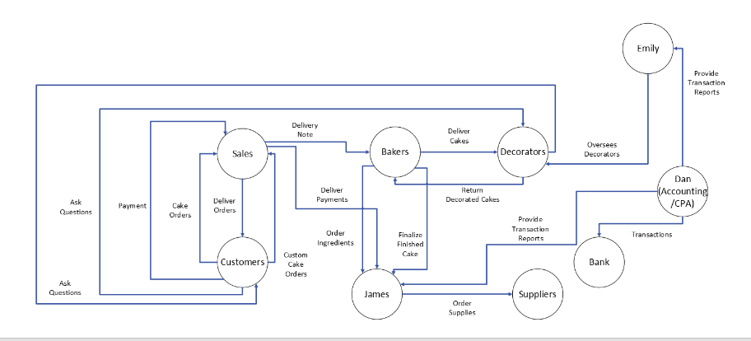

Problems and requirements list

Project organization chart

Problems and requirements list

Responsabilities matrix

Project schedule

Work breakdown structure

Business Case

Issue logs

Problem logs

Change logs

Entity relationship diagram

Data dictionary

Data flow diagram

Required system crud matrix

USE CASES

ProTOTYPE

REPORTS

DATA ACQUISITION AND DATA CONVERSION PLAN

application architecture diagram

data and application testing plan

