 |  | Business Case

Design It  - Meerub Sultan  - Alondra Cisneros  - Huda Memon  - Manya Gogia  - Tawhida Farrag  - Kyla Kemp  - Linda Lopez  - Belma Vazquez | ITCONSULTANT@DESIGNIT.COM  WWW.DESIGNIT.COM

Table of Contents
Executive summary - 3

Scope Diagram - 4

Problems and requirements list - 5

Project organization chart - 10

Responsibilities matrix - 11

Project schedule - 13

Work breakdown structure - 19

System Proposal (Feasibility) (1 & 11) - 21

Issue logs - 51

Problem logs - 54

Change logs - 57

Entity relationship diagram - 60

Data Dictionary - 61

Data flow diagram - 64

Required system crud matrix - 72

Prototype -74

Reports - 85

Data acquisition and data conversion plan - 117

Application architecture diagram - 120

Data and application testing plan - 121

Lessons Learned - 123

List of authors and references - 124

Executive
  - summary
Introduction
We are DesignIT, an IT consulting company delighted to present our project for Emily Bakes. This is an executive summary that will provide an overview of the project objective, company approach, and timeline of the overall project.
Project Objective
The main objective of this project is to reduce customer order time, reduce lost or duplicated orders, and increase customer acquisition by creating a customer and order web database application.
Problem Statement
Emily Bakes uses an outdated written system that causes a significant loss in custom cake orders and a notable decrease in returning customers.
Approach
DesignIT’s approach for this project is to develop a database system that will allow employees to input customer information, create custom orders, remind the bakery of upcoming orders and status of orders.
Analysis Summary
With an estimated 36-60 orders lost per year, leading to $4,800 costs lost within the year, the current order process to be inefficient and leads to approximately 15% returning customers. With the lack of stored data, it makes it difficult to anticipate preferences of future and returning customers.
Timeline
Project initiation will begin in Q4 2024 and with stage implementation and employee training, we aim for system utilization by Q2 2025.

Scope Diagram

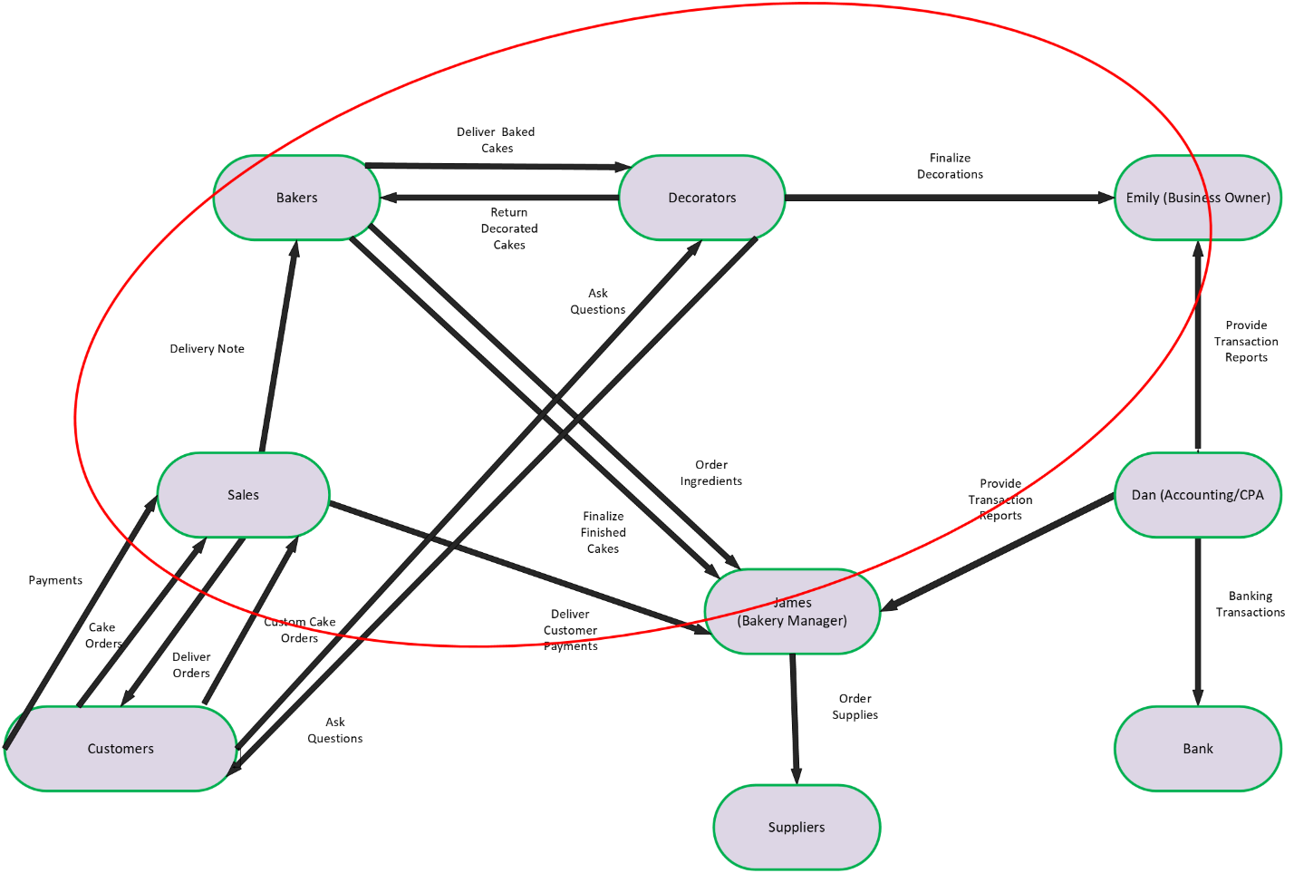

Problems and requirements list

Problems/Requirements List
ID | Category | Prioity Level | Rank | Problems/Requirements | Status: Desc
1 | Initiation & Analysis | Mandatory | 1 | System should be compatible with the company's desktop | Complete: System Proposal
2 | Initiation & Analysis | Mandatory | 2 | System should incorporate a customer management system that includes customer details | Complete: System Proposal
3 | Initiation & Analysis | Mandatory | 3 | System should allow user to pull up email/phone lists | Complete: Prototype
4 | Initiation & Analysis | Mandatory | 4 | System should allow user to input customer information | Complete: Prototype
5 | Initiation & Analysis | Mandatory | 5 | System should display customer status (active/inactive) | Complete: Prototype
6 | Initiation & Analysis | Mandatory | 6 | System should display product status (available/unavailable) | Complete: Prototype
7 | Initiation & Analysis | Mandatory | 7 | System should be able to select 1 product and customer to create an order | Complete: Prototype
8 | Initiation & Analysis | Mandatory | 8 | Products can only be in one category | Complete: Prototype
9 | Initiation & Analysis | Mandatory | 9 | System should remind the bakery when orders need to be made | Complete: Prototype
10 | Initiation & Analysis | Mandatory | 10 | System should be able to update status of the order | Complete: Prototype
11 | Initiation & Analysis | Mandatory | 11 | System should track who was last working on an order | Complete: Prototype
12 | Initiation & Analysis | Mandatory | 12 | System should include confirmation of an order if placed over the phone | Complete: Prototype
13 | Initiation & Analysis | Mandatory | 13 | Each unique person is a customer | Complete: Prototype
14 | Initiation & Analysis | Mandatory | 14 | One cake/product per order | Complete: Prototype
15 | Initiation & Analysis | Mandatory | 15 | Customer can either be retail/corporate NOT both | Complete: Prototype
16 | Initiation & Analysis | Mandatory | 16 | "Preferred" customers can receive a discount of 10% (must be approved by Emily) | Complete: Prototype
17 | Initiation & Analysis | Mandatory | 17 | Corporate customers can have more than one location | Complete: Prototype
18 | Initiation & Analysis | Mandatory | 18 | Corporation should be considered a single customer | Complete: Prototype
19 | Initiation & Analysis | Mandatory | 19 | Customers must pay at least 50% deposit on all custom orders | Complete: Prototype
20 | Initiation & Analysis | Mandatory | 20 | Valid forms of payment: Cash, Debit, and Major Credit Cards | Complete: System Proposal
21 | Initiation & Analysis | Mandatory | 21 | Customer can customize any of the "standard" cakes | Complete: Prototype
22 | Initiation & Analysis | Mandatory | 22 | System should include textbox so the customer can choose to write on a cake | Complete: Prototype
23 | Initiation & Analysis | Mandatory | 23 | Custom cakes should be ordered at least 2 days in advance (store manager can make exceptions) | Complete: Prototype
24 | Initiation & Analysis | Mandatory | 24 | Layer 1 is always the bottom-most layer | Complete: Prototype
25 | Initiation & Analysis | Mandatory | 25 | 1 Layer can have 0, 1, or 2 layers of the SAME filling | Complete: Prototype
26 | Initiation & Analysis | Mandatory | 26 | Prices of decorated cakes are negotiated at the time of ordering | Incomplete: Out of scope
27 | Initiation & Analysis | Mandatory | 27 | Emily or the Bakery Manager must approve all completed customized cakes | Incomplete: Out of scope
28 | Initiation & Analysis | Mandatory | 28 | Cakes should be completed at least 4 hours before customer is scheduled to pick up | Complete: Prototype
29 | Initiation & Analysis | Mandatory | 29 | Cake orders can be cancelled prior baking beginning | Complete: Prototype
30 | Initiation & Analysis | Mandatory | 30 | Decorations can be modified before decorating begins (can result in change of quoted price) | Complete: Prototype
31 | Initiation & Analysis | Mandatory | 31 | Customers can provide photos, clippings, or examples of their desired finished products (to be evaluated) | Complete: Prototype
32 | Initiation & Analysis | Mandatory | 32 | Cup Cakes can also be customized (all fillings must be in the top center portion) | Incomplete: Out of scope
33 | General | Key | 1 | Create team name that is not already copyrighted | Complete: Team Name
34 | General | Key | 2 | Create a business logo for our team | Complete: Team Logo
35 | General | Key | 3 | An overall summary that states project objective, problems, and challenges. Explain teams' analysis an approach to client problem | Complete: Executive Summary
36 | Project Management | Key | 4 | Sources and Recipients must be ovals or circles, and key flows of information must be displayed by arrowheads | Complete: Scope Diagram
37 | Project Management | Key | 5 | 8-15 key flows of information are required | Complete: Scope Diagram
38 | Project Management | Key | 6 | Must be a high-level interface and must have a project boundary | Complete: Scope Diagram
39 | Project Management | Key | 7 | Establish roles for team members | Complete: Team Roles Matrix
40 | Project Management | Key | 8 | Identify project teams' reporting structure | Complete: POC
41 | Initiation & Analysis | Key | 9 | Must include all problems and requirements related to the project | Complete: P/R List
42 | Project Management | Key | 10 | Outline time frame for deliverables and must include project timeline already given | Complete: WBS
43 | Project Management | Key | 11 | Must be in a high-level format and display 5-6 stacks | Complete: Gantt Chart
44 | Initiation & Analysis | Key | 12 | Define entities and attributes showing relationships | Complete: ERD Diagram
45 | Initiation & Analysis | Key | 13 | ERD diagram must follow rules discussed in class (singular entity, relationship lines have verbs, no unresolved M:M relationship, etc.) | Complete: ERD Diagram
46 | Initiation & Analysis | Key | 14 | DFD diagram must show the flow of data in the system using processes, entities, and data stores | Complete: DFD Diagram
47 | Initiation & Analysis | Key | 15 | Entities and Attributes represented and described | Complete: Data Dictionary
48 | Initiation & Analysis | Key | 16 | Create application architecture and network diagram to show the flow of devices from the frontend to backend from the GUI point of view | Complete: Application architecture diagram
49 | Initiation & Analysis | Key | 17 | Lists every process from DFD as Rows and every Entity from the ERD as columns | Complete: ERD Diagram
50 | Initiation & Analysis | Key | 18 | Every entity has at least one process that creates, updates, and deletes the entity | Complete: ERD Diagram
51 | Project Management | Key | 19 | Create issue, problem, and change logs with clear columns providing team with a place to report any concerns | Complete: Issue/Change/Problem Logs
52 | Initiation & Analysis | Key | 20 | Reports must provide clear and concise feedback for the client | Complete: Quality check
53 | Initiation & Analysis | Key | 21 | Provide client with details of economic, technical, and operation feasibility | Complete: System Proposal
54 | Initiation & Analysis | Key | 22 | Create economic and technical analysis in excel and operational analysis in a document for clients to see | Complete: System Proposal
55 | Project Management | Key | 23 | Economic Feasibility should include a business case breaking down costs, benefits, and risks of proposed system as well as TCO | Complete: System Proposal
56 | Initiation & Analysis | Key | 24 | GUI design has been thoroughly reviewed and a plan is in place | Complete: Prototype
57 | Initiation & Analysis | Key | 25 | System should allow user to update prices of products/products offered | Complete: Prototype
58 | Initiation & Analysis | Key | 26 | PowerPoint should have all required deliverables | Complete: PowerPoint presentation
59 | Initiation & Analysis | Desirable | 1 | System should show pricing information for all product options | Complete: Prototype
60 | Initiation & Analysis | Desirable | 2 | System should provide customer support features | Complete: Prototype
61 | Initiation & Analysis | Desirable | 3 | All slides should have a similar theme and follow guidelines provided | Complete: Quality check
62 | Initiation & Analysis | Desirable | 4 | Reports should all be consistent with requirements, uniform, and well designed | Complete: Quality check
63 | Initiation & Analysis | Desirable | 5 | Provides client with information of data acquisition for system with details of how it will be handled | Complete: Data Acquisition and Conversion Plan
64 | Initiation & Analysis | Desirable | 6 | Provide client with recommendation on database and application testing | Completed: Data and Application Testing Plan
65 | Initiation & Analysis | Desirable | 7 | System should be compatible with the Emily and James company-provided laptops | Complete: System Proposal
66 | Initiation & Analysis | Desirable | 8 | Proposal should recommend new components that will better the overall system | Complete: System Proposal
67 | Initiation & Analysis | Desirable | 9 | Should have at least 2 system solution options for the client to choose from | Complete: System Proposal
68 | Initiation & Analysis | Desirable | 10 | All authors of each deliverable are clearly stated in a spreadsheet | Complete: Team Roles Matrix
69 | Initiation & Analysis | Desirable | 11 | All deliverables must be checked and compared to rubric to ensure it is done properly | Complete: List of authors and references
70 | Initiation & Analysis | Desirable | 12 | Team members must share what worked, what did not work, and what they would do differently from the project manager's point of view. | Complete: Lessons learned
71 | Initiation & Analysis | Desirable | 13 | List of all referenced used on for this project organized by deliverable | Complete: List of references and authors
72 | Initiation & Analysis | Desirable | 14 | Website with a user-friendly design, a clear layout and easy navigation | Incomplete: Out of scope
73 | Initiation & Analysis | Desirable | 15 | Newly revised customer-facing website providing information about bakery/products | Incomplete: Out of scope
74 | Initiation & Analysis | Desirable | 16 | System should incorporate an order management system that allows for tracking, updating, and customizing orders to ensure accurate fulfillment and customer satisfaction | Complete: CRUD Matrix

Project organization chart
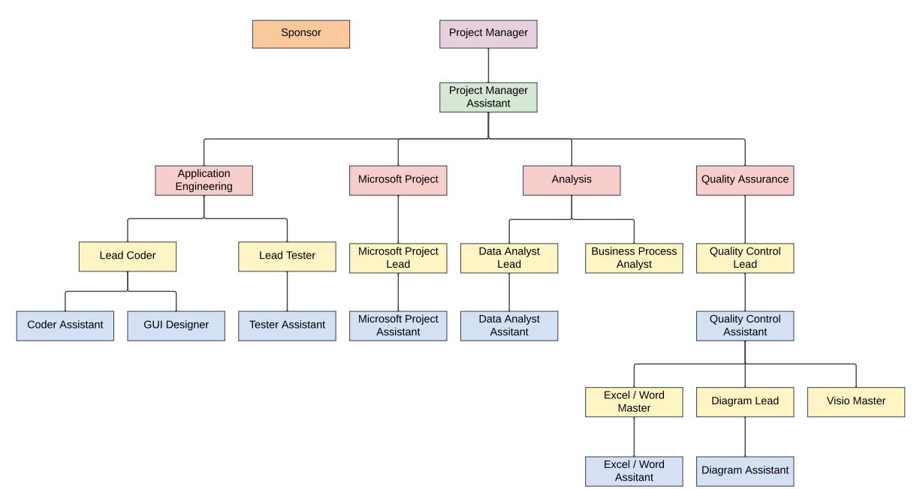

Responsibilities matrix

Name | Roles | Description
Alondra | Microsoft Project Assistant | Responsible for assisting the Microsoft Project Lead in managing Microsoft Project software. Worked on planning, scheduling, and reporting on the project and the creation of the Gantt chart. Aided the Microsoft Project Lead to ensure tasks were being completed within the corresponding timeline.
 | Quality Control Lead | Ensured project deliverables met client's expected standards. Worked with Quality Control Assistant to inspect each project deliverable thoroughly. Developed a systematic process to inspect project by focusing on reviewing, reporting, and coordinating with team members to improve quality of deliverables.
Belma | Project Manager | Oversaw the planning, execution, and completion of the project. Ensured team stayed on schedule and objectives were met. Developed Systems Proposals and Systems Feasibility Analysis for each solution with Project Manager Assistant. Designed Team Logo.
 | Quality Control Assistant | Aided Quality Control Lead in inspecting deliverables, and reviewed requirements to ensure client standards were met. Documented test results, edited business reports, and assisted in identifying areas for improvement. Helped implement corrective actions alongside Quality Control Lead.
 | Diagrams Assistant | Aided Diagrams Lead and VISIO Master in creating diagrams and process maps. Ensured diagrams were accurate and formatted correctly. Assisted in revising diagrams based on feedback.
Huda | Microsoft Project Lead | Oversaw the planning, scheduling, and resource management of the project using Microsoft Project. Created project timeline and optimized stage/task schedule. Created Work Breakdown Structure and worked with Microsoft Project Assistant to ensure successful coordination and project execution.
 | Visio Master | Collaborated with team to determine project scope. Created Scope Diagram using VISIO. Aided and worked with Diagrams Lead and Diagrams Assistant to edit diagrams.
Kyla | Business Processes Analyst | Analyzed client's business processes and determined ways to optimize and improve efficiency and productivity. Gathered requirements, examined existing workflows, identified issues, and recommended improvements.
 | Diagrams Lead | Oversaw the management of required diagrams including DFDs, Scope Diagram, and ERD. Created DFDs of level 1 and level 2 processes. Ensured diagrams represented correct processes, communicated ideas clearly, represented project objectives.
Linda | Tester Assistant | Aided Lead Tester with testing prototype to ensure proposed system met client's business requirements. Provided feedback on application design, functionality, and accessibility.
 | Lead Coder | Oversaw coding of application prototype. Ensured that the application met client requirements and specifications. Worked with Coder Assistant to write and review code. Worked with GUI designer to ensure consistent and engaging design. Gathered feedback of prototype from client and team and implemented changes.
Manya | GUI Designer | Designed and created visually appealing and user-friendly interface for web application. Ensured consistent look and feel and made sure flow of GUI matched client's business process flow. Collaborated with Lead Coder to express client requirements in a functional and accessible way.
 | Coder Assistant | Assisted Lead Coder in coding, debugging, and testing web applications. Ensured usability of prototype and worked with team to address issues and feedback.
 | Excel/Word Assistant | Worked with Excel/Word Master to manage data and documentation using Microsoft Excel and Word. Assisted in creating spreadsheets and data entry. Created System CRUD Matrix using processes from DFD and entities from ERD.
Meerub | Project Manager Assistant | Contributed to assigning roles based on prior experience. Created Issue/Problem/Change Logs allowing team members to contribute and add to the logs throughout project. Created PowerPoint with a basic outline allowing team members to work on their slides.
 | Data Analyst Assistant | Identified valuable information from case study business rules to create P/R list. Created one solution based on the information of the current system in place. Created feasibility analysis for one of the proposed solutions.
 | Excel/Word Master | Created sheets within shared team Excel file for necessary deliverables. Created tables for everyone to add and contribute to. Created outline of economic/technical feasibility sheets in Excel.
Tawhida | Data Analyst Lead | Organized data from case study to identify patterns and solutions. Created Executive Summary to help understand project objective, timeline, and problem. Developed Data Acquisition and Conversion strategy to develop an outline plan that converts historical data into database. Worked with Project Manager and Assistant to help assign roles.
 | Lead Tester | Created data dictionary outline and regularly updated with prototype update. Helped overlook prototype to confirm it corresponded with client's business requirements. Develop Data and Application Testing Plan to recommend to client.

Project schedule
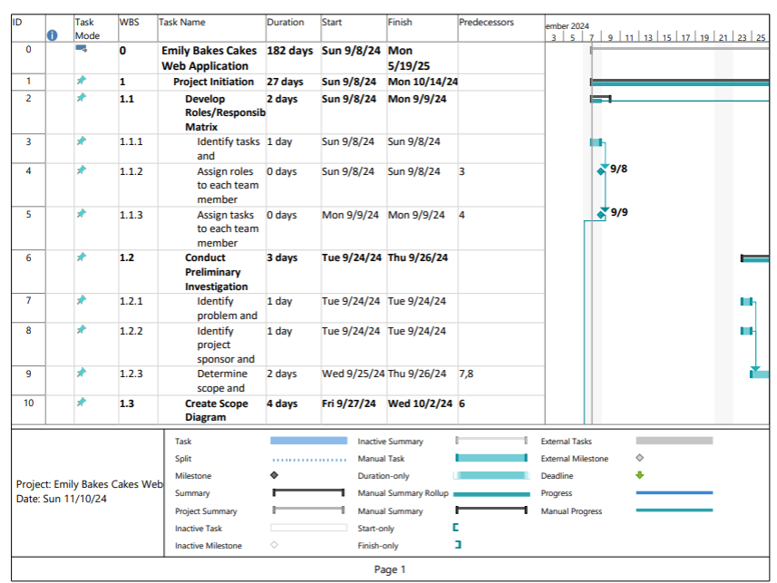
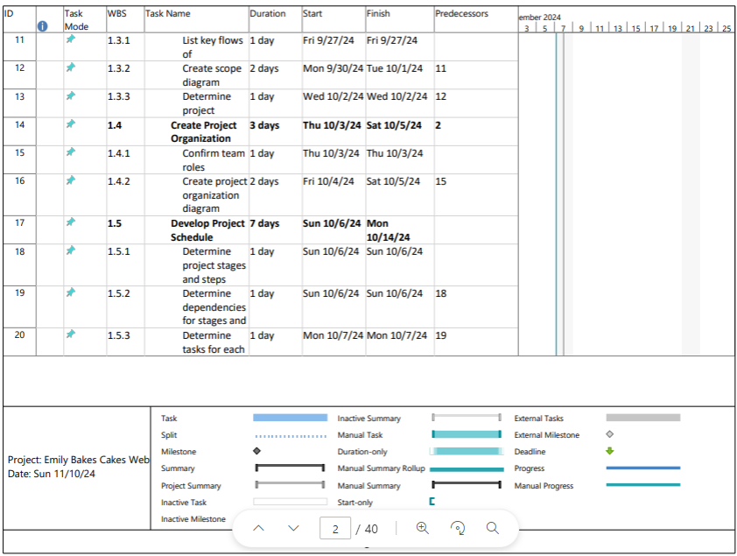
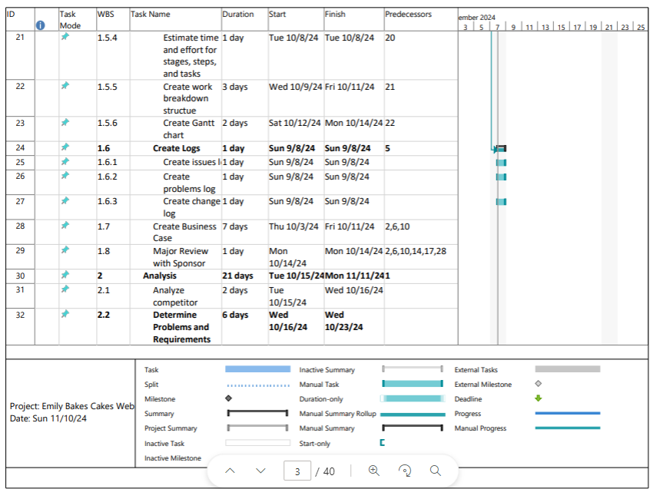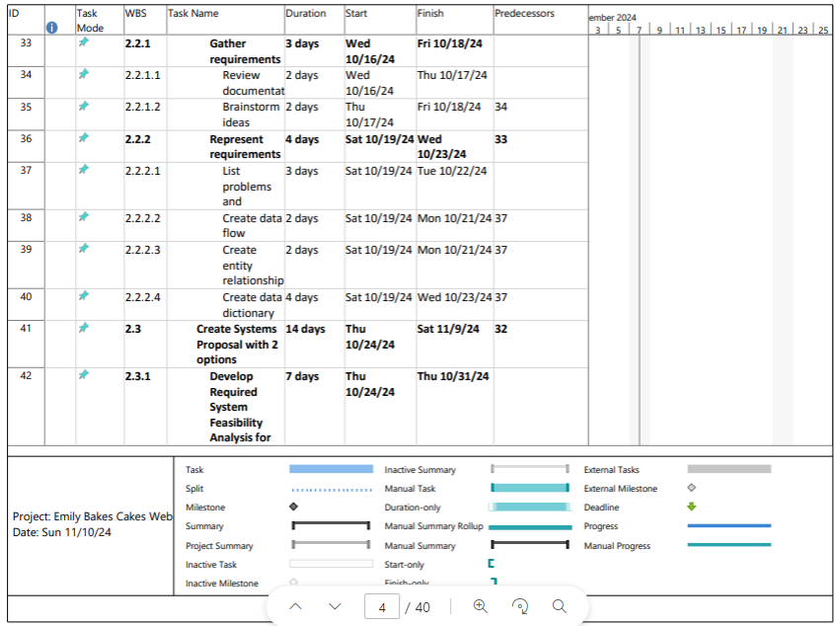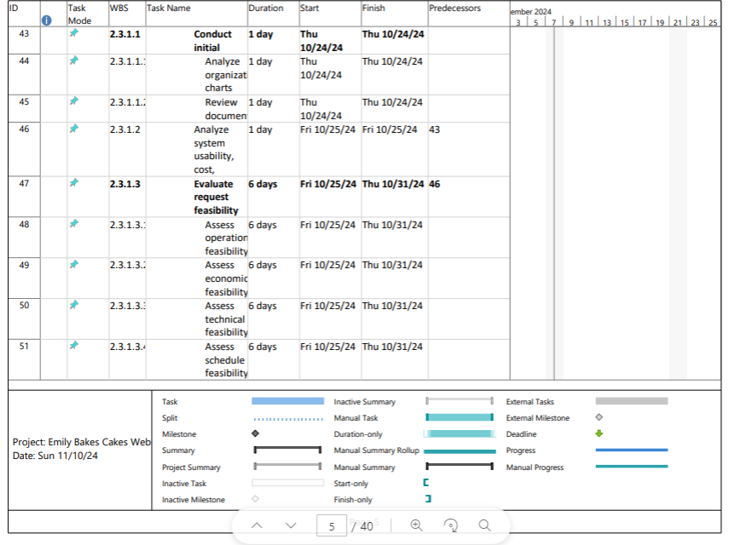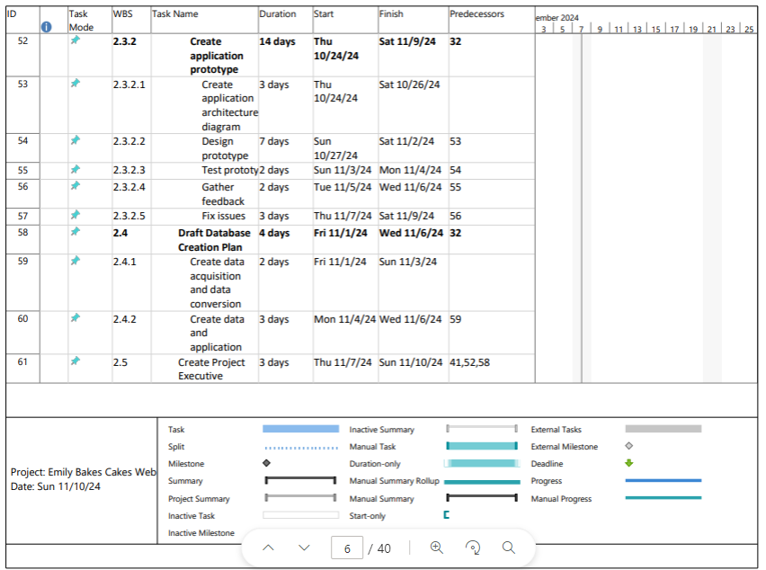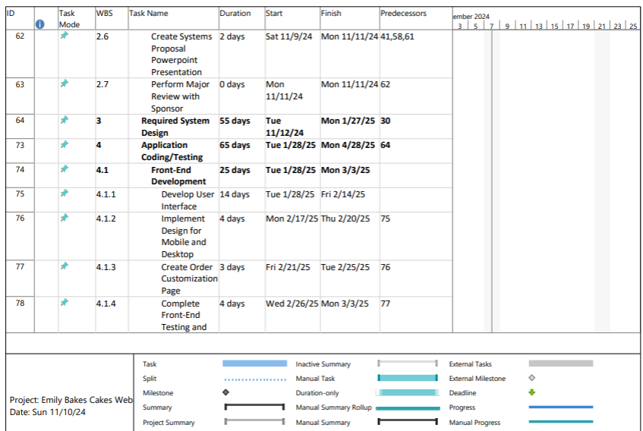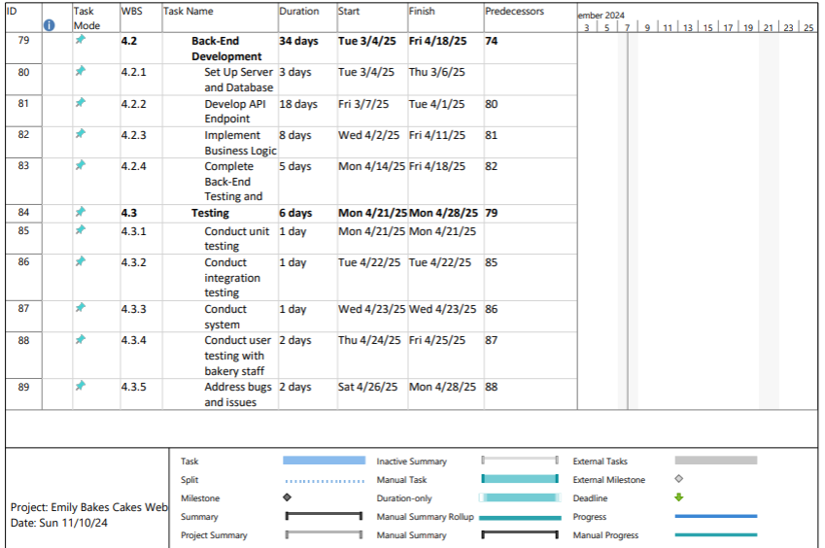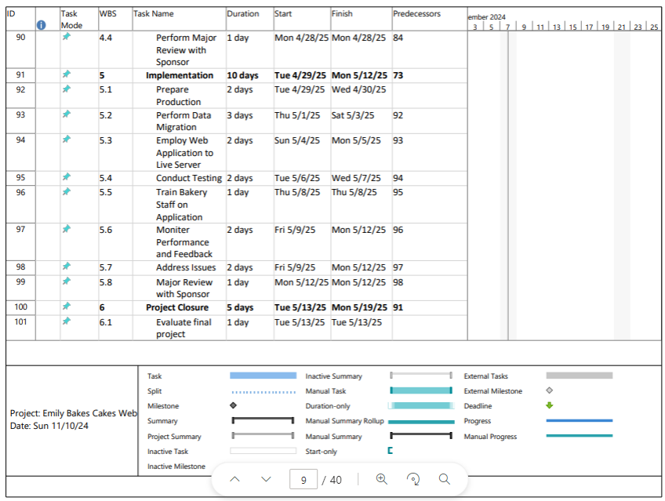

Work breakdown structure
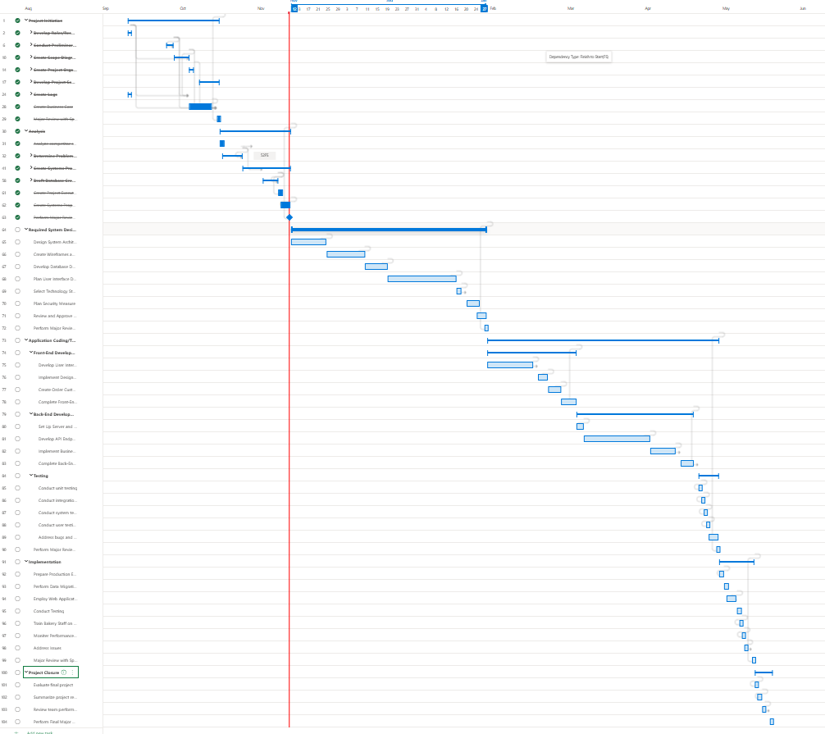

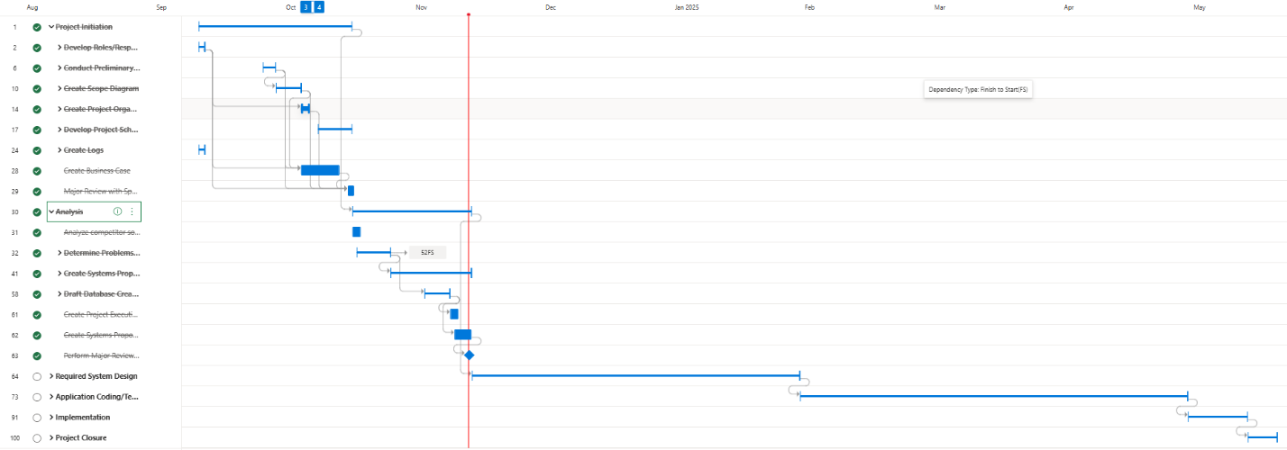

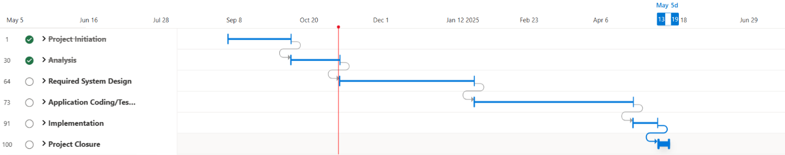

System Proposal 1
This proposal outlines the new system recommended to address your business challenges. Working with DesignIT, we guarantee a solution that will streamline your custom cake ordering process, improve customer retention, and reduce your operational inefficiencies. Our team will collaborate closely with Emily Bakes Cakes to ensure that the system is tailored to meet your unique needs and integrates with workflows seamlessly.
The proposed solution is created to:
- Simplify the order creation process/tracking
- Eliminate lost and duplicate orders
- Increase customer satisfaction/retention
- Improve customer data management
The current paper-based ordering and tracking system at Emily Bakes Cakes creates major inefficiencies and an operational burden on the business. By utilizing a digital order management system, we aim to streamline the entire process from new customer sign-ups to final order fulfillment. The proposed digitized system allows employees to input custom cake orders directly into a centralized backed up database, eliminating the paper-based system adding to costs.
One of the most significant factors in the current system that has resulted in added costs to your business is the loss or misplacement of orders. Losing an estimated 3 to 5 orders each month is affecting customer satisfaction and retention rates. The proposed solution will eliminate this issue by storing all customer data in a secure database accessible to employees. With a system like this the risk of lost and duplicate orders decreases significantly leading to a direct result in increased revenue.
Below you will find several key recommendations we plan to implement to improve customer satisfaction. Once our custom cake ordering & customer management system is in place we also recommend a few other components to enhance the current system. We recommend the Square POS system because it offers a range of features that will benefit your business. Square offers flexibility in payments, security, and affordable pricing. This will allow for quick processing times with customers, leaving them more satisfied. We also recommend using Backblaze, a cloud-based service that allows for unlimited space to back up critical information, such as customer data and custom cake orders. Preventing loss of orders will ensure higher customer retention.

A key challenge for Emily Bakes Cakes has been handling customer data and storing it in an efficient manner. Our solution provides the business with the ability to store all relevant information about customers, making it easy to handle future orders and contact them when needed. One of the reasons we recommend using Shopventory is that it allows you to analyze trends in what customers are purchasing. Shopventory also provides staff with critical information about inventory, reducing the chance of stockouts, and providing customers with the products they would like.
The new system will provide significant improvements in operational efficiency and customer experience. This solution offers valuable insights into your customers' needs and trends. The result will be a bakery that does not just meet customer expectations but exceeds them. Together with DesignIT’s expertise, we are confident that this solution will enhance your business and provide success in a competitive market.

Proposal 1 – Operational feasibility

Introduction:
Finding a solution that streamlines operations while addressing your specific business challenges is critical for growth and efficiency. The proposed application that we have designed will solve your business’s key challenges by automating customer and order management. By eliminating paper records and transitioning to a digitalized system, we aim to improve the speed of order processing, the reduction of lost orders, and improve customer satisfaction. This solution not only addresses your business needs but also provides key recommendations that will further enhance your overall business operations.
Does it solve the business problem?
The proposed application directly addresses your business challenges by efficiently managing customer information. The application will eliminate the need for paper records relating to customers and product orders. It provides a way for users to track orders and retrieve customer information efficiently. Choosing the fully customized route will allow you to have an application tailored to your specific business rules and needs. By centralizing and digitizing orders, it will reduce the risk of losing orders and increase customer retention. This system will ensure quicker order processing, and reduceduce lost and duplicate orders, while increasing customer retention.
Does it fit into day-to-day operations?
The benefit of our proposed application is that the new system will blend right into your current workflow guaranteeing smoother operations. Shifting to a paperless system, employees will be able to take and track orders quickly within the system, giving them more time for other operational activities. If you adopt the recommended square POS terminal, you will gain real-time insights into inventory which would be beneficial to James and Emily. Now that card payments account for twice as many cash payments, the Square Terminal and Software will enhance customer experience, increasing customer satisfaction.

What is the impact of the application on users?
The system that I am proposing allows employees to focus more on customer engagement, preparation, and value-adding activities instead of repetitive tasks like paper orders and inventory updates. Bakers and decorators can track the status of all product orders that need to be made on time. The system will provide alerts and reminders of when the custom cake needs to be made by. Emily, James, and the sales staff will be able to efficiently take custom cake orders from customers. James and Emily will have the ability to track inventory and receive alerts of their current and future stock needs.
Implementation & Training
For successful implementation of the system, we will provide comprehensive training for your staff, ensuring a smooth transition with minimal disruptions. Our approach prioritizes efficiency, implementing without compromising your business productivity. The system also provides important help features for specific tasks within our system. Experts on our proposed solution will work closely with your team offering ongoing support and guidance to address any challenges you may face in the process.
Conclusion:
In conclusion, the proposed application offers you and your business a solution tailored to your unique business challenges. By going this route, you would never need to worry about misplacing an order as it will be stored within our system and backed up in the cloud. This will help users reduce errors and create valuable time to focus on customer engagement and satisfaction. With its seamless integration into daily activities, you will experience improved efficiency and streamlined workflows like before. This solution will provide growth and success in your future.

Proposal 1 – Economic feasibility – Business Case
Economic Feasibility/Business Case (Solution #1)
Category | Item/Description | Cost | Benefit | Risk
Hardware | Dell XPS Desktop | $1,699 | - Ability to handle customer data  - Ability to handle business applications  - High performance based on components  - Ability to upgrade specific components as needed (scalability)  - Many different ports including one for ethernet  - Capable of handling frontend/backend features needed to support GUI | - Initial investment is high  - Possibility of needing to replace in uncertain circumstances  - Added costs if you choose to upgrade which could mean the asset depreciates faster than anticipated  - May need to make extra space for it (bigger in size)  - Not portable
Hardware | 2 x Dell XPS 13 | 2 x $1,000.99 | - Good performance  - Lghtweight  - Great for cake graphics  - Long battery life  - Capable of handling frontend/backend features needed to support GUI allowing them to work remote if needed | - Initial investment is high  - May not need to update laptops if you plan to take orders on just the desktop (redundant)  - Limited ports (would need adapters/dongles)  - Screen may be too small if you plan to use it for extended periods of time
Hardware | Dell 27 4K UHD Monitor (S2721QS) | $279.99 | - Offers high resolution for detailed graphics  - Great for multitasking which will improve efficiency | - This may be an added cost for a monitor (redundant) if you already have a functioning monitor from the previous system
Hardware | Square Terminal | 2 x $298.99 | - Portable payment system  - Includes built-in receipt printing  - Faster transactions and flexibility  - Multiple payment methods per transactions | - Has the potential for technical issues  - Long-term reliance can result in downtime if it malfunctions  - Added cost
Hardware | XFi Gateway (modem/router combo) | $15/month | - Provides a reliable internet connection for business operations from the current provider  - Needed for Square POS system and other cloud-based services as well  - Needed for hardware components | - Monthly fees can add up  - Internet outages can disrupt business operations
Software | Custom Cake Ordering & Customer Management GUI | Basic Plan: $60/month  Custom Plan: $110/month | Basic Plan:  - 1 free month using our basic software  - Ability to configure GUI following contract agreement  - Less expensive  Custom Plan:  - Available to customize to your liking for an additional fee  - Ability to create software based on business rules and requirements | Basic Plan:  - Limiting business operations  - GUI will not be tailored to unique business requirements  Custom Plan:  - Available to customize to your liking for an additional fee  - Higher maintenance  - Tailored to unique business requirements
Software | Square POS Software | Free + transactions fees (2.6% + 10c per swipe for card payments) | - Ability to integrate sales, inventory, and customer management tools  - Useful for reporting with real-time analytics | - Dependent on Square’s POS system  - Must ensure integration with other business applications and tools  - Ongoing fees
Software | Backblaze (Cloud Backup Service) | $6/month | - Has unlimited cloud backup with automatic syncing, restoration, and version history of files  - Ensures data security  - Business will be able to recover quickly in case of a disaster | - Ongoing monthly costs  - Reliance on cloud services  - Possibility of data being vulnerable in case of a data breech
Software | Shopventory | $49/month | - Real-time inventory updates  - Able to create alerts on stock status  - Reports on inventory  - Prevents stockouts/overstocking | - Ongoing monthly payment can add up  - Must ensure integration with Square POS system

Proposal 1 – Break even analysis
Table showing breakdown of the breakeven analysis with cumulative savings and investment for the basic plan.

Month | Savings (Cumulative) | Total Investment (Cumulative)
1 | $400 | 4708.95
2 | $800 | 4838.95
3 | $1,200 | 4968.95
4 | $1,600 | 5098.95
5 | $2,000 | 5228.95
6 | $2,400 | 5358.95
7 | $2,800 | 5488.95
8 | $3,200 | 5618.95
9 | $3,600 | 5748.95
10 | $4,000 | 5878.95
11 | $4,400 | 6008.95
12 | $4,800 | 6138.95
13 | $5,200 | 6268.95
14 | $5,600 | 6398.95
15 | $6,000 | 6528.95
16 | $6,400 | 6658.95
17 | $6,800 | 6788.95
18 | $7,200 | 6918.95
19 | $7,600 | 7048.95
20 | $8,000 | 7178.95
21 | $8,400 | 7308.95
22 | $8,800 | 7438.95
23 | $9,200 | 7568.95
24 | $9,600 | 7698.95

Graph showing the breakeven point.
Excludes Transaction Fees

Table showing breakdown of the breakeven analysis with cumulative savings and investment for the custom plan.

Month | Savings (Cumulative) | Total Investment (Cumulative)
1 | $500 | 4758.95
2 | $1,000 | 4938.95
3 | $1,500 | 5118.95
4 | $2,000 | 5298.95
5 | $2,500 | 5478.95
6 | $3,000 | 5658.95
7 | $3,500 | 5838.95
8 | $4,000 | 6018.95
9 | $4,500 | 6198.95
10 | $5,000 | 6378.95
11 | $5,500 | 6558.95
12 | $6,000 | 6738.95
13 | $6,500 | 6918.95
14 | $7,000 | 7098.95
15 | $7,500 | 7278.95
16 | $8,000 | 7458.95
17 | $8,500 | 7638.95
18 | $9,000 | 7818.95
19 | $9,500 | 7998.95
20 | $10,000 | 8178.95
21 | $10,500 | 8358.95
22 | $11,000 | 8538.95
23 | $11,500 | 8718.95
24 | $12,000 | 8898.95

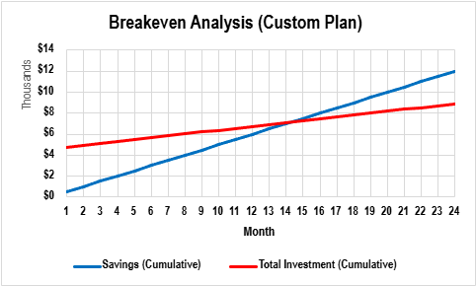

Graph showing the breakeven point.
Excludes Transaction Fees

Proposal 1– Technical Feasibility
Technical Feasibility (Solution 1)
Category | Current System | Recommended System | Compatibility | Impact
Hardware | 1 x Desktop/Monitor | 1 x Desktop | Since the current desktop is unable to support the new Custom Cake Ordering & Customer Management GUI the business needs, we recommend purchasing a desktop cable to do so. It has been chosen based on its ability to perform and support the GUI needed. Purchasing the suggested desktop will allow you to expand as your business grows as it has the option to upgrade specific components. All required software for the proposed solution will be integrated through this desktop. | This will allow for the GUI to be backed up to the cloud, transaction management, and inventory management. Most importantly it will be able to quickly handle custom order forms.
Hardware |  | 1 x Monitor | The monitor we suggested will connect to the desktop proposed as the user interface. It is possible that this may be redundant depending on the previous monitor you have been using, in this case we will have to get more information on the current monitor being used to determine the best solution. | This monitor will allow the user to efficiently work with the GUI, taking orders, and handling customers. It gives the user the opportunity to multitask enabling them to get more work done.
Hardware | 2 x Laptops | 2 x Laptops | It is recommended that you purchase two new laptops that are able to support the proposed GUI because it has similar capabilities to the desktop and is able to handle the software suggested. | Emily and James having two laptops that support the GUI will allow them to work remotely or around the bakery in general. They will be able to handle business matters from wherever they are, giving them much more flexibility. This will make it easier for them to investigate orders, customers, and inventory on the go.
Hardware | 1 x Credit Card Machine | 2 x Square POS terminals | The Square POS terminals are compatible with the hardware selected and allow customers to pay using all major credit and debit cards. | Having two of these terminals will help quicken transactions with customers and double the number of card payments made at one time. This will allow more customers to be served efficiently and reduce wait times leading to a faster checkout experience and improved customer satisfaction. Offers customers different options on how they would like to pay for their orders. Customers can split payments if they want.
Hardware | 1 x POS Cash register | keep | Staff will still be able to handle and track transactions taken through the cash register. If it is one of the more modern cash registers it should be compatible with Square POS, if not, then it is another component to consider looking into. This will allow all transactions made to be tracked and stored in one place. | Multiple employees can handle customers with different forms of payment. Offers customers different options on how they would like to pay for their orders.
Hardware | 1 x Router | 1 x XFi Gateway (router/modem combo) | Adopting the XFi Gateway will offer the business a seamless integration as the business has already established a relationship with this ISP (Xfinity). All other hardware and software devices will have no issues with the current 800 Mbps. | Emily will not need to find another ISP for the business. Getting the combo will be cheaper for them because renting out a router and a modem separately costs them more money monthly. This recommendation will help save them money.
Hardware | 1 x Modem | (same as above)
Hardware | 1 x Canon Color multi-function Printer | keep | No issues listed about the printer suggests that it works and supports day-to-day activities performed by the business. This printer should be able to connect with the newly proposed hardware and other devices as well through a stable internet connection or USB. | Business would not need to upgrade this item since it has not caused them any kind of issues. Staff will be able to utilize the multi-function color printer as needed.
Hardware | 1 x Icings inks Cake Topper Image Printer | keep | Since the software is available to get and previously owned it should be simple to integrate into the new system as it is familiar to them already. | Keeping this printer is an acceptable solution since there were no issues related to it listed.
Software | Icing inks Cake Topper Image Printer Software | keep | This software should be available (Windows option) to use with the proposed desktop and would make connecting the printer simple. | Users can easily print out cake toppers through the new proposed system.
Software |  | Backblaze | This software is available to Windows users and can be accessed through the web browser. It is important to have a stable internet connection for this service since it is cloud-based. | This service offers unlimited storage space to the business and ensures orders are held in a secure place while being accessible. In case of an emergency, you would not have to worry about lost orders and losing customer data. They also offer security by encrypting data being stored.
Software |  | Shopventory | This software is available to Windows users and can be accessed through the web browser. It also allows you to sync to Square POS offering real-time data. However, it is important to have an internet connection since it is a cloud-based service. | Shopventory is great for inventory management since it is able to connect to Square POS which tracks transactions. This service also offers reports on real-time being collected constantly.
Software |  | Custom Cake Ordering & Customer Management GUI | The desktop and laptops (Windows) selected were chosen based off whether it would be able to support the GUI created. The GUI would be designed to be able to integrate with other systems such as Square POS, Icinginks Cake Topper Image Printer, and the database. | This GUI will streamline operations, better customer management, and address business challenges.
Software |  | Square POS Software | As mentioned, Square POS is designed to work on Windows devices making it compatible with desktops and laptops. It also requires a stable internet connection because it is a cloud-based service. It allows Shopventory to synchronize to it and provides data. | Square POS Software syncs sales data giving Emily and James insights of the business. It can tell you how often a customer returns, sales trends, and customer preferences which can help set up business strategies and improve customer satisfaction and retention.

System Proposal 2 – Operational Feasibility

Introduction
Assessing the operational feasibility to implement a new customer and order web database application for the business is crucial. This solution seeks to address current operational challenges, particularly with the management of custom orders, customer data and the inefficient manual order tracking system. The proposed system aims to streamline the creation of orders while enhancing customer retention, reducing errors, and improving the bakery’s revenue and customer satisfaction.

Does it solve the business problem?
The new system allows for real-time order tracking, which also helps customers to track the status of their order. Since the application stores all order details in a digital manner, there is no risk of losing physical paperwork or misplacing orders. The system also prevents the creation of duplicate orders since it cross checks and verifies customer information. By reducing the annual cost associated with lost or duplicate orders the bakery saves up to 80%.
Since the business does not possess a centralized costumer database, this leads to a loss of 15% returning customers due to the inability to track or recall previous orders and preferences. With the proposed system, the costumer data (which includes previous orders and preferences as well as contact details) will be stored in a centralized location, making it easier for the bakery to engage with costumers, allowing them to offer personalized service, as well as encouraging repeat business.

Does it fit into day-to-day operations?
Yes, this solution helps in day-to-day operations for the business, the system is designed to seamlessly integrate with the current workflow of your business such as reducing time and efficacy when it comes to manual order tracking and costumer management. By automating the process as well as the tracking of the orders, the system will streamline workflows for your sales, baking, and decorating teams.

What is the impact of the application on users?
By implementing the proposed system that we recommend we expect to have a 25% reduction for the time that takes to create a custom order as well as a significant reduction in the number of lost orders, which then leads to an improved customer satisfaction and retention rate.
Sales staff will be able to enter orders directly into the system, allowing for it to automatically update the status of each order, notifying the relevel teams who oversee the various departments such as sales, baking and decorating staff to give them a schedule to complete their tasks as well alert them of when action is needed
This system will also help users by updating them of real time inventory on product, and their pricing, and with this the business can also avoid overstocking as well as understocking ingredients.

Implementation and training:
Implementing the new system into the business will be broken down into phases to ensure a seamless transition and minimize downtime. For phase one we expect to have it done in two weeks, since this phase involves the setup of the web database application as well as data migration and hardware and software check, ensuring that the business has the compatible equipment, but if needed additional devices can be provided to sales staff for mobile access.
During the pilot testing the system will run a pilot test for the members to ensure that all the functions are working properly, this phase is also the one where there is feedback from the application and necessary tweaks as well as customization will be made to the system.
Lastly for phase three, once the testing is complete and all issues have been resolved, the system will be available for the staff to try, and the database application will go live, during this phase the team will closely monitor the system performance and address any outstanding issues.

Conclusion:
In summary, the proposed system directly addresses the core business challenges that Emily Bakes Cakes is currently facing such as reducing time when it comes to manual order entry by improving it and having a bigger efficiency of order tracking, as well as eliminating the risk of losing orders or having duplicates. This system enables better customer management, leading to improved retention and repeat business, not limited to that, but it modernizes the bakery and their online ordering capabilities, which attracts new customers.

Proposal 2 – Economic Feasibility – Business Case
Economic feasibility
Category | Item | Quantity | Cost | Benefit | Risk
Hardware | Tablet for order management | 2 | $600 | Staff can take orders from anywhere in the bakery so they can improve the efficiency and customer interaction | Tablets are fragile and they can be dropped or exposed to heat and moisture
Hardware | Barcode scanner | 2 | $350 | Order accuracy, speeds up the process of tracking and identification process, minimizes the time spent locating orders, can be used to login of inventory | Learning curve, staff might require training, requires additional integration with existing systems
Hardware | Label Printer | 2 | $260 | Enhanced order tracking, improves overall organization, reduces chance of a mix-up, and enhances the costumer experience, gives a more professional image to costumers | Incorrect label printing could lead to errors, label and ink prices might add up overtime
Hardware | Desktop HP All-in-One 27-cr0000m, 27 | 2 | $2,000 | High performance saves space and minimizes clutter in the workspace. Desktop computer last longer than mobile devices | Higher upfront cost compared to other alternatives such as laptops or tablets
Hardware | Receipt printer | 1 | $180 | Speed and convenience, quickly prints receipts and helps reduce wait times, inexpensive to maintain and customers have a clear record of their purchase | Can be prone to jamming or have ink related issues. Adds another device in the limited counter space
Software | Dropbox for business (9TB) | 1 | $15/month | Large storage capacity, ample space for storing customer records, order history and allows for remote access to the information. Helps preventing data loss | Requires a stable internet connection, otherwise, accessing the data can be challenging
Hardware | Upgraded router and modem: Netgear® Nighthawk AX/5-Stream AX2400 Wi-Fi 6 Router, Black, RAX30-100NAS | 1 | $150 | Enhances Wi-Fi speed as well as its reliability, handles more devices simultaneously, helps reducing the lag, provides better long-term compatibility with newer devices | Setup complexity, without proper configurations, the network could be vulnerable to external sources.
Software | TOAST POS | 1 | $69/month | Custom configuration, comes with a handheld device or terminal, flat rate on payment processing, installation and network configuration, automatic software upgrades, payroll included, | Business is dependent on this POS to track their orders, payments, and payroll all in one.
Software | Web design + Domain + Customer management GUI | 1 | Basic plan: $45 Includes software and changes for the business, contract required Business plan: $120 Software + contract required + customization depending on the business | Basic plan covers the required needs and overall satisfies what the business is looking for Second plan is more business oriented, and the GUI can be modified to their liking and needed requirements. | Basic plan is extremely limited, coding features are limited as well and can be tricky when custom changes are needed the first year of implementing this feature. Business plan is expensive, and has a higher maintenance from the company, so requires closer monitoring

Proposal 2 – Breakeven analysis
Month | Savings | Investment
1 | 400 | 3685
2 | 800 | 3815
3 | 1200 | 3945
4 | 1600 | 4075
5 | 2000 | 4205
6 | 2400 | 4335
7 | 2800 | 4465
8 | 3200 | 4595
9 | 3600 | 4725
10 | 4000 | 4855
11 | 4400 | 4985
12 | 4800 | 5115
13 | 5200 | 5245
14 | 5600 | 5375
15 | 6000 | 5505
16 | 6400 | 5635
17 | 6800 | 5765
18 | 7200 | 5895
19 | 7600 | 6025
20 | 8000 | 6155
21 | 8400 | 6285
22 | 8800 | 6415
23 | 9200 | 6545
24 | 9600 | 6675

Month | Savings | Investment
1 | 500 | 3760
2 | 1000 | 3965
3 | 1500 | 4170
4 | 2000 | 4375
5 | 2500 | 4580
6 | 3000 | 4785
7 | 3500 | 4990
8 | 4000 | 5195
9 | 4500 | 5400
10 | 5000 | 5605
11 | 5500 | 5810
12 | 6000 | 6015
13 | 6500 | 6220
14 | 7000 | 6425
15 | 7500 | 6630
16 | 8000 | 6835
17 | 8500 | 7040
18 | 9000 | 7245
19 | 9500 | 7450
20 | 10000 | 7655
21 | 10500 | 7860
22 | 11000 | 8065
23 | 11500 | 8270
24 | 12000 | 8475

Proposal 2 – Technical feasibility

Category | Current System | Recommended System | Compatibility | Impact
Hardware | 1 Desktop/monitor | 2 | The desktop and monitor are the main hardware used in the business, so the staff can be able to process orders as well as track their payroll and keep track of their sales | GUI will keep orders on track, as well as the staff and customers. This interface with this equipment will make order taking more effective and reduce labor
 | 1 Desktop/monitor | 2 | The recommended desktop and laptop are compatible with the recommended GUI, making this more effective as well as reliable | Having a better system with better hardware which is compatible with the GUI as well as easier to access will help the business tremendously
Hardware | 2 Laptops | 2 Tablets | Tablets can be used to access the GUI, so they can be taken where needed to track the status of the orders and receive alerts of new orders, login and update any necessary info. | This will benefit the decorating staff, and the customers in real time so they can be constantly updating the progress in each order as well as staying up to date on their orders.
Hardware | 1 Credit Card Machine | TOAST Terminal for contactless payments | The terminal comes with a designed interface, allowing it to receive orders from online and show at the terminal, not limited to that it can be adapted with the suggested GUI. | Contactless payments are a business must nowadays. Clients want to be safe when it comes to using their card, and not only that, but the software integrates our GUI, and we can have an in-person terminal as well as an online order system.
Hardware | 1 POS Cash Register | Keep | The system would need to be looked at and the compatibility should be assessed with the suggested software. This could be a benefit for the store so we can have more hardware in person to use the suggested GUI | Having two efficient POS would be great for the store since as business starts to keep up, these will come in useful, and this also includes the audience who opts in for cash payments rather than credit card
Hardware | 1 Router | Upgraded router and modem | When using cloud storage as well as the GUI, and suggested POS, a strong and reliable Wi-Fi connection is important for the business, so this is why is recommended to acquire an upgrade | A fast and strong Wi-Fi connection ensures that the business runs smoothly, so there are no issues since most of the implemented tools are Wi-Fi based
Hardware | 1 Modem | Upgraded router and modem | Same as above | Same as above
Hardware | 1 Canon color multi-function printer | Keep | Order details and scheduling could be printed to remind the staff of the needed orders, as well as the assignment of each | This will make scheduling and assigning duties easier, since the GUI will provide a summary of the order with the details.
Hardware | Icinginks Cake Topper Image Printer Software | Keep | The new hardware suggested could help with having more designer tools for the toppers, run different programs as well as use this hardware to its full potential | This will make more room for personalization for the clients, so they can have more room for expression with their cakes and images.
Software | Web design + Domain + Customer management GUI | 1 | The suggested hardware is compatible with the suggested GUI, all the items meet the requirements to run this | This will help when taking care of the orders, also giving the users a clear price of what they are paying for as well as giving them options and ideas for more customization. This GUI also reduces labor for the business
Hardware | Barcode scanner | 2 | It is compatible with the POS and the hardware suggested above | Orders will be easier to identify, and lookup as well as to lookup in the system
Hardware | Label printer | 2 | It is compatible with the POS and hardware suggested above | Will give a more professional look to the orders as well as it will be easier to scan, rather than to lookup the order name into the system
Hardware | Receipt printer | 2 | It is compatible with the POS suggested, as well as the hardware, it can be integrated into the terminal | The client will have a proof of their order, and will include a barcode as well as tracking number so they can check on the status of their order

Issue logs

Issue Log
ID | Problem/Requirement ID | Identified by | Issue Description | Possible Solutions | Current Status | Comments
1 | 15 | Tawhida | Subscription isn't part of cast study | Change to customer type(Retail or Corporate) | Solved | N/A
2 | 40 | Alondra | Placed roles not in appropriate area | Establish final role descriptions | Pending
3 | 39 | Meerub | Issue/Problem/Change log did not show dependence | Create a column for previous table ID to clearly show with issue/problem is being referred to | Solved
4 | 41 | Meerub | Problems/Requirements list missing ID and Category | Add P/R ID and Category column to the P/R table | Solved
5 | 44 | Meerub | Created Economic Feasibility in word doc instead of excel spreadsheet | Transfer all information into shared excel spreadsheet | Solved
6 | 12 | Alondra | ERD Diagram showed incorrect relationships between entities | Re-evaluated entity relationships | Solved
7 | 12 | Alondra | ERD Diagram did not include attributes | revise and include attributes to their corresponding entity | Solved
8 | 13 | Alondra | ERD Diagram has missing verbs on relationship lines | Revise and include verbs on ERD editing software | Solved
9 | 7 | Alondra | Some members only had one role | Assign additional roles to meet requirement | Solved
10 | 11 | Tawhida | Unsure if system tracks last employee working on order | Create an employee ID/tab that records last worked on employee | Pending | N/A
11 | 63 | Tawhida | Pricing for data acquisition and conversion plan | if bakery decides to stay in-service include with subscription | Solved | Based off economic/technical feasibilty 1
12 | 41 | Meerub | Missing components in technical feasibility (solution 1) | Go through the case study and make sure that all components from the current system are in the TF | Solved
13 | 3 | Tawhida | Phone Number list is not pulled up on GUI | Maybe change customer since - to customer phone number | Solved
14 | 46 | Kyla | DFD diagram had an entity connected to an entity | Correct diagram to prevent the entities from directly connecting | Solved
15 | 46 | Kyla | Level 1 DFD may not have enough detail | Include more processes, data stores | Solved
16 | 46 | Kyla | Not sure about James' role in DFDs | Look through the case study | Solved
17 | 46 | Kyla | Unsure about Emily's role in DFDs | Look through the case study | Solved
18 | 46 | Kyla | Can't connect two processes because there's too many other lines in DFD | Reformat DFD | Solved
19 | 46 | Kyla | Messed up James' role in DFD | Go back to case study again | Solved
20 | 42 | Tawhida | Data Dictionary unorganized | reorganize based on ERD/Prototype | Solved | N/A
21 | 42 | Huda | Microsoft Project was not working properly | Obtain a working copy of Microsoft Project | Solved
22 | 39 | Meerub | Problems/Requirements list missing deliverables | Add deliverables based on proper ranking with a description | Solved
23 | 20 | Linda | LucidChart having limited shape to design | Signed Up for free trial | Solved
24 | 22 | Linda | Product navigation too small for user to see | Increased size of product navigation for prototype | Solved
25 | 37 | Huda | Scope Diagram was missing information flows | Reviewed case study and discuss with team members to determine missing flows of information | Solved
26 | 38 | Huda | Project boundary was not added to scope diagram | Reformat Scope Diagram and add boundary | Solved
27 | 42 | Huda | Adding dependencies in WBS changed the task durations | Manually change the durations | Solved
28 | 1 | Belma | Financial Feasibility study was not accounting for wifi | Added Wi-Fi costs | Solved
29 | 20 | Belma | Financial Feasibility study was not accounting for payment terminal | Added payment terminal costs | Solved
30 | 6 | Belma | Unsure about adding inventory through the system | Consult with Emily if she would need to add this feature | Solved
31 | 56 | Manya | The header looks submerged with the page. | Add shadows so that it differs. | Solved
32 | 45 | Alondra | Status entities in ERD need to be uniquely named | Rename status entities to show differentiation | Solved
33 | 60 | Manya | No place for customers to submit any reports. | Make a contact us page where the customer can directly contact the employees or submit any reports. | Solved
34 | 73 | Manya | Status entities in the CRUD Matrix should be unique | Rename the status entities in the CRUD matrix so that it can be differentiated easily. | Solved
35 | 16 | Manya | The preferred customers are not defined. | Added a custom note so the employee can add and update the information about a preferred customer | Solved

Problem logs
Problem Log
ID | Issue ID | Identified By | Problem Description/Impact | Detailed Soution | Status
1 | 1 | Tawhida | Subscription isn't part of cast study | Change to customer type (Retail or Corporate) | Complete
2 | 3 | Meerub | Problem and Change log did not show dependency making it difficult to refer to the issue log | Created a column in excel table for each of the logs after table ID referring to the previous table | Complete
3 | 4 | Meerub | Because the P/R list was missing ID we were unable to refer to it in our issue log | Created new columns in P/R list table to include ID and category | Complete
4 | 5 | Meerub | The economic feasibility was initially done in a word document which is not as effective for others to look at efficiently when comparing costs/benefits/risks | Created a new sheet for economic feasibility so that the material covered is clear to the reader and easy to understand | Complete
5 | 6 | Alondra | ERD diagram did not show proper relationships between entities thus impacting the business case requirements | Re-evaluated the entity relationships to make sure they were accurate | Complete
6 | 7 | Alondra | ERD diagram did not show the attributes which impacted the data dictionary | Revised and included the attributes that belonged to an entity in the diagram | Complete
7 | 8 | Alondra | ERD diagram had missing verbs on the relationship lines which led the relationships between entities being partially explained | Went back in and created an updated version making sure all relationship lines included verbs | Complete
8 | 9 | Alondra | Some members only had on role which affected the operation of our project management team | Assigned additional roles so each member had a minimum of two roles | Complete
9 | 13 | Tawhida | Email is only shown on all customer page - affect client's needs - and protype report | Change/add a column to make it easier to view customer contact info | Incomplete
10 | 14 | Kyla | DFD diagram had an entity connected to an entity | Went back and connected one entity to a process and then connected that process to the other entity | Complete
11 | 15 | Kyla | Level 1 DFD may not have enough detail | Re-evaluated the data flows and came up with more processes to include in diagrams | Complete
12 | 16 | Kyla | Not sure about James' role in DFDs | Went and looked at the roles in the case study to determine his role more clearly | Complete
13 | 17 | Kyla | Unsure about Emily's role in DFDs | Went and looked at the roles in the case study to determine her role more clearly | Complete
14 | 18 | Kyla | Cannot connect two processes because there is too many other lines in DFD | Had to re-format one section of the level 1 DFD to make sure they connected properly | Complete
15 | 19 | Kyla | Messed up James' role in DFD | Went back to case study and corrected his role regarding how he checked cakes | Complete
16 | 21 | Huda | Microsoft Project was not installing properly delaying the creation of the work breakdown structure and Gantt chart | Obtained a new licensed copy of Microsoft Project from a trusted source | Complete
17 | 12 | Meerub | Did not include printers in the technical feasibility (solution 1) initially | Added both printers to the technical feasibility | Complete
18 | 22 | Meerub | Did not include all project deliverables in the P/R list which is important for tracking all tasks that need to be completed | Added missing deliverable with descriptions to the list by rank | Complete
19 | 27 | Huda | WBS task durations were automatically changed when adding dependencies creating an incorrect timeline | Manually changed all the task durations after adding the dependencies | Complete
20 | 23 | Linda | Designing Application Architecture on Lucid Chart had no icons and limited shapes | Sign up for free trial to add more shapes and searched for icons relationing to elements | Complete
21 | 25 | Huda | Scope Diagram was missing flows of information | Reformatted Scope Diagram and added missing components after reviewing requirements and gathering team feedback | Complete
22 | 24 | Linda | Product navigation is too small for user to notice and click through | Increased sizing of navigation menu for user to see on laptop device | Complete
23 | 31 | Manya | The header for the prototype was submerged with the whole page. | Added shadows to the header to make it different from the page. | Complete
24 | 26 | Huda | Scope Diagram was missing project boundary | Reformatted Scope Diagram and added missing components after reviewing requirements and gathering team feedback | Complete
25 | 32 | Alondra | Status entities in ERD are not unique, duplicate names | Re-edit the ERD diagram and modify status entities to make them unique | Complete
26 | 33 | Manya | There is no tab under which a customer can report any concerns. | Make a contact us page where the customer would be able to submit any reports | Complete
27 | 34 | Manya | The status entities in the CRUD Matrix are not unique so it is not differentiable. | Rename the entities in the CRUD Matrix so that they are easily differentiated. | Complete
28 | 19 | Linda | Duplication orders not listed causing to not know if more than one order is the same | In order management prototype added warning flags to detect duplicate orders | Complete
29 | 20 | Linda | Modified by was not included as part of table to detect who last made the order | In order management prototype added lasty modified by column for employee who last worked on order | Complete
30 | 21 | Linda | Needed two new statuses to detect when an order is approved by managers and when the order is ready to be picked up. | New status called confirmed made for when manager approved customized order and ready for pickup for when order is ready to be picked at counter. | Complete
31 | 35 | Manya | There is no place to locate preferred customers. | Make a custom box where the information about the preferred customer can be updated | Complete

Change logs

Change Log
ID | Problem ID | Changed By | Description | Documents Impacted | Status (modified?)
1 | 2 | Meerub | Created new columns in log tables to show dependency | Issue log, Change log, Problem log | Complete
2 | 3 | Meerub | Created new columns in P/R table to include ID and category so they can be referred to in other documents. It also allows for filtering the P/R table by category | Problems/Requirements List | Complete
3 | 4 | Meerub | Created a new sheet for economic feasibility listing all required information for the reader to understand the analysis | Economic Feasibility Analysis (Solution 1) | Complete
4 | 5 | Alondra | Revised entity relationships so that they were accurate | ERD Diagram | Complete
5 | 6 | Alondra | Created an updated ERD diagram that showcased entities attributes as well | ERD Diagram | Complete
6 | 7 | Alondra | Updated ERD diagram and made sure all relationship lines had a verb | ERD Diagram | Complete
7 | 8 | Alondra | Revisited roles matrix and edited so all members had a minimum of two roles | Project Organization Chart | Complete
8 | 1 | Tawhida | Changed GUI to properly incorporate client need | Protype | Complete
9 | 10 | Kyla | Revised entity and process relationship to make sure entities did not connect directly to entities | DFD Diagram | Complete
10 | 11 | Kyla | Came up with several additional processes to make the diagram more detailed and accurate | DFD Diagram | Complete
12 | 12 | Kyla | Updated James' role in diagram | DFD Diagram | Complete
13 | 13 | Kyla | Updated Emily's role in diagram | DFD Diagram | Complete
14 | 14 | Kyla | Reformate level 1 diagram to allow two processes that could not connect to connect | DFD Diagram | Complete
15 | 15 | Kyla | Updated James' role in diagram again | DFD Diagram | Complete
16 | 17 | Meerub | Updated the technical feasibility for solution 1 to include printers to compare compatibility | Technical Feasibility Analysis (solution 1) | Complete
17 | 18 | Meerub | Updated the Problems/Requirements List to include all deliverable based on rank and category | Problems/Requirements List | Complete
18 | 21 | Huda | Updated scope diagram to include missing information flow | Scope Diagram | Complete
11 | 19 | Huda | Revised WBS task duration after dependency addition | WBS | Complete
19 | 28 | Linda | Updated warning flags for duplication orders | Prototype | Complete
20 | 29 | Linda | Updated Order Management to include last employee that modified order | Prototype | Complete
21 | 30 | Linda | In Order Management updated new status to keep track of orders approved by manager and ready for pickup for customer | Prototype | Complete
22 | 24 | Huda | Updated scope diagram to include project boundary | Scope Diagram | Complete
23 | 25 | Alondra | Updated ERD status entities to have unique names | ERD Diagram | Complete
24 | 23 | Manya | Added shadows to the header in the prototype so that it differs from the whole page. | Prototype | Complete
25 | 26 | Manya | Made a contact us page so that the customers can easily contact the employees | Prototype | Complete
26 | 27 | Manya | Renamed the status entities in the CRUD Matrix so they are different from each other | CRUD Matrix | Complete
27 | 28 | Manya | Made a custom note where the info about a "preferred" customer can be logged. | Prototype | Complete

Entity relationship diagram

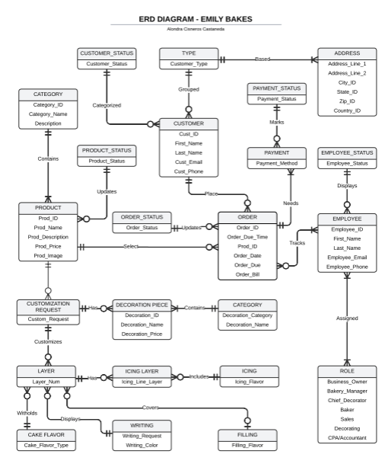
Better quality diagram here
https://drive.google.com/file/d/17pcgBM6TCvfHPC44piMRUvLAwmaC-1gF/view?usp=sharing

data Dictionary
Product
Products
Attribute Name | Data Type | Length | Required or Optional | Domain | Null? | Format | PK/FK | Description
Prod_ID | Integer | 5 | R |  | No | xxxx | PK | Unique ID for Product in Bakery
Prod_Name | Char | 40 | R |  | No |  |  | Name of Products/Baked Goods
Prod_IMG | IMG | 20 | R |  | No |  |  | Image of Each product
Prod_Price | Integer | 6 | R | 00.00-9999.99 | No | $xx.xx |  | Corresponding Pricing
Prod_Description | Char | 1000 | O |  | Yes |  |  | Simple descriptions of product

Cake Customization
Attribute Name | Data Type | Length | R/O | Domain | Null | Format | Pk/FK | Description
Customiz_ID | Integer | 5 | R | 1-99999 | No | xxxxx | PK | ID for customization
Order_ID | Integer | 5 | R | 1-99999 | No | xxxxx | FK | Order customization correlates with
Cake_Size | Varchar | 20 | R |  | No |  |  | Cake size, can be decided in gui drop down selection box
Cake_Flavor_Type | Varchar | 50 | R |  | No |  |  | Cake flavor chosen
Layer_Num | Varchar | 3 | R |  | No |  |  | Number of layers included
Filling_Flavor | Varchar | 20 | R |  | No |  |  | Flavor of filling
Icing_Flavor | Varchar | 30 | R |  | No |  |  | Flavor of icing
Icing_Color | Varchar | 30 | R |  | No |  |  | Color of icing
Writing_Request | Varchar | 255 | O |  | Yes |  |  | Any extra written detail cutomers need to add
Writing_Color | Varchar | 50 | R |  | No |  |  | Color writing needs to be in

Customer
Customer
Atritibutes | Data Type | Required/Optional | Length | Format | Domain | Default | PK/FK | Null? | Description
Cust_ID | Integer | R | 5 | xxxxx | 1-99999 | Auto_Increments | PK | No | Customer Identification
Cust_Status | Char | R | 8 | Inactive/Active |  |  |  | No | Customer Status with bakery - Determined by Owner or Bakery Manager
Cust _Type | Char | R | 10 |  |  |  |  | No | Type of Customer (Retail or Corporate)
Company_Name | Varchar | O | 20 |  |  |  |  |  | May replace customer name
Cust_First_Name | Varchar | R | 20 |  |  |  |  | No | Customer's First Name
Cust_Last_Name | Varchar | R | 20 |  |  |  |  | No | Customer's Last Name
Cust_Addr_Line1 | Varchar | R | 60 |  |  |  |  | No | Customer's Address Line 1
Cust_Addr_Line2 | Varchar | O | 60 |  |  |  |  | Yes | Customer's Address Line 2
State | Char | R | 2 |  |  |  |  | No | State Abbreviation
Country_ID | Integer | R | 3 |  | 1-999 | Code for USA |  | No | Country Code
Cust_ZipCode | Char | R | 10 |  |  |  |  | No | Customer Zip Code
Cust_Mobile | Char | R | 20 | (999)999-9999 |  |  |  | No | Customer Mobile/Cell Number
Cust_Email | Varchar | R | 40 |  |  |  |  | No | Customer Email Address
Cust _Sinc | Date | R | 20 | mm/dd/yyyy |  |  |  | No | How Long Have they been a customer
Comments | Varchar | O | 1000 |  |  |  |  | Yes | Additional Comments about Customer

Employee
Employee/Admin
Attribute Name | Required or Optional? | Data Type | Length | PK/FK | Null? | Description
Employee_Email | R | Varchar | 20 |  | No | Employee Email to Login
Employee_Password | R | Varchar | 20 |  | No | Password for Employee to login
Employee_Name | R | Char | 30 |  | No | Employee Full Name
Employee_ID | R | Integer | 6 | PK | No | Employee ID

Order
Orders
Attribute Name | Required Or Optional? | Data Type | Length | PK/FK | Null? | Domain(Range) | Format | Description
Order_ID | R | Integer | 5 | PK | No | 1-99999 | xxxxx | Order Number/Identification
Product_Name | R | Char | 30 | FK | No |  |  | Name of Product/Baked Good
Cust_Email | R | Varchar | 40 | FK | No |  |  | Customer Given Email
Cust_Type | R | Char | 20 | FK | No |  |  | Customer Type
Order_Due_Time | R | Date | 20 |  | No |  |  | When order is due for pick up
Order_Bill | R | Integer | 20 |  | No |  |  | Order billing
Order_Date | R | Date | 20 |  | No |  | mm/dd/yyyy | Date order made

Data flow diagram

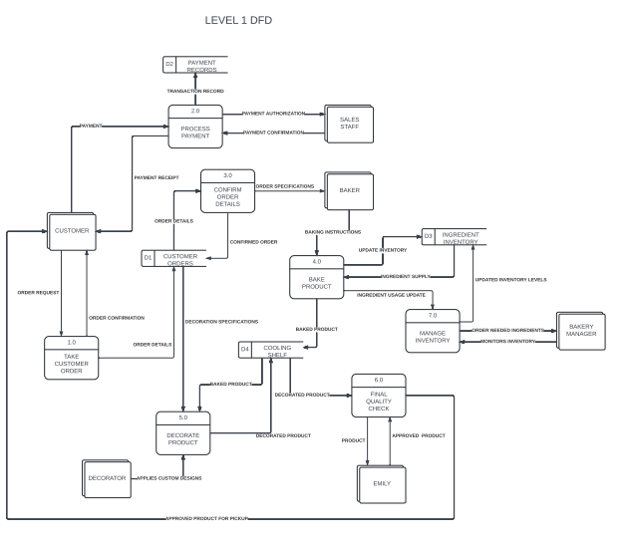

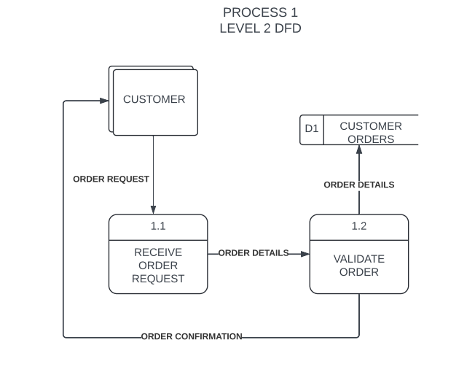

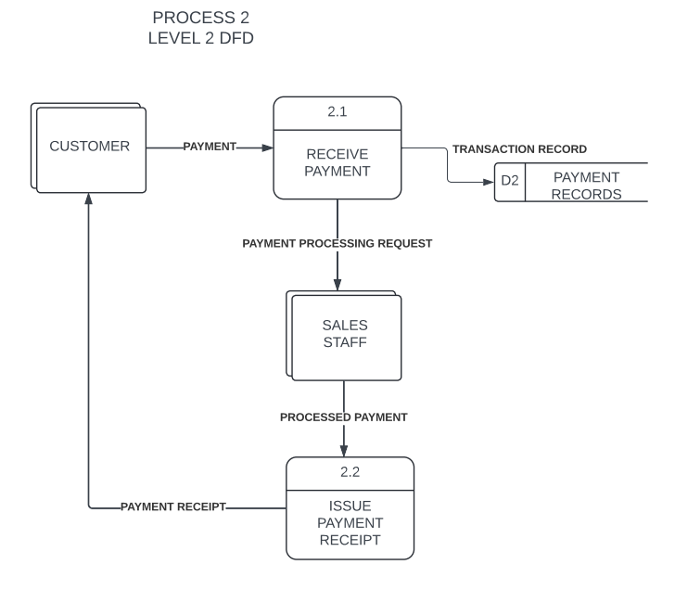

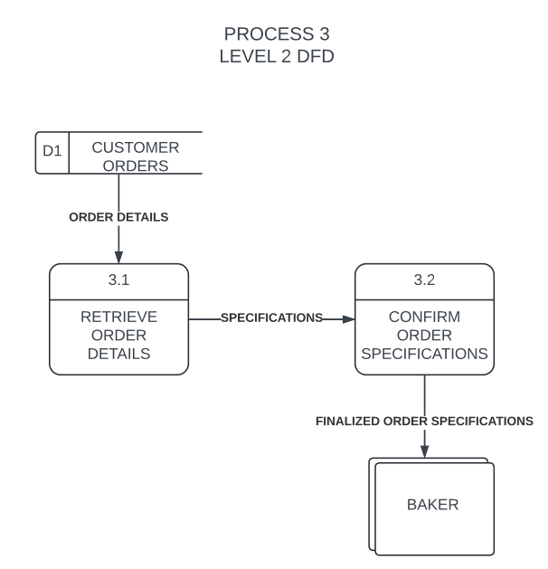
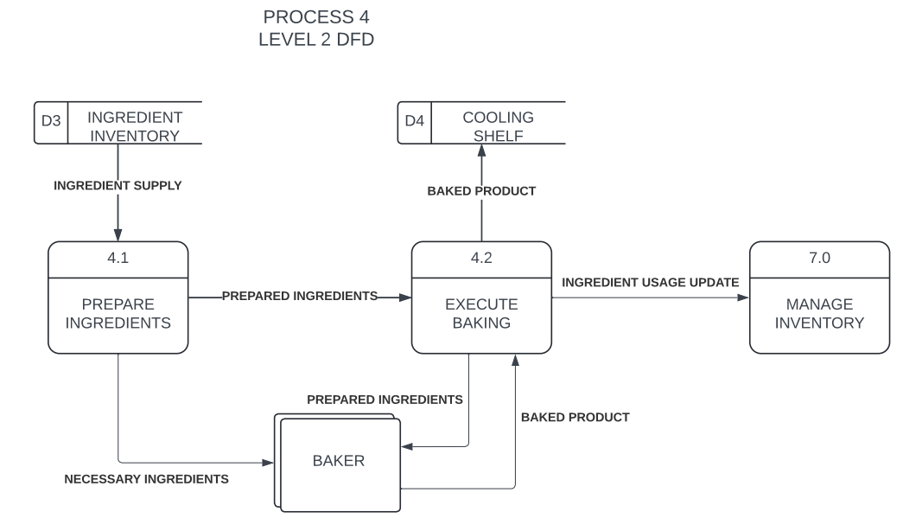

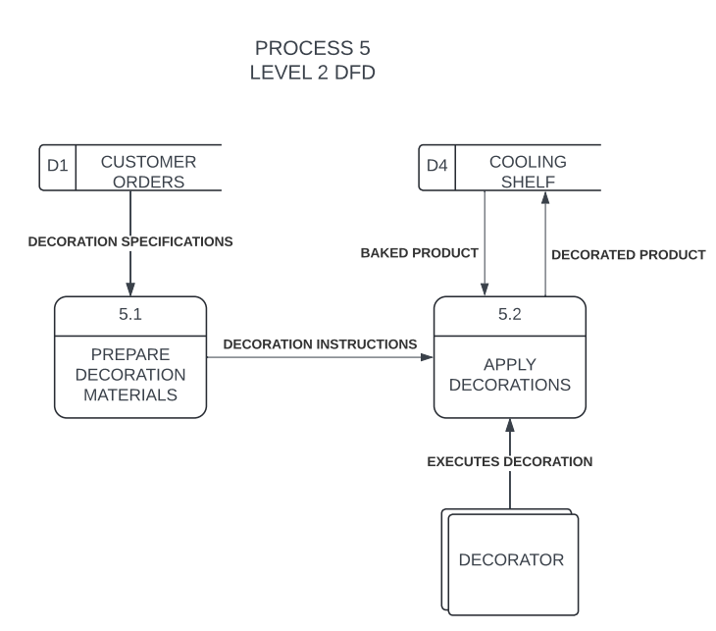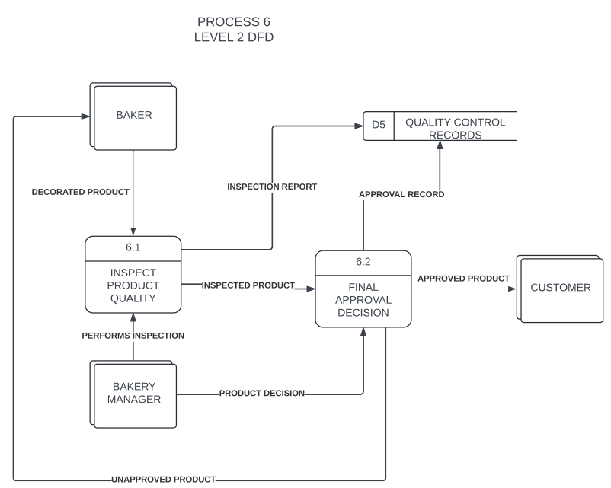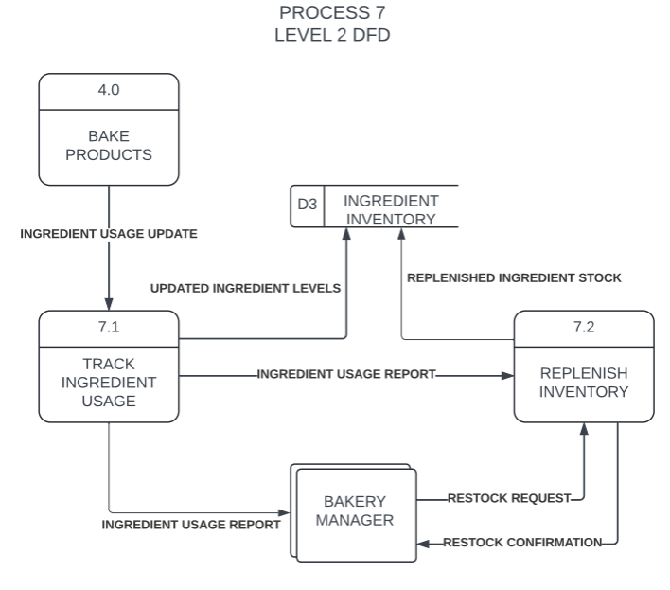

Required system crud matrix

Process/Entity | Customer | Type | Address | Order | Product | Category | Customization | Layer | Icing | Filling | Cake Flavor | Writing | Employee | Employee_Order | Payment
Take customer Order | C,R | R | C,R,U | C | R | R | C | R | R | R | R | C |  | C,R
Process Payment |  |  |  |  |  |  |  |  |  |  |  |  |  |  | C
Confirm order details | R | R | R | R | R | R | R | R | R | R | R | R | R
Bake product |  |  |  | U | R |  | R
Decorate Product |  |  |  | U | U |  |  | U | U | U | U | U
Final Quality check |  |  |  | U | R
Manage inventory |  |  |  | D | C,U,D | R
Validate Order | R | R | R | R,U | R | R | R | R | R | R | R | R | R | R
Track ingredient usage |  |  |  |  |  |  |  | U | U | U | U
Receive payment | R |  |  | R |  |  |  |  |  |  |  |  |  |  | C
Issue Payment receipt | R |  |  | R |  |  |  |  |  |  |  |  |  |  | C
Retrieve order details | R | R | R | R | R | R | R | R | R | R | R | R |  | R
Confirm order specifications | R | R | R | R | R | R | R | R | R | R | R | R |  | R
Prepare ingredients |  |  |  |  | R | R | R | R | R | R | R
Execute baking |  |  |  | R | R
Prepare decoration materials |  |  |  |  | R | R |  | R | R | R | R
Apply Decorations |  |  |  |  | U |  | U | U | U | U | U | U
Inspect product quality |  |  |  |  | R |  |  |  |  |  |  |  | R
Final Approval Decision |  |  |  | U | R
Update customer | U
Delete customer | D
Delete order |  |  |  | D

Prototype

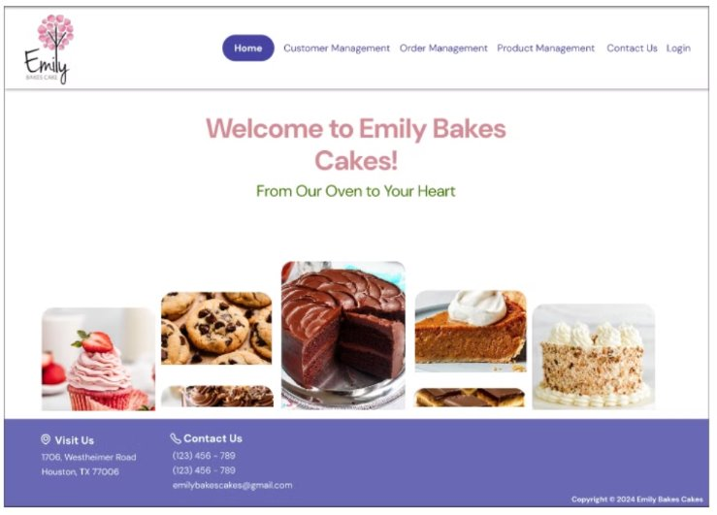
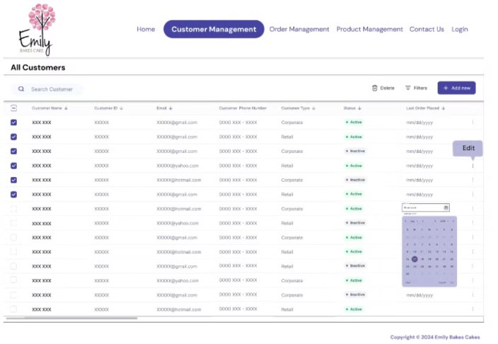
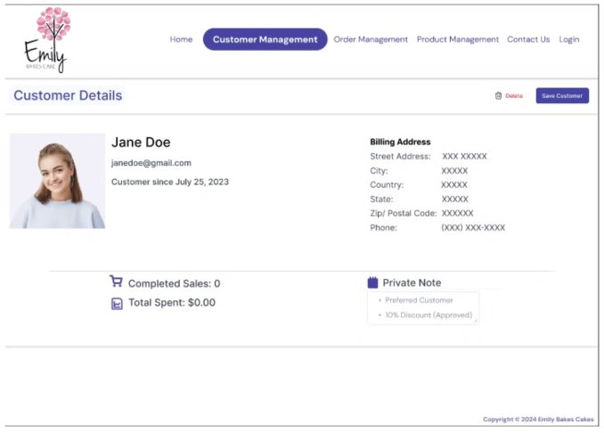
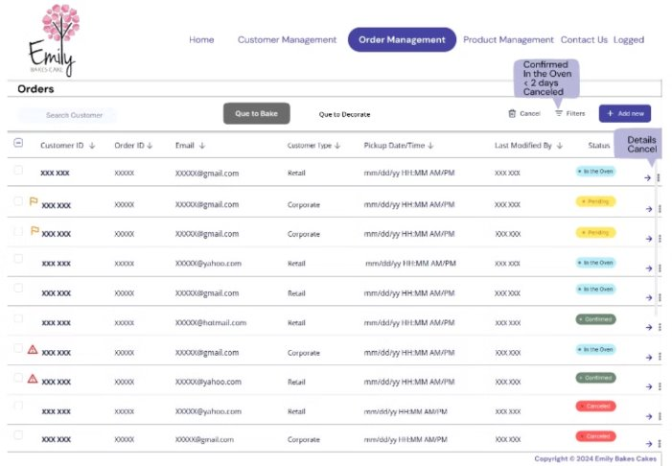
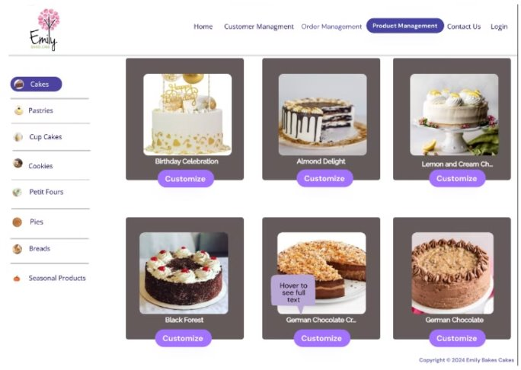
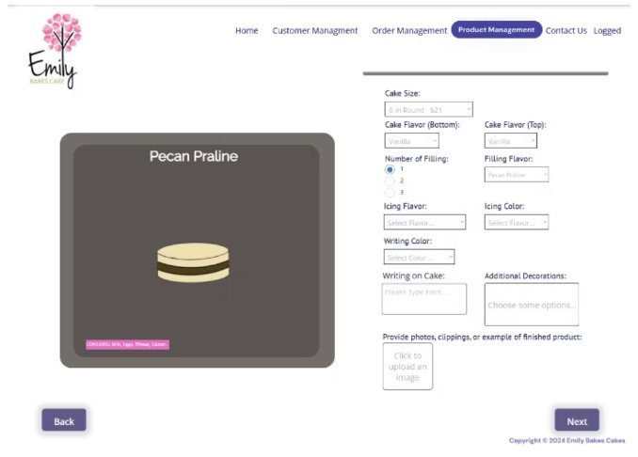
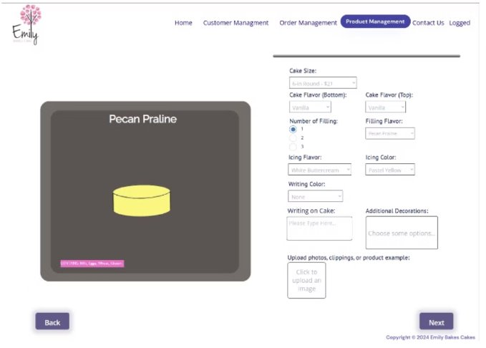
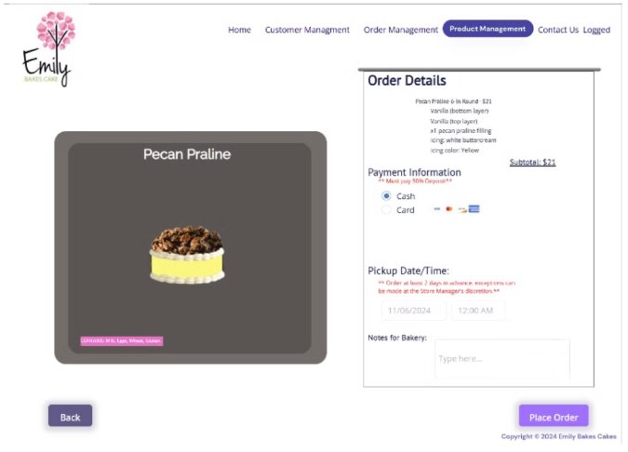
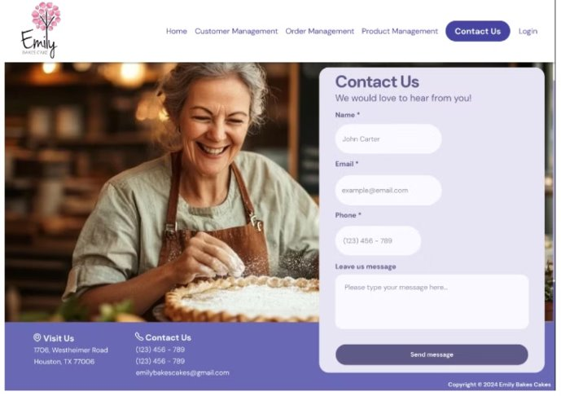
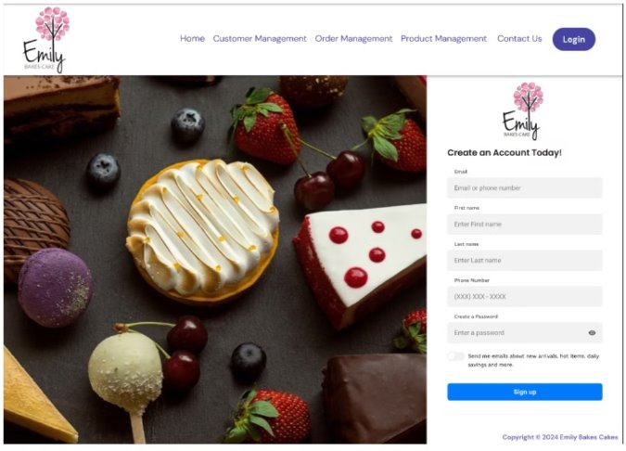
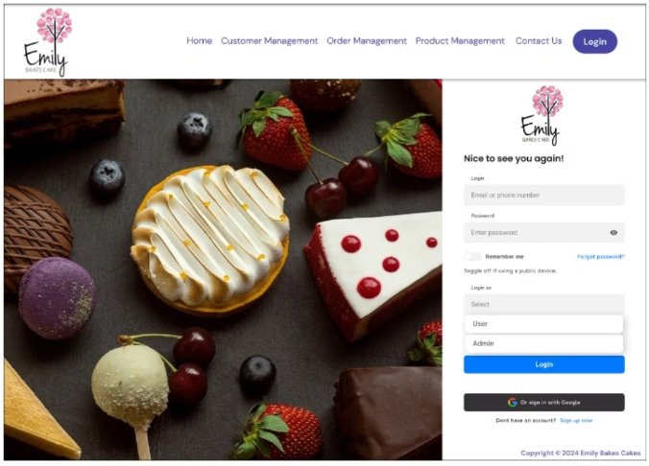

REPORTS
Business Report
Subject: Reduction in Hours Spent Tracking Orders
Prepared by: Meerub Sultan
Date: May 30, 2025

Introduction
Previously, Emily Bakes Cakes had a paper records system making custom cake ordering a tedious task for employees taking up around 50% of their time. Once all cake requirements had been written down onto a piece of paper it had been placed in a pink basket which every employee must refer to create the order. To streamline this process, we have created a graphical user interface to handle custom cake orders.

Requirements Met
The GUI includes real-time order tracking allowing employees to see the most status of each custom cake order. Instead of having to pass the slip around from the staff who took the order to the bakers to the decorators then back to sales, employees now have a centralized location where they can see what they need to do to prepare each order. Another feature that helps employees keep track of the orders that have been placed are the alerts placed in the GUI letting employees know that a cake should be prepared for pick up 4 hours prior. Considering these key changes made to the business we have now seen that time tracking order has been reduced to only XX% of an employee's time.

Conclusion
The implementation of our GUI has led to a significant reduction in the number of hours spent manually tracking cake orders. Now employees have a substantial amount of time to focus on other activities critical to the business. In conclusion the GUI has proved to be an effective tool which optimizes your operational workflows and will continue to do so.

Business Report
Subject: Reduction in Lost and Duplicate Orders
Prepared by: Meerub Sultan
Date: May 30, 2025

Introduction
In response to the challenges your business has faced with lost and duplicate orders, the system we have offered has significantly reduced this from taking place. In the past you reported that on average you were losing 3-5 orders per month by either misplacing or throwing the orders out. Now that you have experienced how our system works, we have been able to evaluate how effective the system is in this regard.

Requirements Met
The new system was developed with specific objectives to resolve the issue on hand. This has been done by assigning orders with unique order identification numbers to ensure that duplicates are not being made, we have also included a reminder for the user to double check. Now that cake order data is securely stored in a centralized database, we can back it up using a cloud-based service to ensure orders are not lost or misplaced. After evaluating the past month's data, we can report that not one order has been lost or duplicated. We were able to reduce lost and duplicate orders by 100% in May, saving $400 this month. The system's ability to eliminate these errors has led to improved customer satisfaction, increasing customer retention, and improving the business’s reputation. This has demonstrated the system's ability to be a reliable and effective tool for your operational needs.

Conclusion
As a result, the system has proven to be successful in addressing your business challenges. It has proven this through reducing the number of orders lost and duplicates made in the past month, saving your business operational costs. Moving forward with this data, we predict that the system will continue to save Emily Bakes Cakes from additional costs and increase revenue. This allows us to assume customer retention and satisfaction has also increased. We believe that this solution will continue to benefit your business as it grows.

BUSINESS REPORT
Subject: Evaluation of Preferred Customer Data to Enhance Loyalty Program and Increase Customer Retention.

Prepared by: Manya Gogia
Date: November 9, 2024

Purpose
The Preferred Customers Report identifies key customers who frequently purchase products and have been granted a “Preferred” status, making them eligible for exclusive discounts. This report aids in managing loyalty programs and enhancing customer retention strategies.
Requirements Met:
This report addresses the following requirements:
- Customer Management:
  - Tracks and stores detailed customer information, including customer type (Retail or Corporate) and purchase history, aiding in targeted marketing.
- Order Creation and Tracking:
  - Monitors repeat purchases and spending patterns, allowing the bakery to offer personalized services and promotions.
- Product Management:
  - Provides data on product preferences, helping the bakery adjust offerings based on high-value customers’ preferences.

Report Fields
- Customer ID: A unique identifier for each preferred customer.
- Customer Name: The full name of the customer.
- Customer Type: Retail or Corporate.
- Total Orders: The total number of orders placed by the customer.
- Total Spend: The cumulative amount spent by the customer.
- Discount Applied: The percentage of discount offered (typically 10%).
- Last Order Date: The date of the most recent order placed.
- Employee Responsible: The employee who last handled the customer's order. Sample Report

Usage
- Loyalty Programs: Helps identify top customers for rewards and special promotions.
- Customer Retention: Provides insights into customer loyalty and spending habits.
- Sales Strategy: Enables personalized marketing and upselling opportunities based on customer preferences.

BUSINESS REPORT
Subject: Analysis of Customer Order History for Improved Order Tracking and Operational Efficiency.

Prepared by: Manya Gogia
Date: November 9, 2024

Purpose
The Customer Order History Report provides detailed information about each order placed by customers, helping the bakery track order statuses, manage customer interactions, and analyze purchasing patterns. This report is essential for enhancing customer service and ensuring operational efficiency.
Requirements Met:
This report addresses the following requirements:
- Customer Management:
  - Allows input and retrieval of customer information, enabling the bakery to access historical data for customer service and marketing purposes.
- Order Creation and Tracking:
  - Provides a detailed record of each custom order, including status updates and customization details, helping reduce order errors and improve management.
- Product Management:
  - Tracks customization details and pricing, enabling better management of product offerings and customer preferences.

Report Fields
- Customer ID: A unique identifier for each customer.
- Customer Name: The full name of the customer.
- Order ID: A unique identifier for each order.
- Order Date: The date when the order was placed.
- Product Type: The type of product ordered (e.g., cake, cupcakes, cookies).
- Customization Details: Descriptions of customizations (e.g., icing, cake flavor, decorations).
- Order Status: The current status of the order (Pending, Baking, Decorating, Ready for Pickup, Completed).
- Order Total: The total cost of the order.
- Payment Status: Status of payment (Deposit Paid, Fully Paid, Outstanding).
- Employee Name: The employee who managed the order. Sample Report

Usage
- Operational Efficiency: Helps track order statuses and identify bottlenecks.
- Customer Service: Facilitates quick retrieval of past orders for customer inquiries.
- Marketing Analysis: Provides insights into customer preferences and order frequency.

Business Report
Subject: Front Page
Prepared by: Linda Lorie Lopez
Date: 11/10/2024

Introduction
The report assesses the effectiveness and user engagement of the homepage, where customers are first greeted. It evaluates how visitors interact with the navigation menu, product image examples, and the footer containing direct company information. Additionally, providing a welcome message and slogan. The goal is to understand how these features contribute to the overall user experience and business objectives

Fields
1.Navigation Menu
- Home – Front Page where uses are welcomed and introduced to the website
- Customer Management – Customer Account and confidential data
- Order Management – A unique orders tracking system, updating progress of orders from pending to completion.
- Product Mangement – Products available displayed with option to customize by selecting preferred product.
- Contact Us – Direct contact in providing feedback or ask questions, fostering communication.
- Login – Allow customers to sign up or sign in to their existing account for personalized services. 2. Product Showcase and Message
- Highlights bakery products to give insight into the type of products offered.
- Welcome message with the bakery name and a slogan to capture the essence of bakery.
3. Footer
• Contains business contact details of address, phone number, and email address.

Conclusion
The homepage features, including the navigation menu, product showcase, welcome message, and footer, are well-organized and designed to enhance user engagement. The navigation menu allows users to easily access key sections of the site, while the footer ensures they can quickly contact the business. The product showcase gives a preview of what the bakery offers, and the welcoming message creates a personal connection with visitors. Overall, the front page is effective in creating a positive first impression and promoting the business's offerings.

Business Report
Subject: Order Detail
Prepared by: Linda Lorie Lopez
Date: 11/10/2024

Introduction
The order details page prototype provides the final step when customizing a product, specifically a cake in this cake. It lists valuable information the customer must be aware of before the product is placed. The page includes necessary details about the customization, payment process, and pickup schedule. Additionally, each order is assigned a unique ID for tracking, and staff members sign off on the order, allowing the business to monitor performance and customer preferences. Fields

1. Order Details
- Product Chosen – The name and customization boxes to create order of selected product.
- Customization details – Cake size and name, Layer 1 (bottom) flavor, Layer 2 (top) flavor, filling type based on the number of fillings chosen, icing flavor, icing color, writing color, writing on cake, decorations, and photo’s, clippings, or product examples provided by customer.
- Subtotal price – The total before applying deposit, but with applied discount if applied to customer account.
- Payment method – choice of cash made in person or card but must have 50% deposit for order to be in process. Choice of card will allow pop up of credit card details with encryption.
- Pickup Date/Time - The scheduled date and time for order pickup with warning to customer to place order 2 days in advance. Calendar will pop up and have restrictions placed to valid dates and times. • Additional notes – any additional information provided by the customer for the baker to be aware of.

Conclusion
This report provides a detailed summary of the bakery's order process, helping staff track product selections, customization details, payment status, and pickup information. By organizing the order data in a clear and structured manner, the report ensures that orders are processed efficiently and accurately. It also helps to keep customers informed about necessary payments and pickup timing. Including order details, payment information, and pickup schedules helps streamline the bakery's internal workflow, ensuring smooth and efficient order management. Furthermore, this organized data offers key insights for decision-making and business analysis, enabling the bakery to operate effectively while fulfilling customer expectations.

BUSINESS REPORT
Subject: Cake Orders That Need To Be Made
Prepared by: Alondra Cisneros Castaneda
Date: November 11, 2024

INTRODUCTION
With the proposed database system prototype, the ease of determining what orders need to be made has become substantially easier with the following features being implemented.

REQUIREMENTS MET
The proposed database system includes features such as when an order is due. The order due feature includes the date and time of pickup. This allows for employees to be able to determine which cakes need to be made based on the orders due information. The inclusion of the time of the pickup ensures customized cake orders will be completed at least 4 hours before the customer has to pick their order up. Keeping track of the cake orders that need to be made has also been difficult due to not knowing the status of an order and if it has already been worked on. This can be time consuming and ineffective as it may lead to miscommunication and an incomplete order that is waiting to be picked up by a customer at the service area. By including the feature of the order status, it provides vital information about an order and the additional steps that must be taken based on the status. Cake orders that have the “confirmed” status marked by Emily or the Bakery Manager are the cake orders that need to be made. Database prototype allows a filtering feature that can filter cake orders based on the status of it.

CONCLUSION
With the proposed database system, employees are able to determine what cake orders need to be made by using features that allow an employee to know when an order is due and the feature of showing the status of a customized cake order. Additionally, hours spent tracking customers orders have been reduced by 25% thus meeting one of the client’s vital requirements.

BUSINESS REPORT
Subject: New Customers
Prepared by: Alondra Cisneros Castaneda
Date: November 11, 2024

INTRODUCTION
The proposed database system contributes towards the tracking of new customers by using a customer management system that includes existing and new customers. The input of customer information such as their name, email, phone number, address(s), and their type has become substantially easier and useful for Emily Bakes Cakes with their business decisions.

REQUIREMENTS MET
The prototype allows for new customers to create an account when they are placing their first order with us and the information being collected from the sign up will be inputted into a
customer management system that holds their information. The customer management system allows Emily Bakes Cakes to have a masterlist of all customers and the date that they became a customer. The features that allow new customer information to be collected also allows Emily Bakes Cakes to analyze the overall data when they are viewing customer retention, average cake orders for new customers, and if a new customer comes back to place another order.

CONCLUSION
With the proposed database system, employees are able to register and view the information of new customers. The information being collected from new customers can be used by Emily Bakes Cakes such as customer analysis to make valid business decisions. This contributes to the overall requirement of increasing customer retention as new customer data has to be tracked as well.

Business Report
Subject: Seasonal products not advertised
Prepared By: Belma Vazquez
Date: November 11, 2024
INTRODUCTION
Currently Emily Bakes Cakes has seasonal products that need to be sold. By showing them in the website they should increase their profit and not loss any revenue from it, but it seems that this important aspect is missing in their business. This is why we

REQUIREMENTS MET
Website needs to add another tab promoting the seasonal products so they can be able to keep track of that inventory and see what is working and what is not, as well as to keep the clients updated of any new seasonal product. In order to do so, they should be highlighted in the website whenever you select products. Making seasonal products easily accessible improves the overall user experience. Customers can quickly find and explore new items, enhancing their shopping experience and increasing the likelihood of purchases. A dedicated seasonal products tab provides a platform for targeted marketing campaigns. Special promotions, discounts, and featured products can be showcased, attracting more customers and boosting sales.

CONCLUSION
The website can be used as a strategic marketing tool, by adding a feature that depicts this, we would be able to do so and generate more revenue in the long run. This approach not only improves operational efficiency but also drives customer interest and sales, ultimately contributing to the business's growth and success. Implementing this feature will ensure that seasonal products are always highlighted

Business Report
Subject: Avoid overstocking or understocking of products
Prepared By: Belma Vazquez
Date: November 11, 2024
INTRODUCTION
Currently Emily Bakes Cakes has a problem with inventory control since their system for tracking ingredients as well as product supplies and seasonal products is manual and does not fully integrate with other parts of the system.

REQUIREMENTS MET
Hardware was upgraded to newer more powerful system with faster processors, larger memory and upgrades storage, significantly improving the speed of the order processing, data entry as well as access to costumer information. The new system will allow for smoother multitasking as well as faster access to the required business data which also leads to improvement for the staff. Newer hardware also comes with enhanced security features, allowing for stronger encryption and automatic software updates which help with protecting the costumer data.

CONCLUSION
This report discusses how improving the hardware is a helpful tool for the business as well as how this investment will have a significant impact on the business. Having outdated hardware creates significant barriers to efficient operations but also to data security and customer service.
By investing in a system like this, we upgraded the immediate operational challenges, and we positioned the business for long-term success in an increasingly competitive market.

BUSINESS REPORT
Subject: Cake Pickup Orders for 11/11/24 - 11/18/24

Prepared by: Kyla Kemp
Date: 11/10/24
——————————————————————————————————————————

Purpose
The report provides a detailed overview of all cake orders scheduled for pickup between 11/11/24 and 11/18/24. The report will assist the bakery staff in organizing order pickups and preparing cakes accordingly, ensuring timely service and customer satisfaction.

Fields
The following fields are included in the Cake Pickup Orders for 11/11/24 - 11/18/24 report:
- Order ID: The unique identifier for each order.
- Customer Name: The full name of the customer who placed the order.
- Customer Type: Retail or Business.
- Cake Type: The type of cake the customer ordered.
- Order Amount: The total cost of the order, including taxes or discounts.
- Order Date: The date the order was placed.
- Pickup Date: The scheduled date for order pickup.
- Order Status: Indicates whether the order is “Pending”, “Ready for Pickup”, or “Completed.”

Conclusion
The Cake Pickup Orders for 11/11/24 - 11/18/24 report aids the bakery in streamlining order processing, ensuring cakes are ready for timely pickups, and helping with capacity planning. By examining the details of each order, including the cake type ordered and order status, Emily Bakes Cakes can ensure that all orders are prepared promptly for the customer’s scheduled pickup. The cake type ordered helps the bakery plan the necessary ingredients and baking times for each order. The order status indicates any issues with specific orders that need to be resolved before the pickup date. Popular cakes can be prioritized based on this report, aiding in customer management and marketing.

BUSINESS REPORT
Subject: Returning Customers

Prepared by: Kyla Kemp
Date: 11/10/24
——————————————————————————————————————————

Purpose
This report analyzes the key details for returning customers, including their ordering patterns and customer type, to assist in identifying trends and supporting customer engagement initiatives.

Fields
The following fields are included in the Returning Customers report:
- Customer ID: The unique identifier for each customer
- Customer Name: The full name of the customer who placed the order.
- Customer Type: Retail or Business.
- Total Orders: Total count of all previous orders placed by the customer. ● Last Order Date: The date of the customer’s most recent order.

Conclusion
The Returning Customers report helps gain a better understanding of returning customer behavior and preferences. It serves as a vital tool for tailoring marketing strategies, enhancing customer loyalty, and driving revenue.
- Marketing Strategy: The report provides insight into frequently ordered products and ordering habits, which can aid in creating/adjusting future promotions and marketing efforts. Separate marketing strategies can be created based on customer type.
- Customer Retention: By identifying loyal customers (customers who order frequently), Emily Bakes Cakes can target returning customers using methods that increase repeated business and customer loyalty.
- Revenue Growth: By identifying trends in order and customer behavior, Emily Bakes Cakes can explore opportunities for future growth, leading to increased revenue.

Business Report
Customer Contact
DesignIT
Prepared by Tawhida Farrag
November 9, 2024

Introduction
This business report examines the prototype’s functionality of viewing customer contact information including customer email address and phone number. The goal is to meet the client’s requirements by creating a database system that efficiently manages customer data and decreases time spent searching for customer information.
Overview
Emily Bakes Database protype has been constructed to easily view and edit customer contact information. Included in the customer management tab a list of customers is provided and a third column in customer email is provided. When the customer row is clicked, details are given including email, phone number, and billing address. Any piece of the information can be edited at a later dated if needed.
Conclusion
The database prototype satisfies clients’ requirements to view customer contact information and will support the client’s business with an effective database system. With continued client/user feedback, any needed adjustments can be made to enhance usability.

Business Report
Analysis of Reduced Time Creating Order
DesignIT
Prepared by Tawhida Farrag
May 30, 2025

Introduction
This business report provides an analysis of the Emily Bakes Database prototype’s purpose in reducing the time spent creating orders by sales associates. This is intended to meet clients’ requirements of decreasing order time retention to increase profitability and retain customer loyalty.
Overview
With the client’s legacy system being a paper-based system and custom cake orders that are continuously moving throughout the bakery, the protype gives an efficient and straightforward process to create orders that aren’t susceptible to loss.
Key Factor
Product Management: The database has been set up to make it simpler for employees to input cake order information with drop-down selection boxes with the product options that the bakery offers.
Conclusion
The protype meets clients’ requirements to decrease order time retention. For further confirmation, when the system is implemented, the client can confirm by viewing reduced operational cost in year 3.

Business Report
Subject: Cake Customization
Prepared By: Huda Memon
Date: November 11, 2024

INTRODUCTION
The product management section of the prototype allows a straightforward method for cake customization by the customer. It offers a variety of options, dropdown menus, and simple instructions. Customers are also able to provide photos, clippings, text, and examples in the inquiry form. The navigation buttons grant easy maneuvering between the different sections of the form.
REQUIREMENTS MET
The proposed customer inquiry form allows user to input information regarding their custom cake. Standard cakes are displayed on the product management page and each cake has a customization option. The inquiry form lists options for cake size and provides pricing information for standard cakes. The layers are labeled as ‘Top’ and ‘Bottom’ preventing any misunderstanding of layer flavors. Different flavors can be chosen for each layer. The number of fillings can also be chosen with the minimum being one filling and the maximum being three fillings. The filling flavor can be selected through a dropdown menu next to the number of fillings. The icing flavor, icing color, and writing color are selected through similar dropdown menus. A textbox is provided for customers that choose to write on their cakes. An additional decorations menu is also available. As the customer creates their custom cake, an image of their desired product is developed on the left side of the page to display the possible product. Customers can upload images of photos, clippings, or examples of their desired finished product. There are ‘Back’ and ‘Next’ navigation buttons to move through the pages and inquiry form. The final page displays all of the order details, the subtotal, payment information, pickup date/time, and notes for the bakery. Notes regarding a minimum 50% deposit and placing custom orders at least two days in advance are displayed.

CONCLUSION
This report describes the benefits of the cake customization process available in the prototype. Several sponsor requirements regarding order creation and product management are met in the proposed system. The customization options are easily understandable and provide the bakery with all of the necessary information about the order. This system reduces order time creations and lost/duplicate orders.

Business Report

Subject: Customer Account Creation
Prepared By: Huda Memon
Date: November 11, 2024

INTRODUCTION
The login page of the prototype allows customers to create their own account and login. The simple sign-up process requires multiple inputs from the customer including phone number and email. By creating an account, customers can easily save their orders and provide necessary customer information to the bakery.

REQUIREMENTS MET
This system simplifies the customer management system by asking the customers to submit required details such as name, email, and phone number. They also create a password and select if they would like to receive emails from the bakery. This process reduces employee order creation time as they do not have to record customer information themselves. Customer email/phone lists can be easily created by the system because account information will be saved. By having an account, customers can track the status of their order. It also allows each unique person to be a customer and reduces duplicate orders. In the order creation process, the customer will be limited to one cake/product per order. Customers can be easily inputted into the customer management system which simplifies the process of determining preferred, returning, and new customers.

CONCLUSION
This report described the benefits of the customer account creation feature. Sponsor requirements such as customer input of required fields (phone number, email, etc.) are met. Accounts can save order information for both the bakery and the customer. This reduces order creation time and lowers lost/duplicate orders. It will also increase customer retention as they will be able to easily track, customize, and manage their orders.

DATA ACQUISITION AND DATA CONVERSION PLAN

Data Acquisition and Conversion Plan
Introduction
This acquisition and conversion plan outlines the recommended strategies used in the conversion of Emily Bakes custom cake data into a new database system.
Objective
- To acquire written data – specifically custom cake order - from the full year of 2024.
- Store data into the newly developed system.
- Create a framework for the acquisition process within the bakery.
Constraints
- Lack of time and resources to move data
- The legacy system is written-based, making it difficult for in-house data conversion
- Ensuring data security with an in-house conversion
- Budget for outsourcing
Data Assessment
Preparation
Accountant/CPA, Owner, and/or Manager must collect an inventory of past custom cake order forms and/or receipts from the year 2024. The owner and/or manager must evaluate the volume of the documents. Consider the conditions of the documents and organize them in chronological order. The team recommends the full year of 2024 cake order data be brought forward to be inputted in the new database application.
Acquisition Process
Digitization
Remove any damaged documents, staples, and paper bounding to prep papers for scanning to be digitized. Invest in implementing OCR software such as Adobe Acrobat to convert scanned documents into text files. Manager and/or Accountant can validate information for accuracy. For documents that cannot be scanned/digitized consider a manual data entry for documentation.
Data Conversion
Develop a data mapping document that will map how selected attributes from documents will convert into the new database. Focus should include Sale data and customer data pertaining to custom cake orders. Data transformation and cleanup are the next steps taken to make the data in the database usable. Recommended transforming a week’s worth of data first to ensure conversion took place before completing full amount. Remove any duplicate if spotted. Finalization should include making any adjustments needed and cleaning up any temporary files used.
Conclusion
This Data Acquisition and Conversion Plan provided an outlined method to convert its custom cake order data into DesignIT’s new database. This will help safeguard a smooth conversion process with minimal data loss. Conversion can be completed before, during, or after database is completed and would be included with subscription.

application architecture diagram
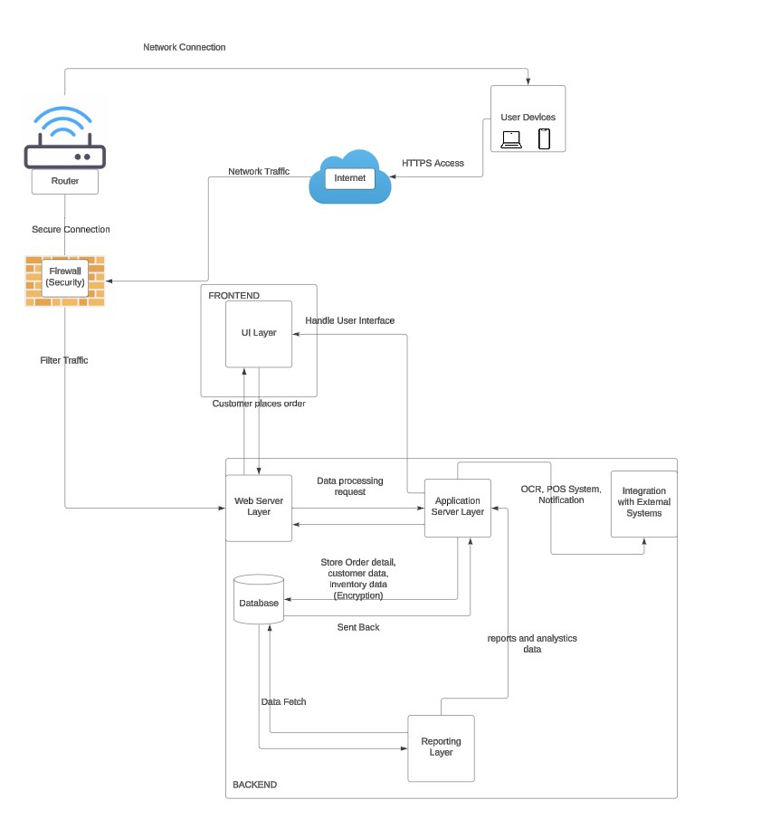

data and application testing plan
Data and Application Testing Plan

Introduction
This test plan is DesignIT’s recommendation on validating and testing Emily Bakes Database Application. The test plan will cover database features to be tested, the type of testing that will be executed, and the scheduling required to complete testing.
Scope
In Scope
Features that will be tested defined by business requirements determined by Emily Bakes.
- Input Customer Information – System be able to pull up customer information
- Order Creation – Orders should be customizable selecting a product and a customer.
- Order Tracking – Bakery is reminded of orders need to be made and updated status of orders. Track Employee last worked on order.
- Product Management – Capture Pricing Information, should allow manager to make prices updated.
Roles and Responsibilities
- Test Lead
- Oversee testing process
- Develop strategy/plan
- Coordinates with sponsor, analyst, developers, and management.
- Developer
- Implement testing program
- Quality Control/Assurance Team
- Confirm testing process is following schedule and client requirements
Testing Recommendations
Database Testing
To ensure that the database is running effectively, it is recommended to run a functional database test. This is being done to ensure that the database, which is run by the end-user side, is working as expected.
Application Testing
To ensure that the application is running effectively, it is recommended to run a UI and performance test.
- A UI test will be conducted by the bakery owner to establish if the application is accessible to employees and delivers all the business requirements of the clients.
- Performance tests such as stress test and load testing check if the application can perform under high pressure cases.
Conclusion
This is an outline recommendation of DesignIT’s plan for Data and Application Testing Plan. Application testing is set to initiate April 2025 and last through May 2025.

Lessons Learned

What worked?
To have a clear goal and be project oriented, have a team that wants to give the best. Have deadlines and be effective, have feedback from each different point of view as well as look for more references and not only get stuck with what we know.
Also, it helped to have a common objective since we all wanted to succeed in this project we

What did not work?
Being all over the place, not having a system for organizing the files and not having thighter deadlines. Having different communication styles, not asking questions when needed, as well as having meetings that were too far from eachother.

What could have been done differently?
Having a better communication overall, not being shy and ask questions since this was new material for all of us. Reviewing the deliverables as soon as they are done and not the day of as well as not being able to meet more than once a week.

List of authors and references
Tawhida
Executive Summary - References

https://www.canva.com/templates/EAFLaqUweYQ-blue-modern-minimal-project-executive-summary-document/

https://www.betterup.com/blog/executive-summary-example

https://www.smartsheet.com/content/executive-summary-examples?srsltid=AfmBOoqkDzbD9lR-EoiaIoRAGd_v-nyP6fNrdM2uutQNf8Y8uC3HX2BB

https://www.workamajig.com/marketing-guide/executive-summary

Data Conversion and Acquisition Plan - References

https://www.astera.com/type/blog/data-conversion/

https://www.sdlcforms.com/PopupForm-ConversionPlan.html

https://urbanlogiq.com/how-to-write-an-effective-data-acquisition-strategy/

https://www.matillion.com/learn/blog/data-conversion

System Analysis and Design, Chapter 11.9.3

https://transcend.io/blog/data-mapping-basics

https://www.v7labs.com/blog/best-ocr-software

Business Reports - References

https://www.indeed.com/career-advice/career-development/formal-business-report-example

https://fastercapital.com/content/Prototype-report--How-to-write-a-prototype-report-and-document-your-findings-and-recommendations.html
Data& Applications Test Plan
https://www.guru99.com/test-plan-for-project.html#2
https://www.testrail.com/blog/create-a-test-plan/
https://www.guru99.com/test-planning.html
https://www.lambdatest.com/learning-hub/test-plan
https://www.guru99.com/application-testing.html
https://www.guru99.com/data-testing.html
Belma
https://www.googleadservices.com/pagead/aclk?sa=L&ai=DChcSEwjmsOiPoteJAxWUNtQBHeItKEgYABAjGgJvYQ&ae=2&co=1&gclid=Cj0KCQiAlsy5BhDeARIsABRc6ZsQnPZ3bo27jT_W98c6HE-wVdoBaIYA9rbcECffCL8vIfDS4rysFUEaAi8CEALw_wcB&ohost=www.google.com&cid=CAESVeD2mBcXD2p_jwTK7SOCV0uyVbYvWKX8tBzsn6TJEq4obEbHFi1n_uUMk42QZiJ6f-Q61YPxtlGXV8EkKeVOKJp-6jy6go3Y6z_LnBzCjGTjFZCobCU&sig=AOD64_2X9irWsX6YwcbKx_dMXrBAl6KBZA&ctype=5&q=&ved=2ahUKEwjC5-KPoteJAxXk5MkDHYVRDJgQww8oAnoECAoQFg&adurl=
https://www.googleadservices.com/pagead/aclk?sa=L&ai=DChcSEwi4tcyYoteJAxXyLdQBHRoRDn4YABAZGgJvYQ&ae=2&co=1&gclid=Cj0KCQiAlsy5BhDeARIsABRc6ZuGUA5xM9fXynTcoxGUloyI_mtitWNCGG0slnYJKOlVZJYY2d1PqYkaAj0CEALw_wcB&ohost=www.google.com&cid=CAESVeD2mmUOXq5_6HYDgryWKWeJgygd6NiDZZxQm2xdTwSrDoulhVdAZrWfzXq3WZICwb3QVdVZPC8ojllh6Sk98qLAu6gXsVwxJUeyzfn0J8KfrORWwQ8&sig=AOD64_2QAvxw0kMHevsfx1xwKCFzWq6NXQ&ctype=5&q=&ved=2ahUKEwi6ycWYoteJAxUS4skDHRj3CIUQww8oAnoECAkQIA&adurl=

https://www.googleadservices.com/pagead/aclk?sa=L&ai=DChcSEwjBuun-odeJAxUqcX8AHTmTKw8YABAAGgJvYQ&ae=2&co=1&gclid=Cj0KCQiAlsy5BhDeARIsABRc6Zs_CekGMIw10_ajAjbnPSJpBoe9Ou3WBAU03JRFGnqY4t3GE8gKmLcaAvJ4EALw_wcB&ohost=www.google.com&cid=CAESVeD2a0JhgjGJfCFBDeEyp31nypQ-ZYFXKTXNZ9TqVnEH-kY7E6uBUf02lxQkMtyX5CASIhAsgTENYSz6omFx_5P79TnNC8ZiucXupfKXTZkJMUlm8G4&sig=AOD64_0cPXVp9vqpDGYa2l2PSe5jD8VCjQ&q&adurl&ved=2ahUKEwjRtuT-odeJAxWJL9AFHfR4DlQQ0Qx6BAgKEAE

Alondra
Project Organization Chart - References
https://online.visual-paradigm.com/diagrams/templates/organization-chart/project-team/

Entity Relationship Diagram – References
CIS 3343 Project Material, Crow’s Foot Notation – ERD

Reports – References
https://templatelab.com/business-report/

Manya
Prototype Photos – References
https://stockcake.com/i/joyful-baking-session_1257394_1149698

Meerub
Feasibility Analysis (Solution 1)
https://www.backblaze.com/

https://www.backblaze.com/cloud-storage/solutions/server-backup

https://wallethub.com/edu/cc/cash-vs-credit-card-spending-statistics/133985#:~:text=Credit%20cards%20are%20used%20twice,demographics%20of%20users%20are%20shifting

https://www.xfinity.com/learn/internet-service/modems-and-routers

https://www.bestbuy.com/site/dell-xps-13-13-4-fhd-laptop-intel-core-ultra-7-evo-edition-16gb-memory-intel-arc-graphics-512gb-ssd-graphite/6575146.p?skuId=6575146&extStoreId=354&utm_source=feed&ref=212&loc=18532055452&gclsrc=aw.ds&gad_source=1&gclid=CjwKCAiAxKy5BhBbEiwAYiW--wmM5ulBhzQGSGpwGJuuW4Kz9D5EhqiZBZ57adPvLQiw9BrzJQ4IVhoCEOUQAvD_BwE

https://www.bestbuy.com/site/square-terminal-white/6481619.p?skuId=6481619&extStoreId=1517&utm_source=feed&ref=212&loc=19615448081&gad_source=1&gclid=Cj0KCQjw7Py4BhCbARIsAMMx-_KcaCjB9rc45OvY3K7vcz7Owxzj51ulUUxvViIuSbmC-XrFJnc-kcUaAu1dEALw_wcB&gclsrc=aw.ds

https://squareup.com/us/en

https://shopventory.com/

https://www.dell.com/en-us/shop/dell-27-4k-uhd-monitor-s2721qs/apd/210-axlg/monitors-monitor-accessories?tfcid=91049735&dgc=opl&gacd=9684992-1102-5761040-266906002-0&dgc=ST&SA360CID=71700000117208879&gad_source=1&gclid=Cj0KCQjw7Py4BhCbARIsAMMx-_IlSIwcV1_Aw1n8mx88NQnipbwz-z5T401cBw7iLXhMq8hHo0USncsaAmKrEALw_wcB&gclsrc=aw.ds

https://www.dell.com/en-us/shop/cty/pdp/spd/xps-8960-desktop/usexthbts8960gskj?tfcid=91049735&dgc=opl&gacd=9684992-1105-5761040-266906002-0&dgc=ST&SA360CID=71700000109860337&gad_source=1&gclid=Cj0KCQjw7Py4BhCbARIsAMMx-_Jf_eAg_yteTv6SlP1qiscbEA8vgQQMfB7aeyKCqVpiIbvTrY2QpC8aAghMEALw_wcB&gclsrc=aw.ds
https://techhowtohub.com/explainers/a-guide-to-computer-hardware-components-and-their-functions/

https://www.icinginks.com/blog/2017/02/21/cake-printer-settings-tips?srsltid=AfmBOoo0hBLEOCHBjKKS7lh7jboZ8P101n1ZayKjoAK0KDgX8Bw3kER0

https://www.officedepot.com/a/products/6778545/Canon-imageCLASS-MF753Cdw-Wireless-Laser-All/?utm_source=google&utm_medium=sag?utm_source=google&utm_medium=cpc&utm_campaign=pla_cor_evg_printers_general_unid_prch_non-match&mediacampaignid=71700000119141377&utm_source=google&utm_medium=cpc&gad_source=1&gclid=Cj0KCQiA0MG5BhD1ARIsAEcZtwTDjkLw5OGGgwl5w-xg7TmBaku3iOZBdITm9emVfc8Kfpdd449LMRUaAgQXEALw_wcB&gclsrc=aw.ds
Linda
https://www.walmart.com/cp/976779?q=bakery
https://3brothersbakery.com/product/baby-shower-elephant-tier/
https://www.peerbits.com/blog/web-application-architecture.html

Kyla
DFD Diagram – references
System Analysis and Design, Chapter 5.2 - 5.7
Chapter 5 Data and Process Modeling PowerPoint, Tilley12e_PPT_Ch05
DFDs Various Levels PDF
CIS 3343 Fall 2024 Case Study - Emily Bakes.pdf
https://www.lucidchart.com/blog/data-flow-diagram-tutorial

Reports - references
https://templatelab.com/business-report/

