Case study 1

Maud Bernard-Verdier

4/18/2020

The following example replicates the first case study included in the article by Schittko, Bernard-verdier et al., published in Global Change Biology in 2020.

The Biotic Novelty Index (BNI) of 56 grassland commmunities in Berlin was evaluated based on vegetation surveys, and results were presented in **Figure 4**, replicated below.

source('BNI function.R')  
load("data/berlin.rda")  
  
bni <- BNI.calc(com = community, YSI = YSI$years_since_introduction, trait.mat = trait_matrix)

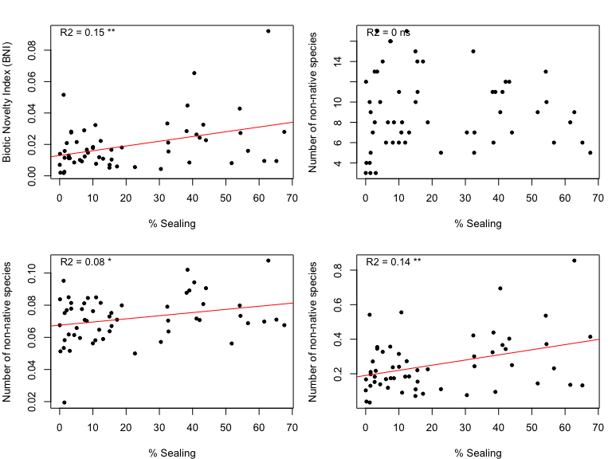

**Figure 4**: Case study 1 – relationships between the percentage of sealed surface area in a 500 m buffer zone around the 56 urban grassland plots and (a) the BNI, (b) the number of non-native species, (c) Rao’s Q as a measure of functional diversity, and (d) the standardized BNI. Asterisks indicate statistical significance using linear models (*** = P < 0.001, **= P < 0.01, * = P < 0.05, n.s. = P ≥ 0.05).