Questions:

Sem 2, 2022

Q1)

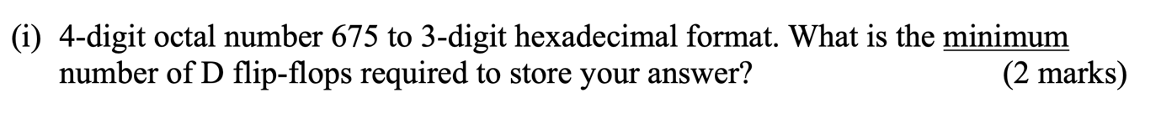
First 3 bits are 0, so 9 FF needed in total, but could I apply the same logic if it was the last bits being zero? Or does that mess up the representation of the number?

Q2)
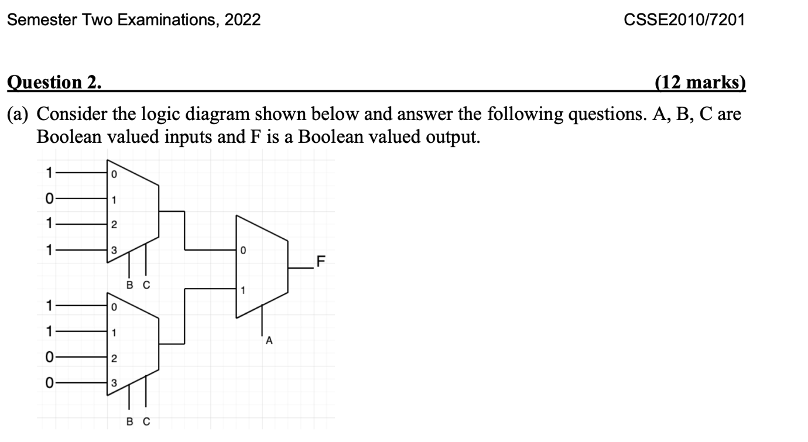

Q4)
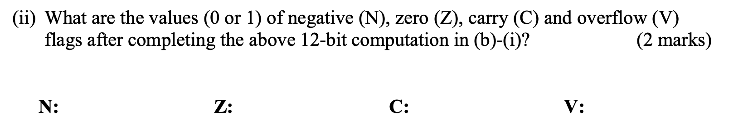
The above number was two’s complement, how do we deal with carry in twos complement?

Q5)
Let’s say my mantissa was 8 bits, that leaves 15 bits for it to be correctly stored in the IEEE single precision format, would these bits be added to the front or the back of the mantissa?
From the lecture it seemed like he would have done it in the back, but I’m thinking that we usually pad in the front to keep the value correct, but maybe the respresentation of the mantissa in IEEE SP represents the increase of the negative exponent which would then make sense to pad on the back.
Also more to this, when converting our representation to hex, do we draw the lines “separating” 4 and 4 bytes from the top or from the botton?
Example:

100111001100001
- 1001 1100 1100 0010
- 0100 1110 0110 0001

Answer:
- For integers, you usually pad to the front, because 12=012=0012≠12012=012=0012=120. For decimals, you could pad in either direction because 12.3=012.3=12.3012.3=012.3=12.30. However, since you don't store the integer part (which is always 11 after conversion to scientific notation) for floats, you have to pad to the right, since you've only got part of the actual representation (12).3=(12).30≠(12).03(12).3=(12).30=(12).03. Single and doubles are 32 and 64 bits respectively, which are both multiples of 4, so it doesn't matter where you start.

Q5)
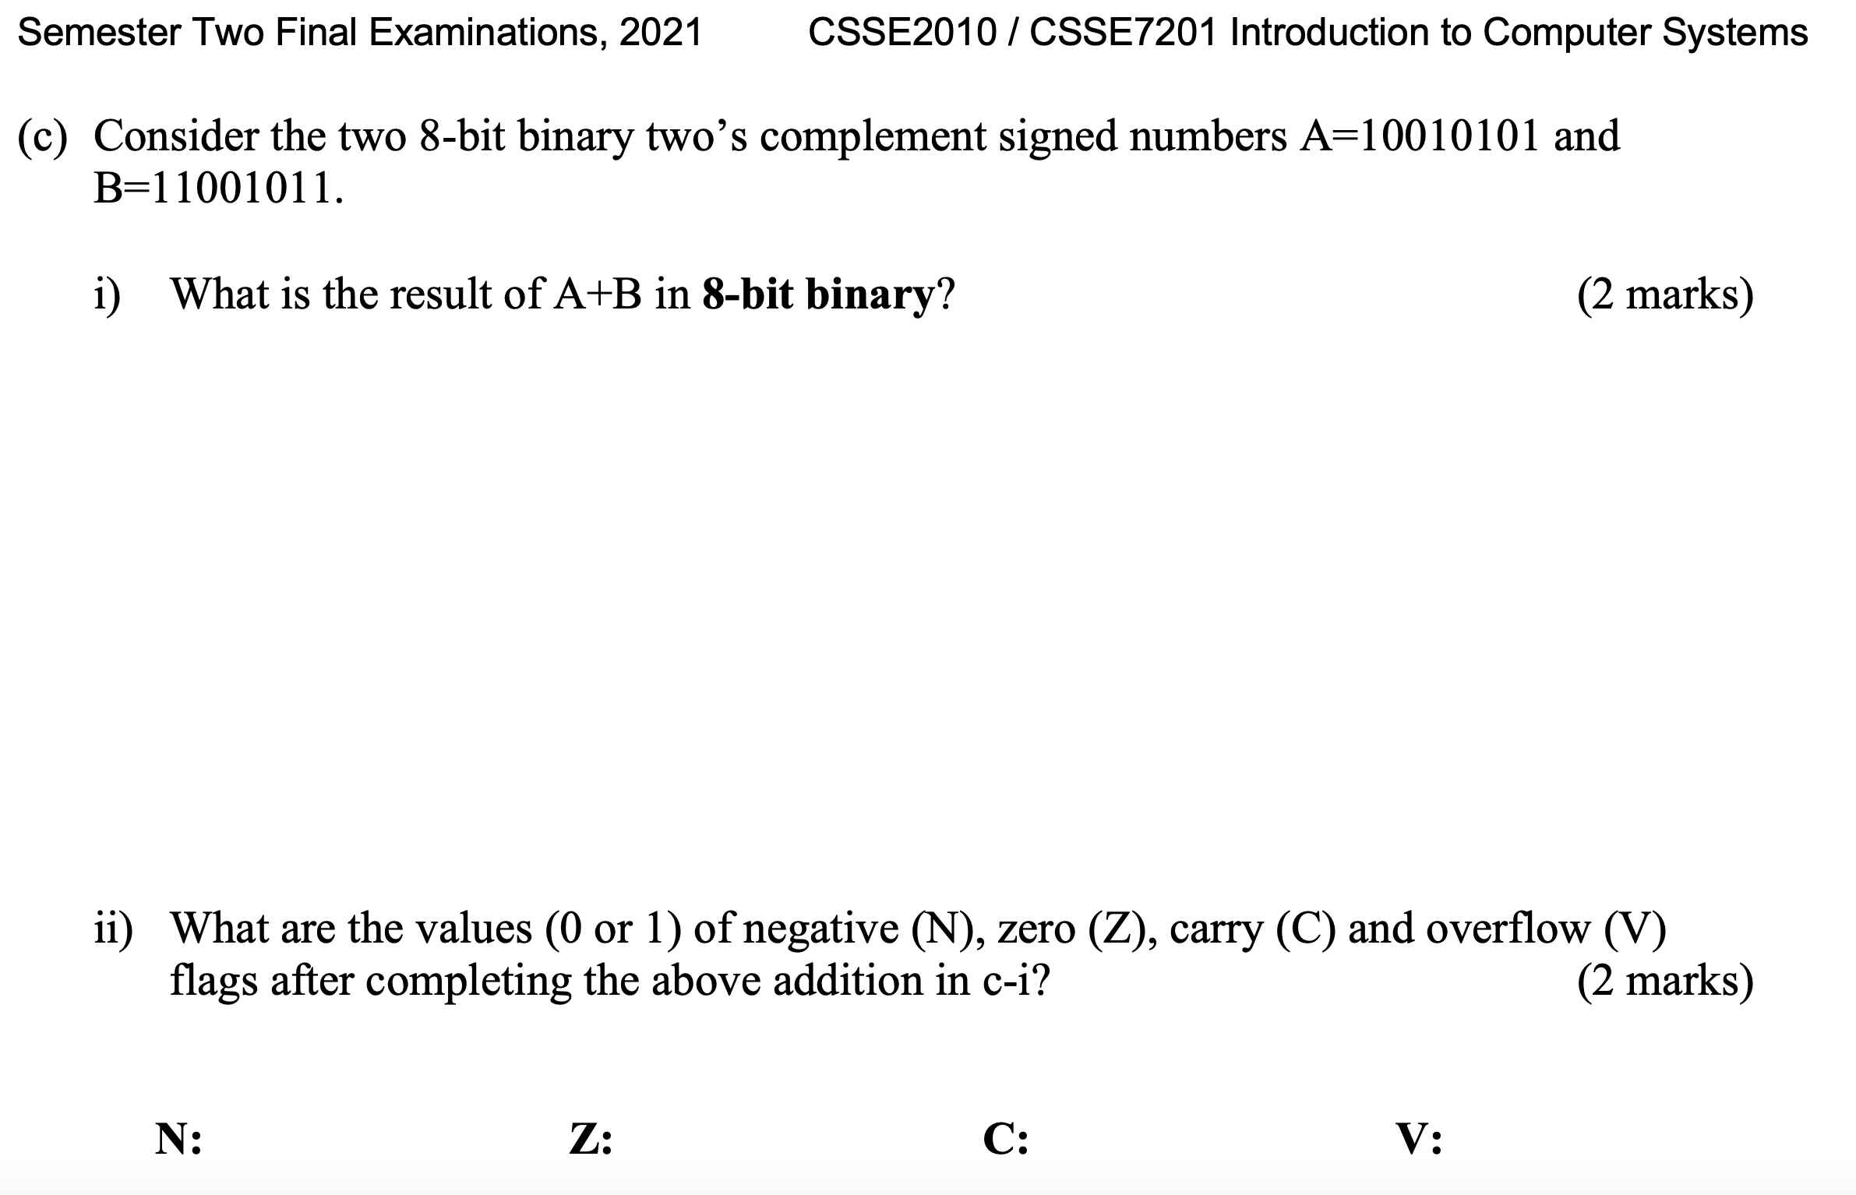
Here the result is overflow because of a different cin and cout respective to MSB. When we set the flags, we set them to the literal byte obtained? Although the result should be negative (N=1)?

