CSS

Cascadian style sheet

INLINE CSS:

Applying styling on single line.forexample <h2 style=””></h2>

Style =” attribute name : value ; attribute name: value ;etc”

Font-family : times Font style.

font-size : 30px size of font.

color : green color of text (heading, button, paragraph, selectbox etc.)

background-color : green create a colored box around heading, paragraph, button etc.

INTERNAL CSS:

Applying styling on group of items. For examples to apply styling on all H2 headings in sheet, we will use like following.

<head>

<style>

h2{

color:green;

text-decoration:underline;

}

</style>

</head>

EXTERNAL STYLE SHEET :

To apply styling on multiple webpages, we create an other CSS file containing styling for specific headings, buttons, paragraphs, and selectboxes and than link any html file with that css file.

To link html file with css file :

<head>

<link rel=”stylesheet” href=”address of css file” type=”text/css”>

<head>

**CLASSES:**

If we want to use same styling on 2 or more dives than I have to declare all dives with same class and to call that class in styling (whether inline, internal and external).

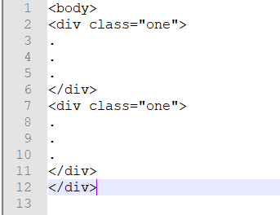

Now, I will create an external css sheet to style div1 and div 2

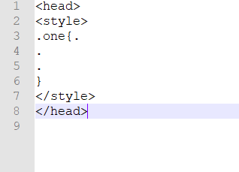

Both the dives are applied same styling using same class.

But if I want one specific element (**suppose paragraph and there** is no any other paragraph in class one) of any div any other style than

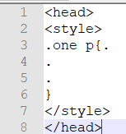

But if there are 2 paragraph in class one(in div1 and div2) than and I want any other styling of div 1 paragraph than..

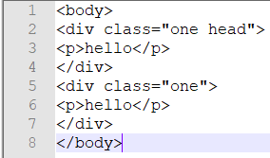

And styling sheet:…

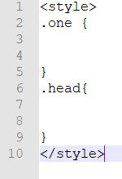

If we want two classes same styling than

**. one, .two { }**

**IDs:**

IDs are same as class. They are declared in html sheet same as class but in styling sheet

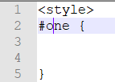

Major difference is, classes can be call for many time in html sheet but IDs cannot be called more than one time in any language.

**FONT PROPERTIES:**

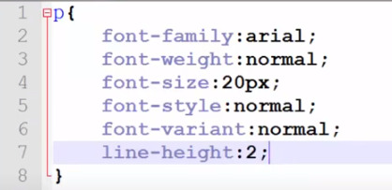

Also in single tag :

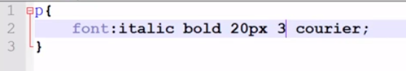

Order must be same, other wise it will not work properly.



**Color/Align/decoration of text:**

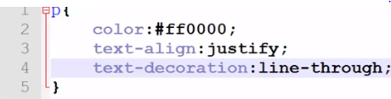

Also

Text-decoration: overline (underline)

**Text-shadow,Text-indent,Text-transform:**

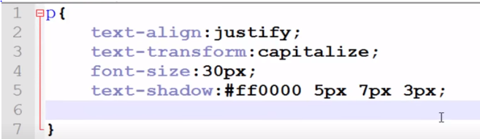

In text-transform : capitalize (capitalize 1st alphabets of all words)

Text-transform : uppercase (capitalize all letters)

In text shadow

**(color : horizontal axis of shadow: vertical axis of shadow: blur level)**

**Letter spacing :2px;**

**Word spacing:5px;**

**Directions:**

Direction : ltr ; (left to right)

Direction : rtl ; (right to left)

Direction : inheritance ; (in accordance with whole div)

**SELECTORS:**

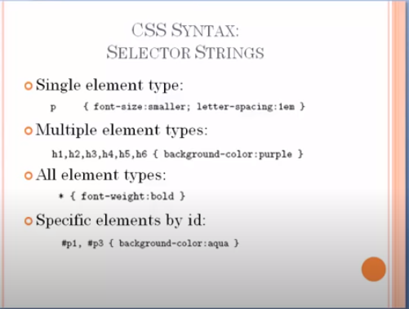

In all element types same styling will be applied on whole webpage.

**Child Selectors :**

div>h1{ } in this way styling will be applied on h1 heading in **all** dives.

**adjacent siblings styling selector:**

h1+p{ } in this way, when ever compiler finds h1 heading than it will apply styling on its next or adjacent paragraph. But remember it will apply styling only **one** adjacent paragraph.

H1+p+p{ } in this way, when ever compiler finds h1 heading than it will apply styling on its 2nd next or 2nd adjacent paragraph. But remember it will apply styling only **one** adjacent paragraph.

**General sibling styling:**

H1~p{ } in this way compiler will style all paragraphs next to all h1 heading in div on webpage.

**PADDING,BORDER,MARGIN:**

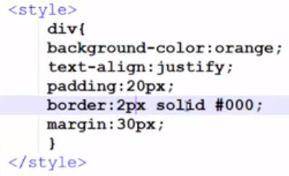

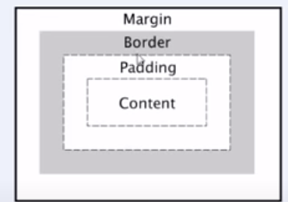

**PADDING:**

**Padding : 20px;** (apply 20px distance or padding in all 4 sides)

**Padding:**10px 20px 30px 40px; (top ,right, bottom, left)

**Padding : 10px 50px ;(**10px on top and bottom and 50px on left and right)

Top & bottom left & right

Also,

Padding-**left/right/top/bottom** : value ; (in this way we can apply padding separately on any side)

**Same procedure for margins.**

**Border color property:**

Border-bottom-color : red ;

Border-top-color : green ;

Border-right/left-color : blue;

**Border style :**

Border-style : solid/dotted/dashed/double/groove/ridge/inset/outset/hidden/dashed dotted/

Border-style : dashed dotted solid none

**Top right bottom left side**

**Border-**left/right/bottom/top**-width : 10px/thin/thick/medium**

**LINK styling:**

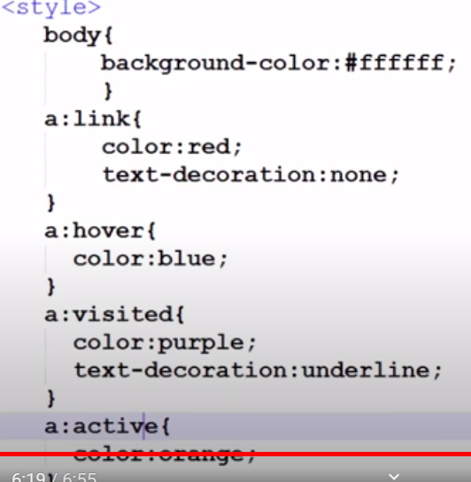

**HOVER:** when mouse is dragged on link than its color changes.

**LIST unordered list styling:**

For un-ordered list

Li{

List-style-type:none/disc/circle/square/

}

For ordered list:

Li{

List-style-type:lower-alpha/upper-alpha/upper-roman/lower-roman

}

**Border of list:**

**Li{**

Border : 1px solid black;

List-style-position : inside/outside;

}

We can also use image as bullets

Li{

List-style-image: url(address);

**TABLE styling:**

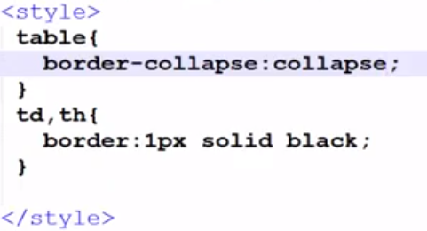

Here **th** is head of table.

**Border-collapse** will assign border to all cells without break

**Border-separate** will assign border to all cells separately.

**Border-spacing : 10px** (distance between cells)

We can also add bottom line of border only.

**Td{**

**Border-bottom:1px solid green;**

**}**

We can also add **caption** in table.

<caption>hello</caption>

**For styling:**

Caption{

Caption-side : right;

}

If there is empty cell in separate border than we can hide that empty cell, but remember we cannot hide in collapse border.

Table{

Empty-cells : hide;

}

To set width and height and alignment of each cell together:

**Table{**

**Width:100px;**

**Text-align:left;**

**}**

**Tr,th{**

**Height:100px;**

we can also use **padding** to set alignment of text in each cell

**td{**

**padding : 2px;**

**}**

**}**

to set vertical alignment of text in each cell :

**td{**

**vertical-align: middle/top/bottom;**

**}**

To add color of text and background color

**Td{**

**Color:red;**

**Background-color:red;**

**}**

**HOVER property:**

When mouse is drag to specific row than its color/background changes until cursor is move away from that row

**Tr:hover{**

**Background-color:gray; }**

Sometimes we see that in table every one row is gray and 2nd is white and up to so on

**Tr: nth-child(odd){**

**Background-color:gray;**

**}**

Every odd row will be gray.

**CURSOR PROPERTIES:**

If we want to change cursor sign when move to specific text/div/border than :

Suppose we want to change cursor in **div of class one**

.one{

**Cursor:auto/n-resize/ns,ne,nw,e,ew,nwse,s,se,sw,w-resize/zoom-in,out/text/pointer/progress/grab/help/move/none ;**

If we want to use special icon than:

**Cursor: url(‘error.ico’),default ;**

Here default is used bcz sometimes there got some issues in special icon than default value will be used

**LINE HEIGHT:**

Distance between lines .

Line-height:1.5em;