/*

* Name: Luis Mauricio Hernandez Rodriguez

* Username: hernanluis

* ID: 300412504

*/

DATABASE ASSIGNMENT

My aim was to represent the Mexico City subway system. I thought it wasn’t going to be such a hard task, but it turned out quite difficult. Creating a useful schema for such amount of data was challenging.

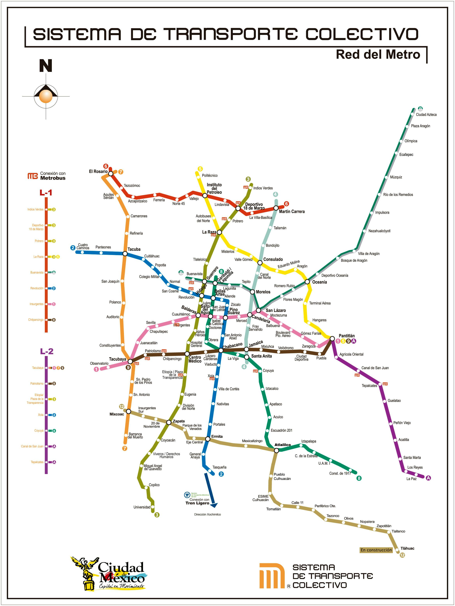

SCHEMA

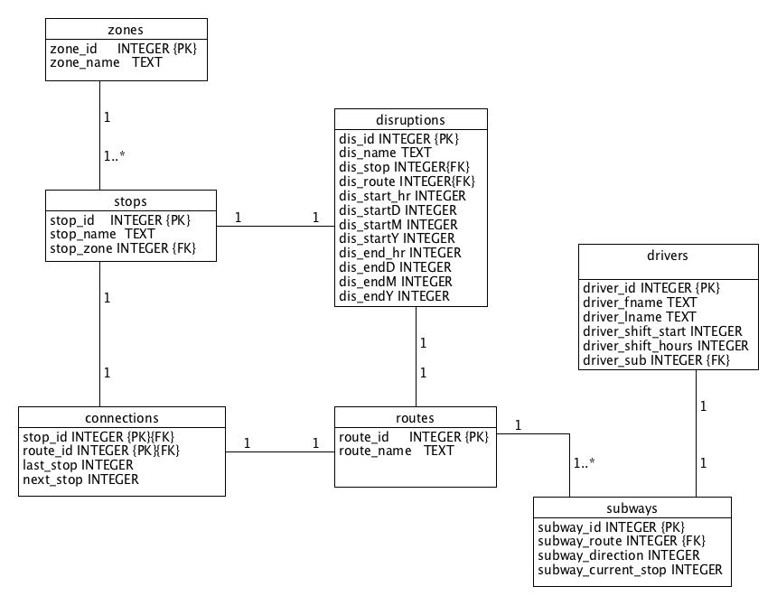

The relationships are as follow:

* Stops can belong just to 1 zone.
* Each connection is unique as it only belongs to a unique stop-route combination
* Disruptions are also unique as they affect a specific stop-route
* Drivers can drive only one subway at a time
* Each subway can only have one route at a time, but routes can have many subways.

I believe my schema performs well with disruptions as you can always find alternative routes to arrive to the desire stop by using the connections entity, which basically represents a graph that relates stops with edges (stops that are next to each other and their belonging routes). Definitely a graph database language would have done a much better job.

For the schema creation please refer to “subway_cdmx.txt”, for all the required queries please refer to “queries_subway_cdmx.sql”. Those files are ready to work by copy-pasting the text into a sqlite environment. Sadly not all queries work in with JDBC, although strangely they have the same syntax, which works perfectly in DB Browser; the time to submit the assignment is over, so I couldn’t finish it.