**Time Series Forecasting**

We used the [NeuralForecast](https://github.com/Nixtla/neuralforecast/tree/main) library from the [Nixtla](https://nixtlaverse.nixtla.io/) framework for our experiments. Three popular models N-HITS, N-BEATS and TimesNet are used for forecasting.

**Single Sample Series:**

**Data:**

The provided data is a single time series with an hourly frequency. The data samples span from ‘2015-04-09 23:00:00’ to ‘2022-03-29 22:00:00’ for a total of 61104 samples. We replace the null values with the mean value of the series.

**Predictions:**

|  |  |  |  |
| --- | --- | --- | --- |
|  | **N-HITS** | **N-BEATS** | **TimesNet** |
| **MAE** | 2190.72 | 1888.55 | 2312.31 |
| **MSE** | 9171805.48 | 6781841.47 | 9177657.76 |

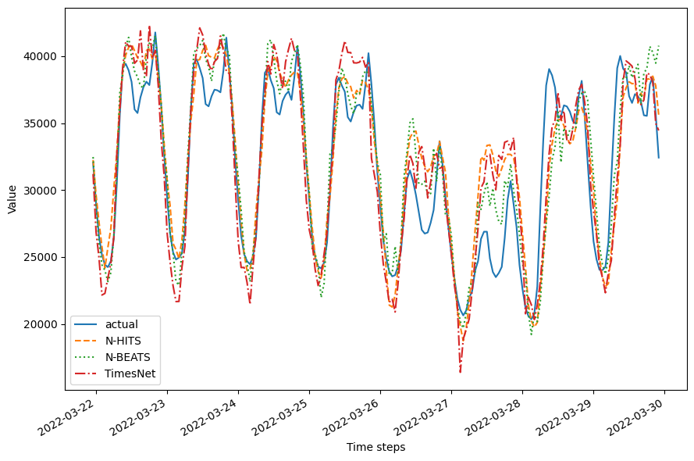

**Multi Sample Series:**

**Data:**

The provided data is a multi time series data with three time series; BE, PT and RO, with hourly frequency. The initial data samples span from ‘2015-04-09 23:00:00’ to ‘2022-04-01 01:00:00’. For consistency, we added the values for the initial 23 hours (first date) and the last 22 hours (last date), for all the series with the mean value of the respective series. The total number of samples are 183,480.

**Predictions:**

|  |  |  |  |  |  |  |  |  |  |  |  |  |
| --- | --- | --- | --- | --- | --- | --- | --- | --- | --- | --- | --- | --- |
|  | **BE** | | | **PT** | | | **RO** | | | **Combined** | | |
|  | **N-HITS** | **N-BEATS** | **Times-Net** | **N-HITS** | **N-BEATS** | **Times-Net** | **N-HITS** | **N-BEATS** | **Times-Net** | **N-HITS** | **N-BEATS** | **Times-Net** |
| **MAE** | 589.6 | 513.7 | **471.5** | 471.2 | 422.5 | **407.4** | **398.6** | 405.6 | 503.8 | 486.5 | **447.3** | 460.9 |
| **MAE** | 539832.4 | 409298.3 | **33059.4** | 362998.1 | 287878.4 | **251465.4** | **289444.7** | 315118.0 | 393331.7 | 397425.1 | 337431.6 | **325952.2** |

