Installing MySQL Server

On Windows

Installing MySQL Server

This document describes how to do basic installation of MySQL server in Windows platform.

First navigate to next URL address with your favourite browser: https://dev.mysql.com/downloads/mysql/

Scroll a little bit down in web page and you should see the following form. Select the platform of your choice, in our case it is Windows. Then press Install button MySQL MSI installer.
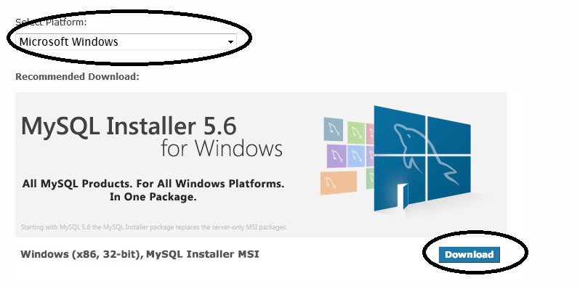

From the next opening form press Download
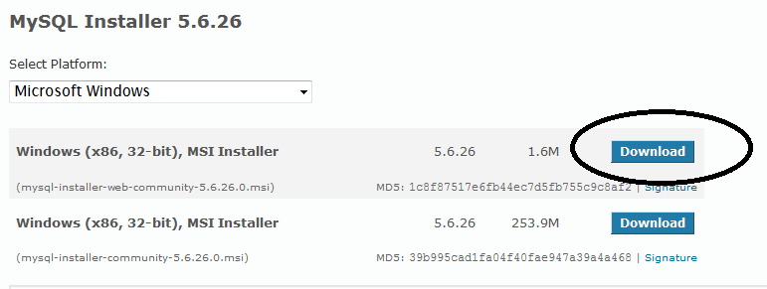

Then you see a form where you can Login or Sign UP. Ignore this and select the link “No thanks, just start my download” below.
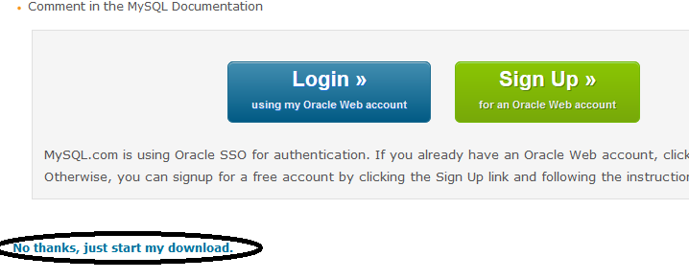
Save the file. By default the .msi file is stored in Downloaded folder in your computer. Wait that download is completed and browse to folder where .msi file is located. No double click the msi file to start the installation.
When the installation starts it asks permissions to install MySQL server. Accept these. If the installation requires you to update the installation, approve this.

After this installation will ask you to approve Licence Agreement. Approve.
Then you are asked to select Setup Type. Select Developer Default and press Next.
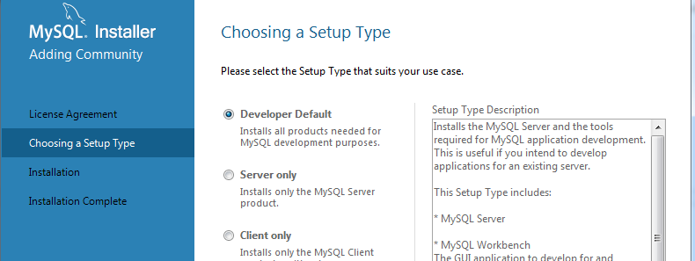
Next you are asked to fill up the requirements. It will complain about missing Visual Studio installation (if it not installed), ignore this and press next.

From next window “Installation” press the execute button and hope everything goes OK (wait that download and installation is complete). No if at this point something goes wrong, there is no much to do about it. Probably the easiest way is just to start the installation from scratch. If everything goes OK press next.
Next you will have to make the product configuration. It shows you two product to be configured. Just press Next button here.
From next window make next selections and press Next
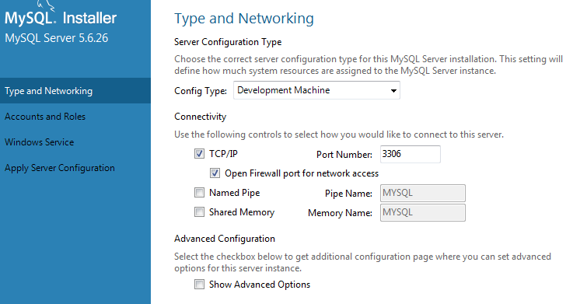

From next window set the Roor user password as “root”. This is not secure, but for development environment is good enough and most important EASY to remember. After typing these press next.
From next page select next configurations.
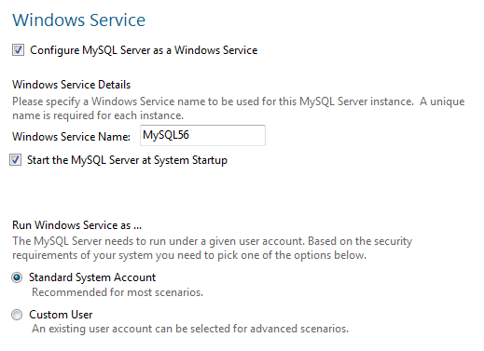
Then apply configuration by pressing Execute button! After this is done press Next. From next page press next. Now you should see “Connect to Server” test page. Press the Check button to test the connection to server. If connection is successful press next. From next page press again Execute button. Wait that configuration is complete and press the Next Finish. Press again Next and then finally the last Finish button!
No your MySQL server installation is complete and MySQL server WorkBench application should be launched automatically for you.

