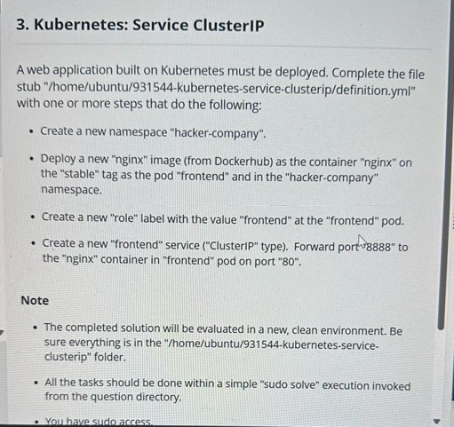

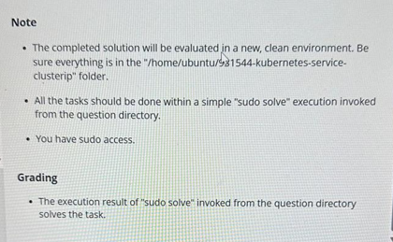

apiVersion: v1

kind: Namespace

metadata:

name: hacker-company

---

apiVersion: apps/v1

kind: Deployment

metadata:

name: frontend

namespace: hacker-company

spec:

replicas: 1

selector:

matchLabels:

app: frontend

template:

metadata:

labels:

app: frontend

role: frontend

spec:

containers:

- name: nginx

image: nginx:stable

---

apiVersion: v1

kind: Service

metadata:

name: frontend

namespace: hacker-company

spec:

selector:

app: frontend

ports:

- protocol: TCP

port: 8888

targetPort: 80

Protocal=== cluster ip  
protocal: tcp

Type of protocal

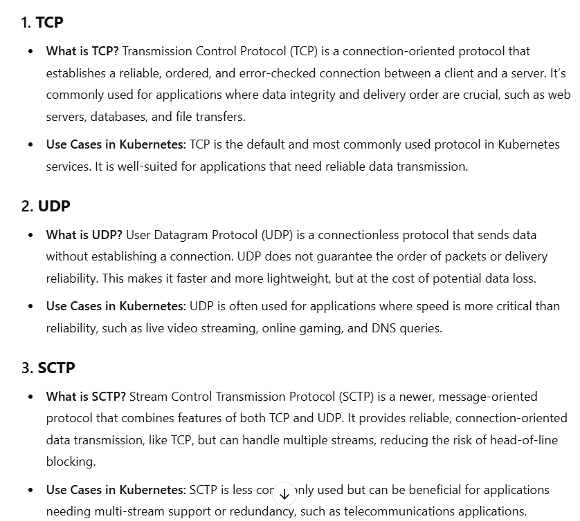

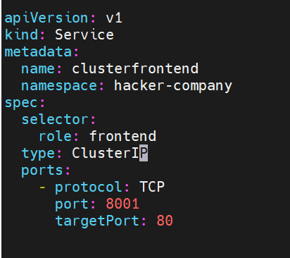

#apiVersion: v1

#kind: Namespace

#metadata:

# name: hacker-company

#

---

apiVersion: apps/v1

kind: Deployment

metadata:

name: nginxdeploy

namespace: hacker-company

labels:

stable: frontend

role: frontend

spec:

replicas: 3

selector:

matchLabels:

role: frontend

template:

metadata:

labels:

role: frontend

spec:

containers:

- name: c001

image: nginx

ports:

- containerPort: 80

---

apiVersion: v1

kind: Service

metadata:

name: clusterfrontend

namespace: hacker-company

spec:

selector:

role: frontend

type: ClusterIP

ports:

- protocol: TCP

port: 8001

targetPort: 80