AI Observability Stack
Customer Case Study | AWS Marketplace (AMI)
Trigent AI Business Unit · GenAI / Ops · Priority-1 Marketplace Offering
ILLUSTRATIVE TEMPLATE — figures in [brackets] are placeholders to be replaced with a real engagement before external use.

At a Glance
Customer | [Mid-size fintech, 800 employees — name withheld]
Industry | [Financial services / SaaS]
Use case | Production observability for GenAI features: tracing, LLM cost control, automated quality evaluation
Offering | Trigent AI Observability Stack — single-AMI deployment from AWS Marketplace
Stack | Langfuse v3 · Grafana cost dashboards · automated eval hooks · ClickHouse analytics
Time to live dashboards | Under 30 minutes from Marketplace subscribe to first trace
Headline results | [38%] reduction in monthly LLM spend · [100%] of production traces auto-evaluated · [3 weeks] of platform build effort avoided

Executive Summary
Teams shipping GenAI features hit the same wall: token spend that nobody can attribute, silent quality regressions, and no single place to answer “what did the model do, what did it cost, and was it any good?” Building that platform in-house typically consumes weeks of engineering time across five or more open-source components.
Trigent's AI Observability Stack packages the answer as a one-click AWS Marketplace AMI: Langfuse tracing, pre-built LLM cost dashboards, and an automated evaluation preset — pre-integrated, secured at first boot, and running inside the customer's own AWS account so no prompt or completion data ever leaves their VPC.

The Challenge
- Unattributed spend — LLM costs were growing [40%] month-over-month with no per-team or per-model attribution — finance saw one opaque API bill.
- No quality signal — Prompt changes shipped without regression checks; quality issues surfaced through customer complaints, not monitoring.
- Data residency — Compliance required prompts and completions to stay inside the customer's own AWS account, ruling out most SaaS observability tools.
- Platform tax — An internal build was scoped at [3–4 weeks] across Langfuse, ClickHouse, Grafana, and custom evaluators — time the team did not have.

The Solution
The customer subscribed to the AI Observability Stack on AWS Marketplace and launched the AMI into a private subnet. Everything below ships pre-wired:
- Langfuse v3 tracing — Full trace tree for every LLM call — prompts, completions, latency, token usage — with prompt management and a scores UI, ingested via Langfuse SDKs or OpenTelemetry.
- Cost dashboards — Grafana dashboards querying ClickHouse directly: total spend, spend by model, tokens over time, p95 latency, and the most expensive traces — live within minutes of the first trace.
- Eval hooks preset — A background worker that scores every new trace automatically against configurable presets: latency SLO, per-trace cost budget, refusal detection, and empty-output detection. Thresholds live in one YAML file.
- Security posture — All credentials are generated at first boot (nothing hardcoded), the EBS volume is encrypted, and the stack runs entirely within the customer's VPC.

Architecture
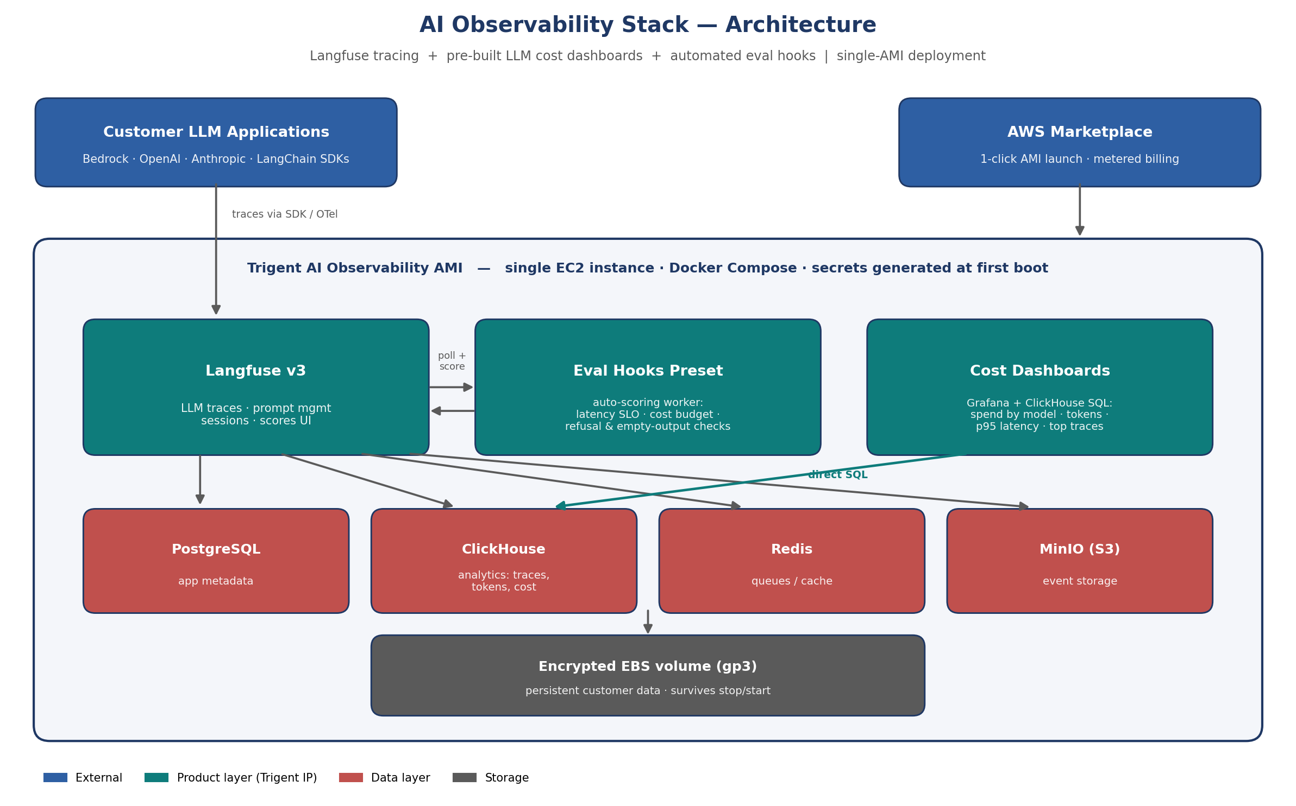
A single EC2 instance runs the full stack under Docker Compose: Langfuse v3 (web + worker) for tracing, PostgreSQL for application metadata, ClickHouse for high-volume trace analytics, Redis for queues, MinIO for S3-compatible event storage, Grafana for the cost dashboards, and the Trigent eval-hooks worker. The same architecture scales up by instance size, and a high-availability tier (RDS + managed ClickHouse) is available as a services engagement.

Deployment via AWS Marketplace
Asset type | AMI (us-east-1 master, cloned to enabled regions)
Provisioning | 1-click launch or Terraform module (provided) · ~8 minutes to running stack
Sizing | t3.large (pilot) → t3.xlarge / m6i.2xlarge (production volumes)
Billing | Hourly via AWS Marketplace with annual option · consolidated on the customer's AWS bill
Services attach | Trigent packages: dashboard customization, custom eval hooks, LLM-as-judge evaluators, HA architecture

Results
- [38%] lower LLM spend — Model-level cost attribution surfaced that [62%] of spend came from one over-provisioned model; routing the workload to a smaller model cut monthly LLM cost by [38%].
- Regressions caught in hours — Every production trace is now scored automatically; a refusal-rate spike after a prompt change was caught in [under an hour], before customers reported it.
- [3 weeks] saved — The platform was live in [one afternoon] versus a [3–4 week] internal build — engineering time redirected to the product roadmap.
- Compliance kept — All observability data remains in the customer's AWS account, satisfying the compliance requirement that blocked SaaS alternatives.

Why Trigent
Trigent's AI Business Unit builds and operates production GenAI systems — agents, voice, RAG, and the operational tooling around them. The AI Observability Stack encodes that delivery experience into an opinionated, supported product: the integration work is done, the defaults are sensible, and Trigent services extend it into each customer's environment. It is one of a focused set of Priority-1 Trigent listings that make AWS Marketplace the first place prospects can find, try, and validate Trigent capability.
Contact: [AI-BU contact name] · [email] · trigent.com | AWS Marketplace: [listing URL]

