Word Count Exercises

# Introduction

Application outputs word count for input strings. For full details please see Wordcount.pdf in this folder.

# How to Build / Run Info:

Cd 1. To build application (on command prompt / terminal )

-> cd Word-Count-App/Word-Count-App/src

-> make

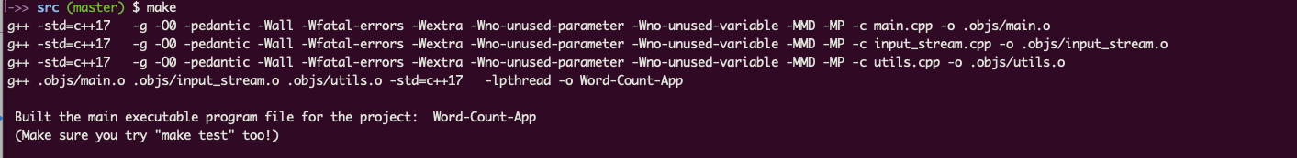

# 2. To run application (on command prompt / terminal )

-> ./Word-Count-App <argv1> <argv2>

Example:

./Word-Count-App ex1 "boy is running around and around"

# 3. To build Unit Test (uses Catch2) (on command prompt / terminal )

-> cd Word-Count-App/Word-Count-App/src

-> make test



# 4. To run Unit test ( on command prompt / terminal )

-> ./test

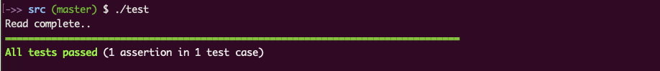

# Some Notes

=> g++ compiler with C++17 is used.

=> All source code with makefile in the src folder.

=> All testing code including the catch2 test header in the src/tests folder.