NIDS Using Machine Learning
Full Project Explanation with Graphs

1. Project Overview
This project is a Network Intrusion Detection System (NIDS) that uses machine learning to detect malicious network traffic. The system learns from labeled network-flow CSV data and predicts whether new network traffic is benign or an attack.

2. Problem Statement
Computer networks generate a large amount of traffic. Manual monitoring is difficult, so an automated intrusion detection system is useful for identifying suspicious traffic quickly.

3. Dataset
The dataset contains CICIDS-style network-flow records. Each row represents one network flow, and the Label column is the target output.
- Source Port
- Destination Port
- Protocol
- Flow Duration
- Packet counts
- Byte rates
- Flag counts
- Active/Idle statistics
- Label

4. System Architecture
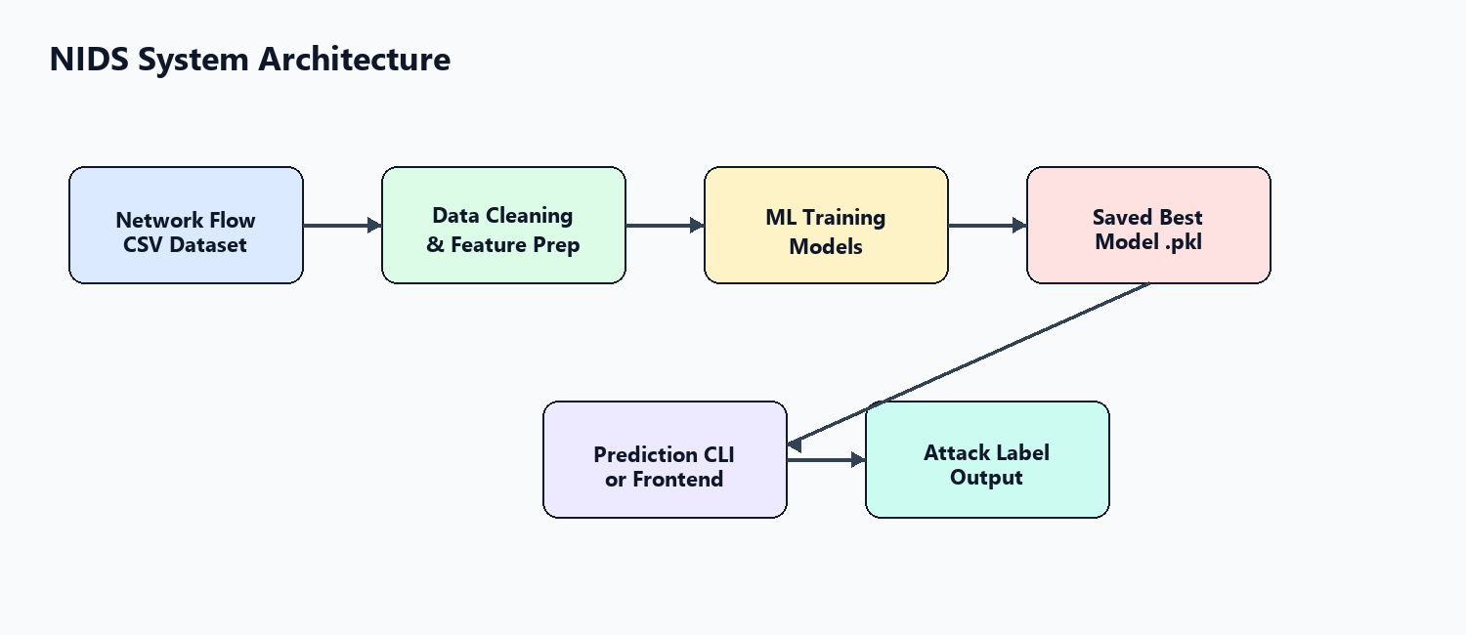

5. Machine Learning Pipeline
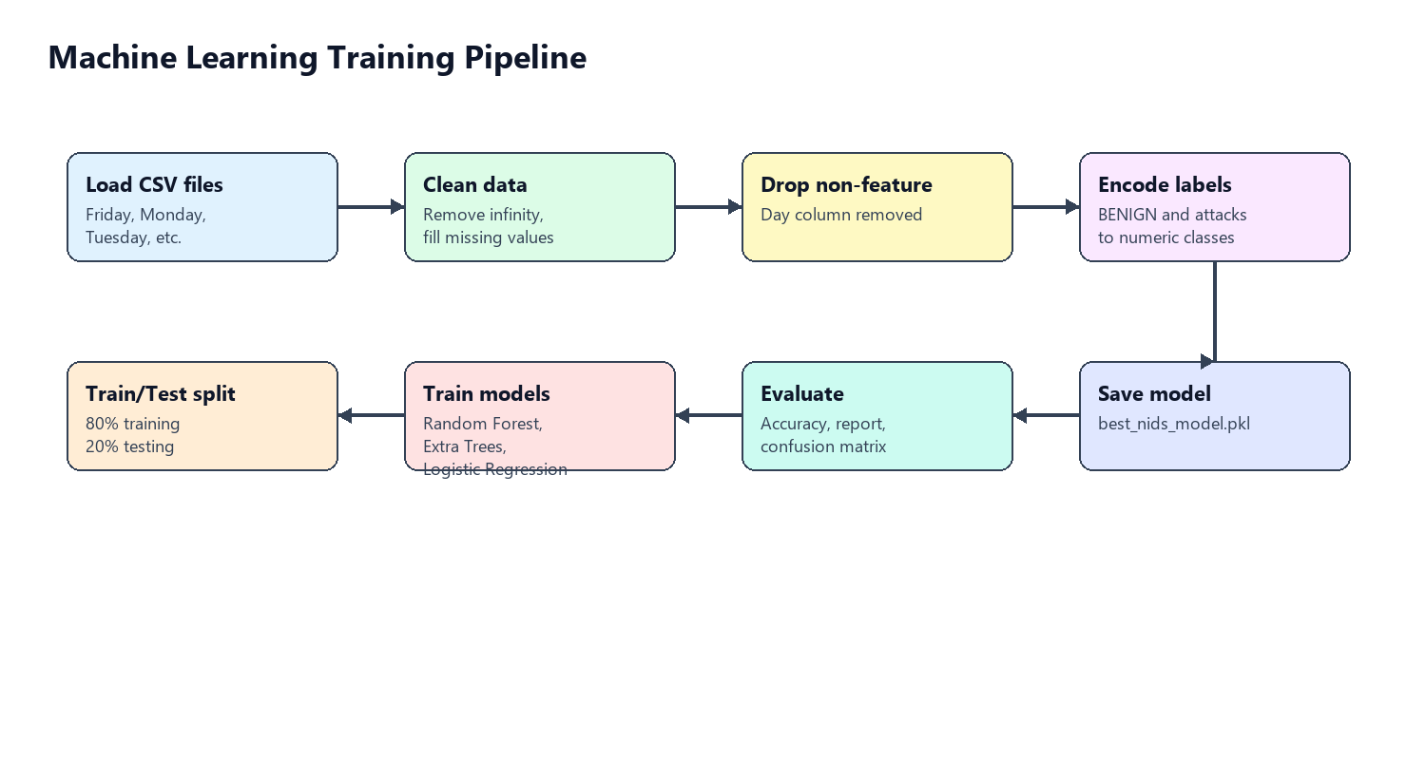

6. Models Used
Model | Purpose
Random Forest | Strong classification model using multiple decision trees.
Extra Trees | Tree-based model with extra randomness, often fast and accurate.
Logistic Regression | Baseline model for comparison.

7. Training Output Files
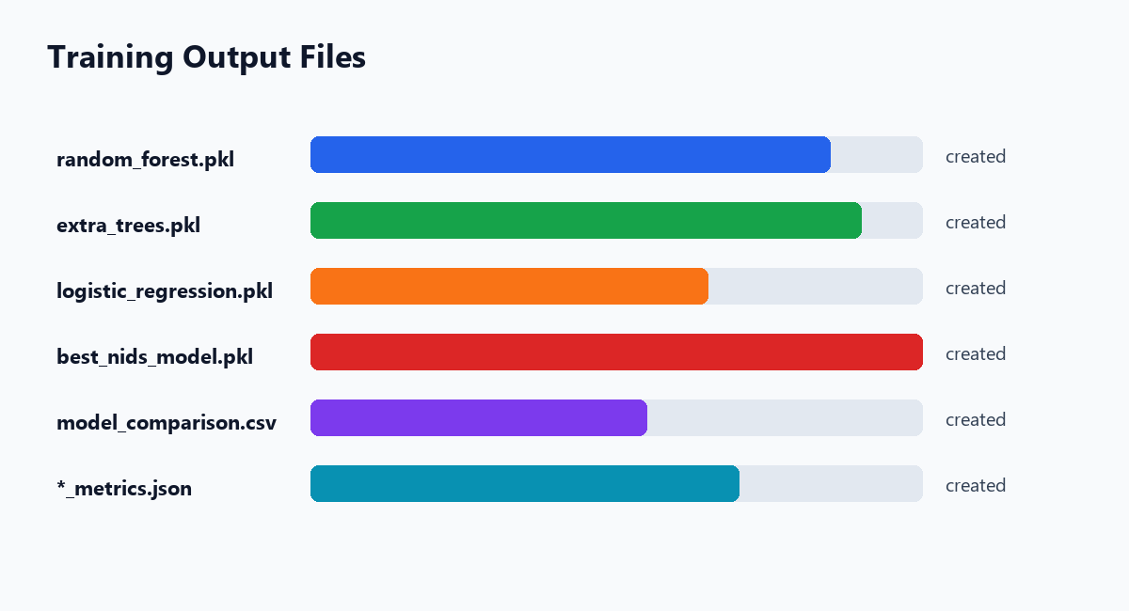
After training, the best model is saved as model/artifacts/best_nids_model.pkl.

8. Training Commands
cd E:\NIDS-Using-Machine-Learning
python -m venv .venv
.\.venv\Scripts\Activate.ps1
pip install -r requirements.txt
python model\train_model.py --data dataset --max-rows-per-file 50000

9. Prediction Command
python model\predict.py --input dataset\Friday11.csv --output predictions.csv
The output CSV contains a Predicted_Label column.

10. Frontend
The Streamlit frontend allows CSV upload and downloads predictions.
streamlit run frontend\app.py

11. Advantages
- Detects malicious network traffic automatically.
- Trains multiple machine learning models.
- Saves the final trained model as a .pkl file.
- Supports both CLI prediction and frontend upload.
- Uses sampling to handle large CSV datasets.

12. Limitations
- Real-time packet capture is not included yet.
- Accuracy depends on dataset quality.
- Large datasets require more RAM and processing time.
- The model should be retrained when new attack types are added.

13. Future Scope
- Add live traffic capture.
- Add dashboard charts for attack distribution.
- Store prediction logs in a database.
- Deploy the frontend as a web application.
- Experiment with deep learning models.

14. Conclusion
This NIDS project uses supervised machine learning to classify network traffic as benign or malicious. It cleans the dataset, trains multiple models, compares performance, saves the best model as a .pkl file, and supports prediction through both command line and frontend.

