**CS673S16 Software Engineering**

**Team X - Project Name**

**Software Design Document**

|  |  |  |  |
| --- | --- | --- | --- |
| Team Member | Role(s) | Signature | Date |
| Rohit Agrawal | Team Leader/ Implementation Leader | *Rohit Agrawal* | 10/16/2017 |
| Yashvardhan Nanavati | Backup Team Leader/ Configuration Leader/ Implementation Leader | *Yashvardhan Nanavati* | 10/16/2017 |
| Wenjun Shen | Requirement Leader/Environment and Integration Leader | *Wenjun Shen* | 10/17/2017 |
| Tianqi Xu | Requirement Leader/ Security Leader | *Tianqi Xu* | 10/17/2017 |
| Anirvan Maiti | Environment & Integration Leader  Design Leader | *Anirvan Maiti* | 10/18/2017 |
| Aswin Vasudevan | Implementation, Design and Security Leader | ***Aswin Vasudevan*** | 10/18/2017 |

**Revision history**

|  |  |  |  |
| --- | --- | --- | --- |
| **Version** | **Author** | **Date** | **Change** |
| **1.0** | **Yashvardhan Nanavati** | **10/16/2017** | **Initial Draft** |
|  |  |  |  |

Introduction

Software Architecture

Design Patterns

Key Algorithms

Classes and Methods

References

Glossary

# Introduction

Motivation for this project comes mainly from the inability of the existing visualization tools like ‘Kibana’ to parse multi-level data in the form of JSON and their outdated, lack-lustered visualizations. Although powerful, Kibana lacks to produce interactive visualizations defeating its own purpose.

The name Ukubuka is inspired from a unique language spoken in South Africa and roughly translates to *"View"* or *"Visualization"* in Zulu which is one of the official languages of South Africa and is spoken by about 9 million people mainly in Zululand.

Ukubuka aims at producing high-quality interactive visualizations. It is powerful, lightweight and easy to use. It allows the users to analyze, manipulate and visualize their datasets in a novel and creative ways with no serious programming.

# Software Architecture

* Backend functionalities
  + Essential Features
* Data Import - With Ukubuka, it’s possible to import your data from many sources including the text files, CSV files, XML files, and databases etc. We also support files having delimiters other than a comma.
* Data Manipulation - You can manipulate your data using a huge bunch of functions such as adding/removing/renaming columns, removing duplicates from the data, and merging multiple data files into one.
* Data Visualization - You can visualize your data in novel and creative ways such as Maps, Scatter Plots, Bar Graphs, etc. for which we use open-source API’s like ECharts and Tau Charts.
  + Desirable Features
* Data Export - You can export your analyzed and manipulated data in the form of flat files and databases. You can also export your visualizations and share them with the world.
* Workflows - You can document your workflows and save them for future use.
  + Optional Features
* Data Analysis - You can analyze your data using machine learning techniques like regression, clustering, classification, etc.
  + - * Front-end functionalities - UI design with colorful declaration and succinct control panel

# Design Patterns

In this section, you shall describe any design patterns used in your software system.

We have used the Java **Singleton** Design pattern for our project which comes under the Creational Design pattern category. As its definition states, this design pattern restricts the instantiation of a class and ensures that there exists only one instance of the class in the JVM (Java Virtual Machine).

We also plan to implement **Factory** and **Builder** design patterns in our project. The Factory method can be seen as a simplified version of the Builder method.

In the Factory design pattern, the factory is in charge of creating various subtypes of an object depending on the needs of a project. However, it does not know the exact subtype of the object. Rather it’s a high level view.

An example of Factory method could be if there is a method named “produceCars”, it might return a “BMW” or “Audi” typed object with it being unaware of the specific subtypes of cars in those objects.

In the Builder design method, different subtypes are also created by it. But the composition of the objects might differ in the same subclass.

As an extension of the example given in the Factory method, we might have a “produceCars” method which creates objects of type “BMW” typed object with a 4 cylinder engine, or a “BMW” typed object with 6 cylinders. The builder pattern thus allows for this type of detailing.

**Factory pattern:**

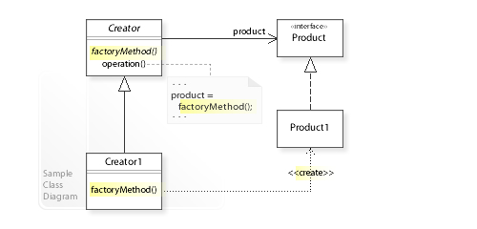

**Builder pattern:**

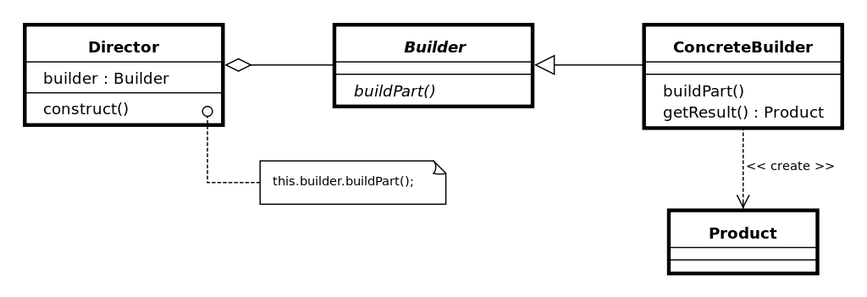

# Key Algorithms

In this section, you shall describe any key algorithms used in your software system, either in terms of pseudocode or flowchart.

**Ukubuka Base Parser:**

This is a key algorithm that we have implemented. The parser acts as an interface between the reader/writer classes and the classes which handle parsing of csv/json/xml files. It is responsible to effectively communicate between the above mentioned modules. It takes the file read by the reader and passes it to a appropriate class depending upon the appropriate type of the file. It also handles if the delimiter of the file is something other than “,” and appropriately passes it to the respective parser. Also, missing headers in a data file are filled up using default column names such as column_1, column_2 etc. At the end, the files are consumed as a list of strings by the Ukubuka Engine.

**Example:** “A;B;C;D” is converted to “A,B,C,D”

**Ukubuka Schema:**

Another novel structure we came up with is the Ukubuka Schema in which the user has been given pre-defined tags to specify the manipulations he/she wants to do on the data set. Also, multiple loads, transformations and extractions can be done using a single schema file. This allows the user to consolidate all manipulations into a single structure seamlessly performs the specified operations without much hassle.

**Example Schema:**

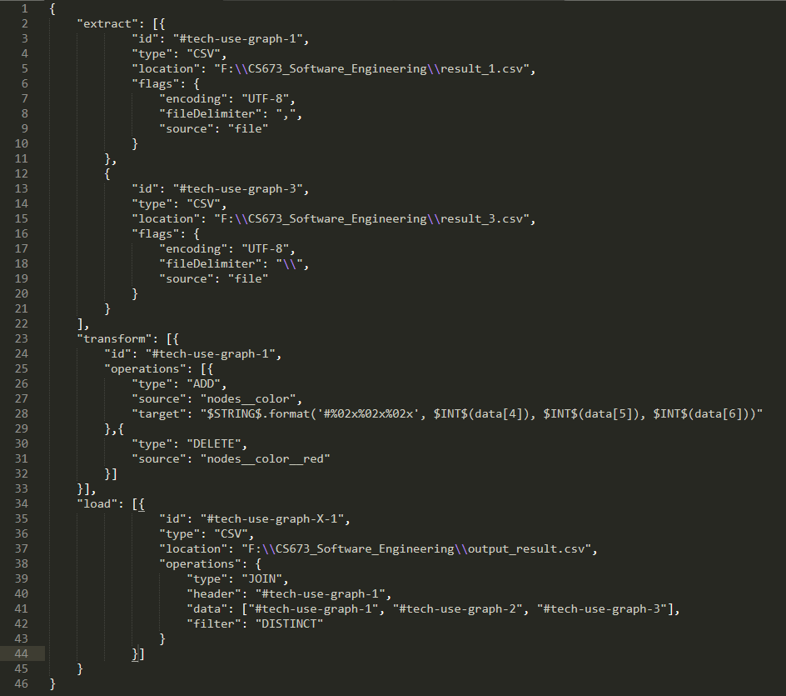

**Ukubuka Transformation:**

This algorithm uses SpEL (Spring Expression Language) to perform transformations on the data in the files specified by the user. The Spring Expression Language (SpEL for short) is a powerful expression language that supports querying and manipulating an object graph at runtime. The language syntax is similar to Unified EL but offers additional features, most notably method invocation and basic string templating functionality. This Algorithm is extremely powerful and can potentially solve any kind of mathematical computational problems including complex trigonometric, and statistical conundrums. For user-friendliness we have created a supporting class called “Shortcuts” which Imports the corresponding libraries in Java with abstraction to the user. The user just enters normal names of the operations and the algorithm takes care of importing the corresponding classes and interfaces.

# Classes and Methods

This part can be a reference to automatic generated document for all classes and methods.

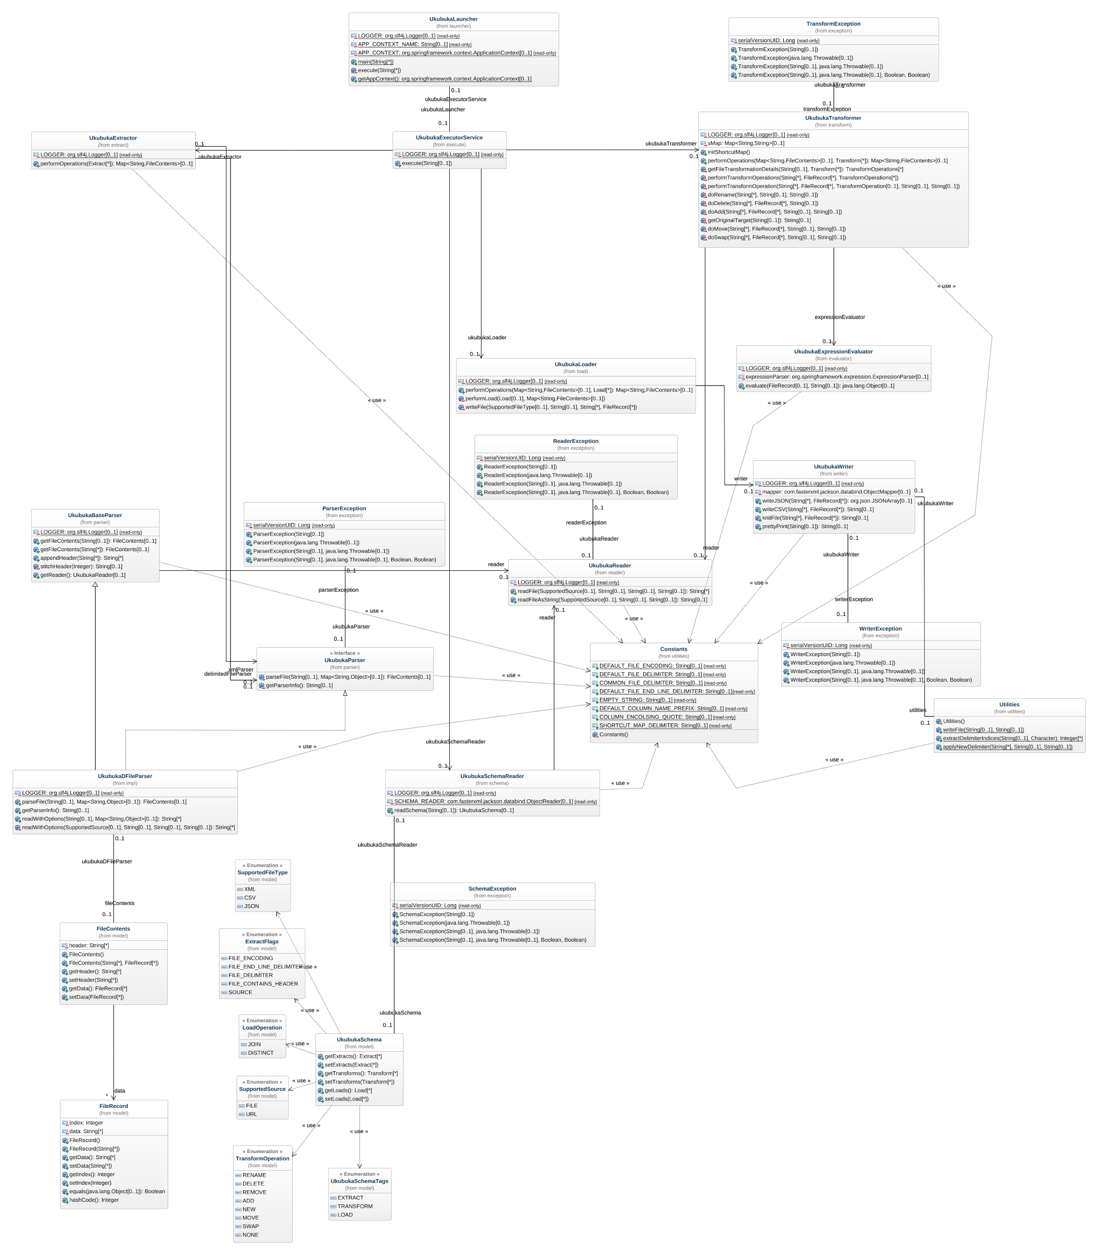

Link to view zoomed in Image Clearly => [Ukubuka-core-class-diagram](https://drive.google.com/a/bu.edu/file/d/0B-YuiXUg094GOE01RWQ2OV9RUDA/view?usp=sharing)

# References

* + Kibana(<https://www.elastic.co/products/kibana>): Kibana gives you the freedom to select the way you give shape to your data. And you don’t always have to know what you're looking for. With its interactive visualizations, start with one question and see where it leads you.
  + <http://www.en.wikipedia.org/>
  + <http://stackoverflow.com>

# Glossary