

Proposal for the development of Website **"Eddi".**

Version 3.0

**Executive Summary**

The purpose of this proposal is to specify functional as well as non-functional requirements and business objectives for **“Website Eddi“.**

Detailed scope is given below.

**Project Details**

|  |  |
| --- | --- |
| **Project Name** | **Eddi** |
| **Company Name** |  |
| **Project Type** | **Website Development** |
| **Project Start Date** | **14th Feb, 2022** |
| **Project End Date** | **15 weeks from the above start date** |
| **Project Methodology** | **Agile Development** |

1. **Project Overview**

**Learning is Everything,** In today's era where everything is online, **Eddi** is designed and developed for the Individuals / Users to enroll for the course online or offline (as per users need). Eddi will act as one platform for suppliers who want to offer their courses online or offline and for users who want to learn courses.

**Suppliers** of the courses need to create their profile with the Eddi platform in order to post courses in different categories for the users to enroll in.

Courses added by the **company / organization** will only be shown to the employees working in that organization.

**Individual/Users**, in order to enroll for the course, need to first log in with the Eddi platform and based on the user’s profile, a list of relevant courses will be shown to them. Users can choose any and view the course details & apply for both online or offline both.

Whereas the **System Administrator** will have full control over the activities of all the users of the system & also be responsible for managing the same.

1. **Project Scope**

This Platform will act as an all-in-one solution for suppliers who want to provide their courses to users who wants to enroll for the courses online or offline (as per their need).

* 1. **Scope of Project Includes:**
* Analysis
* Designing
* Coding
* Testing
  1. **Stakeholders:**
* Suppliers/Company (Education suppliers, course suppliers, Recruitment ads supplier.. so on)
* Individual / User
* System Admin

1. **General CMS Pages**
   1. **Home Page**

* This will be the main page from where the users can access all the features of the site in a user-friendly way.
* **The header** of the **Home Page** contains:
* About Us
* Solution
* Contact Us
* Current Events
* Support
* Login as Supplier
* Login as Individual
* Body Section of the Home Page contains:
* General Info
* What is EDDI
* What's ON
* Roles and professional descriptions – Brief Introduction
* Description of service supply
* Video Section
* Advertisement Space
* Contact Eddi
* Team
* Experience
* Cooperation/Partners
* Open conferences
* Blogs
* Current Areas of Education
* Monthly Email Newsletter
* **Footer** of the **Home Page** contains:
* What On (news & news inner)
* Blog & Blog Inner
* Courses for you
* Partner
* Why Us (content-based)
* Role Specific
* Easy to Use
* Intelligent
* Career Boost
* Supportive
* Dynamic
* Learn More
* Social Media icons
* Terms & Conditions
* Privacy Policy
  1. **About us**
* This will be a content-based page.
* The system admin will manage the content of this page.
  1. **Solution**
* This will be a content-based page.
* The system admin will manage the content of this page.
* Functionality to add info, pictures, animated films, etc
  1. **Contact Us**
* This will be a content-based page.
* The system admin will manage the content of this page.
  1. **Terms & Conditions**
* This will be a content based page.
* The system admin will manage the content of this page.
  1. **Privacy Policy**
* This will be a content based page.
* The system admin will manage the content of this page.
  1. **Partner**
* This will be a content based page.
* The system admin will manage the content of this page.
  1. **Blog & Blog Inner Page**
* This will be a content based page.
* The system admin will manage the content of this page.
* This page contains the following information mentioned below:
* Blog Title
* Image
* Description
* Posted on
* Posted By
* Note:- Blogs could be uploaded directly to the platform – or through links to external sites.

1. **Functional Requirement of Supplier** (Education suppliers, Course suppliers, Recruitment ads suppliers.. so on)
   1. **Login as Supplier**

* If the user is an existing user, by entering the following detail they can log in to the app:
* Email Address
* Password
* Login (button)
* After successfully logging into the site, users will be redirected to their dashboard.
* In case if User forgets their password, they can retrieve and recover the same by simply tapping on the **Forgot Password Link.**
* If supplier user is new to the site & wants to register themselves it can also be done just by clicking on **Create Account** button.
* **Log in Using Social Media:**
* The User can log in to this app using any of his or her social media accounts like Facebook or Gmail.
* This makes the log in a simple one-step process.
  1. **Create Account**
* If the user wants to manually register, it can also be done, for that user needs to enter the following details:
* Full Name
* Profile Image (optional)
* Email Address
* Choose Role
* Company
* University
* Password
* Agree to terms of use (check-box)
* Create Account (button)
* After entering the above details, the user will be redirected to their **Create Profile.**
* **Note:-** The above fields are as per the RFI document shared by the client, if any further changes are required let us know.
  1. **Forgot Password**
* In case a user forgets their password, they can retrieve and recover the same by simply tapping on the **Forgot Password Link.**
* By entering the registered email address an email will be sent to the user, using user can reset their password and login again with the site.
  1. **Create Profile**
* When suppliers logins for the first time with the eddi platform, they are asked to create their profile.
* By entering the following information mentioned below:
* **Basic Information:**
* Username
* Password
* Phone Number
* Email Address
* Company / Organization / University
* **Company / Organization / University Information:**
* Organization Name
* Address
* Country
* City
* Zip Code
* Choose Role (can be multiple)
* Teacher
* Business .. so on
* **Course Information:**
* Case Report forms on a specific course (info will be entered in “fixed” drop-down list/fields as well as in “free text” boxes. )
* Paid or Free
* Online / Physical or both
* Length
* **Note:-** The above fields are as per the RFI document shared by the client, if any further changes are required let us know.
  1. **Supplier Dashboard (if existing supplier)**
* This will be the main page from where the user can access all the features of the site in a user-friendly way.
* **Header Section** of **Supplier Dashboard** Contains the following:
* Course Offered / Listing (Manage Course)
* News
* Manage Events
* Supplier Profile
* Manage Recruitment Ads
* Company / Organization / University Profile
* Logout
* **Note:-** The above fields are just for understanding purpose and can be revised further with client discussion.
* When supplier logs in to the platform they get an overview of the courses they have on the platform, new courses/listing, Company information etc.
  1. **Courses Offered / Listing (Manage Course)**
* This page will enable users to view the list of all courses that the supplier user offers to the individual.
* Supplier users will be able to view the following details about the course mentioned below:
* Course ID (auto-generated)
* Course Name
* Price
* Date Created
* Status
* Active
* In-Active
* Action
* View
* Edit
* Delete
* **Note:-** The above fields are just for understanding purpose and can be revised further with client discussion.
* Supplier Users can also add new courses from this page just by clicking on **Add New Course** button.
  1. **Course Detail**
* This page will enable users to view the detailed information of the particular course that they have selected from the course listing page.
* This page contains the following information about the course mentioned below:
* Course Id
* Image
* Course Name
* Course Overview
* Additional information (if any)
* Purchase Model
* Free
* Price
* Course Level (choose)
* University
* School
* Other
* Status (toggle button)
* Active
* In-Active
* **Note:-** The above fields are just for understanding purpose and can be revised further with client discussion.
* Supplier Users can also edit and delete the course from this page.
  1. **Add New Course**
* This page will enable users to add new courses by adding the following details about the course mentioned below:
* Image
* Course Name
* Course Overview
* Purchase Model (choose)
* Free
* Price (enter price of course)
* Course Level (choose)
* University
* School
* Other
* Status (toggle button)
* Active
* In-Active
* Add (button)
* **Note:-** The above fields are just for understanding purpose and can be revised further with client discussion.
  1. **Manage Events**
* This page will enable users to view the list of all events that the supplier user offers to the individual.
* Supplier users will be able to view the following details about the event mentioned below:
* Event ID (auto-generated)
* Event Name
* Price
* Date Created
* Status
* Active
* In-Active
* Action
* View
* Edit
* Delete
* **Note:-** The above fields are just for understanding purposes and can be revised further with client discussion.
* Supplier Users can also add new events from this page just by clicking on **Add New Event** button.
  1. **Event Detail**
* This page will enable users to view the detailed information of the particular event which they have selected from the event listing page.
* This page contains the following information about the event mentioned below:
* Event Id
* Image
* Event Name
* Event Overview
* Event Price
* Status (toggle button)
* Active
* In-Active
* **Note:-** The above fields are just for understanding purpose and can be revised further with client discussion.
* Supplier Users can also edit and delete the Event from this page.
  1. **Add New Event**
* This page will enable users to add a new event by adding the following details about the event mentioned below:
* Image
* Event Name
* Event Overview
* Event Price
* Status (toggle button)
* Active
* In-Active
* Add (button)
* **Note:-** The above fields are just for understanding purpose and can be revised further with client discussion.
  1. **Supplier Profile**
* This page will enable users to **modify/edit** their own profiles.
* The following fields will be there on this page mentioned below:
* Supplier Name
* Profile Picture
* About Supplier
* Email Address
* Phone Number
* Address
* Change Password
* Save (button)
* **Note:-** The above fields are just for understanding purpose and can be revised further with client discussion.
  1. **Company Profile**
* This page will enable users to **modify/edit** their own company profile.
* The following fields will be there on this page mentioned below:
* Company Name
* Picture
* About Company
* Email Address
* Phone Number
* Location of Company
* Save (button)
* **Note:-** The above fields are just for understanding purpose and can be revised further with client discussion.
  1. **Logout**
* Users can log out of the system any time they want to.
* By clicking on the Logout button, the user will be logged out.
* They can again log into the system by entering a valid email & password.

1. **Functional Requirement of Individual / User**
   1. **Login Page**

* If the user is an existing user, by entering the following detail they can log in to the site:
* Email Address
* Password
* Login (button)
* After successfully logging into the site, the user will be redirected to the **Home Page** of the site**.**
* If a user is new to the site and wants to register themselves, it can also be done for that user just needs to tap on the **Create Account** button available on the page.
* **Log in Using Social Media:**
* The User can log in to this app using any of his or her social media accounts like Facebook or Gmail.
* This makes the log in a simple one-step process.
  1. **Create Account**
* If a user wants to manually register, it can also be done, for that user needs to enter the following details:
* Full Name
* Email Address
* Password
* Profile Image (optional)
* Subscribe to recruitment ads? (checkbox)
* Agree to terms & conditons
* Sign up (button)
* After entering the above details, the user will be redirected to the **Create Profile Page.**
* **Note:-** The above fields are just for understanding purpose can be revised further with client discussion.
  1. **Forgot Password**
* In case a user forgets their password, they can retrieve and recover the same by simply tapping on the **Forgot Password Link.**
* By entering the registered **email address** an reset password link will be shared to the user, using the same user can reset their password.
  1. **Create Profile**
* After successfully signing up, user needs to create their profile.
* Creating profile will be a several step process.
* User can skip the some step if needed or continue later.
* This feature of site will enable user to enter the following information as mentioned below:
* **Basic Info:**
* Full Name
* Email Address
* DOB
* Age (auto generated from DOB)
* Gender
* Phone Number
* Working Status
* **Educational Info:**
* Highest Level (list)
* Area 1 (list)
* Area 2 (list)
* Additional (list)
* Working Experience
* Current Roles
* Future Roles
* Courses users want to attend (free text, more likely fixed drop down lists of various courses they like to attend)
* Other Competences
* Personality (optional)
* Interests (extra curricular)
* Continue (button)
* **Note:-** The above fields are mentioned the RFI document shared by the client, if any further changes required let us know.
* By entering the above details the user profile will created with the site.
* Based on their profile the related courses will be shown to the users.
  1. **Course Listing**
* Based on the user profile, the related course list will be display on this page.
* User can also search for a particular course from this page.
* Filter can be:
* Level
* University
* School
* Other
* Other Constraints
* Free Courses
* Price / day
* Region
* Date / time
* Physical
* Online
* Based on the related filter selected user will be shown the results.
* Following details about the course will be displayed on this page mentioned below:
* Course Image
* Course Title
* Course Overview
* Course Price
* Course Status
* Active
* In-Active
* Enroll Now (button)
* **Note:-** The above fields are just for understanding purpose can be revised further with client discussion.
  1. **Course Detail**
* By clicking on a particular course, user will be redirected to its inner page.
* This page will allow user to view the detailed information about the course as mentioned below:
* Course Id
* Course Image
* Course Title
* Course Overview
* Course Price
* Posted by
* Date and Time (when course was added)
* Choose Mode of Class
* Online Class
* Physical Class
* Enroll Now (button)
* **Note:-** The above fields are just for understanding purpose can be revised further with client discussion.
  1. **Enroll Now**
* By clicking on Enroll button user will be shown an Success Message on the page.
* Note:- User does not have to pay anything in order to enroll for the course.
* Information needed in a form related to the checkout/enrollment.
* As described before – Some enrollment will be on the platform, some will be directed to suppliers page in step two.
* NEED TO HAVE A WORKING CHECKOUT – Confirmation of successful enrollment, e-mail notification etc.
* System Admin needs to be informed about all enrollments to be able to contact cours/edu/event providers.
* Simple payment solution to be added later. (see below)
* FROM previous prospectus: (bullet 6.11) See above.
* Payment
* This page will show the payment details of courses which users have enrolled on.
  1. **My Dashboard**
* This page will enable user to access all the features of the site in a user friendly way.
* **Header Section** of the **Dashboard** contains:
* User Profile (name & image of user)
* Search Bar
* **Body Section** of the **Dashboard** contains:
* Course Listing (based on user profile, most relevant, newly added)
* **Side Menu** of the **Dashboard** contains:
* My Profile
* My Courses (Ongoing & Completed)
* My Feedback
* Notifications
* Logout
* **Note:-** The above fields are just for understanding purpose can be revised further with client discussion.
* **Note:-** If user has subscribed for the recruitment ads, then it will be display on their dashboard.
  1. **My Profile**
* This page will enable users to manage their own information.
* Users can update / modify their personal details from this screen as mentioned below:
* Profile Image
* First & Last Name
* Email Id
* Phone Number
* Location
* Password
* Save Profile (button)
* Delete Profile (button)
* **Note:-** The above fields are just for understanding purpose can be revised further with client discussion.
* User can also edit their details which they have mentioned while creating their profile from this tab.
  1. **My Courses**
* This page will enable user to view the course list which they have enrolled.
* This page will contain two sections:
* Completed Course
* Complete Course section will show the list of course which users have completed.
  1. **Logout**
* User can logout from the site anytime they want to.
* By clicking on Logout button, user will be redirected to the **Login Page** of the site.
* They can login again with the site by entering the valid login credential.

1. **Functional Requirement of System Admin**

* Manage Users and their Profiles **(Add / Edit / Delete)**
* Manage Courses & Events **(Add / Edit / Delete)**
* Manage Notifications
* Manage User Account **(Disable/Enable/On Hold)**
* Manage CMS Pages
* Admin will be responsible for overall managing the site.
* Admin has the power to deactivate any user that is repeated offender.

1. **ADDITIONAL**

System admin need a dashboard/overview of current users, current suppliers and also some sort of filtering function of all users…

Based on User ID – and Profiles (e.g. specific roles such as “business Controllers” or “employed within Business and Administration” - System Admin could direct e-mail push out messages to address changes in the system, new functionality, or PUSH for New courses/education or e.g. SUITABLE conferences or Events. This is to provide attention to the platform, and to “push” login of users to read more….

AS FORMULATED IN PREVIOUS PROSPECTUS

COURSE SUPPLY ON THE PLATFORM

• LOGED IN USER (IND. USER) CAN ATTEND AN ONLINE COURSE THROUGH THE PLATFORM

• CLICK on COURSE THEY HAVE ENROLLED TO

• “LANDING page” FOR COURSE

• VIDEO FUNCTIONALITY – E.g. VIA ZOOM directly on the PLATFORM

• OTHER VIDEO PLATFORM could be discussed

• DOCUMENT AREA– E.g. PRE read documents ahead of the course

• Documents to read “during” the course

• DASHBOARD/FLOW – of course/eduction: E.g. Welcome to this course, read document one before we start.

• On line course could be IRL - through e.g. zoom

• On line course could be through video - Possibility to Upload Videos

• User can go to a course including pre-read, documents to read during the course – and possibility to watch video 1, Video 2, Video 3 for example

**Matching Algorithm**

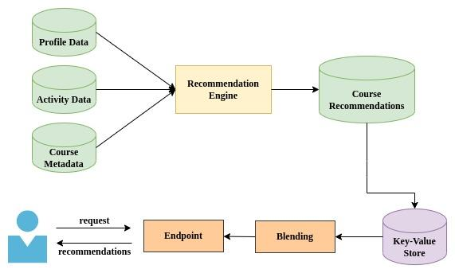

1. **Notes & Assumptions**

* The above scope is based on our assumptions and can be change if there is any change in scope.
* Please confirm the above feature listing and do let us know if you want to add/remove any feature apart from above mentioned.
* You have to provide us with all the third party api’s, Logo (.jpeg, png), Color Combination and high level graphics

**7.1 Execution Environments**

We proposes to have following various execution environments. This primarily means that there will be four different environments for the project execution:

● Development Environment (at Latitude site)

● Testing Environment (at Latitude site)

● Fixes Round (at Latitude site)

● Staging Environment / Testing environment (At Client site)

● Production / Release Environment (At Client site)

**7.2 Supported Browser**

● Google Chrome v96.0 & further

● Mozilla Firefox v94 & further

● Microsoft Edge v96 & further

● Opera v81 & further

● Safari v15.0 & further

1. **Project Timeline**

**Note: -** *Timeline may be changed, if there is any change in scope.*

1. **Project Cost**

|  |  |
| --- | --- |
| **Description** | **Cost** |
|  |  |
|  |  |
|  |  |

1. **Milestones / Payment terms**

* 20% on Completion of Milestone -1 (Wireframe and UX/UI)
* 20% on Completion of Milestone -2 development
* 20% on Completion of Milestone - 3 development
* 20% on Completion of Final Milestone -4 development
* 20% on Going Live (Production Release)

**11. Web Architecture:**

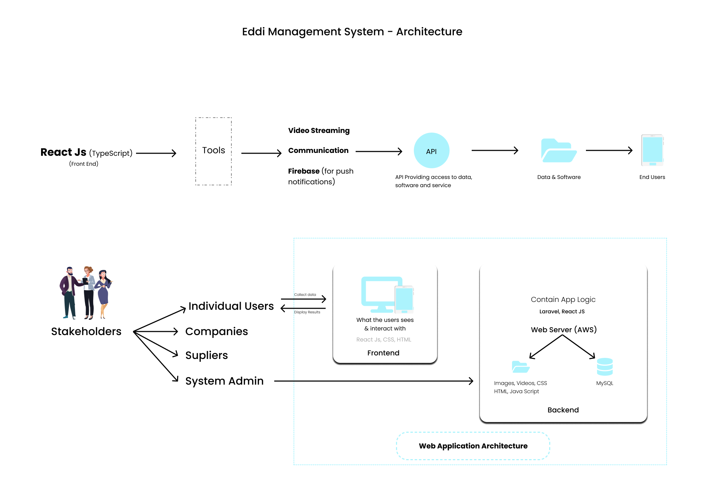

**12. Team Structure**

**Project Manager**

**Business Analyst**

**Developer**

**Designer**

**Tester**

**Team**

1 Coordination & Relationship Manager : Digant

1 Project Manager : Sanjay/Hardik

2 Frontend (React) Developers : Neel and Prince

2 Backend (Python) Developer : Parth and Jugal

2 QA : Dipak and Dilip

1 DevOps Engineer : Ravindra

**13. Process**

Our company latitude works on the simple mantra that success can be achieved by making the customer successful and our main goal is to make our client highly satisfied. We deliver quality software to our client and for that we only follow agile methodology for every software project development. Agile methodology is the proven methodology for software product methodology.

Agile methods primarily focus upon breaking up the entire product into smaller, easily developable, “shippable” product features developed through “incremental” cycles known as “sprints”.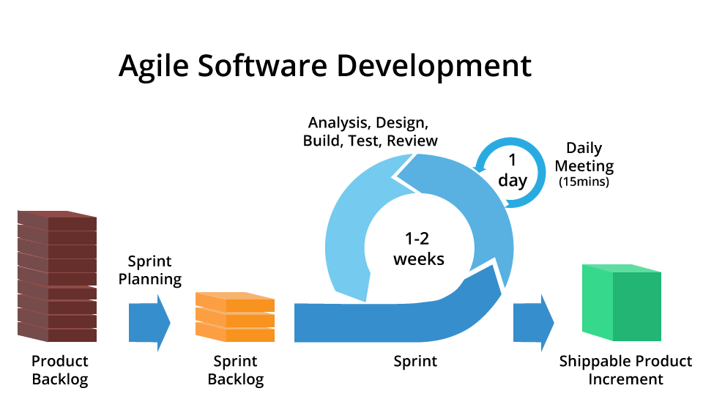

Agile methodology adopts a process of frequent feedback, as and when needed, to collaborate, and speed up the development process through sharing of ideas and self-management. The feedback system helps to support the self-correction features of Agile frameworks, and is very important.

The roles played in the agile process constitute the product owner, Project manager, Business analyst, QA and the development team. The product owner “owns” the project on behalf of the stakeholders and ensures that the entire project is developed successfully keeping in mind the stakeholder’s vision of the product as it should “appear” in the market.

The project manager ensures that the Agile process is followed at all times, and does his or her best to resolve any difficulties or technical issues arising during the development process.

The team members participate actively in the daily sprints and make sure meaningful and useful development of product features is presented at all times.

Agile is the realistic approach of software development.

**14. Testing**

As a company, Latitude believes in manual testing for software development. Our Quality Assurance team performs manual testing of every software product, manual testing results in quality and perfect software product.

Manual Testing is a process of finding out the defects or bugs in a software program. In this method the tester plays an important role of the end user and verifies that all the features of the application are working correctly.

The tester manually executes test cases without using any automation tools. The tester prepares a test plan document which describes the detailed and systematic approach to testing of software applications.

Test cases are planned to cover almost 100% of the software application. As manual testing involves complete test cases it is a time consuming test.

The goal of manual testing is to ensure that application is defect & error free and is working fine to provide good quality work to customers.

**15. Documentation /Handover**

Latitude believes in complete transparency and also respect the confidentiality of the client information. Thus, at the beginning of every development, we mostly sign NDA with our clients for their assurance and once the project is completed, we hand over all the project related documents, commented source code and other details to the clients.

The goal of successful project development is to obtain stakeholder acceptance of the project result. This means that the stakeholder agrees that the quality specifications of the project parameters have been met. In order to make this go smoothly, the stakeholder and project manager must have a well-documented criteria of performance in place from the beginning of the project. Final project delivery is completed when we deliver/handover final software product with all required documents.

Document Handover Activity is a part of the process that must be agreed at the initial stages of the project. The decision can be taken to do the same on a phased basis or on completion of the job.

Document Handover should be completed on time and clients receive all required as built handover documentation for construction projects on time, giving them instant access to critical documentation.

Document handover is a part of project delivery. We deliver the project with all the required documents. In document handover we include manuals, procedures, database, technical documents, and Source code and deliver a High Level overview of the project.

**16. Escalation/Change Request**

Escalation Matrix

**Team Leader**

**Project Manager**

**CTO/CEO**

**17. Change Request**

If there is any change in scope or any additional features are added, then it will be considered as a Change request. We will calculate the total no. of extra efforts required and will be charged at the rate of $15/hour.

The client needs to give the approval of the Change request along with the efforts & cost and then only those changes will be included

**18. About US**

Latitude Technolabs Pvt. Ltd has been in the market since past 10 years. As a market leader in Web & Mobile app development, Latitude focuses on achieving the best through creating the best. Our only objective is 100% satisfaction for our clients, not just on the macro level or application development, but through different stages of the software development life cycle.

Amazing number you might be looking for:-

* 18 Domains Covered
* 200+ Mobile Apps Developed
* 100+ Websites Created
* 20+ countries served
* 100% Retention Rate
* 60+ Professionals with wide experience

The domains we have considered to work on: E-commerce, Banking & Finance, Travel & Tourism, Transportation, Food & Beverages, Health-care, Social Networking, Education, Real Estate, Professional Services, News & Media, Sports, Entertainment, Crowd-funding, Safety, Agriculture and Automobiles

There are multiple reasons to work with Latitude Techno labs, but the biggest is that we enjoy delivering world-class solutions that can win the market.

We don’t speak for ourselves; our clients do!!

