Execution

Sr. No. | Contractor | Area | Activity | % Work Complete as on  02/09/23 | % Progress During Last Weekending  09/09/23 |  | % Progress for upcoming Weekending  16/09/23
 |  |  |  |  | Planned | Actual | Target
1.00 | MCC | Admin Building
1.01 |  | Plinth Beam | Reinforcement | 80% | 20% | 0% | 20%
1.02 |  |  | Concreting | 80% | 20% | 0% | 20%
1.03 |  |  | Back filling up to Tie beam | 65% | 35% | 5% | 30%
1.04 |  | Water body area | RCC wall | 15% | 20% | 5% | 20%
1.05 |  | Admin office area | Grade slab | - | 100% | 100%
1.06 |  |  | Column above grade slab | - | 20% | 20% | 100%
2.00 |  | Sports Building | Basement area column and wall till Tie beam bottom | 100% | - | - | -
2.01 |  | Ground Beam | Concreting | 65% | 35% | 5% | 30%
2.02 |  |  | masonry over GB | 55% | 45% | 5% | 40%
3.00 |  | Recreational Building | PCC | 50% | 20% | 5% | 20%
3.01 |  |  | Footing | 22% | 20% | 5% | 20%
3.02 |  |  | RCC wall | 20% | 10% | 0% | 10%
4.00 | CV&A | Compound Wall | Column till fencing | 100% | - | - | -
4.01 |  |  | First coat plaster | 10% | 50% | 10% | 50%
4.02 |  |  | Toe wall up to 14” | 40% | 60% | 10% | 50%

Note:
- Admin Building: Ground beam work is remains for logistics.
- Recreational Building: Work slow because of the muddy soil.
- Work progress slow due to Janmashtami and rain fall during the week.

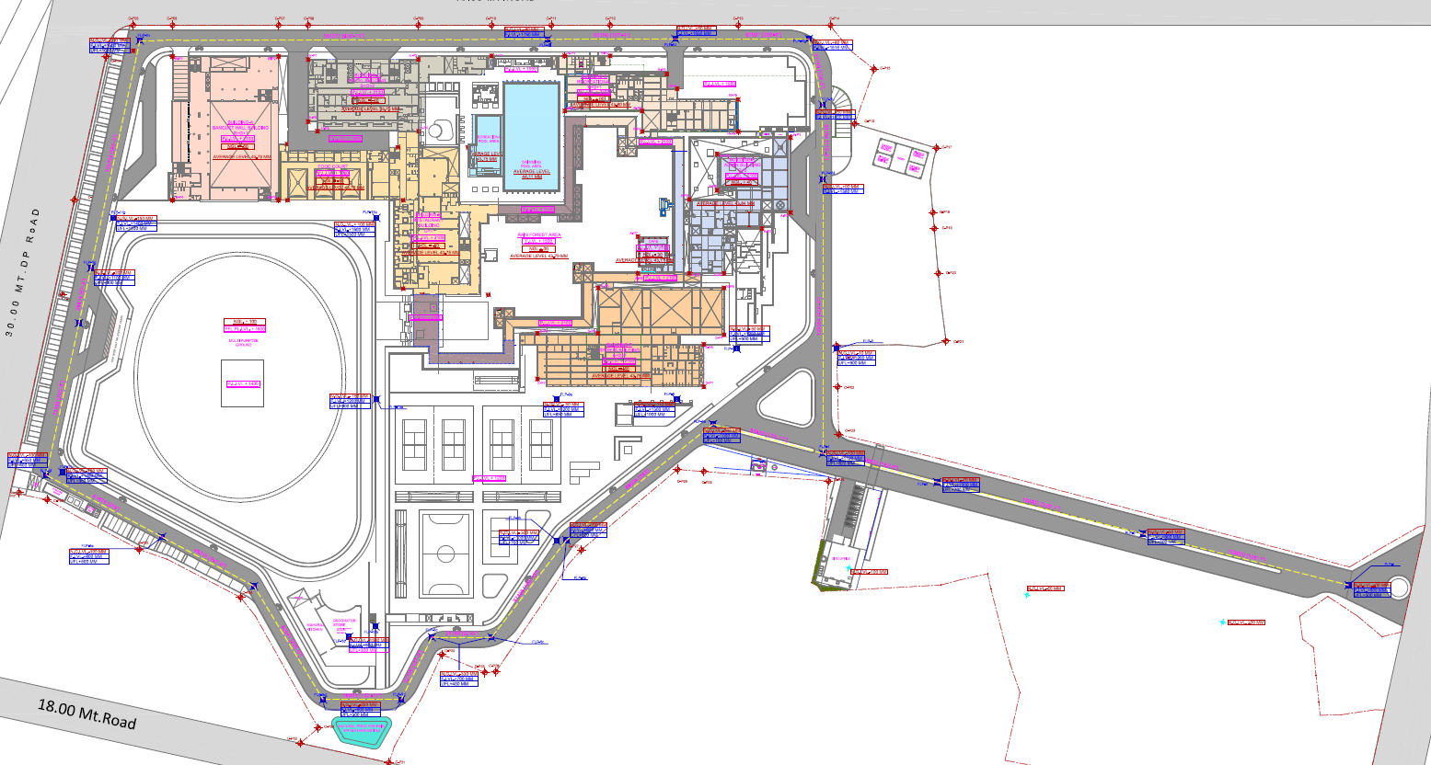
Recreation

Multipurpose lawn
Pic 01 : Site Plan
Note : Yellow highlighted Areas Indicate Works in progress.

Toe Wall
Additional Compound Wall
Admin
Sports
Fabrication yard
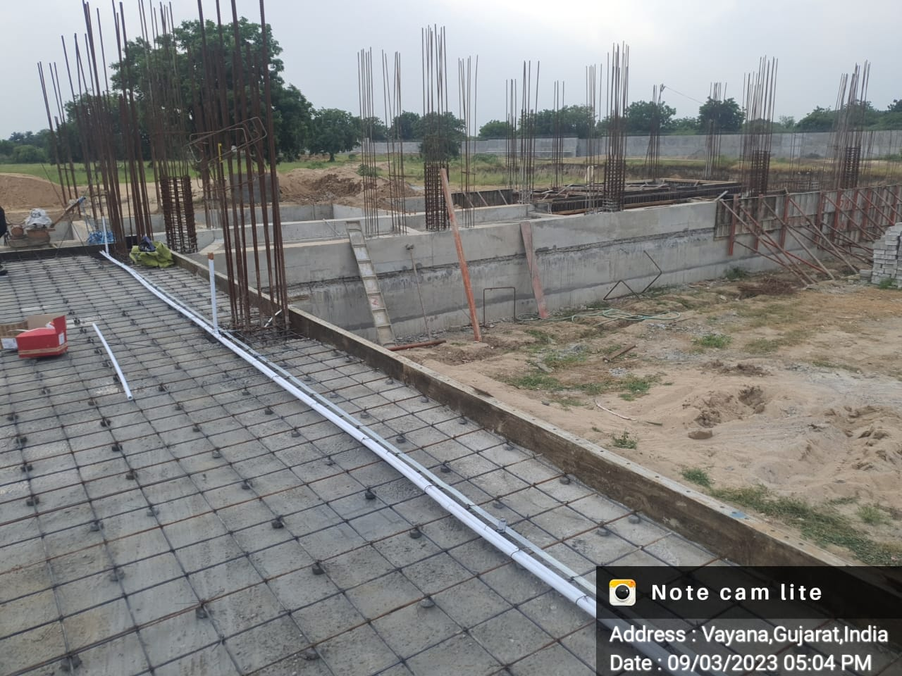 | 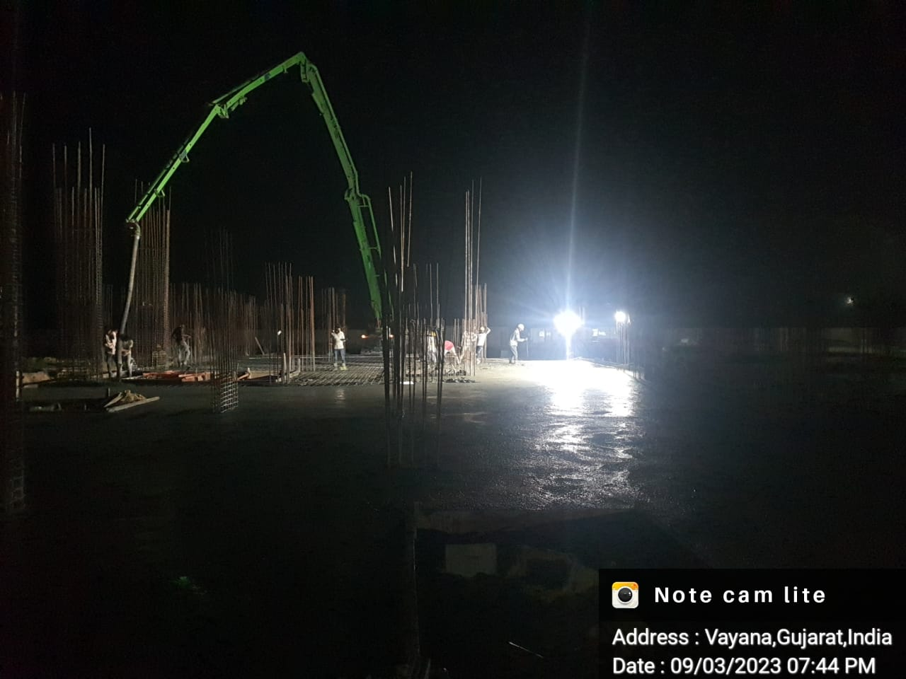
Admin Building: Office area floor conduiting work under progress | Admin Building: Concreting work of grade slab on office area under progress
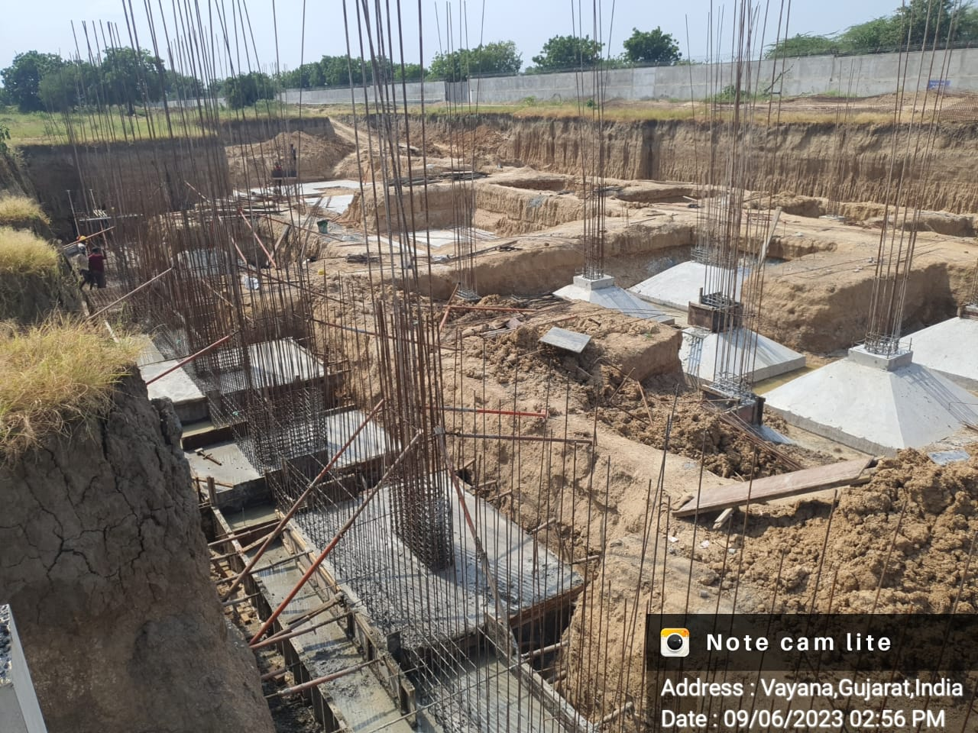 | 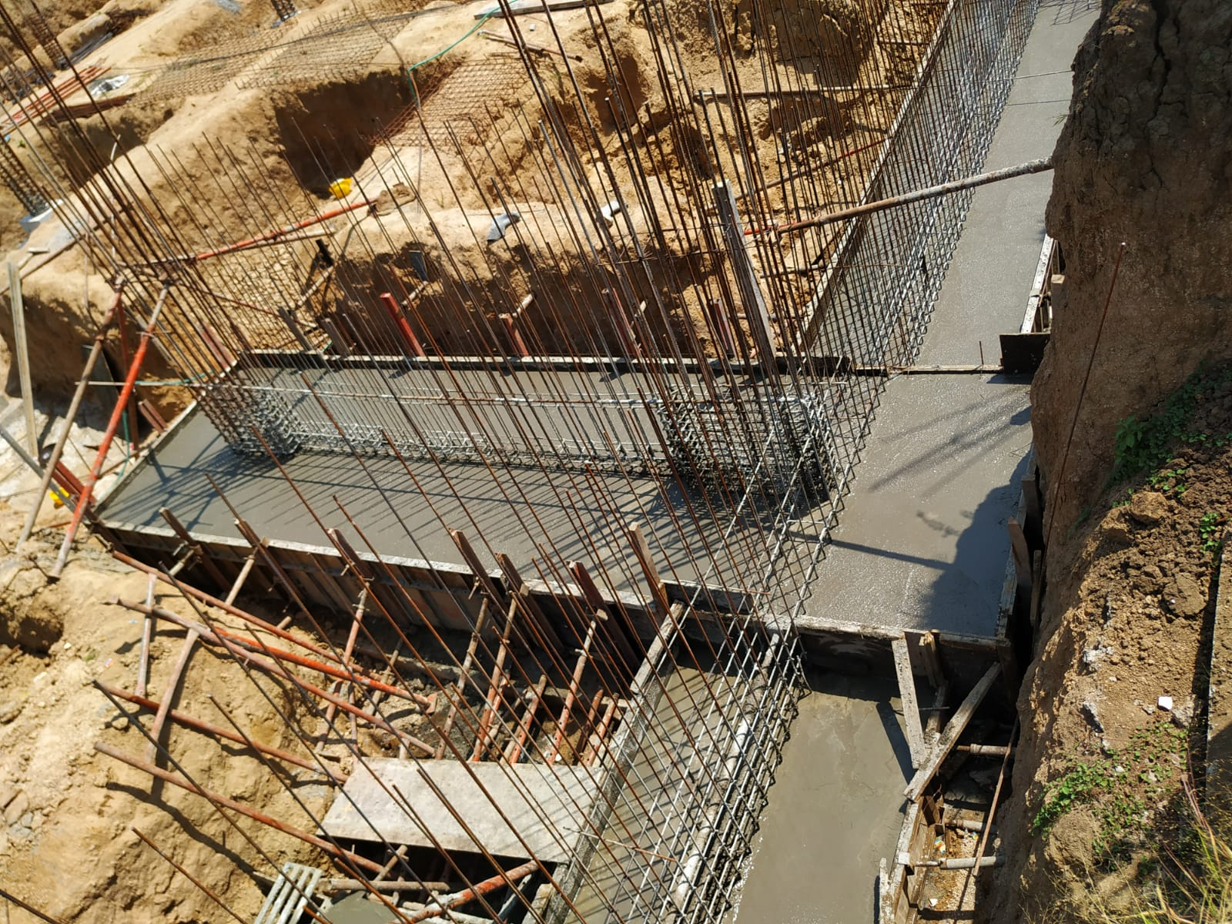
Recreational Building: Reinforcement work on footing of RCC wall under progress | Recreational Building: Concreting work on footing of RCC wall under progress
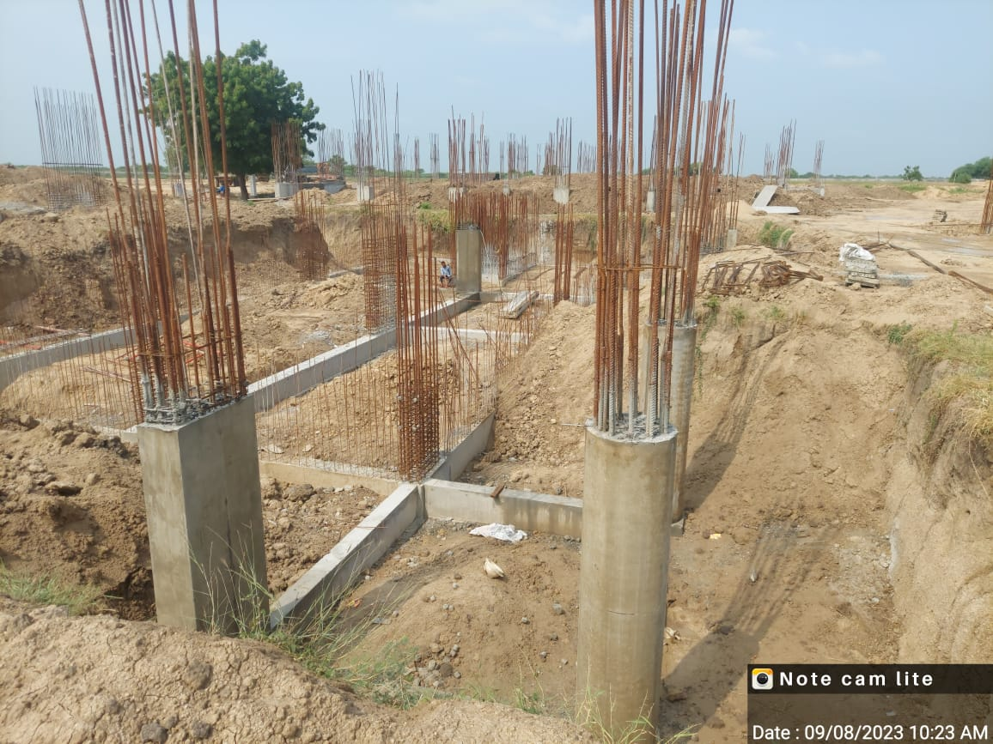 | 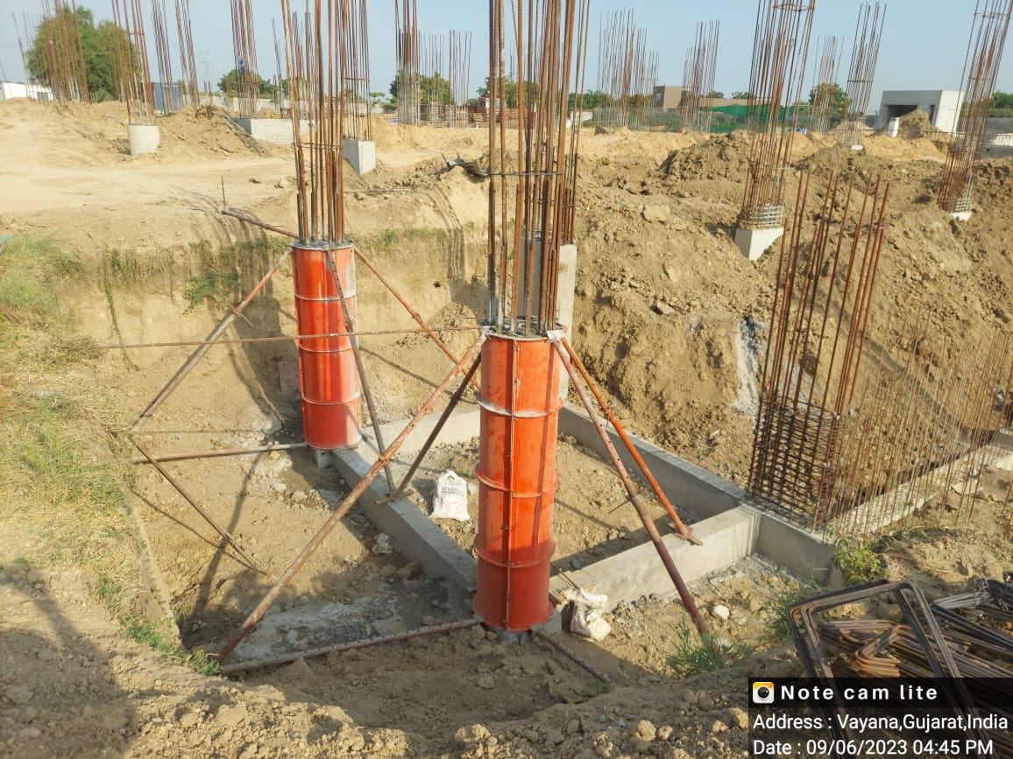
Sports Building: Basement area Tie beam work completed | Sports Building: Concreting on column near basement area under progress

