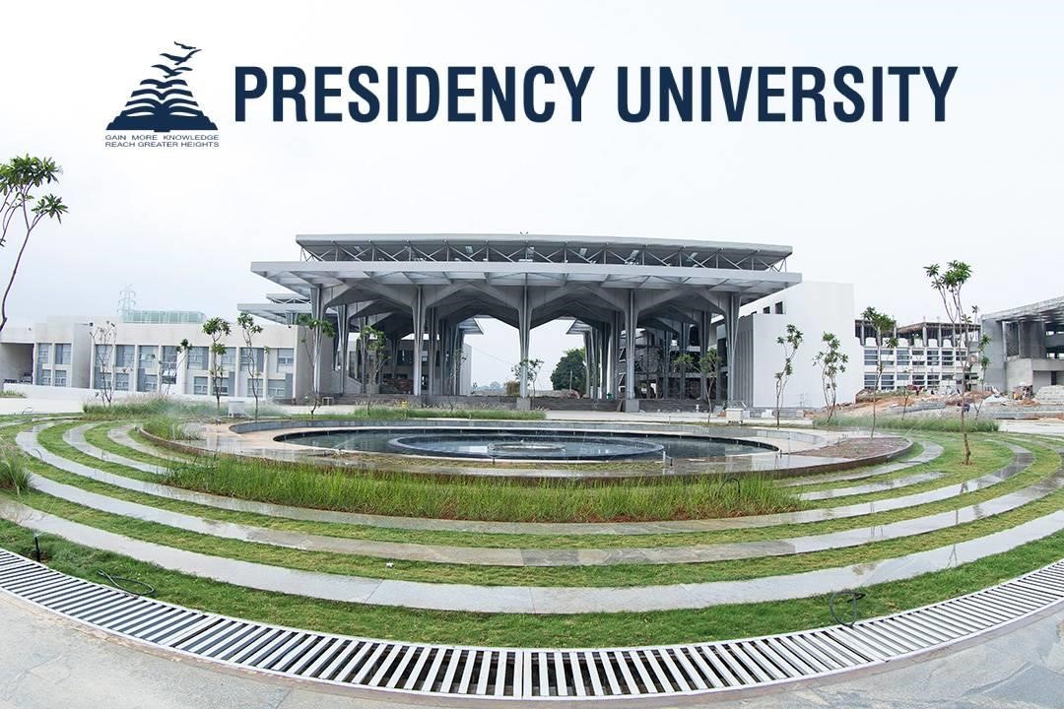
PRESIDENCY SCHOOL OF ARTIFICIAL INTELLIGENCE
AND ADVANCED COMPUTING
NVIDIA GPU USER INTERNSHIP

PROJECT REPORT
AI Railway Track Safety System using Computer Vision
Name: | Maulya Reddy M
Roll Number: | 20241CBD0022
Department: | CSE (Big Data)
HOD: | Dr. Pravintharaj
Project Name: | AI Railway Track Safety System using Computer  Vision

1. Introduction

- Railways carry millions of passengers and huge amounts of goods every day, which makes track safety extremely important.
- .Accidents happen when people, animals, or vehicles cross or stay on the tracks without being noticed in time.
- .It is impossible for human staff to watch every stretch of track, all day and night, without missing something.
- This project builds an AI-based system that watches a railway track video and automatically spots dangerous obstacles before an accident can happen.
- .It combines YOLOv8 (an object detection model), OpenCV (for handling video), and a live Streamlit dashboard, so that an operator can see exactly what the AI sees, in real time.

2. Problem Statement

- .Manual monitoring of railway tracks is slow, tiring, and cannot cover every location at once.
- .Small but dangerous situations — like a person walking on the track, or an animal wandering onto the rails — are often noticed too late.
- There is no simple, low-cost tool that watches track footage continuously and instantly warns someone the moment danger appears.

Goal of this project
To build an AI system that watches railway track video in real time, automatically detects obstacles such as people, animals, and vehicles, and raises an immediate alert so accidents can be prevented before they happen.

3. Objectives

- Automatically detect obstacles — people, animals, and vehicles — on railway tracks.
- Generate a clear, real-time alert (a visual warning banner, plus an optional alarm sound) the moment a hazard is found.
- Display the live video feed, detections, and alerts together on an easy-to-use web dashboard.
- Keep a saved record (log and screenshot gallery) of every incident, so it can be reviewed later.
- .Demonstrate, in a practical way, how AI-based automation can genuinely improve safety in the transportation sector.

4. Technologies Used

The table below lists every tool used to build the project and explains, in simple terms, what job it does.
Technology | Purpose
Python | The main programming language used to build the whole project.
YOLOv8 | The AI model that looks at each video frame and detects objects like people, animals, and vehicles.
OpenCV | Reads the uploaded video and breaks it into individual frames for the AI model to process.
Streamlit | Builds the interactive web dashboard where the video, alerts, and statistics are displayed.
NVIDIA GPU (CUDA) | Speeds up the YOLOv8 model so detection happens quickly, almost instantly, instead of lagging.
VS Code | The code editor used to write, test, and debug the project.
Antigravity (AI coding assistant) | An AI tool that helped write and debug code faster while building the project.

5. System Architecture

The system has two connected parts: a web app the operator interacts with (Streamlit), and a detection engine that runs in the background using YOLOv8 on a GPU. The diagram below shows how data moves through the system, from the moment a video is uploaded to the moment an alert appears on screen.

Operator uploads railway track video (Streamlit)
↓
OpenCV splits the video into individual frames
↓
Each frame sent to YOLOv8 model (running on NVIDIA GPU)
↓
Model returns bounding boxes + confidence score for each object
↓
System checks if the object is inside the marked danger zone
(ROI)
↓
If yes → Alert banner + alarm sound + incident logged
↓
Dashboard updates live: video, alert, analytics, and gallery

6. Working Methodology

The system follows a simple, repeating loop for every video that is processed:
- The operator uploads a track video (or selects the demo video) on the Live Monitor tab.
- OpenCV reads the video and processes it frame by frame.
- Each frame is sent to the YOLOv8 model running on the GPU.
- YOLOv8 returns the object label, bounding box position, and confidence percentage for anything it detects.
- The system checks whether the detected object falls inside the marked danger zone.
- If it does, three things happen at once: a red alert banner is shown, the alarm sound plays (if enabled), and the detection is saved to the incident log and screenshot gallery.
- The Analytics Dashboard updates automatically to reflect the new incident count and charts.
- This loop repeats continuously for every frame in the video, giving the operator a near realtime safety monitor.

7. GPU Utilization

- YOLOv8 is a deep learning model with millions of internal calculations to run for every single frame — this is heavy work for a normal CPU.YOLOv8 is a deep learning model with millions of internal calculations to run for every single frame — this is heavy work for a normal CPU.
- An NVIDIA GPU, using CUDA, performs these calculations in parallel, making detection many times faster than running on a CPU alone.An NVIDIA GPU, using CUDA, performs these calculations in parallel, making detection many times faster than running on a CPU alone.
- Faster detection means the alert appears almost instantly after a hazard shows up in the video — this is essential for a safety system, since a delayed alert is far less useful.Faster detection means the alert appears almost instantly after a hazard shows up in the video — this is essential for a safety system, since a delayed alert is far less useful.
- The lightweight yolov8n.pt model was used, which is designed to run smoothly even on entry-level GPUs while still being accurate.The lightweight yolov8n.pt model was used, which is designed to run smoothly even on entry-level GPUs while still being accurate.
- An NVIDIA GPU with around 4–6 GB of VRAM is enough to run this project smoothly for real-time video processing.An NVIDIA GPU with around 4–6 GB of VRAM is enough to run this project smoothly for real-time video processing.
- This project reflects the core purpose of the NVIDIA GPU User Internship — using GPU acceleration to make a real AI application practical and fast.This project reflects the core purpose of the
NVIDIA GPU User Internship — using GPU acceleration to make a real AI application practical and fast.

8. Results

The system was tested using uploaded railway track videos containing a person walking near and on the track. The table below summarises the key results observed during testing.
Metric | Observation
Model used | YOLOv8n (yolov8n.pt)
Confidence threshold | 0.40
Obstacle type tested | Person (on / near track)
Detection confidence range | 84% – 89% across test frames
Total incidents logged | 95
Critical threats | 95
Top hazard type | Person
Alert response | Alert shown in the same frame the obstacle entered the danger zone

.
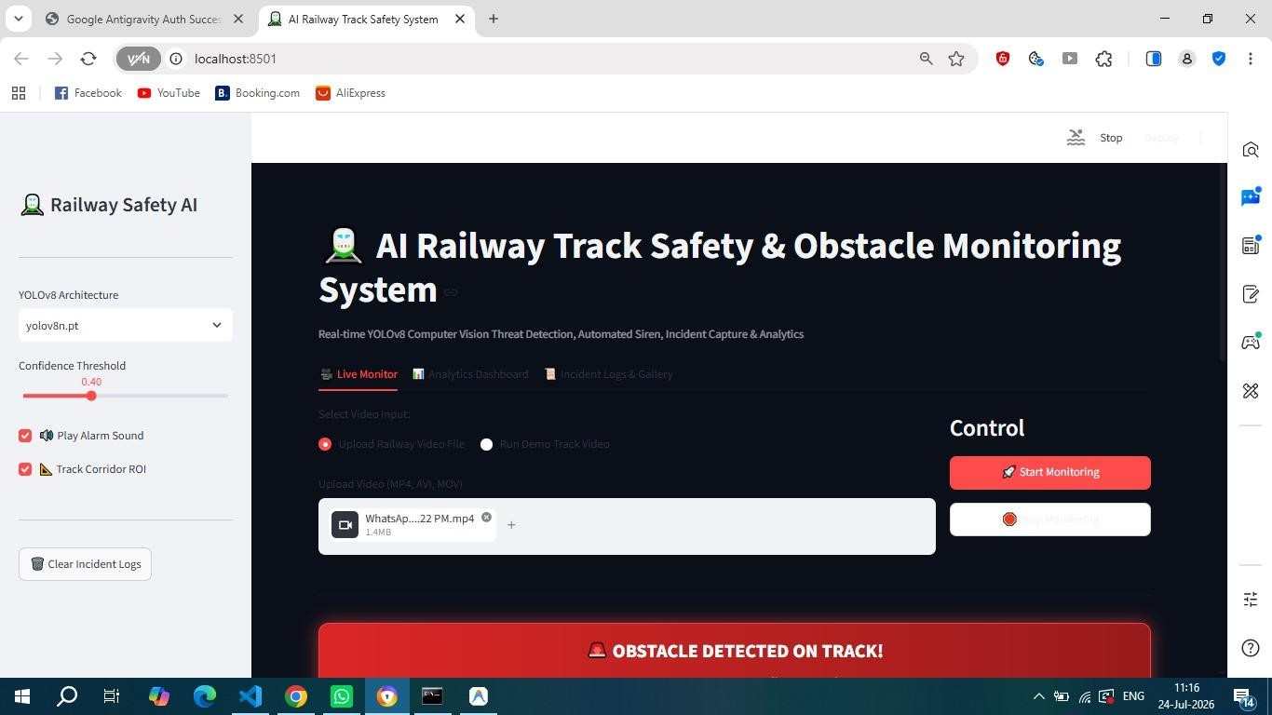
Screenshots
—

Home Page

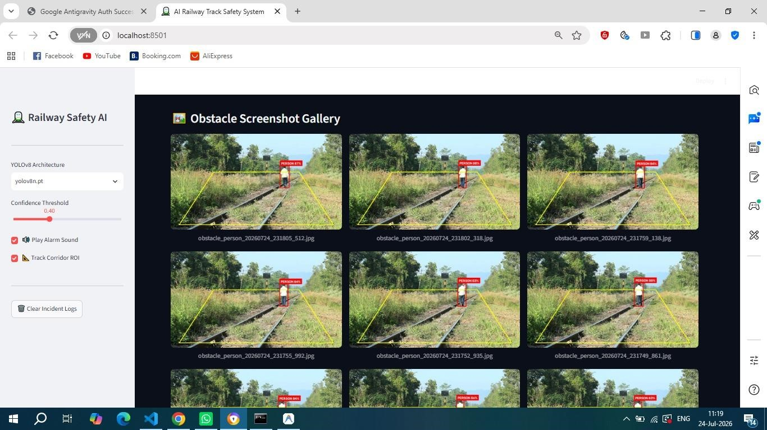
Screenshots
—

Object Detection Gallery

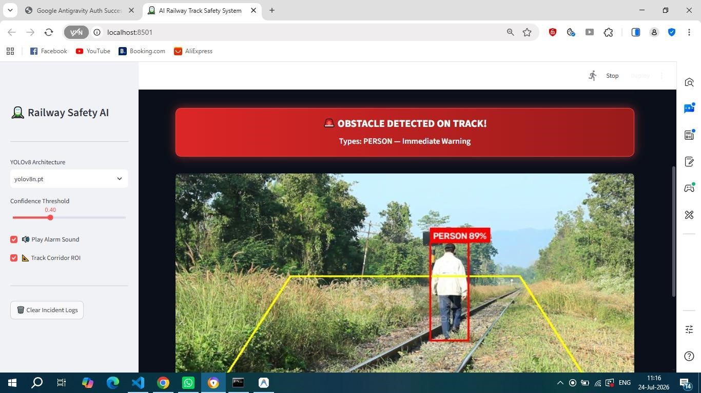
Screenshots
—

Alert Message

Screenshots — Detection History / Analytics
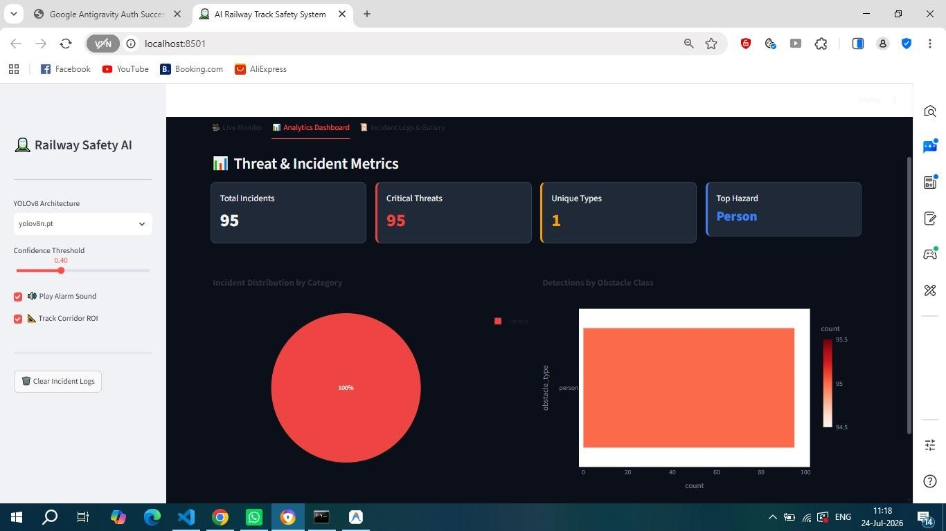

10
. Advantages

- Works in real time, so alerts appear almost as soon as a hazard enters the danger zone.
- Simple web dashboard — no special software needed, just a browser.
- Keeps a visual history (screenshot gallery) of every incident, useful for later review or reporting.

11. Limitations

- Currently tested on uploaded videos, not yet connected to a live CCTV camera feed.
- Detection accuracy depends on video quality — poor lighting, rain, or fog could reduce accuracy.

13. Conclusion

This project shows that combining YOLOv8, OpenCV can produce a working, real-time obstacle detection system for railway tracks. The system successfully detected people on the track with high confidence and raised alerts instantly, exactly as intended. The live dashboard, alert system, and incident logging together turn a fairly simple pipeline into a genuinely usable safety tool.

