**Name & Surname : Maumela Tshifhiwa**

**Course-Activity-no : SE-Assignment-5**

**1. Installation of VS Code:**

To download and install Visual Studio Code (VS Code) on Windows 11, follow these steps:

**Prerequisites:**

* Windows 11 operating system
* An active internet connection

**Steps:**

1. **Download VS Code:**
   * Visit the [Visual Studio Code website](https://code.visualstudio.com/).
   * Click on the "Download for Windows" button. This will download the installer for Windows.

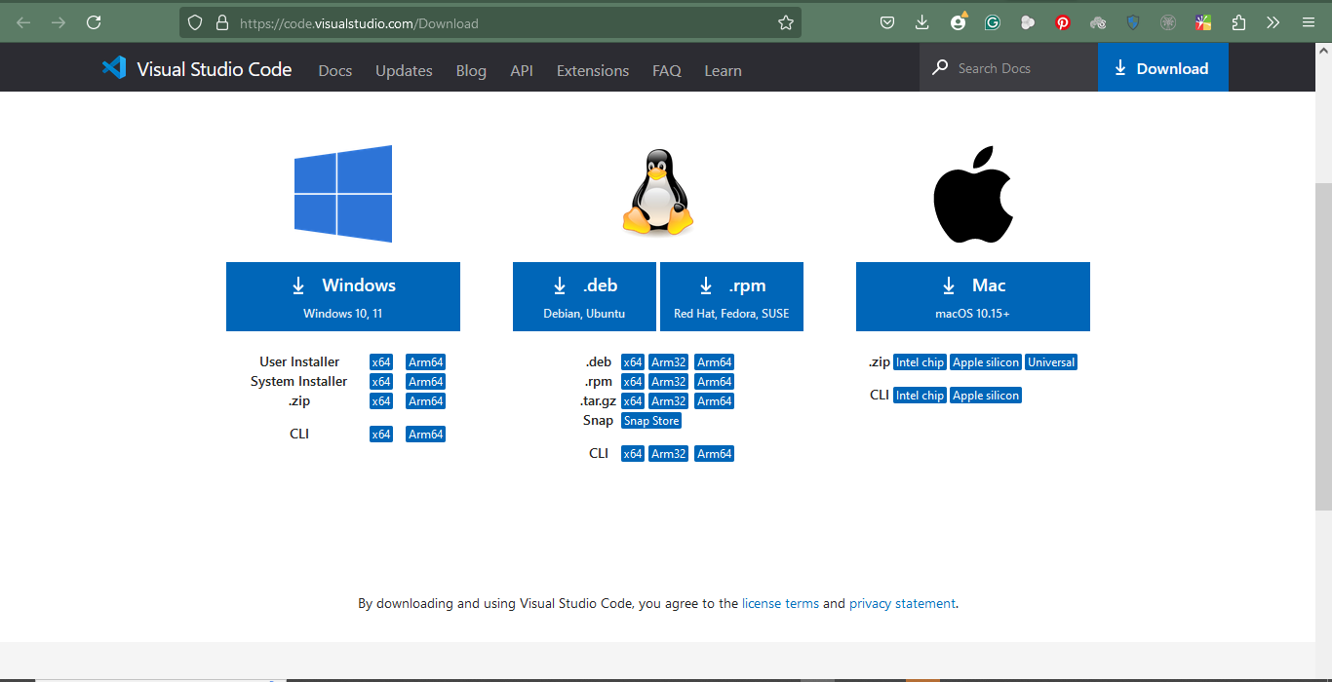



1. **Run the Installer:**
   * Locate the downloaded file (VSCodeUserSetup-x64-<version>.exe) in your Downloads folder.
   * Double-click the installer to run it.
2. **Install VS Code:**
   * Follow the prompts in the installer:
     + Accept the license agreement.
     + Choose the destination folder (default is recommended).
     + Select additional tasks (optional), such as creating a desktop icon.
   * Click "Install" to begin the installation.
3. **Launch VS Code:**
   * Once the installation is complete, you can choose to launch VS Code immediately by keeping the checkbox "Launch Visual Studio Code" checked and clicking "Finish."
   * Alternatively, you can launch it later from the Start menu or desktop shortcut.

**Optional Configuration:**

* **Extensions:** After installing, you can add extensions for languages, debuggers, and other tools from the Extensions view in VS Code.
* **Settings Sync:** Sign in with a Microsoft or GitHub account to sync settings across devices.

**2.Initial Setup for VS Code:** 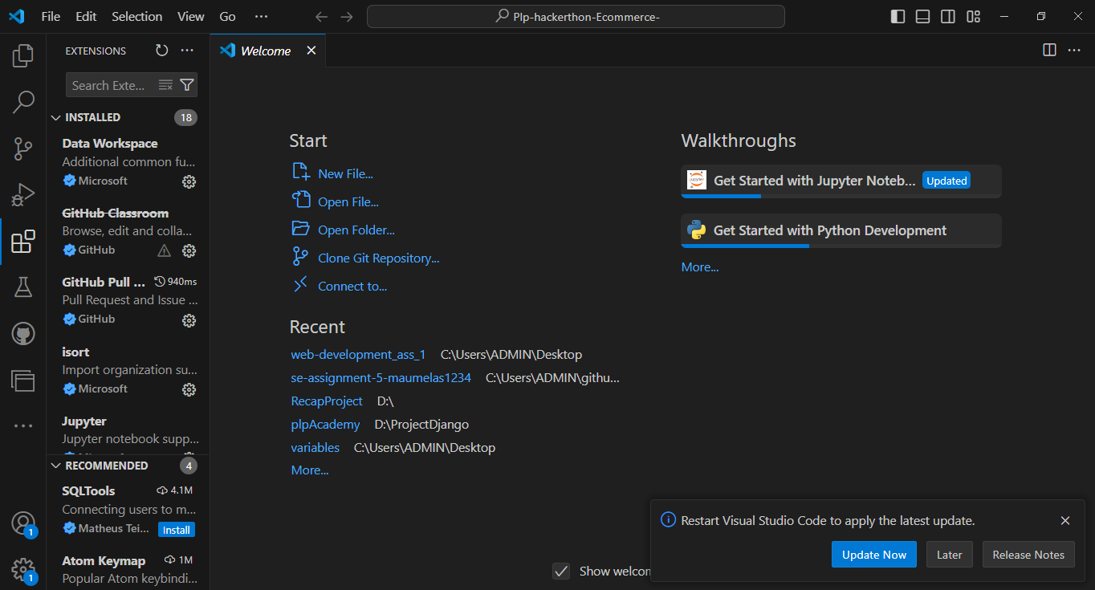



1. **User Interface Settings:**
   * **Theme:** Go to File > Preferences > Color Theme and choose a theme you like (e.g., Dark+, Light+).
   * **Font Settings:** Adjust the font size and family in File > Preferences > Settings > Text Editor > Font.
2. **Key Extensions:**
   * **Language Support:** Install extensions for languages you'll use, like Python, JavaScript, or C++.
   * **Code Formatting:** Prettier for code formatting.
   * **Linting:** ESLint for JavaScript, Pylint for Python.
   * **Version Control:** GitLens for enhanced Git capabilities.
   * **IntelliSense:** Install relevant language packs for code completion.
3. **Settings Sync:**
   * Enable Settings Sync (Manage > Settings Sync) to sync settings across devices.
4. **Custom Shortcuts:**
   * Customize keybindings in File > Preferences > Keyboard Shortcuts.
5. **Extensions Marketplace:**
   * Browse the Extensions view (Ctrl+Shift+X) to find and install additional tools and extensions relevant to your projects.
6. **Workspace Setup:**
   * Set up workspaces by creating or opening folders/projects via File > Open Folder.
7. **Terminal Configuration:**
   * Configure the integrated terminal to use your preferred shell (PowerShell, Bash, etc.) in File > Preferences > Settings > Terminal.

**3.User Interface Overview:**

1. **Activity Bar:**
   * Located on the left, provides access to Views like Explorer, Search, Source Control, Run and Debug, and Extensions.
2. **Side Bar:**
   * Shows different views like the file explorer, search results, or source control information.
3. **Editor Group:**
   * The central area where you edit files. You can split the editor into multiple groups for side-by-side editing.
4. **Status Bar:**
   * Located at the bottom, it shows information about the current workspace, such as encoding, line endings, and connected branches.

**4.Command Palette:**

* **Access:** Press Ctrl+Shift+P or F1.
* **Purpose:** Provides a quick way to access all commands and actions in VS Code.
* **Examples:**
  + Open a file: Ctrl+P.
  + Install extensions: Extensions: Install Extensions.
  + Change settings: Preferences: Open Settings.

**5.Extensions in VS Code:**

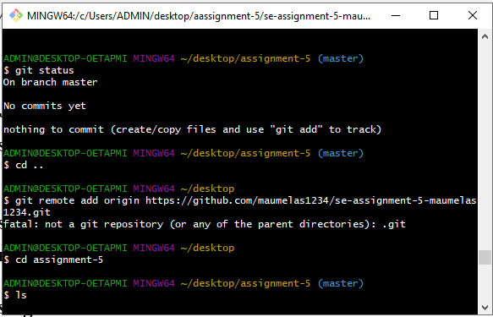

* **Role:** Enhance functionality by adding support for languages, debuggers, and tools.
* **Finding and Installing:** Go to the Extensions view (Ctrl+Shift+X), search, and click "Install".
* **Managing:** View installed extensions, disable, or uninstall them from the Extensions view.
* **Examples for Web Development:**
  + HTML, CSS, and JavaScript support.
  + Live Server.
  + Prettier for code formatting.
  + ESLint for linting JavaScript.

**6.Integrated Terminal:**

* **Opening:** Use Ctrl+ or go to View > Terminal.
* **Advantages:**
  + Convenience of running commands within the editor.
  + Supports multiple terminals.
  + Shares the workspace environment.
* **Usage:** Execute commands, run scripts, and manage processes.

**7.File and Folder Management:**

* **Creating and Opening:** Use the Explorer view or right-click in the Side Bar.
* **Managing:** Drag and drop to move files, use right-click for options.
* **Navigating:** Use the File Explorer, Ctrl+P to open files quickly, or Ctrl+Tab to switch between files.

**8.Settings and Preferences:**

* **Location:** File > Preferences > Settings or use Ctrl+,.
* **Customizing:**
  + Change theme: Color Theme in Command Palette.
  + Adjust font size: Editor: Font Size in settings.
  + Modify keybindings: File > Preferences > Keyboard Shortcuts.

**9.Debugging in VS Code:**

1. **Setup:**
   * Open the file you want to debug.
   * Set breakpoints by clicking in the gutter next to the line numbers.
   * Configure the launch configuration in launch.json (automatically created for supported languages).
2. **Starting Debugging:**
   * Click the Run and Debug icon in the Activity Bar or press F5.
3. **Key Features:**
   * Breakpoints, watch variables, call stack, and stepping through code.

**10.Using Source Control:**

1. **Integrating Git:**
   * Initialize a repository: View > Source Control and click "Initialize Repository".
   * Stage changes: Click the + icon next to changed files.
   * Commit changes: Enter a message and click the checkmark.
   * Push changes: Use the ... menu and select "Push".
2. **Pushing to GitHub:**
   * Link your local repo to a GitHub repo using the terminal (git remote add origin <URL>).
   * Push changes with git push -u origin master.

