CSCI 5112

Final Report – ProductReport.com

By

Team 9

Priya Kuchipudi
Sandhya Nune
Sathish Ramamoorthy
Jatin Zalavadia

Table of Contents

1. Project Overview 4
Project Scope and Objectives 4
2. Customer Requirements 5
2.1 Use Case: Compare Products 6
2.2 Use Case: Reviews 6
2.3 Use Case: Browse Product Information 6
2.4 Use Case: Search Products 6
2.5 Use Case: Maintain Product Data 6
2.6 Use Case: User Account 7
2.7 Use Case: Tendency Tracking 7
2.8 Use Case: Generate Reports 7
2.9 Use Case: Help & FAQ 7
2.10 Use Case: Select Ad to Display 7
3. Architectural Design 8
3.1 Subsystem Architecture 8
3.2 Deployment Diagram 10
4. Use Case Realization Design 11
4.1 Use Case Compare Products 11
4.2 Use Case Reviews 13
4.3 Use Case Browse Product Information 15
4.4 Use Case Search Products 17
4.5 Use Case Maintain Product Data 18
4.6 Use Case User Account 20
4.7 Use Case Generate Reports 22
4.8 Use Case Help & FAQ 24
5. Subsystem Design 25
5.1 Subsystem Design : User Account 25
5.2 Subsystem Design : Manufacturer 28
5.3 Subsystem Design : Category 29
5.4 Subsystem Design : Product 32
5.5 Subsystem Design : MaintainData 39
5.6 Subsystem Design : Tracking 41
5.6.1 Subsystem Design : Tracking info 42
5.6.2 Subsystem Design : Activity Monitor 42
5.7 Subsystem Design : Advertisement 44
5.8 Subsystem Design : Help & FAQ 46
5.9 Subsystem Design : Generate Report 47
5.10 Subsystem Design : App Process 50
5.10.1 Subsystem Design : Search 52
5.10.2 Subsystem Design : Browse/Selection 53
5.10.3 Subsystem Design : Compare 54
5.10.4 Subsystem Design : Review 55
5.11 Subsystem Design : UI, Servlets & Applets 56
5.11.1 Interface: UserValidation 57
5.11.2 Interface: Product Selection 58
5.11.3 Interface: SearchProduct 58
5.11.4 Interface: MaintainData 59
5.11.5 Interface: GenerateReports 60
5.11.6 Interface: ProductReview 61
5.11.7 Interface: CompareProduct 61
5.12 Subsystem Design : Database 62
6. Human interfaces. 64
6.1 Login Screen 64
6.2 Main Screen 65
6.3 Categories Screen 66
6.4 Product listing Screen 67
6.5 Select Product Screen 68
6.6 Compare REsults Screen 69
6.7 REview Listing Screen 70
6.8 Select REview SCreen 71
6.9 Product Info Screen 72
6.10 Manufacturer Listing Screen 73
6.11 SEarch 74
6.12 SEarch Results 75
6.13 Help/faq 76
6.14 Adminstrators Screen 77
7. Use-Case Scenarios 78
7.1 Use Case: Compare Products 78
7.2 Use Case: Reviews 78
7.3 Use Case: Browse Product Information 78
7.4 Use Case: Search Products 78
7.5 Use Case: Maintain Product Data 79
7.6 Use Case: User Account 79
7.7 Use Case: Tendency Tracking 80
7.8 Use Case: Generate Reports 80
7.9 Use Case: Help & FAQ 80
7.10 Use Case: Select Ad to Display 80
8. System/Data Dependencies & Requirements 83
9. Testing Plan & Results 84
9.1 Unit Testing : Black box testing 84
9.2 White box testing: 86
9.3 Integration Testing 87
9.4 System Testing 92
10. Project Status & Summary……………………………………………………………………………..93
10.1 Status……………………………………………………………………………………………..93
10.2 Difficulties Encountered………………………………………………………………………….94
10.3 Journal Of Project Activities……………………………………………………………………..95

Project Overview

In today’s market there are lot of products manufactured by different vendors. They are advertised a lot on the Television, over the Internet and other sources. When it comes to make a decision by the consumer as to what to buy it is a difficult matter. We need a source of information to guide the consumer in making wise purchases. The ProductReport.com site can be a solution for that.

ProductReport.com is a multi-tiered web application that will compare different products and services available in open market by different manufacturers, retailers and service providers to guide consumer user in decision-making before they buy the product

The front end of this application will give a list of products and services from which a consumer user can select a product. The comparison of the selected product will be displayed for all attributes of the product available and disclosed by the manufacturer and service providers. The site also gives the ratings, reviews and guidelines about products and services. It will also provide the links to the different web sites related to the product like manufacturers, retailers and test agencies. The web site will help the consumer user to find the consumer agencies and information sources regarding the consumer issues.

The back end of the application will allow the administrator to edit the data, enter the new products and data, purge the outdated data and other tasks necessary in order to maintain the usefulness of the application. The administrator will have an archive of reports

Project Scope and Objectives

The main objective of this project is to develop a web based application, which deals with the comparison of different products and services provided by different manufacturers. The following are the basic functionalities of the proposed system

- Product listings by Categories and Manufacturers
- General product reviews
- Comparison of Products
- Product feature education
- Search, Help, FAQ
- Tendency tracking
- Member services
- Consumer issues
- Manufacturer links

Customer Requirements

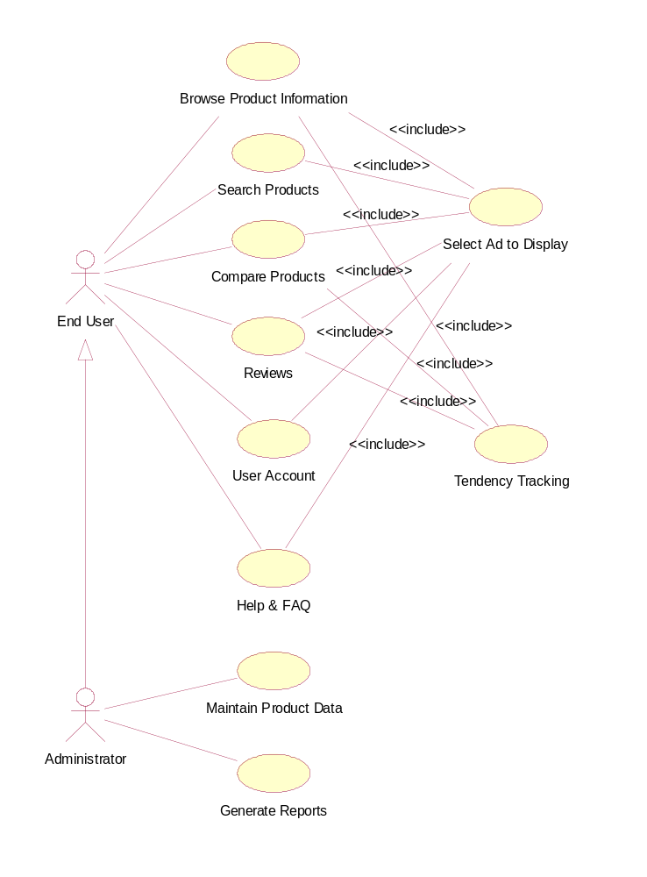

Use Case: Compare Products
In this use case the user selects the category and then the product. The list of manufacturers, the attributes of the product etc are displayed on the screen for the user to select. Then the product information is displayed in table format with the ratings, comments etc.

Use Case: Reviews
The system should provide reviews on various products. The user invokes the use case by choosing the reviews option. A list of all the reviews should be displayed. The user can choose to view any review. If more information is needed the user should be given an option to research further on the products by providing companies links. The use case instance ends when the user leaves the page.

Use Case: Browse Product Information
The user invokes the use case by beginning to browse product information. When the user chooses to browse through all the products the system should give the user an option to choose from a categorized listing or a manufacturer listing. The use case terminates when the user stops browsing.
2.4 Use Case: Search Products
The user invokes the use case by beginning to search for product information. The system should provide an option to execute an AND/OR/LIKE logic for the search keywords as part of search criteria. When the user enters the search criterion the system should look up the database for an appropriate match. If a match is found the results are displayed and the use case instance terminates. If no match is found the system should indicate the user that no match is found and give an option to search again with a modified search criteria. The use case terminates if the user opts not to search further.

Use Case: Maintain Product Data
If the administrator chooses the Maintain Product Data option, system should prompt for options for the ADD, DELETE, and UPDATE
If ADD is selected, system should display the product data form, where administrator can enter information regarding the new product such as product name, product category, and other product Attributes and available information from manufactures. Once the data is filled and submitted by administrator, system should validate the data filled. If the data is found ok it should create new product in the product listings.
If UPDATE or DELETE is selected system should display the listing of available product from which administrator chooses the product to UPDATE or DELETE.
If UPDATE is selected and product to update is selected, system should display the update data form, which will list all the data available for the selected product. With this display administrator should be able to edit the data and submit to system. Once the data is updated the system should validate the data entered.
If DELETE is selected and product to delete is selected, system should display the data for the product selected to delete and prompt for the confirmation of delete operation. If administrator confirms the delete operations, system should mark the product data as deleted and delete all the links of the product to all functionality of the application.
In this process if any validation or confirmation fails, system should display the error message and take the user to previous screen.

Use Case: User Account
This interface should give choice to user for login to the application. The choice should be Login, and Register.
When a user who has already registered chooses Login, the system should prompt for the UserID and Password. Once the user enters the UserID and Password, the system should validate the data Entered, if the data is valid i.e. login is successful.
When a user who has not registered chooses Register, the system should prompt for the new user data Screen where the user can enter information like name, address, age group, income group, sex, etc. This information should be validated once the user completes the data sheet and submits. This information validation should be able to reconfigure for the field validation for mandatory and optional information. Once the information is validated and found valid, system should create new account for the user and assign UserID to this user and should prompt to select Password. Once the Password selection is validated system should display welcome screen to this new user from where user can start using the application.
In this process if any validation fails, system should display the error message and take the user to previous screen.

Use Case: Tendency Tracking
User and tracking information is received from the other use cases, and updated in the database. Tracking information is the Category/Product selections made by the user.

Use Case: Generate Reports
In this use case, the system checks the login to see if the user is the system administrator. If the user is not the administrator then an access denial page is displayed. If the user is the administrator, then the administrator has to select the type of report. The various reports will be Popularity by Category, List of all users interested in a product/category, Users group interest by category etc. The Popularity by Category report will have a pie chart indicating the popular products. Depending on the type of report chosen, the system looks up for the information and displays the results in the report.

Use Case: Help & FAQ
When this Help and FAQ are selected, the system should display the help topic list from which User can select the topic to view the help. Once the topic is selected system should display the selected topic details. If exit is selected system should return to the main screen of application from where user can excess the other functionality.

Use Case: Select Ad to Display
Advertisements are categorized and stored in the database. Depending on what category the user is interested in, an ad from that category is selected for display. A counter keeps track of the number of times an ad has been displayed. If no ad is found in a category, a selection is made from all available ads. Ad selections will be randomized.

Architectural Design

Subsystem Architecture

The Application-specific layer consists of the Client subsystem and Server subsystem.
The Client has other subsystems that are User Interfaces subsystem (UI), Tracking subsystem and Help & FAQ subsystem.
The Server subsystem depends on the subsystems that are Application Process and Data Objects Subsystems.
The Application Process Subsystem depends on other subsystems that are Compare, Search, Browse/Selection, Maintain Data & Generate Reports Subsystems. The customers use this system to mainly compare the products and find the reviews of the products they choose.
The Application-generic layer consists of the Data Objects subsystem.
The Data Objects subsystem depends on the User subsystem, Category & Product subsystem and Advertisement subsystem and Oracle Database Tables in the System software layer.
The Middleware layer consists of Java.servlet, Java Virtual Machine, Web Browser, Java applet, java.rmi and Java.jdbc. Almost all the subsystems depend on the Java Servlets. The Java Servlets depend on the Java Virtual Machine. The Web Browser is used to show the interfaces. JDBC is used for the database connectivity.
The Java Virtual Machine and Web Browser depend on the TCP/IP in the System-software layer. JDBC is used to connect to the Oracle database.

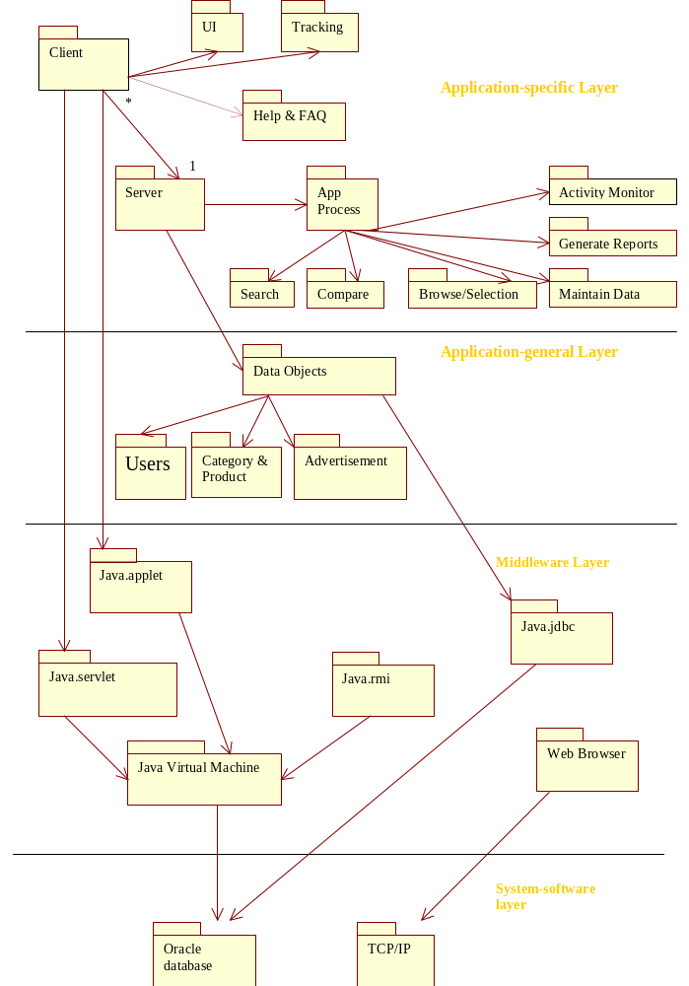

Deployment Diagram

Client
Server
Database

Client Node

Server Node

DB Node
JDBC
TCP/IP
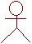
User

Description
The user interacts with the Client node. The Client Node invokes the Server node through TCP/IP protocols. The information from the Oracle database is received through Java Database connectivity (JDBC) when the server sends a message.
The client subsystem is deployed on the Client node. The server subsystem is deployed on the Sever node and the database resides on the Database node.

Use Case Realization Design

This section has a sequence diagram and a class diagram for each of the use cases. Use Cases “Select Ad to Display” and “Tendency tracking” do not have these diagrams as they are realized in other use cases.

Use Case Compare Products

Sequence Diagram:

Actor “End User” interacts with the CompareServlet through a web browser. This servlet then interacts with the other classes. When the user compares two or more products, the compareTo() message is sent that many times to the Product. The servlet then sends an asynchronous message to Tracking Info and then requests an Ad from the Advertisement sub-system.
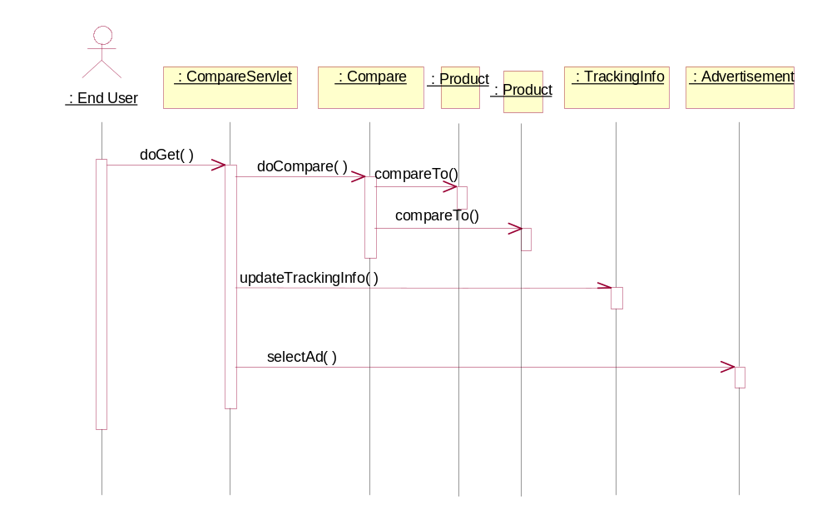

Class Diagram:

The Compare class can have more than one Products. All the other associations are one-to-one.

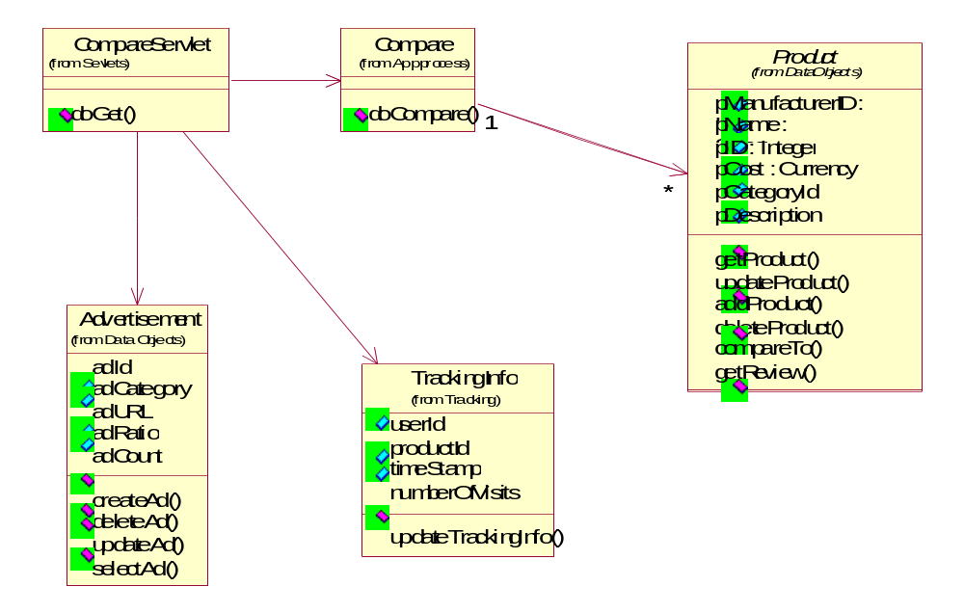

Use Case Reviews

Sequence Diagram:

The actor interacts with the ReviewServlet through the web browser. This servlet interacts with the other classes. It sends an asynchronous message to TrackingInfo.
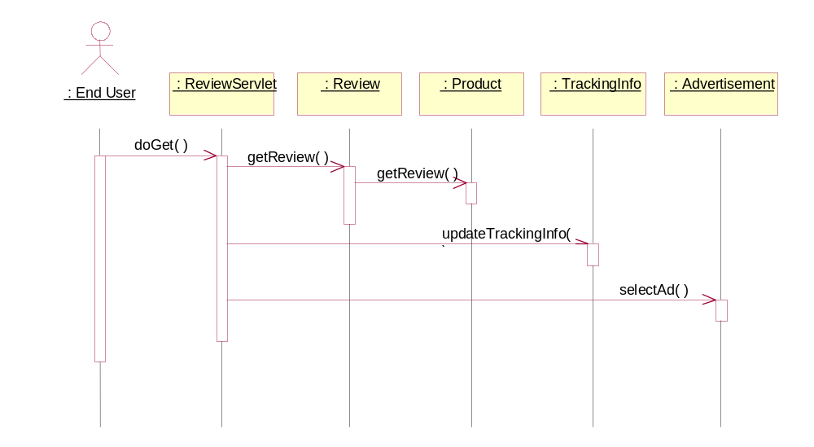

Class Diagram:

The ReviewServlet interacts with the Review subsystem to get reviews for a Product(s).

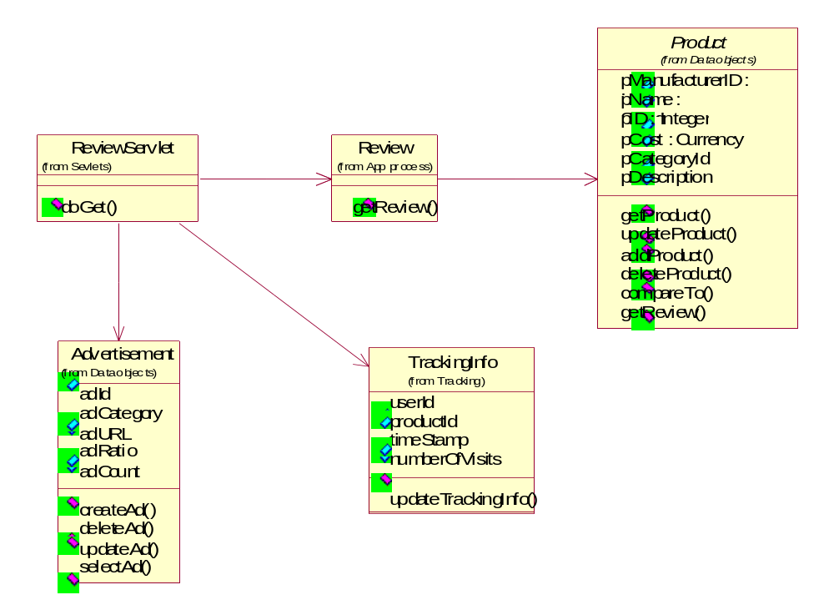

Use Case Browse Product Information

Sequence Diagram:

As the user browses through the information, the SelectionServlet in the Servlets sub-system is called. This servlet interacts with the other classes based on the user action.
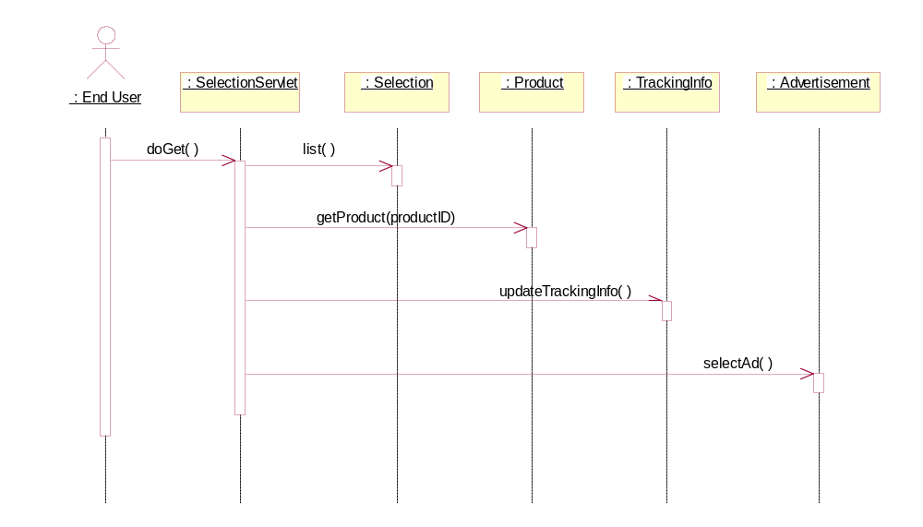

Class Diagram:

The SelectionServlet interacts with classes from other sub-systems based on what the user want to browse.
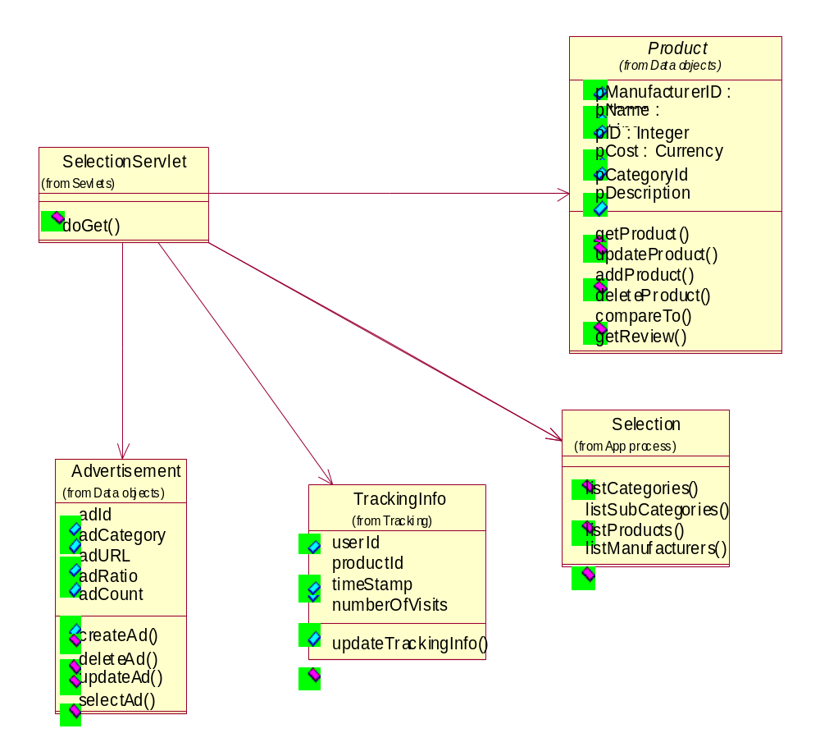

Use Case Search Products

Sequence Diagram:

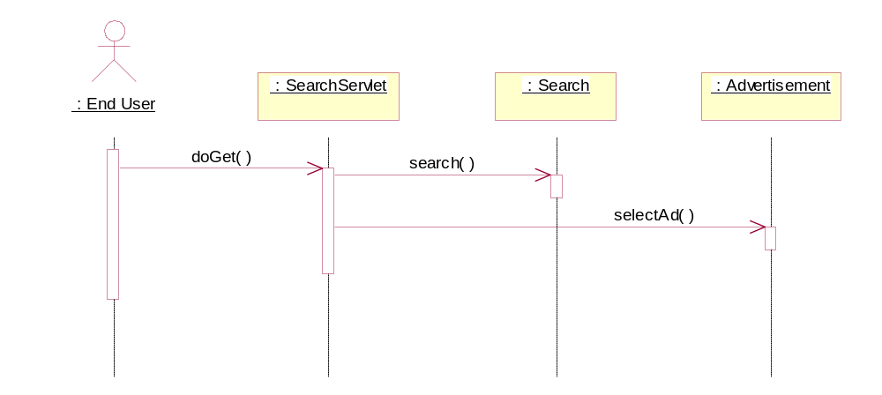
The SearchServlet is invoked when the user wants to search for information. This servlet then interacts with the Search subsystem.

Class Diagram:

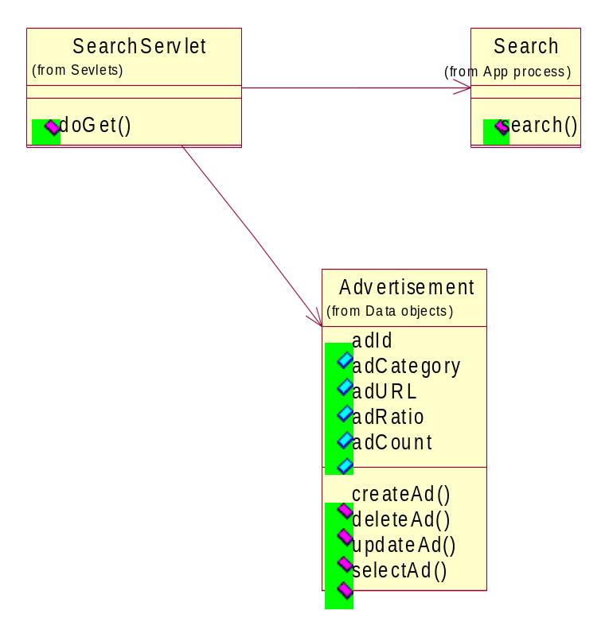The SearchServlet interacts with the Search and the Advertisement classes form their corresponding sub-systems.

Use Case Maintain Product Data

Sequence Diagram:

The Administrator interacts with the MaintainDataServlet through the web browser. This servlet interacts with other classes based on what information is being added/updated/deleted.
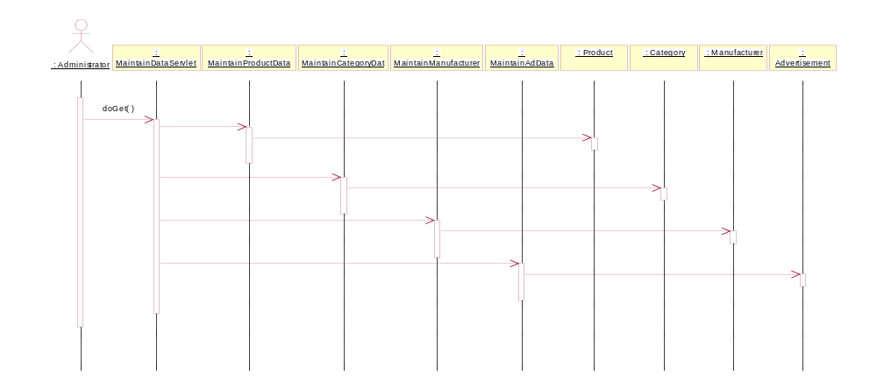

Class Diagram:

The MaintainDataServlet interacts with the MaintainData sub-system to update the information in the database.
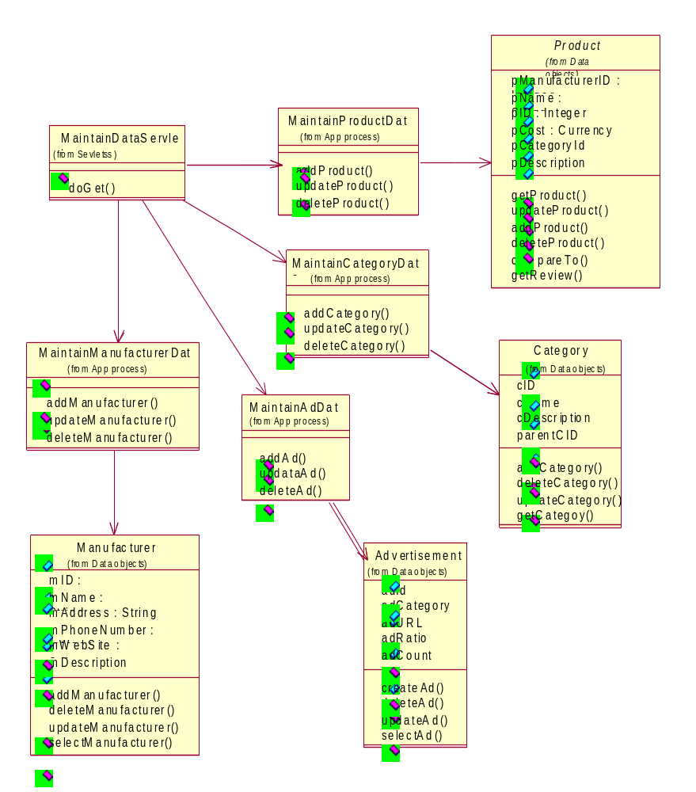

Use Case User Account

Sequence diagram:

Based on user action, the corresponding servlet is invoked, which then interacts with the UserAccount subsystem.
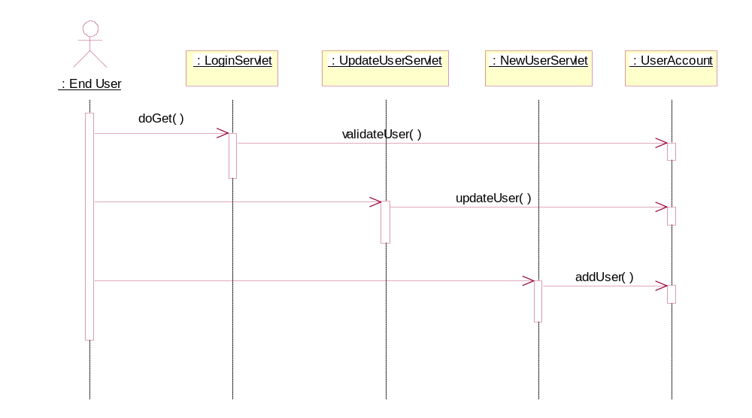

Class Diagram:

The three servlets access the user Information through the UserAccount class in the UserAccount sub-system.

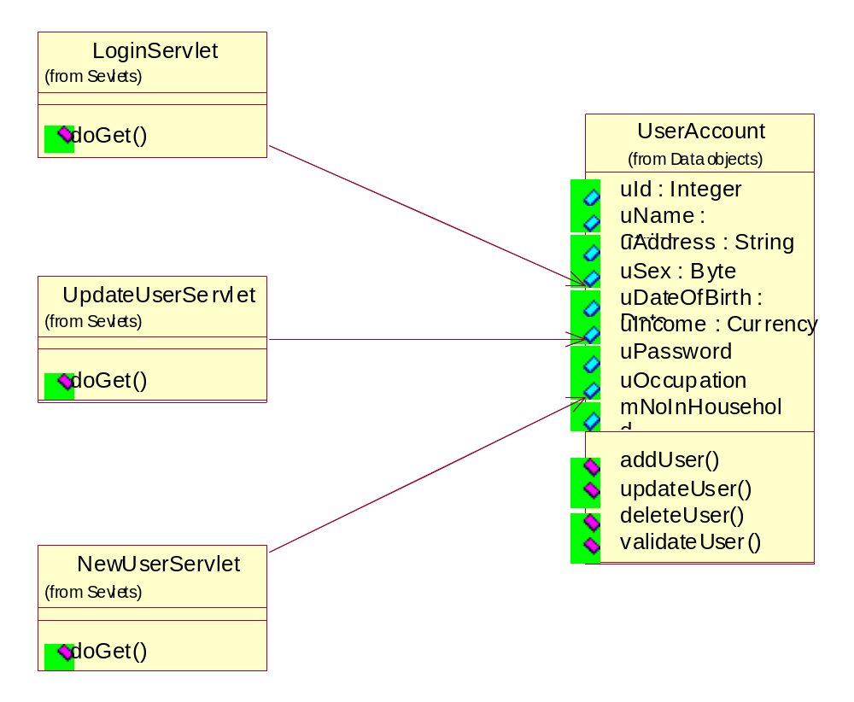

Use Case Generate Reports

Sequence Diagram:

The ReportGenServlet is invoked when the administrator requests for a report. This servlet interacts with the reports sub-system. The MonitorApplet is displayed on all the report screens which gets its update from the ActivityMonitor.

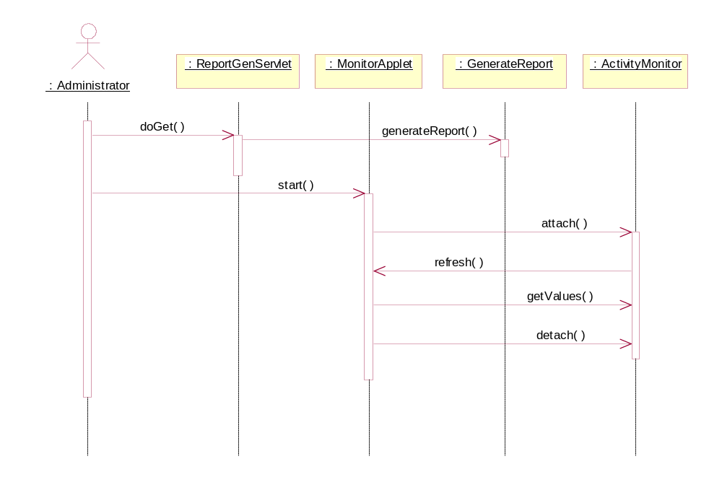

Class Diagram:

The ReportGenServlet uses classes from the GenerateReports sub-system and Tracking sub-system. There will be only one ActivityMonitor in the whole system.

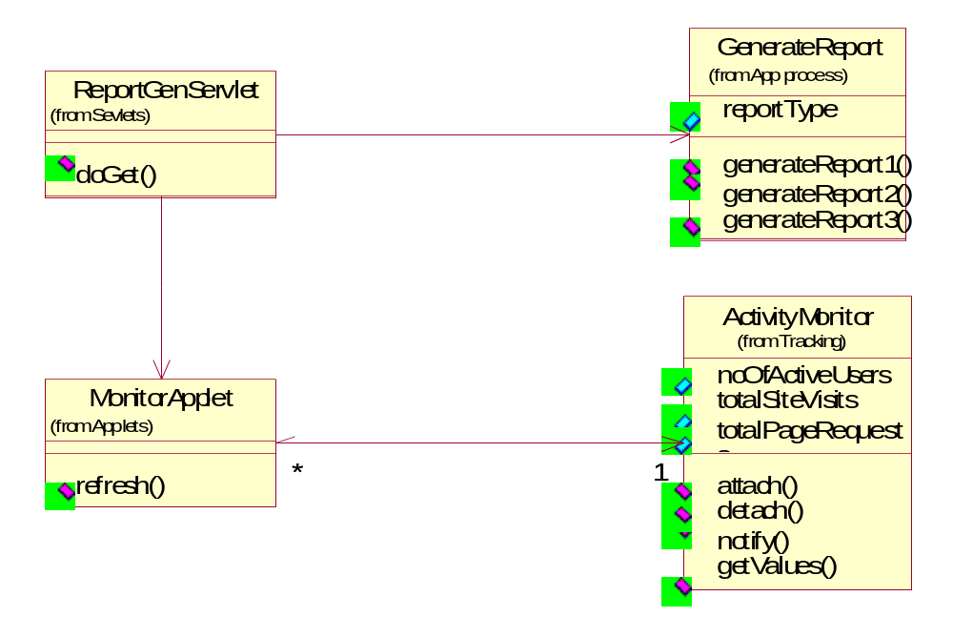

Use Case Help & FAQ

Sequence Diagram:

The Help&FAQ subsystem is used whenever the user requests help or FAQ.

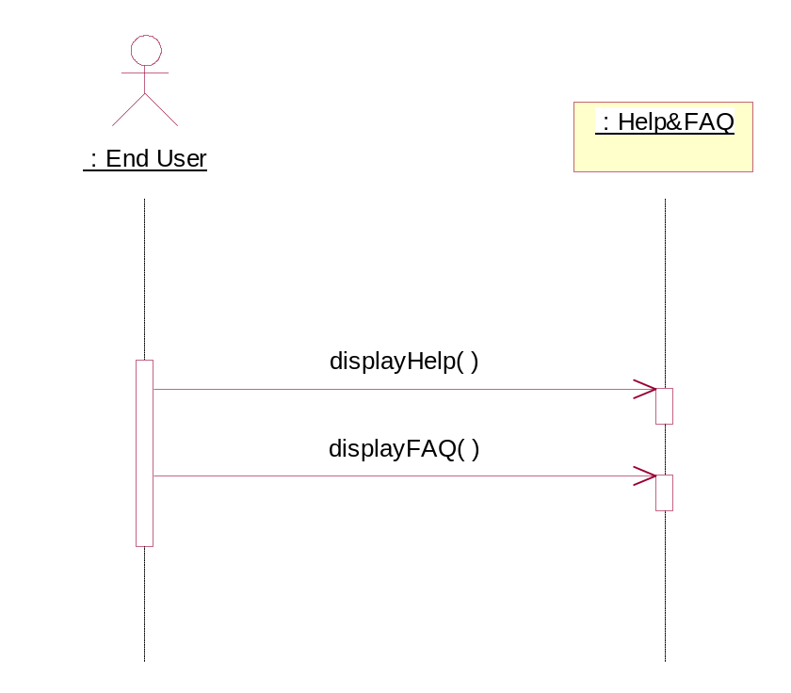

Class Diagram:

There is one class that handles these requests.

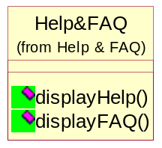

Subsystem Design

Subsystem Design : User Account

The subsystem User Account is shown in the figure below. This subsystem involves only class User Account and that class represents the User Account entity. It has all the attributes defined in the database schema. Also the interface of this subsystem is shown in the figure below.

<< design subsystem >>
USER ACCOUNT

USER
ACCOUNT

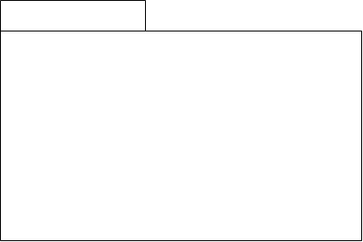

USER ACCOUNT
<< design subsystem >>

LOGIN UI

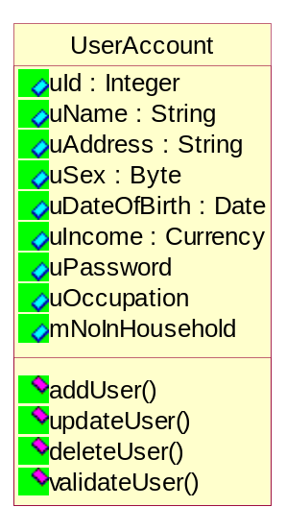
The following figures represents the class User Account and the interaction of this class with other subsystems as a representation of class diagram in the figure below.

The partial use case realization for this subsystem can be drawn as class diagram as follows.
These servlets perform User validation. New user accounts can be created and existing users can modify their account. Whenever a user logs in or logs out, the parameters in the Activity Monitor are updated, which in turn notifies all the observers

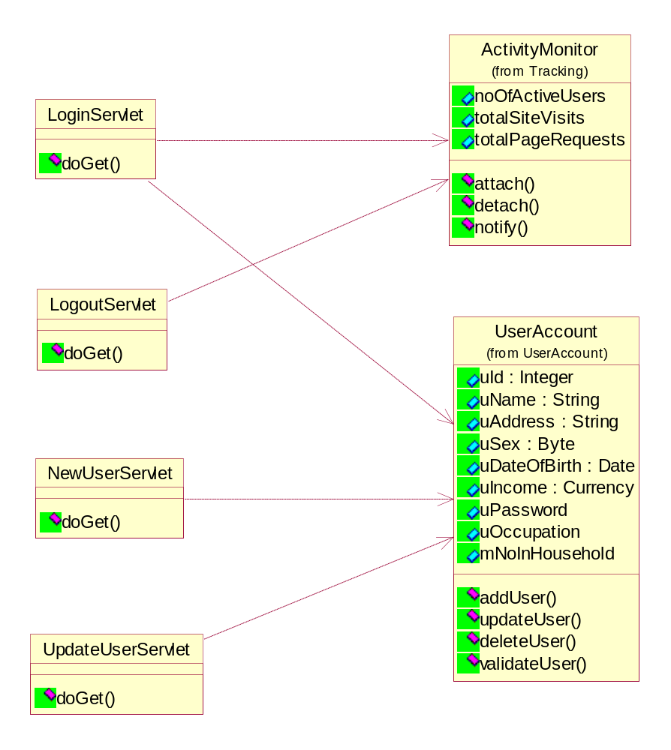

The interactions with this subsystem in partial use case realization can be represented as sequence diagram as follows.

:USER UI Servlet
:User Account
:Activity Monitor
:End User

doGet( )
validateUser( ) attach( )

Subsystem Design : Manufacturer

The subsystem Manufacturer is shown in the figure below. This subsystem involves only class Manufacturer and that class represents the Manufacturer entity. It has all the attributes defined in the database schema. Also the interface of this subsystem is shown in the figure below.

<< design subsystem >>
MANUFACTURER

MANUFACTURER

MANUFACTURER
<< design subsystem >>

SELECT
UI

The following figures represents the class Manufacturer and the interaction of this class with other subsystems as a representation of class diagram in the figure below.
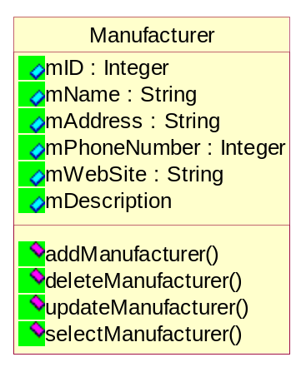

The partial use case realization for this subsystem can be drawn as class diagram as follows.
The selection UI will interact with the Manufacture class to add, update, delete the manufacturer after selecting the manufacturer.

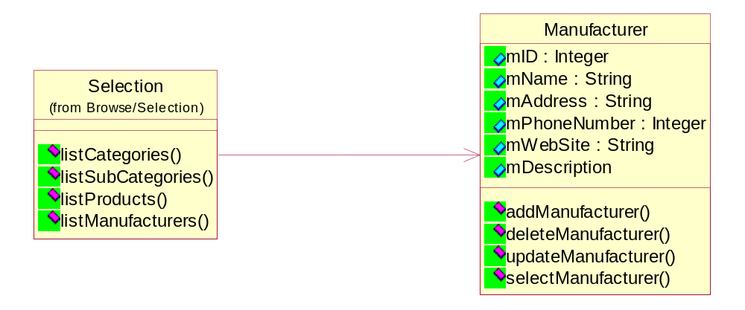

The interactions with this subsystem in partial use case realization can be represented as sequence diagram as follows.

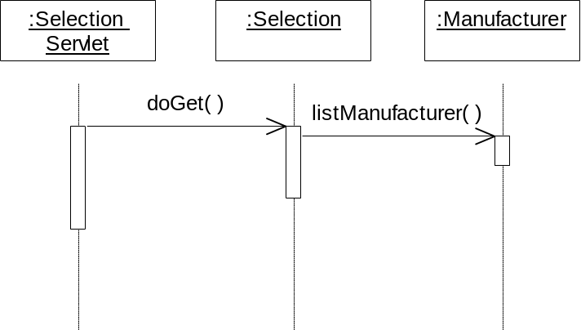

Subsystem Design : Category

The subsystem Category is shown in the figure below. This subsystem involves only class Category and that class represents the Category entity. It has all the attributes defined in the database schema. Also the interface of this subsystem is shown in the figure below.

<< design subsystem >>
CATEGORY

CATEGORY

CATEGORY
<< design subsystem >>

SELECT
UI

The following figures represents the class Category and the interaction of this class with other subsystems as a representation of class diagram in the figure below.

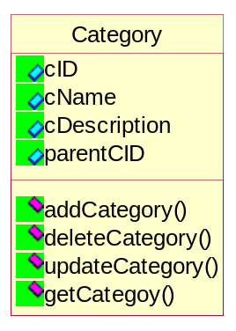

The partial use case realization for this subsystem can be drawn as class diagram as follows.
The selection UI will interact with the Category class to add, update, delete the category after selecting the category.
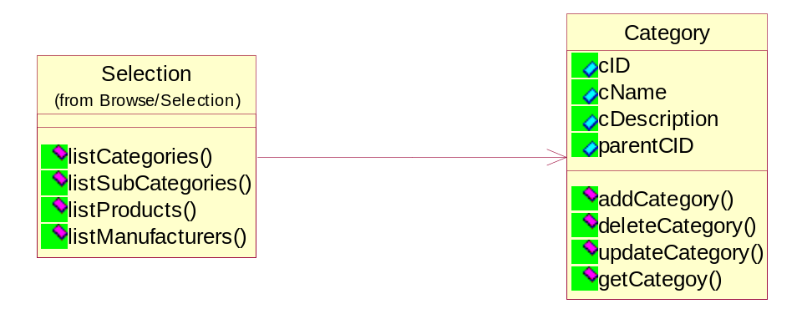

The interactions with this subsystem in partial use case realization can be represented as sequence diagram as follows.

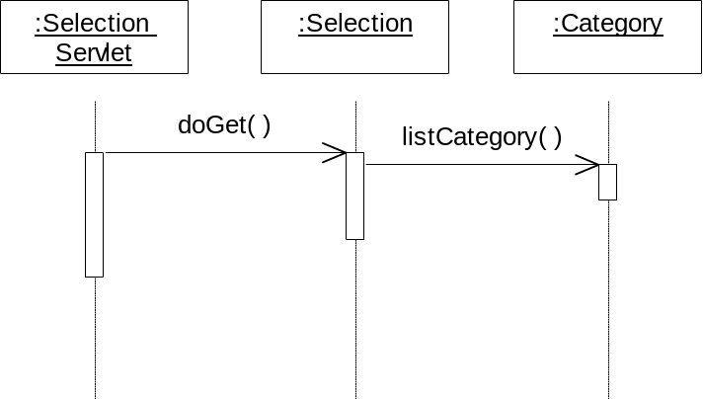

Subsystem Design : Product

The subsystem Product is shown in the figure below. This subsystem involves only class Product and that class represents the Product entity. It has all the attributes defined in the database schema. Also the interface of this subsystem is shown in the figure below.

<< design subsystem >>
PRODUCT

PRODUCT

PRODUCT
<< design subsystem >>

SELECT
UI

The following figures represents the class Product and the interaction of this class with other subsystems as a representation of class diagram in the figure below.
The root of this class hierarchy is the abstract class Product. The first level is the classes for the categories, then the sub-categories and so on. Only the leaf classes can be instantiated. The product class has all the attributes that are common to all products and a list of all methods that must be implemented by all its sub-classes.
This package implements the abstract factory design pattern. Classes from other packages that need an object from this package must use ProductFactory. ProductFactory instantiates the appropriate class and returns the object as a Product. Therefore, all other packages are only aware of Product. With this design, adding new categories or sub-categories will not affect any other packages. Only ProductFactory class has to be modified to make it aware of the additions or modifications.
The attributes and methods are not final. There may be changes during implementation. The assessor methods (get and set) are not shown all the class diagrams. During implementation they will be defined as required.

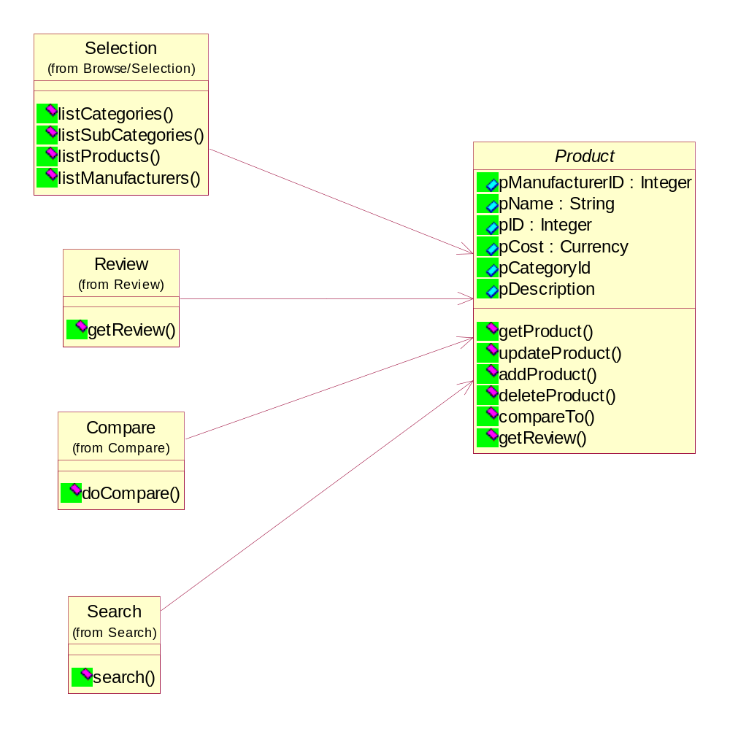

The interactions with this subsystem in partial use case realization can be represented as sequence diagram as follows.

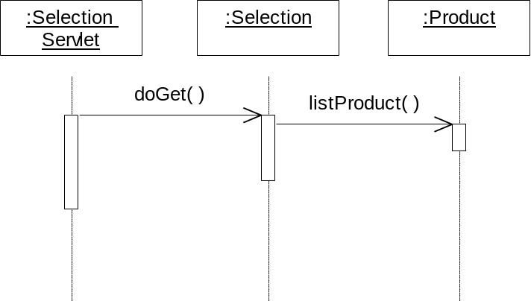

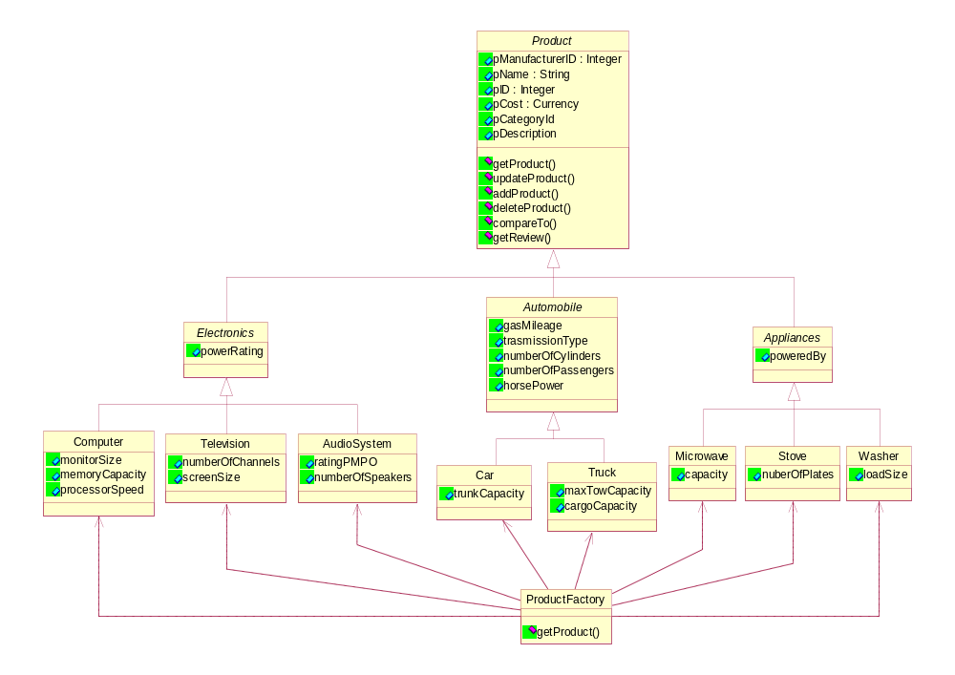

Subsystem Design : MaintainData

The subsystem Maintain Data is shown in the figure below. This subsystem involves only class Maintain Data and that class involves Product, Category and Manufacturer entity. It has all the attributes defined in the database schema. Also the interface of this subsystem is shown in the figure below.

<< design subsystem >>
MAINTAINDATA

MAINTAINDATA

MAINTAINDATA
<< design subsystem >>

MAINTAIN
UI

The partial use case realization for this subsystem can be drawn as class diagram as follows.
The following figures represents the class Maintain Data and the interaction of this class with other subsystems as a representation of class diagram in the figure below.

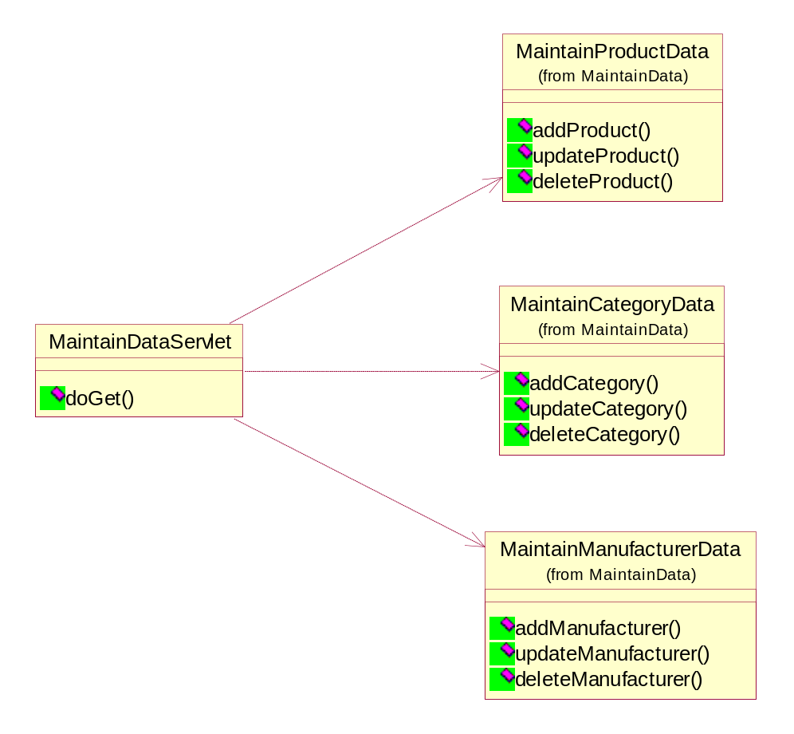

The interactions with this subsystem in partial use case realization can be represented as sequence diagram as follows.

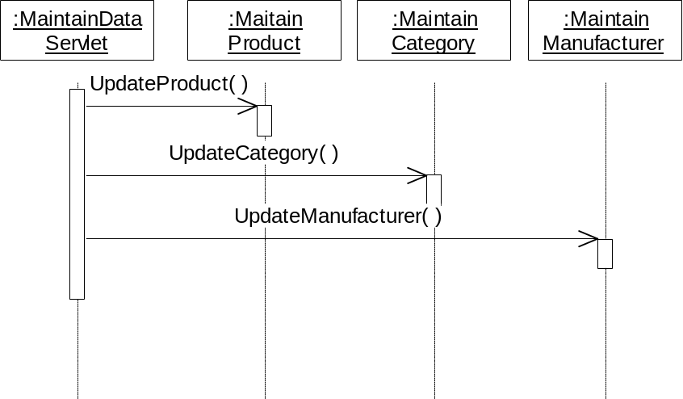

Subsystem Design : Tracking

The subsystem Tracking is shown in the figure below. This subsystem involves class Tracking and Activity Monitor that class involves Tracking Info. It has all the attributes defined in the database schema. Also the interface of this subsystem is shown in the figure below.

<< design subsystem >>
TRACKING

TRACKING INFO

ACTIVITY
MONITOR

ACTIVITY MONITOR
<< design subsystem >>
TRACKING INFO
<< design subsystem >>

MONITOR NOTIFY

Subsystem Design : Tracking info

Tracking Info class represents the Tracking Info entity. It has all the attributes defined in its database schema.

TRACKING INFO
<< design subsystem >>

NOTIFY

Subsystem Design : Activity Monitor

Activity Monitor monitors the activity in the system. It monitors parameter like number of users currently on the system, total number of logins, total pages requests, etc. These parameters are used in reporting. The observer design pattern is applied here. Objects that need to be notified when these parameters change have to attach to this class.

ACTIVITY MONITOR
<< design subsystem >>

MONITOR

The class diagram and partial use case realization for these two subsystems are drawn together as both are interacting together.
The following figures represents the class Tracking Info and Activity Monitor and the interaction of this class with other subsystems as a representation of class diagram in the figure below.
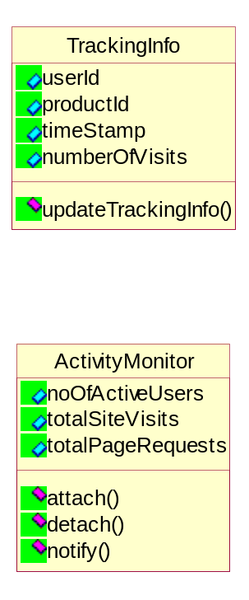

The interactions with this subsystem in partial use case realization can be represented as sequence diagram as follows.

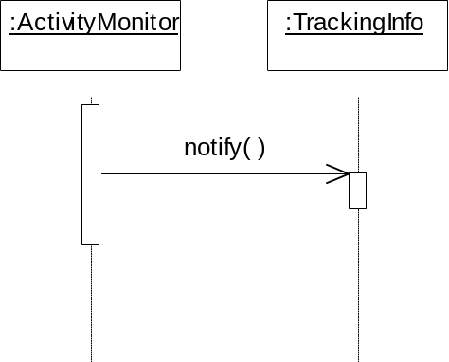

Subsystem Design : Advertisement

The subsystem Advertisement is shown in the figure below. This subsystem involves only class Advertisement and that class involves Ad entity. It has all the attributes defined in the database schema. Also the interface of this subsystem is shown in the figure below.

<< design subsystem >>
ADVERTISEMENT

ADVERTISEMENT

ADVERTISEMENT
<< design subsystem >>

CATEGORIZE
AD

The following figures represents the class Advertisement and the interaction of this class with other subsystems as a representation of class diagram in the figure below.

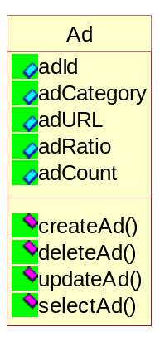

The interactions with this subsystem in partial use case realization can be represented as sequence diagram as follows.

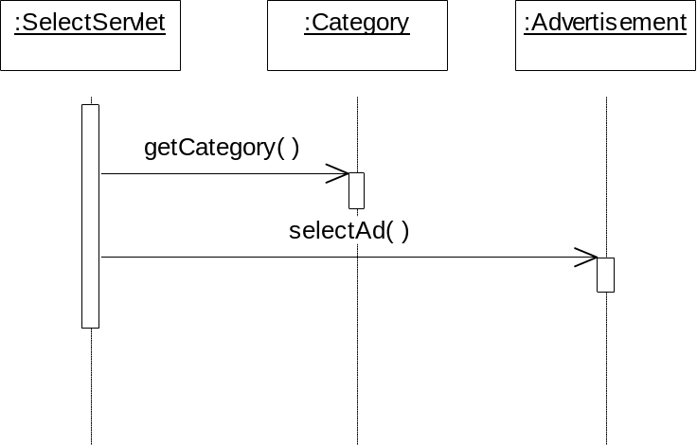

Subsystem Design : Help & FAQ

The subsystem Help & FAQ is shown in the figure below. This subsystem involves only class Help & FAQ. Also the interface of this subsystem is shown in the figure below.

<< design subsystem >>
HELP &FAQ

HELP & FAQ

HELP & FAQ
<< design subsystem >>

USER HELP UI

The following figures represents the class Help & FAQ and the interaction of this class with other subsystems as a representation of class diagram in the figure below.
This class displays the Help & FAQ. These are just HTML pages, so this class may not be implemented.
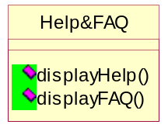

The interactions with this subsystem in partial use case realization can be represented as sequence diagram as follows.
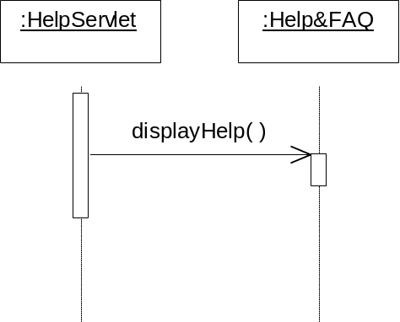

Subsystem Design : Generate Report

The subsystem Generate Report is shown in the figure below. This subsystem involves only class Generate Report. Also the interface of this subsystem is shown in the figure below.

<< design subsystem >>
GENERATE REPORT

GENERATE REPORT

GENERATE REPORT
<< design subsystem >>

REPORT UI

The following figures represents the class Generate Report and the interaction of this class with other subsystems as a representation of class diagram in the figure below.
The administrator can generate various reports. These servlets handle these requests. The administrator can also monitor the system activity via the Monitor Applet. The Monitor Applet attaches to the Activity Monitor to be notified of any changes to system parameters. The Activity Monitor notifies whenever a parameter changes the Monitor Applet and then the Monitor Applet refreshes itself.

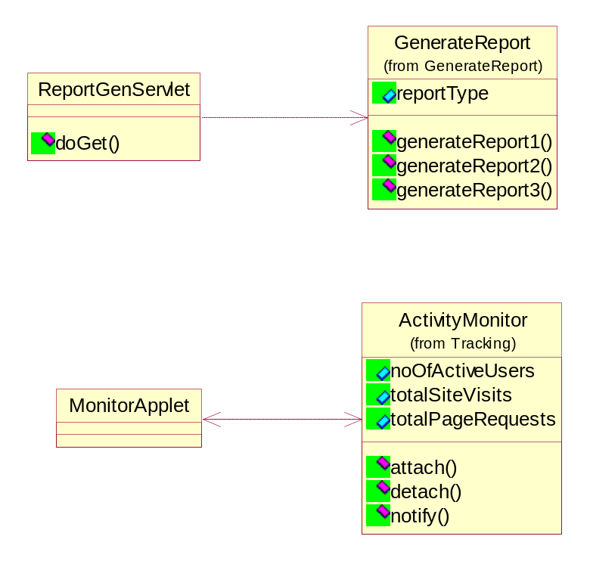

The interactions with this subsystem in partial use case realization can be represented as sequence diagram as follows.

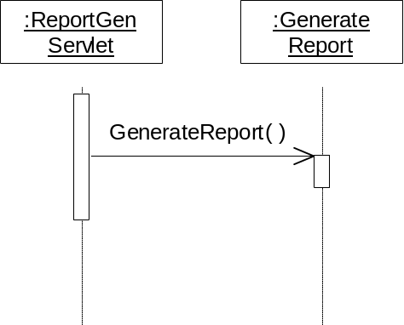

This subsystem will generate the reports for the administrator. It reads information from all the entities and generates the requested report.

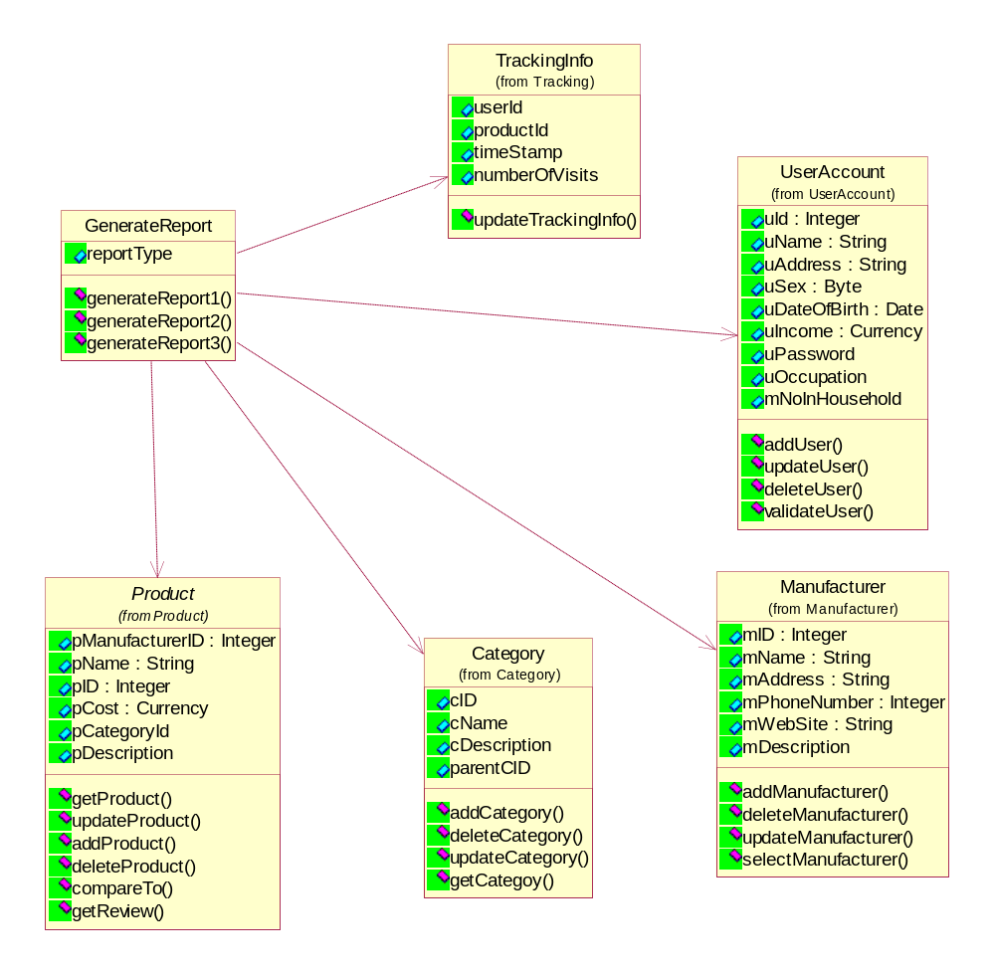

Subsystem Design : App Process

The subsystem App Process is shown in the figure below. This subsystem involves four subsystems Search, Browse/Selection, Compare and Review. Also the interface of this subsystem is shown in the figure below.

<< design subsystem >>
APP PROCESS

Search
Compare

Browse/
Selection
Review

Search
<< design subsystem >>
Compare
<< design subsystem >>

SEARCH UI COMPARE UI

Review
<< design subsystem >>
Browse/Selection
<< design subsystem >>
REVIEW UI BROWSE UI

The partial use case realization for this subsystem can be drawn as class diagram as follows.
The following figures represents the subsystem App Process and the interaction of this class with other subsystems as a representation of class diagram in the figure below. One common partial use case realization is shown below as the interaction with other classes and subsystems are common for most of the subsystems of this subsystem.

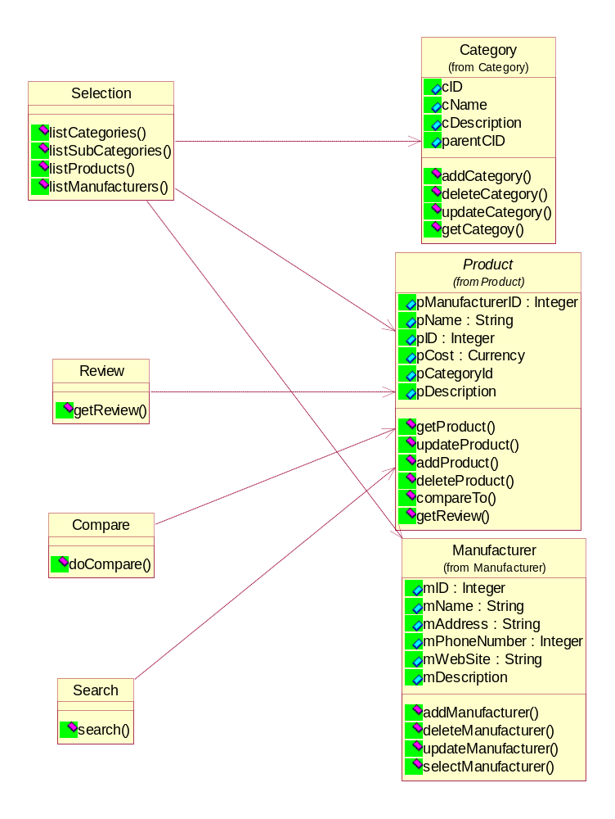

Subsystem Design : Search

Users’ search requests are handled by this servlet

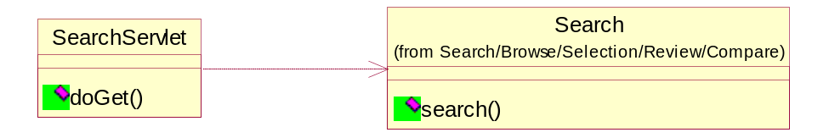

The interactions with this subsystem in partial use case realization can be represented as sequence diagram as follows.

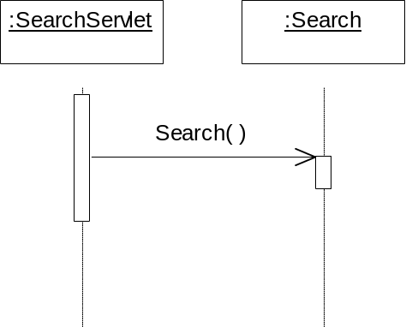

Subsystem Design : Browse/Selection

This servlet handles the users’ product selection requests. Based on user selections the appropriate methods are called in Selection and the result sent back to the users’ browser.

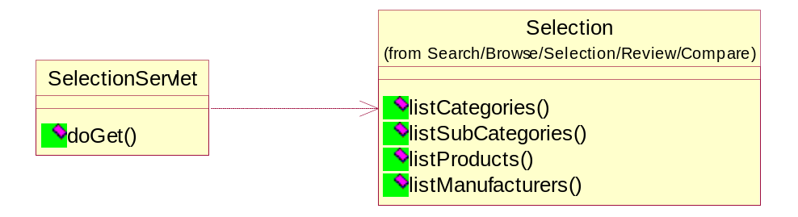

The interactions with this subsystem in partial use case realization can be represented as sequence diagram as follows.

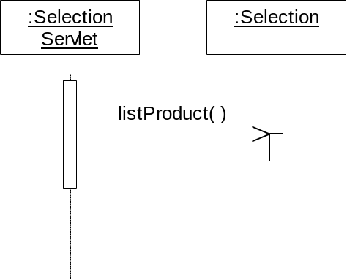

Subsystem Design : Compare

The user can select multiple products and compare them. If the user selects only two products, a one-to-one comparison is performed and if more than two products are selected, a one-to-many comparison is performed. The Compare Servlet handles this.

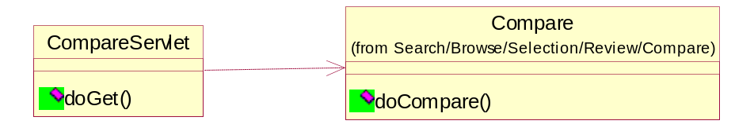

The interactions with this subsystem in partial use case realization can be represented as sequence diagram as follows.

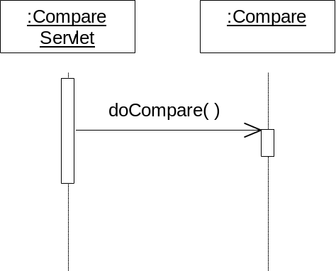

Subsystem Design : Review

The user can select multiple products and request for their reviews. This servlet handles these requests.

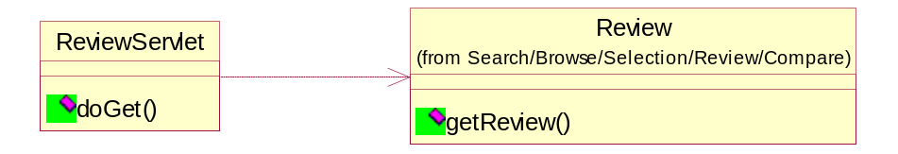

The interactions with this subsystem in partial use case realization can be represented as sequence diagram as follows.

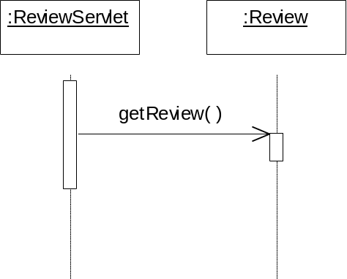

Subsystem Design : UI, Servlets & Applets

The subsystem UI, Servlets & Applets is shown in the figure below. This subsystem involves various user interfaces, servlets and applets. Also the interface of this subsystem is shown in the figure below. The only interface input to this system is user input.

<< design subsystem >>
UI, Servlets & Applets

UI, Servlets & Applets

UI, Servlets & Applets
<< design subsystem >>

USER INPUT

The following are the Servlets and User interfaces are discussed in this section. The layout of the servlets and User interface is drawn in section human interface. The interaction of this servlets and user interfaces are shown below. The following interaction with other subsystems may be repeated here as some of them are shown earlier in other subsystem interaction if the subsystem has interaction with this user interfaces.
There are 7 user interfaces in this subsystems. All User Interfaces are HTML pages. These pages are served by the Servlets in this package. Servlets interact with the other subsystems, classes, generate and send the HTML pages to the users’ browser. There is one applet that will be used by the Administrator. Since data is static in this application, we decided to use HTML pages instead of applets for the User Interface.

UserValidation
Product Selection
SearchProduct
MaintainData
GenerateReports
ProductReview
CompareProduct

Interface: UserValidation

These servlets perform User validation. New user accounts can be created and existing users can modify their account. Whenever a user logs in or logs out, the parameters in the ActivityMonitor are updated, which in turn notifies all the observers.

Interface: Product Selection

This servlet handles the users’ product selection requests. Based on user selections the appropriate methods are called in Selection and the result sent back to the users’ browser.

Interface: SearchProduct

Users’ search requests are handled by this servlet.

Interface: MaintainData

This servlet lets the administrator maintain the database. Since the users maintain their accounts, it is not shown here. Help & FAQ do not have a database. The administrator will use HTML forms to update the database.

Interface: GenerateReports

The administrator can generate various reports. These servlets handle these requests. The administrator can also monitor the system activity via the MonitorApplet. The MonitorApplet attaches to the ActivityMonitor to be notified of any changes to system parameters. Whenever a parameter changes the MonitorApplet is notified by the ActivityMonitor and then the MonitorApplet refreshes itself.

Interface: ProductReview

The user can select multiple products and request for their reviews. This servlet handles these requests.

Interface: CompareProduct

The user can select multiple products and compare them. If the user selects only two products, a one-to-one comparison is performed and if more than two products are selected, a one-to-many comparison is performed. The CompareServlet handles this.

Subsystem Design : Database

The following diagram shows the Database schema for the subsystem design database. The shown ER diagram shows the attributes for the entities User account, Product, Category,
Manufacturer, Tracking info and Advertisement. All attributes for this entities and primary keys are defined in the diagram. Also the relationship among the entities, cardinality and modality is shown in the figure.

Human interfaces.

Login Screen

Main Screen

Categories Screen

Product listing Screen

Select Product Screen

Compare REsults Screen

REview Listing Screen

Select REview SCreen

Product Info Screen

Manufacturer Listing Screen

Search

SEarch Results

Help/faq

Adminstrators Screen

Use-Case Scenarios

Use Case: Compare Products

In this use case the user logins through the Login interface. The main screen shows up with all the menu items. From the category menu item on the main screen the user selects the category and then the subcategory. The products for that category are listed with a check box behind each of the product The user can select the products he is interested in by checking next to each. There is a choice of comparison for the user when the user hits the compare button. If the user selects one-one comparison then the product information will be displayed in alphabetized order of the manufacturer. If the user selects many-many comparison and the user is a subscribed user, then the product information is displayed in table format with the ratings, comments etc. If the user has not subscribed then a page is displayed indicating to the user that he needs to subscribe

Use Case: Reviews

In this use case the user logins through the Login interface. The main screen shows up with all the menu items. From the category menu item on the main screen the user selects the category and then the subcategory. The products for that category are listed with a check box behind each of the product The user can select the products he is interested in by checking next to each. There is a review button at the bottom of the page. When the user hits the review button, all the reviews available are shown for the selected products if the user is a subscribed user. The user can choose to view any review. If more information is needed the user should is given an option to research further on the products by providing manufacturers links.

Use Case: Browse Product Information

The user logins through the Login interface. The main screen is displayed with all the menu items like Category, Manufacturers, Search, Site Map and Help & FAQ. If the user is the Administrator then he will see other items like Maintain Data and Reports. The user browses by selecting any of those menu items and look for category or product information or manufacturer links etc.

Use Case: Search Products

The user logins through the Login interface. The user sees the main screen with all the menu items. The user selects the search menu item to search for any information he wishes to. A search screen is displayed with a text box and with the type of search options. The user enters the search criterion. If a match is found the results are displayed. If no match is found, the search screen is displayed again to search again with a modified search criteria. If a match is found the information is displayed on the screen.

Use Case: Maintain Product Data

The user logins through the Login interface. A main screen is displayed with Maintain Data as one of the menu items. If the administrator chooses the Maintain Product Data option, a screen is displayed with the options ADD, DELETE, and UPDATE
If ADD is selected, the product data form will be displayed, where the administrator can enter information regarding the new product such as product name, product category, and other product attributes and available information from manufactures. Once the data is filled the administrator hits the submit button. If there are any errors in filling the data an error message screen is displayed and takes the user back to the data form.
If UPDATE or DELETE is selected, a screen is displayed with the listing of available product from which administrator chooses the product and the option buttons UPDATE and DELETE.
If UPDATE is selected and product to update is selected, the update data form is displayed, which will list all the data available for the selected product. With this display administrator edits the data and submits to system by hitting the submit button.
If DELETE is selected and product to delete is selected, the data form is displayed with the data for the product selected to delete and prompt for the confirmation of delete operation. If administrator confirms the delete operations by hitting the OK button a message box is displayed indicating the product is deleted.

Use Case: User Account

The login screen gives choice to user for login to the application. The choices are Login and Register.
When a user who has already registered chooses Login, a prompt for the UserID and Password. Once the user enters the UserID and Password and if the data is valid i.e. login is successful, the main screen is displayed.
When a user who has not registered chooses Register, the new user data Screen is shown where the user can enter information like name, address, age group, income group, sex, etc. The user completes the data sheet and submits by hitting the submit button. A password screen is shown with the assigned userID and list of passwords for him to choose. Once the Password selection is complete the welcome screen will be displayed that will lead to the main screen
In this process if any step fails, the error message screen is displayed and takes the user to previous screen.

Use Case: Tendency Tracking
After the user logins through the login screen, the user selects the category menu item from the main screen. Then the product from the Product screen. This use case is basically for the system to track the user’s tendency to select a particular product from the available categories.

Use Case: Generate Reports

After the user logins through the login screen, the administrator selects the Generate Reports menu item from the main screen. If the user is not the administrator then an access denial page is displayed. If the user is the administrator, then the Reports screen is displayed to select the type of report. The various reports will be Popularity by Category, List of all users interested in a product/category, Users group interest by category etc. The Popularity by Category report will have a pie chart indicating the popular products. Depending on the type of report chosen, the report is displayed with the respective results and statistics.

Use Case: Help & FAQ

After the user logins through the login screen, the user selects the Help & FAQ menu item from the main screen. A help screen is displayed with the help topic list from which User can select the topic to view the help. Once the topic is selected the selected topic details will be displayed. If exit is selected, the main screen is displayed again.

Use Case: Select Ad to Display

After the user logins through the login screen, the main screen is displayed. When the user selects the category menu item and then the products of that category, advertisements are displayed on the top of the page depending on what category the user has selected so far. Advertisements will be randomly displayed on the current page.

Interface Flow Diagram
Category Listing Screen
Product Listing Screen

Review Listing Screen

Login Screen

SCREEN

Main Screen

Site Map Screen

Manufacturer Listing Screen

Search Screen

Reports

Help & FAQ

Maintain Data

Product Info
Screen

Compare Results Screen

Product Listing By Manufacturer

Search Results Screen

Listing of Reports screen

Maintain Data options screen

Selected Review

Description of Interface Flow Diagram:
In the above interface diagram the user first sees the Login screen. The Login screen will lead to the main screen. The main screen depending on the Login shows the menu items that are Category, Manufacturer, Search, Site Map, Reports, Maintain Data and Help & FAQ screens. If the user is not an administrator he/she will not see the Reports screen and Maintain Data screen.
The Category menu item will lead to the products listing screen with all the products from the category chosen. This screen will have options to compare the products, look at the reviews of the products or just the product information itself. This screen will lead to the Compare products screen, Reviews screen and Product information screen. The Compare products screen, Product Information screen and Reviews screen will have option to go back to the Product listing screen so that the user can select other products for comparison, reviews and product information.
The Manufacturer menu item will lead to a screen with Product listings by Manufacturer and the manufacturer links. Any other information relating to the manufacturer is listed in this page.
The Search menu item will lead to a search screen where the user can search for product information, manufacturer information etc.
The Site map menu item will give the details of the menu items, purpose of them and a brief tour of the site.
The Help & FAQ screen will assist the user with the list of frequently asked questions and other information regarding the selection of the menu items etc.
The Administrator will see the Reports and Maintain Data menu items on the main screen.
The Reports menu item will show the user the different reports. When the user selects the particular report, the report is displayed with the respective statistics and information.
The Maintain Data menu item will show the user the options whether to maintain category, maintain product, maintain manufacturer, maintain reviews etc.

System/Data Dependencies & Requirements

System Requirements

- Client Operating Systems: Windows NT 4.0, Windows 95/98, or Solaris 2.6
- Server Operating Systems: Windows NT 4.0 or Solaris 2.6
- Internet Software: Netscape Communicator 4.0 or Microsoft Internet
Explorer 4.0/5.0
- Database software: Oracle
- Java Web Server
- JDK 1.2, Internet access

Data Dependencies:

The efficiency of the system and it’s usefulness depends on the availability of the information regarding the products and manufacturers. There are no dependencies within the data and this data does not depend on any other outside sources.

Testing Plan

Unit Testing : Black box testing

1. Use Case: Compare Products

Input: The user selects the two or more products from the product listing and selects the
Compare products option.

Output: Results are displayed in a tabular form showing the attributes of all the products.

Conditions:
The selected products are in the database and the user has logged in successfully.

Results:

2.Use Case: Reviews

Input: The user selects the two or more products from the product listing and selects the
Reviews option. Then he selects a particular review for a product.

Output: The selected review is displayed.

Conditions:
The reviews of the selected products are in the database and the user has logged in
successfully.

Results:

3.Use Case: Browse Product Information

Input: The user selects the Categories or Manufacturer listing option and chooses to browse
product information.

Output: The information of the selected product is displayed in a tabular form.

Conditions:
The selected products are in the database and the user has logged in
successfully.

Results:

4.Use Case: Search Product

Input: The user selects the search option and enters the search criteria.

Output: Links to the matched criteria are displayed. If no match is found a match-not-found page
is displayed.

Conditions:
The information is in the database and the user has logged in
successfully.

Results:

5.Use Case: Maintain Product Data

Input: User selects the correct option from ADD/DELETE/UPDATE
User selects the product to DELETE/UPDATE
User inputs the valid information for ADD/UPDATE
User confirms the ADD/DELETE/UPDATE confirmation prompt

Result: Displays the product selected for DELETE/UPDATE
Validates the information input for ADD/UPDATE
Prompts for confirmation for ADD/DELETE/UPDATE
ADD/DELETE/UPDATE is performed and notify.

Conditions:
Product selected for DELETE/UPDATE is valid and is in database.
User is the administrator and has logged in sucessfully.

Results:

6.Use Case: User Account

Input: User selects the valid option LOGIN/REGISTER/GUEST/UPDATE
User inputs UserID and Password for LOGIN.
User inputs the user information to REGISTER.
User inputs the information to UPDATE.

Result: Information input is validated for LOGIN/REGISTER/UPDATE.
For LOGIN if input UserID and Password is valid user is allowed to browse the application.
For REGISTER user is assigned UserID and prompted for Password selection.
Any input validation failure results in error message display.

Conditions:
For LOGIN user must have registered earlier.
Results:

7.Use Case: Tendency tracking

Input: The activity of the user is tracked.

Output: The database is updated .

Conditions:
The user has logged in successfully.

Results:

8. Generate Reports

Input: The user should be the administrator and has selected the reports option.

Output: The selected report is displayed in the required format.

Conditions: The user should be the administrator.

Results:

9.Use Case: Help & FAQ

Input: User selects the valid Help & FAQ topic

Output: The selected Help & FAQ topic is displayed.

Conditions:
User has logged in sucessfully.
Results:

10.Use Case: Select Ad to Display

Random selection is verified visually by browsing through the pages. The database is queried to verify that the counters are updated properly.
Results:

White box testing:
The tester should test each component. The tester should make sure that all possible paths and conditions are evaluated correctly.
Results:

Integration Testing

Use Case: Compare Product

Method Name | Input | Validation | Verification | Error Handling
CompareServlet.doGet( ) | Input Successfully received |  |  | If input not correct other messages should not be invoked.
Compare.  doCompare( ) |  | Validated Input
Product.compareto( ) |  |  | Compared products Successfully | If table read failed, the error is logged and user is notified.
Trackinginfo.updateTrackingInfo( ) |  |  | Database Updated Successfully.
Advertisement.SelectAd( ) |  |  | Selected the required Ad successfully | If corresponding Ad is not found no Ad is displayed.

- The CompareServlet gets the products that need to be compared.
- The input is validated . For example if no products are selected and the CompareServlet is invoked an error message should be displayed.
- The products are compared successfully.
- Tracking Info is updated successfully.
- Th advertisement is displayed successfully.

Use Case : Reviews

Method Name | Input | Validation | Verification | Error Handling
ReviewServlet.doGet( ) | Input Successfully received |  |  | If input not correct other messages should not be invoked.
Review.  getReview( ) |  | Validated Input
Product.getReview( ) |  |  | Displayed Product Review Successfully | If table read failed, the error is logged and user is notified.
Trackinginfo.updateTrackingInfo( ) |  |  | Database Updated Successfully.
Advertisement.SelectAd( ) |  |  | Selected the required Ad successfully | If corresponding Ad is not found no Ad is displayed.

Use Case : Browse Product

Method Name | Input | Validation | Verification | Error Handling
SelectionServlet.doGet( ) | Input Successfully received |  |  | If input not correct other messages should not be invoked.
Selection.list( ) |  | Input  Validated | Displays Selected List.
Product.  getProduct(product Id) |  |  | Displays Product Information  Successfully | If table read failed, the error is logged and user is notified.
Trackinginfo.updateTrackingInfo( ) |  |  | Database Updated Successfully.
Advertisement.SelectAd( ) |  |  | Selected the required Ad successfully | If corresponding Ad is not found no Ad is displayed.

Use Case : Search

Method Name | Input | Validation | Verification | Error Handling
SearchServlet.doGet( ) | Input Successfully received |  |  | If input not correct other messages should not be invoked.
Search.search( ) |  |  | Search Successful. | If not match not found page should be displayed.
Advertisement.SelectAd( ) |  |  | Selected the required Ad successfully | If corresponding Ad is not found no Ad is displayed.

Use Case : Login

Method Name | Input | Validation | Verification | Error Handling
LoginServlet.doGet( ) | Input Successfully received |  |  | .
UserAccount.  validateUser( ) |  | Validate  Input |  | If input not correct other messages should not be invoked
UpdateUserServlet.  doget( ) | Input successfully Received | Input  Validated |  | If error in input  Notify user.
UserAccount.updateUser( ) |  |  | Database  Updated
NewUserServlet.  doget( ) | Input successfully Received | Input  Validated |  | If error in input  Notify user..
UserAccount.addUser( ) |  |  | Database Updated Successfully.

Use Case : Generate Reports

Method Name | Input | Validation | Verification | Error Handling
ReportGenServlet.doGet( ) | Input Successfully received |  |  | If input not correct other messages should not be invoked.
GenerateReport.  generateReport( ) |  |  | Generates Report  Successfully.
Activitymonitor.attach( )
Activitymonitor.  getvalues( ) |  |  | Verify if the data displayed on the screen matches the database
Activitymonitor.detach( )

Use Case : Maintain Data

Method Name | Input | Validation | Verification | Error Handling
MaintainDataServlet.  doGet( ) | Input Successfully received | Input  Validated |  | .
MaintainProductData.  doGet( ) | Input Successfully received | Input  Validated |  | If input not correct other messages should not be invoked
Product.add()  Product.update( )  Product.delete( ) |  |  | Database Action Successfully  Performed
MaintainCategoryData.  doGet( ) | Input Successfully received | Input  Validated |  | If input not correct adminstrator is notified.
Category.add()  Category.update( )  Category.delete( ) |  |  | Database Action Successfully  Performed
MaintainMaufacturer.  doGet( ) | Input Successfully received | Input  Validated |  | If input not correct administrator is notified
Manufacturer.add()  Manufacturer.update( )  Manufacturer .delete( ) |  |  | Database Action Successfully  Performed
MaintainAd.  doGet( ) | Input Successfully received | Input  Validated |  | If input not correct administrator is notified
Advertisement.add()  Advertisement.update( )  Advertisement.delete( ) |  |  | Database Action Successfully  Performed

System Testing
- The system will be tested for concurrent access to the database.
- The response time for the display of results will be tested.
- The system will be tested for parallel processes.

Project Status & Summary

Status

Finished most of the Servlets and testing also has been completed.

Following are the servlets:

Base Servlet - Completed and tested succesfully
Login Servlet - Completed and tested succesfully
CreateNewUser Servlet - Completed and tested succesfully
UpdateUserServlet - Completed and tested succesfully
Compare Servlet - Completed and tested succesfully
Select Servlet - Completed and tested succesfully
GenerateReport Servlet - Completed and tested succesfully
Activity Monitor - Completed and tested

Integration of the Servlets is completed. The system works fine.

The use case Maintain Data and Help& Faq has not been implemented due to the time constraint

Difficulties Encountered

- Getting Real Data

The purpose of this system is to compare different products based on the user selection. To prove the efficiency of the system we needed the real data with all the attributes of the different products. We could not find the source of this information that could be downloaded into our database. Ultimately we had to enter our own data as test data.

- Generalizing the application for different types of Product data

This was a problem when we were implementing the database design and coding. Each category would have different products and each product had different attributes that are of different nature from implementation point of view.

- Client-Side Programming

Most of implementation was done as Servlets because of the nature of the project. We implemented Activity Monitor as an applet to record the user activities which would help the reports to generate the statisitics. So, we could not do much client-side programming.

- Identifying the Subsystem Design

This was the most challenging problem faced by our group. Originally we didn’t go in a right direction in identifying the subsystems due to insufficient understanding of the Subsystems Architecture and design. Later, with Dr. Tolone’s assistance we came up with an appropriate design.

- Technology

The use of technologies such as Java proved to be a challenge. Perceptions of the capabilities of Java proved to be different from reality which made the design and implementation of the system more difficult.

10.3 Journal Of Project Activities

Sept 7th Team has been announced today. Introduced ourselves. Exchanged e-mail addresses.

Sept 9th Met before class but haven’t achieved anything.

Sept 10th Met after the Java Tutorial class. Discussed about the projects that we can propose. We finally came up with four – Web home page builder, E-commerce application, Graphics designer and Java editor tool.

Sept 13th Decided finally to do an e-commerce application since most of us are new to Java language. We decided to do an application that compares the prices of a product and displays the best product available for the customer something like ConsumerReports.org website.

Sept 14th Met after the class. We discussed about the features and functionalities of the project. We picked Jatin Zalavadia as the leader of the team today. Jatin wrote the project overview to submit on this Thursday.

Sept 22nd Divided our tasks for the Project Proposal & Plan. Today we discussed more about the project scope and objectives.

Sept 23rd Met briefly to get the copies of the Risk Analysis and the status of the project.

Sept 27th Everybody discussed about what they have done and what to be corrected in the document.

Sept 29th We spent two hours and did the final revisions of the document. The others reviewed each person’s work.

Sept 30th Sandhya did the final format and integrated the whole document together for submission today.

Oct 6th We discussed about Dr. Tolones comments on the Project plan and how to rectify the problems. Discussed about the Analysis document, what to be done and how to approach about it. We came up with the Use-case diagram.

Oct 11th Two of us could not meet today with the group. Members who have attended have taken their tasks to do regarding the activity diagrams of the use cases.

Oct 12th We met briefly and decided to meet on this Saturday. We discussed what we have done so far and divided other tasks for the Analysis document.

Oct 16th We discussed about the Activity diagrams for the most of the use cases and finalized them. We discussed about the implementation for this project.

Oct 18th We finalized the collaboration diagrams and the validation criteria for the use cases. We had problems with the diagrams not being consistent and so we came up with the consistent format after Sathish has created bitmaps for all the types of classes. We started to identify the analysis packages but didn’t know where to start and how to approach about that.

Oct 20th Most of us were in the school about till 10:00 PM trying to come up with the Analysis packages but could not finalize it since we were not sure whether we have done it right. Decided to meet one hour before the class to finalize the Analysis Packages.

Oct 21st It was a hectic day because we had done the formatting in the last minute and one of us had problems with their system. Also we had to do the Analysis package in the last minute. We couldn’t attend the class too. Finally submitted it through e-mail.

Oct 25th Discussed about the Design Document that is to be submitted the next. We decided not to repeat the last hour work for submission. We spent lot of time to come up with the Database schema for the project. We discussed the various designs we can do. We also discussed about the client side programming and how to implement it in code as classes, objects etc. We also divided our tasks for this document. Sathish drew a rough figure of the Deployment diagram.

Nov 1st We spent most of the time in finalizing the schema done by Jatin and the human interfaces done by Priya. We also discussed about how to come up with the subsystem design. We are not sure how to do this. We discussed about the time we have for the final document and we discussed when to finish the database implementation and when to start the remaining.

Nov 8th We came up with the Subsystem Architecture and we discussed about it in the meeting. We had difficulty with the design of the subsystems. Priya did most of the interfaces.

Nov 9th We met briefly and decided to co-ordinate through e-mail to finish the remaining document.

Nov 16th Sathish did the final formatting this time. We did it in time this time and submitted it today.

Nov 18th Discussed about the implementation and divided our tasks. We decided to do most of the functions as servlets and some applets in the Administrative Reports. Discussed also about the topics in the Presentation.

Nov 22nd Discussed mostly about the presentation and the implementation process. We created some folders in our accounts to co-ordinate our code.

Nov 23rd We met with Dr.Tolone to go over the comments regarding the Design Specifications document.

Nov 27th We met to discuss about the changes to the subsystem design and the implementation

Nov 29th Did a mock-up session for the presentation and discussed about the status of the project. Jatin has volunteered to do the database design.

Dec 2nd Met briefly and discussed about the project status for implementation and when to integrate the final code.

Dec 6th Did the integration of the individual servlets and applets. We also tested the implementation we have done so far.

