RSR – 3D

Systems Maintenance Manual

Group B

May 1, 2000

TABLE OF CONTENTS

Introduction 3
Background 3
System Requirements 3
System Composition 3
The Visualization Initializer 7
Operation Description 7
Class Descriptions 8
Testing 10
The Visualizer Update 11
Operation Description 11
Class Descriptions 13
Testing 14
The GameMain Component 15
Operation Description 15
Class Descriptions 15
Testing 16
The 'Common' Package Utility Classes 18
Class Descriptions 18
Testing 19
The Maze Component 20
Operation Description 20
Class Descriptions 21
Testing 21
Robot Component 23
Class Descriptions 23
Testing 26
Weapon Component 28
Operation Description 28
Class Descriptions 29
Testing 31
Acceptance Testing 32
Scenarios 32
Test Plan 33
Index 35
PROJECT CODE 36

Introduction

Background

The maze game system developed by Group B is based upon the following concept: two or more robot entities start at random locations in a maze, seek one and other out, and engage in mortal combat to the death. Because the premise is somewhat reminiscent of a children's game from the 1970s called, "Rock 'em Sock 'em Robots," Group B has decided to name its system, "Rock 'em Sock 'em Robots 3D," or just RSR-3D. As the title would suggest, this game is of the 3D, first person variety. To this end, Group B has decided to use the Java language environment, including the Java3D library, for implementation.

User interactivity with RSR-3D is somewhat limited. The user can provide command line arguments to the game upon startup, in order to specify the number of robots and weapons available, and can select different points of view during game play. RSR-3D will randomly generate the 3D maze layout, as well as manipulate all of the robot and weapon agents.

System Requirements

Because the RSR-3D system is written in pure Java, it can be compiled and executed on any operating system for which the Java Virtual Machine (JVM) exists, and on which the Java 3D (J3D) library has been installed. Without J3D present, RSR-3D will not run! Further, due to requirements of J3D, the user's system must be utilizing a graphics card which supports the OpenGL standard (most accelerated graphics cards do). As with any 3D game, a faster CPU and more memory will yield better performance. Although RSR-3D will run on any system that has the JVM and J3D, at least 64 megabytes of RAM and a 300 megahertz CPU are recommended.

System Composition

The RSR-3D system is divided into five major components: Robot, Weapon, Maze, Visualizer, and Controller Interface. Robot, Weapon, and Maze differ from the other two components, in that they are made up of a model and controller sub-component each. The purpose of the model is to define a 3D representation of the component, for example: an X, Y, Z location in a virtual universe, appearance, and visual behavior. Meanwhile, the controller is responsible for managing logical behavior, such as algorithms for movement, firing a weapon, and generating a random maze.

The Robot component deals with creating and operating robot agents in the RSR-3D game. This includes keeping track of where robots are within the virtual universe, deploying various algorithms for interacting with other robots (e.g., searching, running away, attacking) and weapons (e.g., picking up, putting down), and tracking the health status of a given robot.

The Weapon component is responsible for creating and managing weapon agents in the RSR-3D game. This includes keeping track of which robot is holding a given weapon, where a weapon is located if it isn't being held, how many rounds of ammunition are left in a weapon, and how much damage a weapon does when fired.

The Maze component concerns itself with generating and managing all of the data that comprise a maze layout. This includes the data that describe where/how all of the maze walls are positioned, as well as location and rotation data for the positions of robots and weapons within the maze. The Maze component is also charged with collision detection: whenever a robot wants to move from one location to another, it consults with Maze first, to find out how far along a straight path it can actually move. The Maze component will provide the moving robot with coordinates that are nearest to the intended destination, but stopping just short of any obstacles (e.g., enemy robots or walls).

The Visualizer is responsible for rendering the maze and the items it contains, in three dimensions. Much of this component is comprised of code that directly utilizes the Java3D libraries, however a meaty portion of it is also dedicated to interacting with the other component models. The Visualizer carries out its interactions with the models though methods in the Controller Interface (see below): when model data change, the Visualizer is contacted through the Controller Interface, and changes are made to the 3D representation of the virtual universe.

The Controller Interface is actually a sparse set of classes consisting of methods that are used to invoke functionality in the Robot, Weapon, Maze, and Visualizer components. In this way, Controller Interface is a well known means by which the component controllers in Robot, Weapon, and Maze can pass messages within the system. More precisely, each component of the system is responsible for contributing an interface class to the pool of controller interfaces. For example, the Robot component defines the IRobot class, the Visualizer component defines the IVisualizer class, and so on. Each of these classes defines the methods that outside components may access for communication purposes.

The following diagram depicts the component arrangement just described.
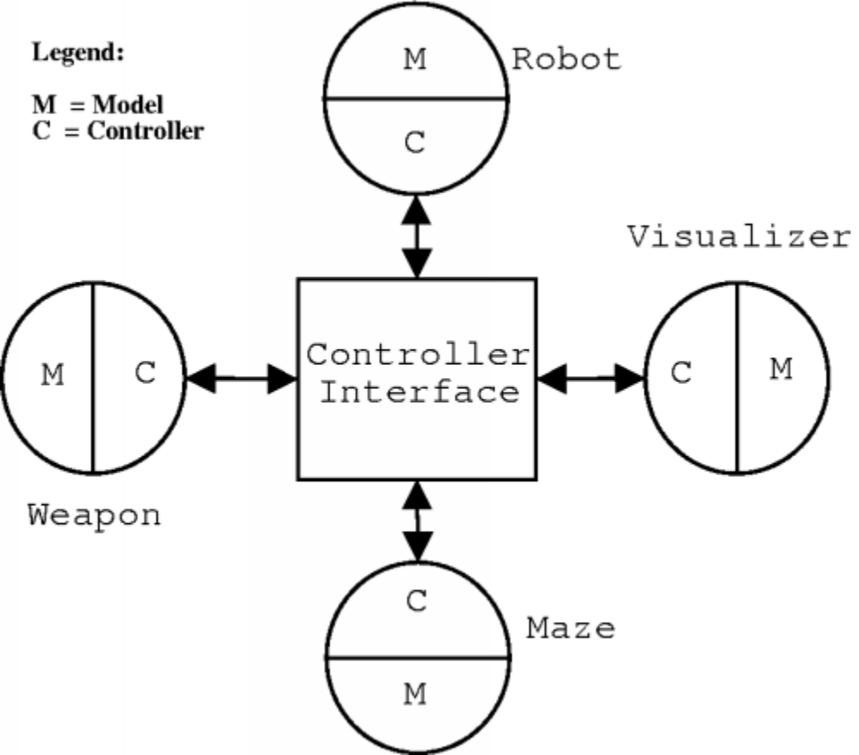

From a very high level perspective, these major system components can be hierarchically viewed as packages of Java classes. The root class, called GameMain, aggregates five different class packages. Each of these packages, except for Common, encapsulates a specific domain of the RSR-3D system functionality. Common provides utility classes that are accessible to the rest of the system, including GameMain.

The areas covered by the remaining classes are obvious from the package names, as seen in the following UML diagram:

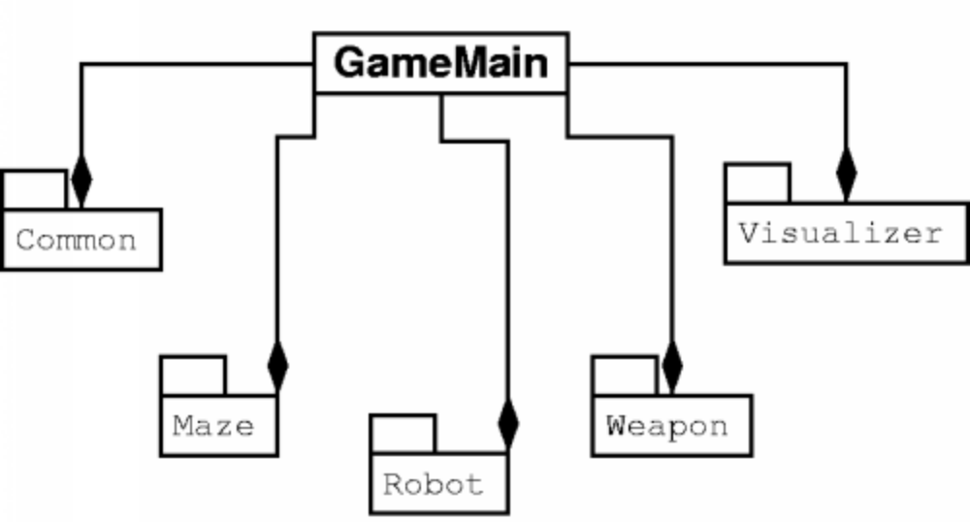

The Visualization Initializer

Operation Description

Here, we focus on describing one half of the Visualizer component within the RSR-3D system. The Visualizer (responsible for 3-D rendering) is made up of two fundamental processes: initialization and update. The former is covered herein, while the latter is described elsewhere within this document. Initialization deals with the initial defining and rendering of the RSR-3D maze along with any weapon and robot items that reside in the maze. The maze itself (e.g., walls) will not change during game play; once it is defined within the data structures used by the Visualizer, the maze remains unaltered. The robot and weapon items, however, are expected to move about the maze and perhaps even change their appearances.

Initialization starts when the the Visualizer retrieves an iterator from the Maze component. This iterator allows the Visualizer to traverse a simple N x N matrix which represents the maze. Each cell of the matrix denotes one "room," and all rooms are the same size. The data contained in a given cell consist of a bit string representing whether or not there are walls on the North, South, East, and West sides of the room, and whether or not there is a robot and/or weapon in the room (only one robot and/or weapon is allowed to be in a given room at initialization). Using the iterator, the Visualizer reads the bit-string definition of each room and converts these definitions into a 3D representation of the maze. Since all rooms are the same size, it's possible to determine an X, Y, Z coordinate for the center of any given room, thereby allowing the location of the room within the maze. Note that the term room is used generically here: everything is a room - it's just a matter of whether or not there are walls present for some or all sides in the room.

When the 3D representation of a room is constructed, simple solids are used to represent each of the room's walls. Each wall is actually a copy of the a single wall prototype, which is a 10 meter by 1 meter by 1 meter solid. For robot and weapon items specified within the maze, cone and sphere solids (respectively) are used for rendering the corresponding 3D object. The cone has a radius and height of ½ meters, while the sphere has a radius of ½ meters. Whenever a robot cone is rendered in the maze, it is displayed 1 meter above the maze floor, because RSR-3D robots hover.

A room is completed when it is inserted into the Java3D scene graph. The scene graph is a tree structure used by the Java3D library to maintain state information about all of the items that make up a virtual 3D universe.

Initialization is complete when the Java3D viewing platform is positioned within the maze. The viewing platform is simply the point of view from which a 3D universe is seen. In RSR-3D, the user can view the game from the perspective of any of the robots in the game maze - the first robot to be rendered in the maze is selected to start the game out.

Now that we've explored the details of the initialization process, let's turn our attention to the java classes that make up the initialization segment of the Visualizer component.

Class Descriptions

There are nine classes which make up and contribute to the initialization process within the Visualizer. The following table provides the names and a brief description for each class:

Class Name | Function
Colors.java | Provides commonly used color constants
IVsualizer.java | An interface that the other components in the RSR-3D system can use to access the Visualizer component
MazeFactory.java | The base class for the abstract maze factory
MazeInitializer.java | Directs all of the initialization process for the Visualizer component
MazeTarget.java | Encapsulates and manages an array of references to items in the Java scene graph (e.g., scene graph objects that represent robots, weapons, and the viewing platform)
RobotFactory.java | The base class for the abstract robot factory
TargetData.java | A utility class used by MazeTarget. TargetData encapsulates critical pieces of information associated with scene graph objects
Visualizer.java | The main class for the Visualizer component. This class is responsible for managing the initialization and updating processes.
WeaponFactory.java | The base class for the abstract weapon factory

In the corresponding class hierarchy, we find a situation where instead of inheritance, we have a lot of composition:
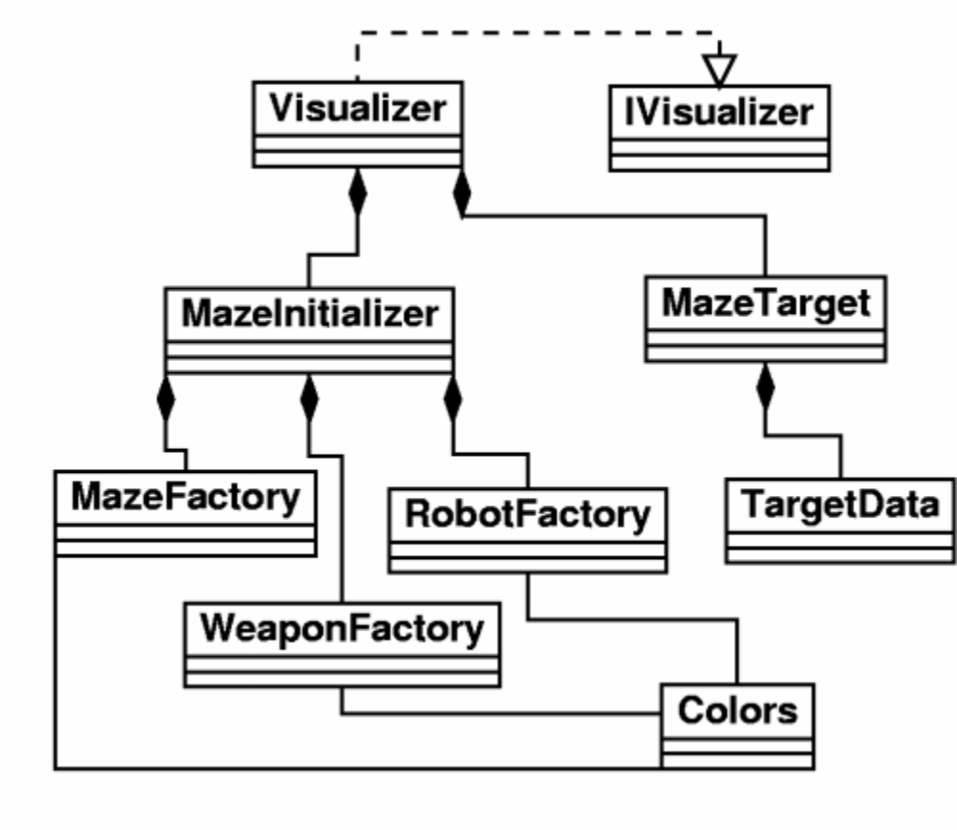

We can see in this UML class hierarchy diagram that Visualizer implements the IVisualizer interface class, and then aggregates MazeInitializer and MazeTarget. MazeInitializer aggregates the three abstract factories, while MazeTarget aggregates TargetData (its helper class); each of the abstract factories has an acquaintance with the Colors class. The Colors class is nothing more than several public, static, color constants which are used by the factories to add color to the 3D items they build. Of course, the IVisualizer class is the means by which the rest of the RSR-3D system can access the Visualizer component. Note, however, that IVisualizer does NOT provide any access into the Visualizer component's initialization process. This is because initialization must take place only once, at the outset of the RSR-3D game. Therefore, it is handled implicitly (and privately) by the class constructor for the Visualizer class. The scene graph objects created during initialization, however, are made available to the Visualizer component's update process through the MazeTarget class.

One question raised at this point is, since the initialization process is so cut off from the rest of the RSR-3D system, how does it even know what sort of 3D maze to render (including where to place robots and weapons)? In fact, although initialization is a very independent function of the Visualizer component, in order to be helpful, it must utilize maze data generated by the Maze component. This is carried out by the MazeInitializer obtaining an iterator object from the Maze component, and then using this iterator to learn the layout of the maze and starting positions of any robots and weapons in the maze.

For a more detailed understanding of how each of the initialization classes operate, please refer to the source code and comments in the relevant java files.

Testing

Because the initialization process in the Visualizer component is so uninvolved with the rest of the RSR-3D system, testing it is actually a simple affair. The only real problem faced in testing, is what to do about obtaining maze layout data. In order to not involve other system components, it's best to hard-code some fake maze layout data right in the MazeInitializer class. Such data would be in the form of a two dimensional array of bit strings; one string per room, where each bit denotes the presence or absence of a wall, robot, or weapon. This is precisely how the Maze component maintains the maze layout data which are accessed by the initialization process through an iterator (see the Operation Description above). Hence, in order to maintain parity with the Maze component, bit strings are used here in testing. The layout of the room bit string is given in the MazeData java class.

Beyond drawing a maze and all of its components, the other chore that initialization is responsible for is positioning the Java3D viewing platform. The viewing platform is nothing more than the perspective (i.e., X, Y, and Z coordinates along with an angle of rotation) of the 3D display. In RSR-3D, this perspective is always from the view point of a robot in the maze, or a fixed spot above the maze. At the outset of game play, the first robot to be placed into the maze is used to position the viewing platform. This, then, can be tested in conjunction with rendering the maze and its components (e.g., one of the hard-coded bit strings should specify that a robot exists in a given room; then, after the maze is rendered, the viewing platform will automatically be set to the perspective of the robot).

The Visualizer Update

Operation Description

Once the game components, the maze, Robots, and weapons, are initialized and rendered in the 3D universe utilizing Java3D, these components must be “observed” for their individual behaviors. When a component or components exhibit new behavior, such as moving for point x to point y, or fire a weapon, or rotate the view, these actions must be updated and displayed properly within the 3D universe for visual display.

The models themselves are responsible for the notification to the Visualizer of an update on a model component. The updates are a direct method call, through the IVisualizer interface, from the model to the visualizer. For instance, when the robot desires to move from point x to point y, the robot component invokes the “updateLocation” method that will notify the visualizer component to change the location. This structure is much simpler than the observer-mediator pattern, but still allows for design flexibility and changes. If a new update behavior needs to be added, simply add the proper method signature to the interface and add the method to the visualizer class.

There are several data structures used to make the above behaviors possible. First, the visualizer component uses a Java vector (much like an expanding array) to keep track of all the robots and weapons inside of the maze. A class called MazeTaget implements this vector and the elements inside the vector are class objects called TargetData. This data structure is not visible to the other components and is used only internally by the visualizer. When the visualizer is asked to add an object to the maze, the visual attributes encapsulated by the MazeData is stored in the vector. Basically I can search for objects by either location or by object type and retrieve all the pertinent image data needed to manipulate the image within the Java3D universe.

Each update is accomplished by directly manipulating the data and state information held in the Java3D scene graph. During initialization of the Visualizer, all of the information necessary to visually render each robot and weapon model is stored in class MazeTarget, as described above. The Visualizer class can identify which model, or robot, is calling for an update by the x, y, z coordinates of each robot and can retrieve the rendering information for this robot from the MazeTarget class, or object instance created during initialization. All of the updates manipulate either the translational, rotational, or physical appearance data associated with the model to render the image to the computer screen. After an update, the new data is stored back into the MazeTarget object.

For now, there are minimal update methods that can be invoked by a robot through the Ivisualizer interface, but additional functionality will be added soon. Please note that the Location and Target class definitions are in the “common” package and basically describe the translational data (x, y, z coordinates) and the rotational view data (which way is robot looking, or rather where is camera pointed). These methods are as follows:

- updateLocation (Location currentLocation, Target newTarget);
- Changes the translational and/or rotational data of a model. A robot can move and rotate simultaneously. Also a robot can rotate in both clockwise and counterclockwise directions. . The method also checks to see if the “view platform” is associated with the model and if so, the “view” would be updated as well to reflect the “eyes of the beholder. The method assumes the caller has insured that the robot is allowed to move to this location without violating the “correctness” of the new position

- fire (Location loc, Target target);
- Fires a “bullet” from Location loc to Target target. This is simulated as a Java3D animation. As with the other methods, the responsibility of the coordinates used by the visualizer to render the image is with the invoker. For instance, the invoker should have the knowledge of the final point of the image, either a wall or another robot. In other words, the visualizer will “blindly” use the firing coordinates to render the image; the overall visual “success” resides with the models.
- addWeapon (Location loc);
- Enables a robot at Location loc to “pick up” or attach a weapon found within maze and change the image accordingly.
- removeWeapon (Location loc);
- Enables a robot at Location loc to “drop” a weapon to maze floor,
again, changing the image accordingly.
- DamageRobot (Location hitTarget);
- Inflicts damage to a robot “hit” by enemy fire by “flickering” the
robot’s color from black to its original color scheme.

The Visualizer update is also responsible for changing and keeping track of the viewing platform, or “camera”. During game play, the user can strike any key on the keyboard and the camera will switch to a different view. The game starts out with a “bird’s eye” view and each key press will rotate the view from each robot in the maze and then back to the bird’s eye view. The private Visualizer class called ChangeViewBehavior handles this.

Class Descriptions

There are five classes that make up and contribute to the updating process within the Visualizer. The following table provides the names and a brief description for each class a more detailed description is below the table:

Class Name | Function
IVsualizer.java | An interface that the other components in the RSR-3D system can use to access the Visualizer component updating methods
ChangeViewBehavior.java | Private class of Visualizer used to change the “camera” view from robot to robot and to a “bird’s eye” view of game
MazeTarget.java | Encapsulates and manages an array of references to items in the Java scene graph (e.g., scene graph objects that represent robots, weapons, and the viewing platform)
TargetData.java | A utility class used by MazeTarget. TargetData encapsulates critical pieces of information associated with scene graph objects and the data to be updated
Visualizer.java | The main class for the Visualizer component. This class is responsible for managing the initialization and updating processes.

The following UML diagram depicts the class structure:

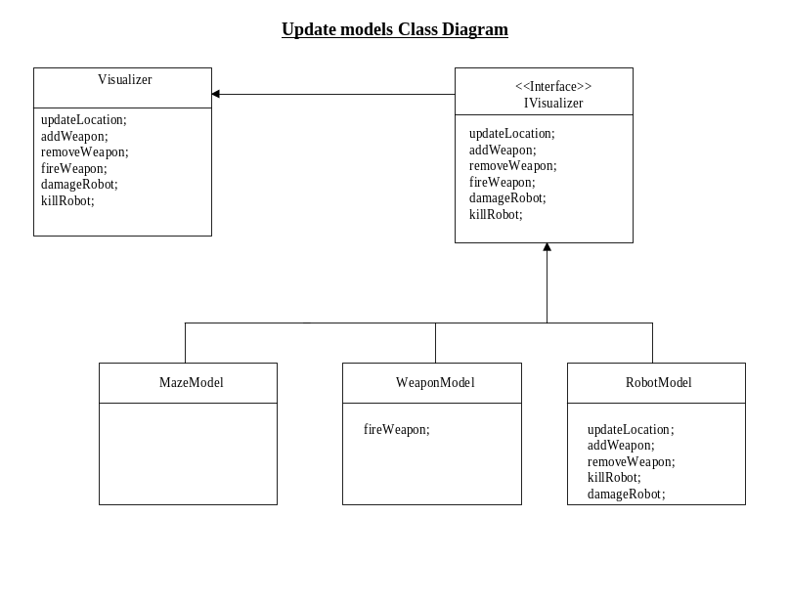

Testing

The functionality of the Visualizer update is fully tested and works as intended. I devised a game simulation that manipulated the model data stored within the MazeTarget data structure. In addition, the test simulated having multiple robots and weapons in the maze, all interacting simultaneously, as would be the case after integration of all components. Each of the methods available through the IVisualizer interface were invoked and rendered the proper visual update effect. The biggest challenge was to implement and maintain “threads” for each robot initialized in the maze. Each method call from a robot must be called within their individual threads so that the robots can move and interact with the game simultaneously. This was a major concern from the outset, but using Java threads turned out to be quite easy and Java3D is very efficient at updating the scene graph. In fact, Java3D is so fast at updating and re-drawing an updated image that it is required to put the thread to “sleep” for a quick moment during intermediate steps so that the user can see the update on the screen. For instance, when a robot moves from point to point, you must “sleep” each step of the way or else the robot will appear to just jump from point to point instead of “hovering” to a new location. In short, the updating methods are fully tested and perform as intended.

The GameMain Component

Operation Description

The game has to be initialized and the proper structures and frameworks must be in place to enable the components to interact and actually ‘play’ the game. “Main” will set up this framework and provide the ability to initialize different game formats.

The class that will initialize the game type, initialize the threads of communication, and terminate the game, is called the GameMain class. This class is NOT dictating or deciding behavior in any shape or form. It will simple initialize the type of game, initialize the game components, set up the necessary references and structures to enable the components to communicate with each other and the 3D universe.

Class Descriptions

GameMain incorporates the Factory and Strategy patterns to create different game formats. The Factory method is used to create instances of the proper game type chosen by the user. The Strategy is used to implement algorithms for each possible game type. This pattern arrangement makes the different game strategies interchangeable by decoupling the user from the strategies. Please note that the GameMain parent class is NOT abstract, it’s sole purpose is just to implement the applet interface required for the Java3D universe and start the chain of events to initialize the game by creating instances of GameType class, the StaticGameFactory, and the GameTypeFactory. The following UML diagram shows the GameMain Class structure:

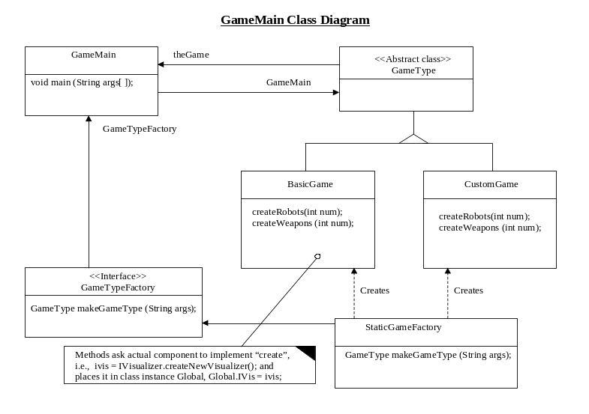

The concrete instances of the GameType will be the basic game and a custom game. The basic game is with just two (2) robots and two (2) different types of weapons, and a simple maze. The custom format allows the user to start with any number of robots and weapons. Other game types can easily be added to the structure and these will develop over time as we test the system.

The concrete game instance creates and distributes the interfaces for the communication references between components. To create the interfaces, the object will ask that the individual game components (maze, robots, and weapons) “create” themselves and pass back an interface reference to the concrete component. The only “behavior” that GameType objects handle is passing input from the user to the components. For instance, if the user wants a game with 10 robots, Custom GameType simply asks the robot model component to create 10 robots (in any way or form that the robot model component wishes) and return to GameMain 10 interfaces to enable communication with these robots across the 3D universe. Additional responsibilities for the concrete GameType objects include initializing and setting up the Java3D “canvas” and initial layout of the Java3D universe. However, the “look and feel” of the universe is determined by the other components, such as the maze. After all of the components are created and the communication references are in place, GameMain can call the method to start the game and spawn the threads necessary to enable the components to communicate with the Java3D universe. Once the game termination conditions are met, GameMain will terminate.

The following is a table briefly describing the classes:

Class Name | Function
GameMain.java | Initializes viewing applet and creates GameType, GameTypeFactory, StaticGameFactory class instances
GameType.java | Creates either a Basic game or Custom game from user input
BasicGame.java | Default game, 2 robots and 2 weapons and a simple maze
CustomGame.java | User decides the number of robots and weapons
GameTypeFactory.java | Interface for creating games from GameMain to StaticGameFactory
StaticGameFactory.java | Part of Factroy pattern, creates concrete instances of game.

Testing

GameMain is quite easy to test and is fully tested. GameMain just sets up the initial framework for the other components, initializes the applet for visualization by the user, and the models take over from here. GameMain requires that all of the individual components can create themselves and return a reference to their unique interface. GameMain then distributes these references to the proper component or places them in the utility class within “Common” called the Global class so that the components have access to them and can communicate through the proper interfaces. GameMain was used by all the other components during their testing and is ready to handle the task at hand.

The 'Common' Package Utility Classes

In order to support the major components that make up the RSR-3D system, several shared utility classes are required. Since each of the system components (i.e., Robot, Weapon, Maze, and Visualizer) is highly encapsulated, it follows that any utilities shared between them would have to be simplistic - in order to be useful all around. This is the case with the classes provided in the Common Java code package.

Class Descriptions

Within the Common package, we find classes that provide utility in three major areas: RSR-3D agents (i.e., robots and weapons), location information, and general RSR-3D maze information. The following table describes all of the classes in this package:

Class Name | Function
AbstractModel.java | Abstract class that provides base implementation for any maze agent (i.e., robot or weapon)
AngleFinder.java | Helper class that will determine the angle between two points within the RSR-3D maze, relative to coordinate 0, 0, 0
Global.java | Convenience class that allows any system component to quickly access the interfaces of other system components
Location.java | Encapsulates and manages basic location data for a maze agent (i.e., robot or weapon). Data include: X, Y, Z coordinate, and angle of rotation
MazeData.java | Encapsulates numerous public, static constants used in building the RSR-3D maze
Target.java | Extension of the Location class. Target adds a direction value (for agent rotation), and a reference to an agent's model

There is no inheritance amongst these classes, with one exception: Location and Target. Target is an extension of Location, in that in addition to providing X, Y, Z coordinate and angle of rotation information, it also includes the direction in which an agent rotates, and a reference to the agent's AbstractModel information. Throughout the RSR-3D system, Target objects are used to refer to a target that an agent intends to interact with (e.g., fire at, pick up, etc.), or to refer to the agent itself (e.g., the agent's current location and angle of rotation). Also, the Target object provides a very convenient way for an agent's AbstractModel to be referenced.

Testing

Because much of the code in the Common package consists of static values and abstract methods, there's very little to be tested. Instead, these utility classes often operate as interfaces, which are utilized in the major system components. Nevertheless, there are three classes that can be tested directly to some degree: AngleFinder, Location and Target.

The best way to test AngleFinder, is simply to create a test class that attempts to find the angle made between two points, relative another point. Within the RSR-3D system, values returned by AngleFinder are used to rotate a robot about its Y axis, in order to turn the robot to shoot at an enemy. Of course, to confirm the accuracy of the angle of rotation provided by AngleFinder, it will be necessary to work out any test case by hand in order to compare with the AngleFinder class' results.

Similar to testing AngleFinder, tests for both Location and Target are best handled by creating a test class that attempts to utilize these classes. Since Target inherits from Location, it's reasonable to collapse the testing of Location into the testing for Target. In such a test, it would be important to confirm that the X, Y, Z coordinates and angle of rotation for a maze agent can be initialized, retrieved, and updated. Also, the ability to set a direction for rotation, and get a reference to an AbstractModel must be verified. All of this can be easily accommodated with a small test class.

The Maze Component

Operation Description

The Maze component in the RSR-3D system takes care of all the necessary activities related to the mazes. The various features of this component can be divided into two fundamental processes: Maze generation & Behavior. The maze generation deals with the creation of random mazes and the login there in, while the behavior deals with various aspects like the collision detection, agent & weapon search etc., at the lower level of working.

Generation starts when the call for the initialization takes place elsewhere in the code. The maze is thought of as a simple N x N matrix. The points where the horizontal rows and vertical columns meet are thought of as the coordinate points (“cell points”) for the rooms. Each cell of the matrix grid denotes a single “room”. It is assumed that all the rooms are of the same size. The configuration of each room, like the presence of the walls on all the sides of the room (East, West, North and South), presence/absence of a robot or a weapon etc, is represented using a bit string. Also two vectors (arrays) are considered to store the total number of robots and weapons present in the maze whose initialization takes place in some other part of the system. In the creation of the maze structure, initially, the user is allowed to choose the size of the maze matrix. Taking this size, a grid like structure is generated, wherein all the walls are set up at each cell point. In this initial stage it is seen that robots and weapons are set up at each and every cell points (only one agent/or weapon is allowed to be in a given room in the initial stage). Thus in this state it is assumed that all the walls are standing up. Now a simple algorithm is used to randomly select cell points and knock down walls in some arbitrary direction resulting in rooms with entrances and exits. Also at some points, agents, weapons set up earlier are removed. Care is taken to see that the randomly selected cell points always fall within the user specified size for the maze. Note that every cell point shows a room and absence of wall is either an entrance or an exit. It is also interesting to note that since all the rooms are of the same size, its possible to determine X,Y,Z coordinates for the center of any given room, thereby allowing the location of the rooms with in the maze. Such a generated maze structure is passed onto the Visualization component to be rendered in the 3-D environment via an iterator. The maze thus generated will not vary once it has been passed to the Visualizer. However, each instance of the game system results in the creation of a new type or maze thus providing a unique maze environment.

Once the generation and initialization is complete, behavior needs to be taken care of by taking care of things like collision detection, locating other agents/weapons in the line of sight and angle of sight etc., for an agent with in a room. Since only robot/or weapon is allowed per room in the initial stage, it becomes easier to locate the other agents and weapons. Obtaining the room coordinates in which the first robot is rendered, all the immediately adjacent rooms (forming a closed square around this room) are searched for the presence of other agents/weapons. This is implemented simply by checking for the Robot and Weapon bits in the bit string attached to all these rooms that are to be checked. Similar logic is used to check for any agents or weapons with in the angle of sight of the robot (at time of rendering the robots, it is seen that they are made to face a particular direction). Moving a robot towards another robot or weapon is taken care of by finding out the robot/weapon X, Y, Z coordinates. In this process of moving, it is checked for the presence of a wall in the bit string thus taking care of collision detection. The call to move the robot is given from elsewhere the robot which gets rendered first. Thus these coordinates are passed to the caller to move the robot. The maze also takes care of giving a reference to any particular robot or weapon in the maze to the caller.

Class Descriptions

There are five classes which make up and work towards the initialization and behavior of the maze component. The names and brief descriptions of their actions are provided below.

Class Name | Function
IMaze.java | An interface that the other components in the RSR-3D system can use to access the Maze component
MazeData.java | Contains the information for the bit string representing the configuration for a room
Room.java | The base class for a single room in the maze. This class is responsible for containing the data that make up a room
Matrix.java | This implements the MazeDatan interface. This class is responsible for the generation of the maze grid. This provides methods for setting up and removing the agents at different cell points.
Maze.java | Implements the interface IMaze. It is responsible for the behavior of the maze. It also gives the handle to MazeIterator.

Testing

As the Maze component is involved much less with the other classes in the system except the Visualizer component, it is easy to test the classes in the code for the purpose. All the classes in the maze component are programmed keeping the interfaces in view.

For the purpose of generating the maze, the code is tested assuming the fake size of the matrix and input vectors of robots and weapons. Methods to add or remove the robots/or weapons also given in this class are tested by obtaining data from the room class, which in turn is programmed with reference to an interface (MazeData). But, after the maze is generated, its entirely dependent on the Visualizer to render it and complete the testing process. For the purpose of testing the behavior part, different methods are implemented. However to realize the proper functioning of the methods, again the dependence on the Visualizer component comes into picture. The testing is done using the standard Black box and White box testing techniques.

Robot Component

This package contains the classes required for the creation and behavior of the robot. A class diagram is given for each unit of functionality showing how the classes relate to each other. This package is known to the other packages through the interface IRobot. IRobot defines a set of operations that classes from other packages can use.

Class Descriptions

Class Name | Function
IRobot.java | This is the interface that defines the operations “publicly” available.
RobotModel.java | This class defines all the data members required to represent the state of the robot.
AbstractRobot.java | Here we define all common methods for all robots.
ConcreteRobot(A, B, C, D, …).java | One class for each concrete robot will be created. Currently there are four concrete robots(A-D) that can be used in the game.
Goal.java | This is the super class for different goals that the robot can have.
GoalSearchRobot.java | This class will have all the methods required to reach the goal – seach robot.
GoalSearchWeapon.java | This class will have all the methods required to reach the goal – seach weapon.
RobotFactory.java | This class will create instances of available concrete robots.
Test.java | This program will be used to do unit testing for the robot package.
Class Diagrams

RobotModel

This class stores all information of the robot. An instance is created for each Robot instance. It extends the AbstractModel class to inherit what is required by the Visualization. The model will allow other objects to observe its state changes. Eg) Some other objects can request notification when the Robot’s position changes. This will be implemented using the Observer pattern.

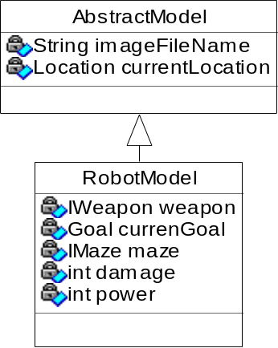

Model Class diagram

Robot

Each concrete robot will have its own “personality”. They will look different and behave differently. Class AbstractRobot will implement all common robot behavior. Each instance of Robot will run in its own thread. After the “Main” program creates and initializes all objects, it will call the start methods on all robots. This will cause the robots execution to start in its own thread.

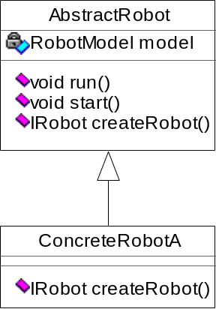

Robot class diagram

RobotInterface

This is the robot’s interface to weapon and maze classes. It follows the Facade pattern. Operations defined in this interface are the only ones available to classes in other packages.

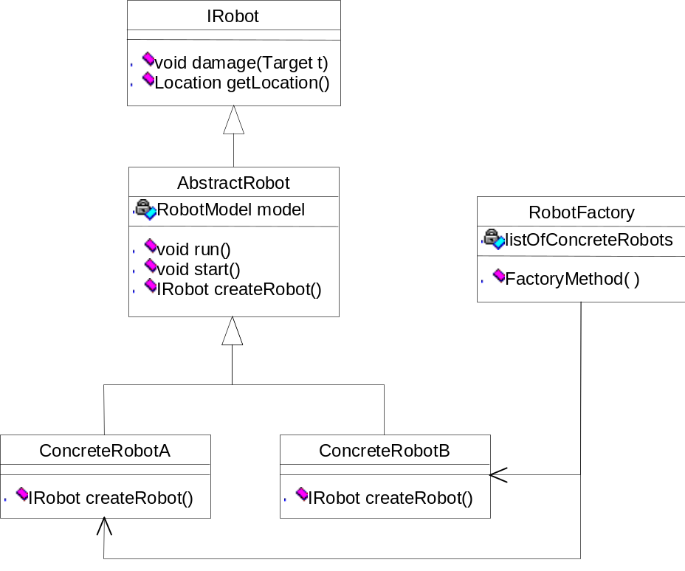

Interface and Factory class diagram
RobotFactory

This factory class will be responsible for creation of different robot objects. RobotFactory must be aware of all ConcreteRobot classes. Robot creation is implemented with a slight variation to the Factory Method pattern. The main program that starts the game will use the RobotFactory to create the robots for the simulation. The factory method can randomly generate a robot from the list of known Concrete robots or create the requested robot. In the second case, the calling class must also know all the Concrete robots.

(See class diagram given for RobotInterface)

Robot Behavior

The robots don’t have a weapon when the game starts. So, the first goal of the robot is to find a weapon. Once a the robot gets a weapon, its goal changes to finding an enemy robot and destroying it. If the robot loses its weapon or runs out of ammunition, it has to find another weapon. These two search operations can be implemented using the State pattern. This way, the logic in Robot does not need to know what it is searching for once the goal has been set.

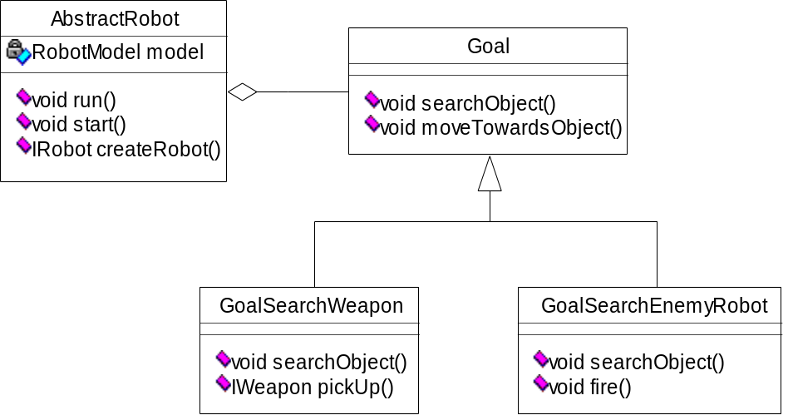

The robot may also attain more power when it enters some special room, such as speed, x-ray vision to look through walls, etc. We should be able to give robots enhanced behavior. We can implement this with the Decorator pattern.

Testing

Creation: Use a test program to do unit testing. This program will create robots using the Robot factory. The test program can print to the console the name of the robot that was created. The robot factory creates robots randomly from a list of available concrete robots. The randomness can be verified by inspecting the output on the console.

Behavior: The same test program can be used to test the threads for each robot. The test will verify that the thread for each robot has been created and is running. Again, printing messages to the console can check this. The robot uses search operations in the maze to locate weapons/agents. For unit testing this can be supplied as hard coded values.

The above unit testing has been completed successfully.
Integration Test

Here we will integrate the robot package with other packages. The integration can be done in steps. Each step will integrate with one other package.

Weapon integration: Here we have to test each of the operations defined in the IWeapon interface. The robot should be able to pickup, drop & fire weapons successfully.

Maze integration: Here we have to test each of the operations defined in the IMaze interface. Test each of the search and move operations. Then, verify that the robot uses these results as designed.

Visualizer integration: Here we have to test each of the operations defined in the IVisualizer interface. As the robot perform different actions it sends messages to the visualizer to update the display. This is verified visually.

After each of the above tests have been done successfully, the Robot should be ready for shooting!

Weapon Component

Operation Description

The Weapon component is responsible for weapon generation and weapon behavior.

At the beginning of the game, the maze component is responsible for initially placing the weapons randomly throughout the maze. Currently, these weapons will all look the same (size and color). The only differences will be (1) the predetermined number of laser beams a weapon can discharge and (2) the size (width) of its laser beam. The following diagrams are for illustrative purposes only:

Predetermined number of laser beams weapon can discharge - The weapon in the example below can discharge only seven (7) times. In its current state, only four (4) discharges are available. The number of charges available is tracked as the weapon is fired. When the number reaches 0, it is fully drained, and will not fire until it is once again recharged. In the current scenario, the weapon is fully recharged only when it is picked up once again by a robot.

7
0

Power remaining

Size (width) of its laser beam - One of the features that distinguishes one weapon from the other is the size of the laser beam; for example, the weapon may have a thin, medium, or thick beam. The thicker the beam, the more damage it can do the target.

Beam Density
0=thin
1 = medium
2 = thick

A number of weapons will be scattered throughout the maze. All the weapons will initially be on the floor and fully charged. Not every room will have a weapon. In addition, no room will have more than one weapon; for example, in a 16-room maze, only 12 rooms may have one weapon each.

As the robots (agents) traverse the maze, they will be searching for weapons. If the robot (friend or enemy) is in the same room as a weapon, and finds it, the weapon can be picked up by the robot and then moved from room to room within the maze. If the robot has the weapon in its possession and finds an enemy agent in the same room, the robot can fire the weapon at the enemy robot as long as the weapon is not empty. The amount of damage the weapon does to the robot depends on factors such as where the weapon was pointing when fired, the laser beam's power, and how many times the weapon was fired at the target.

The robots decide whether a weapon should be picked up or dropped. For example, the first robot entering a room without a weapon may decide to pick up the first available weapon it sees. After traveling from room to room, let’s say the robot’s weapon is empty or the weapon on the floor is more powerful than the one in its possession, it may choose to drop the existing weapon and pick up the other weapon. Once a robot picks up the weapon, it will automatically fully recharge, ready once again to fire.

Class Descriptions

There are currently seven classes that make up the Weapon component. Provided below are the class names and their brief descriptions.

Class Name | Function
AbstractWeapon.java | Stores all information about the weapon
WeaponFactory.java | Creates concrete weapons randomly from a known set of concrete weapons
ConcreteWeaponA.java | Concrete Weapon – slightly different from B, C and D
ConcreteWeaponB.java | Concrete Weapon – slightly different from A, C and D
ConcreteWeaponC.java | Concrete Weapon – slightly different from A, B and D
ConcreteWeaponD.java | Concrete Weapon – slightly different from A, B and C
IWeapon.java | Interface for Weapon - all other classes must use this interface to interact with weapon

All models in this game system inherit from the AbstractModel.

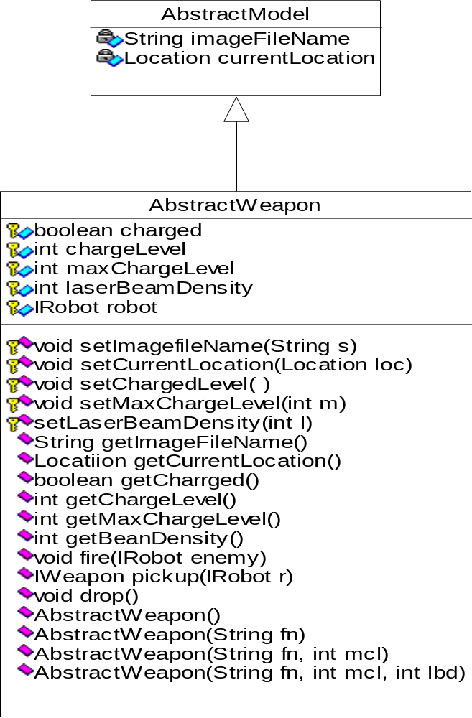

All components will communicate with the Weapon through its interface class, IWeapon. The WeaponFactory is responsible for creating the different Weapon objects. This class must be aware of all the ConcreteWeapon classes that exist.

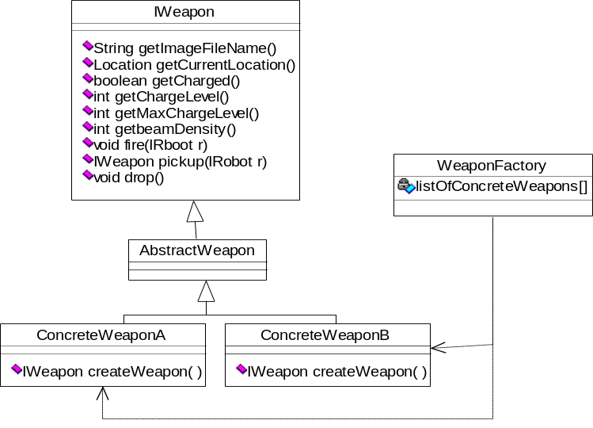

Testing

Testing will include ensuring that:
- maze can generate the weapons upon demand,
- robot(s) can pick them up and drop them,
- size of the laser beam being discharged from the weapon matches the attribute value assigned to the weapon, and
- weapon fires when the robot(s) invoke the firing method.

Acceptance Testing

Scenarios

Scenario 1
- User loads game
- passing no arguments
- User exits the game

Scenario 2
- User loads game
- passes one argument (integer)
- User exits the game

Scenario 3
- User loads game
- passes two arguments (both integers)
- User exits the game

Scenario 4
- User loads game
- passes more than two arguments (all integers)
- User exits the game

Scenario 5
- User loads game
- passes non-integer arguments
- User exits the game

Scenario 6
- User loads game passing no arguments
- User changes between views during the game
- One of the two robots is dead
- Game is finished

Test Plan

Game starts properly
The number and type of arguments passed should match the expected number and type of arguments. The only two acceptable cases include: (1) no arguments or (2) two integer arguments. If the user provides more or less than the two arguments, GameMain simply ignores the arguments and falls back to a default game.

Maze is properly generated
At the beginning of the game, the maze should be randomly generated.

Robots and Weapons

- Creation
- If there are no arguments passed, the default value for robots and weapons is 2.

- If two integer arguments are passed, the first integer argument denotes the number of robots to create, and the second integer argument determines the number of weapons that should be created.

- Location
- The robots and weapons are randomly distributed throughout the maze. No more than one robot and/or weapon should be in one room at the start of the game. The only exception would be if the generated maze includes less number of rooms than the number of robots and weapons requested by the user.

- Properties
- The robots will look different (color), while the weapons will be the same color (Cyan). Although they will basically look the same, they will differ as follows:
- one robot may be more powerful than the other robot
- one weapon may have less ammunition than another weapon

- Events
- The robot(s) can move around the maze without hitting walls.

- The robot can find each other with the help of the maze. .

- The robot(s) can find weapons.

- The robot(s) can pick up weapons.

- The robot(s) can drop weapons.

- The weapon(s) automatically reload to its fullest capacity once dropped.

- The robot(s) can request information about the weapon(s). For example, if a robot is holding a small weapon, but comes across another weapon, the robot can ask how powerful is the weapon on the floor. If the weapon is more powerful than the weapon it is holding, the robot can drop the smaller weapon and pick up the more powerful weapon.

- The robot requests the weapon to fire at another robot. As long as it is not empty, the weapon fires at its target.

- The weapon will tell the robot that it hit how much damage the robot should be taking. For example, a more powerful weapon would cause more damage than a less powerful one.

- The robot that was hit appears damaged.

- A robot dies once it is fully damaged.

View Perspective

- The user can change view perspectives by tapping the space bar.

Exit Game

- The user can exit the game gracefully (by closing the window)

Index

C
Common package 4, 16, 17, 18
Component 2, 3, 4, 6, 7, 8, 9, 10, 12, 14, 15, 16, 17, 19, 20, 21, 22, 27, 28
G
GameMain 4, 14, 15, 32
I
Interface 2, 3, 7, 8, 10, 12, 13, 14, 15, 16, 20, 21, 22, 24, 26, 28, 30
M
Maze 2, 3, 6, 7, 8, 9, 10, 11, 13, 15, 17, 18, 19, 20, 24, 25, 26, 27, 28, 30, 32
R
Robot 2, 3, 6, 7, 9, 10, 11, 12, 13, 15, 17, 18, 19, 22, 23, 24, 25, 26, 27, 28, 30, 32, 33
V
Visualizer 2, 3, 6, 7, 8, 9, 10, 11, 12, 13, 17, 19, 20, 21, 26
W
Weapon 2, 3, 6, 7, 9, 10, 11, 17, 19, 22, 24, 25, 26, 27, 28, 30, 32, 33

PROJECT CODE

As one might expect, GameMain is responsible for orchestrating the start-up and shutdown of the RSR-3D game system.

