CSCI 6160
Database Systems, Design & Management

PKDD’99 Discovery Challenge

by
Sornalatha Rathnasamy
Sathish Ramamoorthy
Table of Contents

Objective 3
Entity Relation Diagram 4
Database Schema 5
TSUM_A 5
TSUM_B 5
TSUM_C 6
PATIENT 7
DISEASE 9
DS_CLASS 9
Initial Observations 10
Query 1: Thrombosis distribution by age 11
Query 2: Thrombosis Probability by Disease 12
Query 3: Disease distribution 13
Query 4: Symptom distribution 14
Query 5: Patient distribution by Disease classification. 15
Query 6: Creation of table with Diseases & their classifications 16
Query 7: Correlation between Thrombosis and lab test with abnormal results 18
Future Work 20
Acknowledgements 20

Objective

Use DATAMINING
- To find the symptoms that predict thrombosis.
- To find the diseases that are related to the occuring of thrombosis.
- To find the lab tests (with abnormal values) that predict thrombosis.
- To get the distribution of patients with thrombosis according to certain factors such as age, disease types (collagen, non-collagen, normal)

The data was availble in files as comma seperated values. The tables had to be created and a Java program was used to load the tables from the files.

Entity Relation Diagram

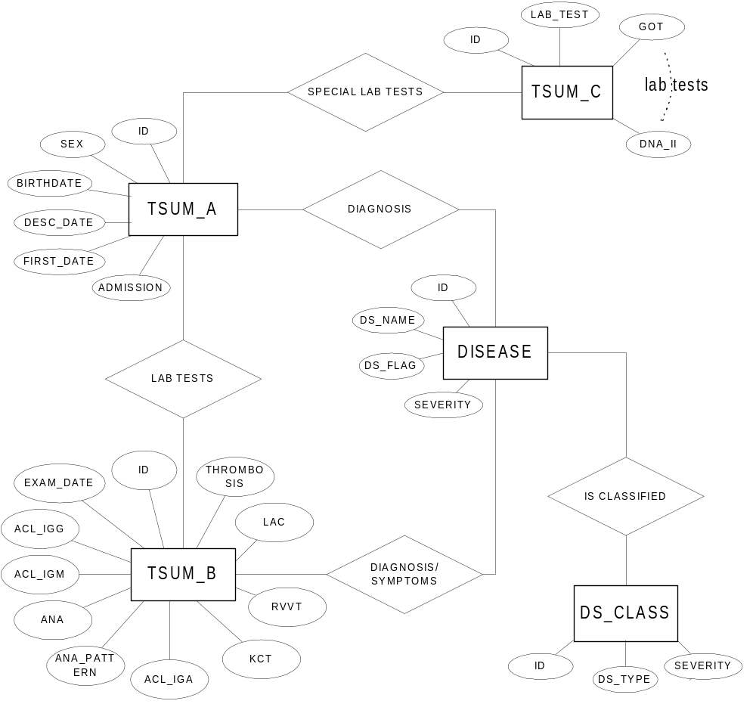

Database Schema

Medical database consists of three main tables. (TSUM_A, TSUM_B, TSUM_C). The patients in these three tables are connected by ID number. Also we have PATIENT, DISEASE, DS_CLASS tables which are derived from the three main tables.

TSUM_A
Basic information about patients (input by doctors). This dataset includes all patients (1237 records).

item | meaning | remark
ID | identification of the patient | VARCHAR2(10)
SEX |  | CHAR(1)
BIRTHDATE |  | DATE
DESC_DATE | the first date when a patient data was recorded | DATE
FIRST_DATE | the date when a patient came to the hospital | DATE
ADMISSION | patient was admitted to the hospital (+) or followed at the outpatient clinic (-) | CHAR(1)
DIAGNOSIS | disease names (multivalued attribute) | VARCHAR2(50)

TSUM_B
Special laboratory examinations (input by doctors) (measured by the Laboratory on Collagen Diseases). This dataset does not include all the patients, but includes the patients with these special tests. It includes 805 records. (only 769 are relevant with proper IDs)
item | meaning | remark
ID | identification of the patient | VARCHAR2(10)
EXAM_DATE | date of the test | DATE
ACL_IGG | anti-Cardiolipin antibody (IgG) concentration | NUMBER(6,2)
ACL_IGM | anti-Cardiolipin antibody (IgM) concentration | NUMBER(6,2)
ANA | anti-nucleus antibody concentration | VARCHAR2(8)
ANA_PATTERN | pattern observed in the sheet of ANA examination | VARCHAR2(3)
ACL_IGA | anti-Cardiolipin antibody (IgA) concentration | NUMBER(6,2)
DIAGNOSIS | disease names (multivalued attribute) | VARCHAR2(50)
KCT | meassure of degree of coagulation | VARCHAR2(2)
RVVT | meassure of degree of coagulation | VARCHAR2(2)
LAC | meassure of degree of coagulation | VARCHAR2(2)
SYMPTOMS | other symptoms observed (multivalued attribute) | VARCHAR2(50)
THROMBOSIS | degree of thrombosis.  0: negative (no thrombosis)  1: positive (the most severe one)  2: positive (severe)  3: positive (mild) | VARCHAR2(1)
Examination date is very close to the date on thrombosis. In negative examples, these tests are examined when thrombosis is suspected.

TSUM_C

Laboratory Examinations stored in Hospital Information Systems (Stored from 1980 to March 1999) All the data include ordinary laboratory examinations and have temporal stamps. The tests are not necessarily connected to thrombosis. This dataset includes 57385 records.

item | meaning | normal range | remark
ID | identification of the patient |  | VARCHAR2(10)
LAB_DATE | Date of the laboratory tests |  | DATE
GOT | AST glutamic oxaloacetic transaminase | N < 60 | NUMBER(6,2)
GPT | ALT glutamic pylvic transaminase | N < 60 | NUMBER(6,2)
LDH | lactate dehydrogenase | N < 500 | NUMBER(6,2)
ALP | alkaliphophatase | N < 300 | NUMBER(6,2)
TP | total protein | 6.0 < N < 8.5 | NUMBER(6,2)
ALB | albumin | 3.5 < N < 5.5 | NUMBER(6,2)
UA | uric acid | N > 8.0 (Male) ;N > 6.5 (Female) | NUMBER(6,2)
UN | urea nitrogen | N < 30 | NUMBER(6,2)
CRE | creatinine | N < 1.5 | NUMBER(6,2)
T_BIL | total bilirubin | N < 2.0 | NUMBER(6,2)
T_CHO | total cholesterol | N < 250 | NUMBER(6,2)
TG | triglyceride | N < 200 | NUMBER(6,2)
CPK | creatinine phosphokinase | N < 250 | NUMBER(6,2)
GLU | blood glucose | N < 180 | NUMBER(6,2)
WBC | White blood cell | 3.5 < N < 9.0 | NUMBER(6,2)
RBC | Red blood cell | 3.5 < N < 6.0 | NUMBER(6,2)
HGB | Hemoglobin | 10 < N < 17 | NUMBER(6,2)
HCT | Hematoclit | 29 < N < 52 | NUMBER(6,2)
PLT_EQ_VAL |  |  | VARCHAR2(1)
PLT | platelet | 100 < N < 400 | NUMBER(6,2)
PT | prothrombin time | N < 14 | NUMBER(6,2)
NOTE | comment for the test PT |  | VARCHAR2(10)
APTT | activated partial prothrombin time | N < 45 | NUMBER(6,2)
FG | fibrinogen | 150 < N < 450 | NUMBER(6,2)
AT3 | marker of DIC- important complications of collagen diseases | 70 < N < 130</TD | NUMBER(6,2)
A2PI | marker of DIC | 70 < N < 130 | NUMBER(6,2)
U_PRO_EQ_VAL |  |  | VARCHAR2(2)
U-PRO | proteinuria | 0 < N < 30 | NUMBER(6,2)
IGA_EQ_VAL |  |  | VARCHAR2(1)
IGG | Ig G | 900 < N < 2000 | NUMBER(6,2)
IGA | Ig A | 80 < N < 500 | NUMBER(6,2)
IGM_EQ_VAL |  |  | VARCHAR2(1)
IGM | Ig M | 40 < N < 400 | NUMBER(6,2)
CRP | C-reactive protein | N= -, +-, or N < 1.0 | VARCHAR2(6)
RA | Rhuematoid Factor | N= -, +- | VARCHAR2(6)
RF_EQ_VAL |  |  | VARCHAR2(1)
RF | RAHA | N < 20 | NUMBER(6,2)
C3_EQ_VAL |  |  | VARCHAR2(1)
C3 | complement 3 | N > 35 | NUMBER(6,2)
C4_EQ_VAL |  |  | VARCHAR2(1)
C4 | complement 4 | N > 10 | NUMBER(6,2)
RNP | anti-ribonuclear protein | N= -, +- | VARCHAR2(6)
SM | anti-SM | N= -, +- | VARCHAR2(6)
SCl70 | anti-scl70 | N= -, +- | VARCHAR2(6)
SSA | anti-SSA | N= -, +- | VARCHAR2(6)
SSB | anti-SSB | N= -, +- | VARCHAR2(6)
CENTROMEA | anti-centromere | N= -, +- | VARCHAR2(6)
DNA | anti-DNA | N < 8 | NUMBER(6,2)
DNA_II | anti-DNA | N < 8 | NUMBER(6,2)

PATIENT
We joined the TSUM_A table with the TSUM_B and TSUM_C by an SQL query, taking only the first laboratory examination for each patient.We also added an attribute THROM_FOUND which was set to 'Y' (Yes) for TSUM_B.THROMBOSIS = (1,2,3) and set to 'N' (No) for TSUM_B.THROMBOSIS = 0.
This dataset has 416 records.

item | meaning | remark
ID | identification of the patient | VARCHAR2(10)
SEX |  | CHAR(1)
BIRTHDATE |  | DATE
DESC_DATE | the first date when a patient data was recorded | DATE
FIRST_DATE | the date when a patient came to the hospital | DATE
ADMISSION | patient was admitted to the hospital (+) or followed at the outpatient clinic (-) | CHAR(1)
EXAM_DATE | date of the test | DATE
ACL_IGG | anti-Cardiolipin antibody (IgG) concentration | NUMBER(6,2)
ACL_IGM | anti-Cardiolipin antibody (IgM) concentration | NUMBER(6,2)
ACL_IGA | anti-Cardiolipin antibody (IgA) concentration | NUMBER(6,2)
ANA | anti-nucleus antibody concentration | VARCHAR2(8)
ANA_PATTERN | pattern observed in the sheet of ANA examination | VARCHAR2(3)
KCT | meassure of degree of coagulation | VARCHAR2(2)
RVVT | meassure of degree of coagulation | VARCHAR2(2)
LAC | meassure of degree of coagulation | VARCHAR2(2)
SYMPTOMS | other symptoms observed (multivalued attribute) | VARCHAR2(50)
THROMBOSIS | Degree of thrombosis:  0: negative (no thrombosis)  1: positive (the most severe one)  2: positive (severe)  3: positive (mild) | VARCHAR2(1)
THROM_FOUND | 'Y' if thrombosis is positive ;  'N' if no thrombosis; | CHAR(1)
LAB_DATE | Date of the laboratory tests | DATE
GOT | AST glutamic oxaloacetic transaminase | NUMBER(6,2)
GPT | ALT glutamic pylvic transaminase | NUMBER(6,2)
LDH | lactate dehydrogenase | NUMBER(6,2)
ALP | alkaliphophatase | NUMBER(6,2)
TP | total protein | NUMBER(6,2)
ALB | albumin | NUMBER(6,2)
UA | uric acid | NUMBER(6,2)
UN | urea nitrogen | NUMBER(6,2)
CRE | creatinine | NUMBER(6,2)
T_BIL | total bilirubin | NUMBER(6,2)
T_CHO | total cholesterol | NUMBER(6,2)
TG | triglyceride | NUMBER(6,2)
CPK | creatinine phosphokinase | NUMBER(6,2)
GLU | blood glucose | NUMBER(6,2)
WBC | White blood cell | NUMBER(6,2)
RBC | Red blood cell | NUMBER(6,2)
HGB | Hemoglobin | NUMBER(6,2)
HCT | Hematoclit | NUMBER(6,2)
PLT_EQ_VAL |  | VARCHAR2(1)
PLT | platelet | NUMBER(6,2)
PT | prothrombin time | NUMBER(6,2)
NOTE | comment for the test PT | VARCHAR2(10)
APTT | activated partial prothrombin time | NUMBER(6,2)
FG | fibrinogen | NUMBER(6,2)
AT3 | marker of DIC, one of the most important complications of collagen diseases | NUMBER(6,2)
A2PI | marker of DIC | NUMBER(6,2)
U_PRO_EQ_VAL |  | VARCHAR2(2)
U-PRO | proteinuria | NUMBER(6,2)
IGA_EQ_VAL |  | VARCHAR2(1)
IGG | Ig G | NUMBER(6,2)
IGA | Ig A | NUMBER(6,2)
IGM_EQ_VAL |  | VARCHAR2(1)
IGM | Ig M | NUMBER(6,2)
CRP | C-reactive protein | VARCHAR2(6)
RA | Rhuematoid Factor | VARCHAR2(6)
RF_EQ_VAL |  | VARCHAR2(1)
RF | RAHA | NUMBER(6,2)
C3_EQ_VAL |  | VARCHAR2(1)
C3 | complement 3 | NUMBER(6,2)
C4_EQ_VAL |  | VARCHAR2(1)
C4 | complement 4 | NUMBER(6,2)
RNP | anti-ribonuclear protein | VARCHAR2(6)
SM | anti-SM | VARCHAR2(6)
SCl70 | anti-scl70 | VARCHAR2(6)
SSA | anti-SSA | VARCHAR2(6)
SSB | anti-SSB | VARCHAR2(6)
CENTROMEA | anti-centromere | VARCHAR2(6)
DNA | anti-DNA | NUMBER(6,2)
DNA_II | anti-DNA | NUMBER(6,2)

DISEASE

For the diagnosis and symptoms attributes which were multivalued, we created another table called DISEASE. We populated the table using JDBC. This dataset has 1588 records.

item | meaning | remark
ID | identification of the patient | VARCHAR2(10)
DS_NAME | Disease/Symptom name | VARCHAR2(40)
DS_FLAG | 'S' if it is a symptom ; 'D' if it is a disease. | CHAR(1)
SEVERITY | 'I' if the disease is identified in the patient;  'S' if the disease is suspected in the patient; | CHAR(1)

DS_CLASS

For classifying the diseases into collagen, non-collagen, and other types we created another table called DS_CLASS. This table has 66 records.

item | meaning | remark
ID | identification of the patient | VARCHAR2(40)
DS_TYPE | Disease Type which has one of the following values:  'C'-collagen; 'D'-other disease;  'O'-observation; 'S'-Symptom;  'H'-Healthy; 'N'- No diagnosis; | CHAR(1)
SEVERITY | Values in the range 1-14 | CHAR(2)

Initial Observations

- There were some records with bad data. These records were deleted.
- Some records had IDs as null values. These records were also ignored.

Query 1: Thrombosis distribution by age

SQL used:

create view tsum_a_age as select id, birthdate,
trunc((sysdate - birthdate)/365) as age,
trunc(trunc((sysdate - birthdate)/365)/5) * 5 as age_group
from mdoman.tsum_a;

select age_group, count(age_group) from tsum_a_age
where
id in (select id from mdoman.tsum_b where thrombosis = '1')
group by age_group;
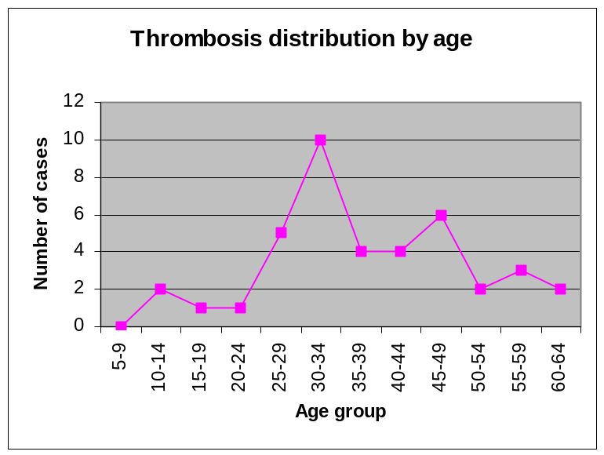

From the above observation, we can say that Thrombosis is not a disease that is caused by age.

Age Group | Cases
5 | 0
10 | 2
15 | 1
20 | 1
25 | 5
30 | 10
35 | 4
40 | 4
45 | 6
50 | 2
55 | 3
60 | 2

Query 2: Thrombosis Probability by Disease

In this query, we tried to find the probability of Thrombosis when a disease is found. There were seven diseases found when Thrombosis is positive.

SQL used:

create view dyt as
select ds_name, count(*) as tot from mdoman.disease
where ds_flag = 'D' and
id in (select id from mdoman.tsum_b where thrombosis = '1')
group by ds_name;

create view dtot as
select ds_name, count(*) as tot from mdoman.disease
where ds_flag = 'D' and
ds_name in (select ds_name from dyt)
group by ds_name;

select dyt.ds_name, dyt.tot/dtot.tot from dyt, dtot
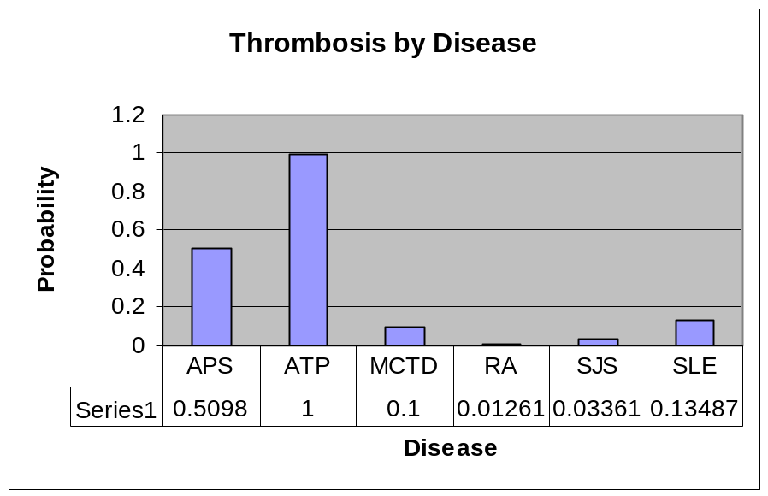 where dyt.ds_name = dtot.ds_name;

Note: APSAPS disease is combined with APS

Query 3: Disease distribution

SQL used:

select ds_name, count(ds_name) as kount from mdoman.disease
where ds_flag = 'D'
group by ds_name order by kount desc;
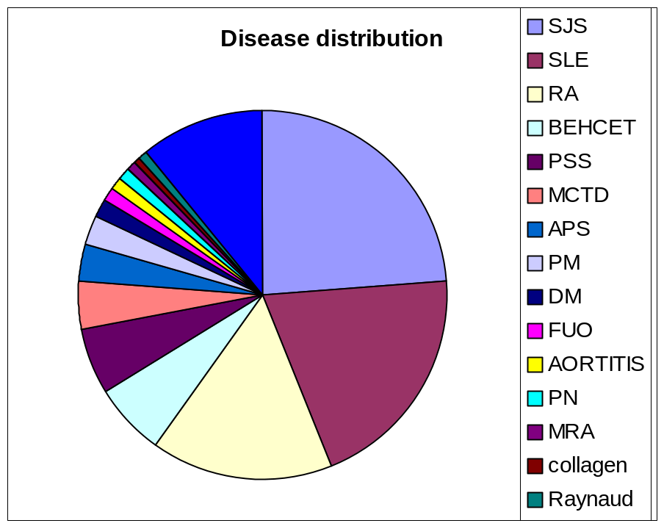

Disease | # of Patients
SJS | 357
SLE | 304
RA | 238
BEHCET | 96
PSS | 87
MCTD | 60
APS | 50
PM | 39
DM | 23
FUO | 19
AORTITIS | 16
PN | 16
MRA | 12
collagen | 11
Raynaud | 10
Other | 164

Query 4: Symptom distribution

SQL used:
select ds_name, count(ds_name) as kount from mdoman.disease
where ds_flag = 'S'
group by ds_name order by kount desc;

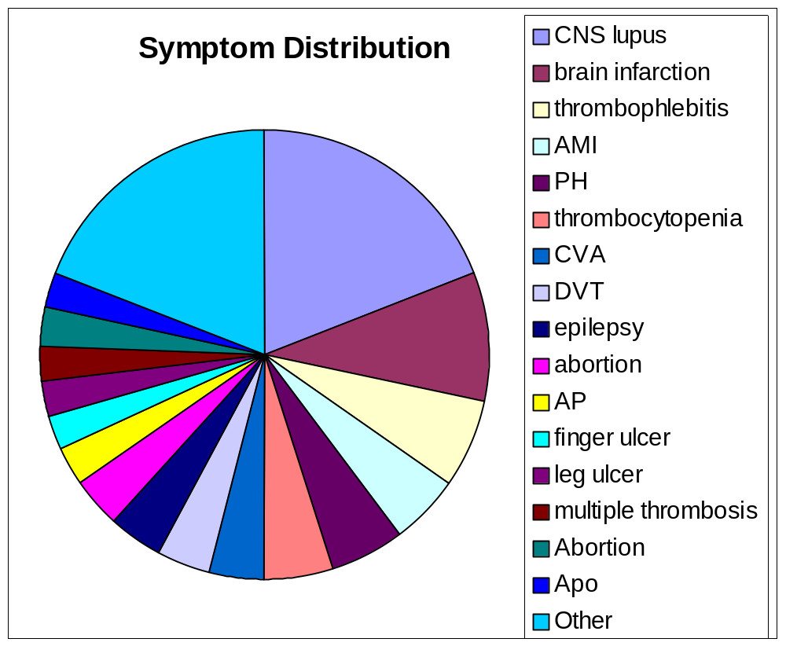
Symptom | # of Patients
CNS lupus | 15
brain infarction | 7
thrombophlebitis | 5
AMI | 4
PH | 4
thrombocytopenia | 4
CVA | 3
DVT | 3
epilepsy | 3
abortion | 3
AP | 2
finger ulcer | 2
leg ulcer | 2
multiple thrombosis | 2
Abortion | 2
Apo | 2
Other | 15

Query 5: Patient distribution by Disease classification.

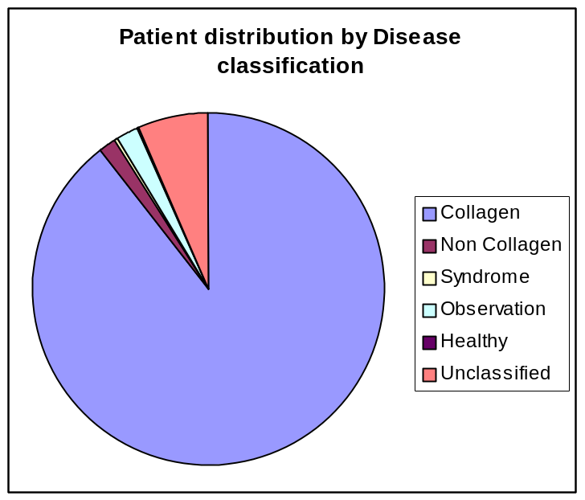

Collagen | 1343
Non Collagen | 27
Syndrome | 1
Observation | 32
Healthy | 3
Unclassified | 96

Query 6: Creation of table with Diseases & their classifications

Collagen Diseases (total 18)
IP | 1
PN | 1
WG | 2
MRA | 3
BEHCET | 4
PSS | 5
MCTD | 6
Relapsing Polychondritis | 6
DLE | 7
SLE | 7
RA | 8
DM | 9
PM | 9
SJS | 10
Sweet | 11
Psoriatic Arthritis | 12
Raynaud | 13
Reiter's syndrome | 14

Non-Collagen Diseases (total 11)
AIHA
AORTITIS
Chronic Palvo V
Chronic EBV
Hypergammmaglobulinemia
McArdle
Myasthenia G
Sarcoidosis
Drug Induced Hepatitis
Mononucleosis
Lupoid Hepatitis

Observations (total 10)
ANAPHYLACTOID PURPURA NEPHRITIS
Angioedema with Eosinophilia
EN
FUO
Morphia
Musculitis
Vasculitis
Arthralgia
Autoimmune Leukopenia
Paniculitis

Syndrome (total 1)
Adie
Healthy (total 1)
CPK
Unclassified (total 24)
AGA
ANCA
APS
ASO
ATP
Adult STILL
CREST
Focal Myositis
Henoch-Schoelein purpura
ITP
JRA
OA
PBC
PIT
PMR
Scleroderma
TA
UC
UCTD
Weber-Christian
Arthritis (r/o Behcets)
Neonatal LE
Neuro
Pemphygus

Query 7: Correlation between Thrombosis and lab test with abnormal results

First a query was used to get count of Thrombosis patients with abnormal values for each of the lab test(n1). Then another query was used to get the count of all patients with abnormal values for each of the lab tests(n2). Ratio = n1/n2. High ratio for a lab test shows that the probability of Thrombosis is high if that Lab test is Positive.
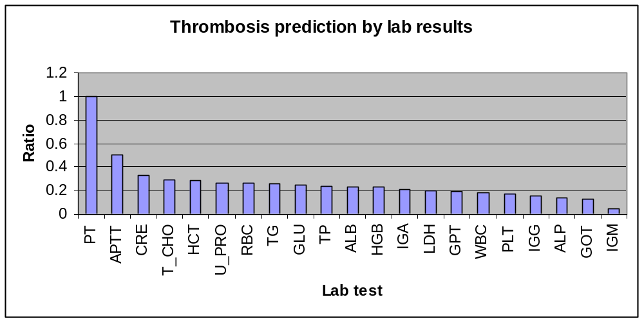
GOT | 38 | 5 | 0.131578947
GPT | 46 | 9 | 0.195652174
LDH | 66 | 13 | 0.196969697
ALP | 15 | 2 | 0.133333333
TP | 58 | 14 | 0.24137931
ALB | 57 | 13 | 0.228070175
UN | 4 | 0 | 0
CRE | 3 | 1 | 0.333333333
T_BIL | 1 | 0 | 0
T_CHO | 27 | 8 | 0.296296296
TG | 27 | 7 | 0.259259259
CPK | 11 | 0 | 0
GLU | 4 | 1 | 0.25
WBC | 121 | 22 | 0.181818182
RBC | 42 | 11 | 0.261904762
HGB | 44 | 10 | 0.227272727
HCT | 28 | 8 | 0.285714286
PLT | 46 | 8 | 0.173913043
PT | 2 | 2 | 1
APTT | 8 | 4 | 0.5
FG | 2 | 0 | 0
AT3 | 0 | 0 | 0
A2PI | 0 | 0 | 0
U_PRO | 80 | 21 | 0.2625
IGG | 132 | 20 | 0.151515152
IGA | 42 | 9 | 0.214285714
IGM | 24 | 1 | 0.041666667

Future Work

Acknowledgements

