**Phytoplankton (CO2 -->Glu + O2 + Xphyto)**

metabolic stoichiometry (catabolism +biomass yield or whole metabolism, either way)

For freshwater phytoplankton from Reynolds et al. 2002 Freshwater Biology. 47(6):1183

Maximum standing crop yield = 0.11 g Chla (or C)/g N

Maximum standing crop yield = 0.82g Chla (or C)/g P

Chla max = 6.32 *(bioavailable phosphorus)0.585

Light limitation = 20 micromol photon m-2 s-1

Light extinction coefficient= 0.01 m2 (mg Chla )-1

kinetic parameters (i.e. qmax and Ks and any relevant reported inhibition)

From Rigosi_2010 (also there are some other tables in that paper).

Lichman_2007.pdf also has some information, but I think it’s more of a ratio. Not sure if it’s useful.

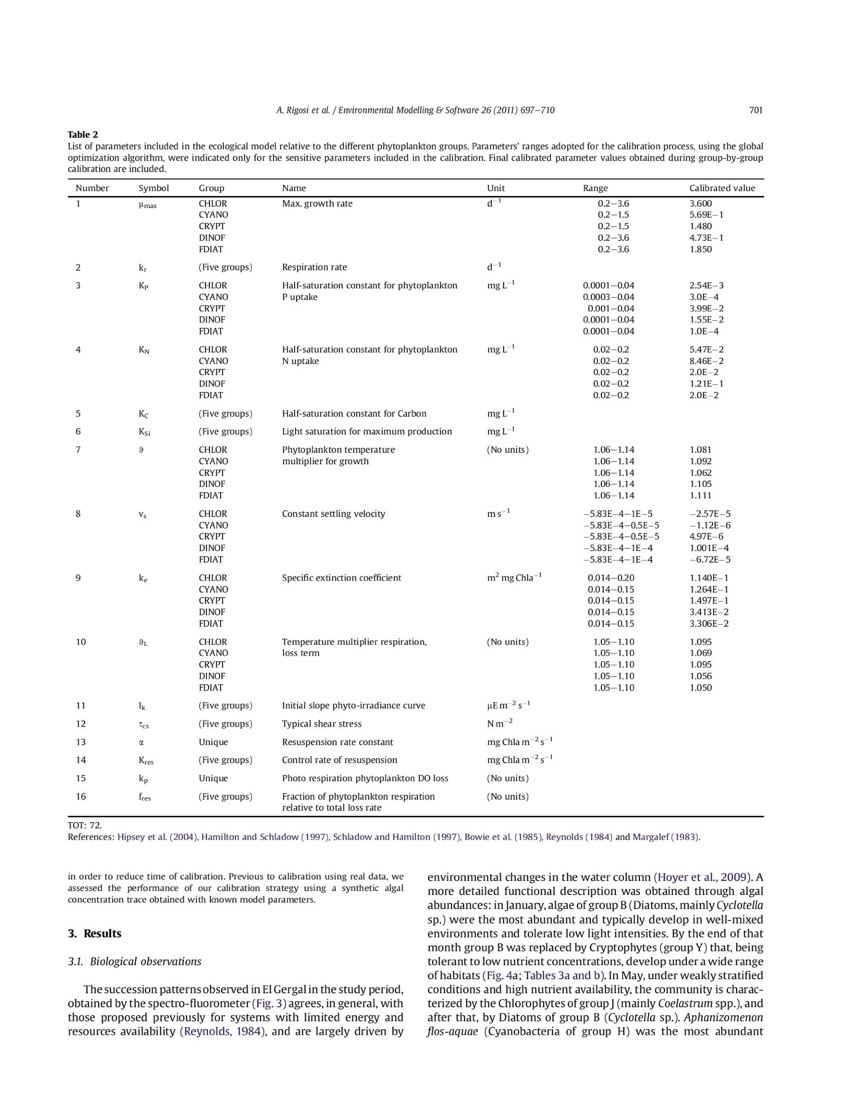

**Iron oxidizers (2Fe2+ + 1/2O2 + 2H+ 🡪 2Fe3+ H2O+ Xfeo)**

Merino_2010.pdf

Calc flux value mol/C-mol h-1

qO2 1.12

qCO2 0.04

qNH4+ 0.01

qFe2+ 6.72

qATP 1.68

Yields of *L. ferrooxidans* on ferrous iron:

YSX=0.007 (C-mol/mold Fe2+) (from Merino et al. 2010 Biotechnology and Bioengineering 107(4):696)  
YSX=0.006 (C-mol/mold Fe2+) (ref in Merino- Breed et al 1999)

YSX=0.01 (C-mol/mold Fe2+) (ref in Merino- Scherpenzeel et al 1998)

YSX=0.006 (ref in Merino- Mignone and Donati 2004)

## Iron reducers (Fe3+ + Ac --> Fe2+ + CO2 + Xfer) or similar metabolism From Zhuang_2010_SOM.doc

biomass yields of Geobacter can vary between 1.95 and 4.05 gDW per mol acetate

### Acetate Uptake Parameters

|  |  |  |
| --- | --- | --- |
| *G. sulfurreducens* | | |
| Ks,1 | 0.012 mM | (Richter *et al.*, Submitted; Esteve-Nunez *et al.*, 2005) |
| Ks,2 | 0.017 mM |
| Ks,3 | 0.78 mM |
| Vmax,1 | 2.7 mmol/gDW/hr |
| Vmax,2 | 2 mmol/gDW/hr |
| Vmax,3 | 13 mmol/gDW/hr |
| *R. ferrireducens* | | |
| Ks | 0.012 mM | Assumed to be the same as *G. sulfurreducens* |
| Vmax | 1.7 mmol/gDW/hr | (Finneran *et al.*, 2003) |

### Ammonium Uptake Parameters

|  |  |  |
| --- | --- | --- |
| *G. sulfurreducens* | | |
| Ks | 0.025 mM | Assumed based on literature values.  (Reay *et al.*, 1999) |
| Vmax | 0.47 mmol/gDW/hr | Calculated by FBA |
| *R. ferrireducens* | | |
| Ks | 0.025 mM | Assumed based on literature values.  (Reay *et al.*, 1999) |
| Vmax | 0.13 mmol/gDW/hr | Calculated by FBA |

### Fe(III) Uptake Parameters

|  |  |  |
| --- | --- | --- |
| *G. sulfurreducens* | | |
| Ks | 1 mM | (Esteve-Nunez *et al.*, 2005) |
| Vmax | 568 mmol/gDW/hr | Calculated from chemostat data.  (Esteve-Nunez *et al.*, 2005) |
| *R. ferrireducens* | | |
| Ks | 1 mM | Assumed to be same as *Geobacter*. |
| Vmax | 568 mmol/gDW/hr | Calculated from chemostat data.  (Esteve-Nunez *et al.*, 2005) |

### Simulations under Natural Conditions

|  |  |  |
| --- | --- | --- |
| [Fe(III)]init | 10 mmoles/l | (Anderson *et al.*, 2003; Vrionis *et al.*, 2005; Yabusaki *et al.*, 2007; Petrie *et al.*, 2003) |
| Acetate Turnover  Rate | 0-0.54 μM/hr | (Balba & Nedwell, 1982; Chapelle & Lovley, 1990; Crill & Martens, 1986; Hansen *et al.*, 2001; Kuivila *et al.*, 1989; Lovley & Klug, 1983; Lovley & Klug, 1986) |
| Ammonium Concentration | 0 – 400 μM | (Mouser *et al.*, 2009) |
| [*G. sulfurreducens*]init | 105 cells/L | (Holmes *et al.*, 2007) |
| [*R. ferrireducens*]init | 105 cells/L | (Holmes *et al.*, 2007) |
| Dilution rate | 0.00141 hr-1 | Calculated based on geometry (Anderson *et al.*, 2003; Petrie *et al.*, 2003; Vrionis *et al.*, 2005; Yabusaki *et al.*, 2007) |

### Simulations During Acetate Addition

|  |  |  |
| --- | --- | --- |
| [Fe(III)]init | 10 mM | (Anderson *et al.*, 2003; Petrie *et al.*, 2003; Vrionis *et al.*, 2005; Yabusaki *et al.*, 2007) |
| Acetate Injection Rate | 4.2 - 7 μM/hr | (Anderson *et al.*, 2003; Vrionis *et al.*, 2005) |
| [NH4]init (excess) | 400 μM | (Mouser *et al.*, 2009) |
| [NH4]init (limiting) | 5 μM | (Mouser *et al.*, 2009) |
| [*G. sulfurreducens*]init | 105 cells/L | (Holmes *et al.*, 2007) |
| [*R. ferrireducens*]init | 105 cells/L | (Holmes *et al.*, 2007) |
| Dilution rate | 0.00141 hr-1 | Calculated based on geometry (Anderson *et al.*, 2003; Vrionis *et al.*, 2005) |

**Sulfate reducers ( SO4+ + Ac --> Sh2 + Xsor) and**

**Methanogens (Ac + ? 🡪 CH4 + Xmb)**

Kalyuzhnyi_1998.pdf

|  |  |  |  |  |  |
| --- | --- | --- | --- | --- | --- |
|  | T (deg C) | um (day-1) | Ks (gCOD/l) | Y (g VSS/gCOD) | Ref |
| **Acetotrophic MB:** | **37** | **0.21** | **0.258** |  | **Wandrey and Aivasidis -1983** |
| Methanosarcina barkeri | 37 | 0.11 | 0.028 | 0.023 | Huser -1981 |
| Methanothrix soehngenii | 30 | 0.24 | 0.409 | 0.051 | Lawrence and McCarty -1969 |
| **Acetotrophic SRB:** |  |  |  |  |  |
| Desulfobacter postgatei | 28 | 1.03 | 0.015 | 0.04 | Brandis-Heep et al. -1983 |
| Desulfomaculum acetoxidans | 36 | 0.55 |  | 0.098 | Widdel and Pfennig -1977 |
| Desulfonema limicola | 30 | 0.55 |  |  | Widdel -1980 |
| Mixed culture | 31 | 0.51 | 0.006 |  | Middleton and Lawrence -1977 |

**Sufide oxidisers (H2S + 2O2--> SO42- +2H+ + Xsho)**Gonzalez-Sanchez_2009.pdf

exogenous speciﬁc oxygen uptake rate (OUR)max= 0.127 +/- 0.01 mmol O2 gProt-1 min-1

oxygen uptake rate referenced in Gonzalez-Sanchez_2009 = 2 mmol O2 gProt-1 min -1

OURmax=0.11

Ko = 0.02808 +/- 0.006 mmol O2 L-1

Ks = 0.001 +/- 0.0006 mmol S L-1

Ki = 1.015 +/- 0.512

Ki= 2-4 mmol S L-1 for phototrophic organisms (not what we have here, but possible upper limit)

**Sufide oxidisers (H2S + [Fe or Mn hydroxides]--> SO42- ? + Xsho)**

There is a significant abiotic reaction with half-life of 25 min. with H2S and Fe. (Aquatic Geomicrobiology)

**Methanotrophs (CH4 + O2--> CO2 + Xmto)**

Coming up short here.

**Methanotrophs (CH4 + [SO4- or NO3- or Fe3+] --> CO2 + Xmto) this is the interesting part to explain you findings**

Beal_2009.pdf- Values are umoles methane oxidized

Sulfate-coupled methane oxiation:

CH4 + SO4→ HCO3+ HS+ H2Oo

DG = –14 kJ/mole

52 umole/year/cm3sed

Mangenese-coupled methane oxidation:

CH4 + 4MnO2 + 7H→ HCO3+ 4Mn+ 5H2O

DG = –556 kJ/mole

14 umole/year/cm3sed

Iron-coupled methane oxidation:

CH4 + 8 Fe(OH)3 + 15H→ HCO3+ 8Fe+ 21H20

6 umole/year/cm3sed

1.6 J/year/cm3sed

Not much else known about how methane would be oxidized anareobically.