Hi Sophia,

I’m excited to hear you want to work towards a research project. Publishing is always an ultimate goal, but I have to warn you, it is a lot of work! These things can take a couple years even with PhDs. However, I think I have an idea which we can build upon which would allow you to learn some new computer skills, create a presentable product, and then write up a manuscript which we can polish.   
  
Would you be interested in helping me create a webmap of Fracking data? This is a bit of a spin from what Krissy was working on. This is a direction towards the: “Well…now what do we do?” This is the community presentation component.   
  
I’m going to teach you how to make a Webmap using Javascript, HTML, and CSS. Don’t be scared, this is at the most simple level, but my intention is to build comfort in this for you. I would like to ultimately make an interactive risk assessment map with Wells… but for now let’s make something simple for fun. Ready?

Task 1: Download Brackets: <http://brackets.io/> This is a free text editor platform which we will use to design our webmap.

Task 2: I attached a file called “ for_sophia.html “ Open this in chrome browser. What do you see? Something silly I hope. These are cheesesteak locations in Philly. We are going to look under the hood of this file and make some edits. We are going to make the webmap using Javascript’s leaflet library. Once you get good at this, you’ll release that coding isn’t so bad… powerful in fact. And people will pay you to do things like this!

Rules to working inside brackets

1. In the top right hand corner there is a thunderbolt – this is the live preview – this lets you know your map is working
2. Use control S or file save every time you make a change. To see the change appear please refresh your map from the live preview
3. If your map doesn’t show up – you did something wrong. No problem just press control z in brackets to undo (edit – undo) and save. Please make sure your maps works after every change you make so you can go back and correct yourself. If you get frustrated re download the .html file and start over.

Task 1: Change the Title of the map to something to do with Cheesesteaks (between the h1 tags where ‘Title’ is.

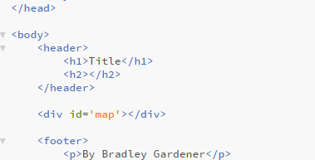

Task 2: Change the footer of the map (between the p tags to your name)

Task 3: Change the color of the text in the h1 tags under style

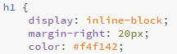

Find the colors by typing in ‘html color picker’ in google. Make sure all of the notion is correct.

Task 4: Change the color of the text in the p tags under style



Task 5: Find the name of a cheesesteak place that is not mentioned in the array ‘var cs’. Put the name of the new cheesesteak spot in the spot where I have Oregon steaks highlighted.

This is an array – a handy way for storing data. See here for more [information](https://www.w3schools.com/js/js_arrays.asp)



Task 6: Change the latitude and longitude of the first entry in ‘var CsCoord’

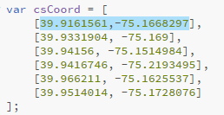

Find the lat lon of the new cheesteak place by looking it up on google maps

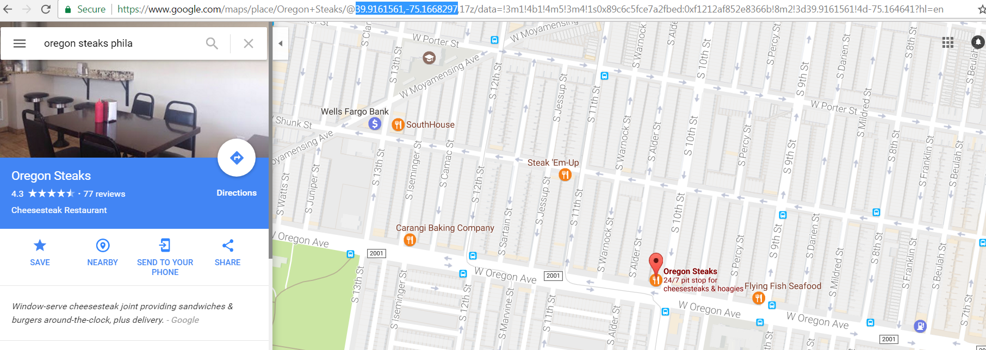

Paste the lat lon into the highlighted space (the first set of coordinates.

Task #7 and Task #8

In ‘var csStar’ replace the first entry to the right of the square brackets (3.5) with the number of starts the cheesteak place your chose has on yelp. Please look it up on Yelp to find it out

For Task #8 please find the number of reviews your cheesesteak place has on Yelp. Replace the first entry in the ‘var csReviews’ array. (89)



Task #9 (Just read this – don’t touch it)

These pieces of information will be combined to produce what I am calling a Yelp Factor in a function. The function multiplies the yelp stars by the number of yelp reviews. Click [here](https://www.w3schools.com/js/js_functions.asp) for more about functions – please don’t touch the function!

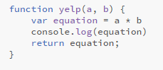

Task #10 (Just read this – don’t touch it)

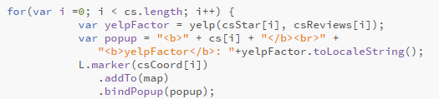

The for loop allows the computer to loop through the data structure in the code (an array) For more information go [here](https://www.w3schools.com/js/js_loop_for.asp)

Please don’t touch the for loop!

Inside this for loop is also a method called .bindpopup. Find more about methods [here](https://www.w3schools.com/js/js_object_methods.asp)

The popup determines what will come up when you click on the map marker. Don’t worry about this too much.

As I mentioned – we are sending a request to an external server through the internet. This ‘leaflet’ server which we have a link to in the header of our .html file then spits back the map (and it’s functionality) that we see on the screen.

This is the [documentation](http://leafletjs.com/reference-1.0.3.html)

**Question:** Please browse through the documentation. What are some things you can do with Leaflet code that we didn’t do in this lab?

Final Submission – Please submit the .html file with the changes you made for tasks #1 - #8. Rename it to Sophia_finished.html.   
  
Task 3: Make a github account <https://github.com/> . This will be important for the next step.