Notes
Use of AI tools is allowed, but do not allow it to do all the coding for you. You must generate comments explaining your code, and your intent/interpretation of each major section. AI-generated comments are red flags that you are relying too much on the AI tool rather than using it to help you do your stuff.
If you have significant questions or issues, post these as an issue in the original repository, do not email. Issues are visible to all and are a vital part of the Github and coding ecosystem.

Task instructions
- Install and load your R packages. At a minimum, we recommend the “tidyverse”, “ggplot2” and “oce” libraries for this exercise. We recommend using a local installation of RStudio rather than the cloud service provided by URI.
- Read in the data file that is inside the “Data” subfolder using the oce::read.ctd() function. Note: this data was collected as part of a moored deployment (as opposed to a profile cast). There is an argument within the read.ctd() function that you can use to specify this.
- Examine the structure of the output. The oce package generates a “ctd” object that contains nested slots with the data values, metadata, and processing logs (for any changes you make to the object). Look at the documentation from the oce package to understand how to access data vectors and metadata. Note that the data slot “timeS” contains data time stamps as the number of seconds elapsed since the first measurement time point.
- Find and extract the first time point from the ctd object and save it to your environment with the name “start_time”.
- Generate a simple plot of the ctd object using the generic plot() function. If you have read-in the file correctly, oce will produce an output containing 3-panel time series of salinity, temperature and pressure. The plot should look like:
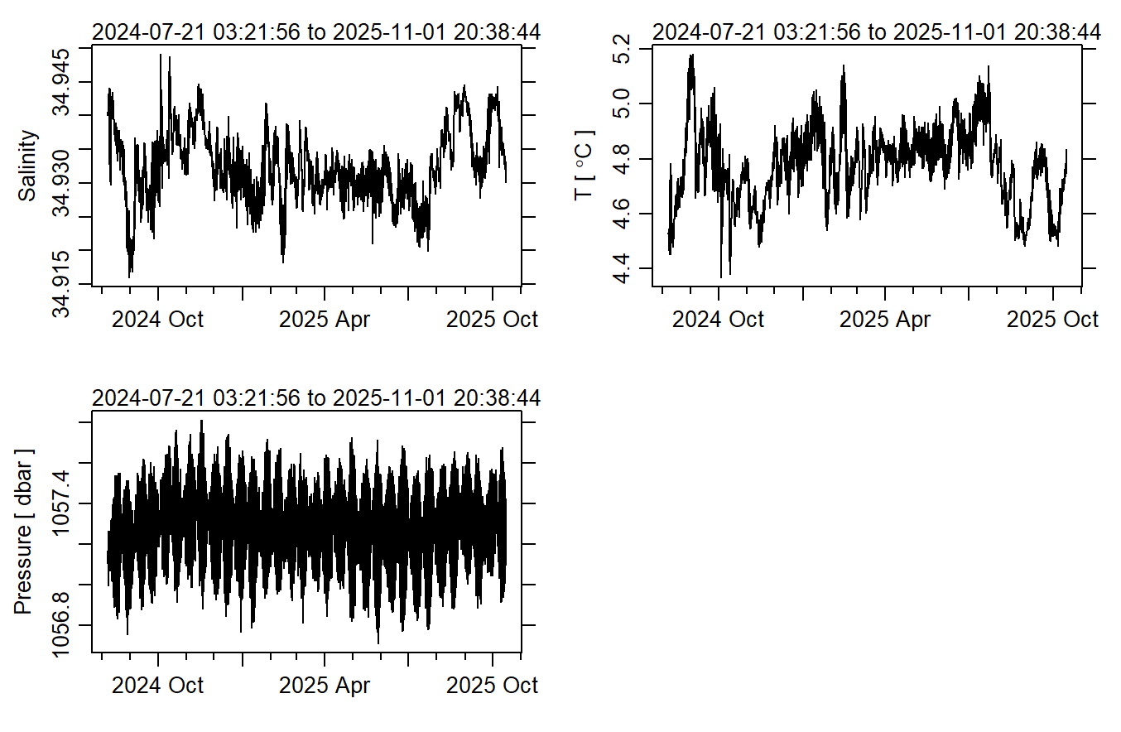

- Create a generic data frame by extracting data from the ctd object you created. The data frame should include the following columns: Date, Temperature, Salinity, Fluorescence, Turbidity, Oxygen. When creating the Date column, recall that the first time point should match the date-time you extracted as “start_time”, and each value after will be the number of seconds elapsed since then, so you need to correct each value to be a date time object rather than just time elapsed in seconds.
- Using ggplot, generate a line plot of temperature over time. The plot should include the units (°C) in the y-label and should have a white background with no gridlines (hint: use a ggtheme other than the default). Export this plot as a png to the R project directory with the name “ctd_temperature.png”. It should look something like this:
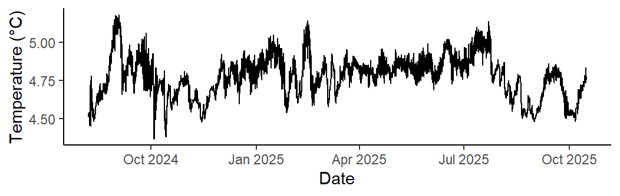

- Make a second data frame in long format using the dplyr::pivot_longer() function. The data frame should have just 3 columns: Date, Variable, and Value (or names of your choice). The Variable column should contain the names of each of the 5 environmental variables while the Value column should contain their corresponding values.
- Generate a 5-panel graph of all time series using the long-format data frame and the facet_wrap() function from ggplot. Each panel of the plot should have its own y-scale range, and each panel should have its own row. The variables should also have the following colors: temperature = red, salinity = orange, oxygen = blue, turbidity = purple, fluorescence = green. Remove the legend for the color scale and, as before, change the ggplot theme for a clean background. Export this plot as a png to the R project directory with the name “ctd_all_variables.png”. The plot should look something like this:
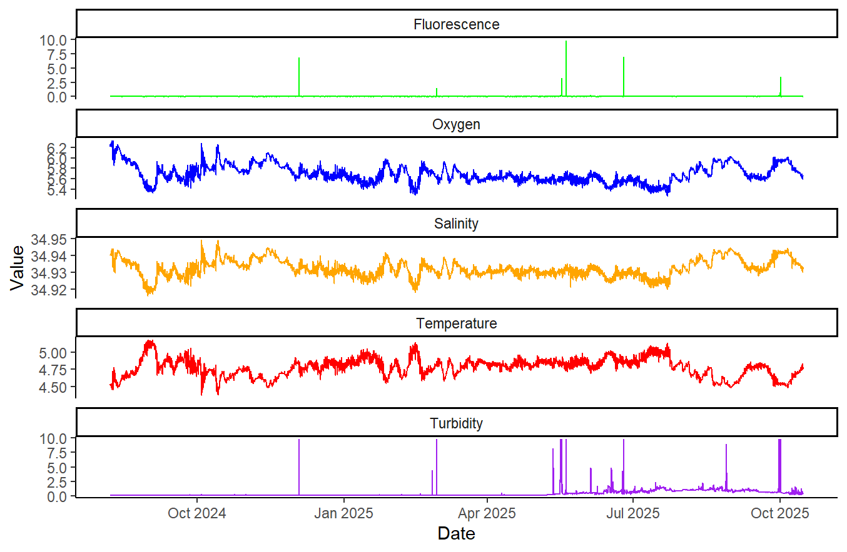

- Export the two data frames as csv files to the project directory. The files should be named “ctd_wide.csv” and “ctd_long.csv”.
- Show your data management skills: You should use a subdirectory to store your exported files, R script(s) and output graphics. The directory and files MUST be named well, and if we have specified file names, that convention should be followed.
Bonus task if you are feeling up to it and have time:
Generate a third data frame that contains values for each variable averaged by 24-hour time increments. Export this as a csv file with the name “ctd_24hr_mean.csv”. This is generally called a “moving average”.

