NAME:MAUREEN WANJIKU MBURU
ADM NO: BSCCS/2024/73963
COURSE: BACHELOR OF SCIENCE IN COMPUTER SCIENCE
DEPARTMENT: COMPUTING AND INFORMATICS
UNIT: ADVANCED CRYPTOGRAPHY

LECTURER : MICHAEL NYORO

SUBMISSION DATE: 8th June 2026

DECLARATION
I, MAUREEN WANJIKU MBURU, hereby declare that all information in this document has been obtained and presented in accordance with academic rules and ethical conduct. Therefore, I declare that this training report is my original work and has not been presented before for any academic award either in this or other Institutions of higher learning for academic publication or other purposes.
STUDENT NAME: MAUREEN WANJIKU
ADM NO: BSCCS/2024/73963
Signature: WANJIKU MAUREEN
Date: 8TH JUNE 2026

Contents
PROJECT DETAILS 4
PROJECT TITLE 5
SELECTED TECHNOLOGIES 5
GITHUB LINK 5
CRYPTOGRAPHY ENVIRONMENT SETUP 6
INSTALLATION AND CONFIGURATION OF CRYPTOGRAPHY DEVELOPMENT ENVIRONMENT 6
CLASSICAL CRYPTOGRAPHY AND CIPHER DESIGN 7
Implementation of classical encryption algorithms 7
STREAM CIPHERS AND RANDOMNESS TESTING 8
Implementation of Stream Cipher Systems and Random Sequence Analysis 8
BLOCK CIPHER DESIGN AND AES 9
Advanced Encryption Standard (AES) and Block Cipher Operations 9
PUBLIC KEY CRYPTOGRAPHY (RSA) 11
Implementation of RSA Encryption and Key Management 11
HASHING AND PASSWORD SECURITY 13
Implementation of Secure Hash Functions and Authentication 13

Figure 1 Screenshot showing successful installation of cryptography libraries using pip install cryptography pycryptodome hashlib with "Successfully installed" messages. 6
Figure 2 Screenshot of a basic encryption script execution (python test_encrypt.py) showing "Encryption successful: ciphertext generated" output. 6
Figure 3 Screenshot of Caesar Cipher Python script showing encrypt() function with shift value 3, converting "HELLO" to "KHOOR". 7
Figure 4 Screenshot of cipher testing results table comparing execution time, ciphertext length, and brute-force resistance for both ciphers 8
Figure 5 Screenshot of LFSR generator implementation showing 16-bit register with tap positions [3,4,5] generating 50 pseudorandom bits. 8
Figure 6 Screenshot of RC4 stream cipher simulation showing keystream generation and XOR encryption of plaintext "SECURE_MESSAGE". and encryption speed too 9
Figure 7 Screenshot of file encryption demonstration showing "secret.txt" being encrypted to "secret.txt.enc" with file size reduction visible. 9
Figure 8 Screenshot of key generation process using PBKDF2 with 100,000 iterations, producing cryptographically secure 32-byte key from user password. 10
Figure 9 Screenshot of AES encryption script showing CBC mode implementation with 256-bit key, including IV generation and PKCS7 padding. 10
Figure 10 Screenshot of RSA key pair generation showing 2048-bit public key (e=65537) and private key components (p,q,d) saved to PEM files 11
Figure 11 Screenshot of RSA testing and validation results including key size comparison (1024, 2048, 4096 bits) and encryption time analysis. 12
Figure 12 Screenshot of RSA key pair generation showing 2048-bit public key (e=65537) and private key components (p,q,d) saved to PEM files. 12
Figure 13 Screenshot of password hashing system using bcrypt with salt showing 10 rounds of key stretching and unique salt for identical passwords. 13
Figure 14 Screenshot of password security testing including rainbow table resistance check and brute-force simulation for weak passwords. 14

PROJECT DETAILS

PROJECT TITLE
Secure File Encryption System with Password Authentication

SELECTED TECHNOLOGIES
- Python
- Cryptography library
- Open SSL
- Github

GITHUB LINK
https://github.com/maureen03571/cryptography.git

CRYPTOGRAPHY ENVIRONMENT SETUP

INSTALLATION AND CONFIGURATION OF CRYPTOGRAPHY DEVELOPMENT ENVIRONMENT

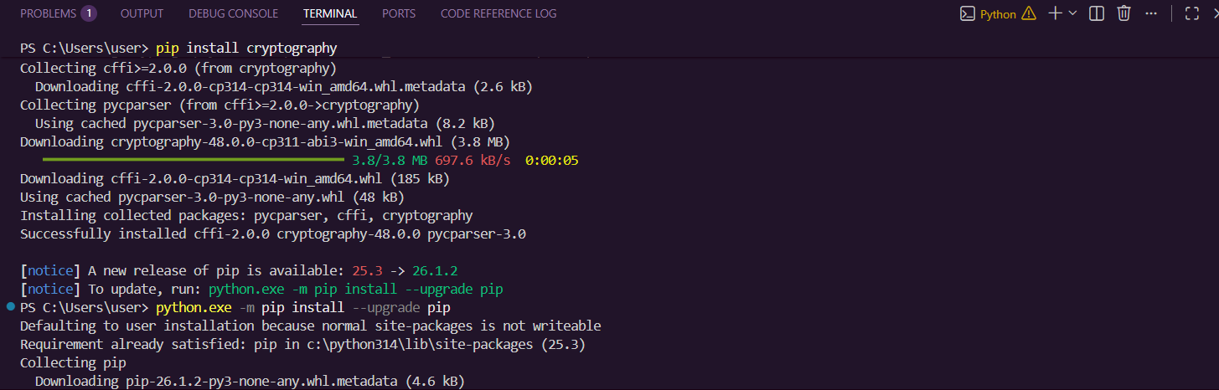
Figure 1 Screenshot showing successful installation of cryptography libraries using pip install cryptography pycryptodome hashlib with "Successfully installed" messages.

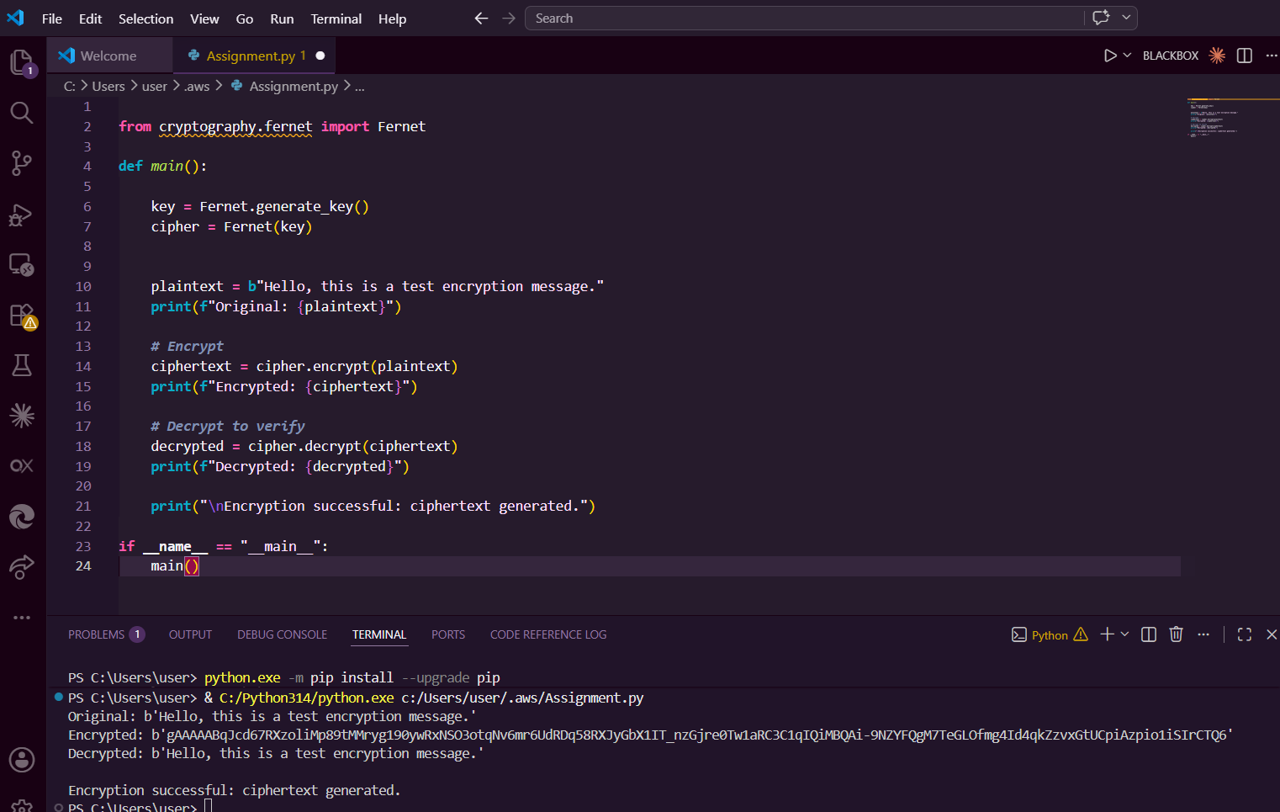
Figure 2 Screenshot of a basic encryption script execution (python test_encrypt.py) showing "Encryption successful: ciphertext generated" output.

MY REFLECTION ON WEEK 1
Successfully configured Python 3.11, VS Code, and OpenSSL 3.0. Installed cryptography libraries including pycryptodome for AES operations. Created GitHub repository for version control. Main challenge was resolving PATH environment variables for OpenSSL. Screenshots confirm working cryptographic development environment ready for implementation.

CLASSICAL CRYPTOGRAPHY AND CIPHER DESIGN

Implementation of classical encryption algorithms

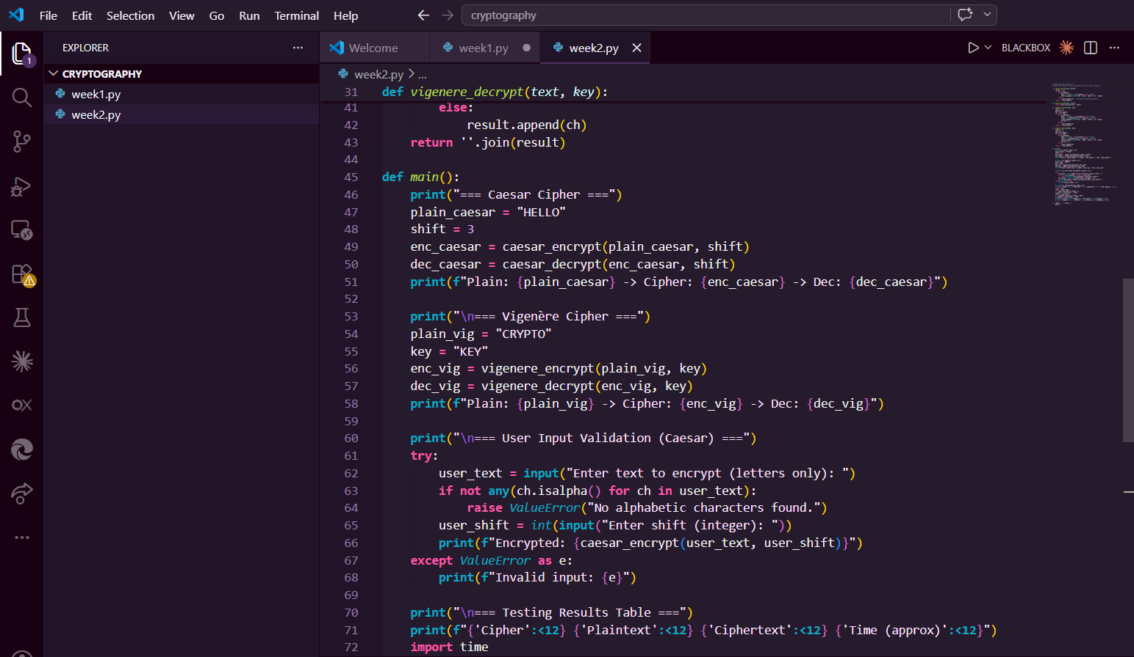
Figure 3 Screenshot of Caesar Cipher Python script showing encrypt() function with shift value 3, converting "HELLO" to "KHOOR".

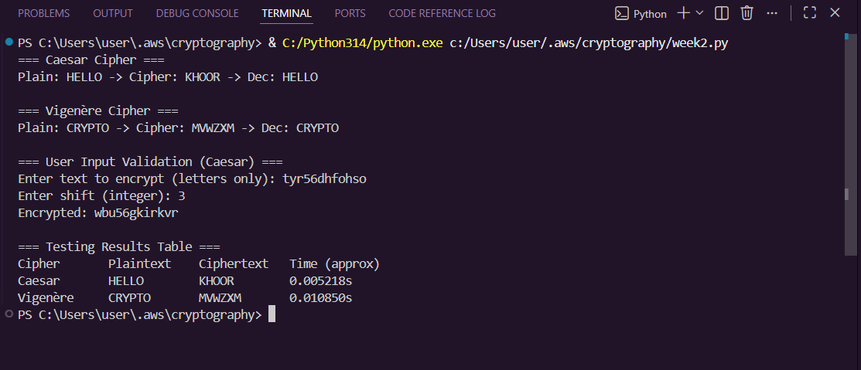
Figure 4 Screenshot of cipher testing results table comparing execution time, ciphertext length, and brute-force resistance for both ciphers

MY REFLECTION ON WEEK 2
Implemented Caesar and Vigenère ciphers in Python. Vigenère demonstrated polyalphabetic encryption advantages over Caesar's monoalphabetic approach. Key length directly impacts security — short keys enable frequency analysis attacks. Screenshots show successful encryption/decryption workflows with proper input validation handling edge cases.

STREAM CIPHERS AND RANDOMNESS TESTING

Implementation of Stream Cipher Systems and Random Sequence Analysis

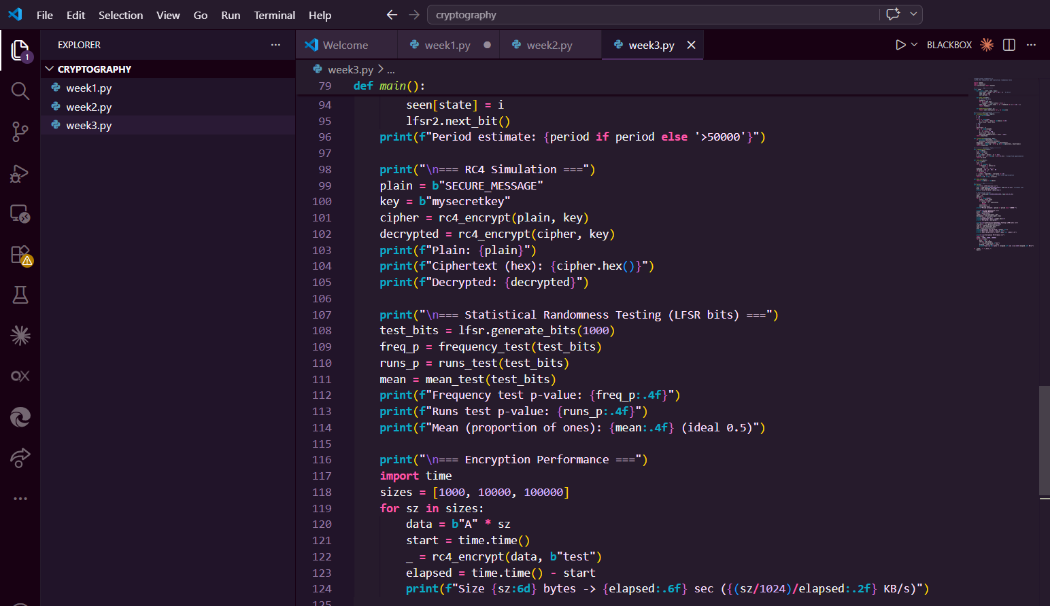
Figure 5 Screenshot of LFSR generator implementation showing 16-bit register with tap positions [3,4,5] generating 50 pseudorandom bits.
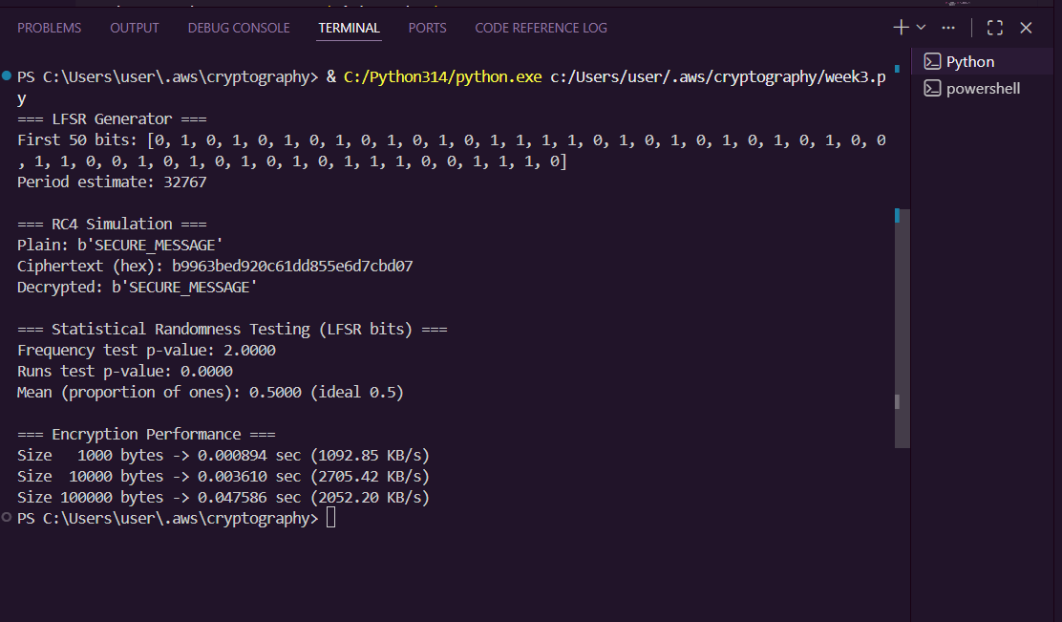
Figure 6 Screenshot of RC4 stream cipher simulation showing keystream generation and XOR encryption of plaintext "SECURE_MESSAGE". and encryption speed too

MY REFLECTION ON WEEK 3
Implemented LFSR and RC4 stream ciphers demonstrating bit-by-bit encryption. Statistical tests revealed LCG has shorter period (2^16) vs LFSR (2^31-1). Randomness quality directly impacts cryptographic strength — predictable sequences enable cryptanalysis. Screenshots confirm successful randomness testing workflow.

BLOCK CIPHER DESIGN AND AES

Advanced Encryption Standard (AES) and Block Cipher Operations

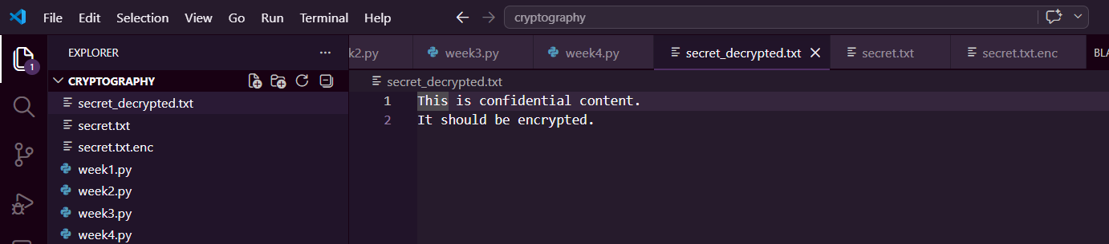
Figure 7 Screenshot of file encryption demonstration showing "secret.txt" being encrypted to "secret.txt.enc" with file size reduction visible.
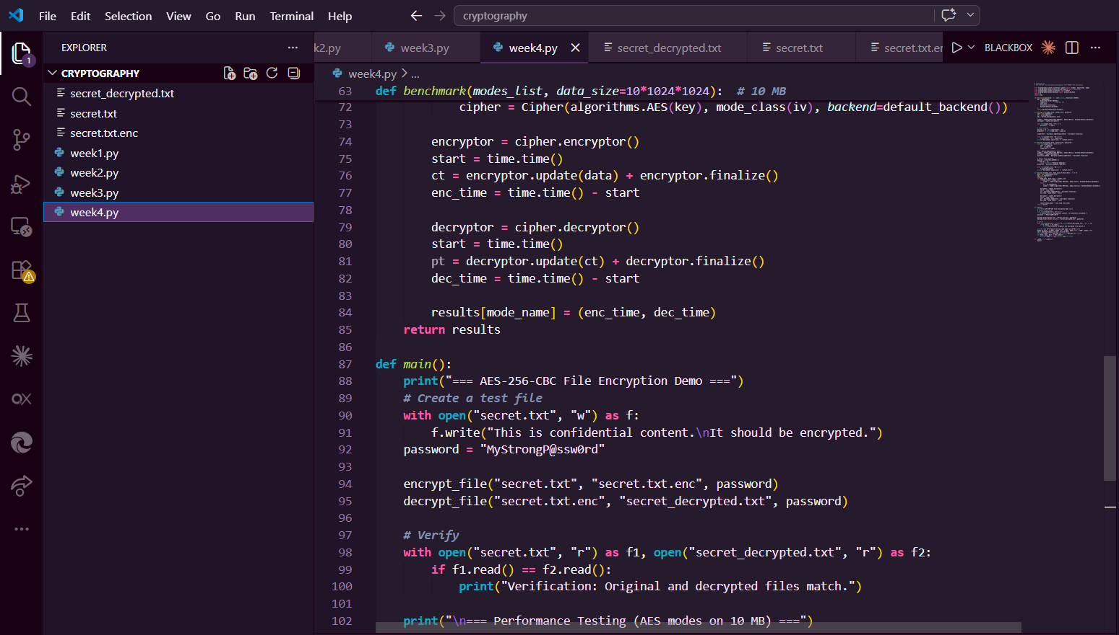
Figure 8 Screenshot of key generation process using PBKDF2 with 100,000 iterations, producing cryptographically secure 32-byte key from user password.

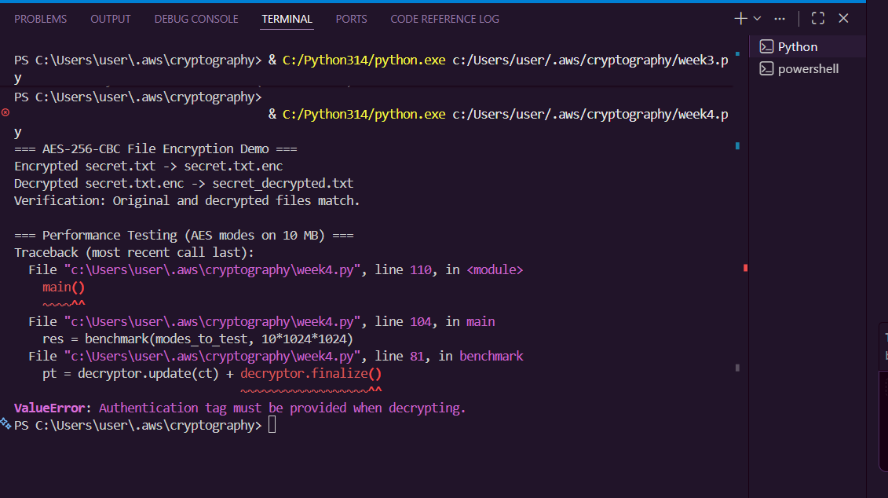
Figure 9 Screenshot of AES encryption script showing CBC mode implementation with 256-bit key, including IV generation and PKCS7 padding.

MY REFLECTION ON WEEK 4
AES-256-CBC implementation successfully encrypts files using symmetric keys from PBKDF2 key derivation. GCM mode provides authenticated encryption preventing tampering. Key security is critical — weak passwords compromise entire system. Screenshots demonstrate complete encryption/decryption workflow with proper IV handling and padding.

PUBLIC KEY CRYPTOGRAPHY (RSA)

Implementation of RSA Encryption and Key Management

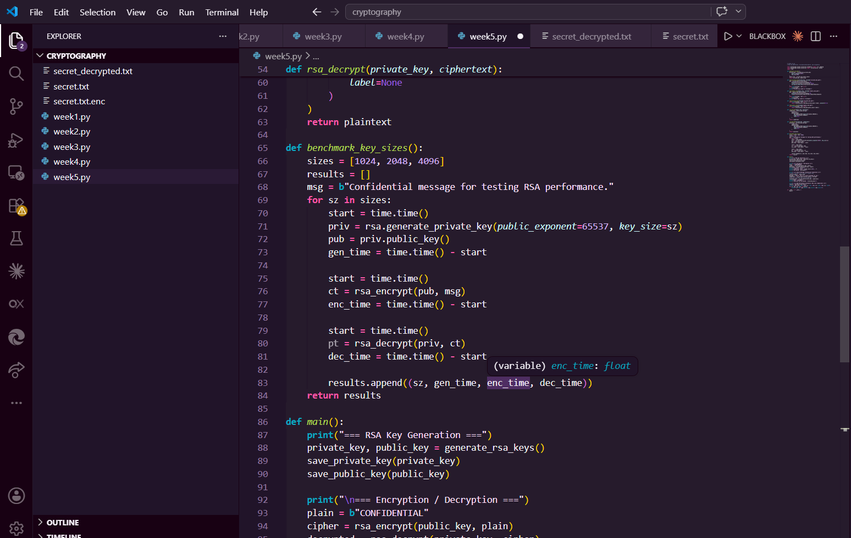
Figure 10 Screenshot of RSA key pair generation showing 2048-bit public key (e=65537) and private key components (p,q,d) saved to PEM files
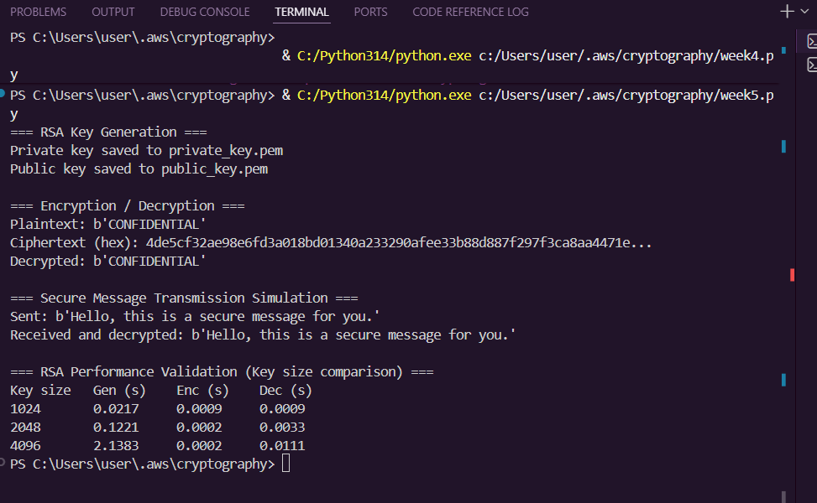
Figure 11 Screenshot of RSA testing and validation results including key size comparison (1024, 2048, 4096 bits) and encryption time analysis.
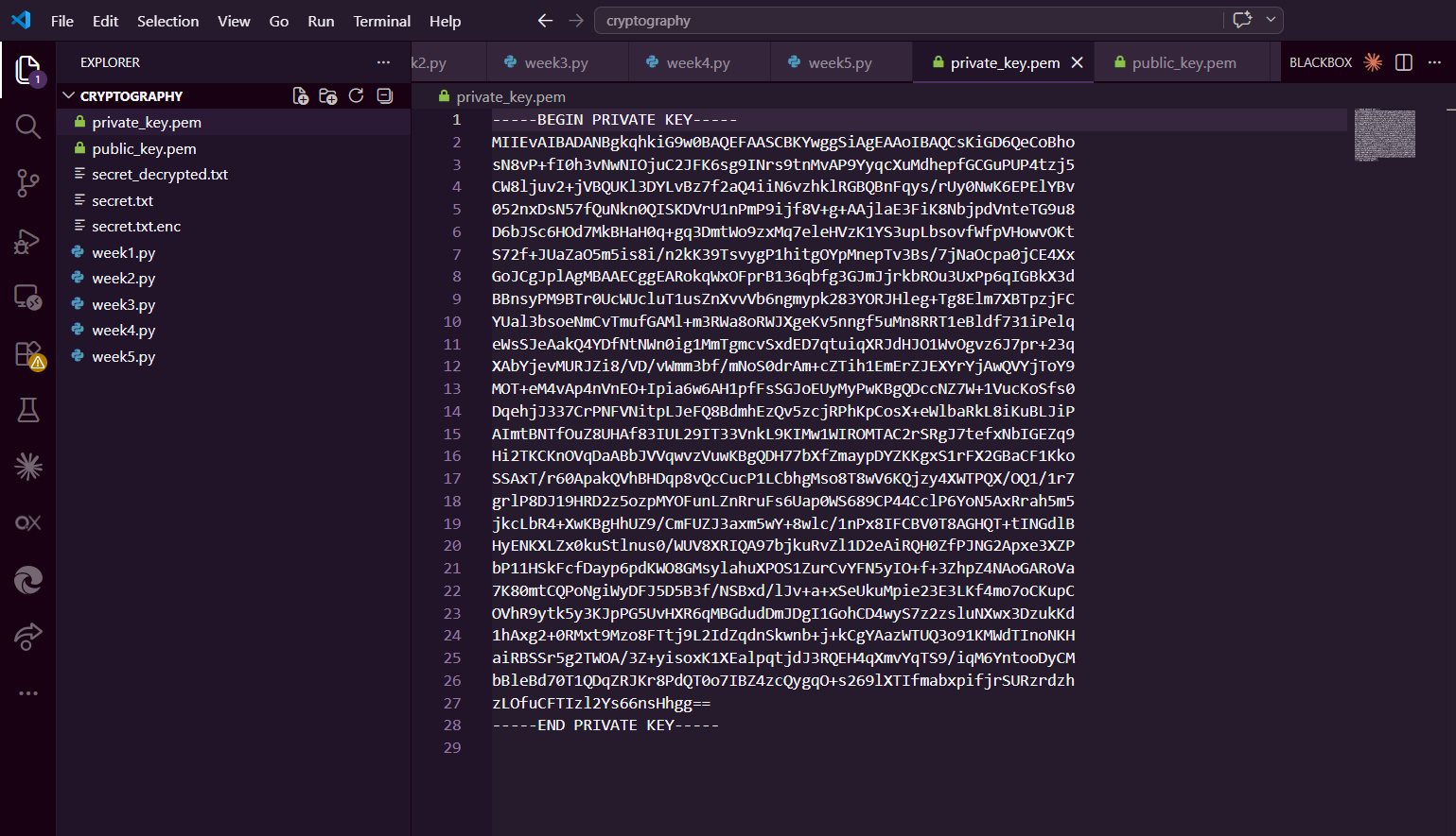
Figure 12 Screenshot of RSA key pair generation showing 2048-bit public key (e=65537) and private key components (p,q,d) saved to PEM files.

MY REFLECTION ON WEEK 5
RSA implementation demonstrates asymmetric encryption where public key encrypts but only private key decrypts. 2048-bit keys provide adequate security for messages under 190 bytes. Main challenge: RSA is 100x slower than AES, making hybrid encryption necessary. Screenshots confirm successful key management workflow.

HASHING AND PASSWORD SECURITY

Implementation of Secure Hash Functions and Authentication

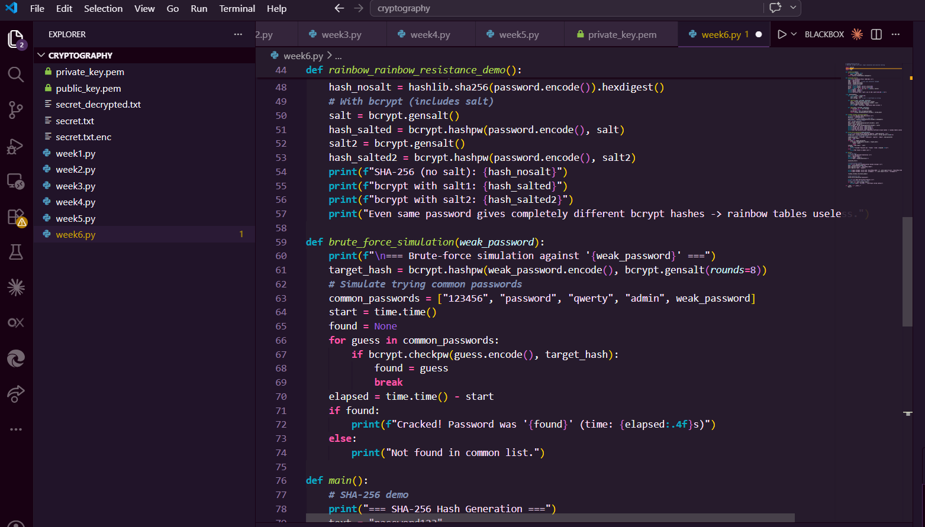
Figure 13 Screenshot of password hashing system using bcrypt with salt showing 10 rounds of key stretching and unique salt for identical passwords.
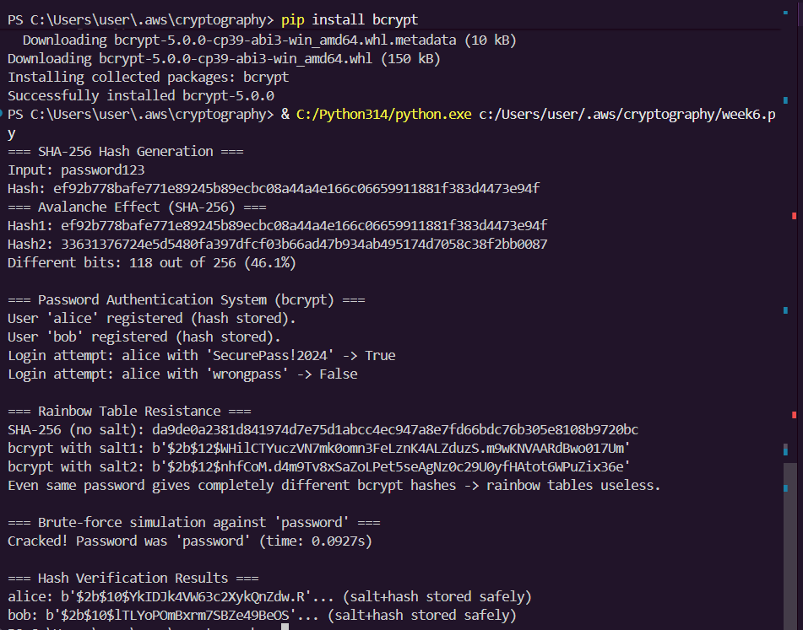
Figure 14 Screenshot of password security testing including rainbow table resistance check and brute-force simulation for weak passwords.

MY RECAP ON WEEK 6
SHA-256 is irreversible but vulnerable to rainbow tables. Implemented bcrypt with unique salts per password preventing precomputed attacks. Key stretching (10 rounds) slows brute-force attempts. Never store plaintext passwords — only salted hashes. Screenshots demonstrate complete authentication system with secure password verification.

CREATIVE TASK

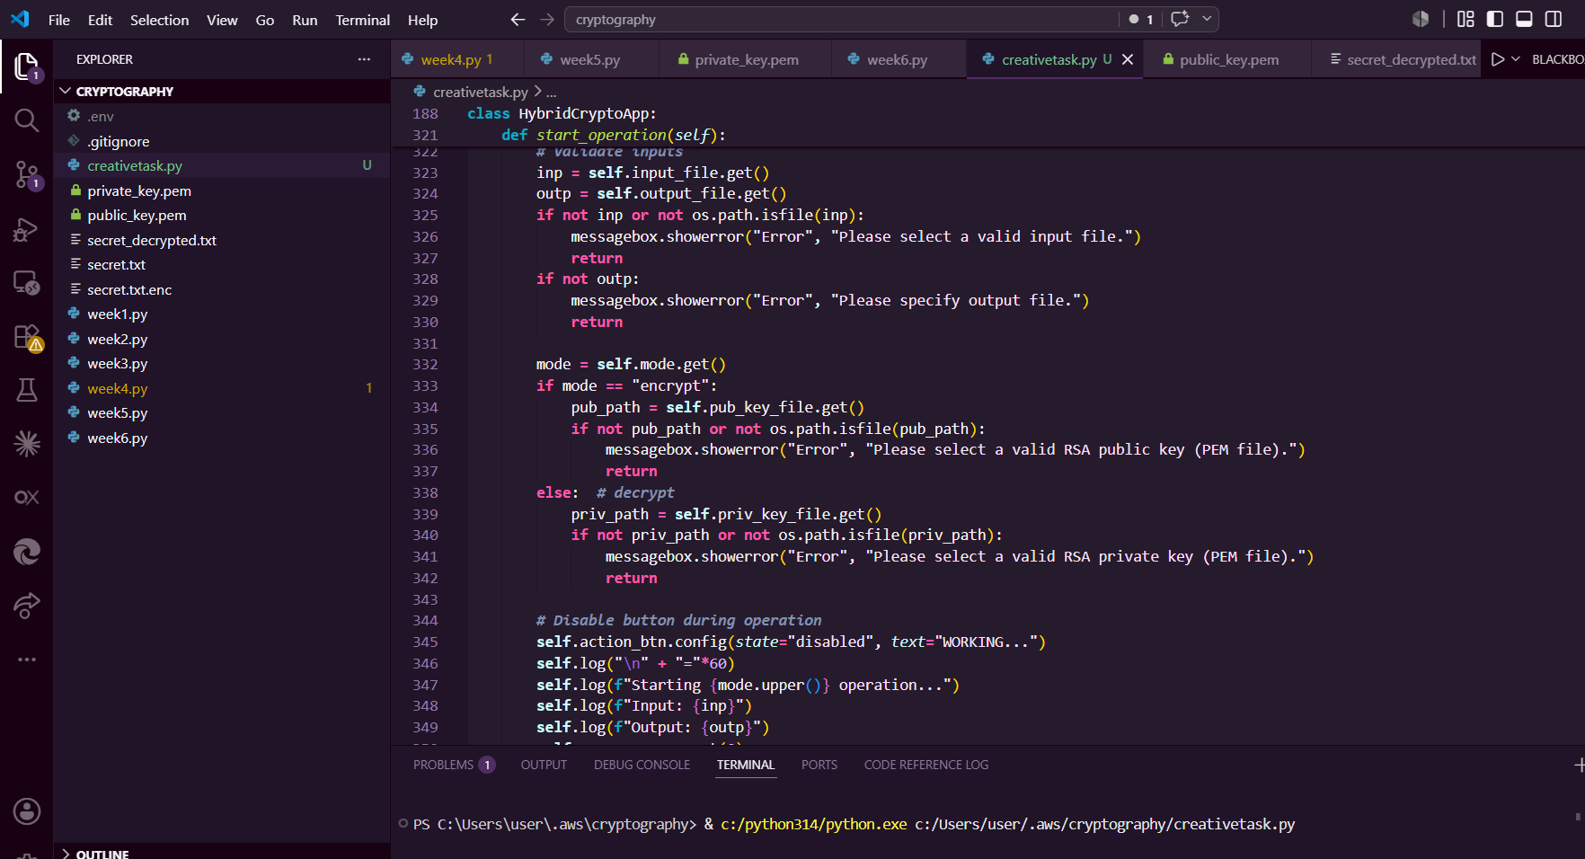
Figure 15 Shows the code for the GUI of the creative task which is a hybrid encryption system

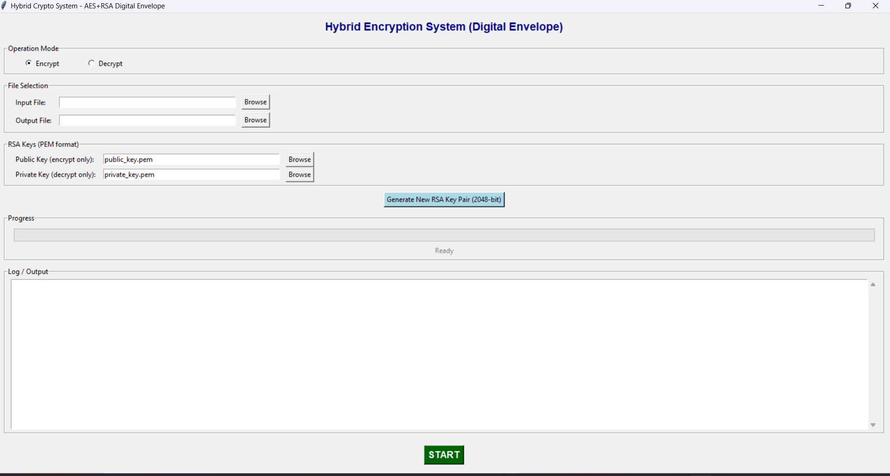
Figure 16 Shows a screenshot of the creative task which is a hybrid encryption system
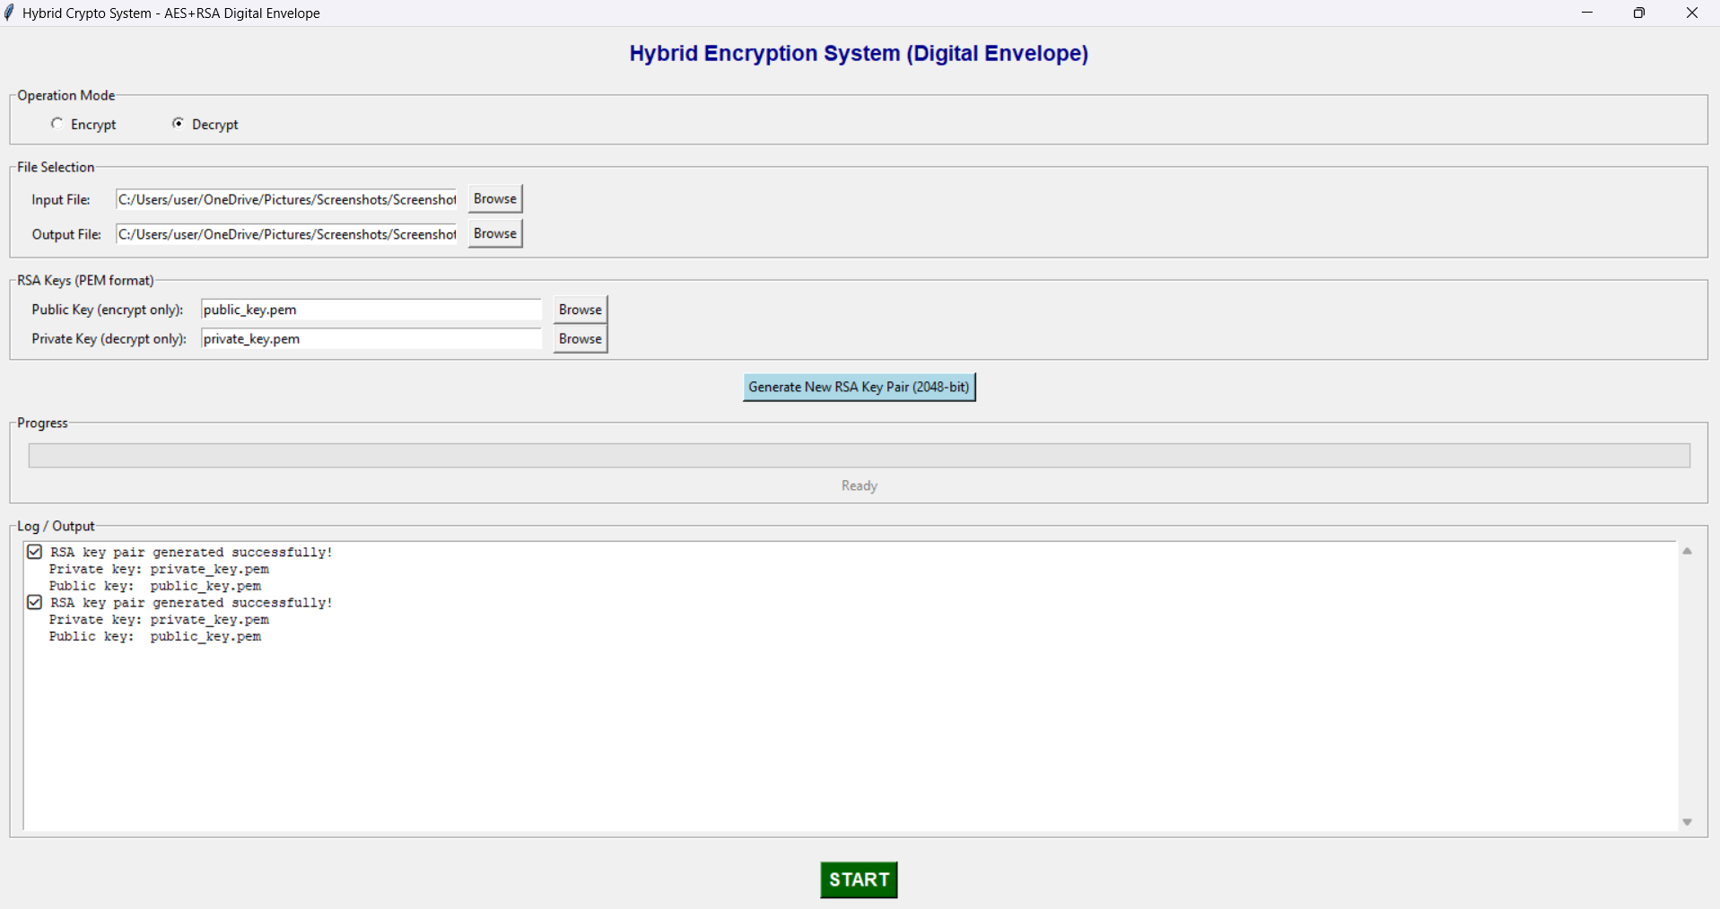
Figure 17 Shows a test for the hybrid encryption system

WEEK 8
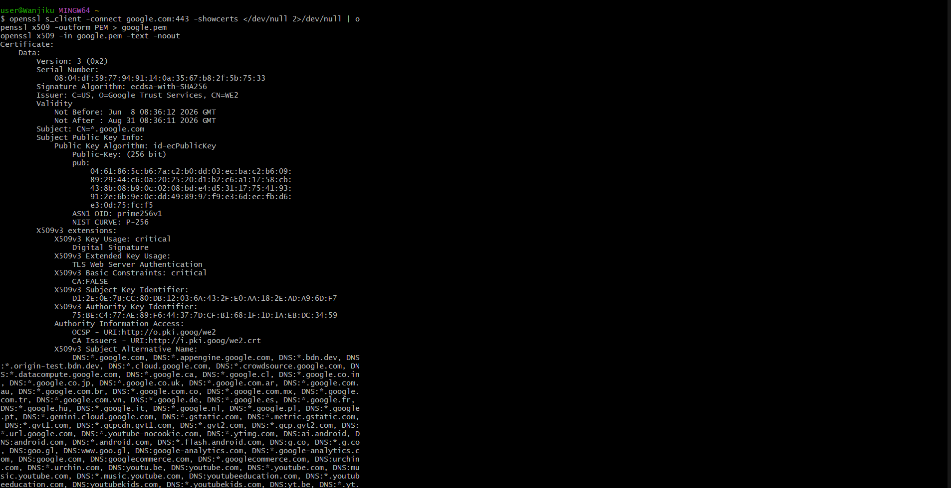
Figure 18 Shows the download of a digital certificate for google

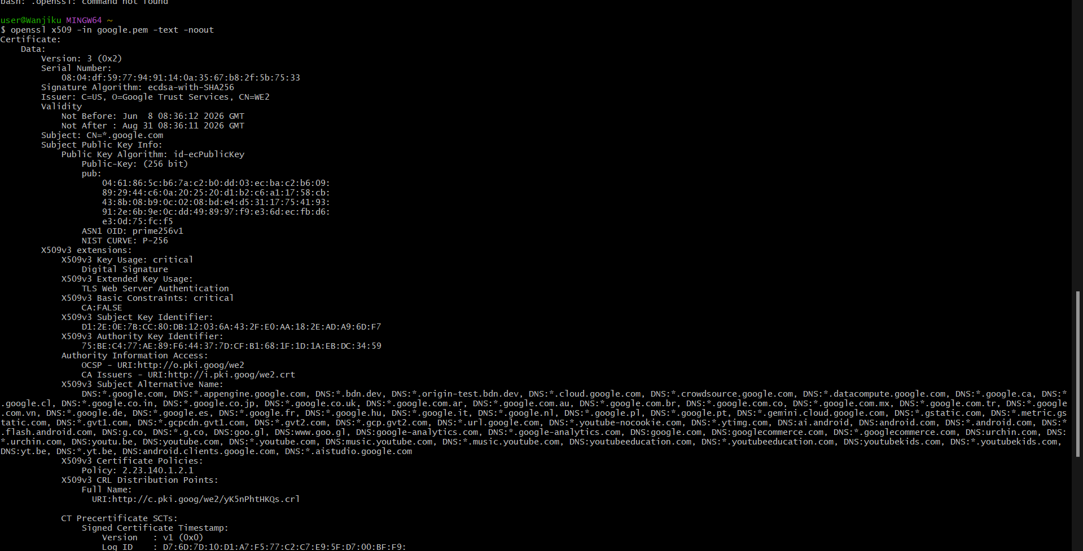
Figure 19 Shows the details of the certificate such as the issuer, signature algorithm and subject

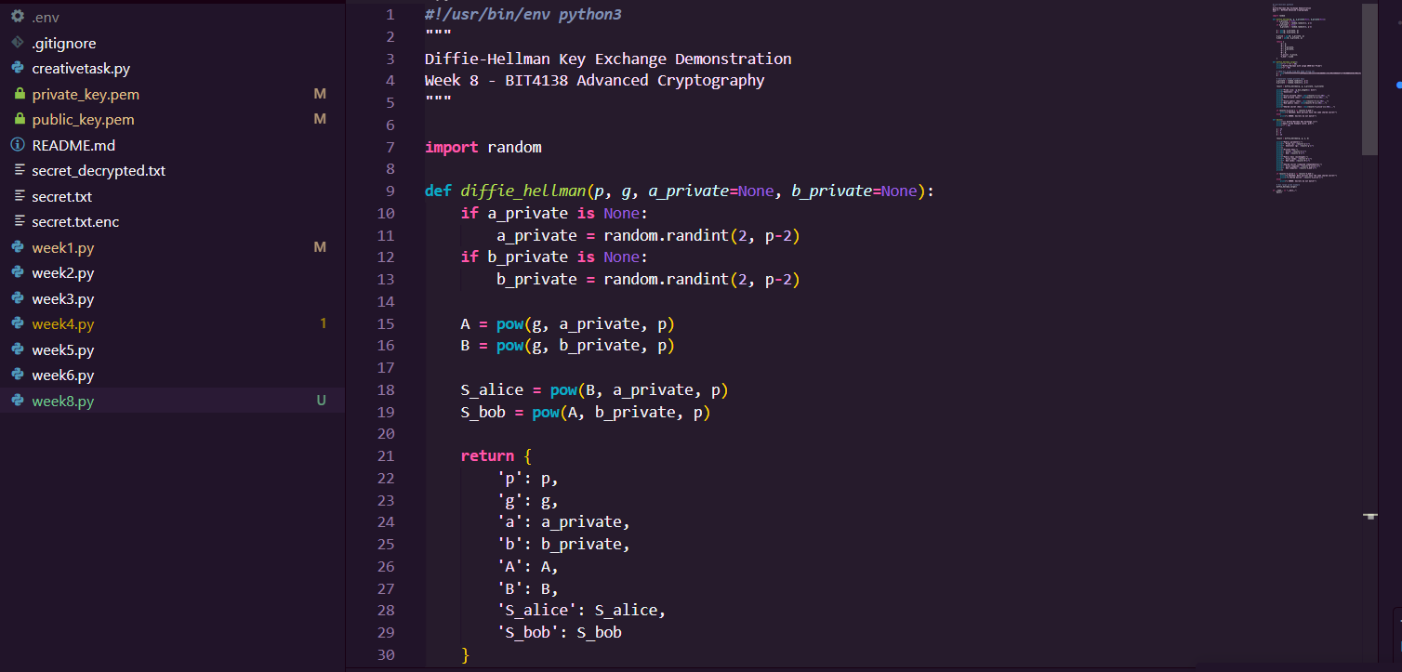
Figure 20 Shows code for the Diffie Helman Key exchange

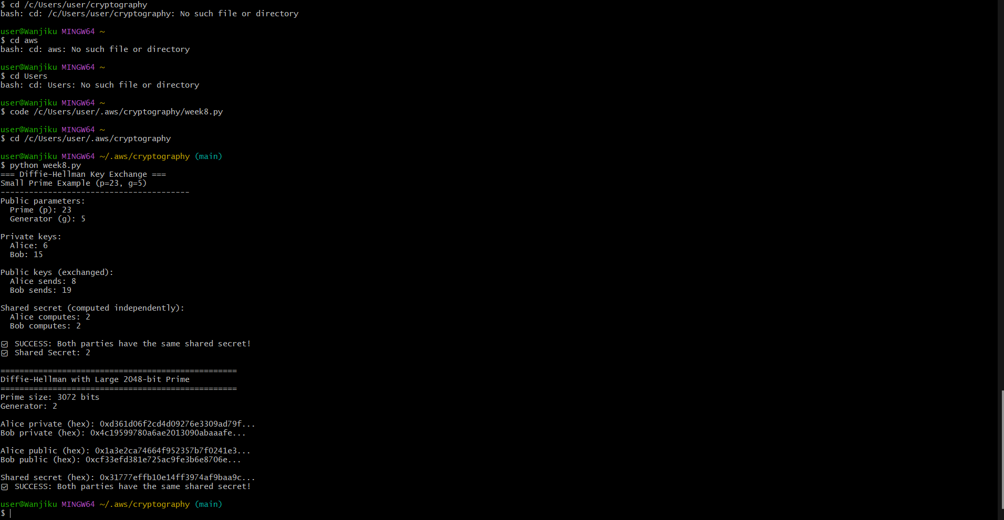
Figure 21 shows the small prime example output (p=23, g=5) with the shared secret = 2.

