

TOPIC: ADVANCED WEB DEVELOPMENT
NAME: MBURU MAUREEN WANJIKU
ADM NO: BSCCS/2024/73963
COURSE: BACHELOR OF SCIENCE IN COMPUTER SCIENCE
DEPARTMENT: COMPUTING AND INFORMATICS
CREATIVE TASK DONE : 1.

LECTURER : MICHAEL NYORO
SUBMISSION DATE: 5th JUNE 2026

DECLARATION
I, MAUREEN WANJIKU, hereby declare that all information in this document has been obtained and presented in accordance with academic rules and ethical conduct. Therefore, I declare that this training report is my original work and has not been presented before for any academic award either in this or other Institutions of higher learning for academic publication or other purposes.
STUDENT NAME: MAUREEN WANJIKU
ADM NO: BSCCS/2024/73963
Signature: WANJIKU MBURU
Date: 5TH JUNE 2026

Contents
PROJECT DETAILS 4
CODE FOR THE APP 8
DATABASE TABLES IN THE CODE 9
INPUTING DATA TO TEST THE DATABASE 10
PATIENT DATA WITH LOG IN DETAILS 10
PATIENT APOINTMENT DATA IN DATABASE 11
PRESCRIPTION DATA IN DATABASE TABLES 12
Php DATABASE CONNECTION 12
Php REGISTRATION 13

Figure 2 Shows tables in XAMPP that have been created for the patient data including the login details, appointments and prescriptions. 7
Figure 3 Shows the code for the web app 8
Figure 4 Shows the tables for the database in the codethat are then linked to XAMPP 9
Figure 5 Shows the login page with the registration option too for the patients. 9
Figure 6 Shows the dashboard of the web app and also the input of patient data. 10
Figure 7 Shows patient log in details in the database 10
Figure 8 Shows patient appointment details in the XAMPP database 11
Figure 9 Shows patient prescription details in the databse. 12
Figure 10 Shows php code connecting the database to the web app 12
Figure 11 Shows the php code for registration. 13

PROJECT DETAILS
Project title: Patient Assistant
Selected technologies:
- php
- React
- Firebase
Github llink
https://github.com/maureen03571/patient-assistant.git

SETTING UP XAMPP

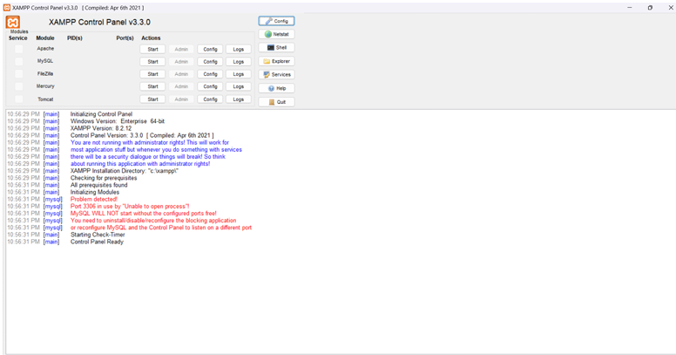
Figure 1 Shows the successful installation of XAMPP that will be used for the database of the app

PROJECT WIREFRAME

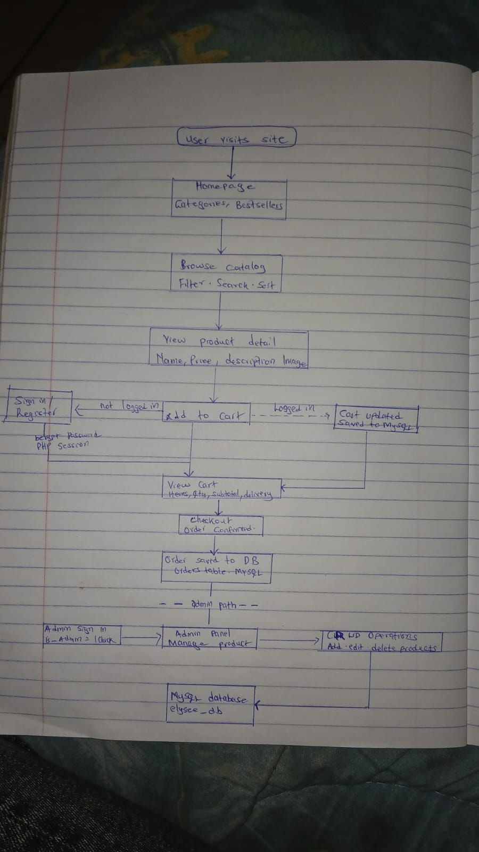
Figure 2 Shows the complete flow diagram of the entire app both frontend and backend

CREATING TABLES
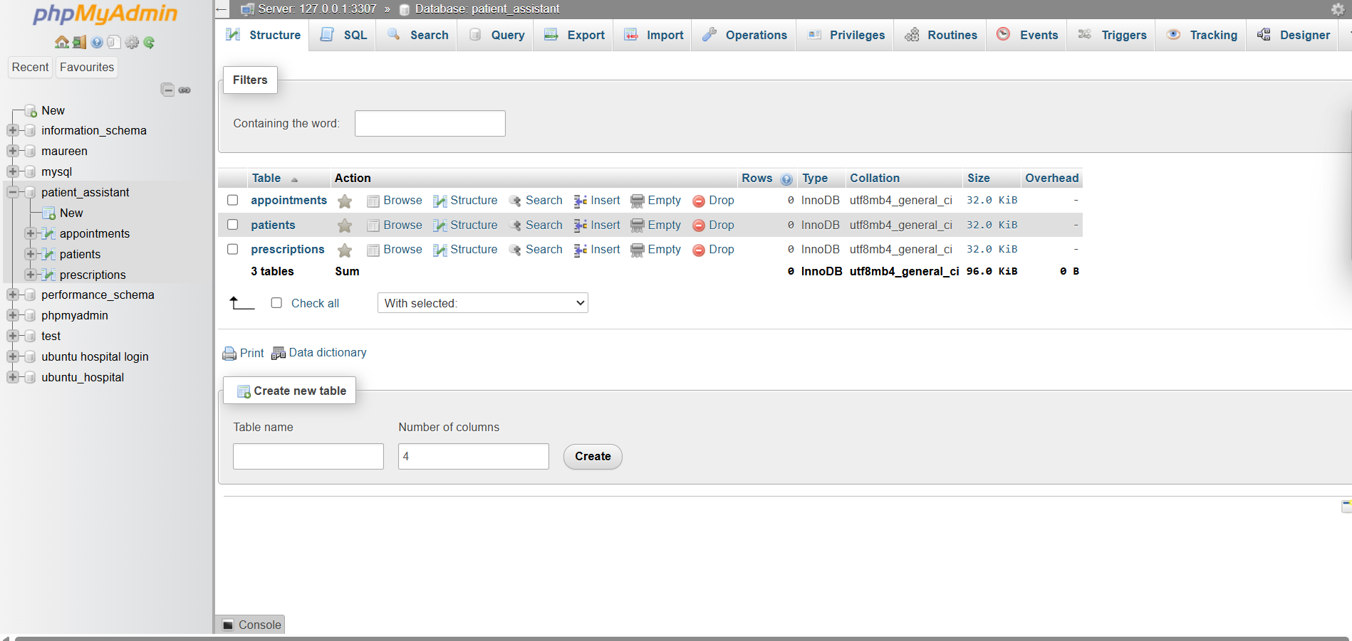
Figure 3 Shows tables in XAMPP that have been created for the patient data including the login details, appointments and prescriptions.

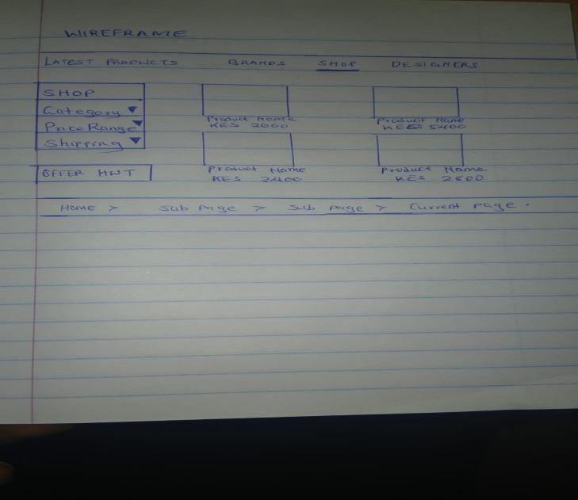
Figure 4 Shows the propsed wireframe for the application.

CODE FOR THE APP
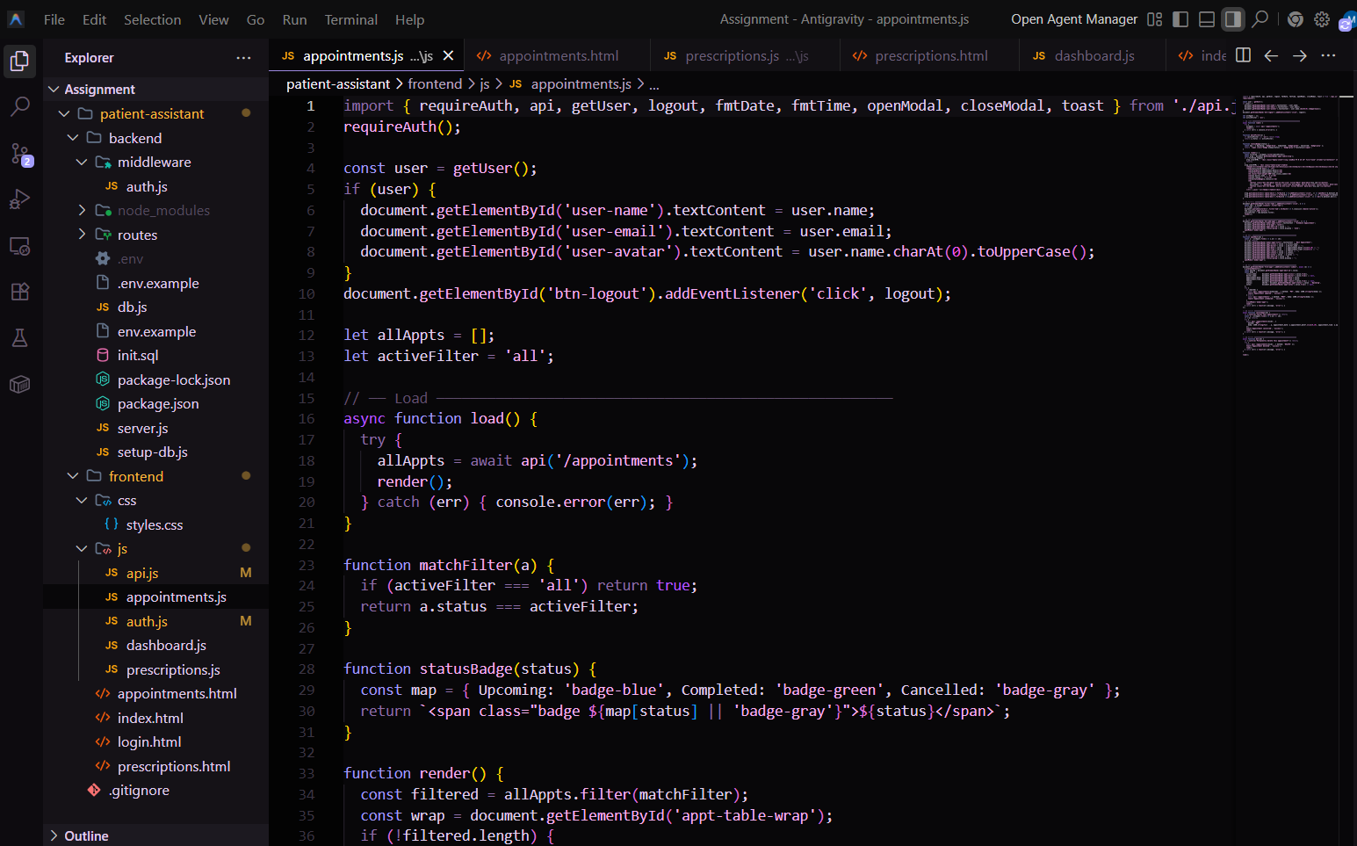
Figure 5 Shows the code for the web app

DATABASE TABLES IN THE CODE
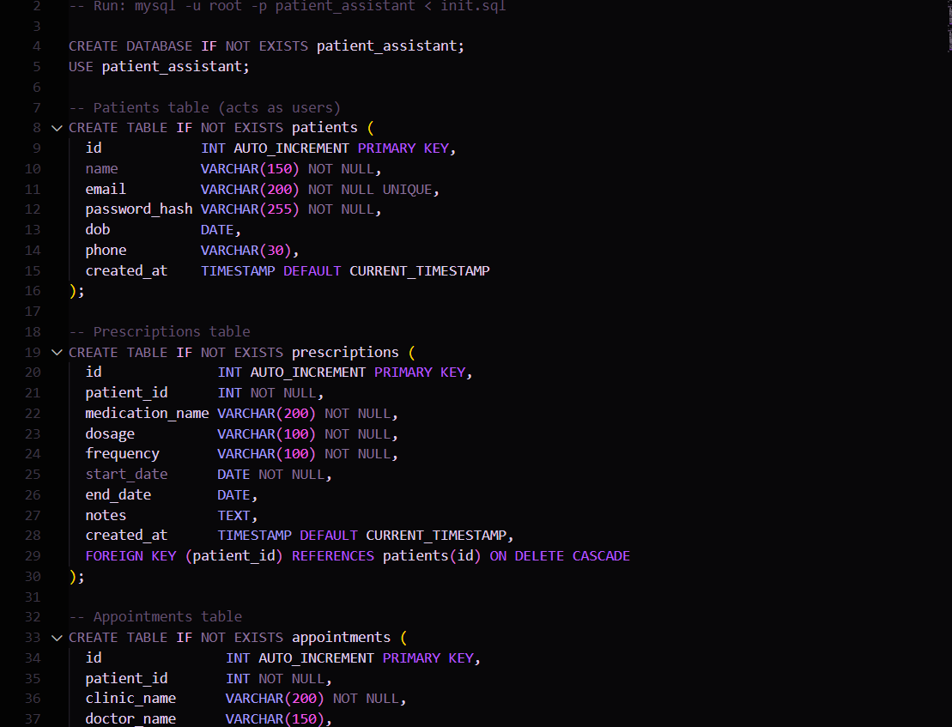
Figure 6 Shows the tables for the database in the codethat are then linked to XAMPP

Shows the configuration page for the Automated Scan targeting the Patient Assistant web application

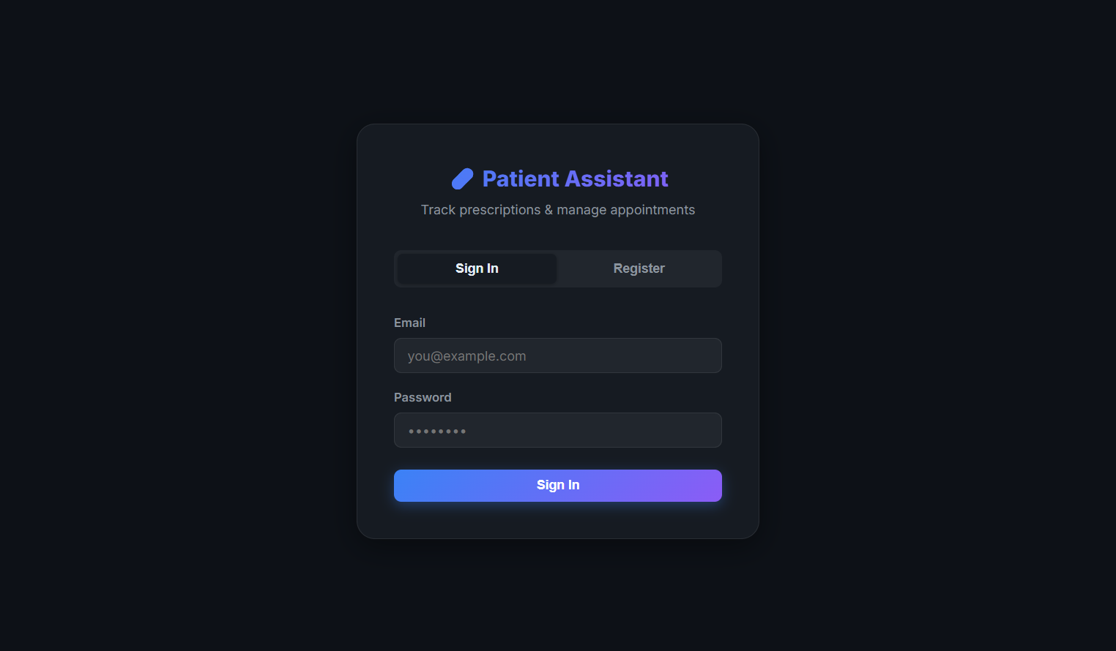
Figure 7 Shows the login page with the registration option too for the patients.

INPUTING DATA TO TEST THE DATABASE
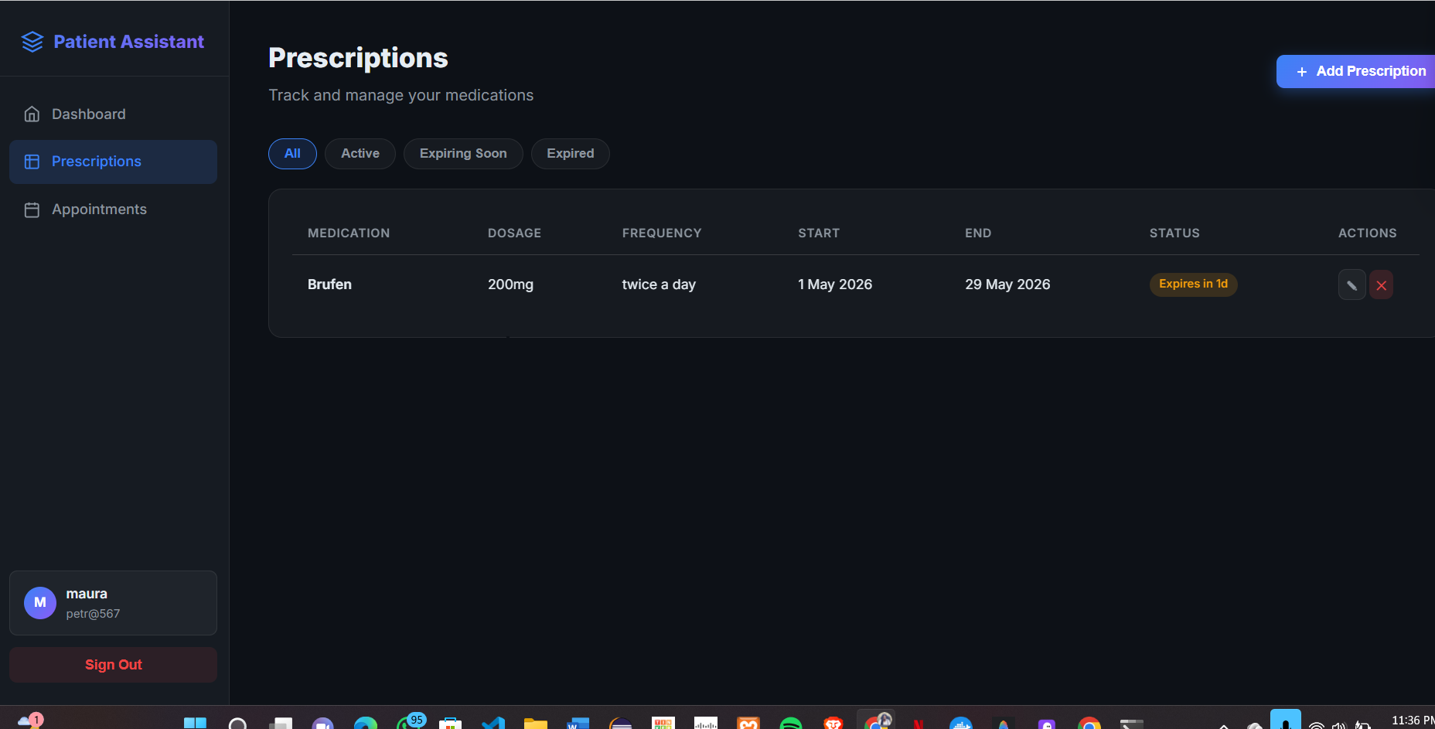
Figure 8 Shows the dashboard of the web app and also the input of patient data.

PATIENT DATA WITH LOG IN DETAILS
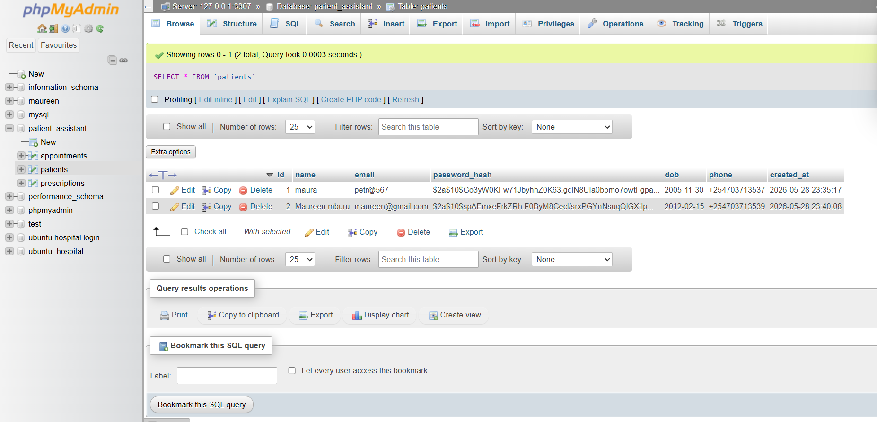
Figure 9 Shows patient log in details in the database

PATIENT APOINTMENT DATA IN DATABASE
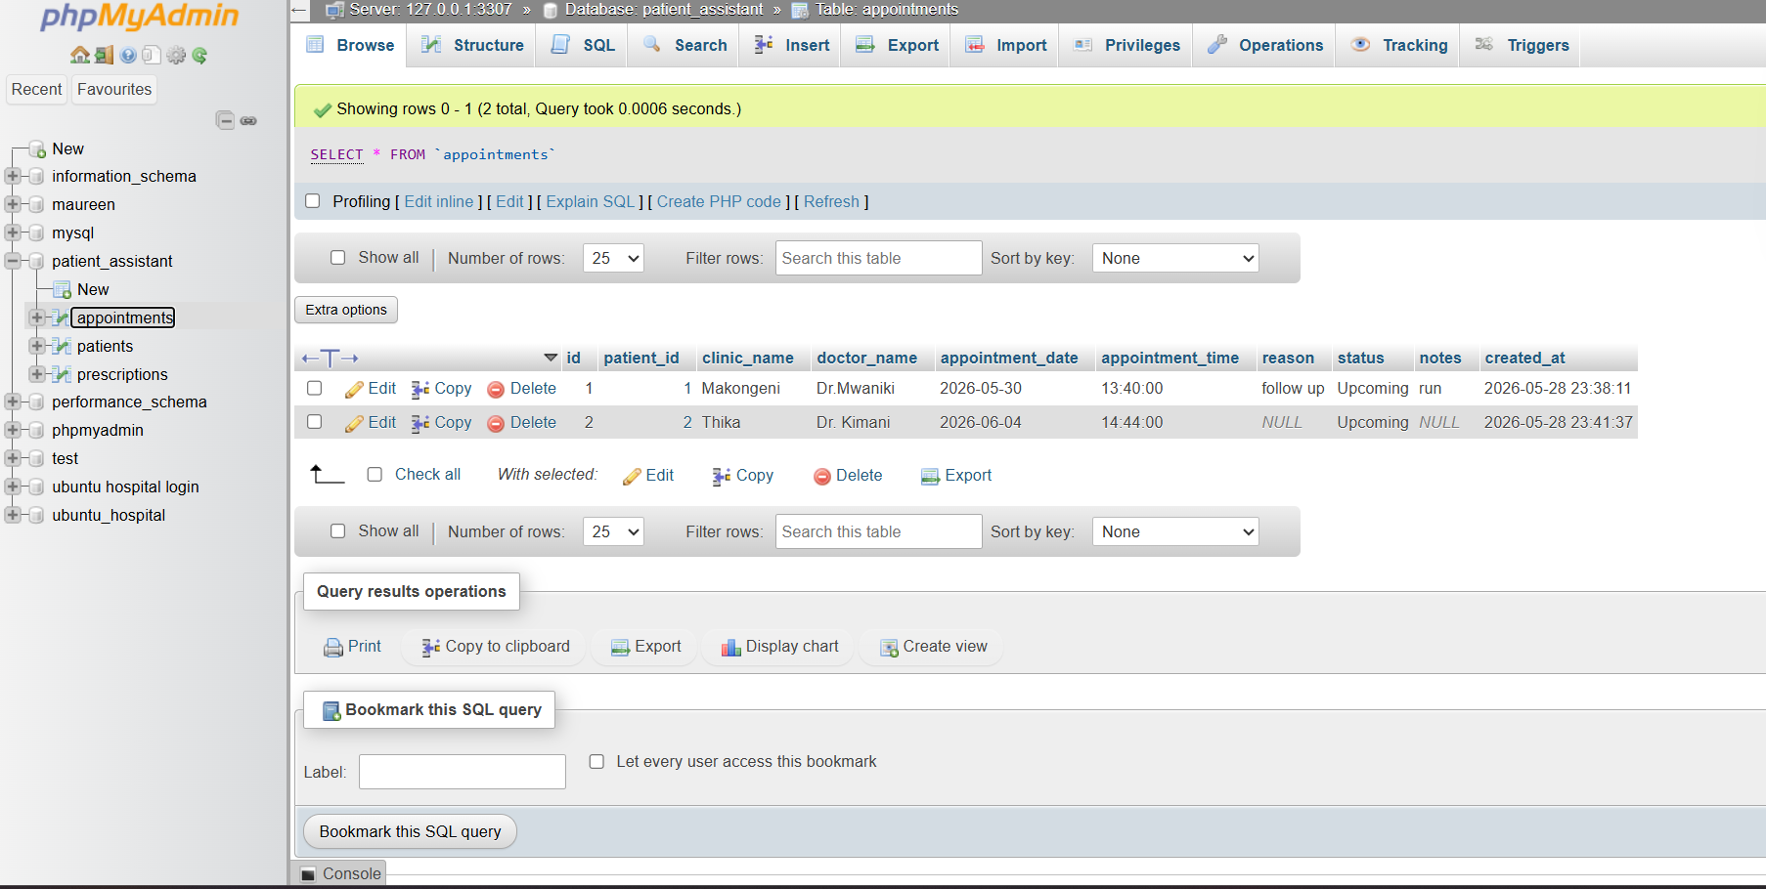
Figure 10 Shows patient appointment details in the XAMPP database

PRESCRIPTION DATA IN DATABASE TABLES
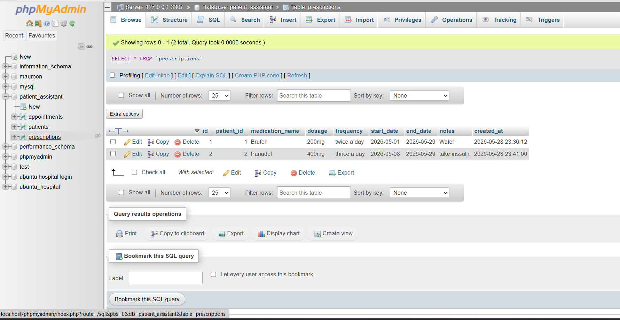
Figure 11 Shows patient prescription details in the databse.

Php DATABASE CONNECTION
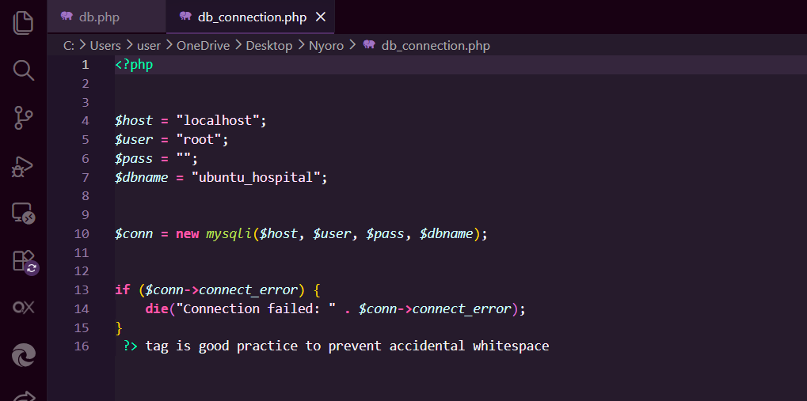
Figure 12 Shows php code connecting the database to the web app

Php REGISTRATION
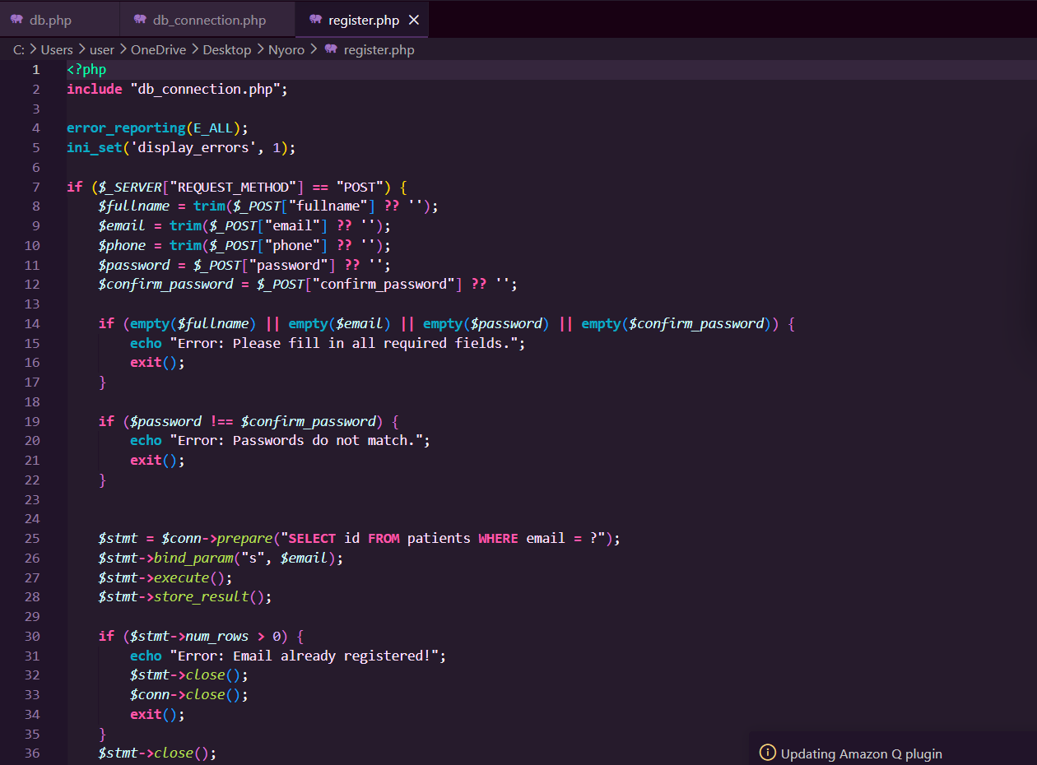
Figure 13 Shows the php code for registration.

REFLECTION FOR THE ASSIGNMENT
The frontend and the backend interact via XAMPP that enables it to be smooth to observe the patient data in the tables. The validation is necessary to reduce data breach and security vulnerabilities. The database connection matters inorder to improve data storage for the app and also easy data retrieval.

