Comparison of background rates in CLAS12 between first engineering run and GEMC.

R. De Vita

*Istituto Nazionale di Fisica Nucleare - Sezione di Genova,*

*Via Dodecaneso 33, 16146 Italy*

V. Burkert, M. Ungaro

*Jefferson Lab, 12000 Jefferson Avenue, 23606 Newport News, VA, USA*

**Abstract**

On December 17 2017, the nominal luminosity of 1035 s-1cm-2 (75 nA on a 5 cm LH2 target) was achieved in CLAS12. The rates in various detectors were measured: Drift Chambers (DC), High Threshold Cerenkov Counter (HTCC), Forward Time-Of-Flight (FTOF), Forward Tagger (FT) and the electromagnetic calorimeter (ECAL). The rates are compared with simulation predictions of beam-related background.

**Experiment Configuration**

Both the solenoid and torus magnet were operating at full current. All baseline CLAS12 detector were turned on except for the Forward Tagger (due to a cooling system issue). See Figure 1.

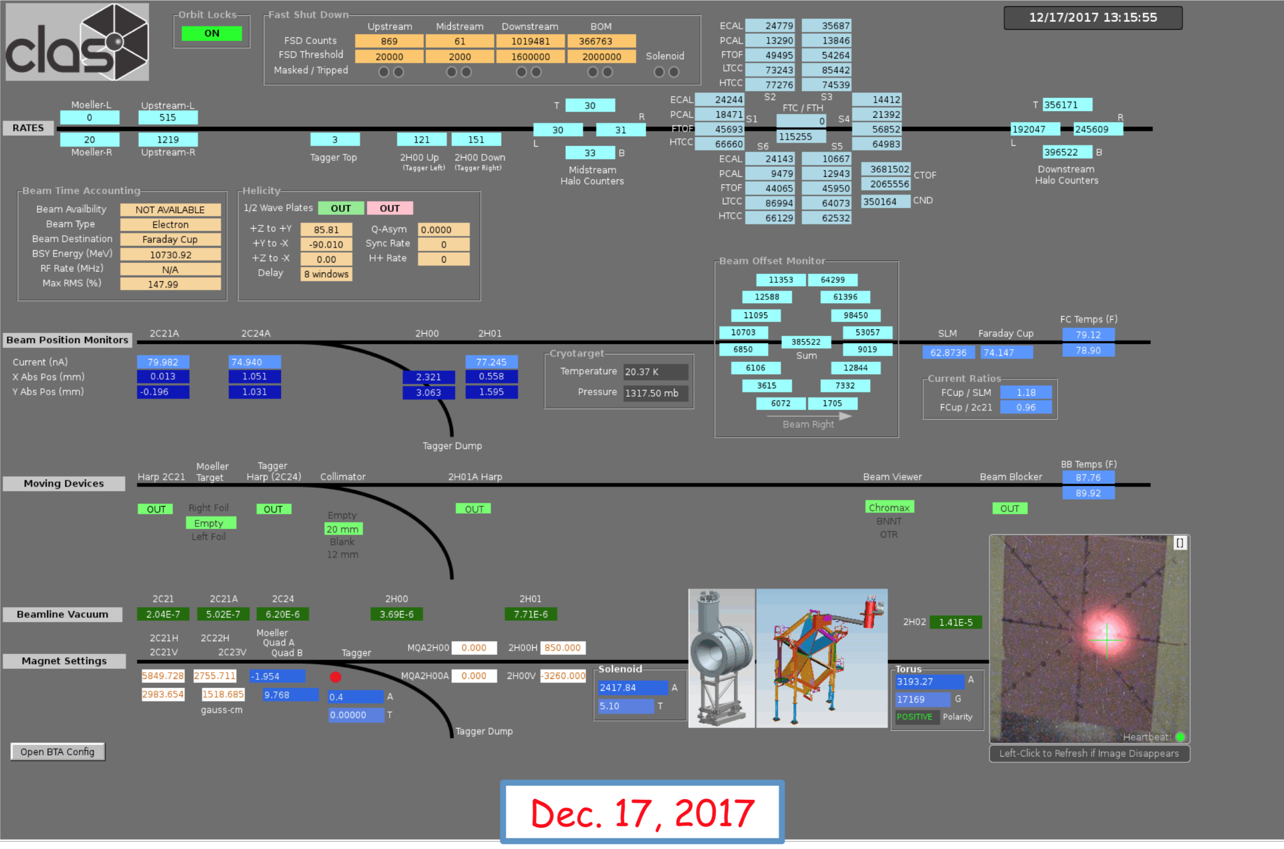

*Figure 1: the 75 nA electron beam on the 5 cm CLAS12 LH2 target that achieved the nominal luminosity of* 1035 *s-1cm-2 on December 17, 2017. The beam spot is visible on bottom right.*

**Simulated Detector, Beam and Target Configuration**

This simulation study is based on the CLAS12 starting configuration “FTOn”, where the Forward Tagger is active, see Figure 1. The Moller cone geometry corresponds to the final engineering design [1], [2], [3]. The beamline, target, shielding, torus components and vacuum beamline geometry were incorporated in geant4 directly from the engineering CAD models. The target was shifted by +3.5 mm along the x-axis, as indicated by installation surveys.

For each event, 124,000 electrons going through the target within a 250 ns time window were simulated. This corresponds to the full CLAS12 1035 cm-2s-1 luminosity on a 5cm LH2 target. Simulations were performed for both 10.6 GeV and 6.4 GeV beam energy. Here results for the highest energy are reported: rates and occupancies for the lower energy were anyway found to be similar with differences of the order of 10%.

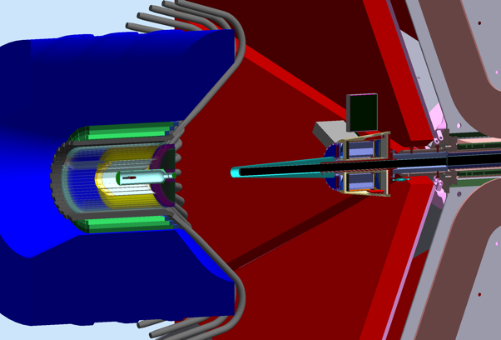

*Figure 2: The starting CLAS12 configuration “FTOn”; the FT is operational. To clear its acceptance at forward angles (2.50-4.50 degrees) the Moller shield (cyan color) is attached to the FT tracker, starting at z=877 mm from the target. Bottom: FToff; the FT is present but not operational. The FT tracker is replaced with a shield. The Moller cone is placed at z=430 mm from the target and additional shielding minimize background in Region 1 Drift Chambers.*

**Comparison of rates in the DCs**

The DC occupancies were measured at several beam currents, and scaled to full luminosity. The comparison with the simulation is shown in Table 1.

The larger occupancy is in Region 1. There is no difference in the occupancy or the hit distribution for the two torus polarities, see Figure 2. Historically the desired DC occupancy limit is 3%.

 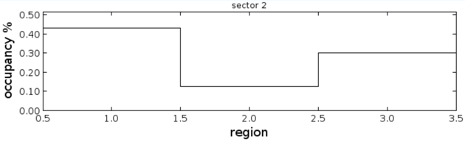 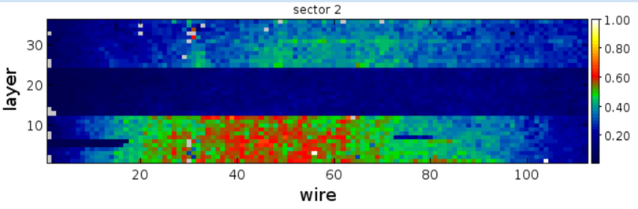

*Figure 3: Results for DC rates for simulation (left column) and measured (right column). Top: the occupancies are below 3% for region 1 and below 1.2% for region 3. The measured occupancy were at a 10 nA beam current (a factor 7.5 less than the nominal luminosity). Bottom: layer versus wire hit distribution: simulated and measured occupancies show similar distributions.*

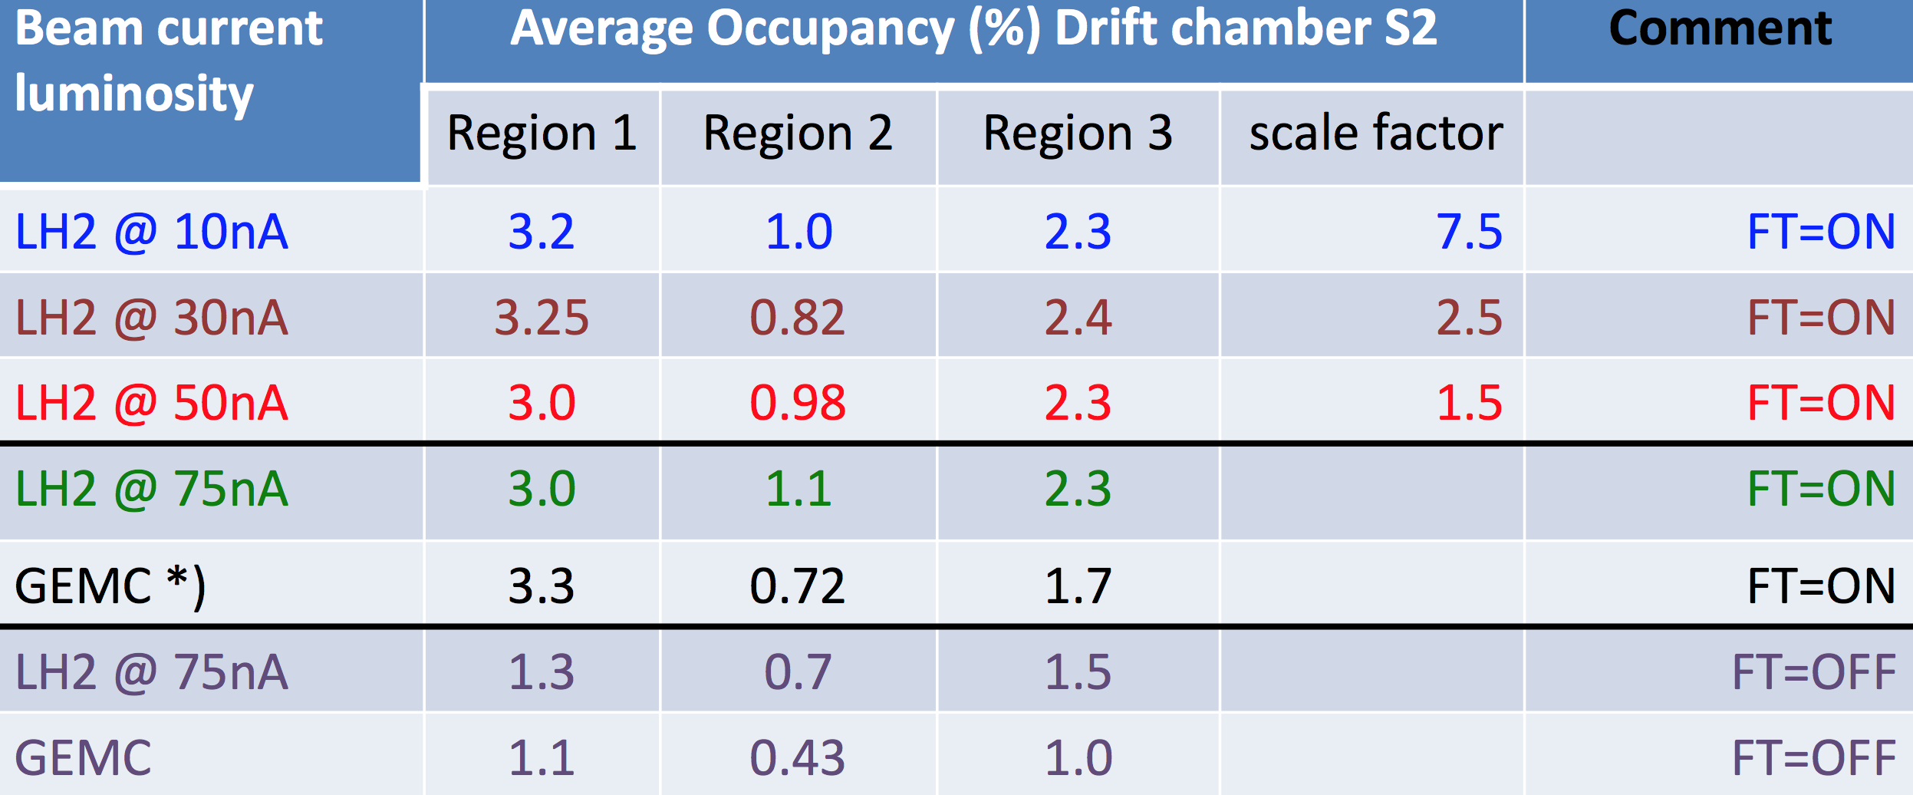

*Table 1: da correggere coi nostril numeri.*

**Rates in the HTCC**

The largest rate is in the inner HTCC ring. There is no significant difference in the hit rates or distribution for the two torus polarities, see Figure 4. The first ring sees a 100 kHz rate w/o threshold, reduced to about 25 kHz with a 3 npe threshold and 12 kHz with a 10 npe threshold. See Figure 6 for a reference picture of the four HTCC rings.

  



*Figure 4: Results for HTCC rates for electrons in-bending (left column) and out-bending (right column). Top row: number of photoelectrons. Middle and bottom row: rates in the four HTCC rings, number 1 being the closest to the beam.*

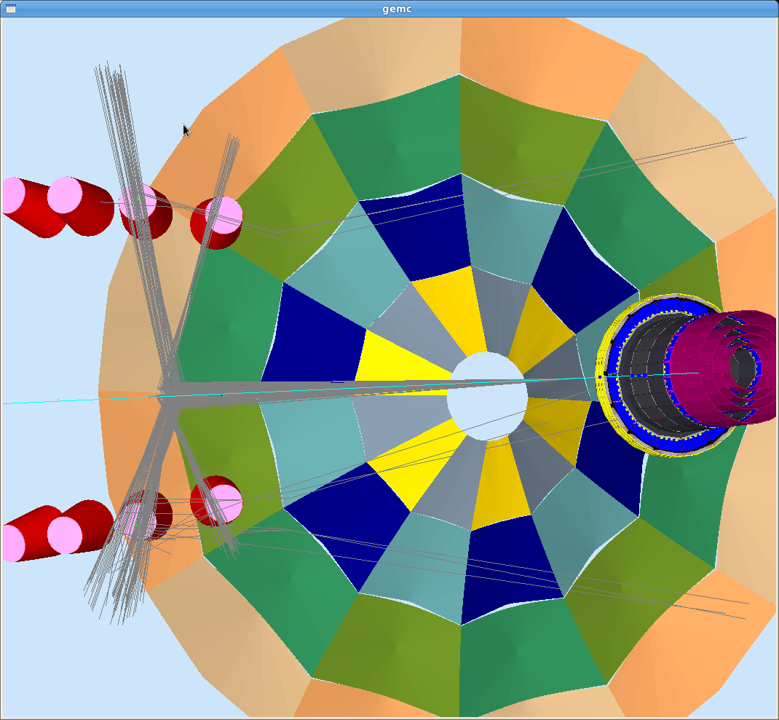

*Figure 6: The four HTCC mirror rings in the simulation.*

**Rates and PMT currents in the FTOF**

Rates for 1 MeV threshold on the energy deposition and PMT currents [4] for FTOF counters are shown in Figure 7. Rates increase with the counter length and with the increase of solid angle, reaching a maximum of 700 kHz for the Panel-2 counters. Similarly, the maximum PMT currents are seen in the same detector elements and are of the order of 15 μA. The dependence on the field polarity is negligible for rates while it is of the order of 10% for the currents. The rates strongly depend on the threshold, going from a maximum of about 6 MHz for 0 threshold, to the 700 kHz for 1 MeV(as shown in Fig. 7), to 70 kHz for 5 MeV.



*Figure 7: Results for FTOF rates (top) and PMT currents (bottom) for electrons in-bending (left column) and out-bending (right column). Rates are calculated for a 1 MeV threshold on the energy deposited and are expressed in kHz while currents are in μA. The different sets of x bins from left to right correspond to Panel-1B, Panel-1A and Panel 2 counters.*

**Rates in the ECAL**

Rates for 1 MeV threshold on the energy deposition for ECAL strips are shown in Figure 9. The highest rates are in general found at the largest angles. No significant dependence on the field polarity is observed. As for the FTOF, the ECAL rates strongly depend on the threshold, going from a maximum of about 2.5 MHz for 0 threshold, to the 400 kHz for 0.1 MeV, to 140 kHz for 1 MeV (as shown in Fig. 9).



*Figure 10: Results for ECAL sector rates for PCAL (top), ECin (middle) and ECout (bottom) for electrons in-bending and FTOff configuration. Rates are calculated for a 1 MeV threshold on the energy deposited and are expressed in kHz.*

**Rates and PMT currents in the CTOF**

Rates for CTOF counters do not depend on the beamline configuration or the field polarity but only on the threshold, varying from about 5 MHz for 0 threshold to about 150 kHz for 1 MeV threshold on the energy deposition. PMT currents are estimated to be in the range of 50 μA.



*Figure 11: Rates (left) in kHz and energy deposition per unit of time (right) in MeV/ns for the FTCAL crystals in the FTOn configuration.*

**Rates and radiation doses on the FT detectors**

The estimated rates in kHz and energy deposition per unit of time in MeV/ns for the FTCAL in the FTOn configuration are shown in Fig. 11. The maximum rates reaching about 100 kHz are observed for the innermost crystals that are closer to the beamline.

Fig. 12 shows the radiation dose in rad/h on the FTCAL for the FTOn and FTOff configurations, respectively. The maximum dose of about 3-4 rad/h is well within acceptable limits for both configurations. These differs, however, for the distribution within the calorimeter volume because of the additional shielding used in the FTOff case.



*Figure 12: Radiation dose in rad/h on the FTCAL for the FTOn (left) and FTOff (right) configurations.*

**References**

*[1] R. De Vita and M. Ungaro,* ***CLAS12-note 2016-006****:* Moller shield simulations: comparison of the GEMC-optimized layout and the engineering design.

*[2] R. De Vita, L. Elouadrhiri, R. Miller, S. Stepanyan, M. Ungaro, C. Wiggins, M. Zarecky, A. Kim and J. A. Tan,* ***CLAS12-note 2017-012****:* Corrections to CLAS12 vacuum beamline

*[3] M. Ungaro,* ***CLAS12-note 2017-013****:* Corrections to CLAS12 target design.

*[4] R. De Vita, D. S. Carman, C. Smith, S. Stepanyan and M. Ungaro,* ***CLAS12-note 2017-016****:* Study of the electromagnetic background rates in CLAS12.

*[5]* *R. De Vita and M. Ungaro,* ***CLAS12-note 2017-017****:* Importing CLAS12 CAD models of target and beamline in the GEMC simulation.

*[6] D.S. Carman,* ***FTOF-note 2014-06****:* Forward Time-of-Flight PMT Currents.