Background Merging Mechanism in GEMC

M. Ungaro

*Jefferson Lab, 12000 Jefferson Avenue, 23606 Newport News, VA, USA*

**Abstract**

A mechanism to merge generated events with background from real or simulated data is presented. The real events could come from a random trigger run, and simulated data could come from events that include a beam within time window. In both cases the reconstruction software is used to produce an ASCII file containing the background hits. An additional mechanism for background merging of tracks (simulation only) is shown as well.

**Introduction**

CLAS12 physics background can be simulated in gemc by using a number of beam electrons impinging on the target within a time window. For the nominal CLAS12 luminosity of 1035 cm-2s-1 and a typical time window of 250 ns this results in 124,000 electrons per event. The electrons are generated just upstream of the target, and the geant4 transportation and physics processes creates secondary particles that interact with the detectors producing physics background.

This mechanism has been used to calculate rates in various detectors, study shielding configuration and optimize the reconstruction software in the presence of background [1], [2], [3], [4].

This physics background can be generated on top of a physics event of interest that includes several particles. An example can be seen in Figure 1, where a deep inelastic scattering event was simulated along the CLAS12 beam background.

The downside of this procedure is a long CPU processing time, due to the high number of electrons / event. For the typical CLAS12 luminosity the 124,000 electrons impinging on the liquid hydrogen target are processed in between one and two minutes, while a single DIS event takes only ~0.5 second.

Another aspect to consider is that the background generated this way does not take into account beam and geometry alignment imperfections, electronic noise and other source of realistic background that cannot be reproduced in geant4. This realistic background is present in the data.

Here new code is shown to import background from either simulation (physics only) or data (more realistic). The mechanism reduces to zero the CPU overhead to handle the background.

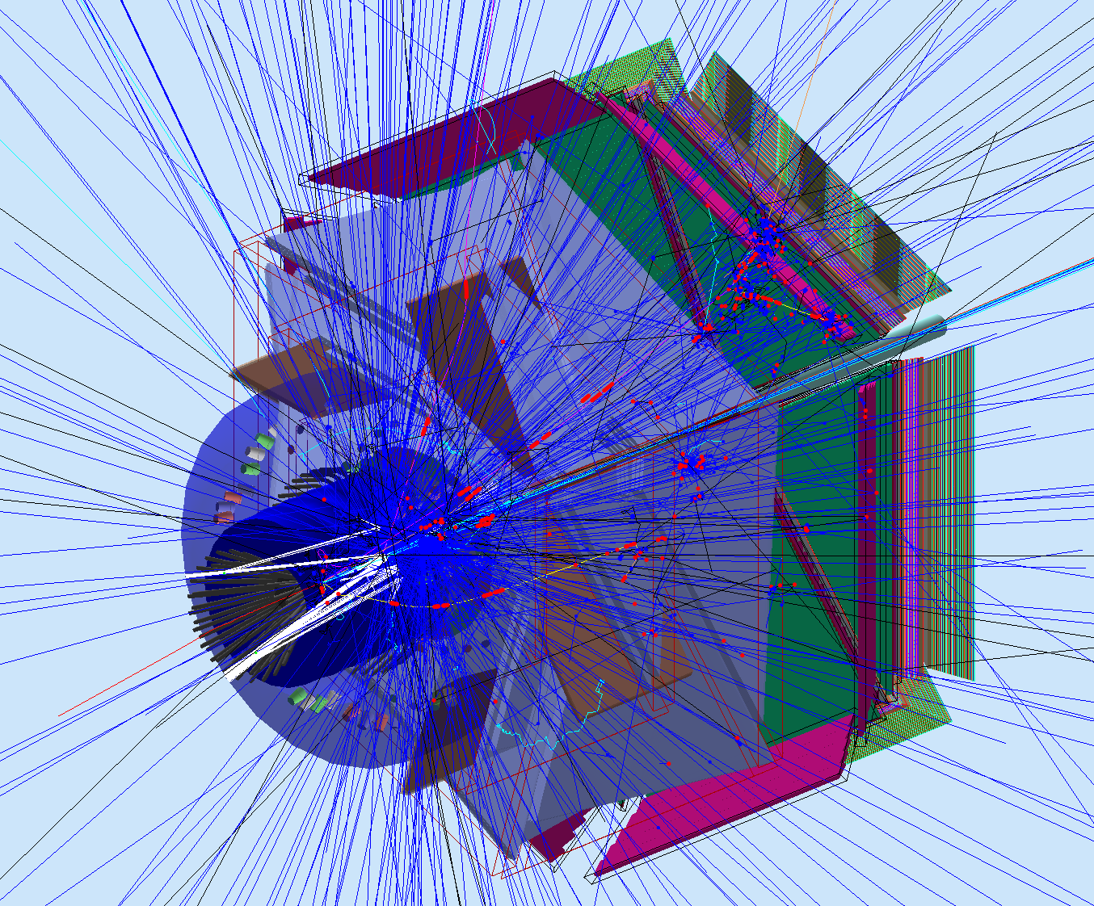

*Figure 1: A Deep Inelastic Scattering (DIS) event and the beam background using the nominal 1035 cm-2s-1 CLAS12 luminosity within a time window of 250 ns. The beam produces secondary particles that generate hits in the Drift Chambers, Cerenkovs, Calorimeters and Time-Of-Flights detectors. Notice the hits coming from the DIS event tracks: electrons,  + and  -. On a single core the time necessary to process the DIS event is ~0.5 seconds, while the time necessary to swim all the beam particles is between one and two minutes.*

**Schematic of the background merging**

A new C++ class “*BackgroundHit*” is introduced to handle both simulated and real data hits, see Figure 2. The class is filled with hits information common for both cases that includes:

* Detector name (e.g. “dc”)
* Detector element identifier (e.g. sector, superlayer, layer, wire)
* Time (from start time)
* Energy
* Number of photoelectrons detected

These quantities are calculated using the reconstruction software in the de-digitization phase.

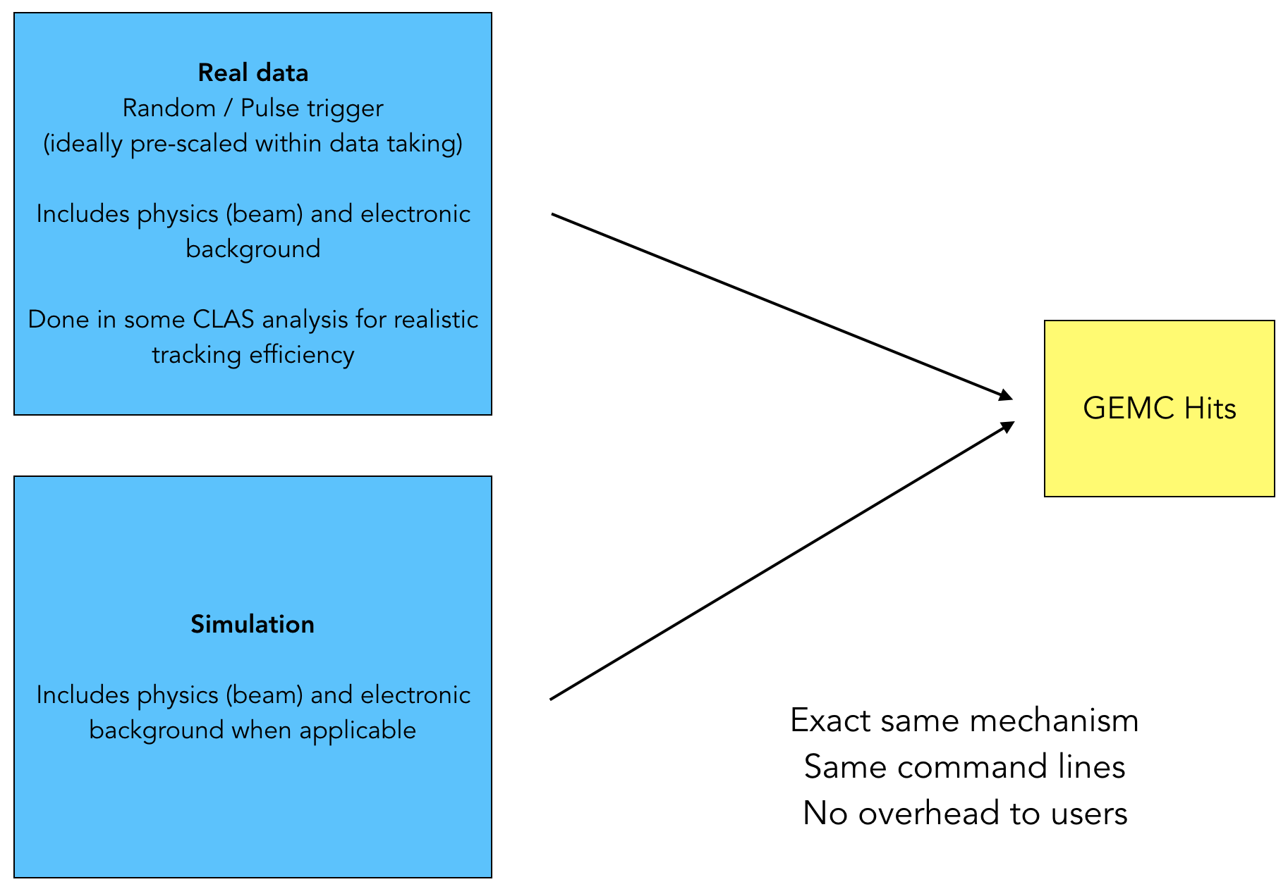

*Figure 2: Hits information from either simulation or real data is saved in ASCII files and is handled the same way by gemc. This minimize overhead to users, as the command lines/option to achieve the merging do not change.*

The events in the BackgroundHit class are merged with real hits in the geant4 implementation of the EndOfEvent routine. They are then processed by the digitization modules as normal hits. An additional Boolean variable “isBackgroundHit” has been added to the gemc hit definition in case the digitization routines need it.

**Timing and pile-ups**

The background merging mechanism can be applied to both integrated data or signal versus time data. The hits can be:

* One hit / detector element. For example, one hit is one ADC value for a TOF paddle at a given time.
* A time evolution signal. For example, a Flash ADC board can produce an ADC value every 2 or 4 nanoseconds. All these steps are merged in the simulation.

Both cases are covered by the same mechanism, because it associates a hit to a given time: the same detector element can receive multiple hits that results in a signal as a function of time, see Figure 3.

The time evolution signals merging allows for a proper treatment of pile-ups.

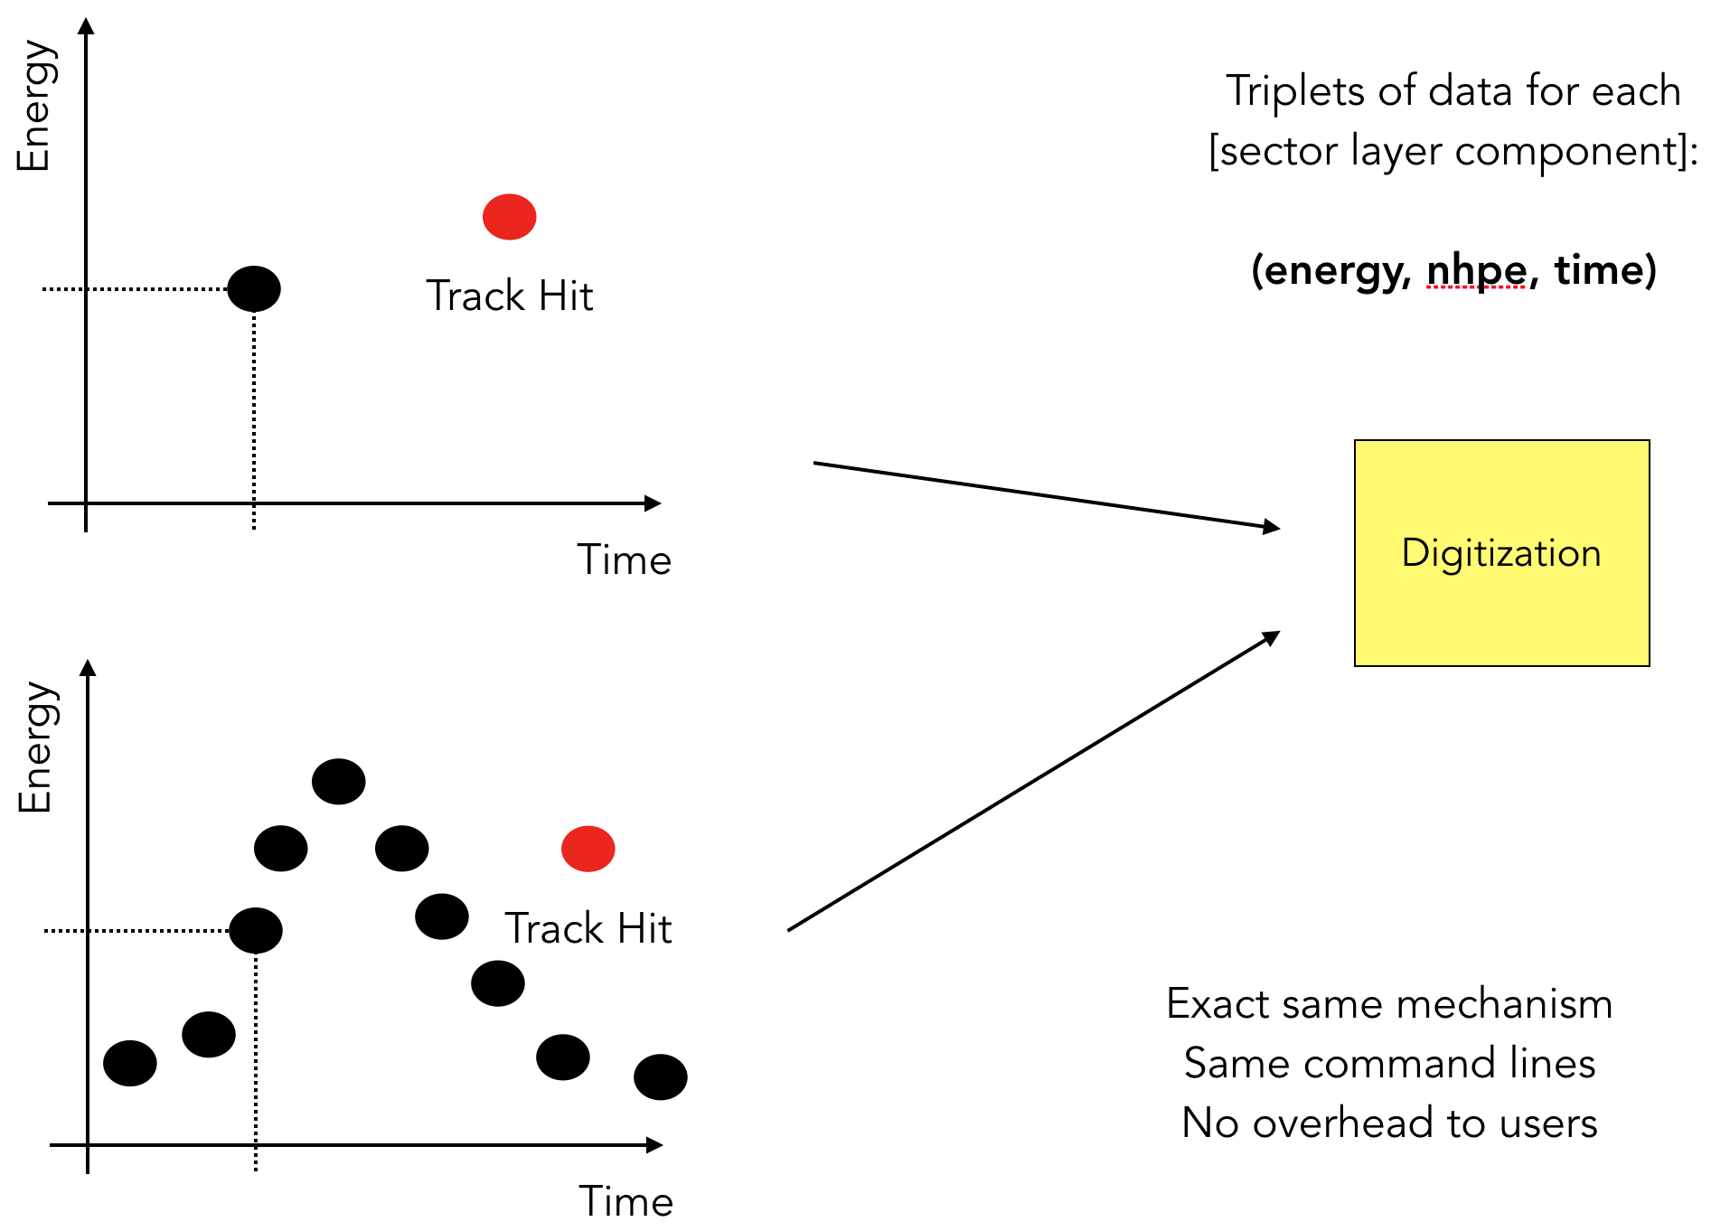

*Figure 3: The red point represent a single hit from a user generated track. Hits information from background (black points) can come from an integrated hit (top) or in the form of a signal as a function of time (bottom). The mechanism is the same in both cases.*

**Background Hits ASCII format**

The columns needed in the asci file are:

1. system name

2. event number

3. number of identifiers: for CLAS12 this number is 3, representing sector layer component

4,5,6: CLAS12 detector element identifiers

7. time (from event start time)

8. energy

9. number of photoelectrons

An example of background hit spreadsheet is shown in Figure 4, where the CLAS12 nomenclature for sensitive detectors is used.

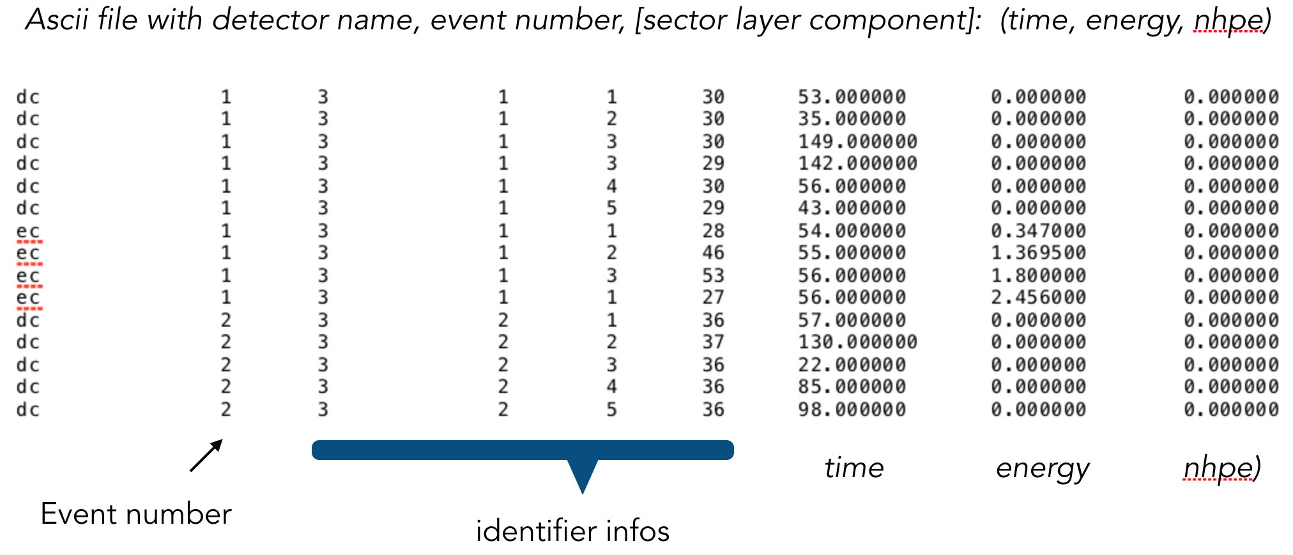

*Figure 4: example of CLAS12 background hits in asci file format. Notice the dc relevant information is time, while the calorimeter ec has an energy and a time description.*

**How to use the background merge algorithm**

Starting with CLAS12Tag 4a.2.3 the option MERGE_BGHITS can be used in the command line or in the gcard to point at the asci file with background hits. As mentioned above this is valid for both simulated data or real data.

Assuming “bg.txt” is the name of the file, the syntax for command line is:

-MERGE_BGHIT=bg.txt

while the syntax in the gcard is:

<option name=”MERGE_BGHIT” value=”bg.txt”/>

**Suggested use of the background algorithm**

A sample of N background hits could represent a background database to be used for any reaction. At event number N+1 gemc will reset the background loop so it starts at the beginning of the file.

**Merging Background tracks**

In absence of a mechanism that can produce an asci file with the necessary information an alternative method exists to produce background using the simulation (not applicable to real data).

The option “SAVE_ALL_MOTHERS” can be used to save all the tracks that pass through any sensitive detector. The tracks are saved at their earlier position with any detector. If a track pass through many detectors it is saved only once.

The tracks are saved in a LUND format and can be injected back in the simulation using the MERGE_LUND_BG option.

Due to the random engine, the propagation of a track could yield slightly different position and energy deposited every time it swims through fields and materials, but in average the background rate and doses in the detector will match the original value.

An example of this mechanism is shown in Figure 5, where the original simulation and the resulting merged background hits are compared. Even if the number of tracks saved can reach ~500 / event, the overhead to handle this background is reduced by two orders of magnitude.

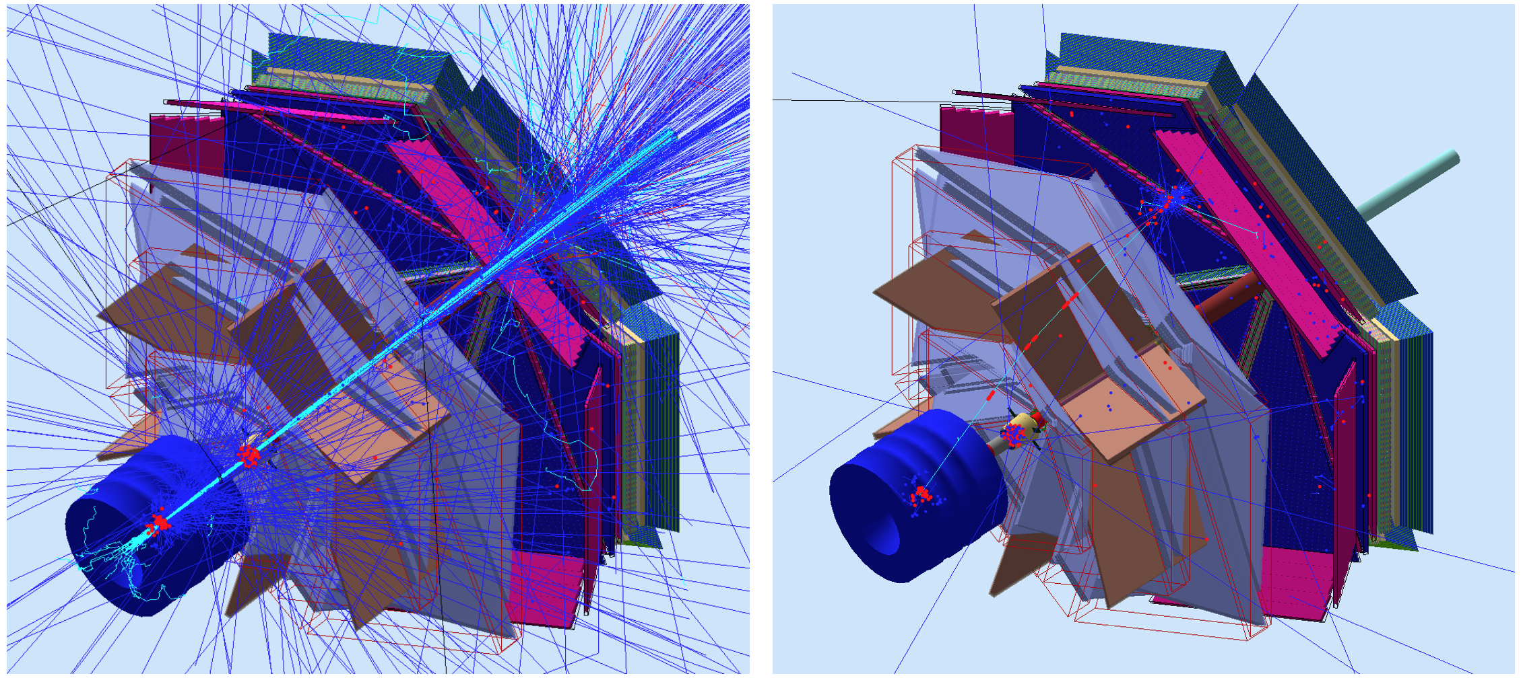

*Figure 5. Left: one event in CLAS12 using the full luminosity beam. Hits (red circles) are produced in the central detector, forward tagger, drift chambers and calorimeters. The tracks producing these hits are saved in LUND format. Right: these tracks are merged to a generated electron. Notice most of the tracks that missed the sensitive detectors are missing, but all the ones passing through (whether they deposited energy or not) are reproduced. The red hits match the original distribution.*

*The time used to produce the hits on the left is 115 seconds. The time needed produce the hits on the right (which include the generated electron) is 1.2 seconds.*

**Conclusions**

A new mechanism to merge hits from real or simulated data has been introduced. It can account for real physics background and electronic noise, handle pile ups. A database of background events can be saved and used at a later time for the reaction of interest.

**References**

*[1] R. De Vita and M. Ungaro,* ***CLAS12-note 2016-006****:* Moller shield simulations: comparison of the GEMC-optimized layout and the engineering design.

*[2] R. De Vita, L. Elouadrhiri, R. Miller, S. Stepanyan, M. Ungaro, C. Wiggins, M. Zarecky, A. Kim and J. A. Tan,* ***CLAS12-note 2017-012****:* Corrections to CLAS12 vacuum beamline

*[3] M. Ungaro,* ***CLAS12-note 2017-013****:* Corrections to CLAS12 target design.

*[4] R. De Vita, D. S. Carman, C. Smith, S. Stepanyan and M. Ungaro,* ***CLAS12-note 2017-016****:* Study of the electromagnetic background rates in CLAS12.