Beam position study on a 3.5 mm shifted target cell

V. Burkert, S. Stepanyan, J. A. Tan and M. Ungaro

*Jefferson Lab, 12000 Jefferson Avenue, 23606 Newport News, VA, USA*

**Abstract**

The CLAS12 target has been installed. Its final position for the engineering run indicates a 3.5mm shift along the x axis. This note details the Drift Chambers (DC) occupancy as a function of transverse position of the beam.

**Simulated Hardware**

This simulation study is based on the two CLAS12 standard configurations. The Moller cone geometry corresponds to the final engineering design [1], [2], [3], [4], [5]. The beamline, the shielding, the torus components and the vacuum beamline geometry were incorporated in geant4 directly from the engineering CAD models.

For each event, 124,000 electrons were impinging on the target within a 250 ns time window. This corresponds to the full CLAS12 1035 cm-2s-1 luminosity on a 5cm liquid hydrogen target. Simulations were performed for a 10.6 GeV beam energy.

The geometries of the two configurations are described below:

* FTOn: FT is operational. The Moller shield starts at z=877 mm from the target center.
* FTOff: FT is present but not operational. The FT tracker is replaced by shielding. The Moller shield starts at z=430 mm from the target center, and additional shielding is present to connect it to the FT.

The two configurations are shown in Figure 1.

The target was also imported in the simulation from the engineering CAD models [3]. Key elements include the torlon tube to the target cell, the target aluminum windows and kapton walls and the scattering chamber. See Figures 2, 3 and 4.

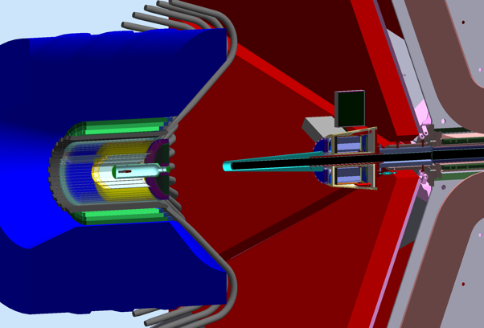

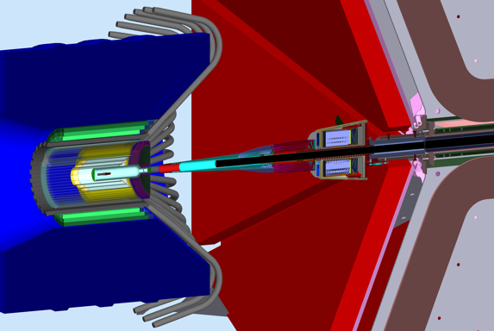

*Figure 1: The two possible CLAS12 configurations. Top: FTOn; the FT is operational. To clear its acceptance at forward angles (2.50-4.50 degrees) the Moller shield (cyan color) is attached to the FT tracker, starting at z=877 mm from the target. Bottom: FToff; the FT is present but not operational. The FT tracker is replaced with a shield. The Moller cone is placed at z=430 mm from the target and additional shielding minimize background in Region 1 Drift Chambers*

**Target offset, Beam Configuration**

The target was shifted at a position of x = 3.5mm. 18 runs were performed at different x position of the electron beam from x = -2 mm to x = 7 mm, see Figure 5. The beam was uniformly distributed along its center on a radius of 0.2 mm. It is important to note that at a transverse position r = 6mm from the target center the beam will start to scrap the 63.7 mm long wall of torlon, until a r = 7.75 mm, see Figure 3.

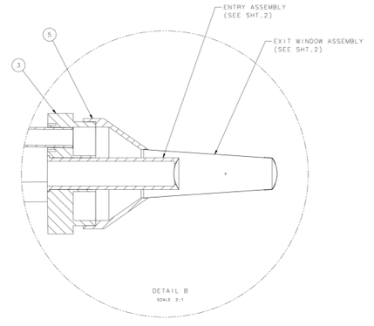 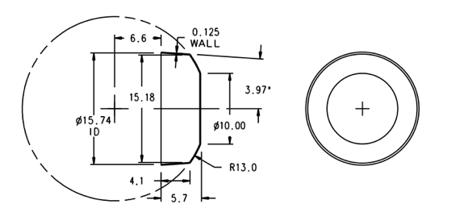

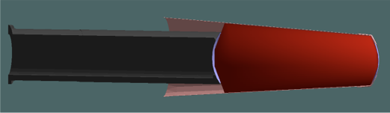 

*Figure 2: The CLAS12 target design. Top left: the entry assembly schematic. Top right: the liquid hydrogen cell dimensions: the outer radius is tapered down from 15 mm at z=-2.5cm to 10mm at z=2.5mm. Bottom left: The cell implementation in GEMC from the CAD drawings. From left to right (beam direction): the black torlon tube, the upstream aluminum window, the target cell, the kapton cup and the downstream aluminum window. Bottom right: the GEMC implementation of the kapton cup.*

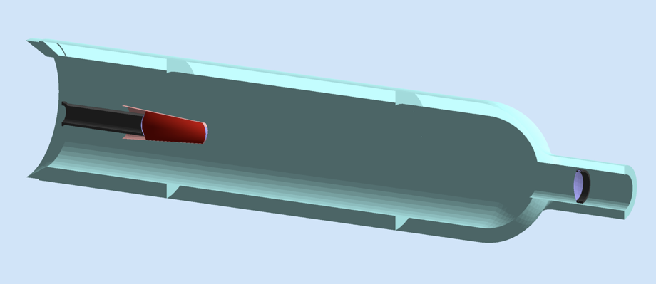

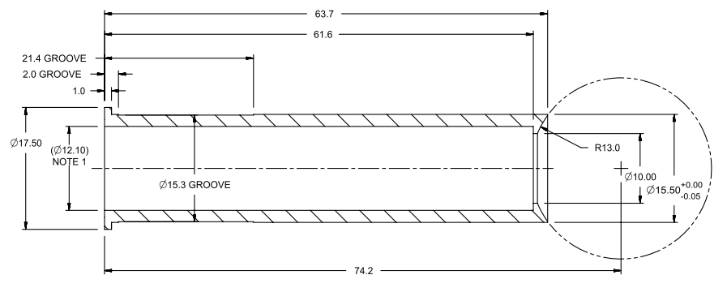

*Figure 3. Top: overview of the target implementation in GEMC includes the scattering chamber (cyan color), the downstream cup near the right of the figure and 50 m aluminum window. Bottom: the torlon base tube starts at a radius of r=6.06 mm, and ends at r = 7.75 mm. It is 63.7 mm long.*

**

*Figure 4: the various materials that the beam goes through (left to right) if it is shifted relative to the target center. The upstream window is 30 m aluminum, with OR of 10 mm. The torlon tube has overlapping thickness below that radius. The downstream aluminum window is also 30 m, but its OR is 13mm and overlaps with the kapton end-cup that has a 0.125 mm thickness. The cell wall is 30 m kapton.*

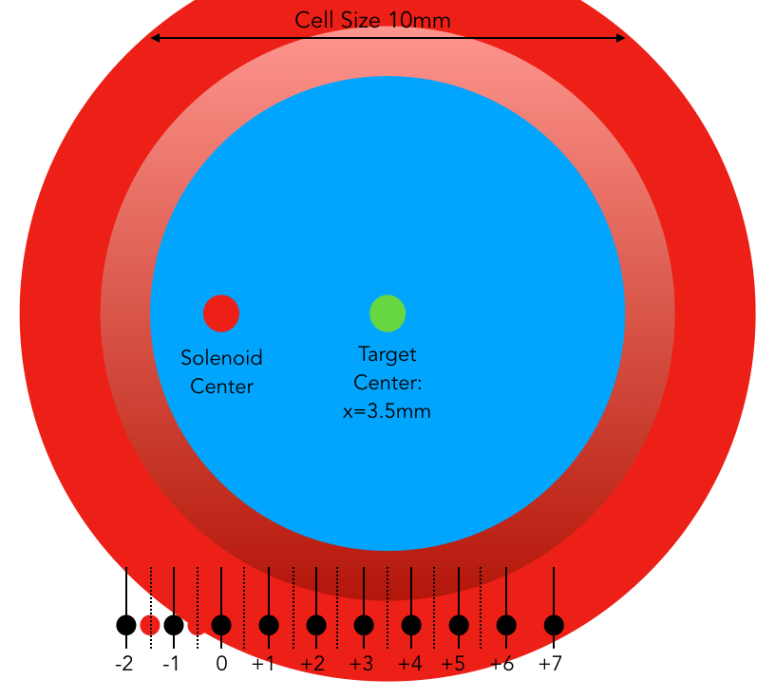

*Figure 5: the target center is shifted from the solenoid ideal center x=0 to x=3.5mm. The simulation was run in 18 different configurations of the beam X position: from x = -2mm to x = 7mm. The circles color represent radii of various elements as follows. Blue: the target cell, 10 mm in diameter. Shaded red: the torlon tube end cup, 2 mm thick in the z directions, from r = 5 mm to r = 6.06 mm. Red: 63.7 mm long torlon tube wall. See the details in Figure 3. Simulations were tried at z = -2.5 mm and z = -3 mm but failed because of the high number of secondaries due to interactions of the beam with the torlon tube (red part).*

**Results for FT On configuration**

In Figure 6 the DC occupancies as a function of CLAS12 sectors for four x beam positions are shown. At x=0 the occupancies are similar to previous studies where the target was not shifted from center [4]. Due to the target shift however moving the beam along the x axis is not symmetrical around x = 0: this is due to the torlon tube and the cell walls, see Figures 2, 3 and 4. In Figure 7 the vertex of the particles hitting region 1 is shown for the same four x beam positions.

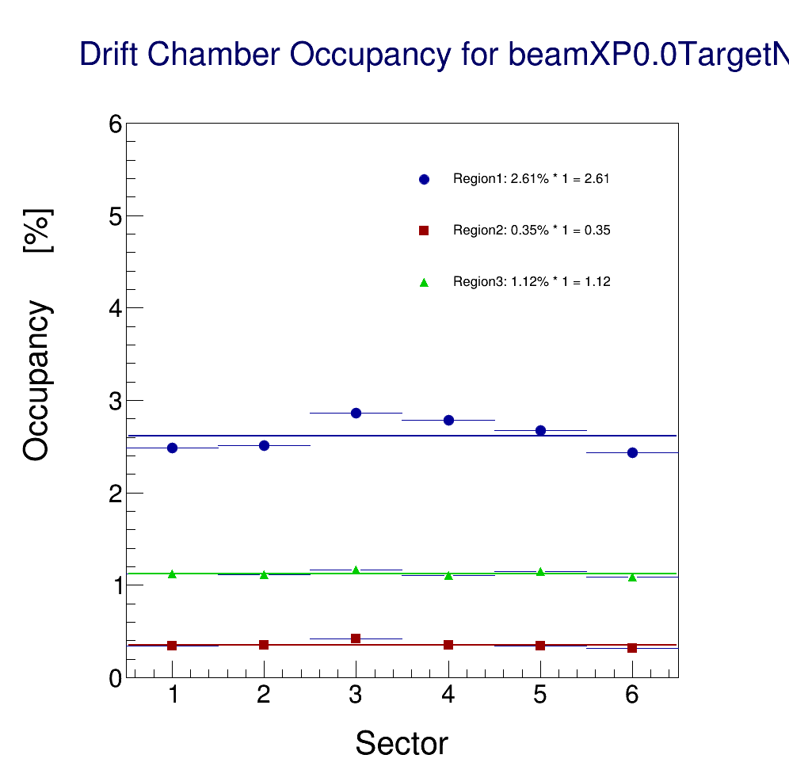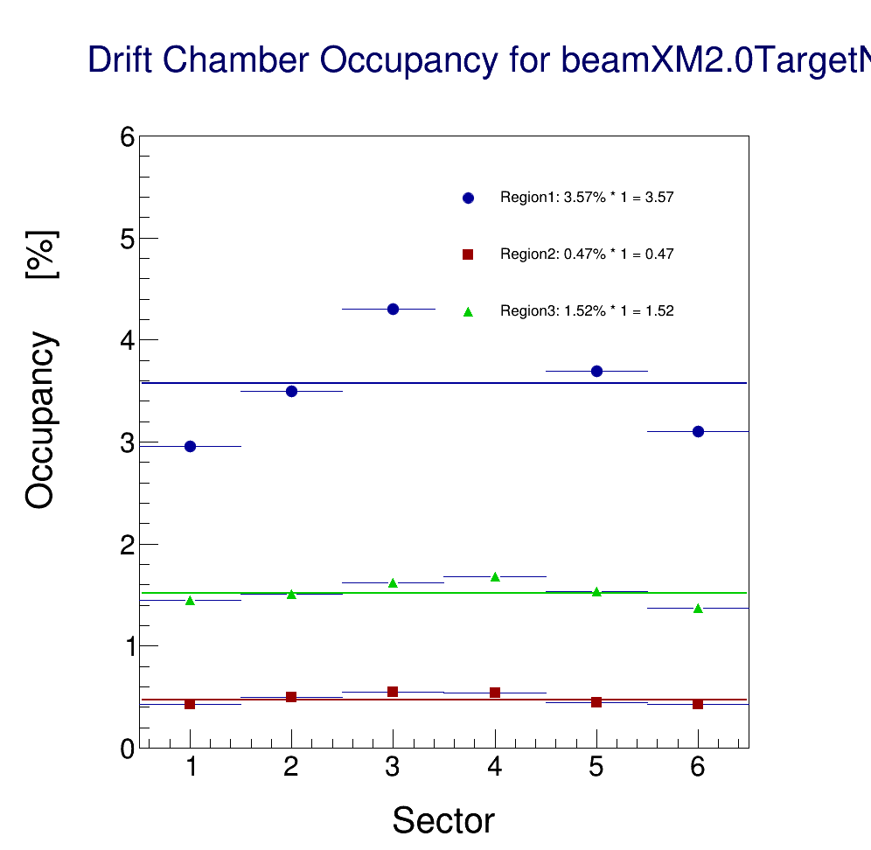

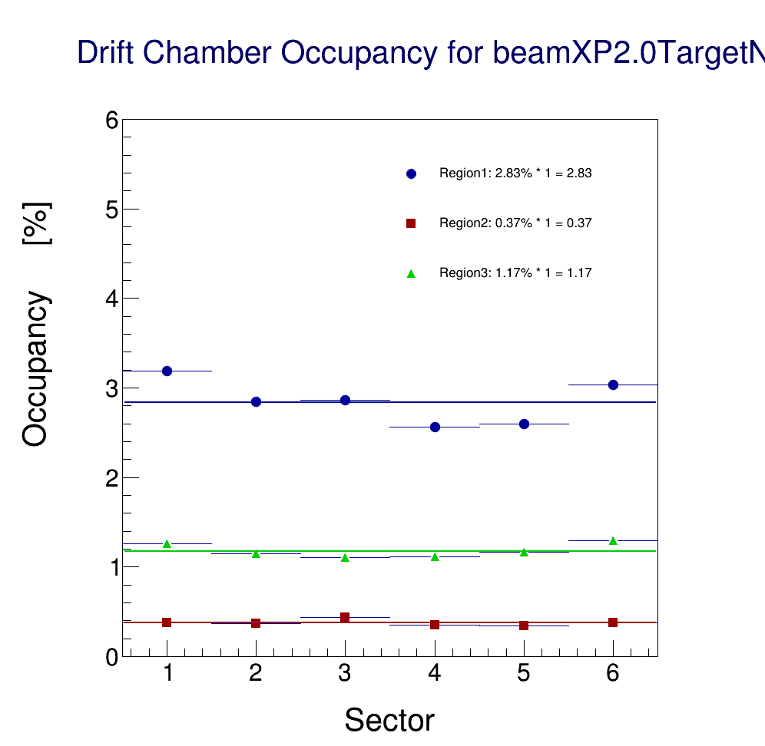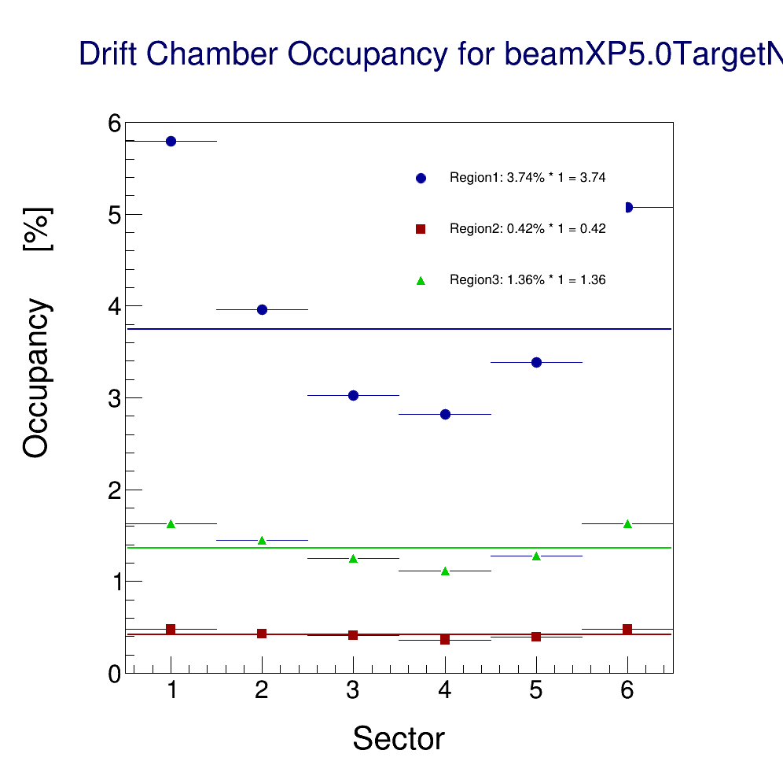

*Figure 6: DC Occupancies for different beam x positions, FT On configuration. Top left: x = 0 (solenoid center). Top right: x = -2 mm: the beam hits the target kapton end-cup and torlon tube, and in addition the Moeller electrons scrap the Moeller shield. The sector 4 point, hidden by the labels, has a value similar to sector 3. The rates are lower for sectors 1 and 6. Bottom left: x = +2 mm. The beam is near the middle of the target, so it doesn’t hit the end-cup or the walls, but the Moeller electrons scrap the Moeller shield. Bottom right: x = +5 mm. More Moeller electrons scrap the Moeller shield. The rates are significantly higher near sector 1 and 6.*

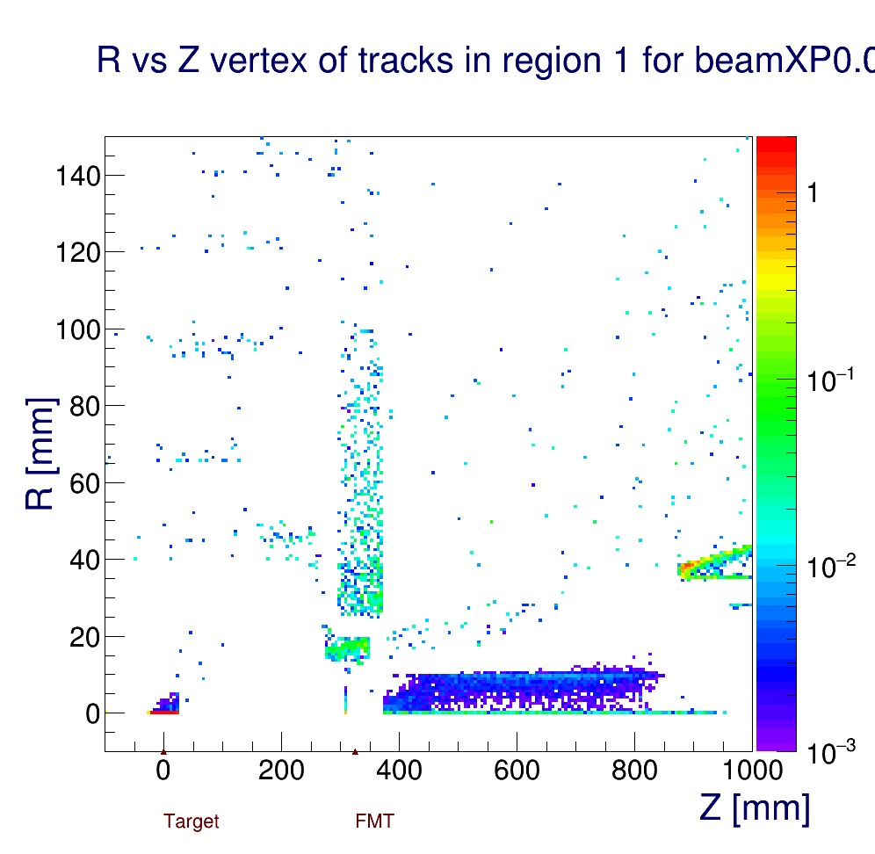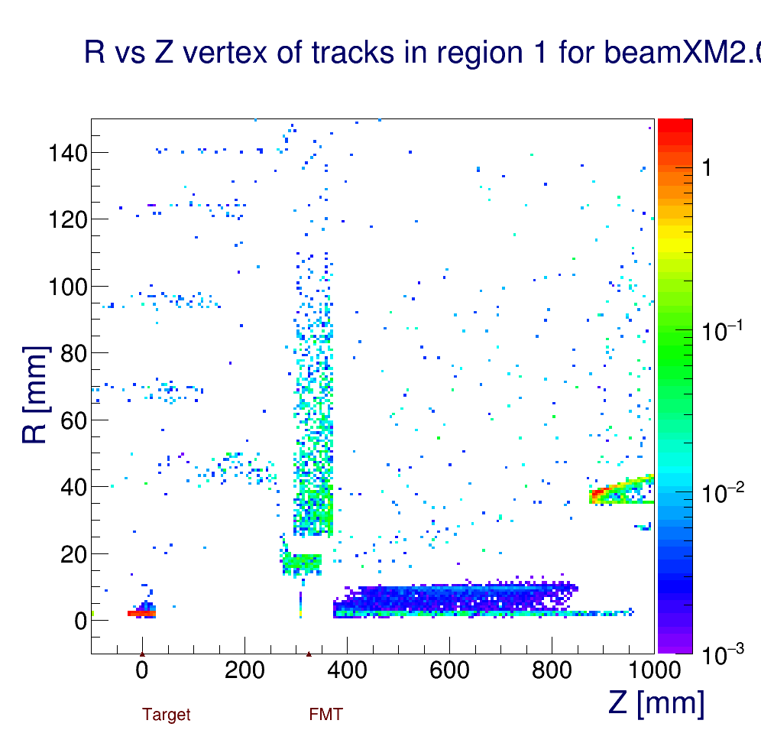

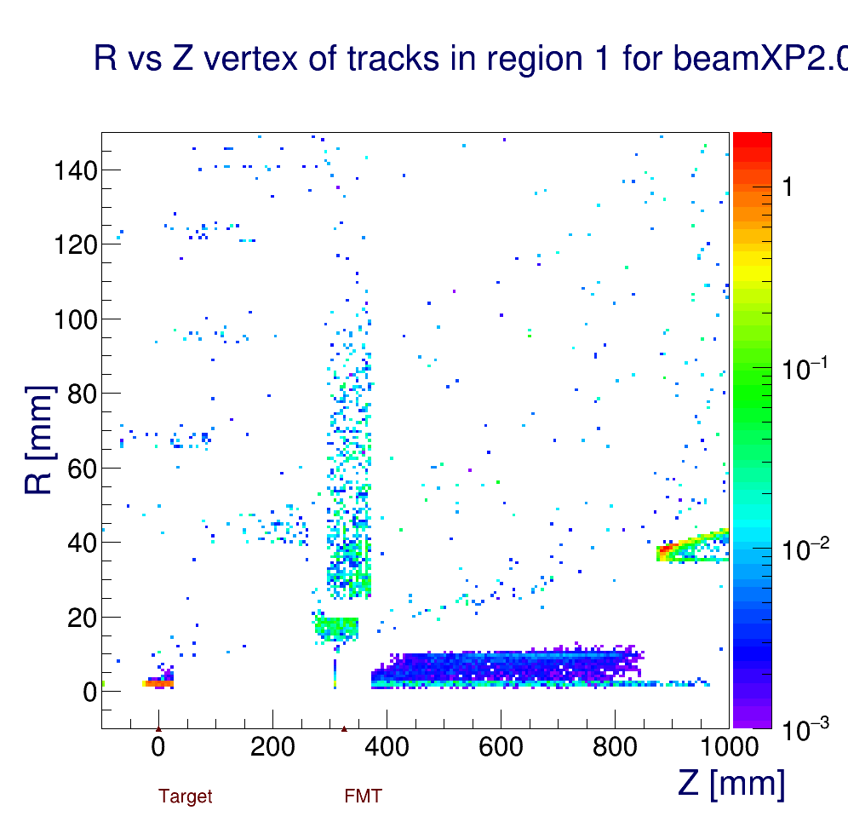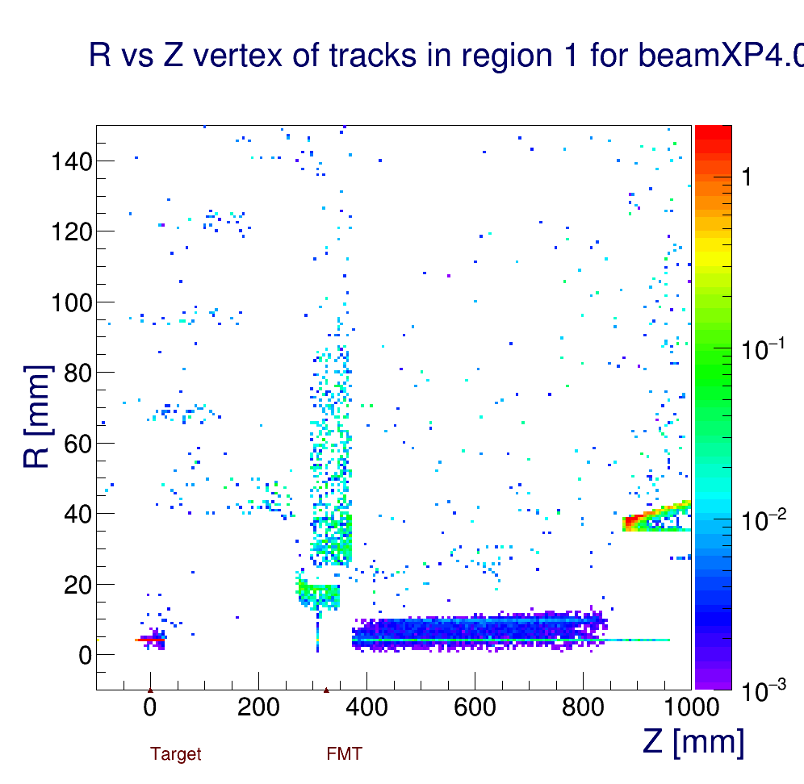

*Figure 7: The vertex of origin of particles hitting DC Region 1, FT On configuration. Top left: x = 0 (solenoid center). Top right: x = -2 mm: the beam hits the target kapton end-cup and the cell walls, and in addition the Moeller electrons scrap the Moeller shield. Bottom left: x = +2 mm. The beam is near the middle of the target, so it doesn’t hit the end-cup or the walls, but the Moeller electrons scrap the Moeller shield. Bottom right: x = +5 mm. More Moeller electrons scrap the Moeller shield. The rates are significantly higher near sector 1 and 6.*

One event at 1/50 of luminosity is detailed in Figures 8 and 9.

Notice that simulations were tried at z = -2.5 mm and z = -3 mm but failed because of the high number of secondaries due to interactions of the beam with the torlon tube (red part) in Figure 5.

The results for all beam positions for the FT On configurations are summarized in Table 1.

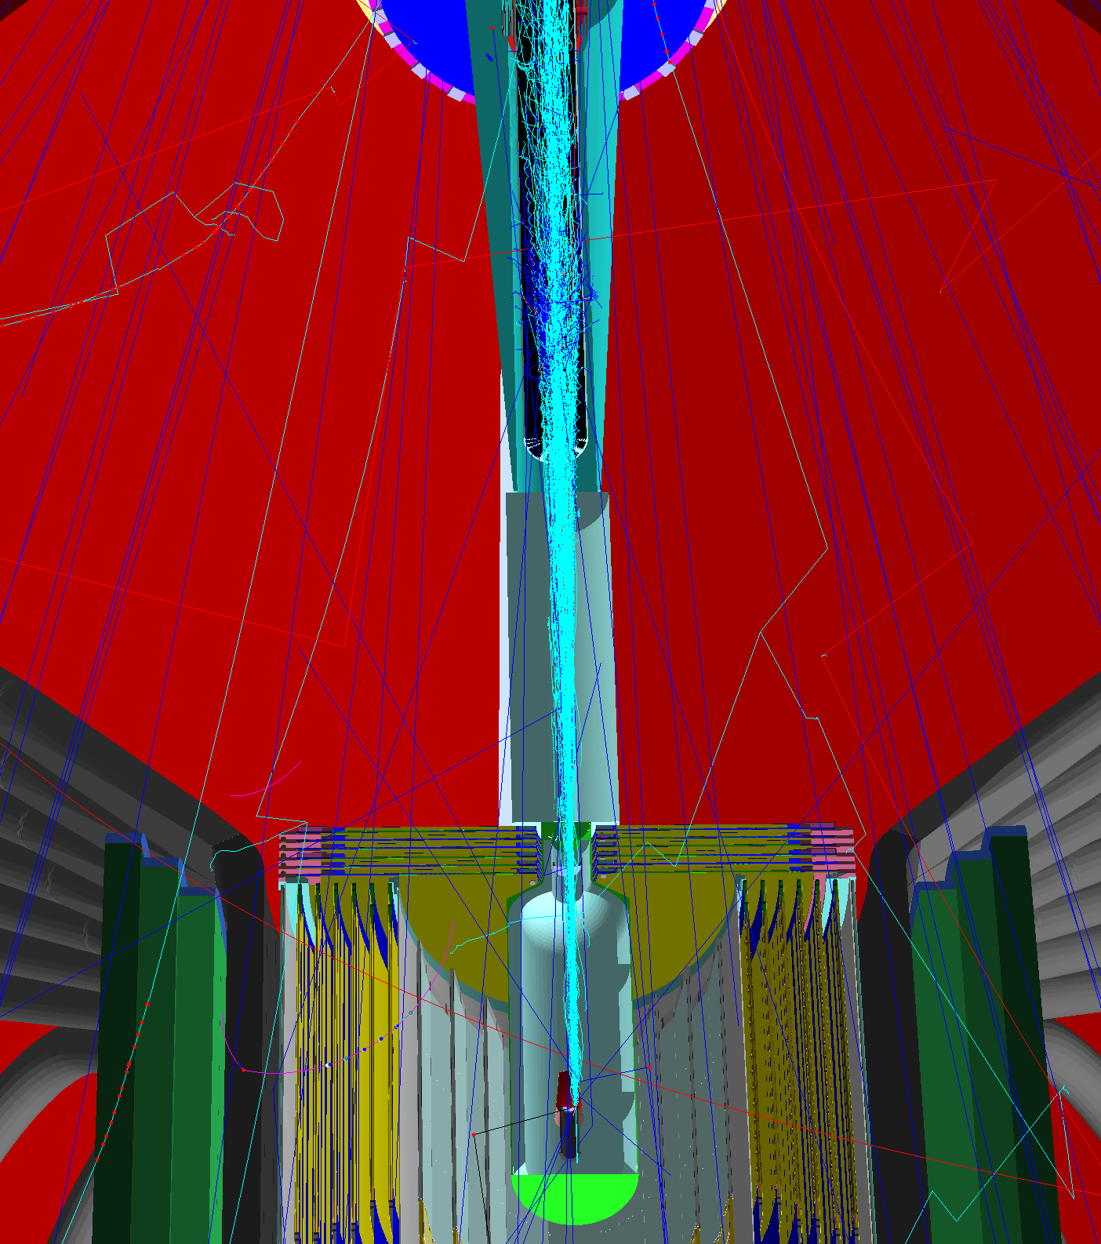

*Figure 8: A top view (XZ plane slice) of one event at 1/50 luminosity. The beam is going from the bottom to the top of the figure. The target shift is noticeable. The beam is placed at x = -2 mm (opposite direction of the target shift). The beam can be seen to hit the cell walls.*

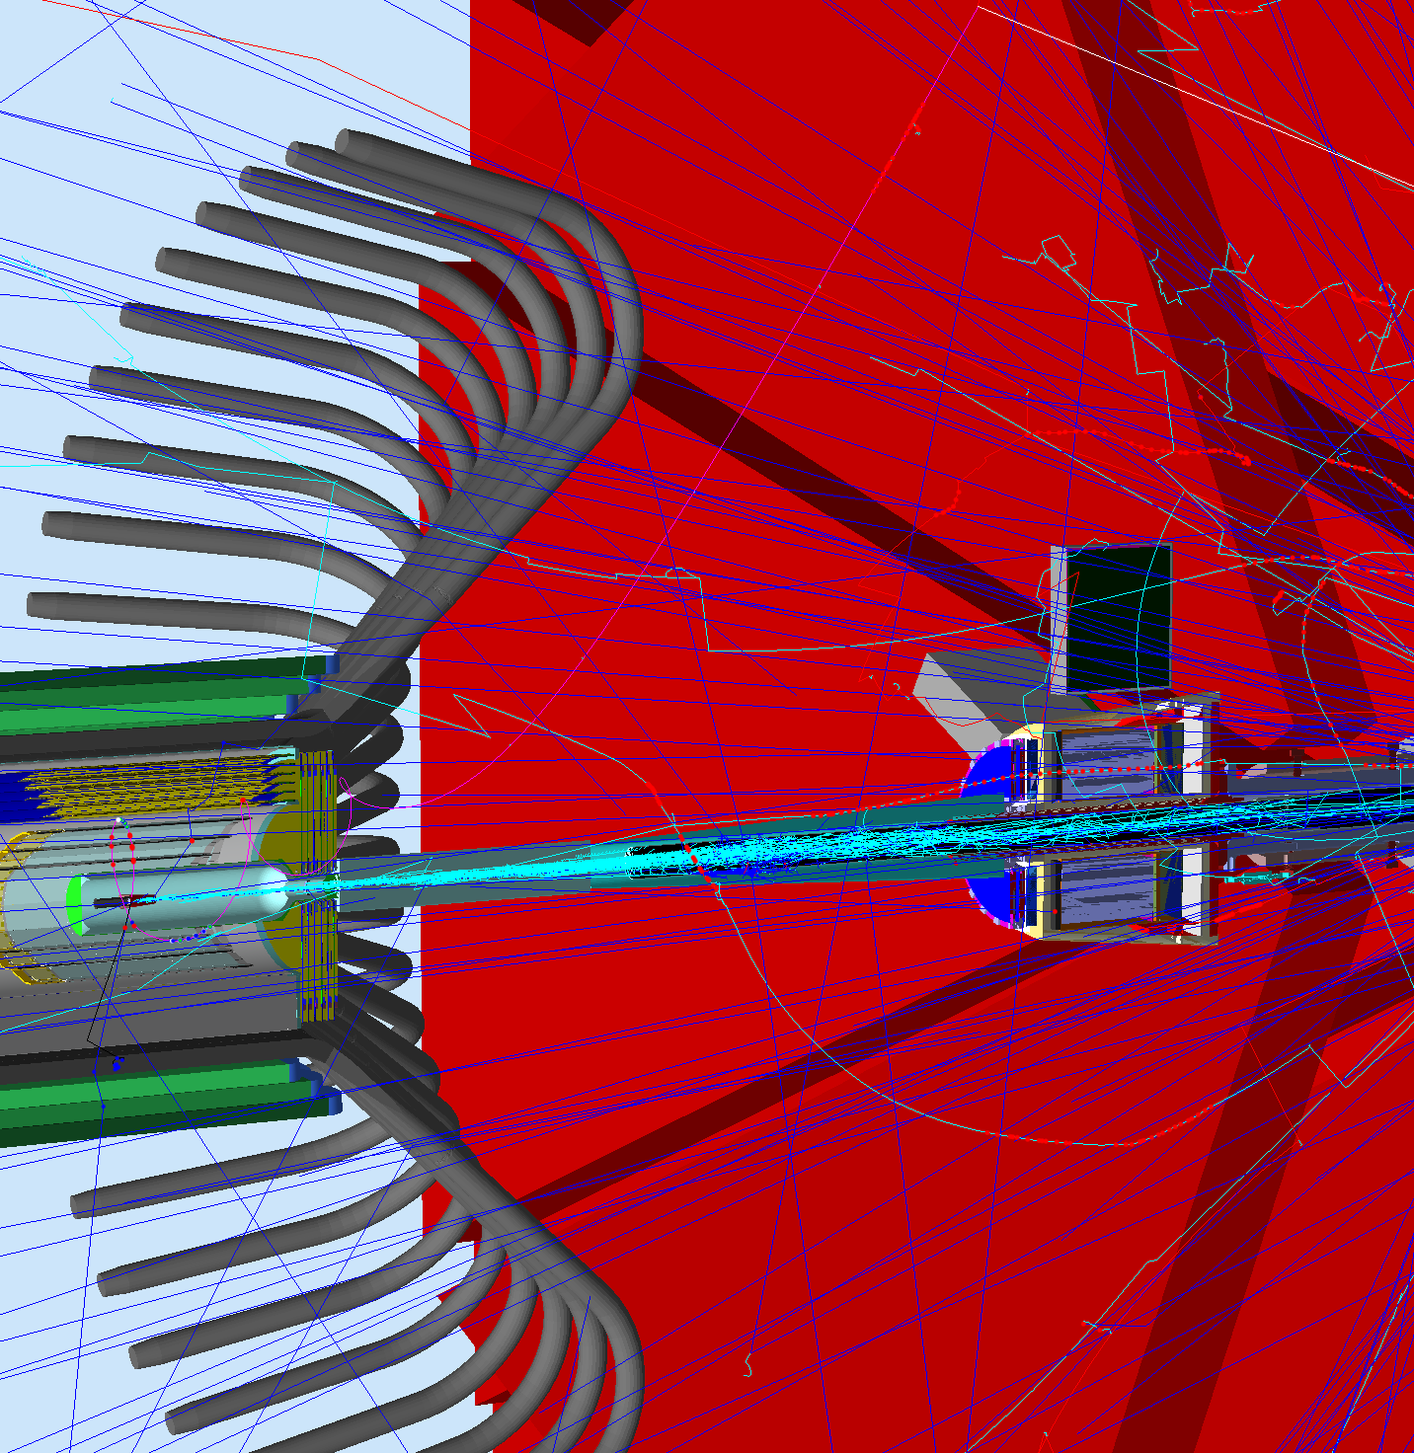

*Figure 9: A side view (YZ plane slice) of the same event of Figure 7. The beam is going from the left to the right.*

|  |  |  |  |
| --- | --- | --- | --- |
|  | R1 | R2 | R3 |
| -2 | 3.57 | 0.47 | 1.52 |
| -1.5 | 3.06 | 0.4 | 1.29 |
| -1 | 2.64 | 0.37 | 1.13 |
| -0.5 | 2.6 | 0.35 | 1.11 |
| 0 | 2.61 | 0.35 | 1.12 |
| 0.5 | 2.62 | 0.34 | 1.12 |
| 1 | 2.66 | 0.36 | 1.12 |
| 1.5 | 2.71 | 0.36 | 1.17 |
| 2 | 2.83 | 0.37 | 1.17 |
| 2.5 | 2.88 | 0.37 | 1.18 |
| 3 | 3.02 | 0.39 | 1.22 |
| 3.5 | 3.23 | 0.4 | 1.23 |
| 4 | 3.31 | 0.41 | 1.29 |
| 4.5 | 3.56 | 0.4 | 1.34 |
| 5 | 3.74 | 0.42 | 1.36 |
| 5.5 | 4.12 | 0.45 | 1.43 |
| 6 | 4.34 | 0.44 | 1.53 |
| 7 | 4.88 | 0.48 | 1.59 |

*Table 1: Occupancies in the 3 regions as a function of the beam x position for the FT On configuration.*

**Results for FT Off configuration**

In Figure 10 the DC occupancies as a function of CLAS12 sectors for four x beam positions are shown. For FT Off the rates are lower at all values of beam x position, however the simulations still fail at x = -2.5 and -3.0, indicating that the torlon tube wall is still a critical problem. At x=0 the occupancies are similar to previous studies where the target was not shifted from center [4].

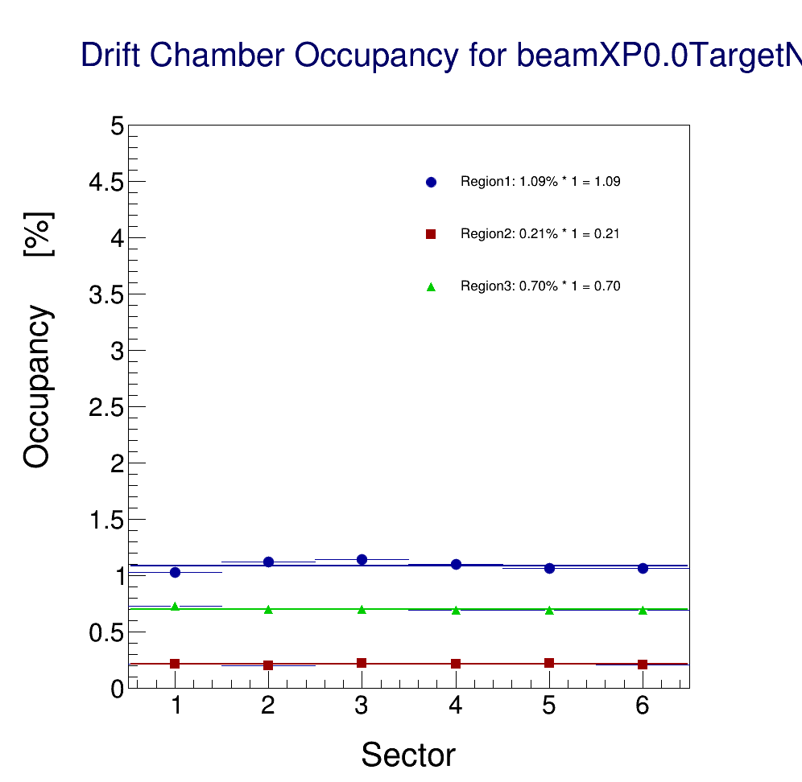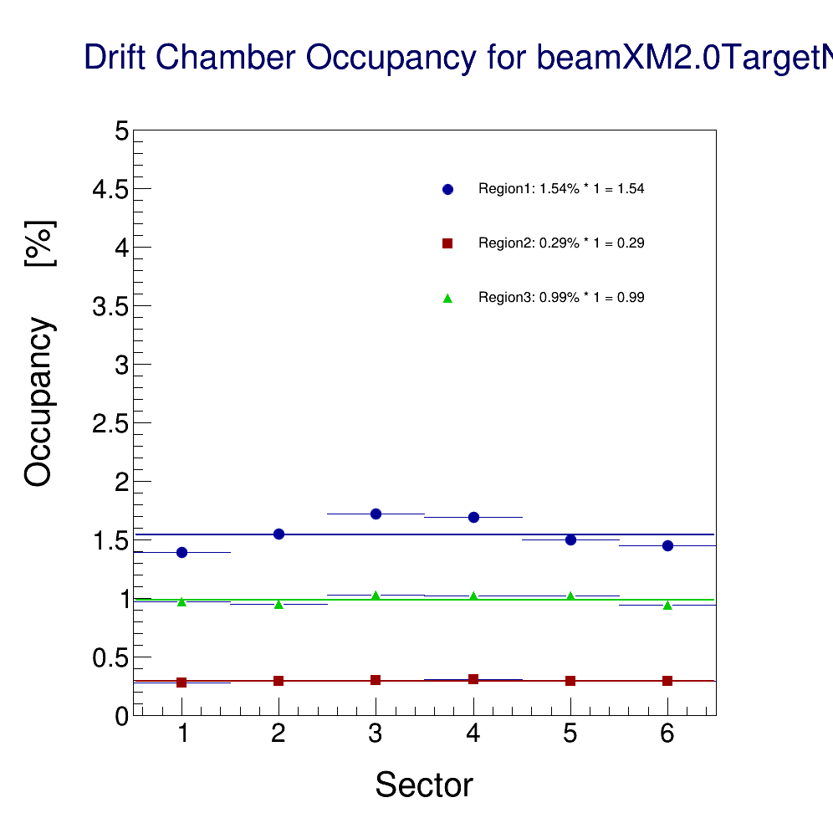

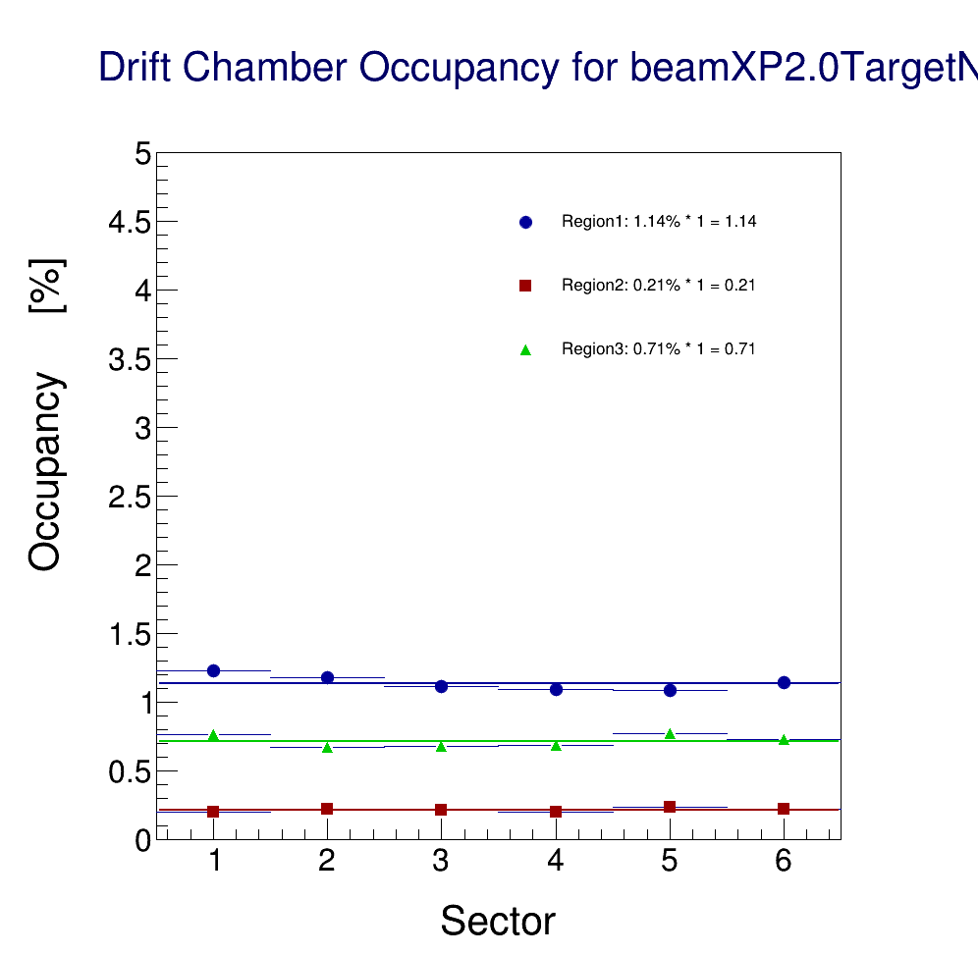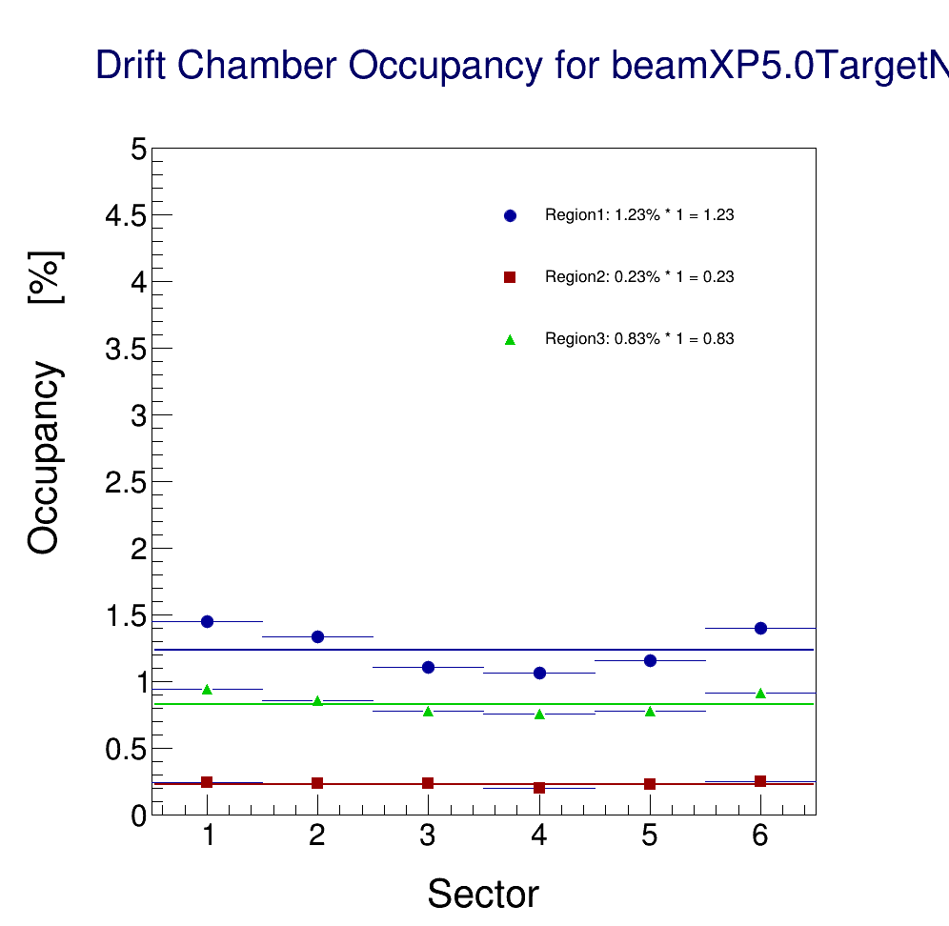

*Figure 10: DC Occupancies for different beam x positions, FT Off configuration. The occupancies are lower across all x beam positions. Top left: x = 0 (solenoid center). Top right: x = -2 mm: the beam hits the target kapton end-cup and the cell walls but do not scrap the Moeller shield, as it is much closer to the target. Bottom left: x=2 mm. The beam is near the middle of the target. Bottom right: some Moeller electrons start to scrap the Moeller shield. The rates are higher near sector 1 and 6.*

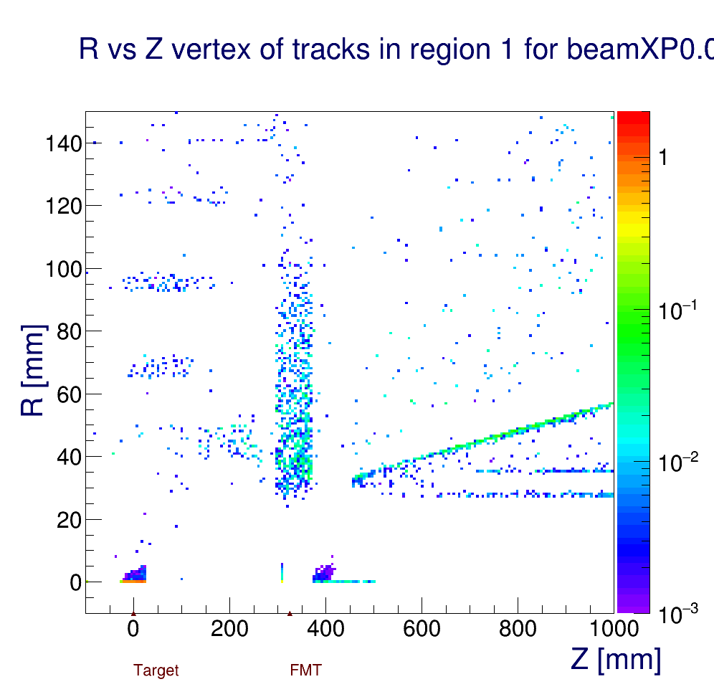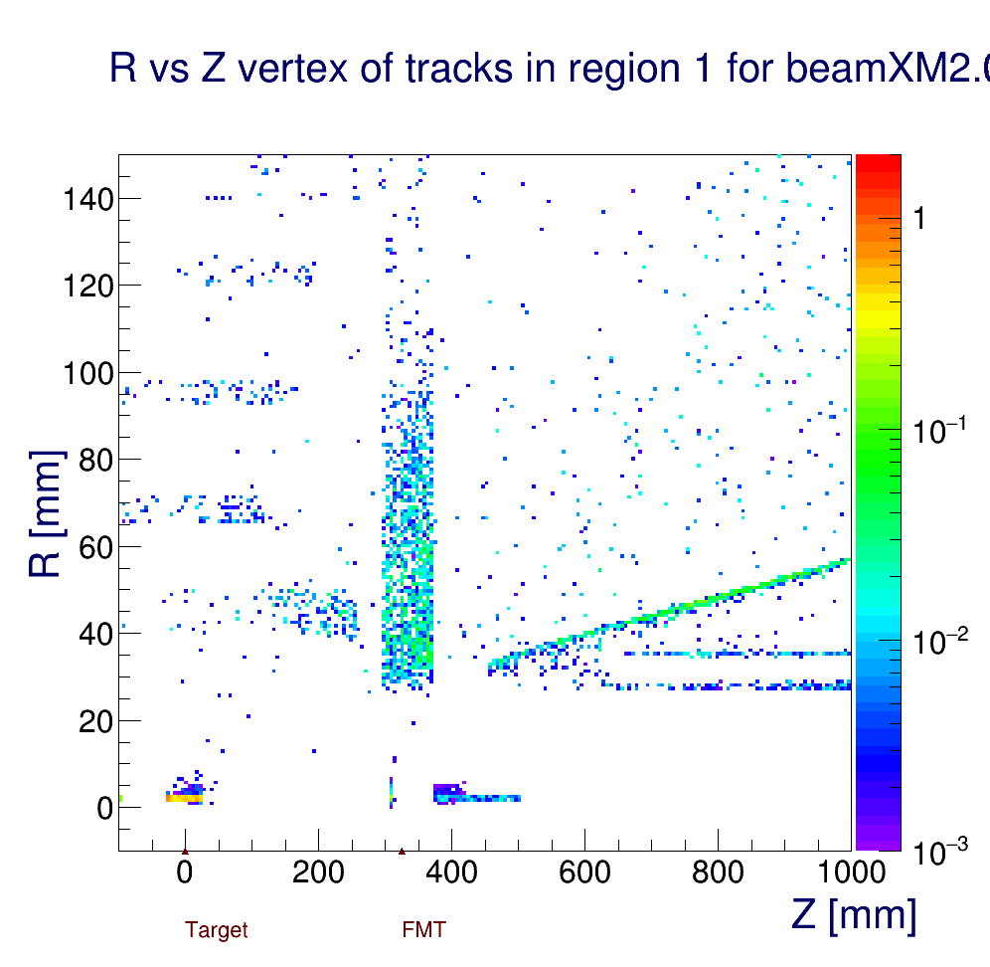

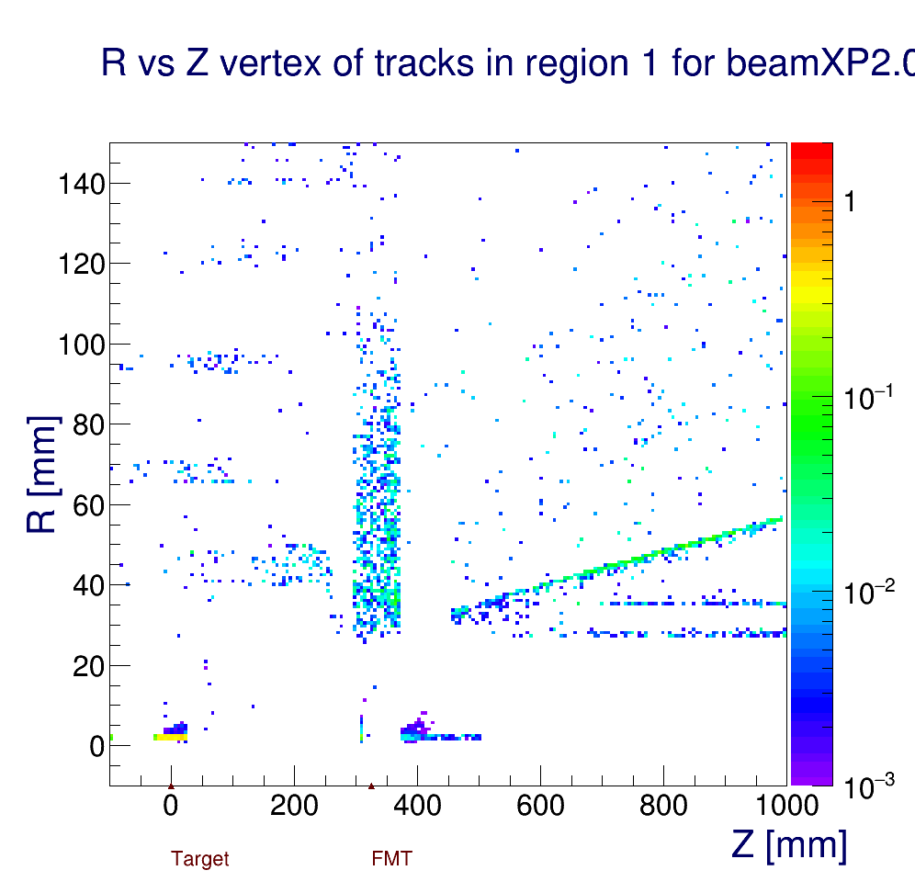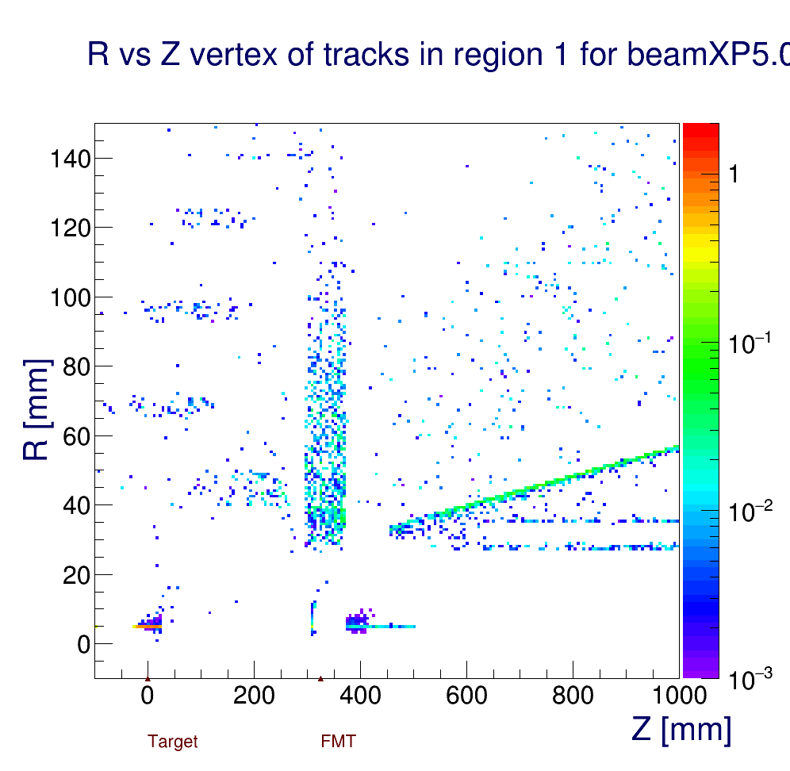

*Figure 11: The vertex of origin of particles hitting DC Region 1, FT Off configuration. The occupancies are lower across all x beam positions. Top left: x = 0 (solenoid center). Top right: x = -2 mm: the beam hits the target kapton end-cup and the cell walls but do not scrap the Moeller shield, as it is much closer to the target. Bottom left: x=2 mm. The beam is near the middle of the target. Bottom right: some Moeller electrons start to scrap the Moeller shield. The rates are higher near sector 1 and 6.*

The results for all beam positions for the FT Off are summarized in Table 2.

The complete set of rates for both FT On and FT Off configurations are shown in Figure 12 and 13 respectively.

|  |  |  |  |
| --- | --- | --- | --- |
|  | R1 | R2 | R3 |
| -2 | 1.54 | 0.29 | 0.99 |
| -1.5 | 1.32 | 0.24 | 0.84 |
| -1 | 1.11 | 0.22 | 0.69 |
| -0.5 | 1.1 | 0.22 | 0.7 |
| 0 | 1.09 | 0.21 | 0.7 |
| 0.5 | 1.11 | 0.22 | 0.71 |
| 1 | 1.12 | 0.22 | 0.72 |
| 1.5 | 1.15 | 0.22 | 0.71 |
| 2 | 1.14 | 0.21 | 0.71 |
| 2.5 | 1.15 | 0.22 | 0.71 |
| 3 | 1.13 | 0.22 | 0.73 |
| 3.5 | 1.19 | 0.23 | 0.74 |
| 4 | 1.19 | 0.22 | 0.77 |
| 4.5 | 1.24 | 0.22 | 0.77 |
| 5 | 1.23 | 0.23 | 0.83 |
| 5.5 | 1.23 | 0.23 | 0.83 |
| 6 | 1.28 | 0.23 | 0.87 |
| 7 | 1.36 | 0.25 | 0.94 |

*Table 2: Occupancies in the 3 regions as a function of the beam x position for the FT Off configuration.*

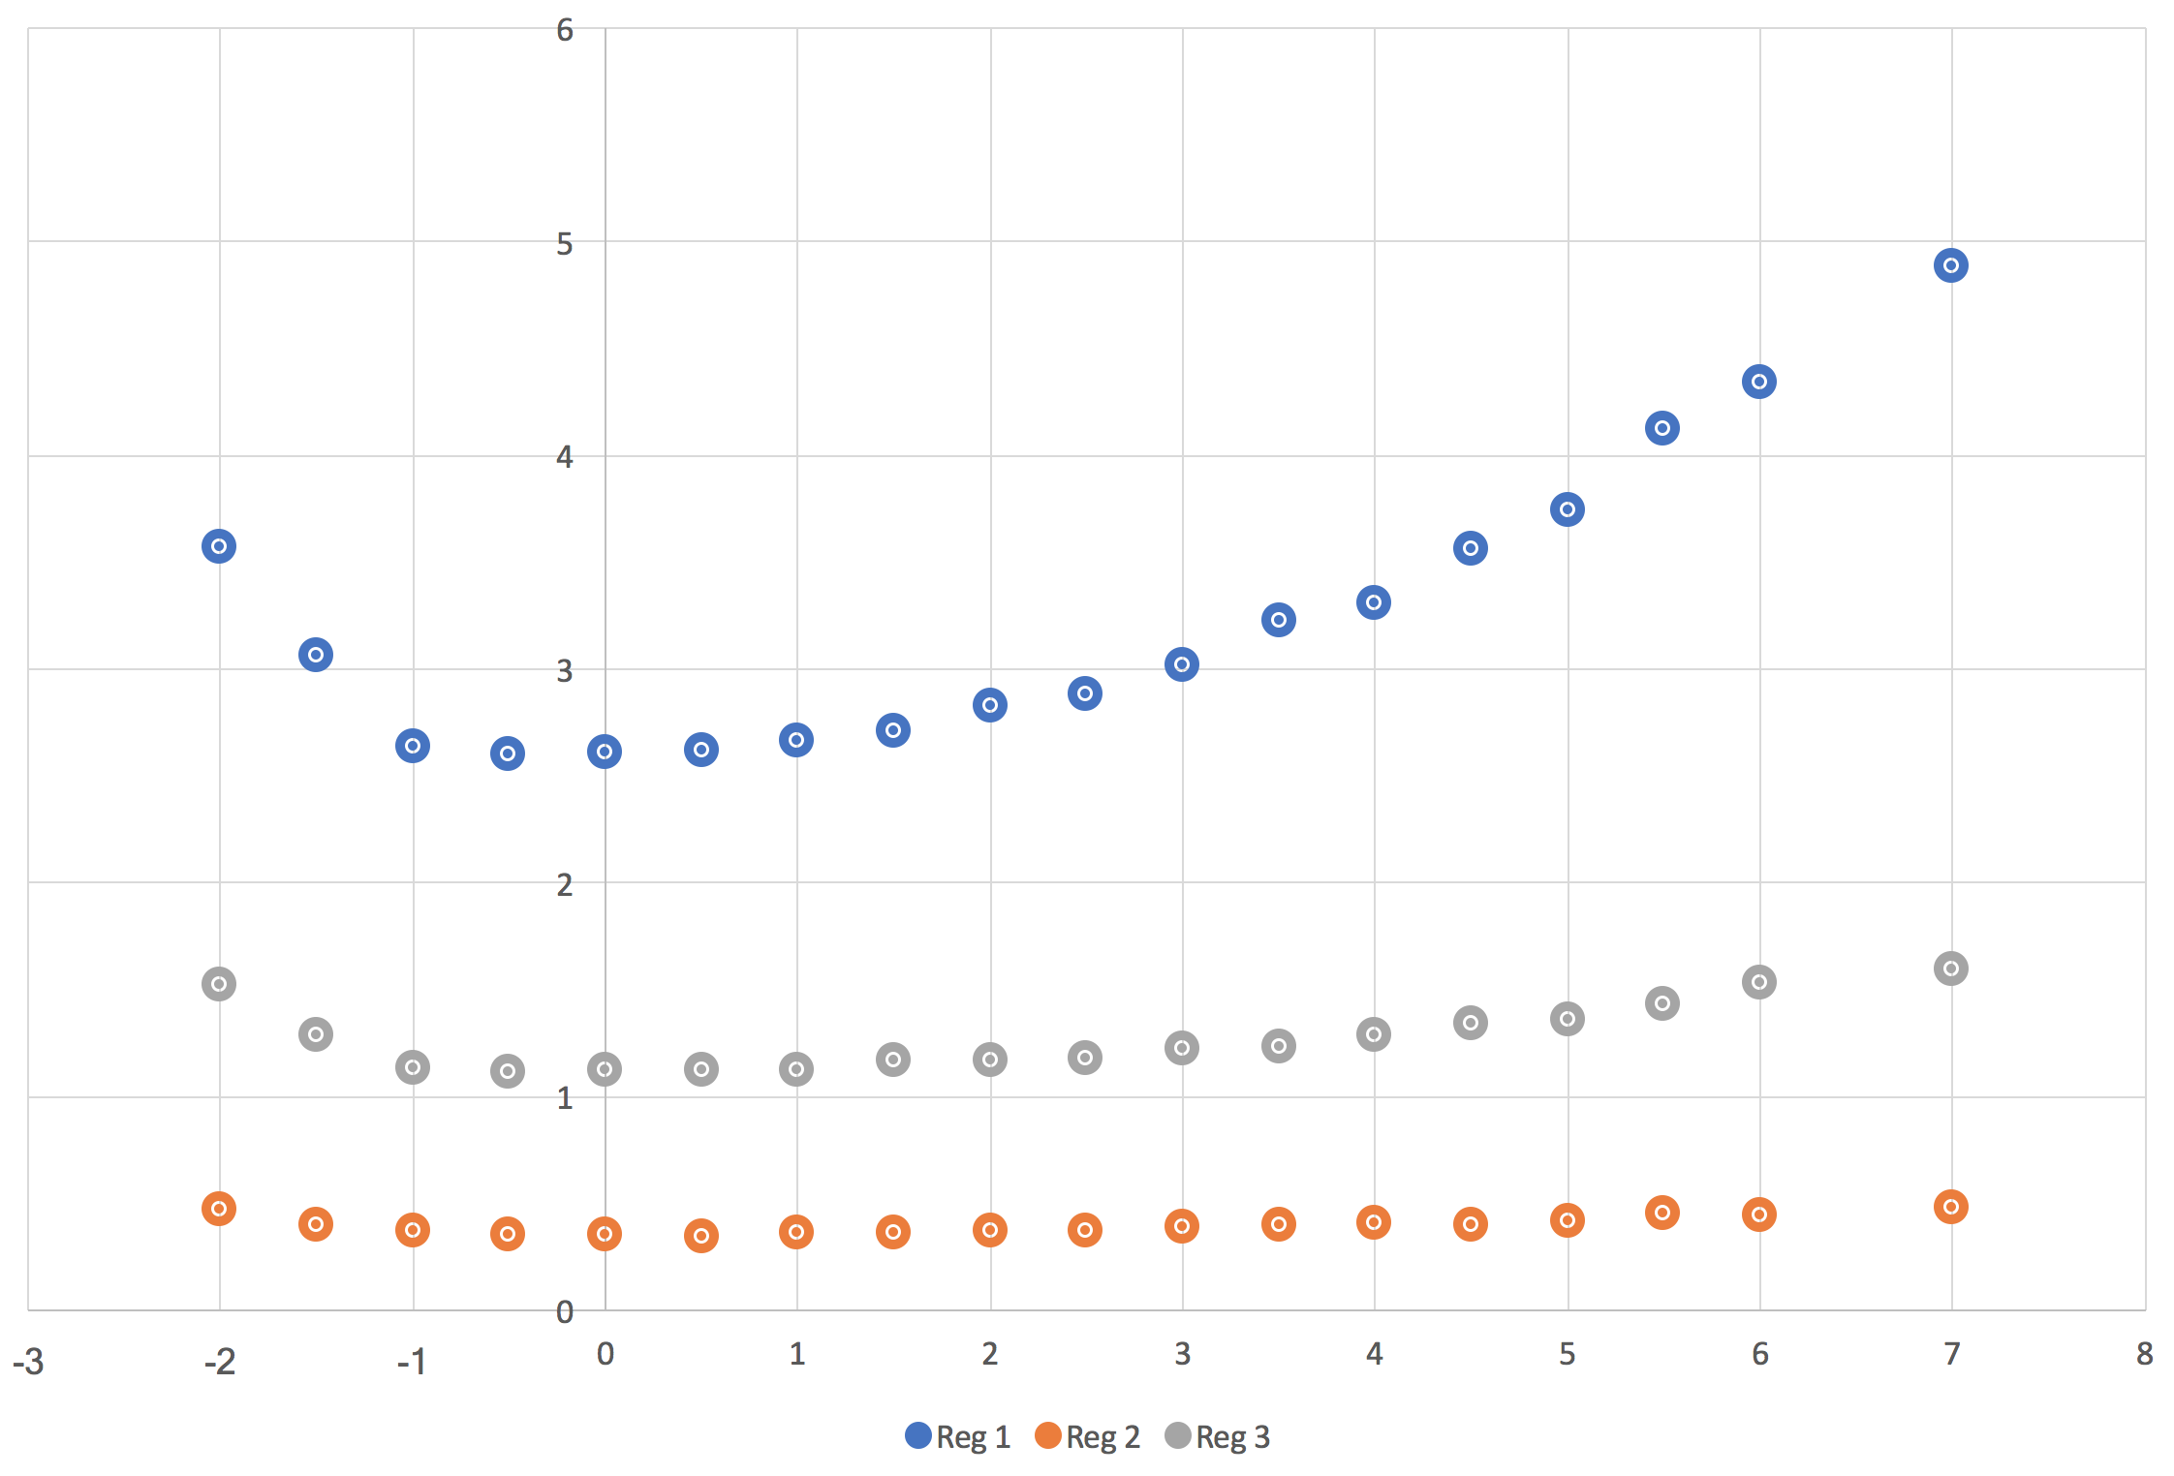

*Figure 12: The three DC regions average occupancies as a function of beam x position for the FT On configuration. Region 1 is the most sensitive to the beam coordinates. Since the target is shifted the distribution is not symmetric around 0 (solenoid center) or around the target center x = 3.5mm.*

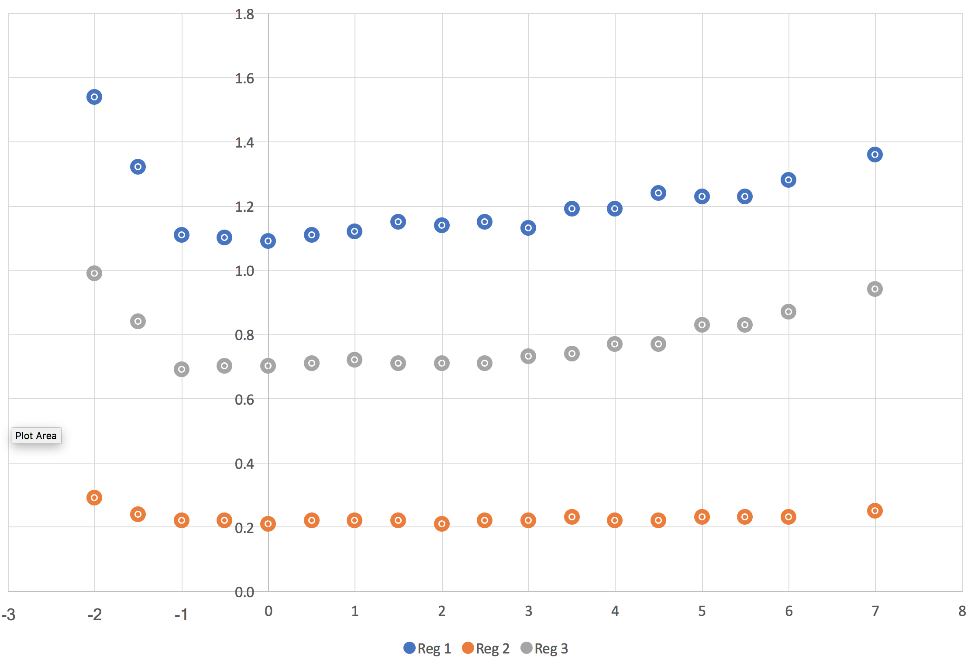

*Figure 13: The three DC regions average occupancies as a function of beam x position for the FT Off configuration. Region 1 is still the most sensitive to the beam coordinates but overall that dependency is mitigated for all regions. Since the target is shifted the distribution is not symmetric around 0 (solenoid center) or around the target center x = 3.5mm.*

**Conclusions**

The target offset relative to the solenoid center present challenges, especially for the FT On configuration, that have to be addressed during the CLAS12 engineering run. The position commissioning may be facilitated by comparing real data distributions to the results presented here.

**References**

*[1] R. De Vita and M. Ungaro,* ***CLAS12-note 2016-006****:* Moller shield simulations: comparison of the GEMC-optimized layout and the engineering design.

*[2] R. De Vita, L. Elouadrhiri, R. Miller, S. Stepanyan, M. Ungaro, C. Wiggins, M. Zarecky, A. Kim and J. A. Tan,* ***CLAS12-note 2017-012****:* Corrections to CLAS12 vacuum beamline

*[3] M. Ungaro,* ***CLAS12-note 2017-013****:* Corrections to CLAS12 target design.

*[4] R. De Vita, D. S. Carman, C. Smith, S. Stepanyan and M. Ungaro,* ***CLAS12-note 2017-016****:* Study of the electromagnetic background rates in CLAS12.

*[5]* *R. De Vita and M. Ungaro,* ***CLAS12-note 2017-017****:* Importing CLAS12 CAD models of target and beamline in the GEMC simulation.