Corrections to CLAS12 target design

M. Ungaro

*Jefferson Lab, 12000 Jefferson Avenue, 23606 Newport News, VA, USA*

**Abstract**

Simulations of beam-related background were performed that include the CAD model of the CLAS12 target. It was found that the target vacuum extension produced 60% more background in the region 1 of the drift chambers. A new configuration without the extension was simulated and resulted in acceptable rates.

**Simulated Detectors, Beam Configuration**

This simulation study is based on the CLAS12 standard configuration. The Moller shield configuration was the standard one to be used with the Forward Tagger. The Moller cone geometry corresponds to the final engineering design [1]. The shielding and vacuum beamline geometry were incorporated in geant4 directly from the engineering CAD models.

For each event, 132,000 electrons going through the target within a 250ns time window were simulated. This corresponds to the full CLAS12 1035 cm-2s-1 luminosity.

**CLAS12 Target design**

The target design was imported in the simulation from the engineering CAD model. This included the scattering chambers, base torlon, the kapton and aluminum target cell, torlon and aluminum vacuum endcup and a 1.6mm thick carbon tube extension to prolong the vacuum to the next vacuum line inside the tungsten shielding. See Figures 1 to 3.

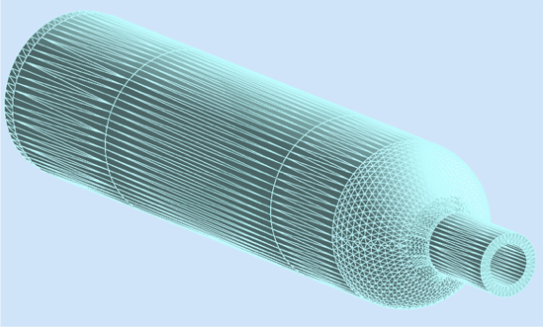

*Figure 1: The CLAS12 rohacell scattering chamber CAD import in the gemc geant4 simulation.*

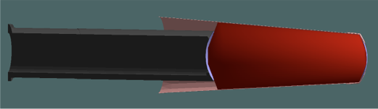

*Figure 2: Cad import of the cell: the base torlon (black tube) and the target cell (red). The cell sidewalls material is kapton. The upstream and downstream windows are 30 microns thick aluminum.*

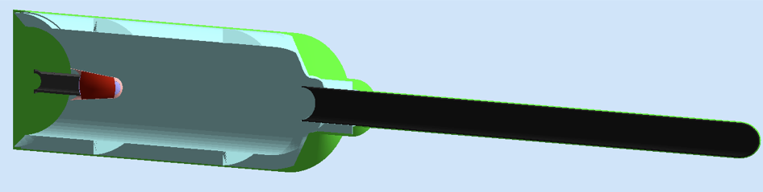

 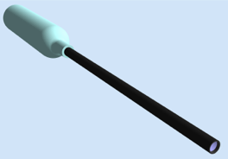

*Figure 3 top: a sliced view of the target. Bottom left: the endcup with a 50 micron spherical shaped aluminum window. Bottom right: a complete view of the target design that includes the 1.6mm thick carbon vacuum extension.*

**Simulation Results**

Simulations were performed with GEMC 2.5 and geant4 4.10.02.p02. The standard geant4 electromagnetic physics list was used. The hadronic physics list was FTFP_BERT. The optical processes were included.

The results are compared with the original simplistic 5cm liquid hydrogen target, that included a cylindrical scattering chamber and 30 microns flat aluminum windows.

The occupancies are shown in Figure 4. The vertex of particles hitting region 1 are shown in Figure 5.

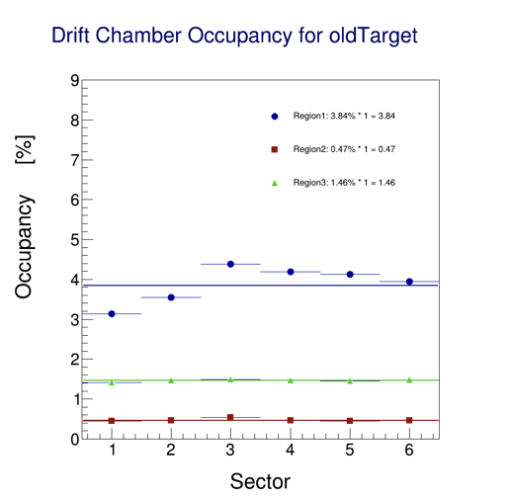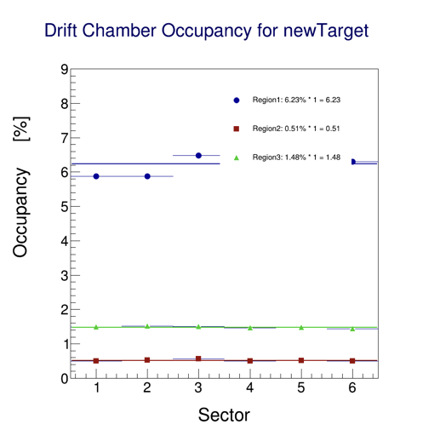

*Figure 4: occupancies. Left: the simplistic 5cm cylindrical liquid hydrogen target, with 30 microns aluminum window produced an average occupancy of 3.84%. Right: the CAD import of the full designed target produced an average occupancy of 6.23%. The sector-dependency is due to an imperfection in a shield volume that was later corrected and aligned the averages to the sector 1 value, 3.2% and 5.9% respectively.*

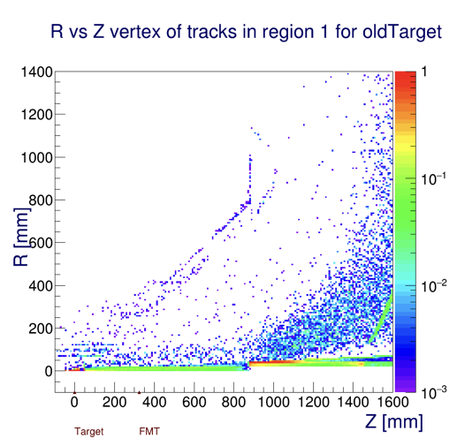 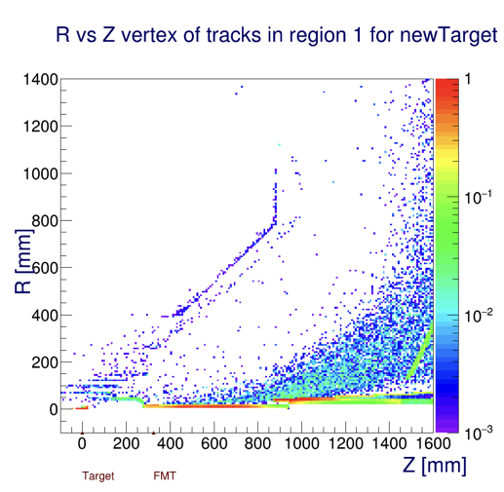

*Figure 5: originating vertex of particles hitting DC region 1. The vertical scale is rates (Hz). Left: the simplistic 5cm cylindrical liquid hydrogen target shows most rates coming from the target. The moeller sausage halo also scraps the tungsten cone. Right: the CAD import of the full designed target. The vacuum extension is a significant source of background.*

The CAD import produced about 60% more rates in drift chambers region 1, due to the beam hitting the vacuum extension, see Fig. 5.

**Changes to the design**

The vacuum extension has been removed, and the vacuum endcup placed in the middle of the scattering chamber, see Fig. 6.

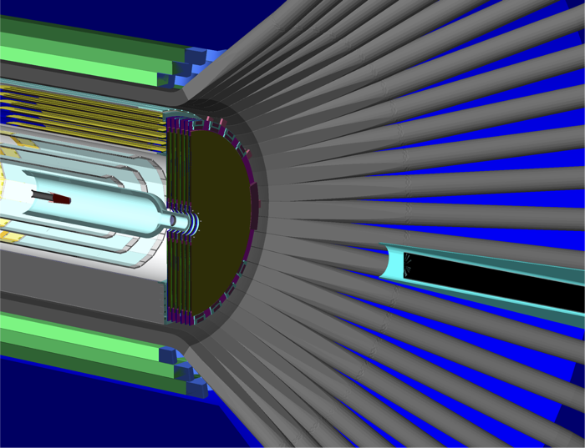

*Figure 6: the modified CLAS12 target in the central detector: the vacuum extension was removed, and the endcup placed near the exit of the scattering chamber.*

With the removal of the vacuum extension, three scenario were envision on the material between the target and the start of the beamline, see Figure 6 and 7:

1. Air
2. A helium bag
3. A bigger vacuum extension.

The presence of helium or vacuum reduced the occupancy from 3.8% average to 3.17% and 2.86% respectively, see Figure 8.

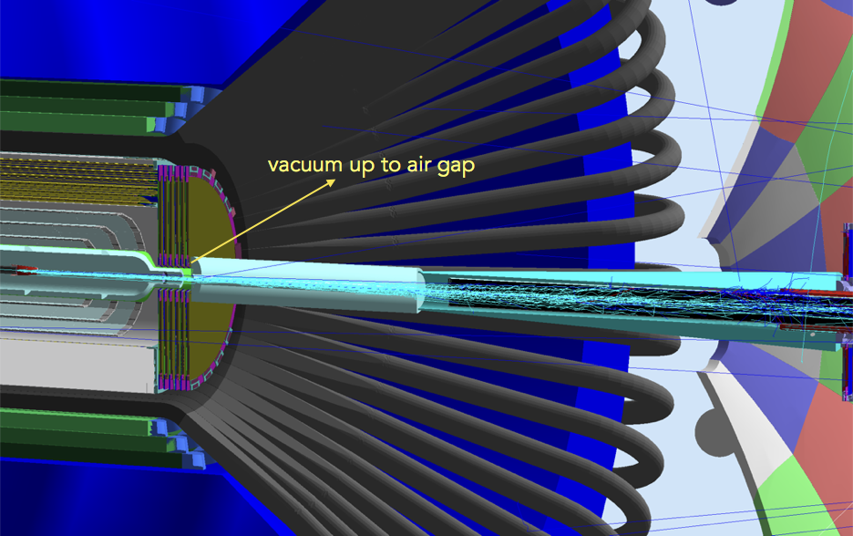

*Figure 7: a cylindrical extension between the target and the tungsten cone was simulated with three different material: air, helium and vacuum.*



*Figure 8: results of the modified clas12 target with three different materials between the target the tungsten cone. Air: 3.8%. Helium: 3.17%. Vacuum: 2.86%. The sector-dependency is due to an imperfection in a shield volume that was later corrected and aligned the averages to the sector 1 value.*

**Conclusions**

The vacuum extension of the CLAS12 target has been removed from the design due to production of background rates in Drift Chambers region 1.

Three different materials between the target and the tungsten cone were simulated, all yielding acceptable rates in the drift chambers. While helium and vacuum performed better, their engineering feasibility is uncertain.

**References**

R. De Vita and M. Ungaro, CLAS12-note 2016-006, Moller shield simulations: comparison of the GEMC-optimized layout and the engineering design.