Corrections to CLAS12 vacuum beamline

R. De Vita

*Istituto Nazionale di Fisica Nucleare, Genova, Via Dodecaneso 33, 16146 Italy*

L. Elouadrhiri, R. Miller, S. Stepanyan, M. Ungaro, C. Wiggins, M. Zarecky

*Jefferson Lab, 12000 Jefferson Avenue, 23606 Newport News, VA, USA*

1. Kim

*UCONN University of Connecticut, 2152 Hillside Road, Storrs, CT 06269-3046*

J. A. Tan

*KNU Kyungpook National University, 80 Daehakro, Daegu 41566 Korea*

**Abstract**

Simulations of beam-related background were performed for the designed CLAS12 vacuum beamline. It was found that the designed beamline inner radius was too small and produced large background in the drift chambers region 3. A new design resulted in acceptable background rates.

**Simulated Detector, Beam and Target Configuration**

The first simulation study was performed in July 2017, based on the CLAS12 standard configuration. The target consisted of 5 cm long liquid-hydrogen target (that includes its containment vessels and scattering chambers). The Moller cone geometry corresponded to the final engineering design [1]. The shielding geometry were incorporated in Geant4 directly from the engineering CAD models. The geometry contained the full CLAS12 detectors, including the solenoid and torus magnets. Simulations were performed for nominal (full) magnetic fields.

For each event, 132,000 electrons going through the target within a 250 ns time window were simulated. This corresponds to the full CLAS12 1035 cm-2s-1 luminosity.

More simulations where performed in August, September and October 2017 as a new design of the vacuum line was being finalized.

**Original vacuum beamline configuration and results.**

The vacuum line radii and thicknesses for various configurations are shown in Table 1. The “ideal” row refers to the physicist original design. The “CAD” row refers to the design included in the first simulation study that used beamline from CAD models, based on various communications with physicists and designers. The “actual” row refers to measurements of the built vacuum line.

The thicknesses and inner radius were designed using safety clearances to the torus hardware based on the CLAS12 beamline and vacuum lines installation plan. Furthermore, the lines were thicker than the ideal configuration. These two factors resulted in a much smaller inner radius than the ideal situation.

|  |  |  |  |  |  |  |
| --- | --- | --- | --- | --- | --- | --- |
|  | Upstream of Torus | | Inside Torus | | Downstream of Torus | |
|  | Thickness | IR | Thickness | IR | Thickness | IR |
| *Ideal* | 3.12 | 22.68 | 3.12 | 36.69 | 6 | 126 |
| *CAD* | 3.12 | 22.68 | 3.12 | 26.68 | 3.12 | 26.68 |
| *Actual* | 3.176 | 22.22 | 6.35 | 25.54 | 6.55 | 64.1 |

*Table 1: The vacuum line thicknesses and IRs of the original ideal vacuum line, the CAD version and the one that was actually built. Units are mm.*

The vacuum beamline was measured in July 2017 in Hall-B, see third column of Table 1. The inner radii were even smaller than the CAD version.

**First Simulation Results**

Simulations were performed with GEMC 2.5 and geant4 4.10.02.p02. The standard Geant4 electromagnetic physics list was used. The hadronic physics list was FTFP_BERT. The optical processes were included.

The small radii in the simulated version resulted in an overwhelming background in the drift chambers region 3 (51% average occupancy), see Fig. 1.

 

*Figure 1: The smaller radii in the CAD geometry (left) produced an average drift chamber region 3 occupancy of 51%, from 1.2% using the same configuration but ideal vacuum line (right).*

The vertex of the particles hitting region 3 is shown in Fig. 2 for the CAD and ideal configurations, showing that the smaller radius is the cause of the background rate increase in all the regions and especially region 1.

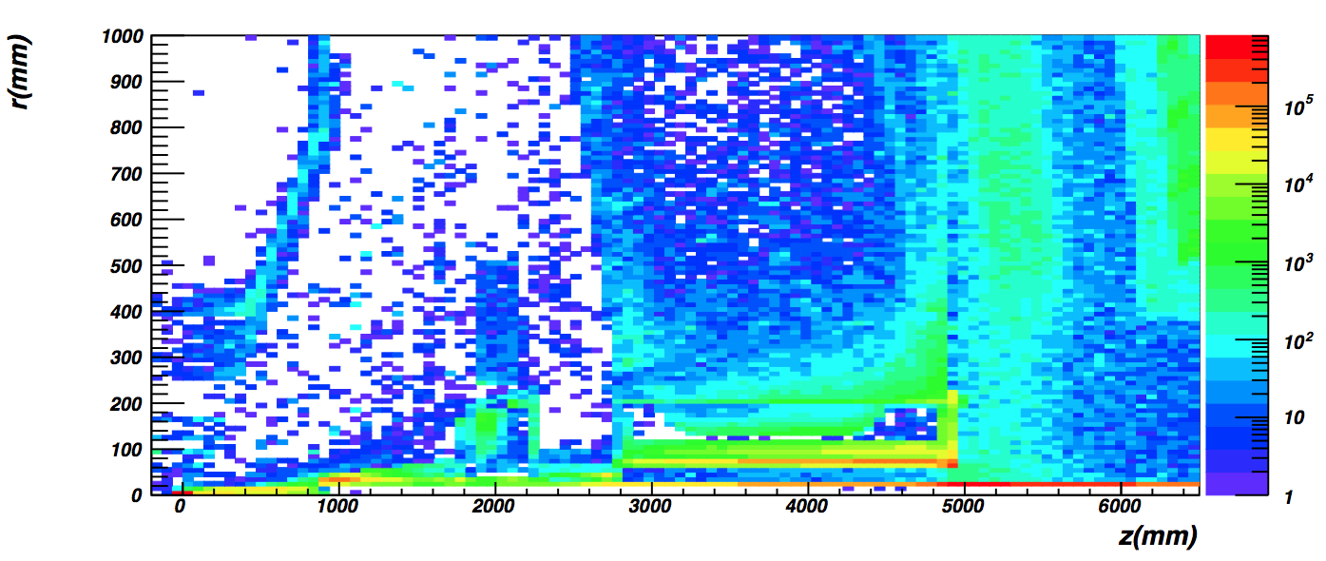

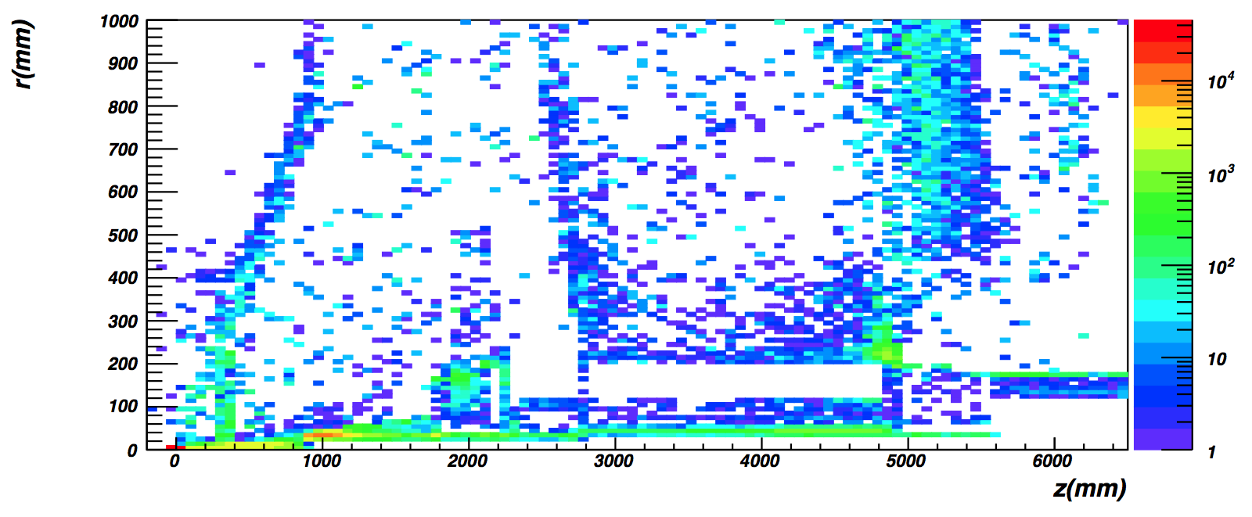

*Figure 2: Transverse versus longitudinal vertex of particles hitting region 3. Top: CAD configuration. Bottom: ideal configuration. The smaller vacuum line causes a dramatic rate increase in region 3.*

**A new design**

A team of physicists and engineers designed a new version of the vacuum line that aimed at enlarging the inner radii as much as possible while maintaining the safety clearances necessary for the CLAS12 installations and operations of the beamline, torus, various shielding. The material chosen was stainless steel.

The new vacuum line radius increases in three steps along the beamline, see Figures 3 to 5. An additional shielding was designed downstream of the torus to reduce a “hot spot” of Moeller electrons originating just before the torus downstream endplate.

Table 2. shows the radii and thicknesses of the new design.

|  |  |  |  |  |  |
| --- | --- | --- | --- | --- | --- |
| Upstream of Torus | | Inside Torus Mount / Torus | | Downstream of Torus | |
| Thickness | IR | Thickness | IR | Thickness | IR |
| 1.6 | 26.9 | 1.6 | 33.3 | 3.2 | 60.3 |

*Table 2: The vacuum line thicknesses and IRs of the new designed vacuum line. Units are mm.*

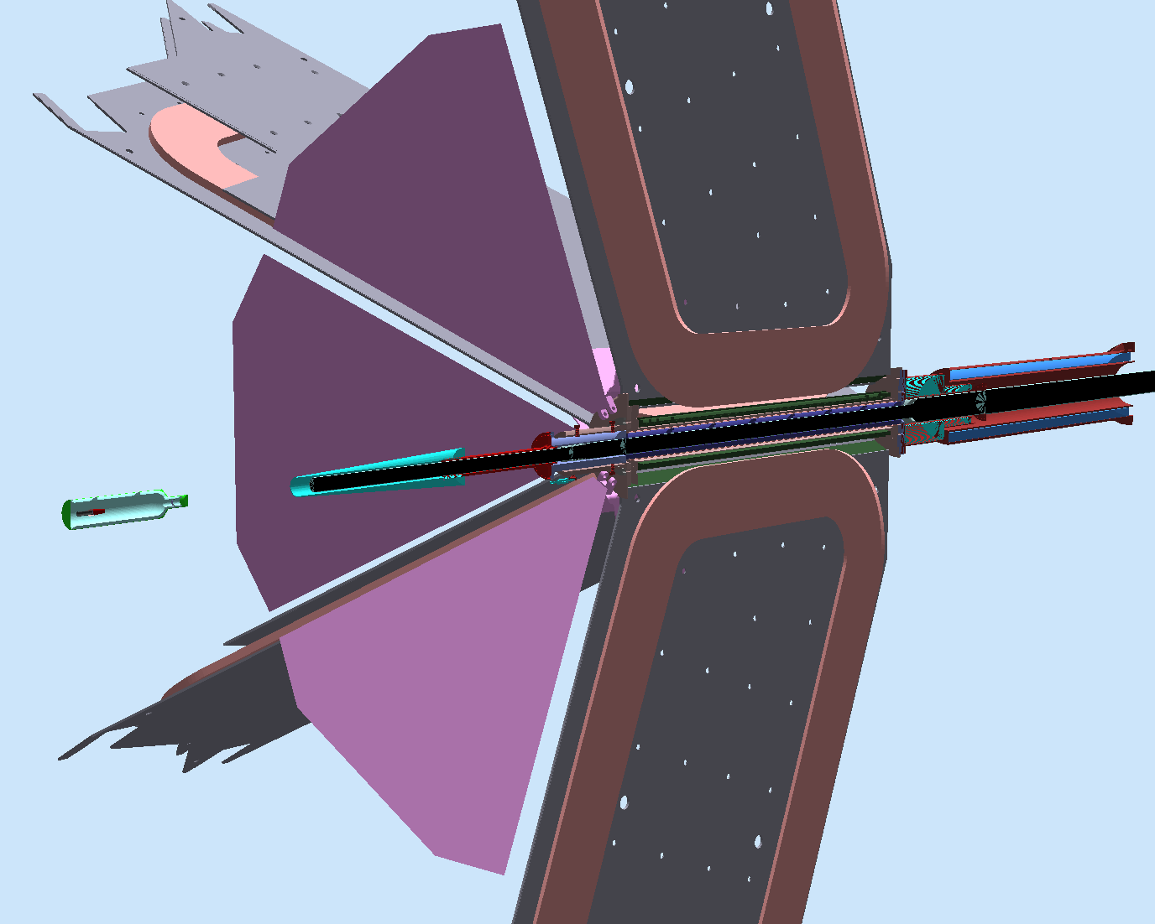

*Figure 3: The implementation of the new design in gemc: overview. The beam goes from left to right. On the left the CAD model of the target is shown. The beam goes then inside the tungsten shield (cyan color), the forward tagger inner mount and shield (red), and the beamline torus mount (blue, with red alignment nuts). The various torus components (coils, cold and warm hub, shields, endplates, steel frame, etc) also imported from the CAD model. Downstream of the torus a new shield is shown together with the “apex” shield that was used in CLAS (red stainless steel enclosure to with blue lead inside).*

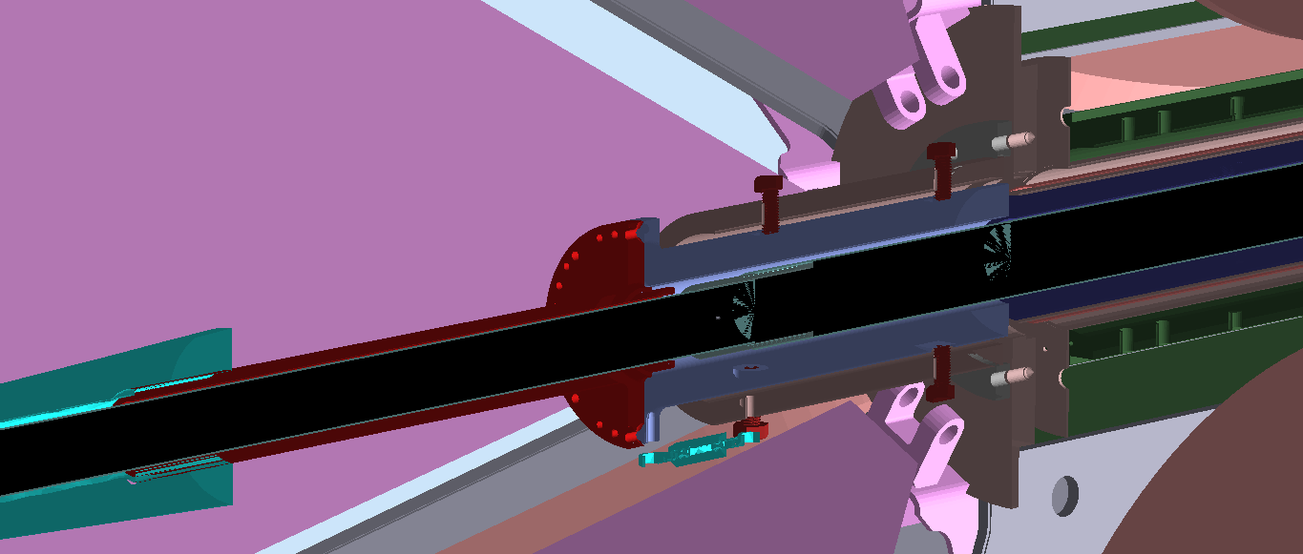

*Figure 4: The implementation of the new design in gemc: upstream of the torus. The beam goes from left to right. The vacuum line is 1.6mm thick and its inner radius is 26.9mm. Inside the torus mount (right center of the figure) the radius jumps to 33.3mm. This size is constant throughout the torus*

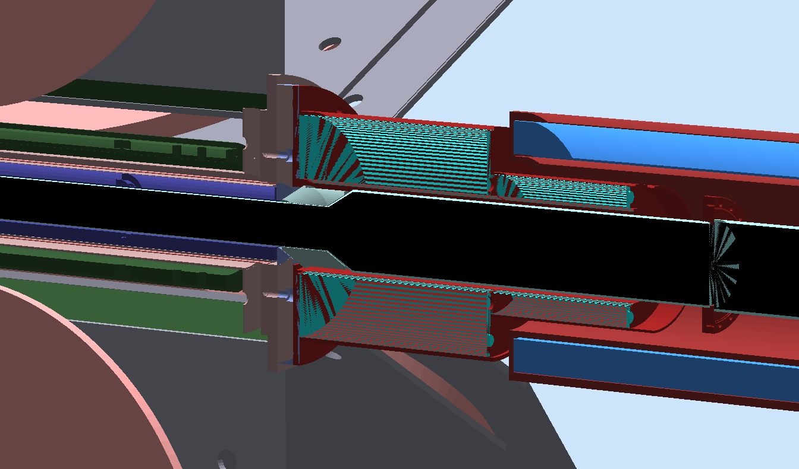

*Figure 5: The implementation of the new design in gemc: downstream of the torus. The beam goes from left to right. The vacuum line radius increases from 33.3mm to 60.3mm inside the newly designed downstream shield. Also in the picture is the “apex” shielding used in CLAS6.*

**New results**

More simulations were performed as the new vacuum line design was being finalized. The final configuration with the new design was simulated in October 2017, and the results are summarized in Fig. 6. The rates are in line with the ideal configuration and the vertex shows the problematic background disappeared from the vacuum line.

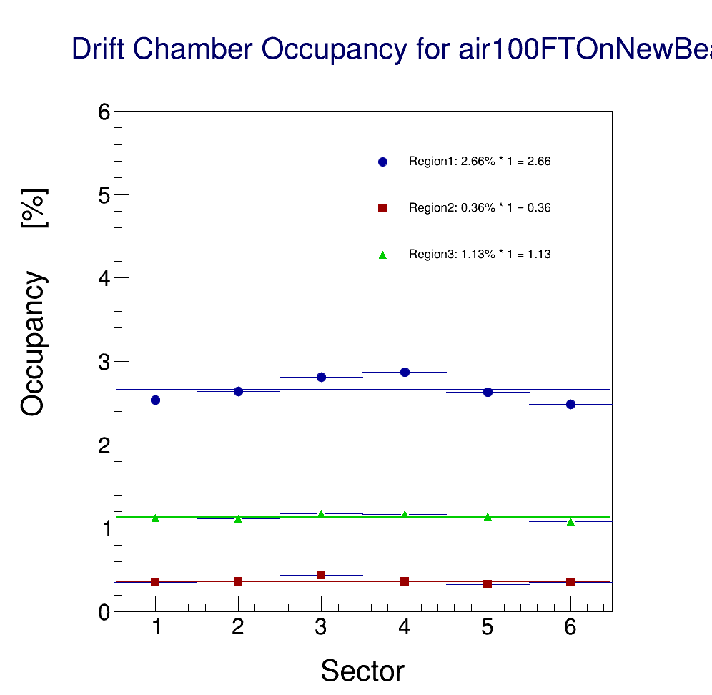 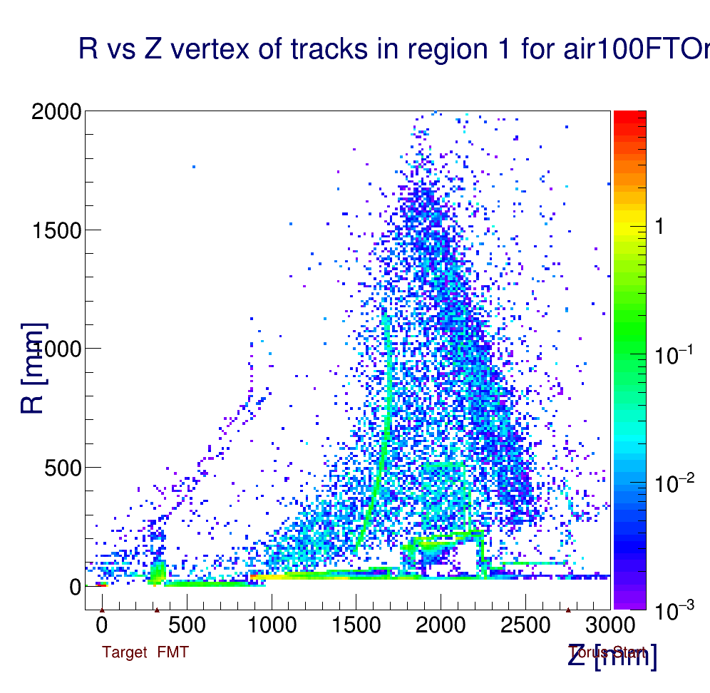

*Figure 6: Results of the new design simulation. Left: the drift chamber occupancies are aligned with the original ideal configuration. Right: the vacuum line does not produce any discernible background in region 3 anymore.*

**Conclusions**

The new vacuum line design and the additional downstream shielding corrected a problematic background rate originating from a small vacuum line radius.

**References**

[1] R. De Vita and M. Ungaro, CLAS12-note 2016-006, Moller shield simulations: comparison of the GEMC-optimized layout and the engineering design.