Importing the downstream beamline from engineering models

Christopher Guthrie and M. Ungaro

*Jefferson Lab, 12000 Jefferson Avenue, 23606 Newport News, VA, USA*

**Abstract**

Simulations of beam-related background show significant contributions from regions downstream of the torus. Up until now the existing shielding and beamline was only partially represented in the GEMC simulation. This note lists the new imports from the engineering models and the modifications applied to the existing geometry.

**CLAS12 Geant4 Simulation**

This CLAS12 spectrometer [1] is simulated using the GEant4 [2] Monte-Carlo (GEMC) package [3]. Its forward detectors are placed between the coils of the superconducting torus magnet [4]. The vacuum line goes through the hub of the magnet. Downstream of the torus, a ‘apex’ shielding, consisting of a steel frame filled with lead, is used to shield background back splashing into the electromagnetic calorimeter. Prior to these modifications, the apex structure was a partial representation of the actual volume, see Fig. 1.

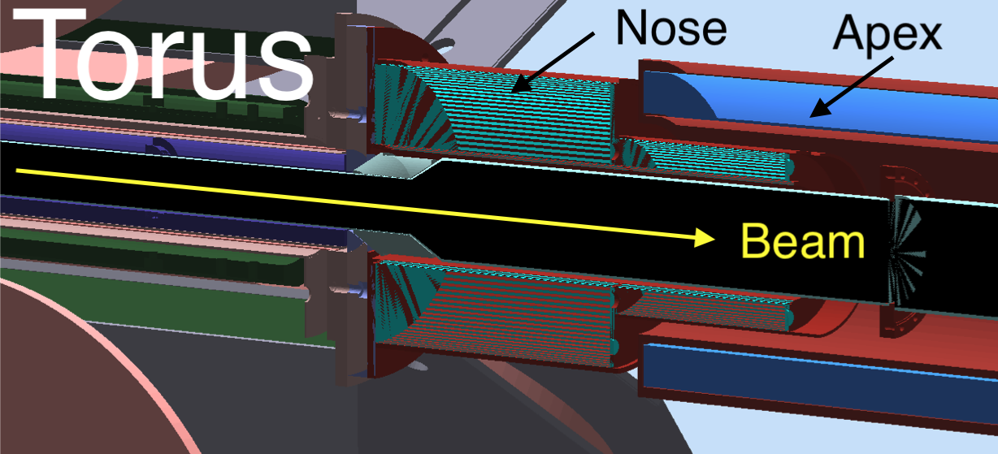

Figure 1. The implementation of the downstream beamline in gemc: a nose fills the air gap from the torus to the apex. The beam goes from left to right. The vacuum line radius increases from 33.3mm to 60.3mm inside the nose.

Detailed studies of beam related background showed backsplash of particles hitting the forward detectors from inside the nose and apex, due to the enlargement of the beam sausage hitting hardware components near the end of the torus hub. Further studies showed evidence of background even after the apex.

The complete vacuum line and beamline shielding is described in the next section.

**Engineering Model**

Simulation software requires the use of models that have the intricate features that interrupt continuous surfaces removed from the models and those features often filled to create continuous bodies. Additionally, it is more favorable for the simulation software to have all interfacing components of the same or similar materials joined into continuous bodies. The engineering models have a medium to high degree of detail and are not acceptable for use without modification. The creation of the simulation model followed the steps below:

* Determination of most current models to use as a starting point
* Isolation of components needed
* Simplifying the geometry of individual components
* Determining materials of individual components
* Joining of bodies of similar materials
* Orienting the model correctly for use in Geant4 simulations

The ALERT Beamline Configuration Model (BL2401-02-00-0000) was used as a baseline model for creating the Downstream Shielding and Beamline Simulation model. This was used due to being the most recent beamline configuration model with downstream components confirmed to be placed using the most current survey data for the location of those components. The location of the Torus and the Forward Carriage drive the location of most of the components.

We identified the components in the model that are needed in the simulation, and a new Step File was created with only those components: the shielding beam pipes and structural mounting of the shielding downstream of the torus.

Most of the model components have features such as mounting holes, recesses, gussets for structure or multiple bodies that make up weldments. If we want to represent all these features in the simulation, the flanges will have holes, and CAD components that include the nuts and bolts would have to be created. However, tessellating these tiny components and sharp variations (such as small holes), a necessary step to be added the Geant4 simulation, is not accurate, produces very large, tessellated files, and causes Geant4 track swimming to crash. On the other end, smooth volumes can be simulated successfully and relatively fast.

Therefore, when a flange with holes for nuts and bolts is in the CAD model, the holes are removed, which approximates filling them with the bolts.

Similarly, separate objects that have the same or similar materials and interfaced with each other were combined into one homogenous body. While this is an approximation and real gaps between objects will be lost, we think this is a small effect and a necessary tradeoff to run the simulation smoothly.

The largest example within this model was combining the outer shell of the Apex Shield, the PCAL Mounting Hub and the PCAL Mount of the Forward Carriage Structure as shown by the green volume in the picture below:

**Coordinate system:**

As of 2024, it was determined that the engineers would give the components in the position surveyed in the Hall at the time of the experiment. However, the engineering model use positive Z direction upstream, and CLAS12 center located 1273.27mm from the center of the solenoid. Since the physicists use the solenoid center as origin of their reference system, with Z along the beam, the STEP file included this coordinate systems change.

Clearance adjustments within the model that was submitted for simulation were also created. While the analysis tools of the CAD programs used to generate the engineering models do not sense interferences in the models when parts are in contact, Geant4 interprets these points of contact as interferences. Approximately 0.5mm clearance from diametrical and flat face features of the lead fill volumes and the steel shell volumes of the shielding was created in the model to allow the simulation software to interpret the model as having no interferences. Additionally, the shoulder diameter of the Torus Reducer to the Torus Beam Pipe with flange had a clearance created as well to avoid being interpreted as an interference in the simulation software. The model went through several iterations to narrow down extraneous features and make adjustments to optimize the model for Geant4.

**Geometry Modifications in the GEMC simulation**

The new geometry is shown in Fig. 3 for the FTOn configurations, which included components downstream of the torus. This and the other existing configurations: FTOff, rghFTOn, rghFTOut, ELMO have been tested to ensure the changes were successful. While the geometry for all these variations is identical, the geometry produced before this change was produced by different files: this update also include a significant cleanup of the code.

The following modifications to the code inside github.com/gemc/detectors/clas12/beamline were done for each of the volume imported from CAD:

* Apex_Shield_Lead_Fill: replaces volume leadInsideApex from Elmoline.pl, rghline.pl, vacuumLineNew.pl. See Figure 4.
* Apex_Shield_PCAL_Hub: new volume, added beamline_CarbonSteel material. See Figure 4.
* Torus_Exit_Shield_Casing, Torus_Exit_Shield_Lead_Fill: replace file afterTorusShielding.pl, now deleted
* Downstream_Beam_tube_Segment 1 and 2.: removed stl volume downstreamPipeFlange and connectUpstreamToTorusPipe

from vacuumLine dir – now all removed. Increased fc z span by 3m to include additional pipes. Notice that FC will be deprecated in further iteration of CLAS12 geometry. vacuumPipe and vacuumPipeToAlcove are removed, and their vacuum volumes are replaced by a fc_beam_vacuum volume. Notice: this change show that the radius of the vacuum line inside Segment 1 was wrong (overlap with pipe) and corrected, from 60.325mm to 59.8, and in Segment 2 from 64 to 63.7mm.

* Torus_Beam_Tube_Reducer_2: new volume, replaced vacuumPipe structure. A new step has been introduced

*Figure 3: summary of downstream beamline in GEMC. From left to right: the “nose” shield inserts into the Apex, which develops into the PCAL hub. The beamline pipe is one stainless steel volume that includes a flange inside the Apex. The vacuum volume have been adjusted to fit inside the pipe*

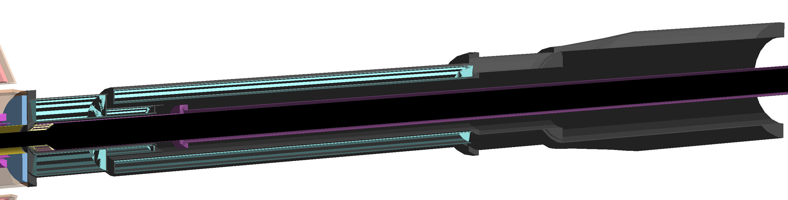

*Figure 4: the nose just downstream of the torus (volumes Torus_Exit_Shield_Casing, Torus_Exit_Shield_Lead_Fill), the Apex and PCAL hub (Apex_Shield_PCAL_Hub and Apex_Shield_PCAL_Fill). The nose and the apex are filled with lead (cyan color volumes) and encased in Carbon Steel.*

**Materials Modifications**

A new material beamline_CarbonSteel was added with the following chemical composition (numbers are percentages):

* Iron: 98
* Carbon 0.3
* Silicon 0.2
* Manganese 1
* Phosphorous 0.3
* Copper 0.2

**GCards Modifications**

The following gcards have been added to better organize the various experiment configurations:

* beamline_FTOn.gcard
* beamline_FTOff.gcard
* beamline_ELMO.gcard
* beamline_rghFTOn.gcard
* beamline_rghFTOut.gcard

The file beamline.gcard has been removed.

The vacuumLine directory has been removed and its reference in all gcards in the clas12-config repository have been removed.

**Summary and Conclusions**

The beamline vacuum line and components have been added to the GEMC simulation. Vacuum components have been simplified and corrected because of these additions.

**References**

*[1] The CLAS12 spectrometer at Jefferson laboratory, Burkert V.D., et al., Nucl.Instrum.Meth.A 959 (2020) 163419*

*[2] Recent Developments in Geant4, J. Allison et al., Nucl. Instrum.Meth.A 835 (2016) 186-225*

*[3] The CLAS12 Geant4 simulation, Ungaro M., et al., Nucl.Instrum.Meth.A 959 (2020) 163422*

*[4] The CLAS12 superconducting magnets, Fair R., et al., Nucl.Instrum.Meth.A 959 (2020) 163578*