Study of the electromagnetic background with varying solenoid field

R. De Vita

*Istituto Nazionale di Fisica Nucleare - Sezione di Genova,*

*Via Dodecaneso 33, 16146 Italy*

S. Stepanyan, M. Ungaro

*Jefferson Lab, 12000 Jefferson Avenue, 23606 Newport News, VA, USA*

**Abstract**

Simulations of beam-related background were performed for various strengths of the CLAS12 solenoid field and 2x1033 cm-2s-1 luminosity. This corresponds to a current of ~1.5 nA on the nominal 5 cm long liquid-hydrogen target. Drift chamber occupancies and rates in the HTCC were also evaluated.

**Simulated Detector, Beam and Target Configuration**

This simulation study is based on the CLAS12 standard configuration. The target consists of 5 cm long liquid-hydrogen target (that includes its containment vessels and scattering chambers). The Moller shield configuration was the standard one to be used with the Forward Tagger. The Moller cone geometry corresponds to the final engineering design [1]. The full CLAS12 detector geometry with the only exception of the LTCC was included. The solenoid field was varied between zero and full strength in 10% steps, with an additional point at 5% strength.

For each event, 2480 electrons going through the target within a 250 ns time window were simulated. This corresponds to 1/50 of the full CLAS12 luminosity, or 2x1033 cm-2s-1 luminosity. A GEMC visualization of one event at full field (top) and one event at zero field (bottom) are shown in Fig. 1.

**Simulation Results: DC**

Simulations were performed with GEMC 2.5 and geant4 4.10.02.p02. The standard geant4 electromagnetic physics list was used. The hadronic physics list was FTFP_BERT. The optical processes were included.

The distribution of the origin of background particles hitting DC Region 1 is shown in Fig. 2 for full solenoid (top) and no solenoid (bottom). Most of the particles reaching Region 1 are low energy electrons originating from the target. With no solenoid field the number of secondaries scattering off the HTCC volume (z between 500 and 1800) and the forward tagger electronics (z between 1800mm and 2200mm) is considerably enhanced.

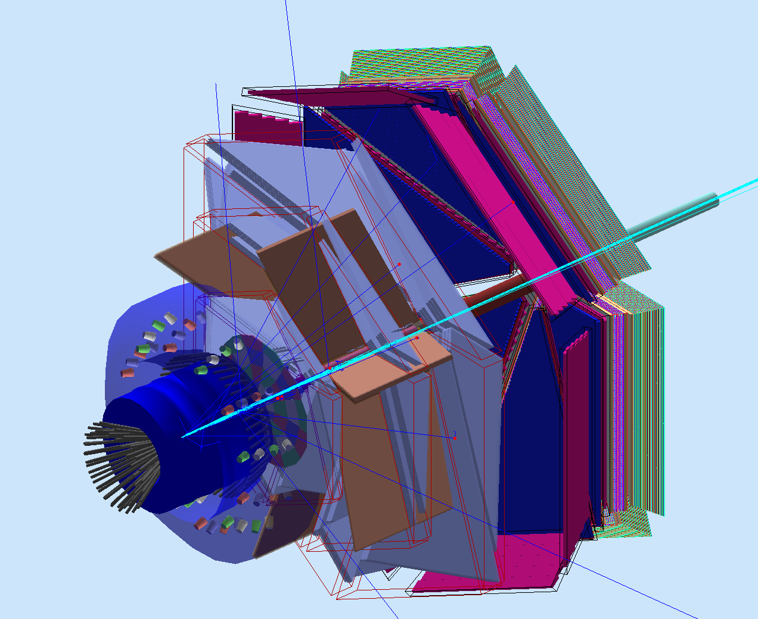

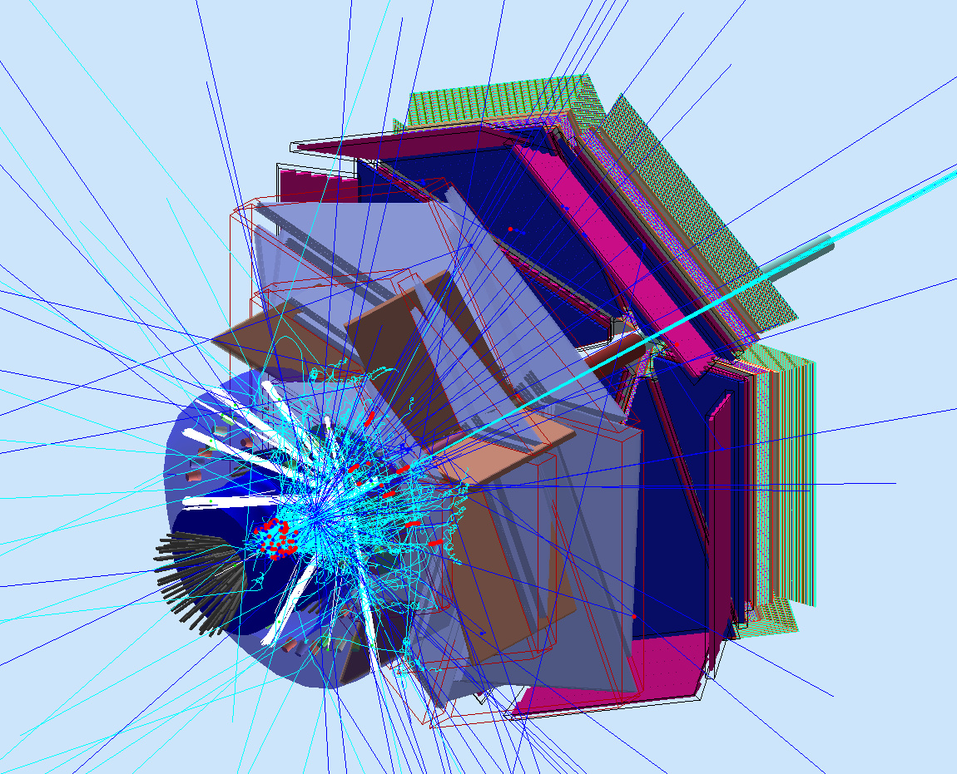

**Figure 1**: Top: GEMC visualization of the background produced by the electron beam at 1.5 nA impinging on the CLAS12 target at full solenoid field. Bottom: backround produced at the same current w/o solenoid field.

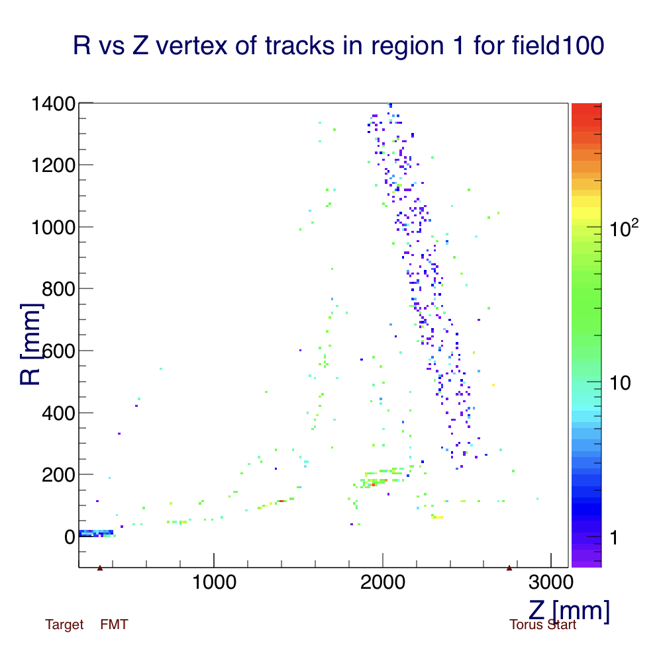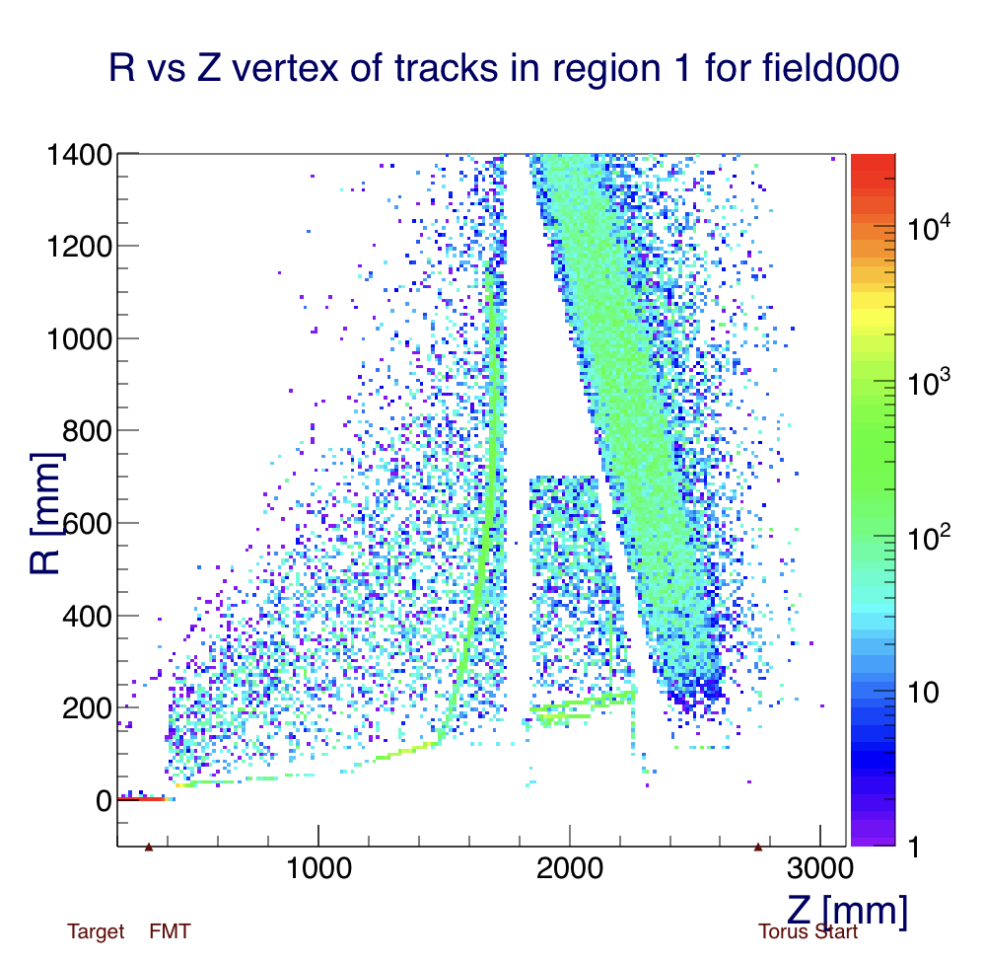

**Figure 2:** Origin of background particles hitting DC Region 1. Top: Full solenoid field. Bottom: no solenoid field

As expected the DC region most affected by a weaker solenoid field is Region 1. In Fig. 3 the hit occupancy is shown for full (top) and zero (bottom) fields. The average occupancies in Region 1 are 0.029% and 19.9%, respectively. The occupancy at full field, 1/50 luminosity is consistent with the full field / full luminosity study [1] when scaled by 50.

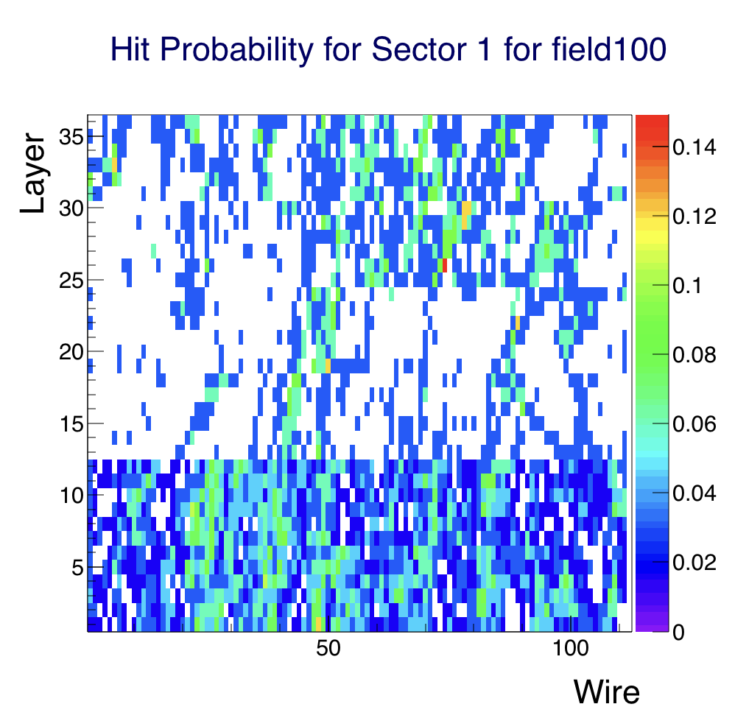

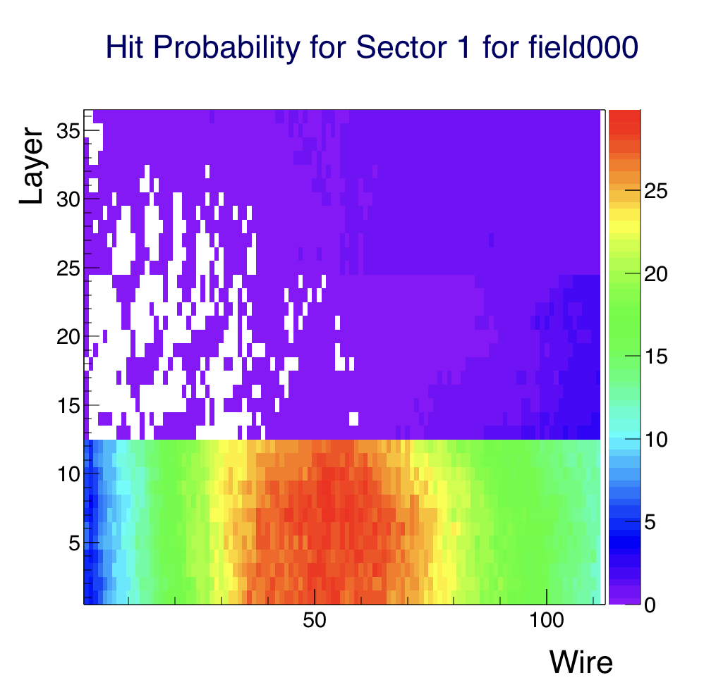

**Figure 3**: DC hit occupancy. Top: full field. Bottom: no field.

In table 1 the results are summarized. The occupancy in the 3 DC regions is reported for the various strengths of the solenoid field at the simulated luminosity and scaled to the CLAS12 luminosity.

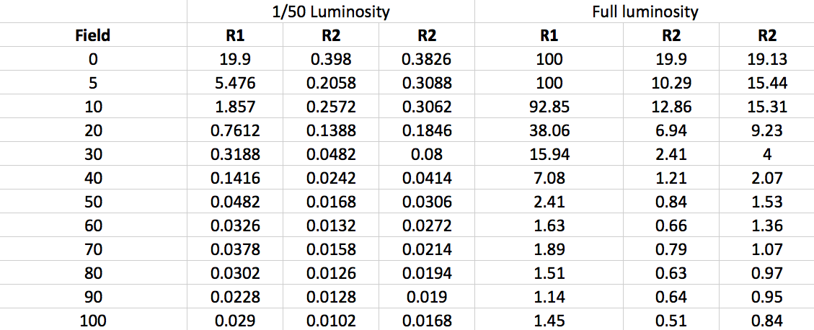

**Table 1**: The 3 DC region occupancies as a function of the solenoid field strength. Columns 2,3,4 include the results at the simulated current of 1.5 nA. The last 3 columns are the results scaled to the full CLAS12 luminosity (78 nA of current on 5 cm LH2 target).

**Simulation Results: HTCC**

Integrated rates in the HTCC were calculated. The Cherenkov processes is simulated in GEMC using a realistic refraction index as a function of wavelength. The quantum efficiency of the PMTs is taken into account in the digitization, so the reported number of photo-electrons is an estimation after detection by the electronics. In Fig. 4 the rates in KHz as a function of number of photoelectrons detected is show for full field (top) and no field (bottom). Table 2 summarizes the results for two thresholds: 10 and 30 detected photons.

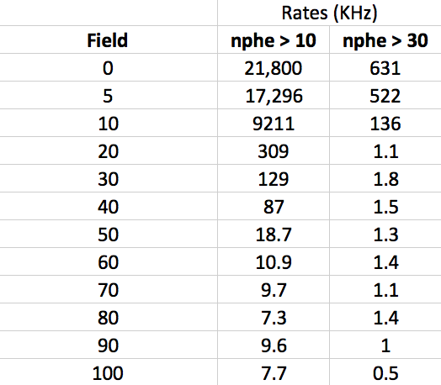

**Table 2**: The HTCC rates of number of detected photons as a function of the solenoid field strength.

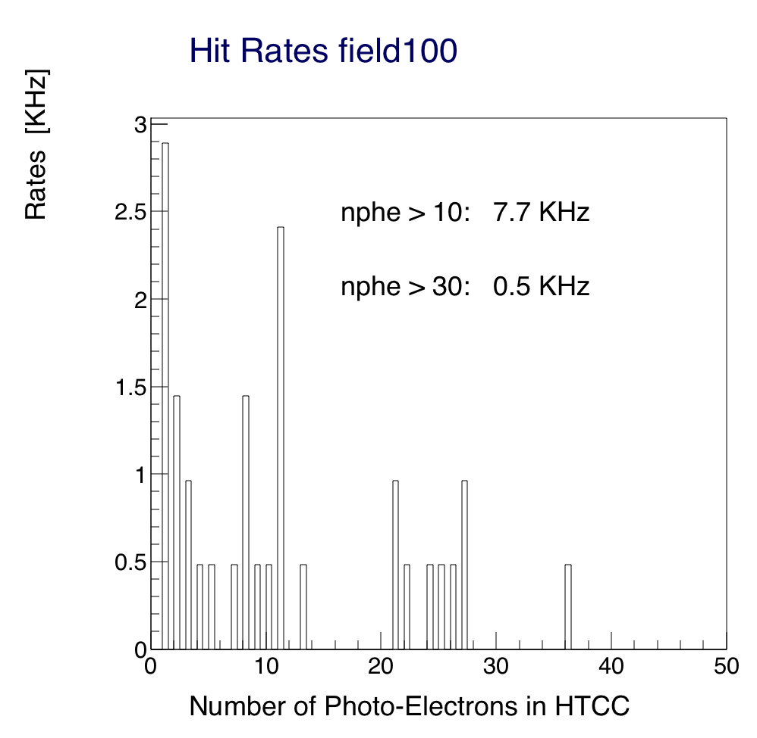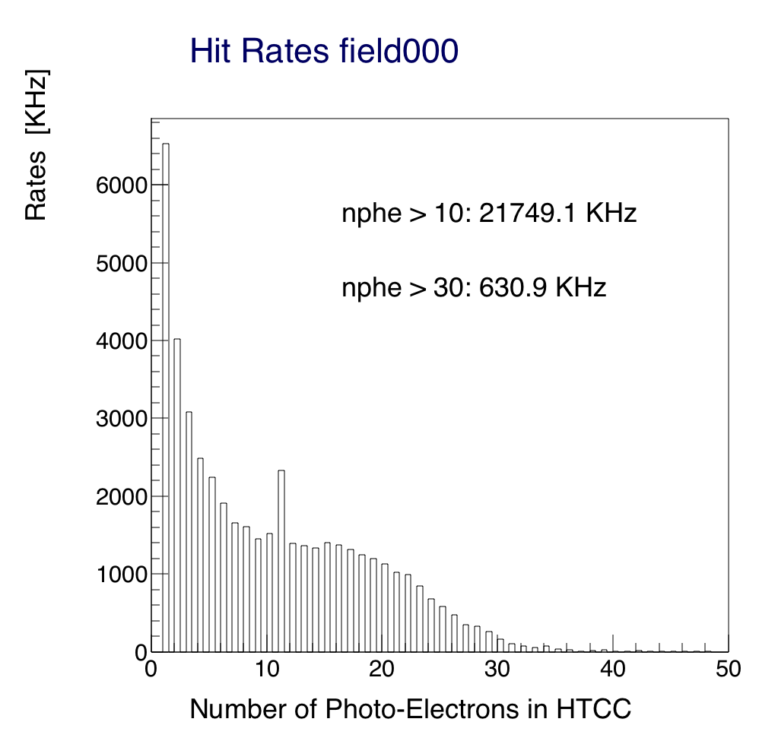

**Figure 4**: HTCC rates as a function of number of photo-electrons detected. Top: full field. Bottom: no field.

**Conclusions**

Based on this study, it is possible to conclude that, using a 5cm LH2 target:

* At 1.5 nA of current, the occupancy in region 1 is too high to detect scattered charged particles.
* The HTCC will give a 21 MHz signal rate because of the large flux of low energy electrons.

**References**

R. De Vita and M. Ungaro, CLAS12-note 2016-006, Moller shield simulations: comparison of the GEMC-optimized layout and the engineering design.