Importing CLAS12 CAD models of target and beamline in the GEMC simulation.

R. De Vita

*Istituto Nazionale di Fisica Nucleare, Genova, Via Dodecaneso 33, 16146 Italy*

M. Ungaro

*Jefferson Lab, 12000 Jefferson Avenue, 23606 Newport News, VA, USA*

**Abstract**

Simulations of beam-related background have shown the impact of having a detailed model of hardware elements, in particular of the components near the beam. This note details the process of importing various elements into GEMC directly from the Hall-B engineering models.

**Step file, volume selection and tessellation**

The Hall-B model is designed with 3D CAD software. This includes a reference system and the hierarchy of all detector elements, down to details like nuts and bolts.

The CAD models are exported into STP files [1]. In order to import them into a geant4 simulation, the elements in the STP file need to be “tessellated”: several polygon shapes are created to define a geant4 volume (see Figure 3). The software used to do this is FreeCad [2], and the workflow is as follows:

1. Selection of relevant volumes to be tessellated (see Figure 1).
2. Choice of tessellation algorithm and parameters.
3. Tessellation of individual volumes into a file.
4. Test for file size and consistency of the volumes in the GEMC simulation.
5. Iterate 2 to 4 until the number of tessellated volumes is reasonable and the precision of the volume tessellation is sufficient.
6. Change coordinates from Hall-B engineering system (z direction goes upstream; target center is shifted upstream by 127.327cm) to the one used in the usual CLAS12 software. This is a 1800 rotation around the y-axis and a shift along z. This step is common to all the volumes imported from the Hall-B engineering group.

It is important to note that during the tessellation process the volumes are not modified in any way: within precisions, the tessellation is identical to the engineering model: the simulated CAD import is as close to reality as the engineering model is close to reality. We did encounter differences between the STP files, the drawings and reality in several occasions (see Figure 2).

In freecad there are several algorithms to tessellate a volume. Depending on the shape of it, some may be more efficient than others. Users can tune certain parameters to control the quality of the tessellation.

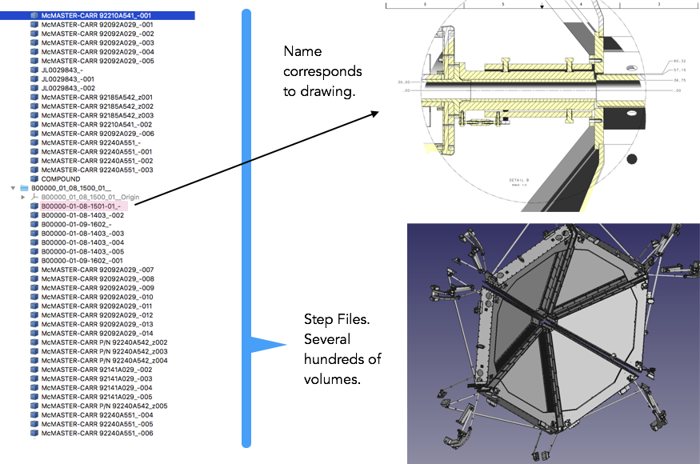

*Figure 1: The selection of the volumes that will be used in the GEMC geant4 simulation. This is a filtering of all the unnecessary volumes that are not in the active region. The process may be lengthy as the STP file contain all the details necessary to build the hardware.*

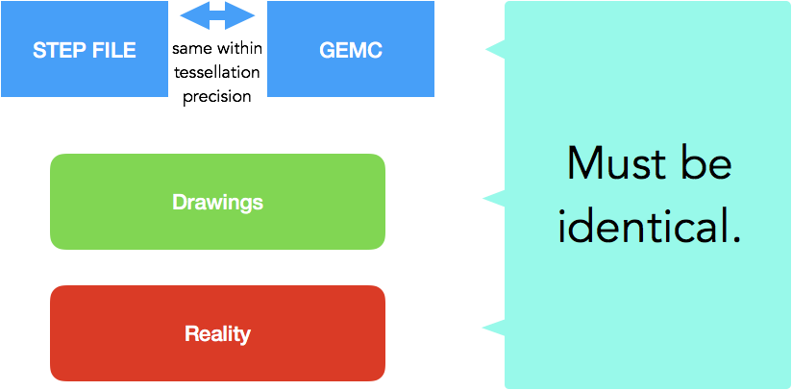

*Figure 2: There are four possible representation of a volume: the one coming from the STP file and the tessellated one are exactly the same object (within the tessellation precision). In some cases, certain elements and their sizes and positions did not match the drawings. In other cases, they did not match what was built and measured, or their position did not match the survey. To eliminate these occurrences physicists and engineers worked until the final iteration of a volume was the same in all 4 models: STP/GEMC, Drawings and Reality.*

In Figure 3 the tessellation process is shown. The number of tessellated volume is important for the simulation efficiency. A volume with millions of tessellations can slow down the simulation, a factor that must be taken into account when choosing the algorithm and precision of the tessellation. The CLAS12 volumes are tessellated typically with 1,000 to 10,000 triangular facets. No significant slowdowns are observed when the number of tessellation / volume is kept in that range.

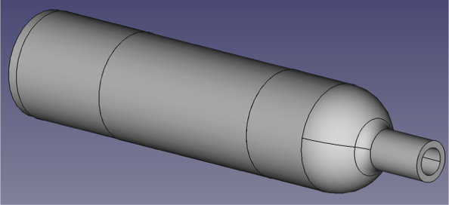

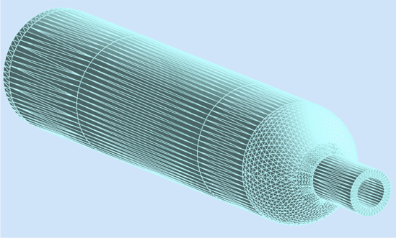

*Figure 3: An example of volume from a STP file (top) tessellated in GEMC (bottom). The volume that is shown is the target scattering chamber.*

**Geometry Validation**

Once the step files, the drawings and the survey data agree with each other, several dimensions and positions are compared with the drawings to make sure the GEMC model matches what is actually installed in the experimental Hall, see Figure 4. This is done by both Raffaella and Maurizio independently, using various techniques, including geantinos particles, see Figure 5.

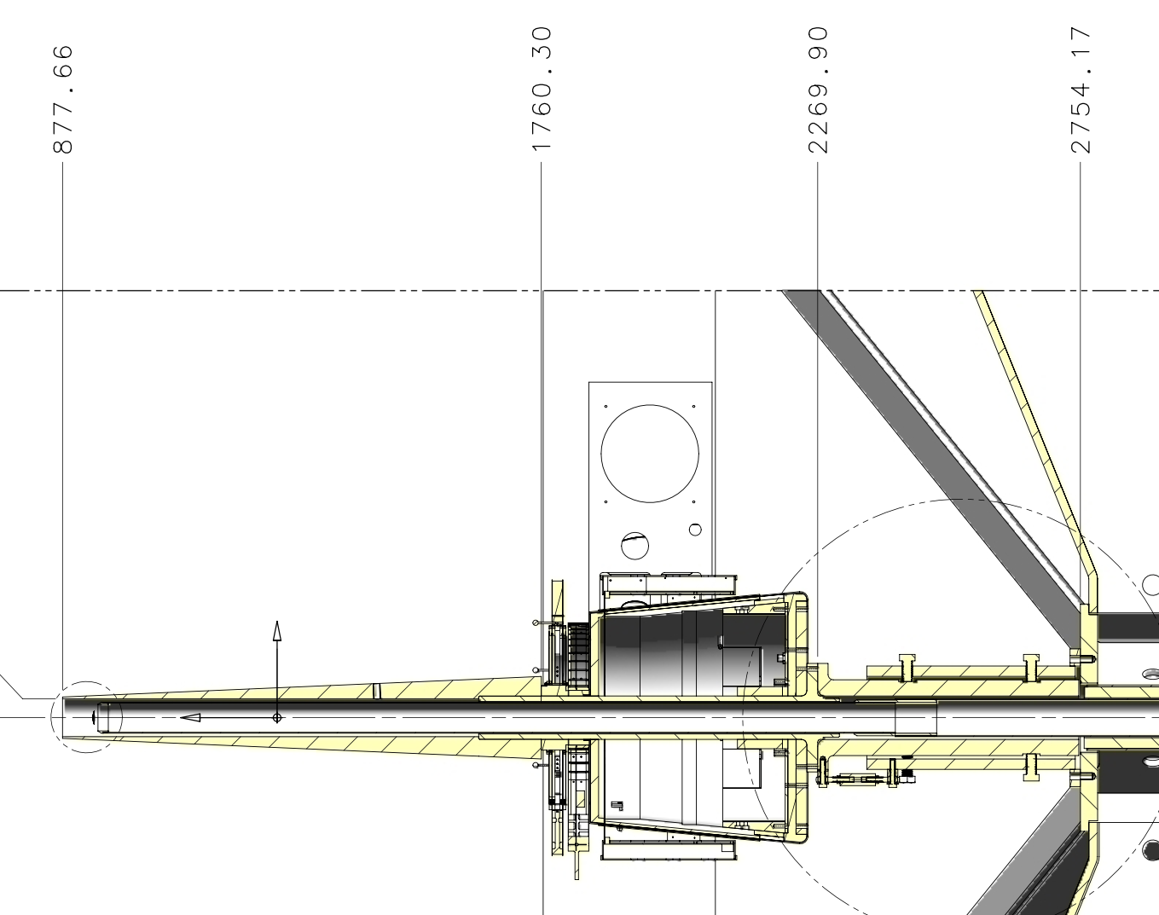

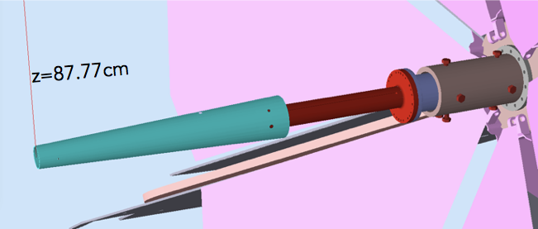

*Figure 4: An example of comparing the gemc simulation to the drawings. Top: engineering drawings of the CLAS12 beamline and shielding. The start of the Moeller shielding is 87.77 cm downstream of the target center. Bottom: a geantino is shot vertically at z=87.77 cm, showing that the geant4 cone position agrees with the drawings.*

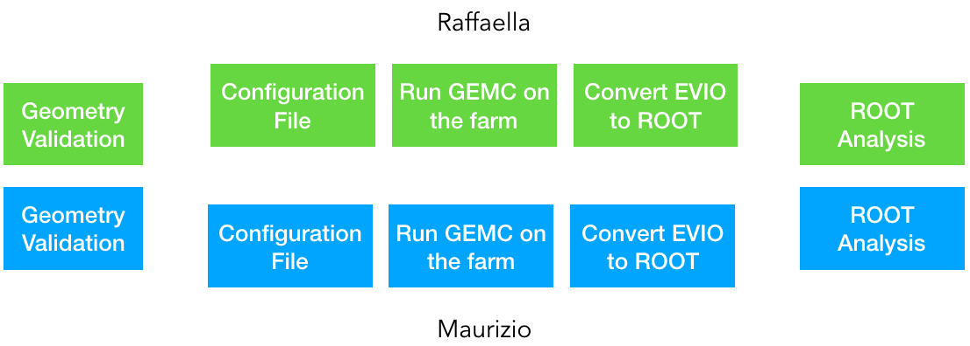

*Figure 5: The two independent algorithms chain to validate the gemc simulation given a particular geometry. First, a configuration file is produced independently. This cross check ensures there are no oversights on the simulation conditions. Jobs are submitted to the JLab farm.*

**Adding CAD volumes in the CLAS12 geometry repository.**

When importing volumes in the gemc simulation, several attributes need to be assigned: material, mother volume, sensitivity if applicable, etc.

In addition, the reference systems used by engineers has the z direction parallel to the beam but with the opposite direction. Their target center is shifted by 1273.27 mm.

In summary the import steps are:

1. Add the volume to the git repository
2. Assign attributes
3. Rotate volume by 1800 - shift by 1273.27*mm
4. Tag repository release

**Conclusions**

With the new geant4 track navigation system it is now feasible to include CAD models into a gemc simulation, even when composed by several thousands of tessellates per volume.

There is no ascertainable slowdown in the graphical capability or CPU processing time / event.

The advantage of a CAD import is significant: the size and position of volumes match the engineering design w/o users needing to approximate it with (sometimes complicated) native geant4 volumes.

Several CLAS12 passive and active elements have been successfully incorporated in the GEMC simulation directly from the CASD engineering models, and used to estimate rates in the detectors for various conditions [3], [4], [5], [6].

**References**

[1] [Step Files](https://en.wikipedia.org/wiki/ISO_10303-21)

[2] [FreeCad](https://www.freecadweb.org/)

*[3] R. De Vita and M. Ungaro,* ***CLAS12-note 2016-006****:* Moller shield simulations: comparison of the GEMC-optimized layout and the engineering design.

*[4] R. De Vita, L. Elouadrhiri, R. Miller, S. Stepanyan, M. Ungaro, C. Wiggins, M. Zarecky, A. Kim and J. A. Tan,* ***CLAS12-note 2017-012****:* Corrections to CLAS12 vacuum beamline

*[5] M. Ungaro,* ***CLAS12-note 2017-013****:* Corrections to CLAS12 target design.

*[6] R. De Vita, D. S. Carman, C. Smith, S. Stepanyan and M. Ungaro,* ***CLAS12-note 2017-016****:* Study of the electromagnetic background rates in CLAS12.