EXECUTIVE SUMMARY
Focus should be on findings (follow a similar structure as the Baseline Report).

H1_EXAMPLE
Text comes here.
Other paragraph

1.1 H2_Example
Example of bullets:
- Leadership and governance systems that plan and respond to crises;
- Ecosystems that provide sustainable access to land, water, and natural resources; and
- Market systems that support inclusive access to financial assets, livelihoods, and services.
By working at the household, community, and system levels, the programme seeks to strengthen absorptive, adaptive, and transformative capacities in a layered and sequenced way.

1.1.1 H3_Example
Example of table title and table Below
Table X. {{table_title}}
Indicator | BL mean (SE) | ML mean (SE)
Average household size | 7.92 (0.16) | 8.33 (0.19)
Average number of female members | 3.97 (0.08) | 4.08 (0.11)
Average number of children under 5 | 1.85 (0.07) | 1.79 (0.07)
% female-headed households | 61.5% (2.42) | 61.0% (2.41)
% households with a farmer | 37.1% (1.69) | 46.7% (1.98)
% households with a member with a disability | 19.2% (2.05) | 26.7% (2.35)
% households receiving BRCiS assistance | 15.6% (1.41) | 52.5% (2.27)

Text after table

2.1 H2_Example
Example text. Figure title and example below.
Figure X. {{figure_title}}
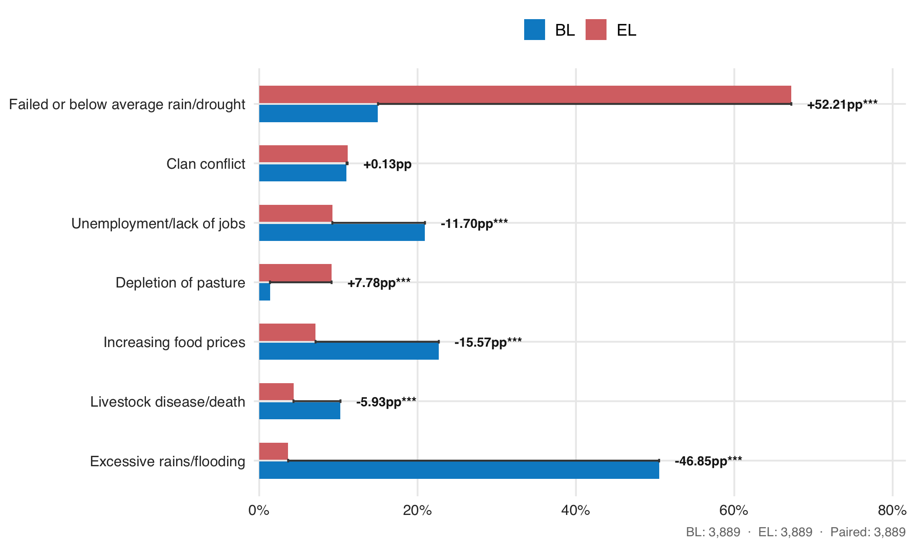

2.1.1 H3_Example
Example of text.

H4_example
Additional levels

H4_example
Additional levels

BRCiS LOGFRAME
Additional levels

H1_EXAMPLE

