Gut als erste Vorlage für FDM troubleShoot

1) Stringing/Oozing
During non-print movements, sometimes filament will ooze from the nozzle and is dragged to the next place. This causes stringing that looks like thin cobwebs between your print and can be a pain to remove.
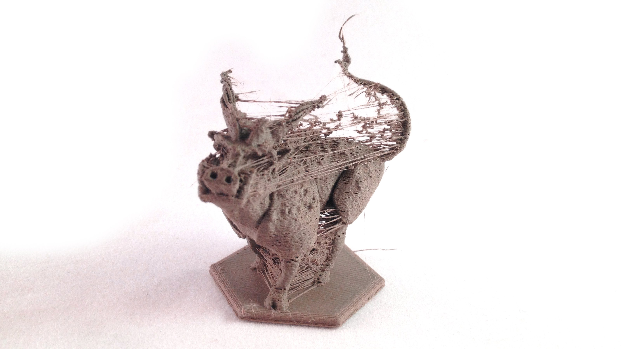Photo Source: Zheng3 from his blog

Enable Retraction: One potential cause of this is your retraction settings aren’t set properly in your slicer program. Luckily this is a simple fix. Every slicer has a feature called retraction which tells your 3d printer to ease pressure in your nozzle and stop filament from coming out between non-print moves. This will prevent the excess material from being dragged from one area of the print to another. When the printing resumes, filament will be pushed out of the nozzle to begin again. If your retraction settings are too high, it may clog your nozzle so you may have to do some experimenting with what works for your printer and the filament you’re using.
One thing to note is the difference in retraction settings for Bowden vs. Direct Drive extruders. Retraction distance determines how much filament is pulled up from the nozzle and should be higher for Bowden extruders because there is more distance in between the nozzle and your drive gear where your filament feeds in. For Direct Drive extruders, the recommended setting is below 2.5mm as anything more can cause a jam. Recommended retraction settings for Bowden extruders are between 1mm and 5mm. If you’re having issues, adjust incrementally by .5mm to find the best setting for your printer and filament. Retraction speed should be set at 30-45mm.
Adjust travel speed for non-print moves: The slower your nozzle moves during non-print moves, the more time filament has to ooze out. Speeding up the nozzle for those movements may help prevent stringing. To see a great example of how to experiment with retraction and nozzle speed, check out the series of test prints that MatterHackers did to figure out the best settings to prevent oozing on their printer. They found that 150mm/s travel speed was ideal for their printer, but this will vary so you may want to play around with this.
Adjust your nozzle temperature: Filament will also have a tendency to ooze from the nozzle when extrusion temperatures are too high. Start by checking the suggested print temperatures for the filament you’re using (this will vary a lot between ABS and PLA). Try adjusting the temperature by 5-10 degrees lower from there and see what gives you the best results.

2) Print not sticking to the bed
One moment your print is doing great, and the next you turn around and the nozzle is dragging your print back and fourth over the bed. It continues to extrude filament that just curls at the nozzle and begins to look like coloured scribbles rather than the beautiful masterpiece you expected.
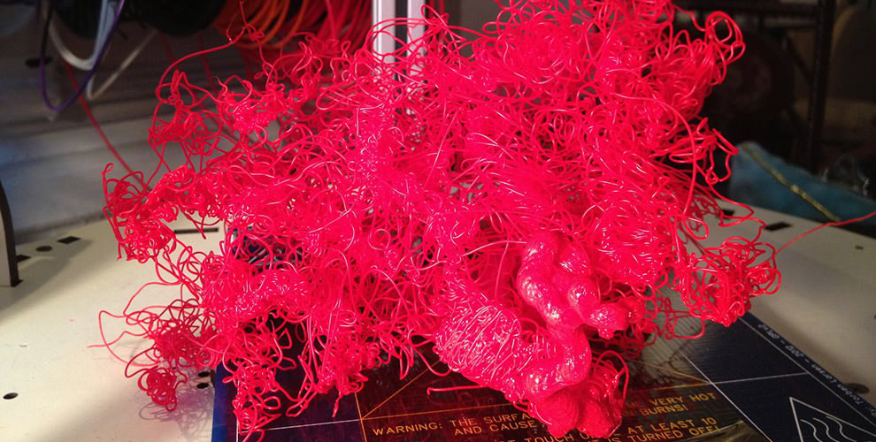
Photo Source: 3dprinting.com
To achieve solid bed adhesion, it’s all about finding the right settings for the first layer of your print. For great first layer adhesion, make sure you do the following:
Level your bed: Your first layers won’t adhere properly to the bed if the distance between the nozzle and your bed isn’t equal throughout the different points of the print. That’s why it’s important to level your bed. Follow the step by step instructions in our Bed Leveling Guide to make sure it’s done properly!
Adjust your starting Z-axis: Even if your bed is level, you want to make sure your nozzle is the right distance away from the bed for the first layer of your print. You can adjust the nozzle position by hand or your slicer program may have settings to adjust this as well. To do it by hand, move the nozzle to the middle of the print bed and bring your Z-axis to home. You don’t want the nozzle to touch the plate, but it shouldn’t be too far either. A good way to test it is to make sure when the filament goes onto the bed, it is flat not round so it’s “squished” onto the bed. Make adjustments by .05mm and see what works best.
Adjust your bed temperature: The purpose of a heated bed is to try to create an even overall temperature for your print. When filament comes out of the nozzle it is very hot and if it is placed on a cold bed and cools too quickly, it will shrink and could hinder adhesion. For PLA recommended heated bed temperatures are between 35-70C and ABS is around 90-110C.
Use Kapton Tape or Glue: Additional tools to help with bed adhesion include Kapton tape, or glue. One layer of Kapton tape over your bed should do the trick! If you are still having issues, you can put a thin layer of glue over the Kapton tape as well. If the Kapton tape begins to rip after you try to take your print off the bed, you should replace the layer for your next print.

3) Plastic Overheating
As we discussed above, when plastic comes out of the extruder and cools too quickly, it can cause warping which leads to poor bed adhesion. When the plastic doesn’t cool down fast enough, it can lead to poor print quality and undefined design features. How do you find a happy medium where you have good bed adhesion but your filament isn’t so hot that it’s preventing your print from solidifying?
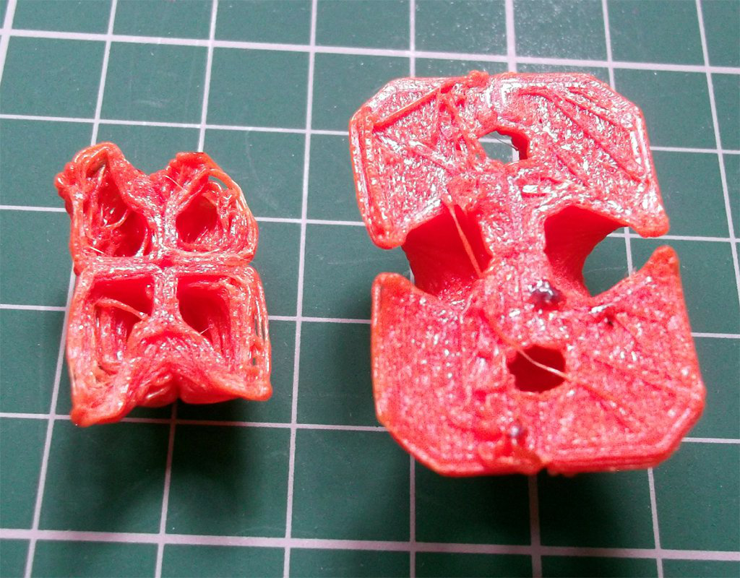
Photo source: Richrap Blog
Lower printing temperature: It may seem obvious, but if you notice your design features aren’t turning out, try lowering the print temperature by 5-10 degrees. This will help the layers cool faster and take form so you can print with more detail.
Increase your cooling fan: Cooling fans help cool down the layers of your print before they begin to melt into each other and potentially change shape. Some printers will have cooling fans built in which you can control with your slicer software and some will need to have an external cooling fan built in. You can also try using a regular fan or handheld to cool down the layers.
Slow down your print speed: When you print slowly, you give each layer time to cool and stick to the bed or previous layer. The great thing is, there aren’t many negative side effects to printing slowly, other than you having to wait longer for it to finish! So you’re not at risk of ruining your print by printing slower. When doing complicated or detailed prints, don’t be afraid to slow it right down.

Other problems?
If you are experiencing problems other than the ones above, check out Simplify3D’s Troubleshooting Guide – it’s an awesome resource and a great place to start looking if you’re experiencing abnormalities in your prints. Keep in mind, it’s always best to experiment with your settings on a test print. That way, you avoid wasting time and filament on a longer more complicated print. Check out these test prints and give them a try!

Retraction Calibration Test by BigBadBison
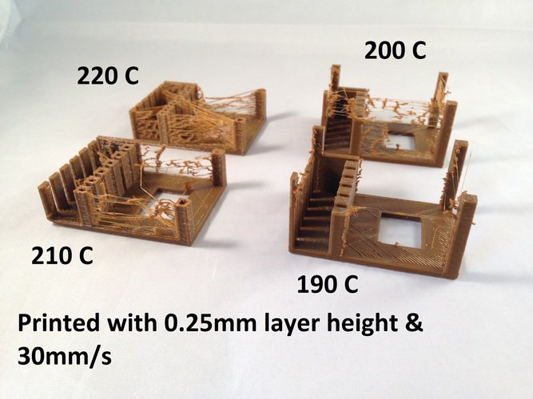

XYZ 20mm Calibration Cube by iDig3Dprinting
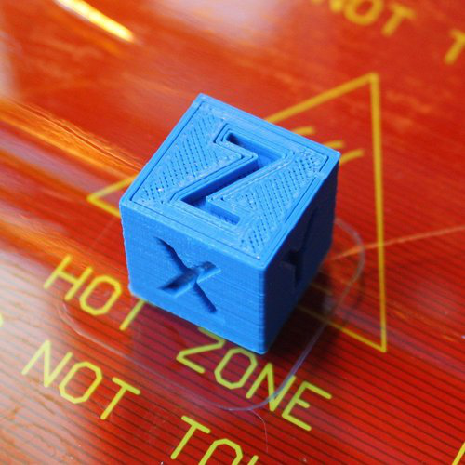

Hole Size test print by Terry Morris


