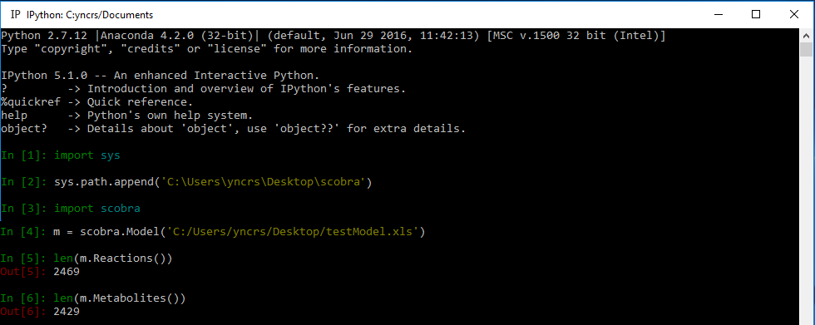
Windows

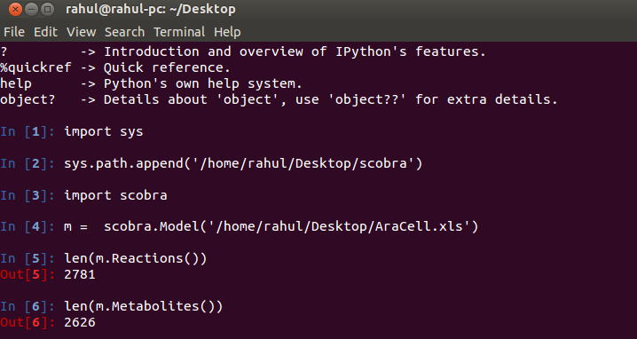
Linux/unix

- This is a scobra version using a working copy of cobra metabolic modelling package.
- Users must install all the dependencies as instructed in the documentation (Comp_bio_docs.pdf). Installation of cobra is NOT required with this version.

