

**INT 247 MACHINE LEARNING PROJECT**

FACE DETECTION WITH PYTHON

Submitted by: Maurice Yengkhom

Registration number: 11907009

Section: K19GA

Date: 11/04/2022

**DECLARATION**

I, Maurice Yengkhom (11907009), solemnly declare that the project is based on my own work carried out during the course of our study under the supervision of Madam Upinder Kaur.

I assert the statements made and conclusions drawn are outcomes of my work.

I further certify that the work contained in this report is original and has not been submitted to any other institution for any other degree/ diploma/ certificate in the University.

**Maurice Yengkhom**

**11907009**

**ACKNOWLEDGEMENT**

I am highly indebted to Madam Upinder Kaur for her guidance and constant supervision as well as for providing necessary information regarding the project and also for support in completing the Project.

**INDEX**

* About the Project
* Modules used
* Code
* Screenshots
* Conclusion
* References

**ABOUT THE PROJECT**

**FACIAL RECOGNITION USING PYTHON**

The main aim of this project is to build a machine learning model to capture and recognise a human face using our laptop or pc webcam with a rectangular box around the faces.

I have used a cascade file with data that can detect a human face easily by implementing it with OpenCV.

The project is published in my GitHub Repository link given below

<https://github.com/mauriceyeng/ML-Project>

**MODULES USED**

**NumPy**

NumPy is a Python Library used for working with arrays. It is an open source project and can be used freely. NumPy stands for Numerical Python.

**OpenCV**

OpenCV is a great tool for image processing and performing computer vision tasks. It is an open-source library that can be used to perform tasks like face detection, object tracking and much more.

Here I have used a function of OpenCV called **cv2** to read and capture video.

**OS**

OS is a module that provides function for interacting with the Operating system.

**Cascade Classifier**

Cascading Classifiers are trained with several hundred or thousand positive sample views of a particular object and arbitrary negative images of the same size.

**Harr-cascade**

In this project harrcascade.xml which is an Object Detection Algorithm is used to identify faces in real time video capture.

It is an open-source algorithm which is the most accurate in detecting faces.

**CODE**

import numpy as np

import cv2

import os

os.chdir(r"D:\LPU\Year 3\6th sem\ML Project")

face_cascade=cv2.CascadeClassifier("harrcascade.xml")

def detect_face(image):

    face_copy=image.copy()

    face_rects=face_cascade.detectMultiScale(face_copy,1.3,5)

    for(x,y,w,h) in face_rects:

        cv2.rectangle(face_copy,(x,y),(x+w,y+h),(0,0,255),5)

    return face_copy

capture=cv2.VideoCapture(0)

while True:

    ret,frame=capture.read()

    frame=cv2.cvtColor(frame,cv2.COLOR_BGR2GRAY)

    output=detect_face(frame)

    cv2.imshow("output",output)

    if cv2.waitKey(1) & 0xff==ord('a'):

        break

capture.release()

cv2.destroyAllWindows()

**SCREENSHOT**

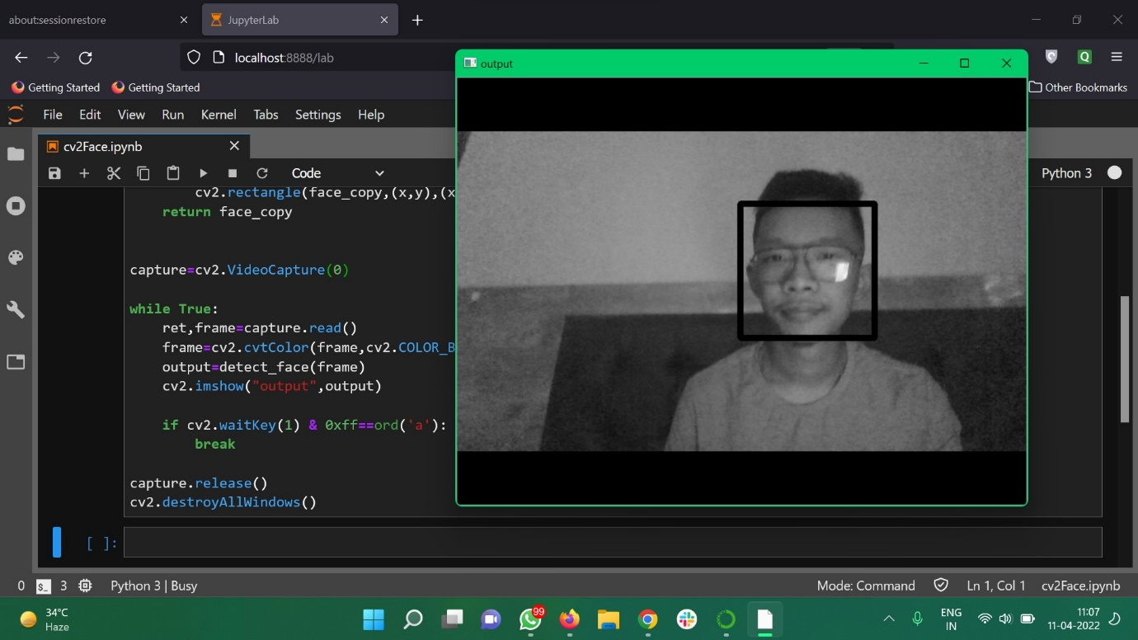

A screenshot of the working model of face detection program in real-time using a webcam.

CONCLUSION

The project is made using a special module called OpenCV which makes it possible to detect and recognise a human face. There are many more functions to the module like detecting eyes, nose, smile etc which is useful in many real life applications like Artificial Intelligence apps.

REFERENCE

* IBM CAREER EDUCATION MACHINE LEARNING TRAINING COURSE
* HARRCASCADE.XML BY VIOLA AND JONES