Bringing Indoor Navigation for the Visually Impaired at Low Cost

Mauricio Porto, Carlos Santos, Juliano Vacaro, Joao Ambrosi

PCL - Brazil R&D

(All email addresses are [firstname.lastname@hp.com](mailto:firstname.lastname@hp.com))

Abstract

This paper presents a low cost indoor navigation system for the visually impaired which takes advantage of Near Field Communication (NFC). The main idea is to orient users by NFC enabled mobile phones that gathers the current position from static tags and guide the user along her desired destination, possibly using intermediate checkpoints. The system also provides a collision detection mechanism that warns user about near obstacles. Since its prototype was implemented on Android and behaves like a guide dog, we named it GuideDroid.

Problem statement

Among the many challenges faced by visually impaired people are the constraints of independent mobility and navigation in an unfamiliar indoor environment. Finding the current location and the path to a desired location can be an arduous task. Besides, constant changes in the workplace offer much higher collision risks than the familiar environment for the visually impaired.

GPS based navigation is not feasible in an indoor environment due the weakness of satellite signal. The existing solutions for indoor navigation systems typically require expensive and heavy sensors, or equipping rooms and hallways with radio-frequency technologies such as A-GPS, Bluetooth, Ultra Wide Band (UWB), Wi-Fi or RFID that are used to determine the user’s location. Most of them are not suitable for the visually impaired and they are either too expensive or experimental.

Although several attempts have been made at making such indoor navigation systems, none of them have found wide acceptance. There is an opportunity that spreads between different areas such as providing HP mobile devices with embedded assistance features, offering services and products via HP eHealth Center and improving the brand image to both external and internal people.

Our solution

GuideDroid was designed to help the visually impaired in their locomotion by unknown places or collision risky environments aiming to be cheap, easy to use and with a very small investment on infrastructure.

It is accomplished through the extensive use of sensors and location features existing in smartphones and other mobile devices, to assist people in tasks such as locomotion, identification of places and services available, and indoor navigation. The design requirements shown below were defined according the identified necessities.

**Design constraints**

* Uniformity of the geographic location model (latitude/longitude) to enable integration with existing outdoor navigation systems and its mechanisms.
* Use only cheap and off-the-shelf components.
* No changes in buildings infrastructure (no wireless network needed).
* Should be useful for both visually impaired or not.
* The user should not be obligated to start the navigation by some initial point; she should be able to start at any point when she feels lost, thus avoiding unnecessary help for well know paths.

How to conciliate the necessity of keeping the same location model (latitude/longitude) widely used in outdoor navigation and the weakness of indoor GPS signal?

Our solution is to distribute strategically NFC tags inside the buildings, providing their accurately calculated coordinates and thus serving as landmarks for orientation (waypoints) in the same way as an open environment (outdoor). The existing compass in the smartphones points out the right direction to the user, signaling it by means of vibration, thus allowing the visually impaired to use the assistant. This is the main aspect of this innovative solution.

**How it works**

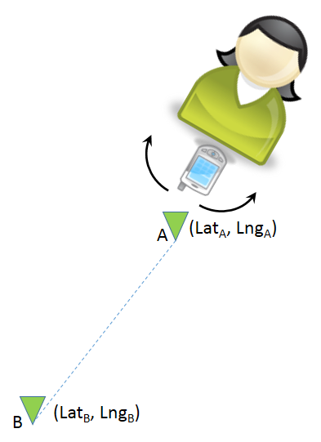The user is guided with turn-by-turn instructions between waypoints (NFC tags). Each tag has a unique identifier that enables to access its geographic coordinates, among several other information. Considering the user needs to traverse from the point A to point B (Figure 1), and given that we know their coordinates (previously determined and stored), we can calculate the bearing and the distance from point A to point B using the WGS84 (World Geodetic System, 1984) ellipsoid.

Figure 1- Searching direction and distance

Let us consider the case where the user needs to reach a particular room in an unknown building. Figure 2 represents that building.

At the entrance door, the user touches with her phone a poster with the NFC tag. Then the detection of a special URL that starts with "guidedroid://" triggers the GuideDroid application that identifies the building and then downloads the XML file that describes it. Following, the application inquires the user the desired room destination, presenting a list with the names of existing rooms in the building. Once the destination is chosen, the application calculates the route using the Dijkstra's algorithm and asks the user to rotate the phone horizontally (see Figure 1) to determine the magnetic orientation of the first stretch of the route. When it finds the magnetic orientation, the phone vibrates and announces the distance the user must walk in that direction. At the end of this passage, she will found another NFC tag that corresponds to the destination or an intermediate point (waypoint) where the process starts again to determine a new stretch.

Exemplifying with Figure 2, we assume that the destination is the room 106. The user touches the NFC tag at the entrance with her phone and after any necessary initialization, the application determines the smallest path A, C, K, J, I to reach room 106. Then the user rotates her mobile phone that will vibrate when it reach the direction that points to the tag C and says, “Walk this direction by 4 meters”. When she reaches this new tag C, the process repeats for the section between C and K, and so on until reaching the point I that represents the entrance of the room 106.

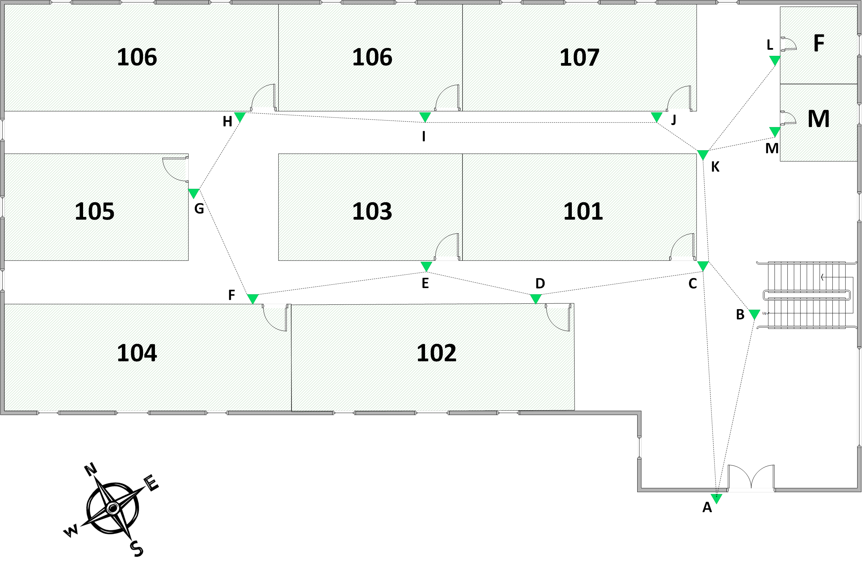This process based on short stretches can be tedious at first, but the user does not need to repeat every time she goes through this same building. Once she learned the environment, she will only need the ask help to GuideDroid when the route to some destination is unknown. Semantically all the NFC tags are equal and the process can start at any of them.

Figure 2- Navigating with NFC tags

The system encompasses a component that helps the user to avoid collisions by warning her through sound signals (beeps) or pulsed vibrations. This component is made of an external ultrasonic sensor that constantly checks the way ahead and will start beeping (or vibrating) when detects some obstacle within the configured range.

TODO: (Aspecto de segurança: as tags contêm identificadores calculados – hash – para o prédio e cada cartaz; suas coordenadas geográficas são fornecidas pelo arquivo XML obtido seguramente do servidor. Isso garante algum nível de segurança contra adulterações das tags pois elas não contém informação que possa ser usada para adulteração, apenas as chaves.)

Evidence the solution works

The solution is already implemented and available for test and evaluation, currently being in use on some buildings at the site of HP Brazil R&D in Porto Alegre/RS.

**TODO**: (falar sobre o aplicativo Android, onde está disponível e também falar sobre o servidor que fornece os arquivos que descrevem cada prédio).

Provide either results from end users of the solution demonstrating that you effectively addressed the original problem, or other convincing demonstrations that the proposal has substantiated merit.

Competitive approaches

Identify other approaches from external literature or HP competitors addressing similar problems. Including comparisons between your solution and theirs (noting both advantages and disadvantages).

Current status and Next steps

How far along are you in putting this solution to use in our business? Where might it be by the time Tech Con takes place? What are interesting ways to use this solution in solving real business problems? Where is further work still required?

**TODO**: (aprimorar as garantias de calibração da orientação magnética – bússola – para evitar erros de orientação; trabalhar mecanismos de segurança que protejam as tags NFC de alteração/apagamento; incrementar as possibilidades de fornecer assistência através da interação entre o aplicativo e o servidor na Cloud; etc.)