Bringing Indoor Navigation for the Visually Impaired at Low Cost

Mauricio Porto, Juliano Vacaro, Joao Ambrosi, Ricardo Moreira

PCL - Brazil R&D

(All email addresses are [firstname.lastname@hp.com](mailto:firstname.lastname@hp.com))

Abstract

This paper presents a low cost indoor navigation system for the visually impaired. The main idea is to orient users through mobile phones that obtain the current position from fixed posters (QR code + NFC tags) on the wall and guide the user along his/her desired destination, sometimes using intermediate checkpoints in a turn-by-turn way. The system also provides a collision detection mechanism that warns user about near obstacles. Since its prototype was implemented on Android and behaves like a guide dog, we named it GuideDroid.

Problem statement

None of the existing indoor navigation systems had obtained wide acceptance so far and their user interface are based on screens making them impractical for use by the visually impaired. Among the many challenges faced by visually impaired people are the constraints of independent mobility and navigation in an unfamiliar indoor environment. Finding the current location and the path to a desired location can be an arduous task. Moreover, constant changes in the workplace offer much higher collision risks than the familiar environment for them.

GPS based navigation is not feasible in an indoor environment due the weakness of satellite signal. The existing solutions for indoor navigation systems typically require expensive and heavy sensors, or equipping rooms and hallways with radio-frequency technologies such as A-GPS, Wi-Fi or RFID that are used to determine the user’s location.

There is an opportunity that spreads between different areas such as providing HP mobile devices with embedded assistance features, offering services and products via HP eHealth Center and improving the brand image to both external and internal people. Besides, “building a diverse and inclusive culture is the right thing to do from a societal standpoint and also the right thing for our business.” as recently declared by HP CEO Meg Whitman.

Our solution

Encompassing different mechanisms existing in smartphones and other mobile devices, GuideDroid was designed to help the visually impaired in their locomotion by unknown places or collision risky environments aiming to be cheap, easy to use and with a very small investment on infrastructure. With the user interface based on text to speech, sound and vibrations for user guidance, it is able to assist people in tasks such as locomotion, identification of places and services available, and indoor navigation. The main design principles were: a) Uniformity with the geographic location model - latitude/longitude - to enable integration with existing outdoor navigation systems and its mechanisms; b) Use only inexpensive and off-the-shelf components; c) No changes in buildings infrastructure, no wireless network needed; d) Should be useful for both visually impaired or not.

To deal with the weakness of GPS signal on indoor environments, we strategically distribute posters inside the buildings, providing their accurately calculated geographic coordinates and thus serving as landmarks for orientation. The existing compass in the smartphones points out the right direction to the user, signaling it by means of vibration, thus allowing the visually impaired to use the assistant and this is the distinguished aspect of this innovative solution. Since the reading of QR codes depends on correctly pointing the camera and it is not feasible for the visually impaired, our posters have both, QR code and NFC tags.

The application gives guidance with turn-by-turn instructions between our posters. Each poster has a unique identifier that enables to access its geographic coordinates, among several other information. Considering the user needs to traverse from the point A to point B, and given that we know their coordinates (previously determined and stored), we can calculate the bearing and the distance from point A to point B. Let us consider the case where the user needs to reach a particular room in an unknown building (Figure 1).

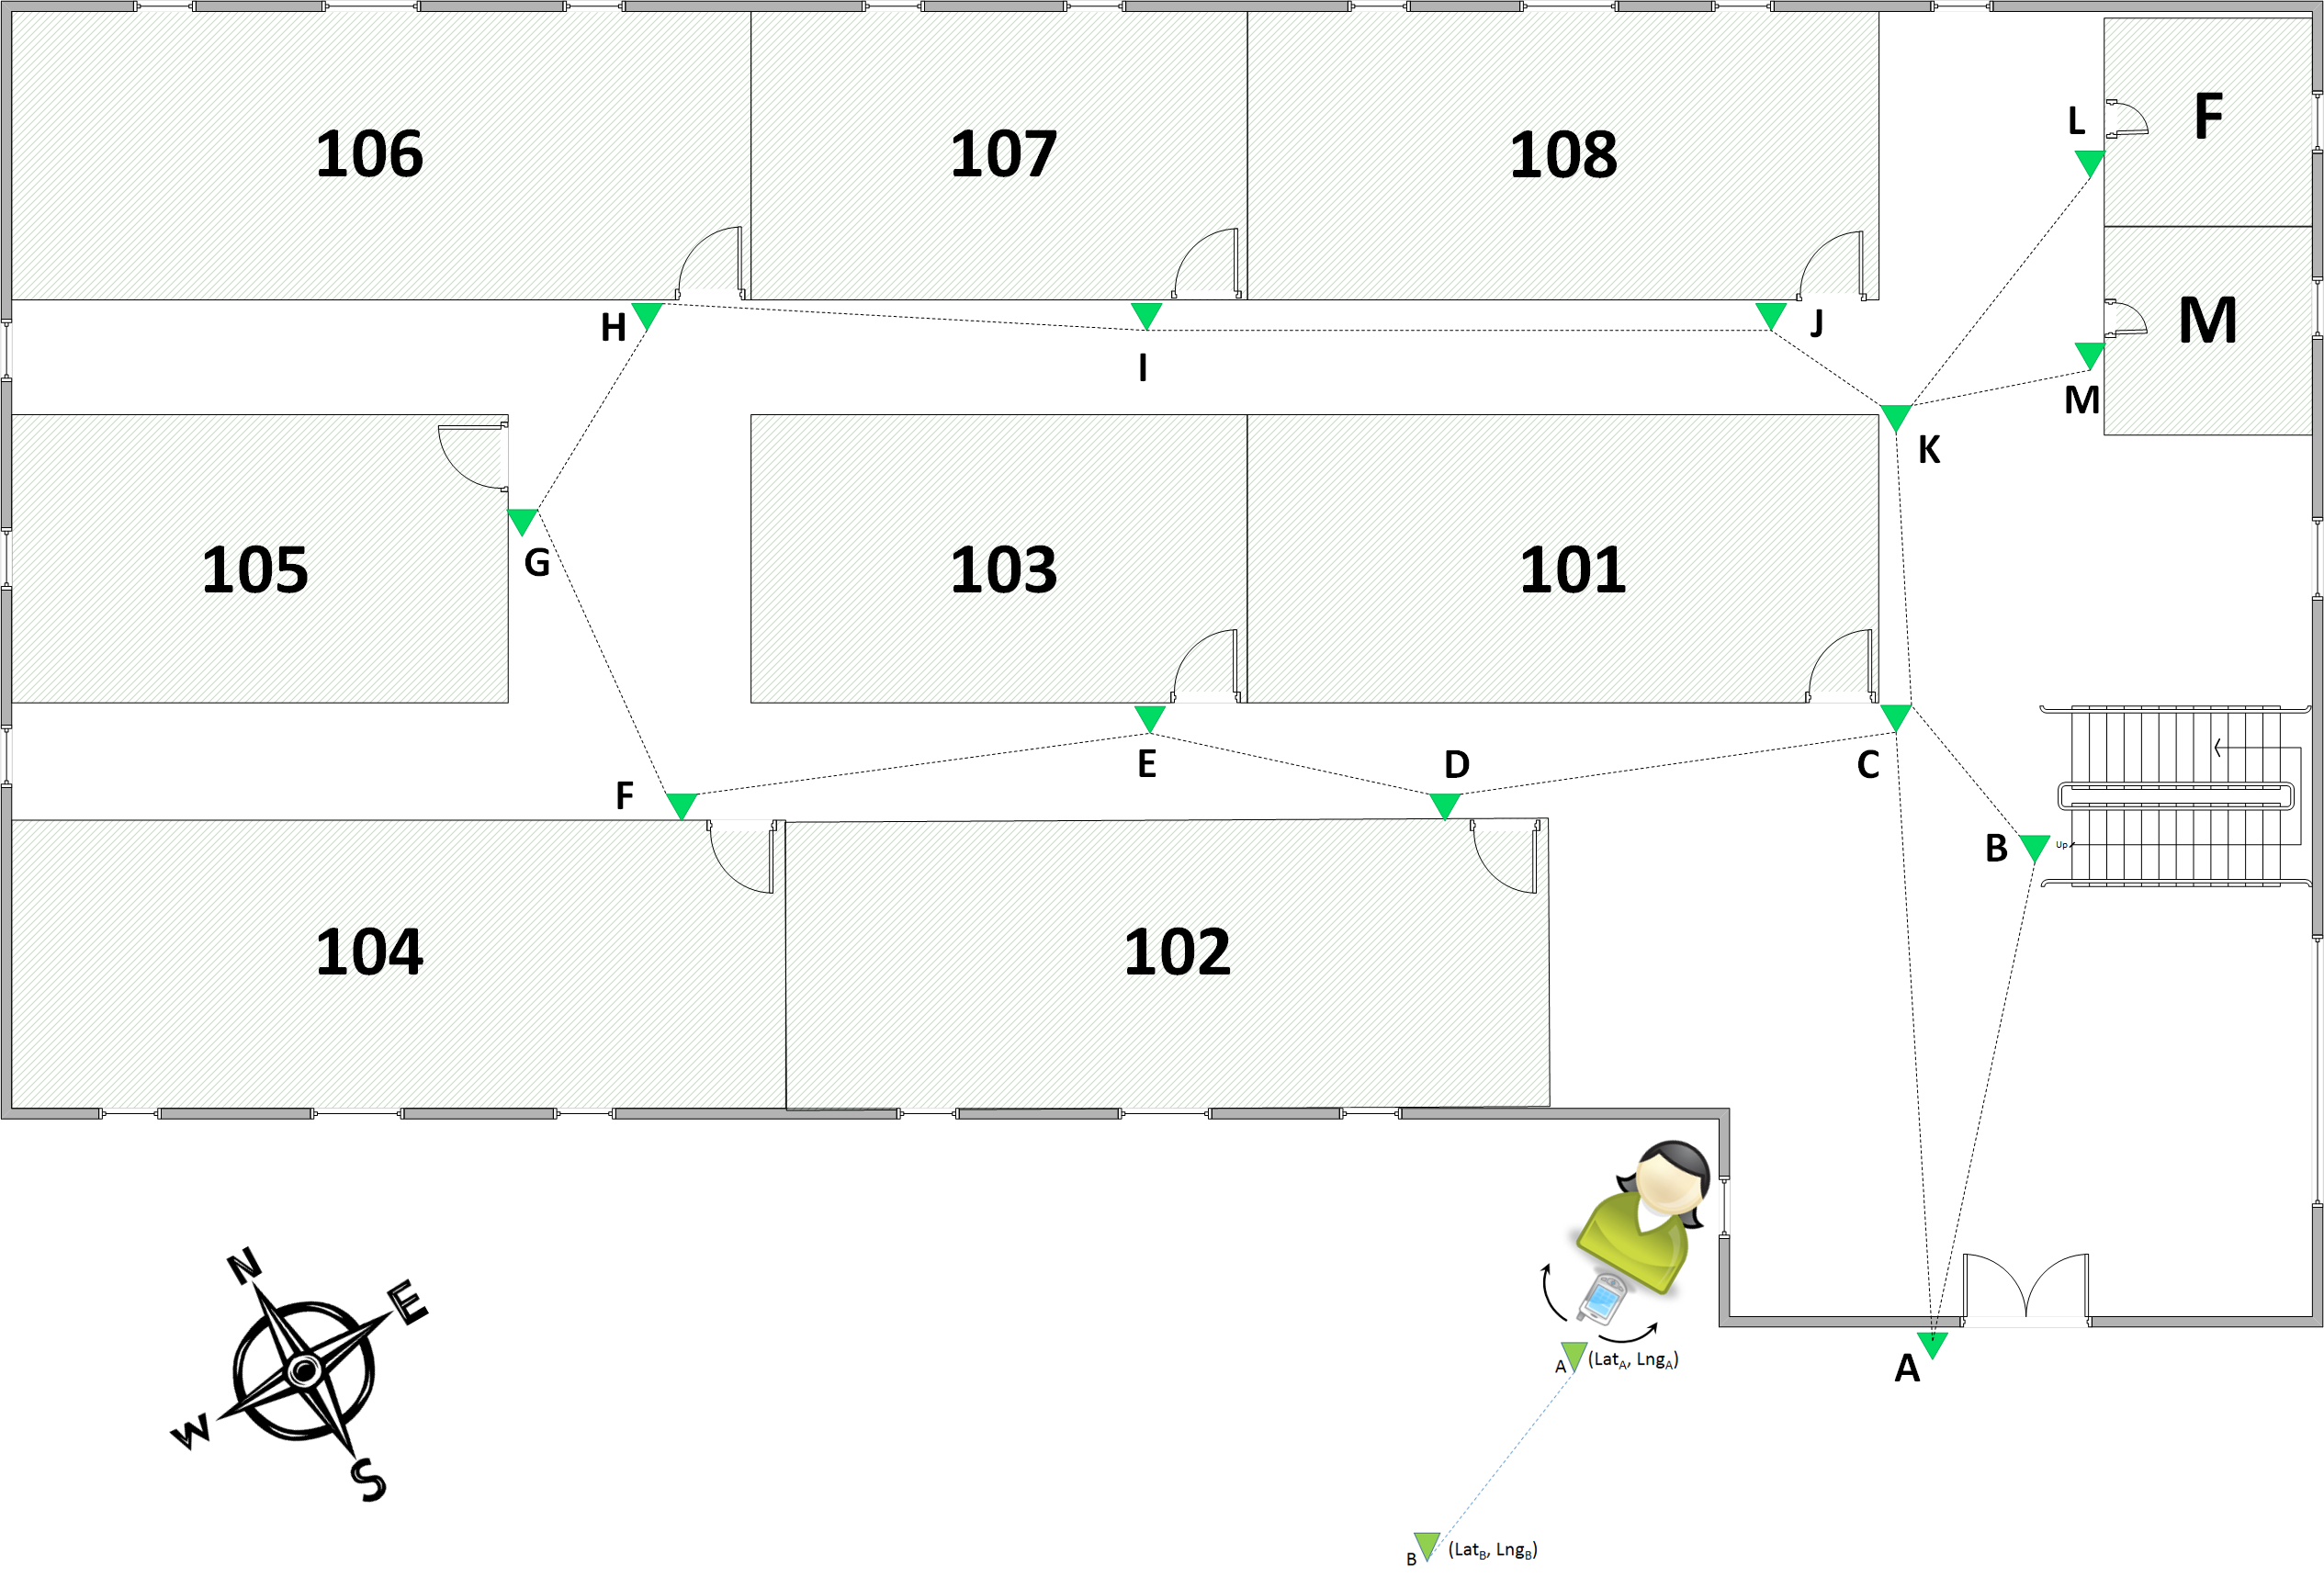At the entrance door, the user reads the poster even by touching it (NFC tag) or reading the QR code. Then the detection of a special URL that starts with "guidedroid://" triggers the GuideDroid application that identifies the building and then downloads the XML file that describes it. Following, the application speaks to inquire the user the desired room destination, presenting a list with the names of existing rooms in the building. The user can choose one by voice search. Once chosen the destination, the application calculates the route and asks the user to rotate the phone horizontally (see Figure 1) to determine the magnetic orientation to the next poster, i.e., the first stretch of the route. Once found, the phone vibrates and announces the distance the user must walk in that direction. At the end of this passage, she will found another poster that corresponds to the destination or an intermediate point where the process starts again to determine a new stretch.

*Figure 1 – Finding orientation and navigating*

For instance, to reach the room 107 since the building entrance, the smallest path is A, C, K, J, I. Once the user reads the poster A and after calculations, we ask the user to rotate her mobile phone that will vibrate when found the direction that points to the tag C and says, “Walk this direction by 4 meters”. When she reaches the tag C, the process repeats for the section between C and K, and so on until reaching the point I that represents the entrance of the room 107.

This process based on short stretches can be tedious at first, but the user does not need to repeat every time she goes through this same building. Once she learned the environment, she will only need the ask help to GuideDroid when the route to some destination is unknown. Semantically all the posters are equal and the process can start at any of them.

The system encompasses a component that helps the user to avoid collisions by warning her through sound signals (beeps) or pulsed vibrations. This component is made of an external ultrasonic sensor that constantly checks the way ahead and will start beeping (or vibrating) when detects some obstacle within the configured range.

To allow the visually impaired find the posters we propose they must be strongly contrasting pictures and their location must be marked by means of high-contrast tactile paving.

Evidence the solution works

There is a first version of the solution implemented and available for test and evaluation, currently being in use on some buildings at the site of HP Brazil R&D in Porto Alegre/RS. With a handheld device containing the sensor, this prototype can precisely detect obstacles as far as 3m with an adjustable distance range, beside the indoor navigation functionality. We presented it as a seminar for the HP Able Week, August 2013 in Brazil and presented on the HP Brazil R&D Poster Session, October 2013, with several good recognitions and feedbacks.

Competitive approaches

Indoor positioning system strategies range from ultrasound, passive tags (RFID), to Wi-Fi. Although valuable, these solutions are in some cases experimental, or require significant changes to the target infrastructure. NFC Internal [1] adopts a practical, low-cost solution by using NFC tags as means of localization. The proposed model associates internal coordinates based on the spatial information maps of the buildings.

The work presented on this paper uses a very similar navigation model, but redefines the user interaction completely to be suitable for users with vision impairments. That imposes a completely different user experience that should not rely only on visual feedback, but also on other sensors available in smartphones. For this purpose, the reference poster is read (by the QR code or the NFC tag), orientation uses the magnetic field sensors, and vibration indicates when we find the correct direction as described above. Besides, by adopting the widely used geographic coordinates system, we can easily integrate with several other outdoor navigation systems.

Current status and Next steps

Our first prototype has demonstrated that this is an efficient, inexpensive and highly available solution for indoor navigation that can be used for both, the visually impaired or not. We were experimenting different ways to facilitate the location of the posters and also different minimum distances between them in order to minimize errors due the discrepancy of the magnetic fields while using the compass built-in on the smartphones.

To go further and refine this solution, we are working on improving mechanisms to get Geo-magnetic orientation in a more reliable manner, as well as seeking other ways to point out the posters precisely. In addition, we are aiming to improve the way the visually impaired can find that posters since it depends on the severity level of the blindness. Wireless sound beacons, infrared ink and several other alternatives are being considered. Another point for improving the solution is to expand the assistance services provided by the HP Cloud infrastructure, providing a broader set of aid features that certainly would increase significantly its access and use.

References

[1] NFC Internal. <http://nfclab.isikun.edu.tr/papers/nfcinternal.pdf>. Accessed October 12, 2013