# Wave order dashboard

Summary:

Develop a page builder for displaying statistics data for dashboard.

The final page will be looks like:

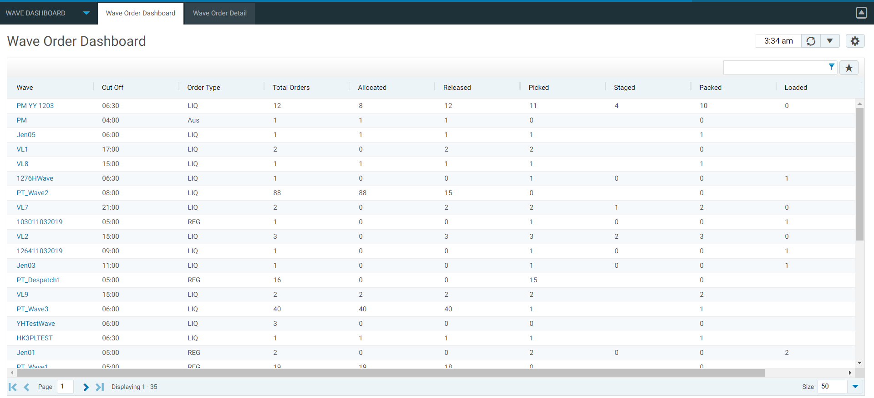

When you click the wave link, it flows to detail page:

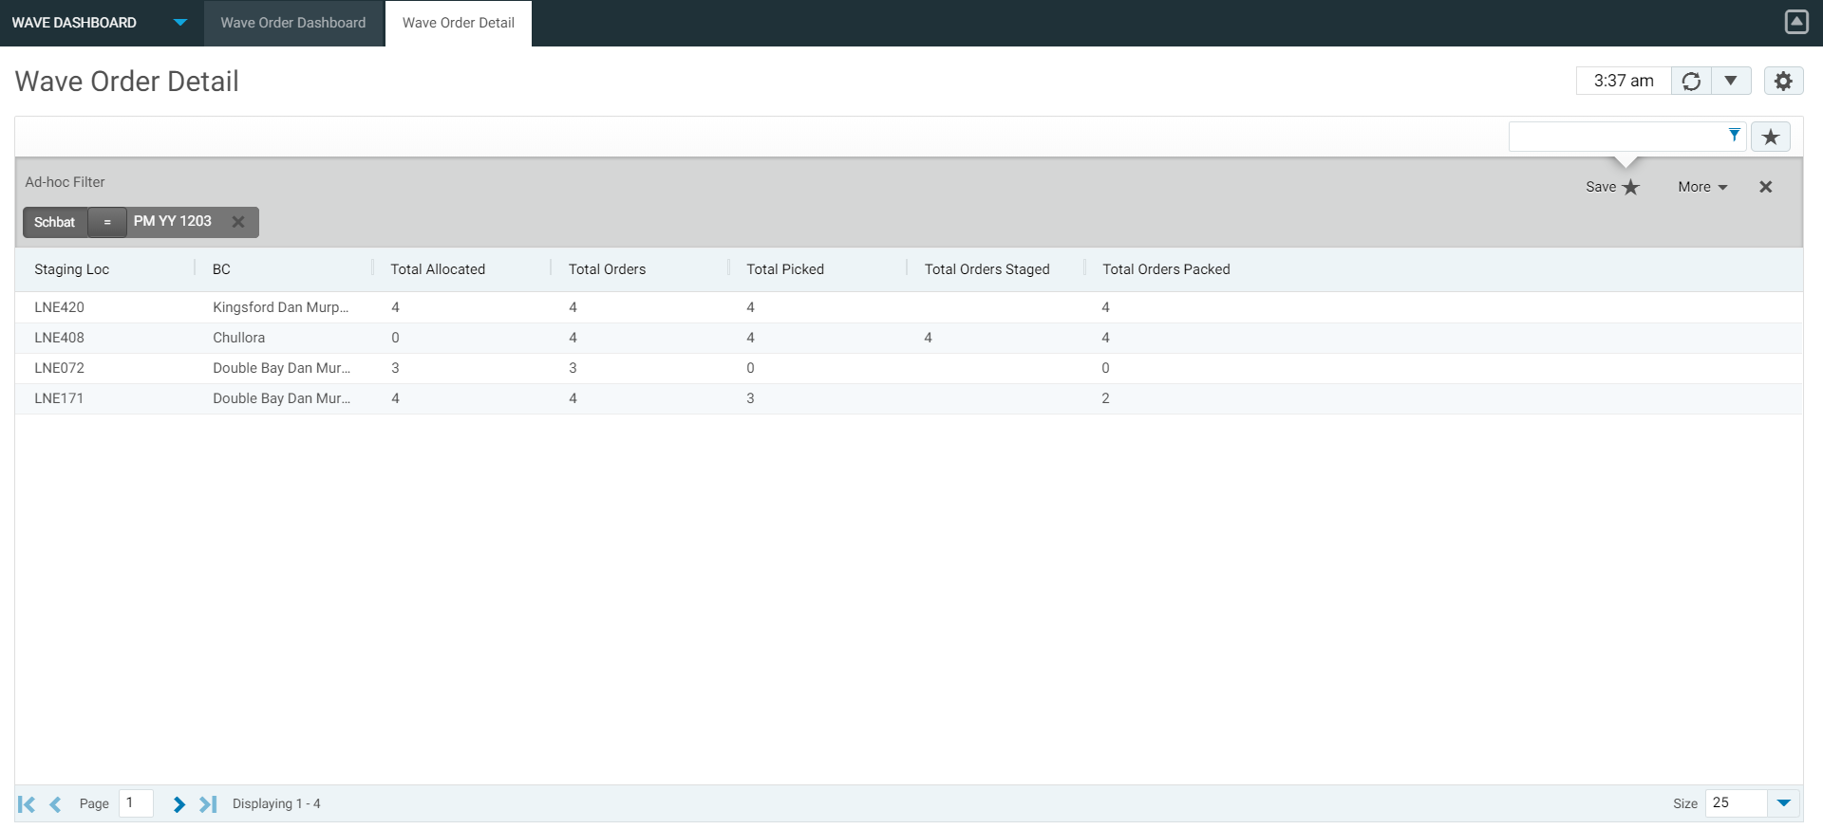

Deployment:

1. Put below 4 files into folder les/data/ws folder, and the 2 mcmd files into les/src/cmdsrc/usrint folder:

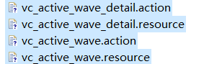



2. Run ‘mbuild’, restart your moca service and refs server.

3. go to menu “Extensions->Page Builder” to add 2 grids as below:

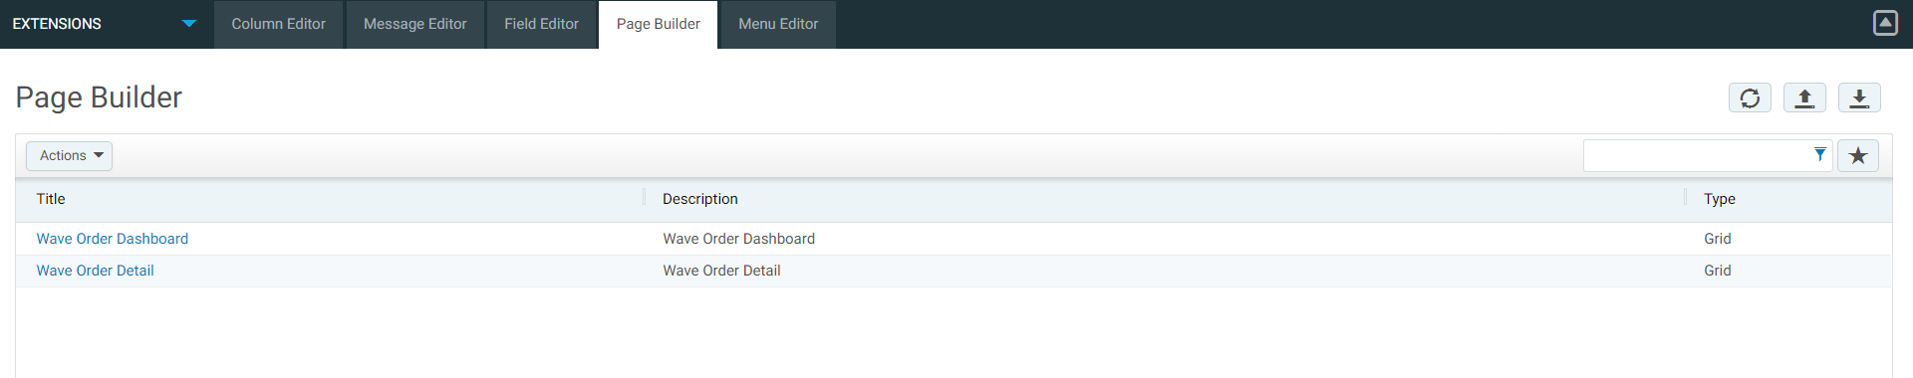

4. Add dashboard page:

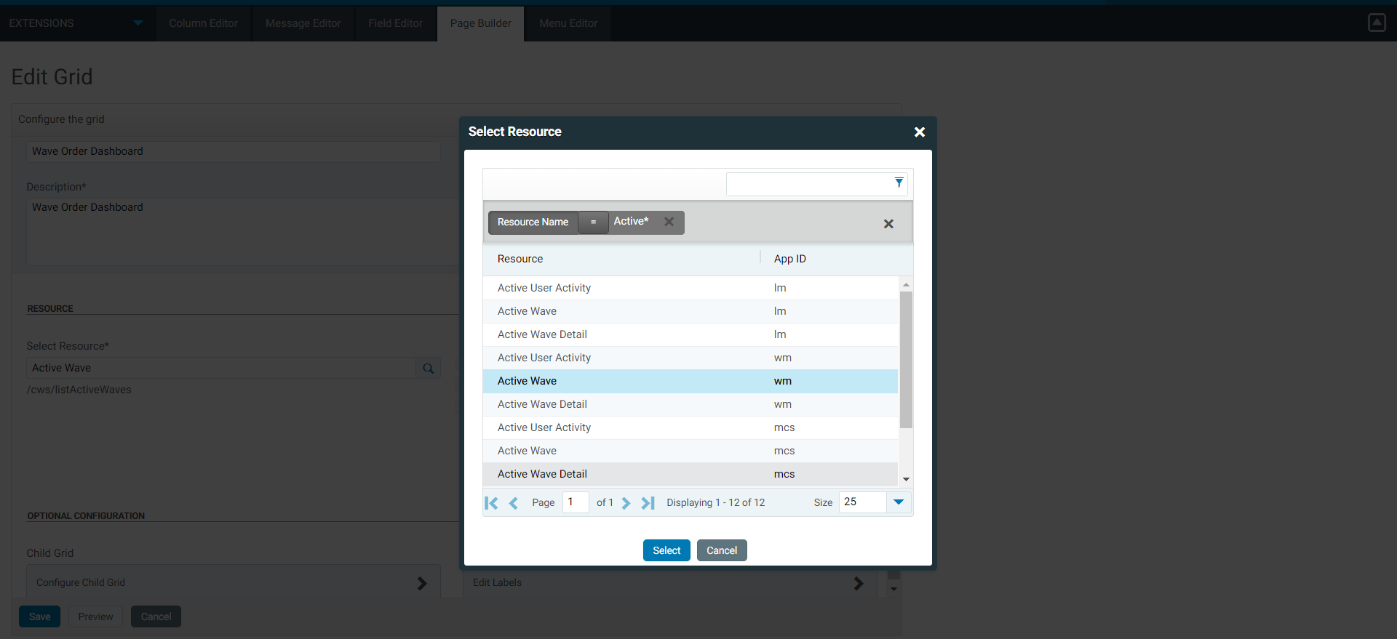

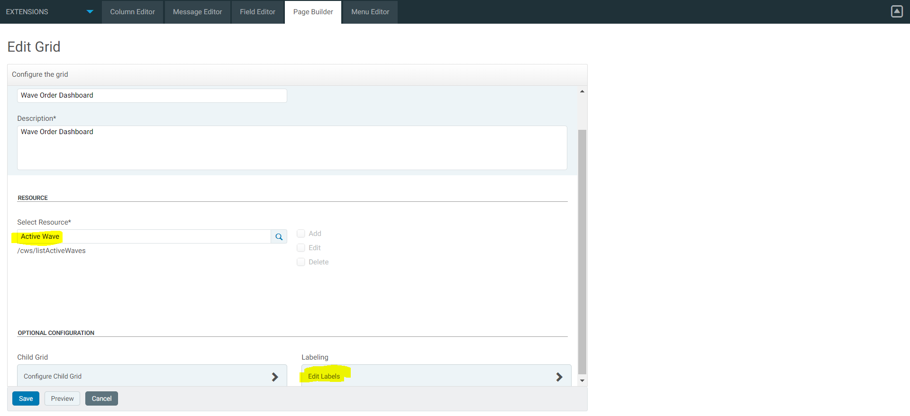

You can click ‘Labeling’ to edit column name as you need:

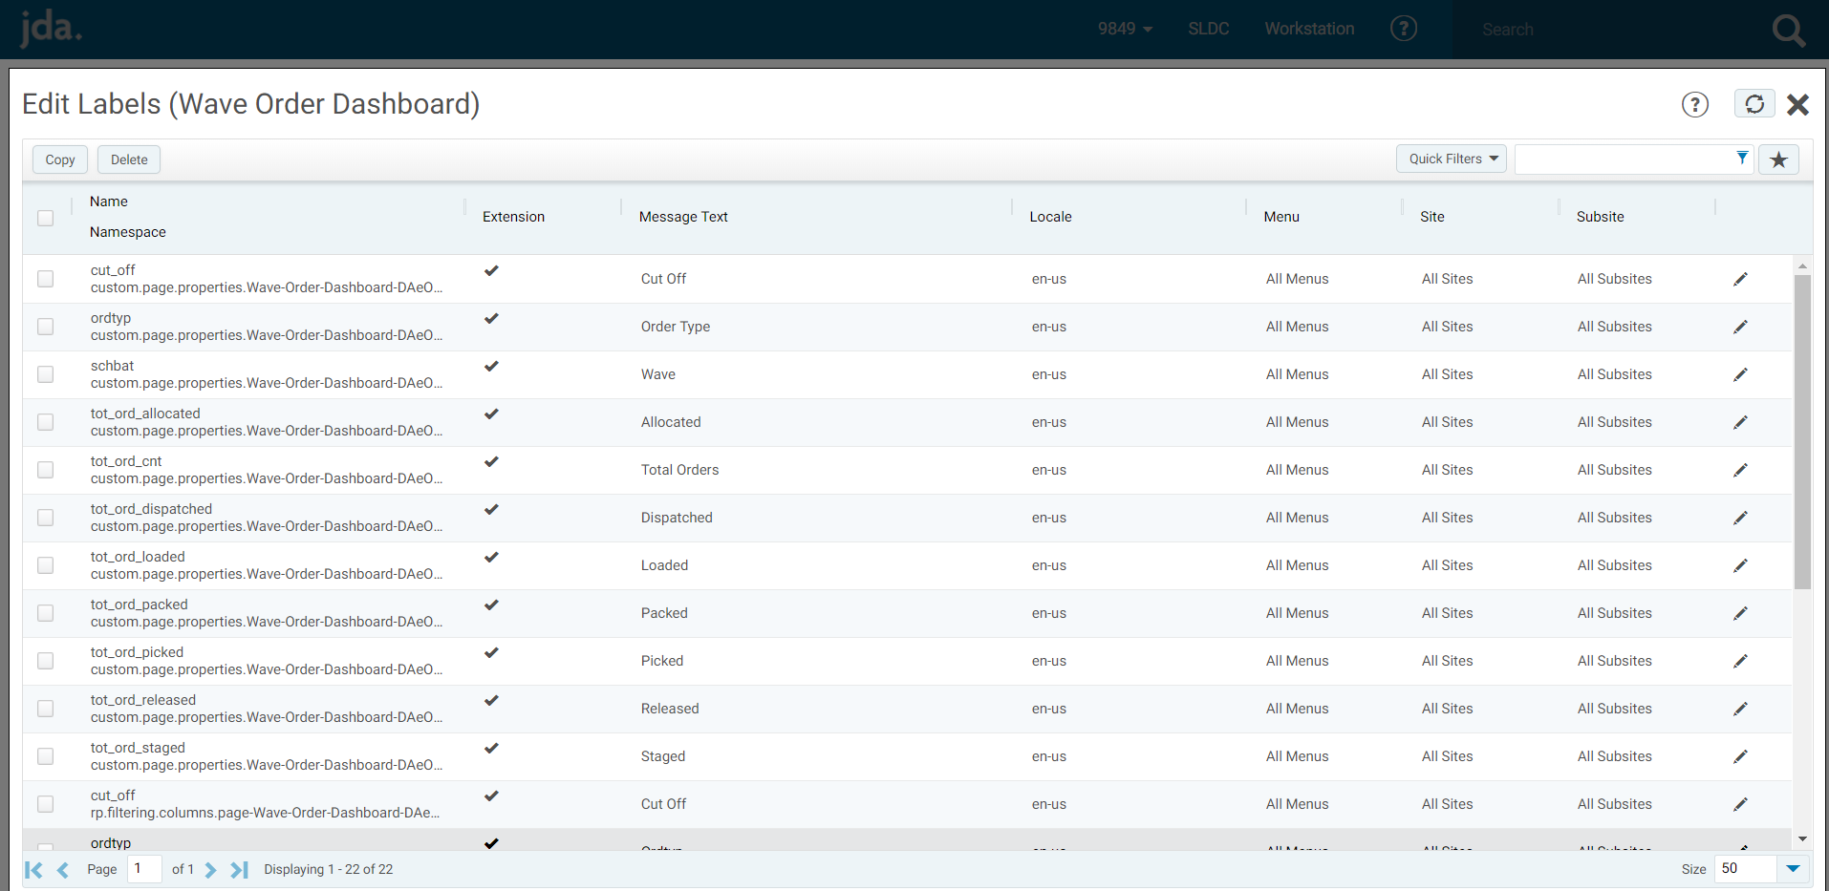

5. Same way to add detail page:

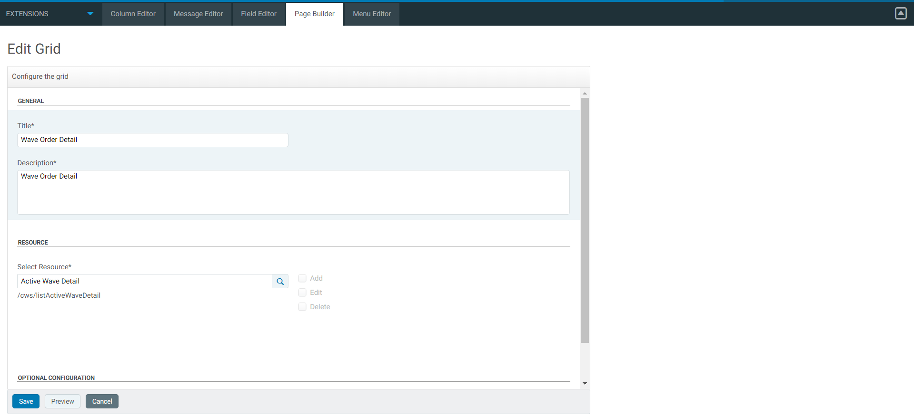

6. Once we added 2 grids, we can add one menu ‘Wave Dashboard’ with 2 pages:

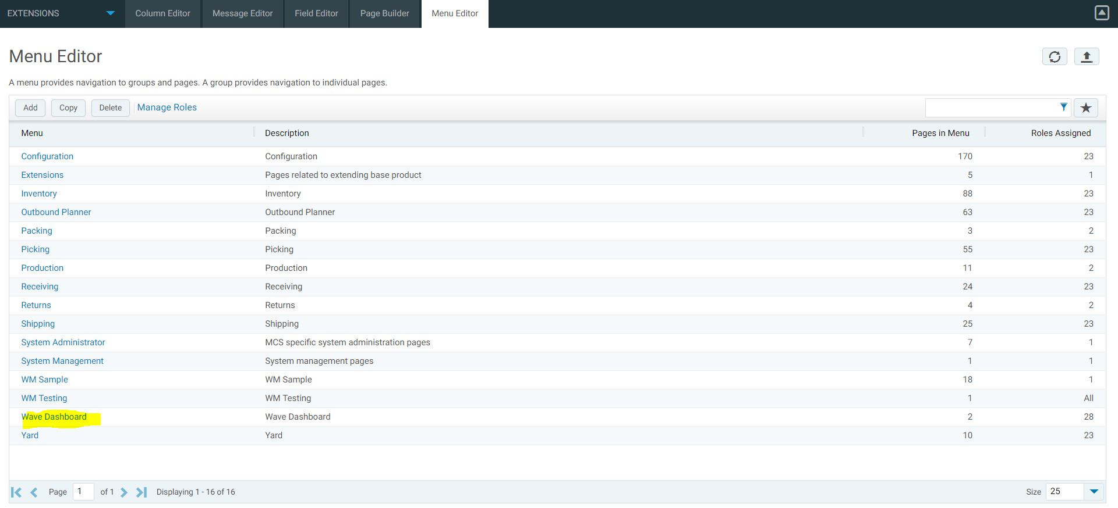

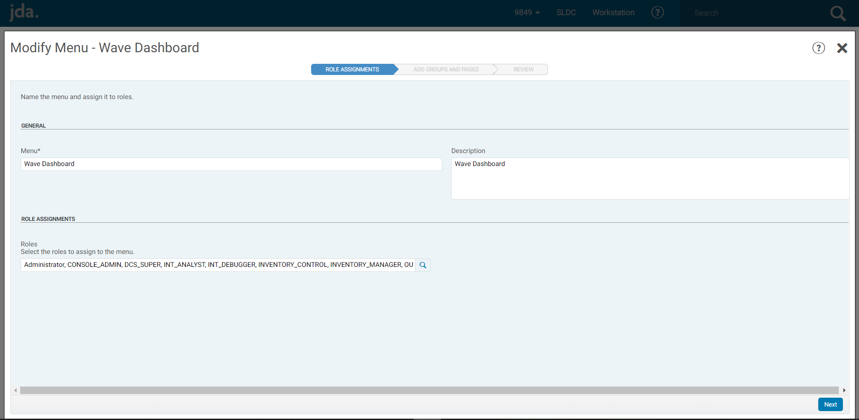

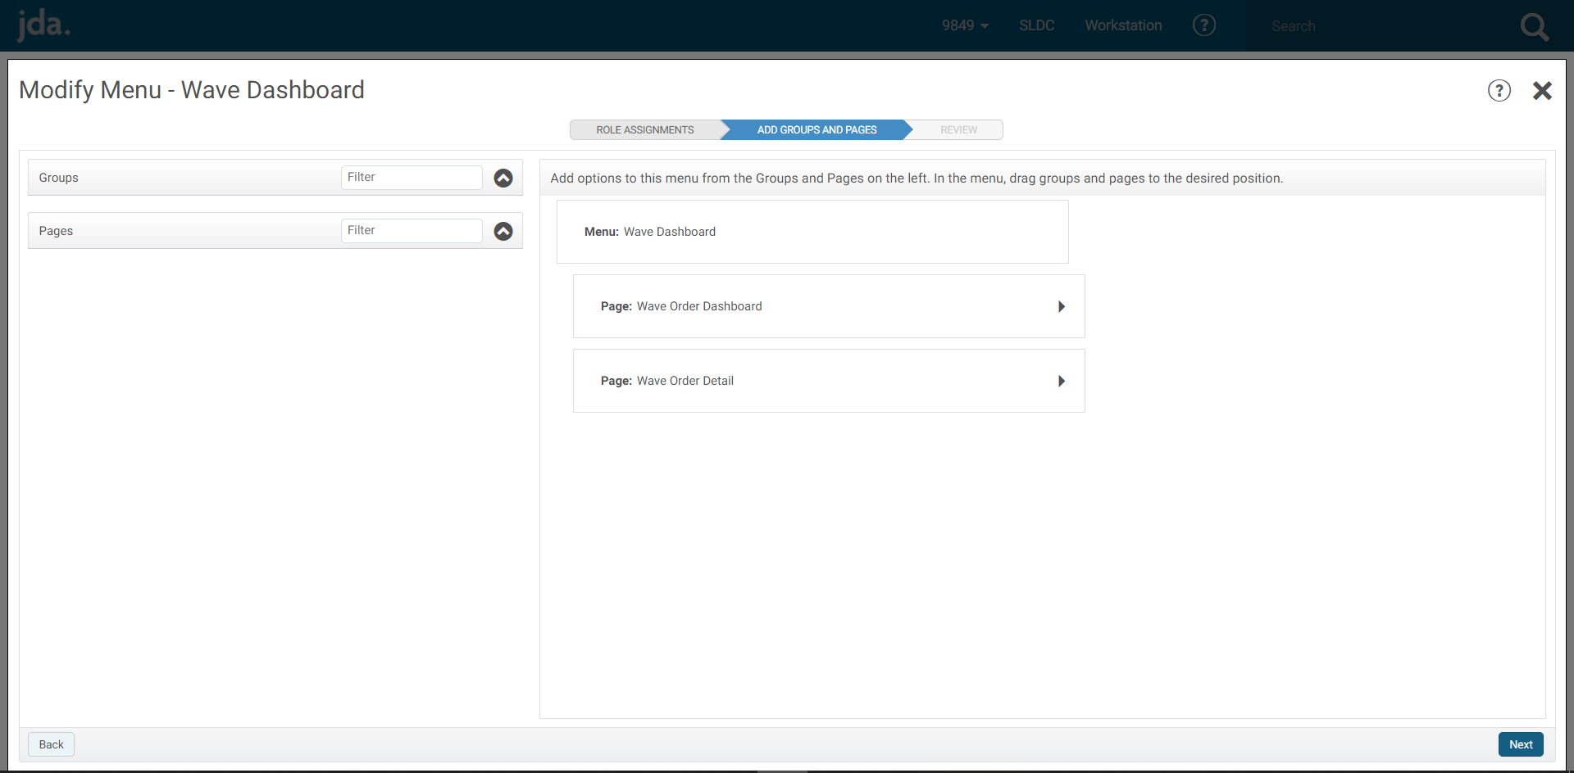

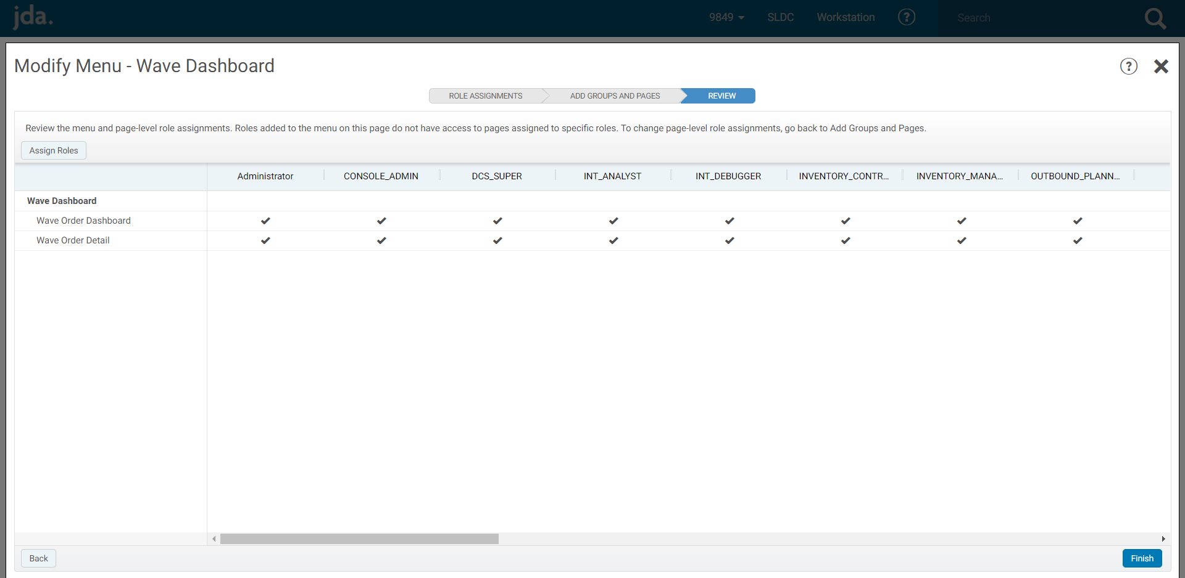

7. Refresh the browser to get the menu added:

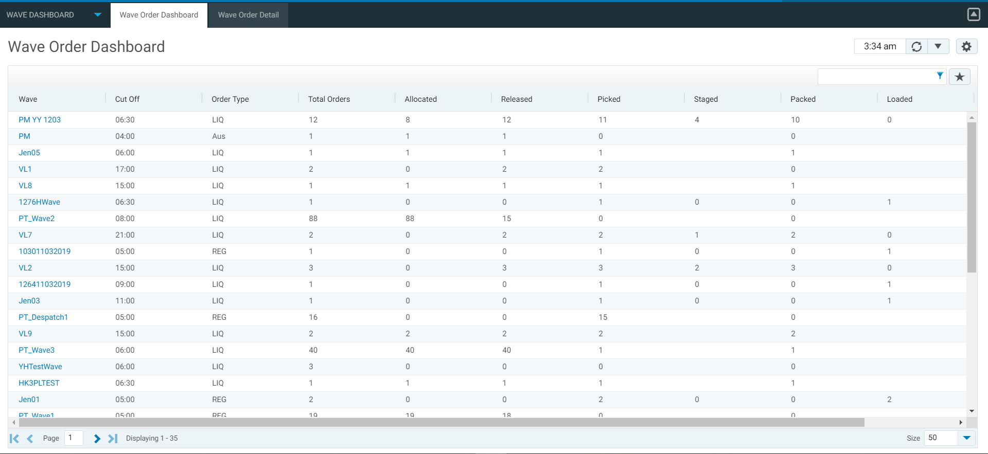

8. Config the ‘Wave’ column as a link:

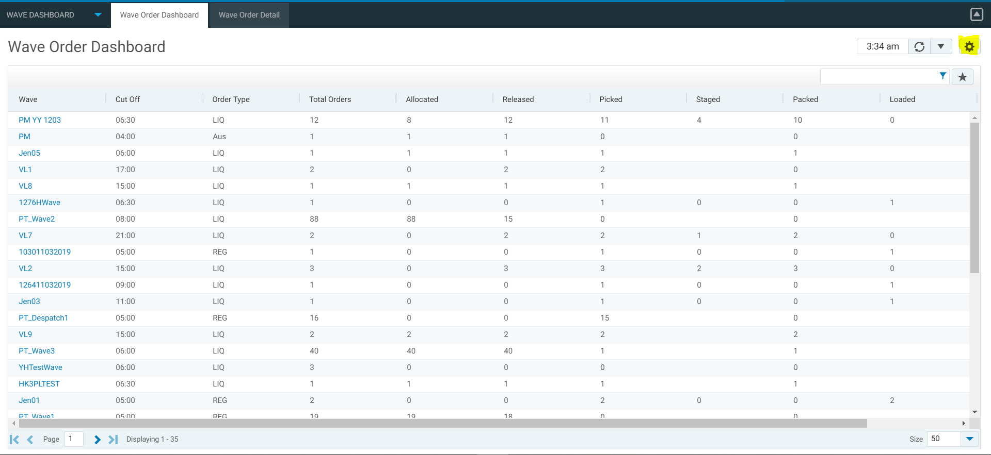

Click the right-top setup icon:

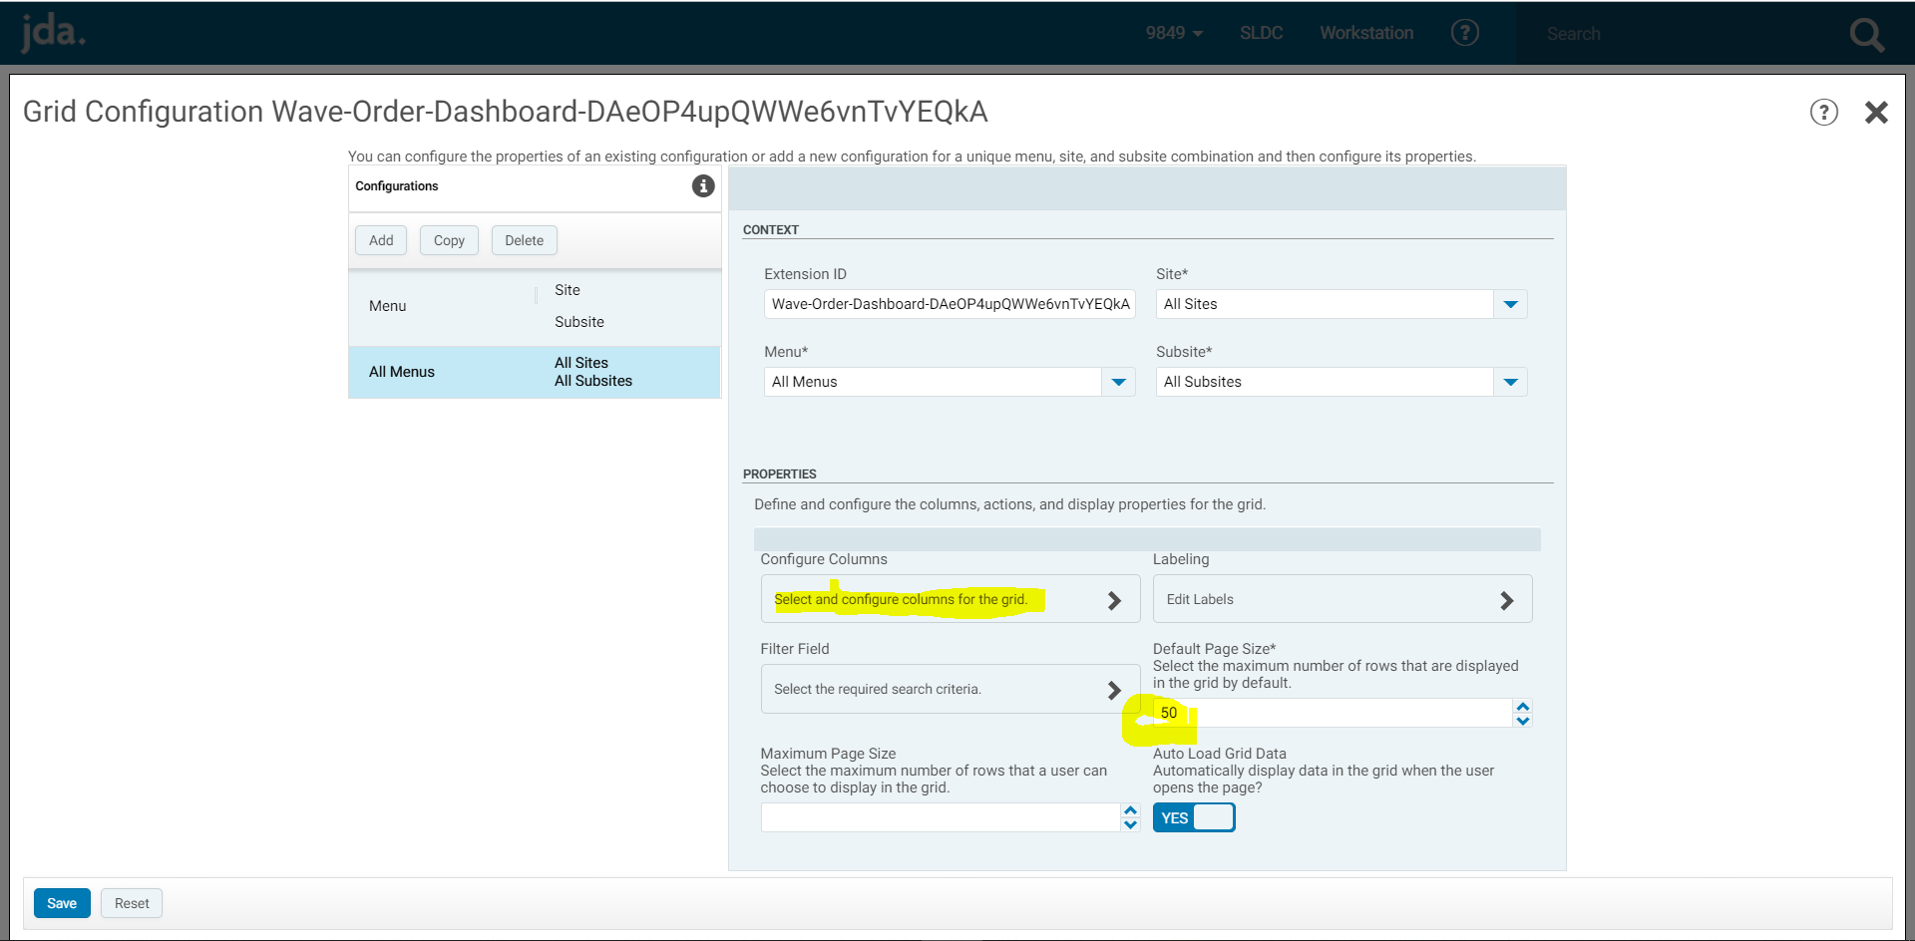

In this page you can setup display 50 rows per page, click ‘Configure Column’ to config link:

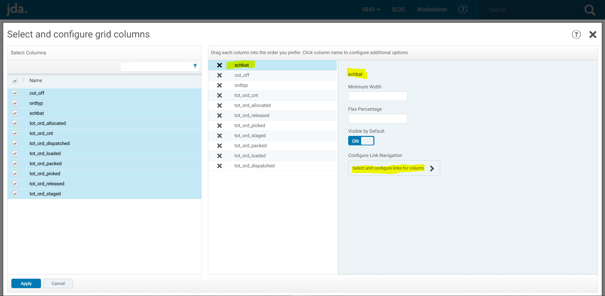

Select the column ‘schbat’ and click ‘Configure Link Navigation’:

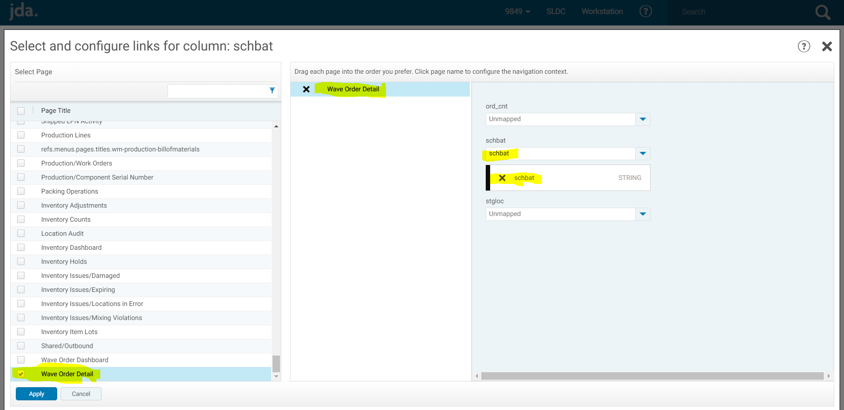

Select page ‘Wave Order Detail’ and select schbat mapped to schbat.

Note: The 2 list commands include 2 queries which may need to adjusted to fit your business.

Enjoy and good luck!