# Guide to install WMS 9.1

1. Install Sql server 2014.
2. Create an administrator user sam, password sam.
3. Login the sql server management tool, goto to Security/Logins, Add the user sam into login.
4. Create a database wm9.1
5. Execute ‘alter database [wm9.1] SET READ_COMMITTED_SNAPSHOT ON’
6. To add the "Log on as a service" right to an account on your local computer
   1. To open Local Security Policy, click Start, point to Control Panel, point to Administrative Tools, and then double-click Local Security Policy.
   2. In the console tree, double-click Local Policies, and then click User Rights Assignment.
   3. In the details pane, double-click Log on as a service.
   4. Click Add User or Group, and then add the appropriate account to the list of accounts that possess the Log on as a service right.
7. Selecting OS/authorization, by typing user sam, password sam.
8. Type wm9.1 as database to connect to.
9. Click next to run the setup, you should be able to see screenshot like:

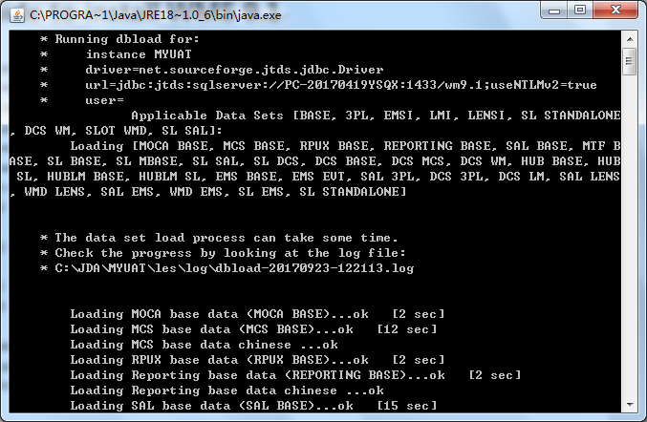

1. After installation, if the service cannot be started success because of db login, then I changed the usr/pwd for db as:
2. For Moca, goto LES/Data/registry, in [Database]section, use username=sa, password=sam, please note I use db account ‘sa’
3. For REFS, goto setting directory, change the setting.xml with below usr/pwd:

<user>sa</user>

<password>sam</password>

1. If everything goes well, you should be able to login with super/super:

