**Scenario of packing**

Configuration:

1. Go to Configuration->Equipment->Hardware->Workstations->Add to add work station PACKSTN001(check the page for detail config).
2. Go to Configuration->Outbound->Packing->Pack Station to config the Pack station (remember to select the ‘Processing destination zone’ as ‘Production stage 1st floor’)
3. Go to Picking->Configuration->Movement->Movement paths to add movement path PATH_FOR_PACKING, for detail pick which from PF2FLOOR to SPSTG (small parcel stage), go through hop PSTG1 which is ‘Production stage 1st floor’.

Create order ORDPAK001:

Prtnum = 999-0273C

Order qty = 5.

Steps:

1. Plan order into wave: BAT000000N, select destination movement zone as small parcel stage.
2. Allocate wave system generate 1 carton pick.
3. Go to work queue assign the carton pick to SAM
4. Login RF to get the directed work.
5. Perform the directed carton pick, and after RF prompt carton pick completed, system will auto deposit the inventory to hop location ‘P-STG1-03-0’which belongs to ‘Production stage 1st floor’

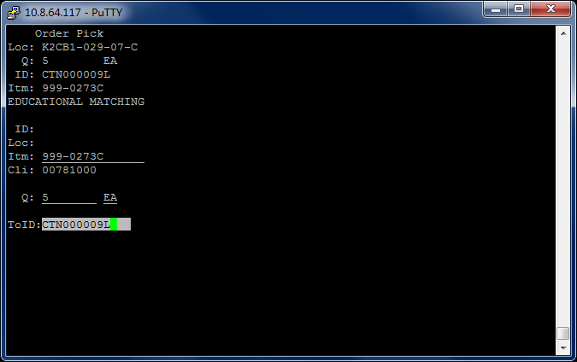

1. Go to Menu Packing->Packing.

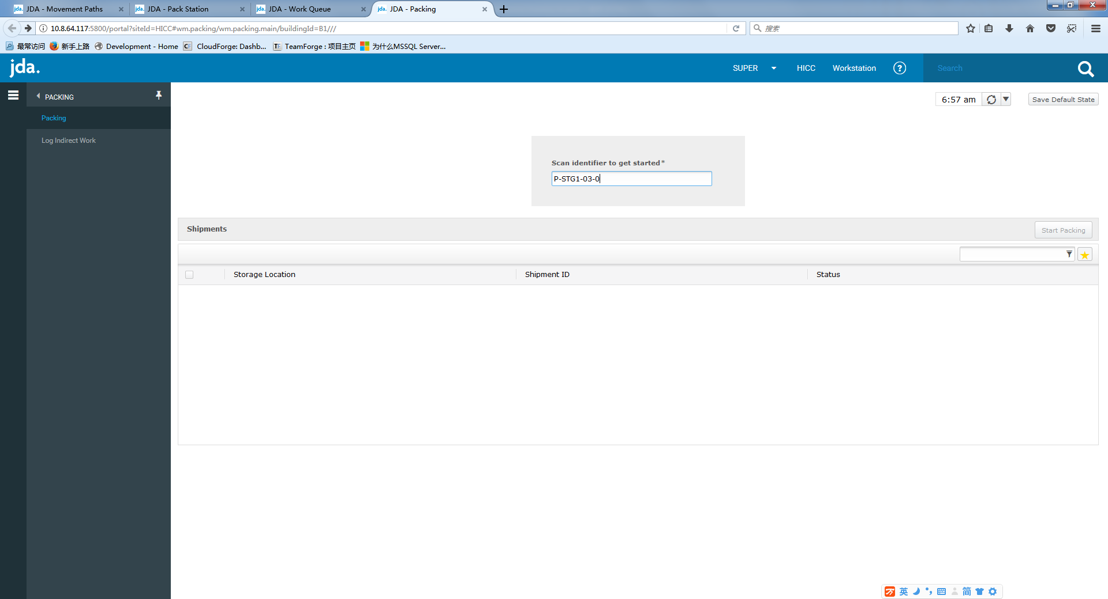

Scan the location P-STG1-03-0, it shows inventory:

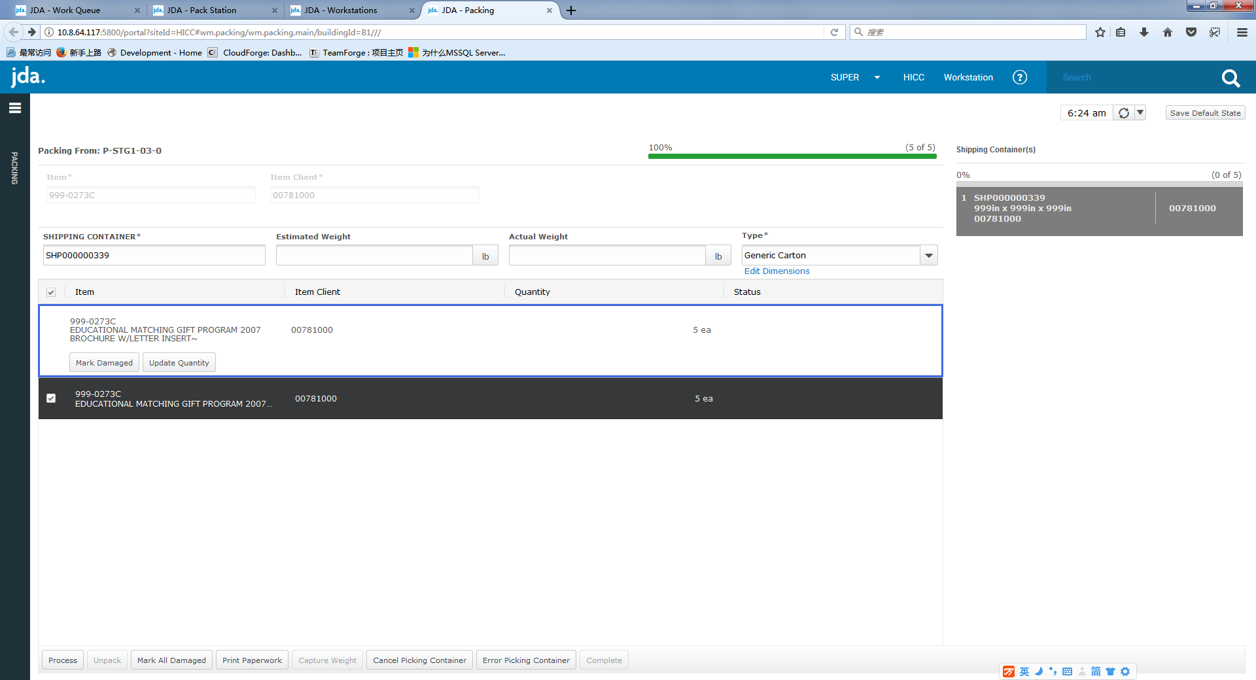

Try to split 3 from 5:

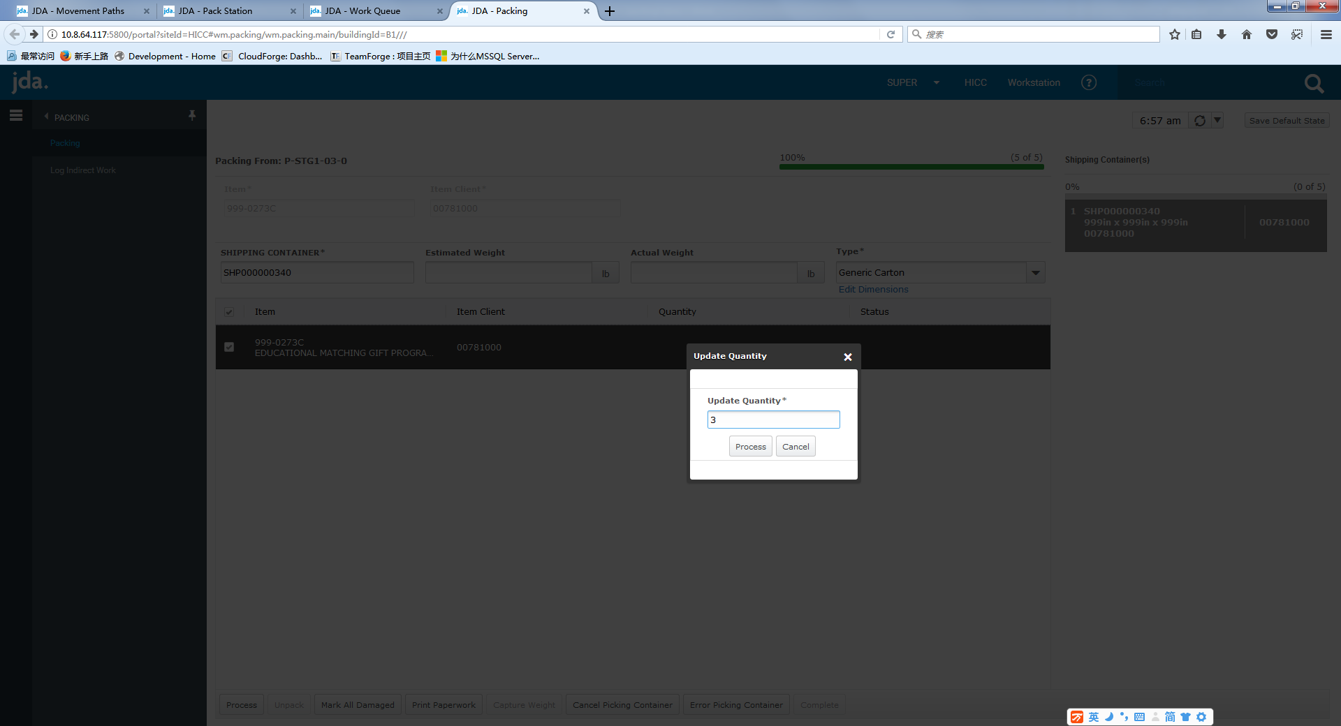

For remaining 2, scan a new shipping container ID and click process:

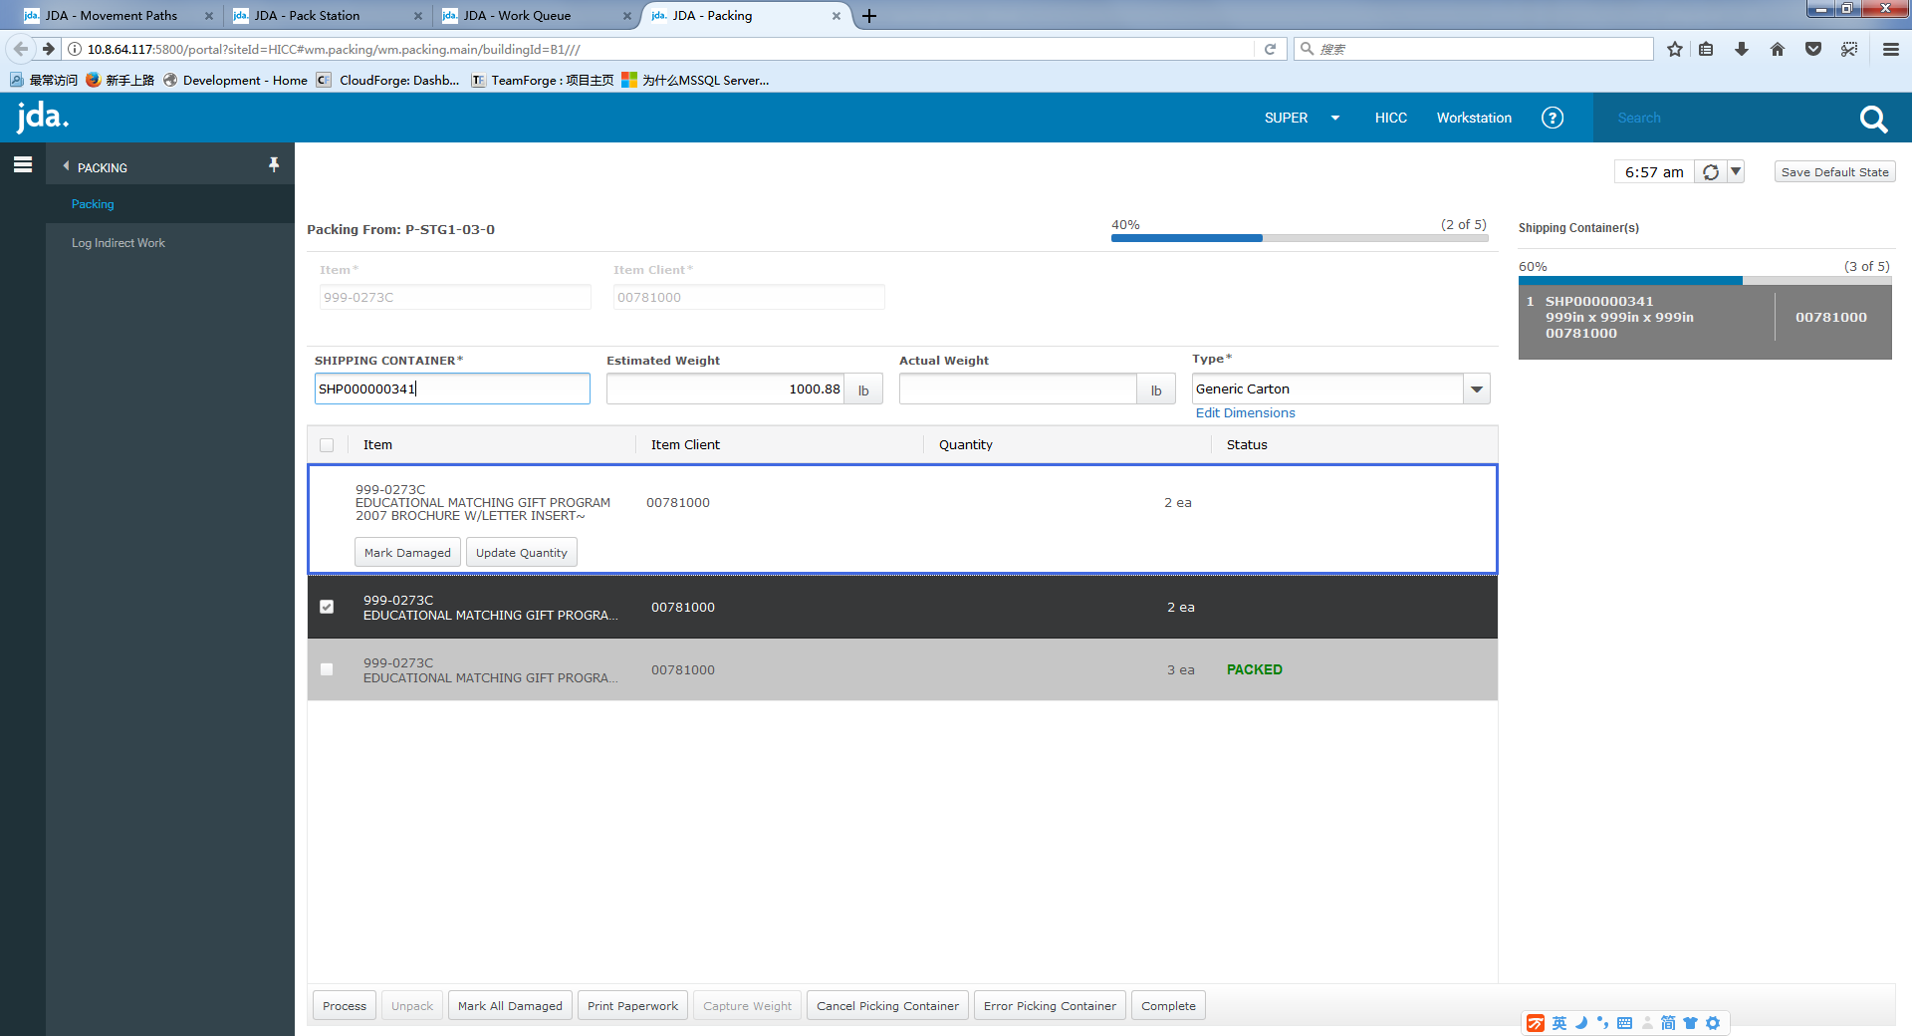

One issue, the shipping container still has 5 instead of splitting to 2 and 3.

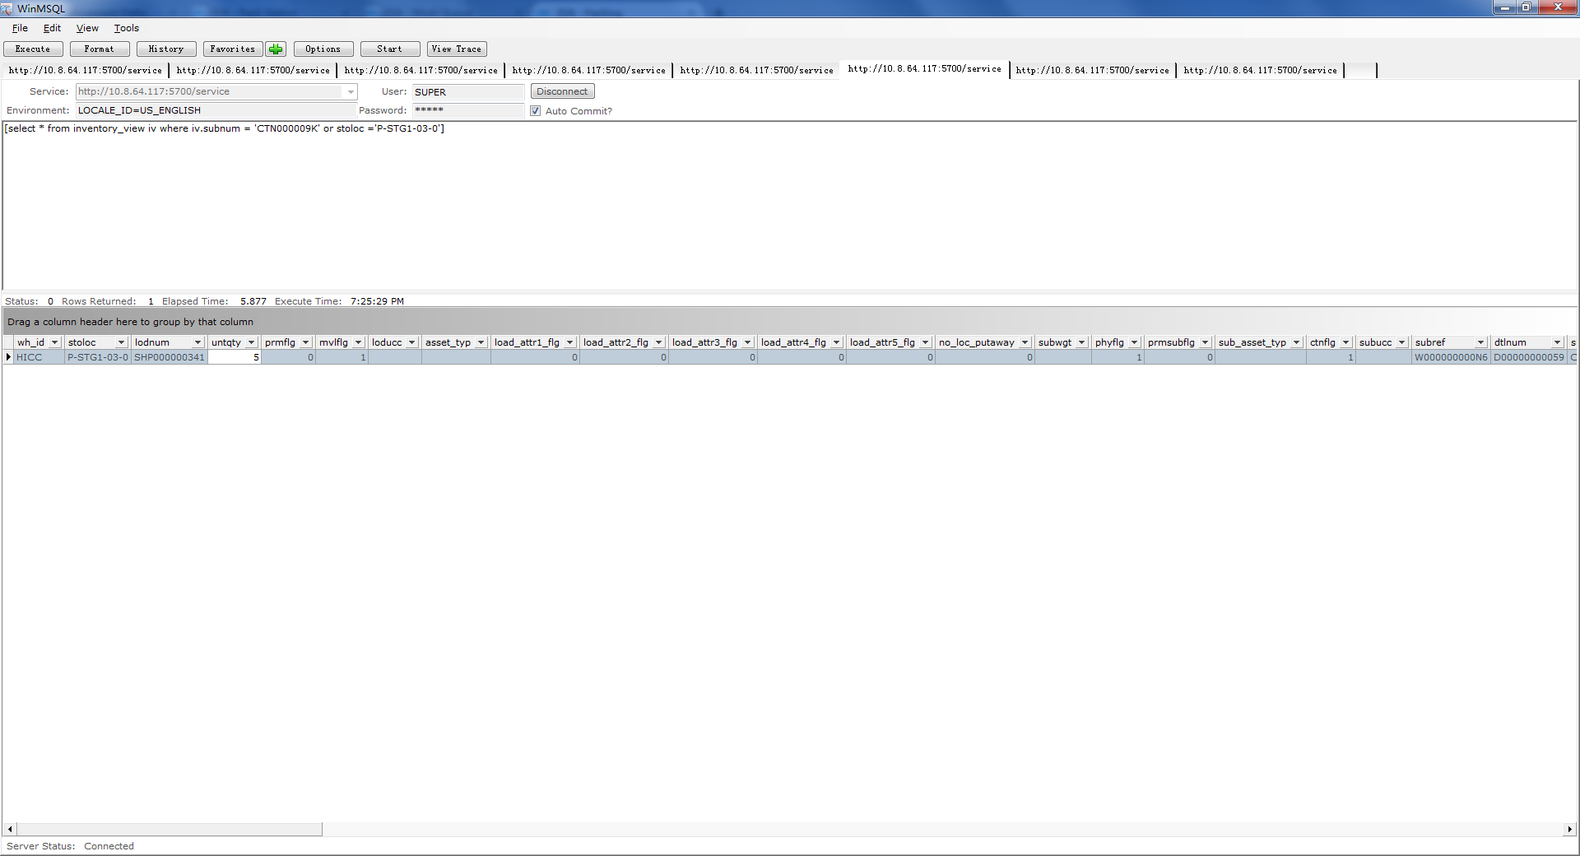

To reproduce this, you can go to RF unpick the inventory and wave allocate again to start over.