# How to run script get the work data

1. Query Script:

*publish data*

*where wh_id = 'LR1'*

*and usr_id = 'HUJUN'*

*and dateRange =*

*[to_char(trndte, 'yyyy-mm-dd hh24:mi:ss') >= '2017-08-28 10:00:00'*

*and to_char(trndte, 'yyyy-mm-dd hh24:mi:ss') <= '2017-09-1 10:00:00']*

*|*

*[select usr_id,*

*sum(case when* ***actcod*** *= 'TRLR_LOAD' and to_arecod = 'SHIP' then* ***1***

*else* ***0***

*end) LPN_LOADED,*

*sum(case when* ***actcod*** *= 'LSTPCK' and oprcod = 'OC-LISTCS' and to_arecod = 'RDTS' then* ***1***

*else* ***0***

*end) CASES_PICKED,*

*sum(case when* ***actcod*** *= 'PALPCK' and oprcod = 'OC-PAPCK' and to_arecod = 'RDTS' then* ***1***

*else* ***0***

*end) FULL_PALLET_PICKED,*

*sum(case when* ***actcod*** *= 'PALRPL' and oprcod = 'OC-ERPL' and fr_arecod = 'RDTS' then* ***1***

*else* ***0***

*end) EMRPL_PALLET_PICKED,*

*sum(case when* ***actcod*** *= 'PALRPL' and oprcod = 'OC-TRPL' and fr_arecod = 'RDTS' then* ***1***

*else* ***0***

*end) TRLRPL_PALLET_PICKED,*

*sum(case when* ***actcod*** *= 'FL_XFR_PTWY' and oprcod = 'UTR' and fr_arecod = 'RDTS' then* ***1***

*else* ***0***

*end) PUTAWY_PALLET,*

*sum(case when* ***actcod*** *= 'FL_XFR' and oprcod = 'UTR' and fr_arecod = 'RDTS' and (frstol not like 'V%') then* ***1***

*else* ***0***

*end) TRANSFER_PALLET,*

*sum(case when* ***actcod*** *= 'ASN_TRUST' and oprcod = 'URC' and fr_arecod = 'RDTS' then* ***1***

*else* ***0***

*end) ASN_IDNFY,*

*sum(case when* ***actcod*** *= 'RCV' and oprcod = 'UID' and fr_arecod = 'EXPR' then* ***1***

*else* ***0***

*end) NON_ASN_IDNFY,*

*sum(case when (frstol like 'VS%' or frstol like 'VAS%') and* ***actcod*** *= 'FL_XFR' and oprcod = 'UTR' then* ***1***

*else* ***0***

*end) VAS_PALLET_MOVED*

*from* ***dlytrn***

*where wh_id = @wh_id*

*and @dateRange:raw*

*and @+usr_id*

*and usr_id in (select usr_id*

*from* ***les_usr_ath***

*where locale_id = 'SIMPLIFIED_CHINESE')*

*group by usr_id]*

1. Go to Dlx, open menu ‘Server Command Operations’:

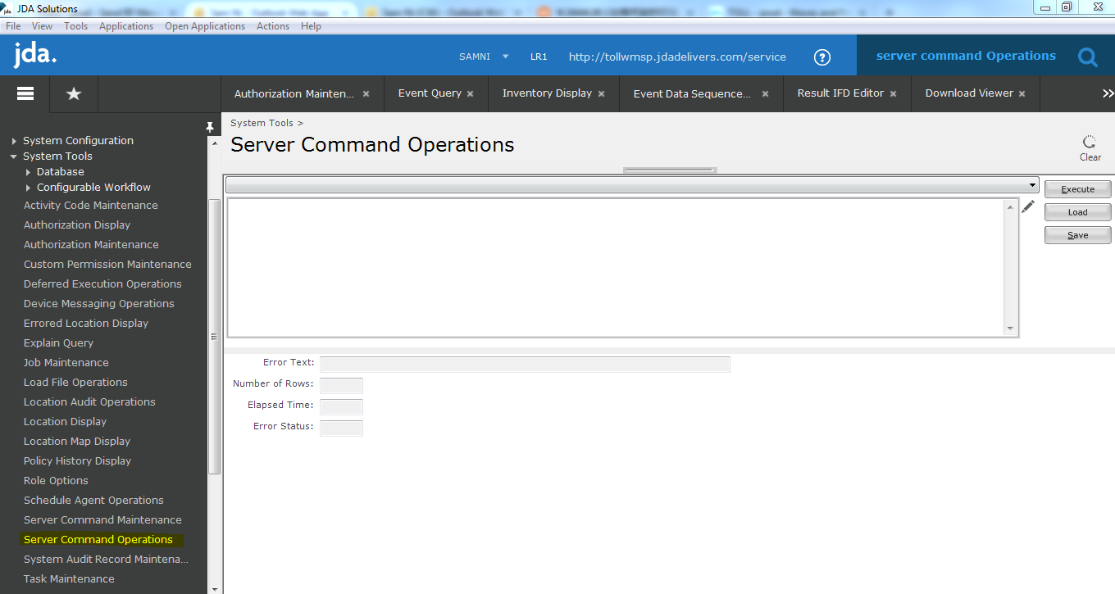

1. Paste above query into the query box and click ‘execute’:

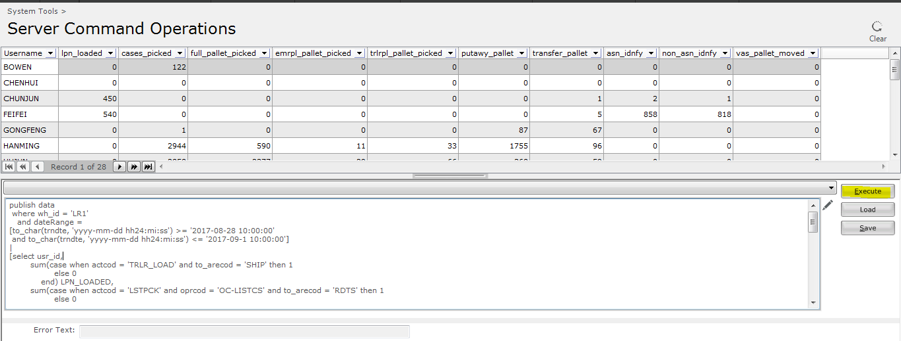

It will return below columns:

**Username:** The user ID.

**Lpn_loaded:** The number of pallet loaded to trailer (装车的托盘数).

**Cases_picked:** Total number of cases did by loose picking (散拣的箱数).

**Full_pallet_picked:** Total number of pallet picking (整托拣的托盘数).

**Emrpl_pallet_picked:** Total number of emergency replenishment picks (紧急补货的托盘数).

**Trlrpl_pallet_picked:** Total number of trigger replenishment picks (触发式补货的托盘数).

**Putaway_pallet:** Total number of pallet putaway(上架的托盘数).

**Transfer_pallet:** Total number of pallet transferred from one place to another place (库存转移的数量).

**Asn_idnfy:** Total number of ASN received (嘉兴大标的托盘收货数量).

**Non_asn_idnfy:** Total number of non-ASN received (欧洲的托盘收货数量).

**Vas_pallet_moved:** Total number of pallet moved from VAS stage to VAS processing area and from VAS processing area to shipping stage area (从VAS集结区转移到VAS贴标区，以及从贴标区到发货集结区的托盘转移数量).

1. Tips for query(查询条件)：

*publish data*

*where wh_id = 'LR1'*

*and usr_id = 'HUJUN'*

*and dateRange =*

*[to_char(trndte, 'yyyy-mm-dd hh24:mi:ss') >= '2017-08-28 10:00:00'*

*and to_char(trndte, 'yyyy-mm-dd hh24:mi:ss') <= '2017-09-1 10:00:00']*

If you want to query one specific user’s data, provide the usr_id, without usr_id will return all Chinese users’ data.

如果要查询某个人的数据，只需要提供他的usr_id即可，去除会返回所有中国用户的数据。

You can also specify the date range for the query.

如果要查询日期范围，上面可以指定日期时间范围。