# Test document for receiving item existing multiple PO

## Summary:

This test document demos the feature of when user receiving an item for which existing multiple PO numbers, after scanning item number in RF screen, system should be prompting a message to notice user to select correct PO number, user either can F1 back to previous UNDIR_IDENTIFY screen to scan a new PO on ‘Rcv ID:’ field, or user just continue pressing Enter to receiving the pallet on current PO, the message will be prompted only once for each item on truck as the logic is prompting message when item changed but multiple POs exists.

## Configuration:

You can put 1 to below USR policy to enable this feature or put 0 to disable it.

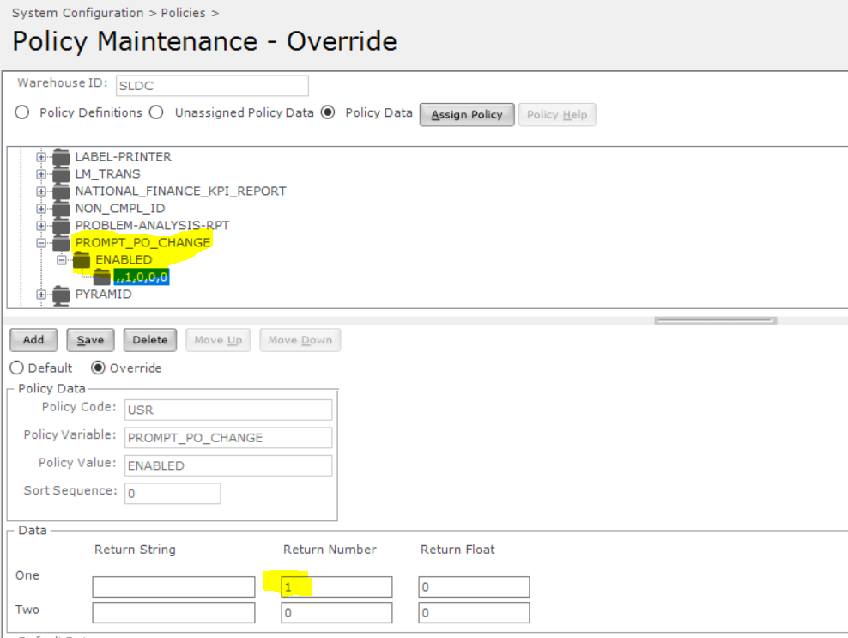

## Test scenarios:

### Scenario 1:

When user receiving an item from multiple POs, prompting message and allow user to go back to scan PO number as Rcv ID to receive.

Data setup:

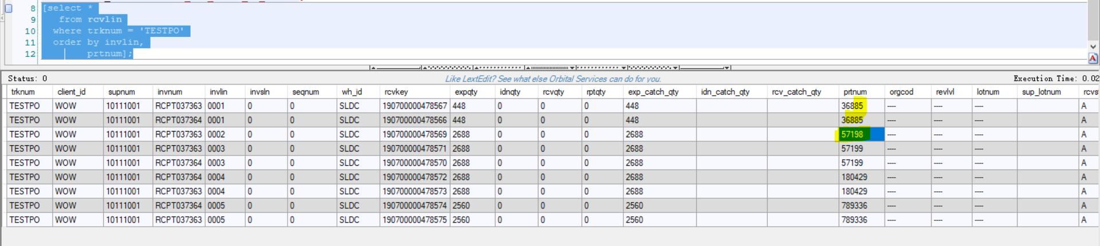

For receiving truck number TESTPO, only item 57198 presents on one receiving line, other item presents on multiple POs:

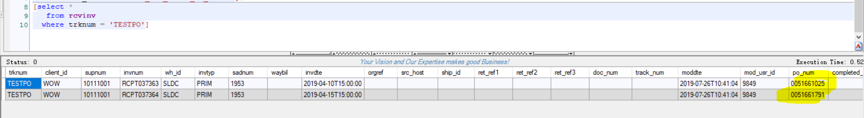

#### Test steps:

Scan Rcv ID ‘TESTPO’ to start receiving:

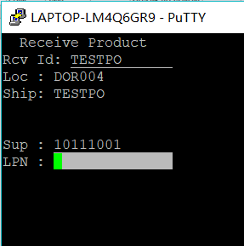

F3 for new LPN:

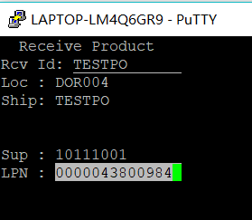

Enter go to next form, scan item 36885, since item is from 2 POs, so system prompt message:

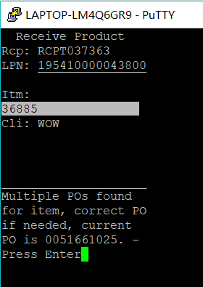

F1 back:

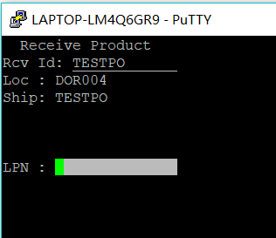

Move cursor back to ‘Rcv ID:’ field to scan PO number ‘0051661791´which for receipt number ‘RCPT037364’, previous screen it was ‘RCPT037363’, and scan LPN:

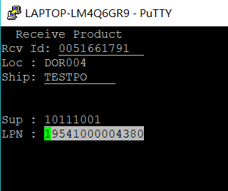

Capture HU:

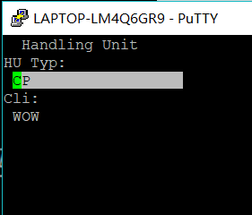

Continue receive (note the Rcp: changed to RCPT037364 since user changed):

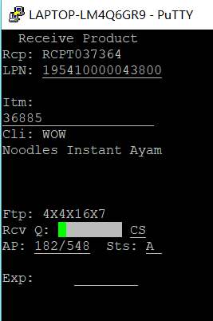

Scan rest fields to finish receiving:

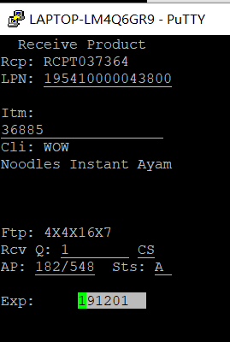

Make sure inventory is received to RCPT037364:

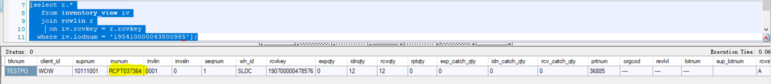

After that, I continue receive next LPN for same item without message prompted any more (Same Item system will only prompt message once, but please note if you receive a different item and come back receive this item again, the same message will be prompted):

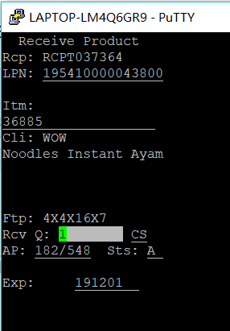

### Scenario 2:

User continue receiving on current PO without F1 back to change PO.

#### Data setup:

Same as scenario 1.

#### Test steps:

After receiving first pallet, stays at IDENTIFY_LOAD form, F3 to receiving a new LPN:

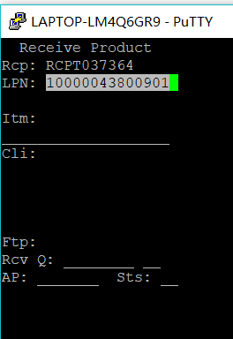

Scans item 57199, got message prompted:

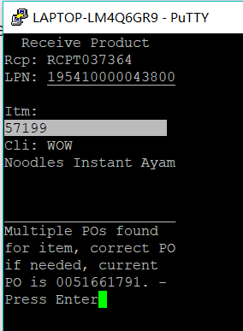

Enter twice to continue receiving on current PO, directly go to Handling Unit form:

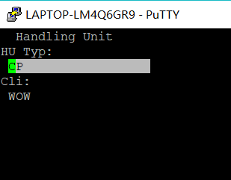

Continue scans rest of fields to finish receiving:

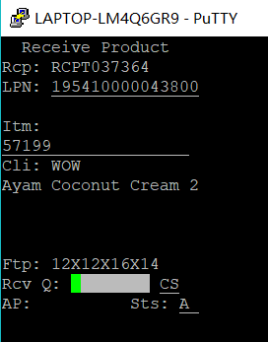

New LPN is received:

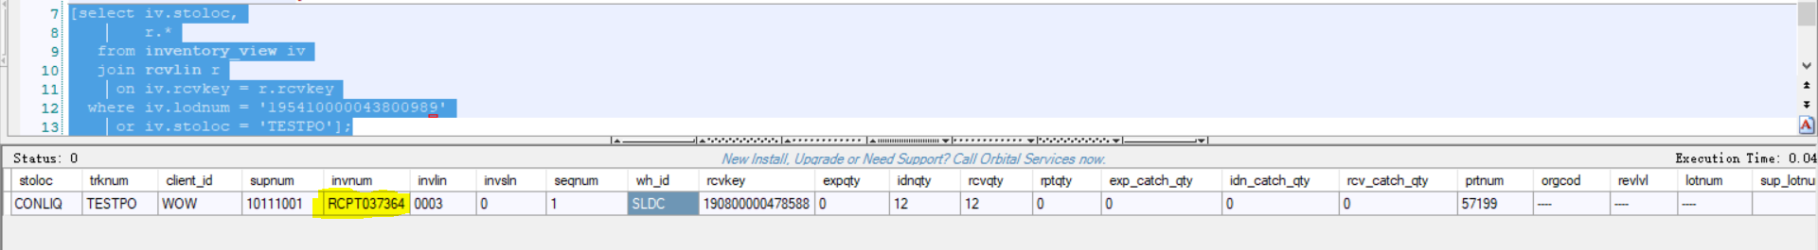

### Scenario 3:

When receiving an item only existing single PO, system should not prompt any message.

#### Data Setup:

Same as Scenario 1.

#### Test Steps:

Scan item 57198 as this item only presents on single PO:

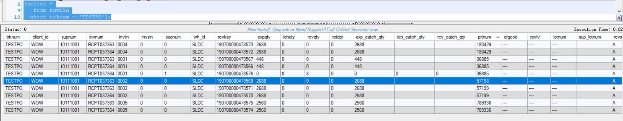

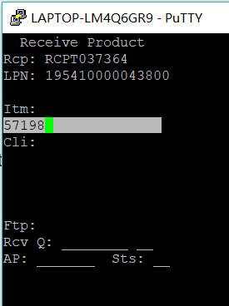

Press Enter directly go to Handling Unit form:

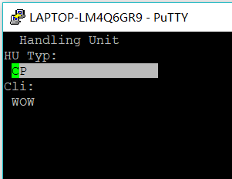

Scan rest of fields to finish receiving the LPN:

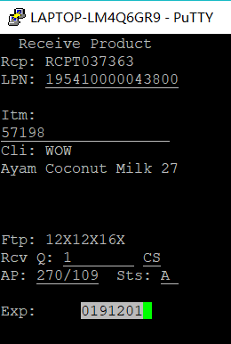

The LPN received success:

