# Test document for RELOCK Demand Replenishment Work if unlocked by QVL

## Issue:

We introduced a customized job ‘USR-UNLOCK-RPL-FOR-MIN-QTY’ to unlock demand replenishment work when inventory level reaches minimum value setup in replenishment configuration. That job is working expected, however there is a trigger ‘move_inventory-change_emergency_replenishment_status_on_move.mtrg’ will unlock work based on available QVL after moving inventory. this workflow is introduced to handle this issue without need a code change(disable this trigger) and a bounce,

## Approach:

Create a background workflow with exit point of ‘move inventory’ to update ‘PEND’ demand replenishment work back to ‘LOCK’ status if the inventory level does not reach the minimum value yet.

## Workflow configuration:

Create a master workflow, named ‘RELOCK-DEMAND-WORK’:

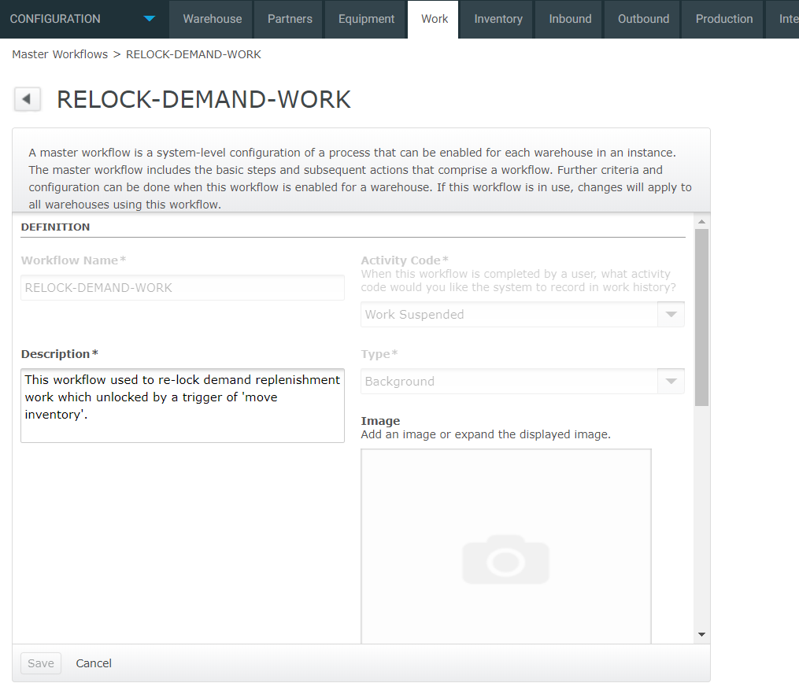

Click ‘User Instructions’:

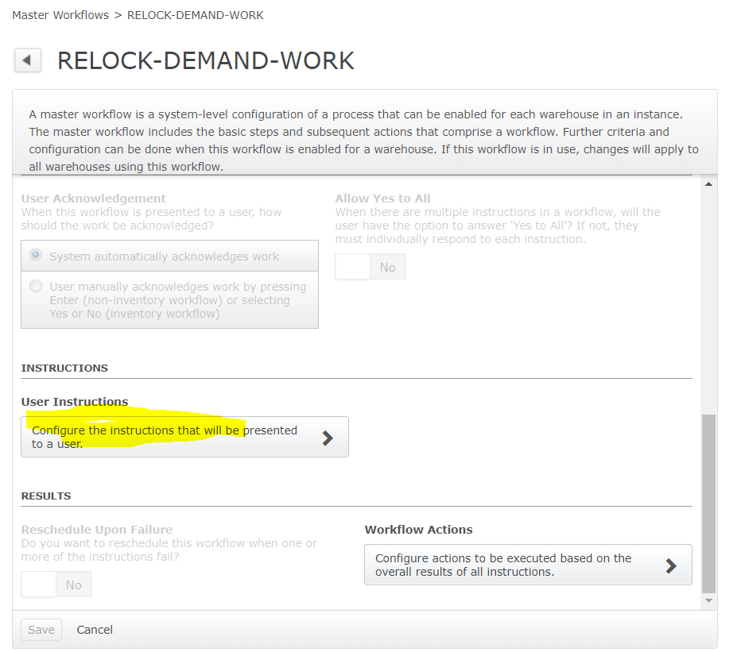

Add one entry:

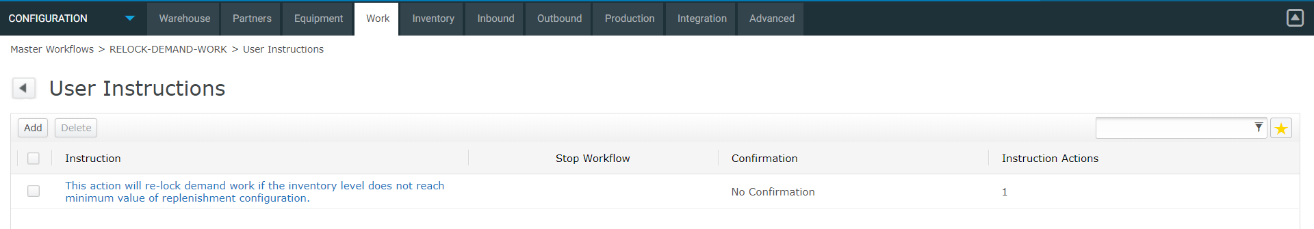

Detail as below:

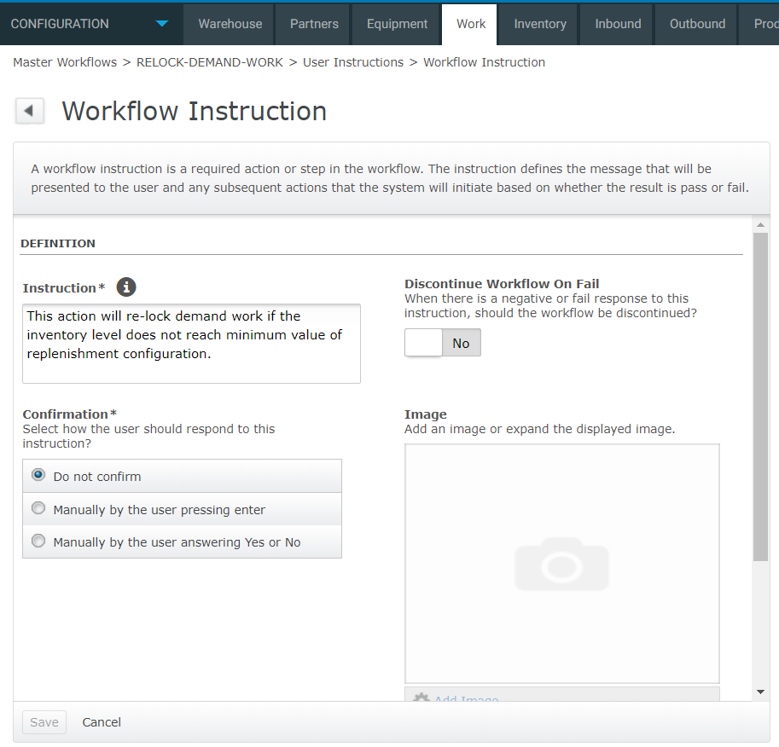

Scroll down and click ‘Instruction Actions’:

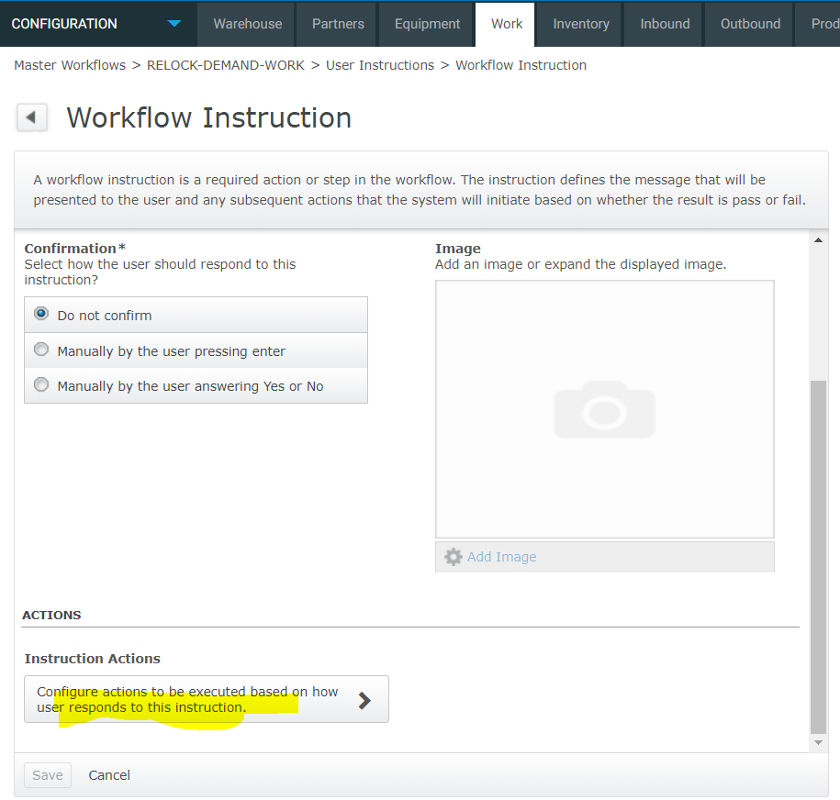

Add one entry:

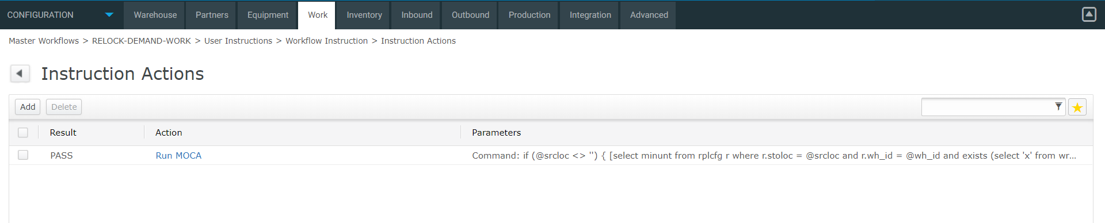

Code to run:

**if** (@srcloc <> '')

{

[select minunt

from rplcfg r

where r.stoloc = @srcloc

and r.wh_id = @wh_id

and exists (select 'x'

from wrkque q

where q.dstloc = r.stoloc

and q.wrksts = 'PEND'

and q.oprcod = 'PIARPL'

and q.wh_id = @wh_id)] **catch**(-1403)

|

**if** (@? = 0)

{

[select sum(untqty) tot_untqty

from inventory_view iv

where iv.stoloc = @srcloc

and iv.wh_id = @wh_id

group by iv.stoloc

having(sum(untqty) > @minunt)] **catch**(-1403)

|

**if** (@? = 0)

{

[update wrkque

set wrksts = 'LOCK'

where dstloc = @srcloc

and oprcod = 'PIARPL'

and wh_id = @wh_id]

}

}

}

Now config a background workflow:

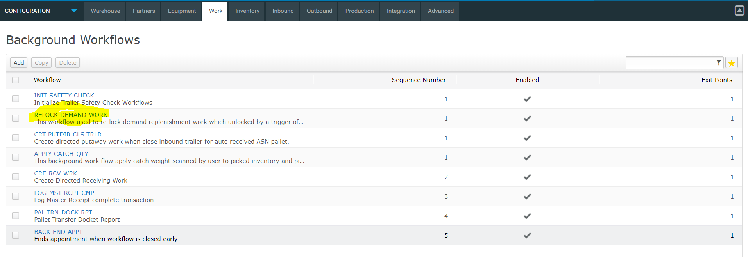

Detail:

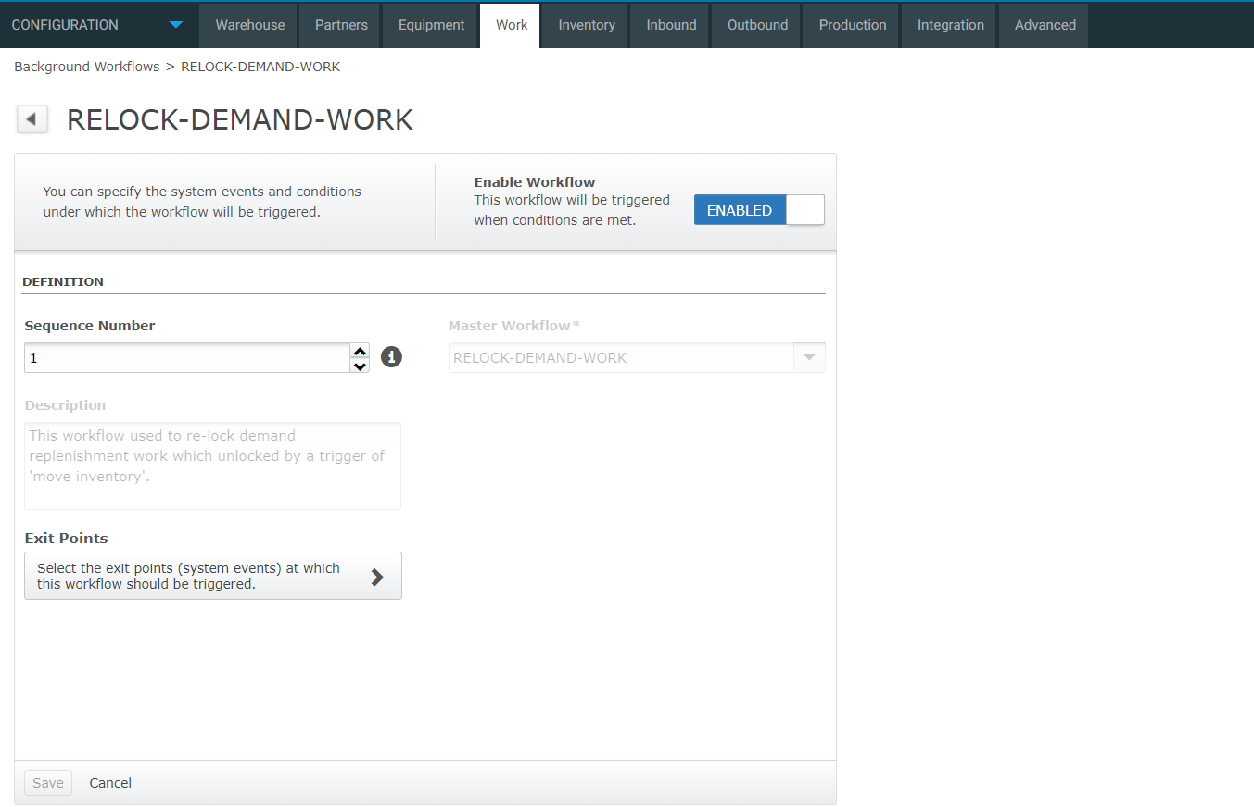

Exit point:

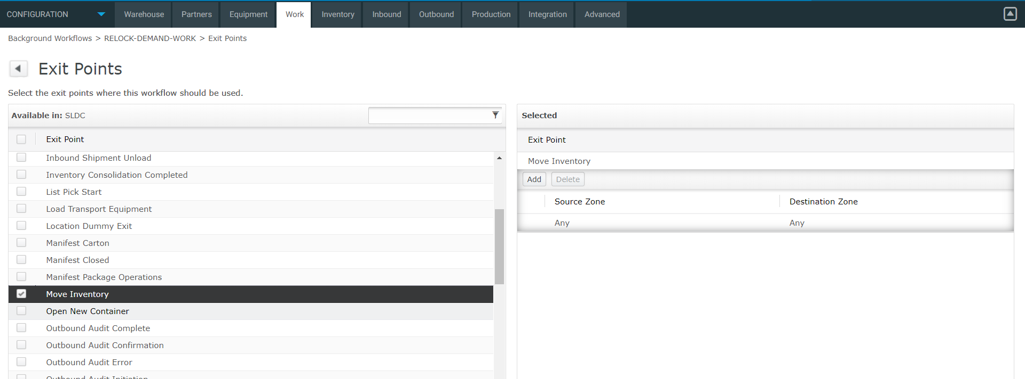

Note: the ‘Source Zone’ ideally should be selection & CLS movement zone from where we do voice picking.

## Test trace:

Trigger of ‘move inventory’ unlock the work:

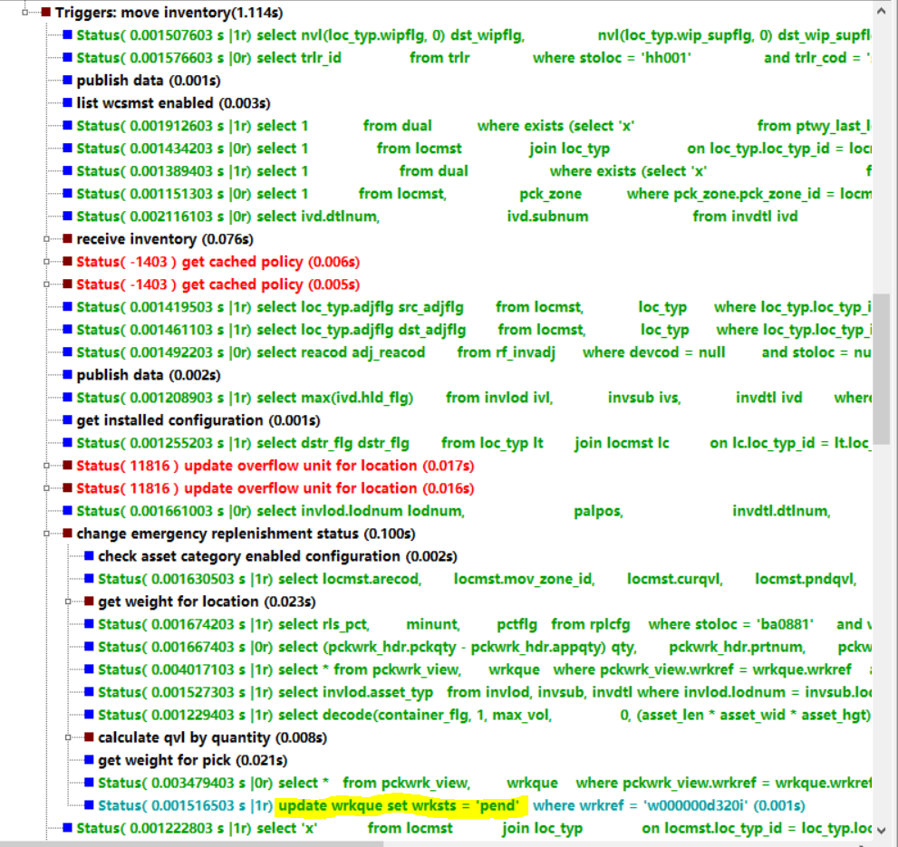

The new workflow re-locked the work:

