# Stop user from assigning continuation assignment from PNDLL/PNDLB

## Summary:

For layer pick continuation assignment, currently process is that after layer picker deposit assignment to PNDLL or PNDLB location, a hauler will do a full inventory move to move the LPN from PNDLL/PNDLB to CONL/CONB from where voice picker can pickup the resume list pick.

We expect user can only get the resume assignment after hauler finished transfer because we don’t expect voice picker go to PNDLL and PNDLB for security reason as that’s layer picking zone(see below picture):

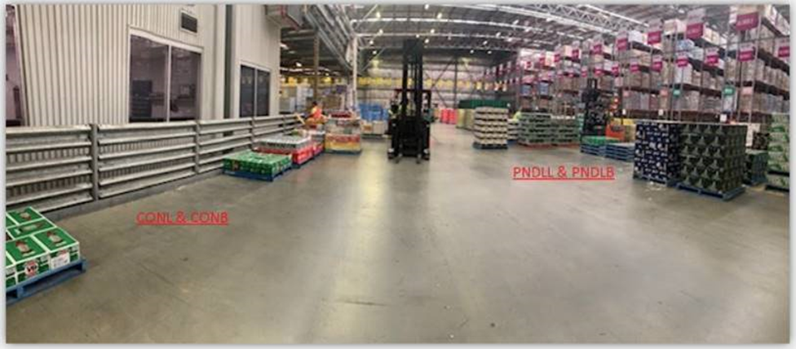

We are trying to achieve this by removing voice user from having location access to PNDLL/PNDLB.

In standard code ‘get directed work’, there is already logic to validate voice user has access to PnD location as well as to the next picking location for the resume list before assigning it to user.

**Gap:**

The gap is related with policy:

list policies

where polvar = 'PROXIMITY'

and polval = 'ENABLED'

and polcod = 'DIRECTED-WORK'

When this policy is enabled, after system grabbed a work for user, system will do a further check to get a better work for user if the ‘better’ work:

**1. has same priority as current work grabbed.**

**2. has smaller movement cost comparing to work grabbed.**

But this part of logic skipped PnD location access validation if the ‘better’ work is a resume list pick which is sitting in PnDLL/PnDLB. but the next picking location access is still being validated.

## Approach:

Use workflow approach to address this issue:

When layer picker set down assignment to PNDLL/PNDLB location, we will assign the work to a dummy user DUMMY_PND_USER, this is a virtual user which is not existing, so essentially this work will not able to be assigned to anybody.

When hauler doing the transfer from PNDLL/PNDLB to CONL/CONB, we clear the dummy user from wrkque table so the work becomes assignable again.

## Configuration:

### Configure a movement zone for location PNDLL/PNDLB.

Currently these 2 locations are not defined with a movement zone, so we need to create a movement zone for them:

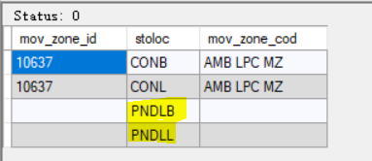

### Add 2 activity codes

Configured below 2 activity codes for 2 master workflows:

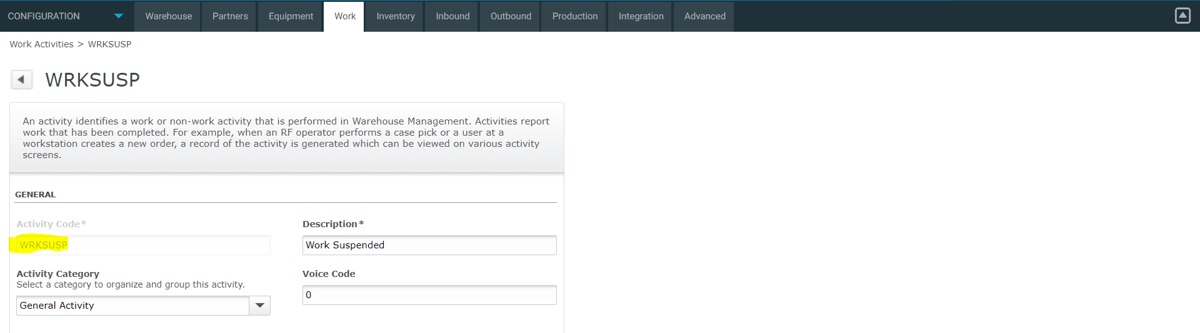

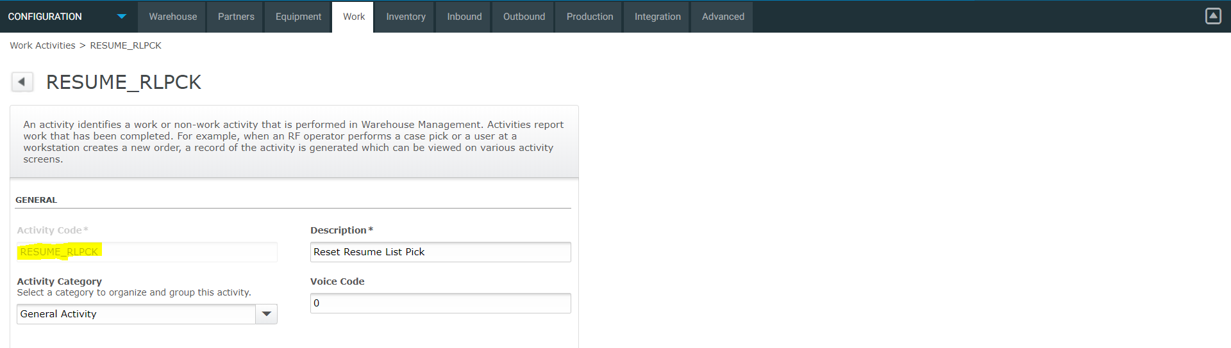

### Add 2 master workflows:

a). **SUSPEND-LIST-PICK**: this workflow fires when layer picker set down pallet to PNDLL/PNDLB location by which it will update DUMMY_PND_USER to the work queue asg_usr_id field.

b). **RESUME-LIST-PICK**: this workflow fires when hauler transfer pallet from PNDLL/PNDLB to CONL/CONB, by which it removes the DUMMY_PND_USER from wrkque.

**Master workflow for SUSPEND-LIST-PICK:**

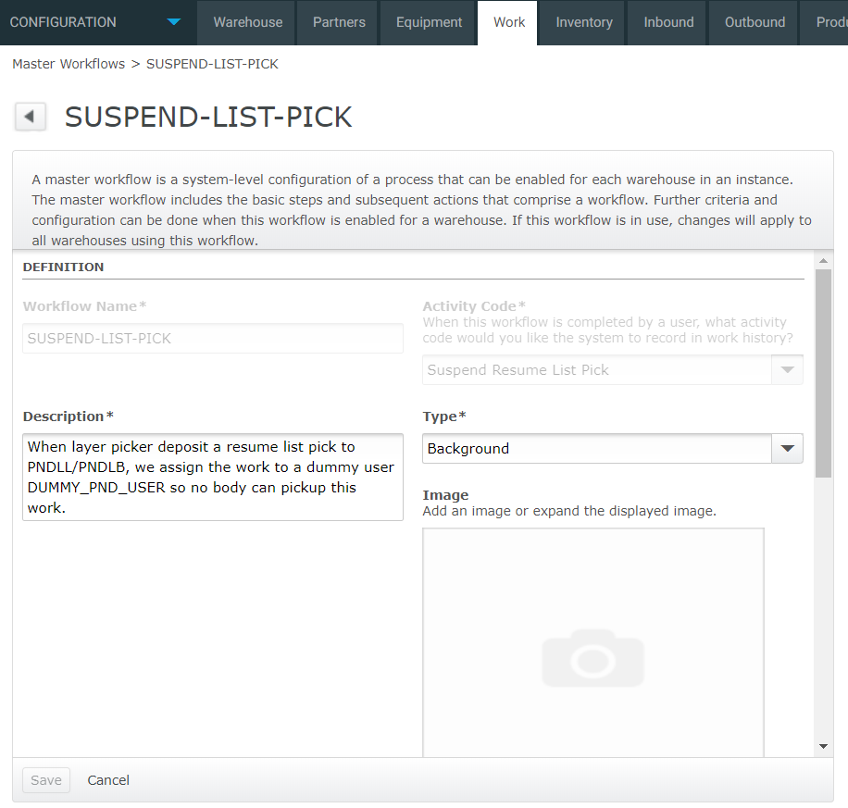

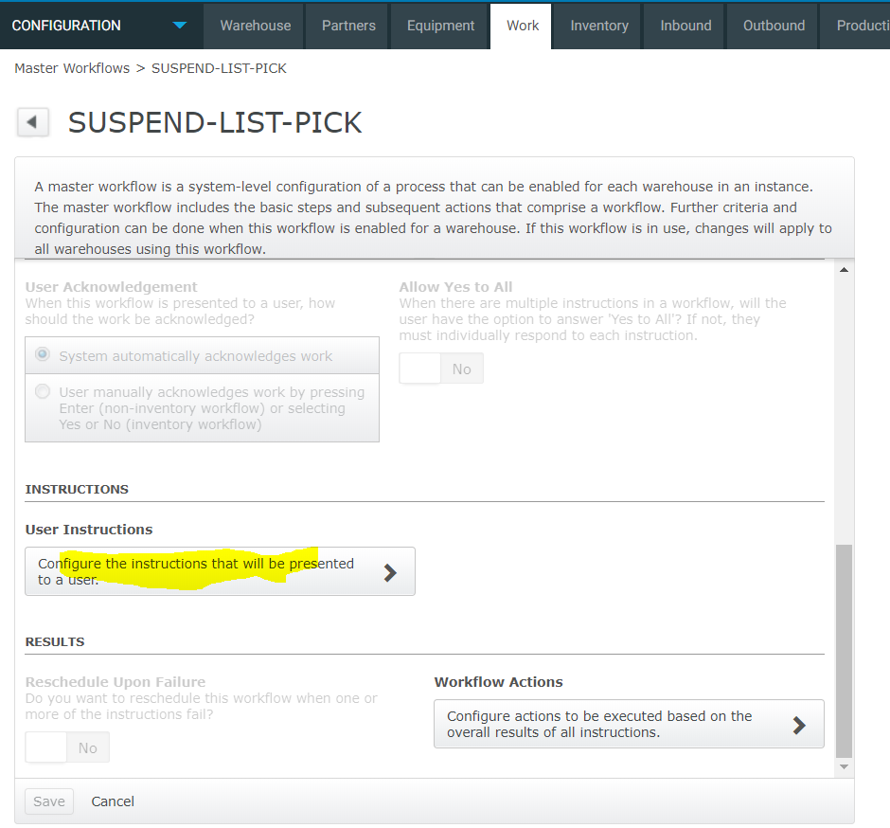

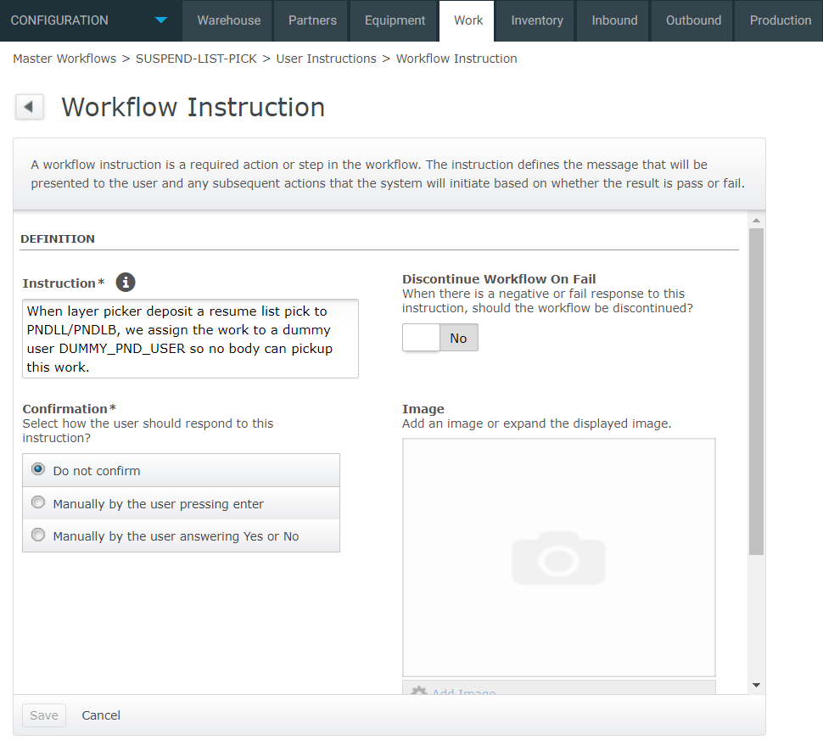

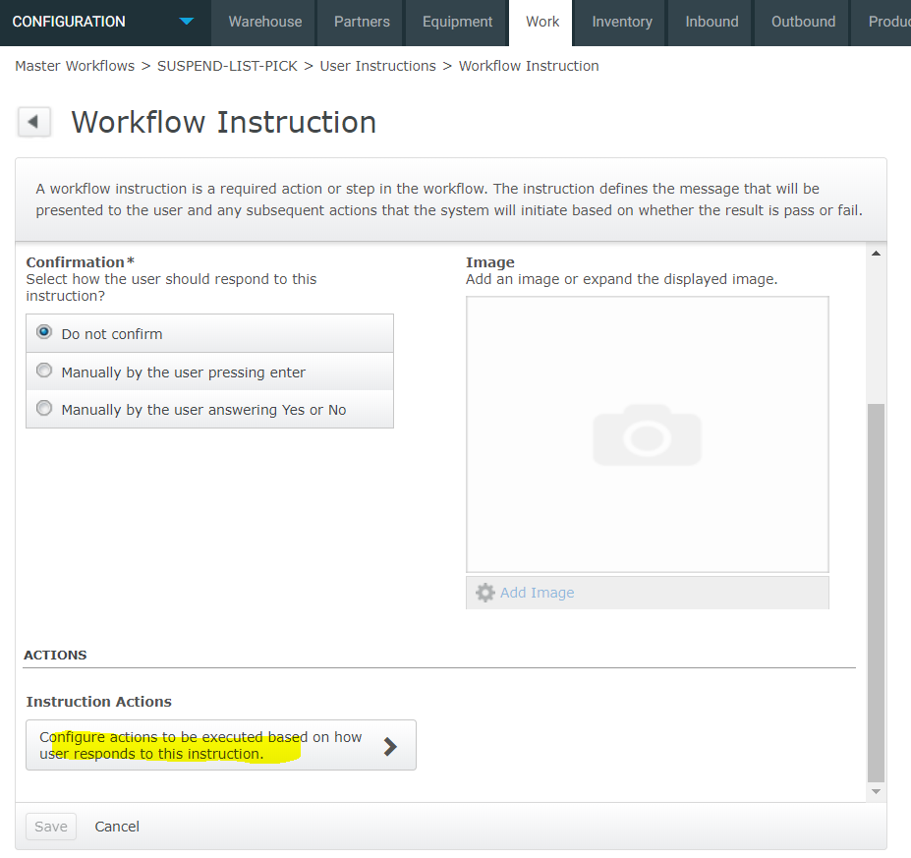

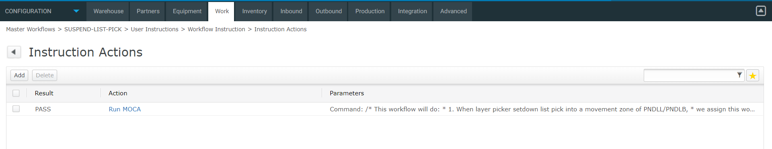

The command to run see file: workFlowForMoveInvSuspendWork.sql

Copy the content of the file and pasted into command field and save.

**Master workflow for RESUME-LIST-PICK:**

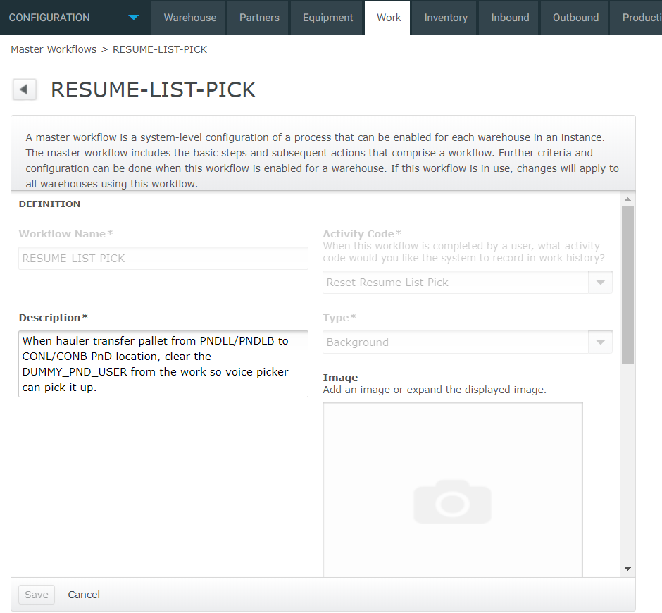

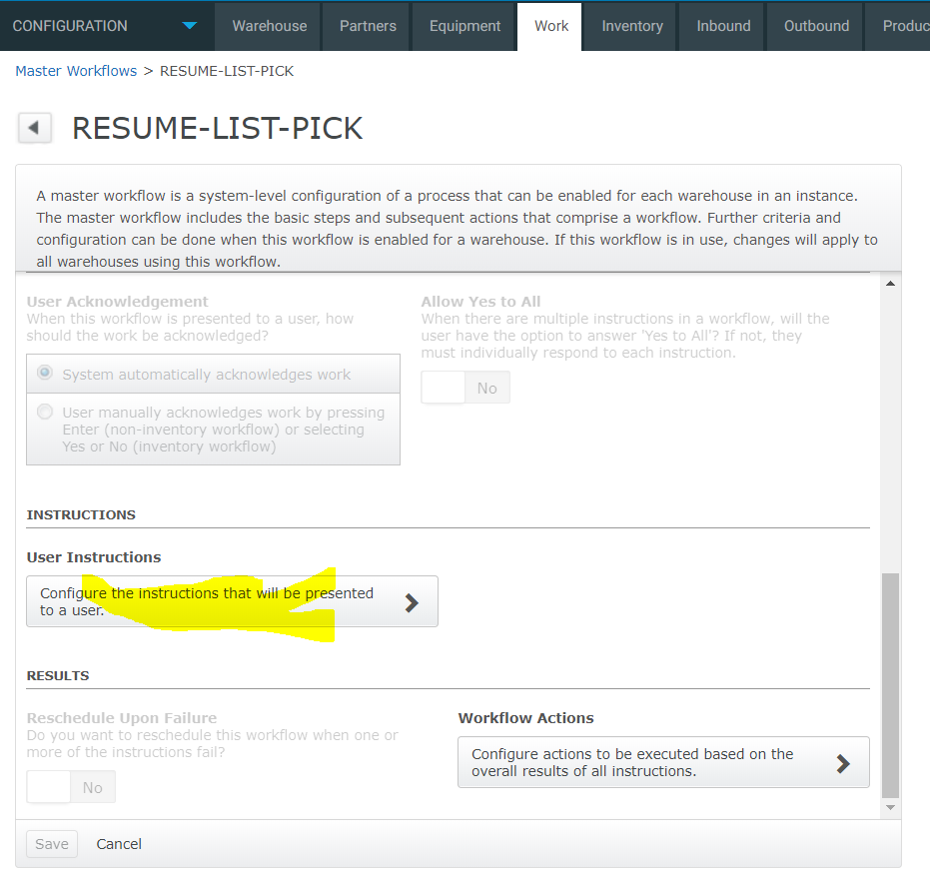

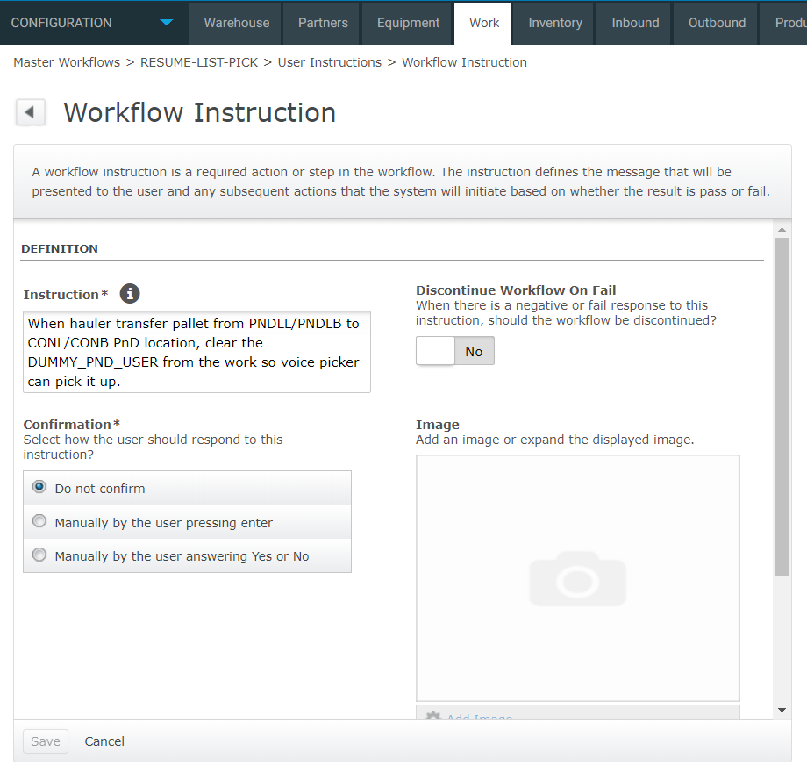

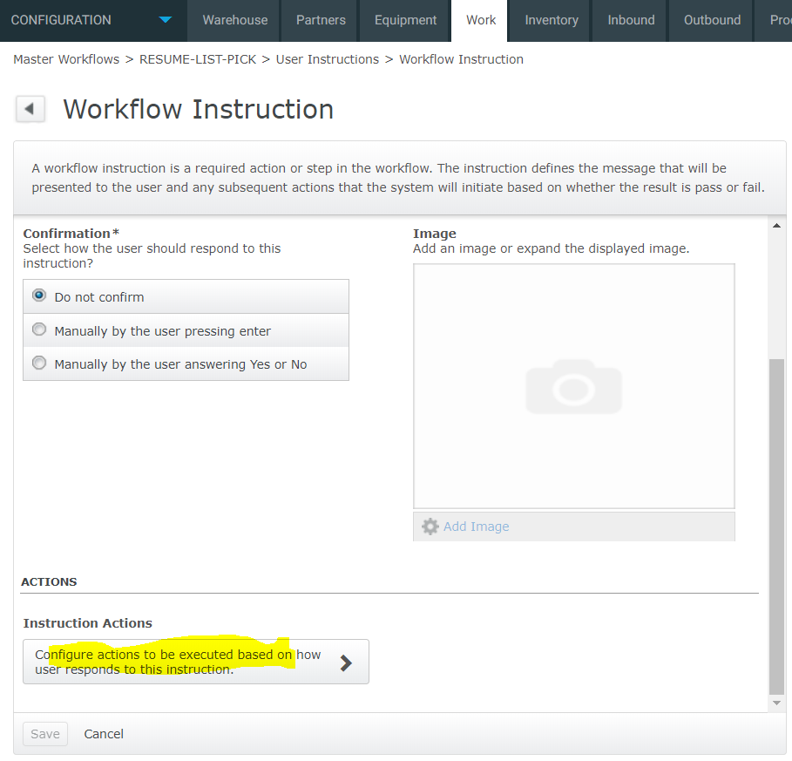

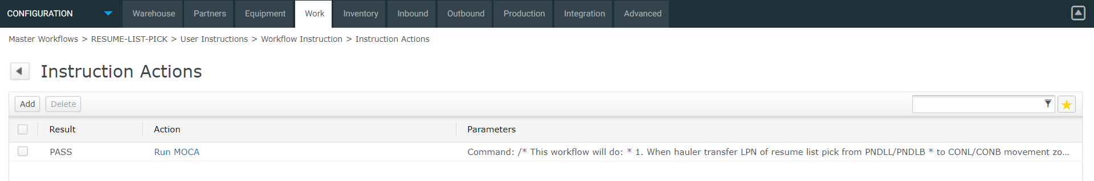

Note: for the command to run see file workFlowForMoveInvResumeWork.sql

Copy the content of this file and paste to command.

### Configure background workflow for above 2 master workflows

1. background workflow for SUSPEND-LIST-PICK

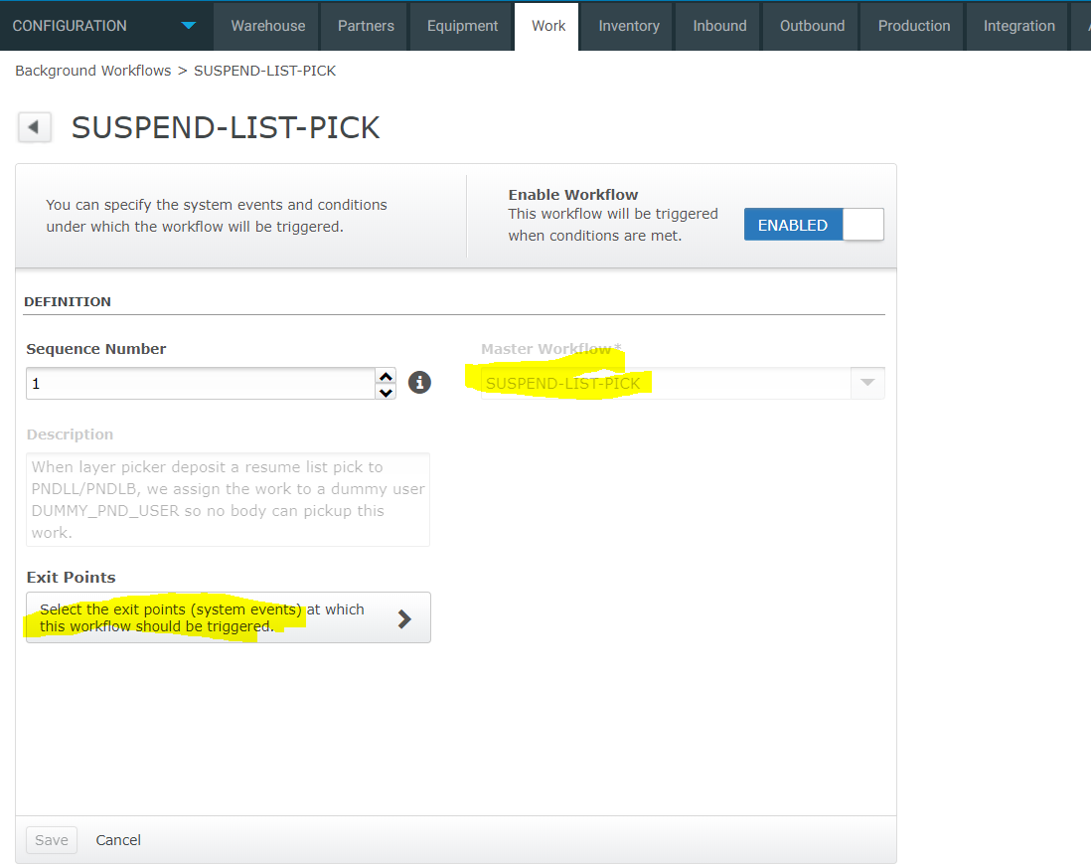

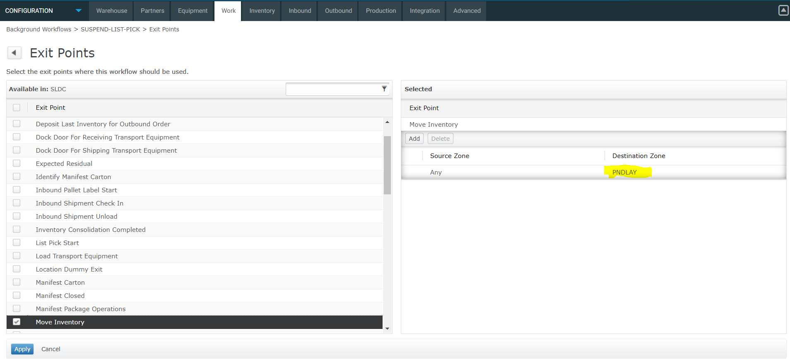

For exit point, make sure this workflow only fires when ‘move inventory’ to movement zone ‘PNDLAY’ which is for PNDLL and PNDLB.

2. background workflow for RESUME-LIST-PICK

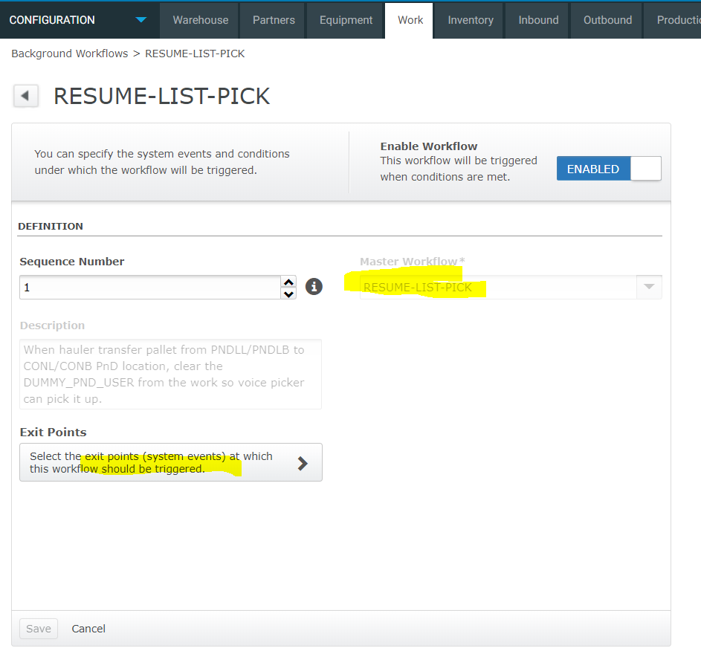

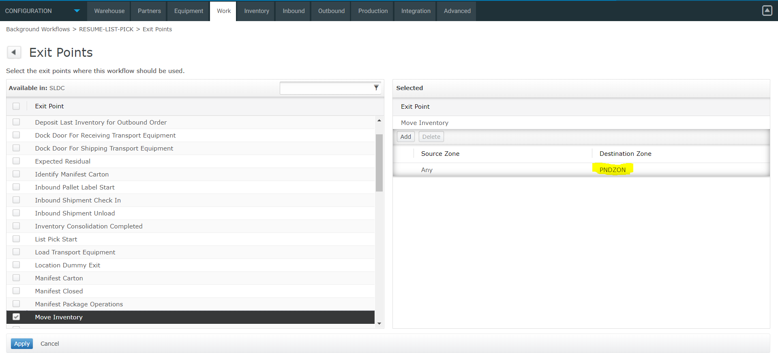

Selection the destination movement zone defined for ‘CONL/CONB’ location.

### Test:

After ‘set down’ assignment to PNDLAY, the work’s asg_usr_id is updated with DUMMY_PND_USER:

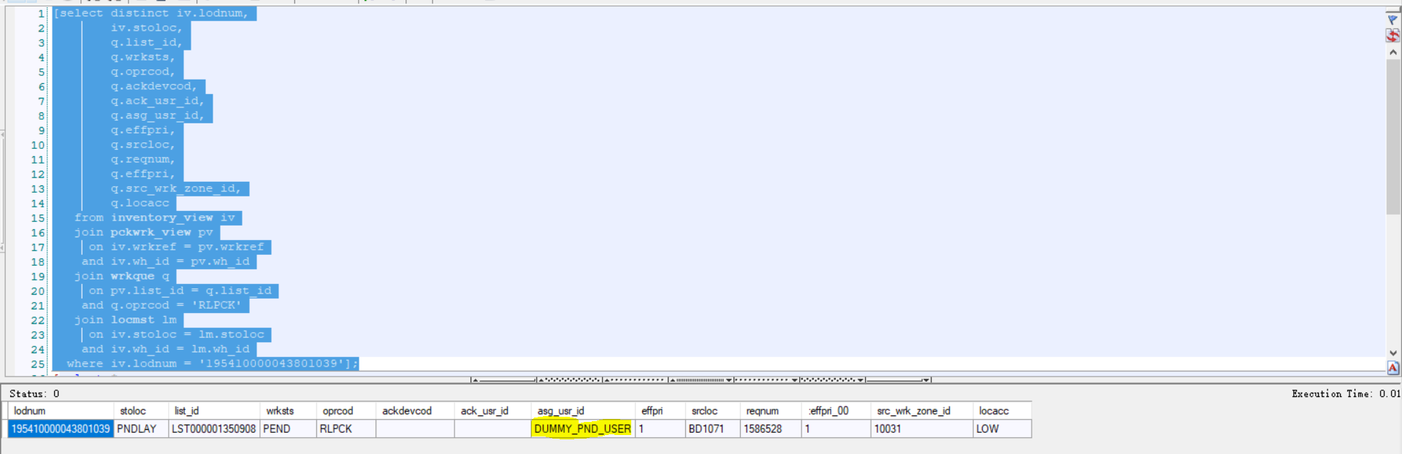

Go to directed work, now a different assignment (this should be tested with voice device, but I’m using RF to simulate this issue).

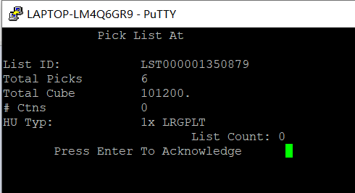

Now I transfer the LPN to PNDOVF which should be CONL in PRDC, the asg_usr_id is removed:

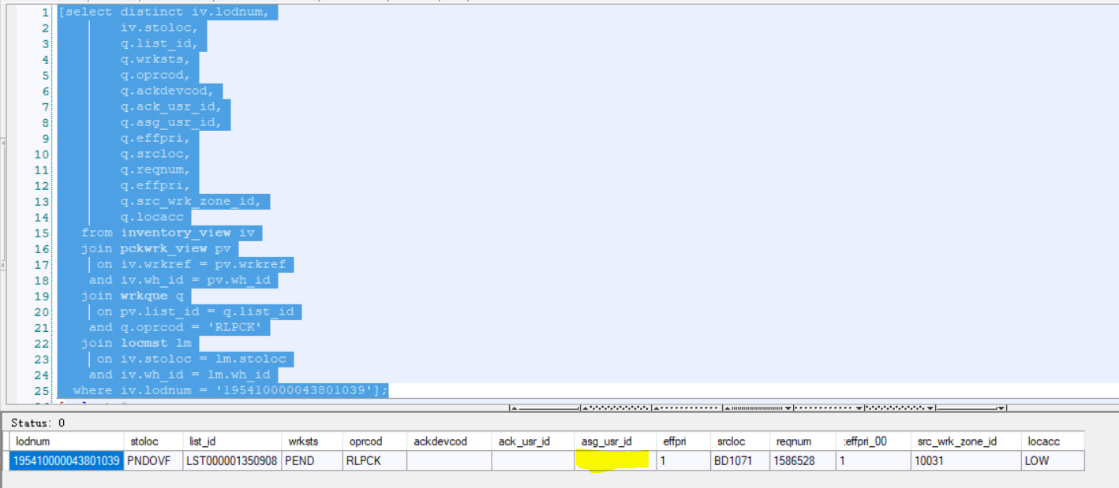

Now if I go to directed work, I am getting this assignment:

