# Uom Picked Per Hour

**To get a better understanding of UOMs Picked Per Hour, we developed a script to calculate this KPI with below methods:**

1. Get all picked assignments, total uoms picked and divide by total hours spent.

2. For each assignment the start picking time of first pick to the last pick picking time is considered as total picking time for the assignment, as a comparison, we also support a flag to include the time spent after last pick to LPN stage time to be considered as part of the assignment time.

After running script for this week:

|  |  |  |
| --- | --- | --- |
| Date | UOM/Hr without stage time | UOM/Hr with stage time |
| Dec 2 | 218.92 | 180.99 |
| Dec 3 | 227.97 | 189.98 |
| Dec 4 | 212.91 | 185.37 |
| Dec 5 | 213.44 | 183.46 |
| Dec 6 | 221.72 | 188.24 |
| Dec 7 | 224.54 | 190.38 |

Note:

1. This script only counting assignment picking, not including pallet pick which would give higher UOM/Hr.

2. This script does not exclude break time within single assignment.

There are some parameters can be used for return detail picking data and time spent:

/*

* usr_id: pass this id to get picking cartons per hour for specific user.

* dtl_flg: return each detail picking record with uoms picked and seconds spent.

* uom_per_hr_by_usr_flg: return cartons per hours for multiple users(usr_id not passed).

* use_stg_time_for_lstpck_flg: including LPN stage timestamp as part of assignment time otherwise use picking time gap

* to pervious picking time as picking time spent for last pick.

*/

publish data

where usr_id = '3622'

and dtl_flg = **0**

and uom_per_hr_by_usr_flg = **0**

and use_stg_time_for_lstpck_flg = **1**

and from_time = '20191207000000'

and to_time = '20191207235959'

Make sure from_time and to_time is not too big as it involves dlytrn table query, I just used one day long to do the query.

Below are some screenshots:

1. Return pick detail data for single user:

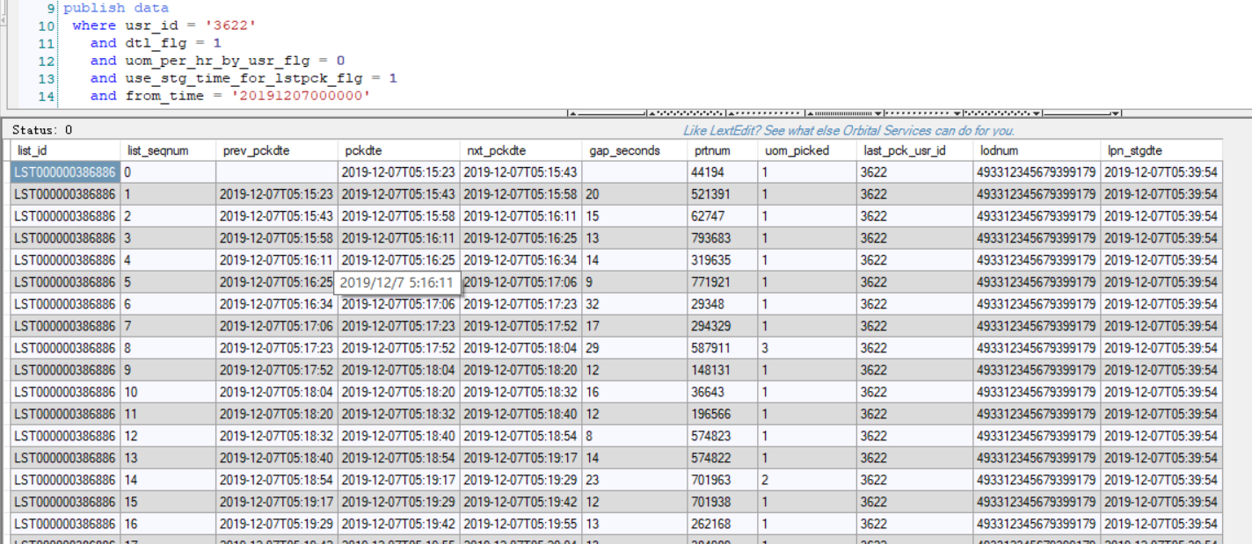

2. Single user picking rate including stage time:

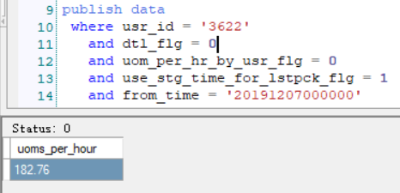

3. Single user picking rate without stage time included.

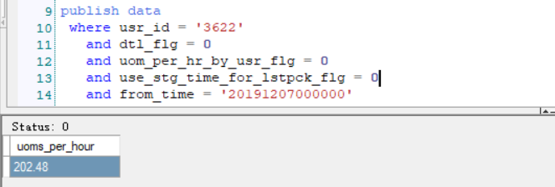

4. picking rate for multiple users including stage time:

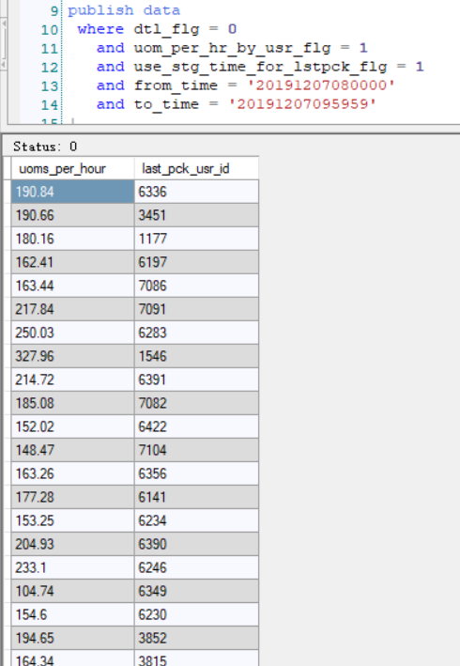

5. Multiple user picking rate without including stage time:

